Supplementary Table 1: Generalized Linear Mixed Effects Model exploring the effect of FiO2 and flow rate
Predictors | Estimates [CI] | p
(Intercept) | 101.22 [-43.14 – 245.59] | 0.167
FiO₂ | 177.24 [33.23 – 321.25] | 0.017
Room air pO₂ | 0.35 [-0.55 – 1.24] | 0.447
Flow rate | -2.42 [-5.09 – 0.25] | 0.075
FiO₂ × Flow (interaction effect) | 3.30 [-0.01 – 6.62] | 0.051
Random Effects | Random Effects
σ | 3095.62
τ00 | 1686.32 id
ICC | 0.35
N | 21 id
Observations | 84
Marginal R / Conditional R | 0.519 / 0.688

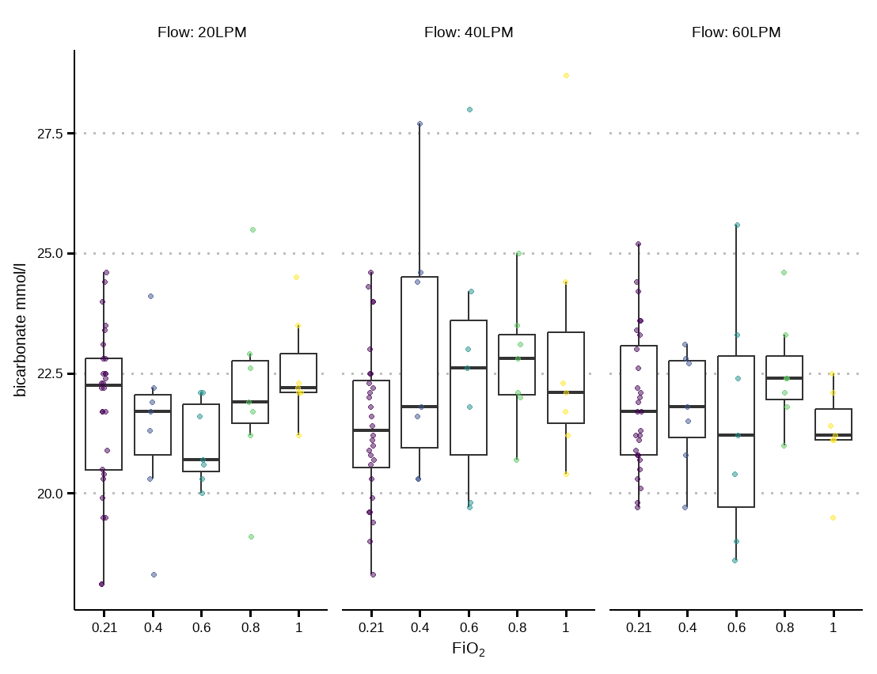
Supplementary Fig. 1 Boxplot of bicarbonate (mmHg) at different FiO₂ and Flow (dots represent individual data points)

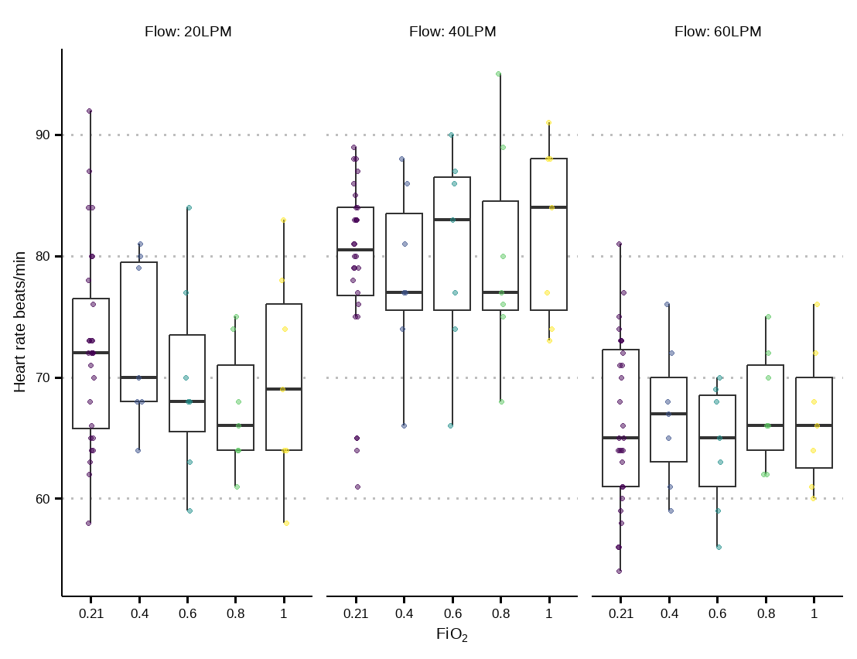
Supplementary Fig. 2 Boxplot of heart rate at different FiO₂ and Flow (dots represent individual data points)

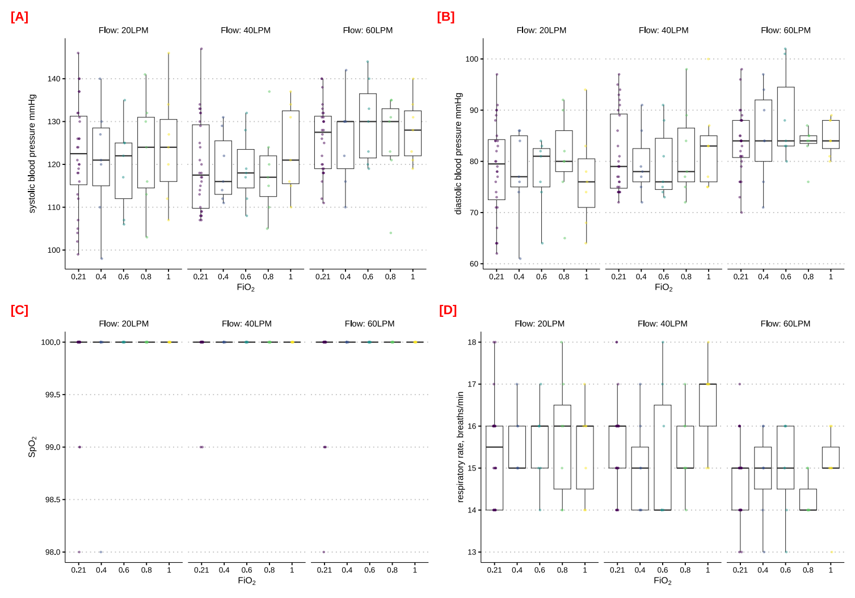
Supplementary Fig. 3 A Systolic blood pressure; B Diastolic blood pressure; C Oxygen saturation (SPO₂); D Respiratory rate

