TITLE: Ultrasonographic Evaluation of Intraoperative Optic Nerve Sheath Diameter Changes in Patients Undergoing Laparoscopic Surgery
1. Author
- Sevim CESUR , Associate Professor
- Affiliation: Department of Anesthesiology and Reanimation, Kocaeli University, Kocaeli, Turkey
-ORCID: 0000-0002-8764-1251
2. Author (Corresponding Author)
- Nur Nazire YUCAL , MD
- Affiliation: Department of Anesthesiology and Reanimation, Başakşehir Çam & Sakura City Hospital, Istanbul, Turkey
-ORCID: 0000-0001-6449-3279
3. Author
- Tülay ÇARDAKÖZÜ , Professor
- Affiliation: Department of Anesthesiology and Reanimation, Kocaeli University, Kocaeli, Turkey
-ORCID: 0000-0002-4936-8020

Address for correspondence: Nur Nazire YUCAL
Department of Anesthesiology and Reanimation, Başakşehir Çam & Sakura City Hospital, Istanbul, Turkey
Turkey
Mail: nuryucal@gmail.com
Phone: +905443898086

ACKNOWLEDGEMENTS
Assistance with the article
None
Financial support
None
Conflicts of interest
None

Abstract
Background:
Laparoscopic surgery offers several advantages such as reduced postoperative pain and faster recovery; however, the establishment of pneumoperitoneum has the potential to transiently increase intracranial pressure (ICP). Ultrasonographic measurement of the optic nerve sheath diameter (ONSD) provides a reliable noninvasive indicator of ICP changes. This study aimed to evaluate ONSD measurements, which may reflect intraoperative ICP changes during laparoscopic upper abdominal surgery performed in the reverse Trendelenburg position, and to assess the specific effects of pneumoperitoneum.
Methods:
Fifty-five patients with ASA physical status I-III who undergoing elective laparoscopic upper abdominal surgery were prospectively enrolled. Bilateral ONSD measurements were performed at four time points: after induction of anesthesia (T₀), 10 minutes (T₁), and 60 minutes (T₂) after the establishment of pneumoperitoneum, and 10 minutes after desufflation (T₃). Respiratory and hemodynamic parameters were recorded simultaneously.
Results:
Mean ONSD values increased significantly at both 10 and 60 minutes of pneumoperitoneum compared to baseline (p < 0.001) and remained elevated even after desufflation (p < 0.01). No significant difference was observed between T₁ and T₂. Peak and plateau pressures increased while compliance decreased during pneumoperitoneum (p < 0.001).
Conclusion:
Pneumoperitoneum during laparoscopic upper abdominal surgery causes a significant yet transient increase in ONSD. Although ONSD values showed a partial decrease after desufflation, they remained higher than baseline measurements but within clinically acceptable and non-critical ranges. Continuous intraoperative ultrasonographic ONSD monitoring may provide real-time insight into intracranial dynamics, particularly in patients at risk for elevated ICP. Further studies are warranted to clarify the underlying multifactorial mechanisms and determine the clinical significance of ONSD alterations.
Keywords: Laparoscopic surgery, Optic Nerve Sheath Diameter, Ultrasonography, Reverse Trendelenburg, Intracranial pressure monitoring, Pneumoperitoneum, Sevoflurane
Ethical committee approval: GOKAEK-2023/19.12.
Clinical trials registration: NCT06209034, Registered January 6, 2024.

1. Background
Laparoscopic surgery has become a widely adopted alternative to open surgery in recent years due to its advantages of reduced postoperative pain, improved cosmetic outcomes, and earlier mobilization [1]. While the minimally invasive nature of laparoscopic surgery offers several benefits, the creation of pneumoperitoneum with carbon dioxide (CO₂) to facilitate surgical visualization can lead to increased intracranial pressure (ICP), in addition to its known cardiovascular and respiratory system effects [2,3]. Although invasive methods for ICP measurement remain the gold standard, they pose risks of complications such as bleeding and infection. In contrast, ultrasonographic assessment of the optic nerve sheath diameter (ONSD) has emerged as a simple, reliable, and non-invasive method that can effectively detect dynamic changes in ICP under clinic conditions [4,5].
Previous studies have demonstrated that increased intra-abdominal pressure (IAP) during pneumoperitoneum reduces venous return, transiently increasing ICP, and that changes in ONSD correlate closely with both the duration of pneumoperitoneum and the degree of ICP elevation [6]. Several mechanisms have been proposed to explain the increase in ICP during laparoscopic surgery, including impaired cerebrospinal fluid (CSF) absorption and obstruction of lumbar plexus drainage due to pneumoperitoneum, and elevated IAP (≥15 mmHg), cerebral vasodilation associated with Trendelenburg position and hypercarbia, as well as the choice of anesthetic agent used [3,6,7]. Although the IAP levels ≥15 mmHg have been identified as a key determinant contributing to significant ONSD elevation, studies have reported that the reverse Trendelenburg position, commonly used in procedures such as laparoscopic cholecystectomy and Nissen fundoplication, can balance the increase in IAP and minimize changes in ONSD [6,8]. Therefore, this study aims to evaluate intraoperative changes in ONSD measured by ultrasonography in patients undergoing laparoscopic upper abdominal surgery in the reverse Trendelenburg position and to investigate the specific effects of pneumoperitoneum on observed changes.

2. Methods

2.1. Ethical Approval and Study Registration.
This study was approved by the Kocaeli University Ethics Committee (decision number: GOKAEK-2023/19.12). After obtaining the Ethics Committee approval, the study was registered on ClinicalTrials.gov (NCT06209034), on January 6, 2024 (Retrospectively registered) . This research fully conforms to the ethical standards of the Helsinki Declaration. Written informed consent was obtained from the participants enrolled in the study.

2.2. Study Design and Participants
A total of fifty-five patients aged ≥18 years with an ASA physical status of I-III, who were scheduled for elective laparoscopic upper abdominal surgery, were included in this prospective, observational, single center study. Patients with known ophthalmic disease or a history of ophthalmic surgery, neurological disorders, a history of intracranial hypertension or chronic respiratory diseases such as chronic obstructive pulmonary disease or asthma were excluded from the study.

2.3. Preoperative Preparation and Monitoring
After establishing peripheral venous access, patients received 0.03-0.05 mg/kg midazolam as premedication and were transferred to the operating room. Standard monitoring was applied, including lead II electrocardiography (ECG), heart rate (HR), noninvasive blood pressure (NIBP), peripheral oxygen saturation (SpO2), and Patient State Index (PSI) for anesthesia depth.

2.4. Anesthesia Induction and Maintenance
General anesthesia was induced with 1 μg/kg fentanyl (Talinat®, Vem Pharmaceuticals), 2-3 mg/kg propofol (Propofol-Lipuro®, B. Braun), and 0.6 mg/kg rocuronium (Myocron®, Vem Pharmaceuticals) administered intravenously (IV). Endotracheal intubation was performed using a cuffed endotracheal tube (ETT) (7.5 mm for women, 8.0 mm for men) after confirming adequate muscle relaxation.
Following endotracheal intubation, all patients were ventilated with a Datex-Ohmeda anesthesia machine in volume-controlled mode, with a tidal volume of 6 ml/kg predicted body weight, an inspiratory-to-expiratory ratio of 1:2 and 5 mmHg positive end expiratory pressure (PEEP) as standard. The respiratory rate was initiated at 12 breaths/min and adjusted to maintain an end-tidal carbon dioxide (EtCO₂) of 35-40 mmHg.
Anesthesia was maintained with a fresh gas flow of 3 L/min containing 40% oxygen (O₂₎ and 0.5-1.0 minimum alveolar concentration (MAC) Sevoflurane (Sevoflurane®, Abbot), together with a remifentanil infusion titrated to maintain mean arterial pressure (MAP) within ±20% of baseline. Depth of anesthesia was continuously monitored using PSI (Masimo SedLine® ) (25-50).

2.5. Surgical Procedure
After nasogastric tube placement, 4 trocars and 1 retractor were inserted with the patients in the neutral supine position. CO₂ insufflation was initiated at a rate of 2-3 L/min until an IAP of 12 mm Hg was reached, after which patients were positioned at 30º reverse Trendelenburg. At the end of the surgery, intra-abdominal gas was evacuated, and the patients were returned to the supine position. To prevent postoperative nausea and vomiting, all patients received 8 mg of intravenous ondansetron (Kemoset®, Deva Pharmaceuticals). Patients who achieved adequate spontaneous tidal volumes were extubated and transferred to the post-anesthesia care unit for recovery.

2.6. Recorded parameters
Hemodynamic and respiratory parameters, including MAP, HR, SpO₂, peak airway pressure (P_{peak}), plateau pressure (P_{plateau}), end-tidal CO₂, and Compliance _{dynamic}, were recorded simultaneously with the ONSD measurements.

2.7. ONSD Measurements
ONSD was measured at four distinct time points.
T₀: After induction of anesthesia, in the neutral position (baseline).
T₁: 10 minutes after pneumoperitoneum and reverse Trendelenburg position.
T₂: 60 minutes after pneumoperitoneum and reverse Trendelenburg position.
T₃: 10 minutes after desufflation, when the patient had returned to the neutral position.
Previous studies have shown that inexperienced ultrasound operators can achieve proficiency after only 25 examinations, while experienced users require about 10 examinations [9].
Before starting our study, the anesthesiologist performing ONSD measurement completed a structured training program with a radiologist involving 25 patients. During the measurement, the patient's eyes were closed and covered with a bio-occlusive dressing (Tegaderm®; 3M™ Healthcare). A thick layer of ultrasound gel was applied over the Tegaderm®, and a linear ultrasound probe (Esaote My Lab 6® US Floransa, Italy) was gently placed over the gel on the eye creating minimal pressure. The probe angle was adjusted to obtain optimal images of the optic nerve sheath (Fig. 1). The optic nerve sheath diameter (ONSD) was measured 3 mm posterior to the globe, in accordance with widely accepted measurement standards. Right and left eye ONSD measurements were analyzed separately in the statistical analysis.

Statistical analysis
A power analysis was performed using the G*Power software based on an assumed effect size of 0.2 for within-subject changes in optic nerve sheath diameter across time points, which was defined as the primary outcome of the study, with α = 0.05 and a power (1−β) of 0.95, resulting in a required sample size of 55 participants. Data analysis was performed using IBM SPSS Statistics version 20.0 (IBM Corp., Armonk, NY, USA). Normally distributed variables were expressed as mean ± standard deviation (SD), while non-normally distributed variables were presented as median (25th–75th percentile). For within-subject comparisons, repeated-measures ANOVA or Friedman’s two-way ANOVA was applied as appropriate. Bonferroni or Dunn's tests were used for post-hoc pairwise comparisons. The correlations between numerical variables were evaluated using Pearson’s or Spearman's correlation coefficients. A p < 0.05 was considered statistically significant.

3. Results

3.1. Patient Characteristics
A total of 55 patients were included in the study, comprising 42 females (76.4%) and 13 males (23.6%), with a mean age of 50.8 ± 14.8 years. According to the ASA physical status classification, 6 patients (10.9%) were ASA I, 41 patients (74.5%) were ASA II, and 8 patients (14.5%) were ASA III. The surgical procedures performed included Nissen fundoplication in 18 patients (32.7%) and laparoscopic cholecystectomy in 37 patients (67.3%) (Table 1).

3.2. Secondary Outcomes
ONSD values increased significantly in both eyes at 10 minutes (T₁) and 60 minutes (T₂) of pneumoperitoneum compared with the baseline post-induction (T₀) values (ONSD_{right} p < 0.001, ONSD_{left} p < 0.001). ONSD values at 10 minutes after desufflation (T₃) were significantly higher than values after baseline post-induction (T₀) (ONSD_{right} p = 0.001, ONSD_{left} p = 0.004). No significant difference was observed between ONSD values at 10 and 60 minutes of pneumoperitoneum (T₁ vs T₂) (ONSD_{right} p = 0.058, ONSD_{left} p = 0.725). A summary of ONSD changes across all time points is provided in Table 2 and illustrated in Figure 2.
During pneumoperitoneum (T1 and T2), the P_{peak}, P_{plateau}, and Compliance_{dynamic} values were significantly higher, whereas Compliance_{dynamic} was significantly lower both post-induction (T₀) and post-desufflation (T₃) values. Respiratory parameters showed no significant differences between T₁ and T_{2,} indicating that the pressure and compliance changes stabilized after the initial establishment of pneumoperitoneum.
End-tidal CO₂ (EtCO₂) levels were significantly higher at 60 minutes (T₂) compared to the post-induction period (T₀), reflecting the effect of sustained pneumoperitoneum. HR was significantly higher after induction (T₀) compared to T₁ and T₃ values (p = 0.012, p < 0.001, respectively). MAP remained stable throughout all measurement periods, with no significant difference observed (p = 0.086) (Table 3).

4. Discussion
In our study, ONSD values increased significantly at 10 and 60 minutes after pneumoperitoneum compared to the post-induction period during laparoscopic upper abdominal surgery. Although they partially decreased after desufflation, values remained high compared to baseline. This observation aligns with the previous reports showing that ONSD rises within the first 10–15 minutes after the onset of pneumoperitoneum and then plateaus [10]. Similarly, in our study, no significant difference was observed between ONSD values at 10 and 60 minutes, indicating that ICP elevation occurs early and stabilizes thereafter.
One of the major factors influencing ONSD changes is IAP. Ertürk et al. demonstrated that ONSD values increase significantly as IAP rises [11]. Furthermore, Ponduru et al. reported that low-pressure pneumoperitoneum (6-8 mmHg) triggered a more limited increase in ONSD compared to high-pressure pneumoperitoneum (13-15 mmHg), suggesting that lower IAP may be safer [12]. Therefore, maintaining IAP at an optimal level is clinically important, especially in neurologically compromised patients.
The effect of patient positioning on ONSD has been inconsistently reported. Consiley, Sahay et al. found that ONSD increased more markedly in the Trendelenburg position than in the reverse Trendelenburg position [13], whereas Kim et al. concluded that pneumoperitoneum, rather than position, is the principal determinant of the ONSD elevation [8]. In our study, all patients were placed in the reverse Trendelenburg position, which may have limited the magnitude of ONSD increase by facilitating cerebral venous drainage and mitigating the ICP rise associated with pneumoperitoneum. In our study, during pneumoperitoneum, increased peak and plateau airway pressures and reduced compliance were observed, confirming the impact of elevated intra-abdominal pressure on thoracic mechanics [14]. These respiratory changes paralleled the increase in ONSD, suggesting a mechanical interaction between intrathoracic and intracranial pressures. Although ETCO₂ values were significantly increased at 60 minutes of pneumoperitoneum, this increase did not appear to have a major clinical influence on ONSD. This interpretation should be regarded as a physiological observation, as postoperative neurological outcomes were not evaluated in the present study and direct clinical implications could therefore not be assessed. The exclusion of patients with chronic respiratory disease allowed a more controlled interpretation of EtCO₂ and airway pressure changes observed during pneumoperitoneum.
When hemodynamic parameters were examined, only limited differences were observed in heart rate during the post-induction and after desufflation periods, while MAP remained stable throughout the surgery. Therefore, it was concluded that hemodynamic changes had no significant impact on ONSD.
Ultrasonic ONSD measurement is increasingly recognized as a reliable and noninvasive indicator of ICP changes [15,16]. However, different threshold values for normal ONSD values have been reported in the literature [17]. Although data suggest that ONSD values above 5.0-5.7 mm are associated with a high probability of ICP exceeding 20 mmHg, the normal and critical values for ONSD do not appear to be clearly defined [18,19] Limitations of ONSD measurements include variability depending on the operator, probe position, and angle, and the anesthesia method used [20]. In our study, measurements were performed by an experienced operator, ensuring measurement standardization and minimizing technical limitations. However, the effects of volatile anesthetics on cerebral hemodynamics in anesthesia management are well known. These agents cause relaxation of vascular smooth muscle, leading to vasodilation, and this effect is more pronounced at concentrations above 1 MAC [21]. Increased cerebral vasodilation raises cerebral blood flow but may also cause an increase in intracranial pressure. Since volatile agents were used in our study, it is thought that the observed increases in ONSD may be related not only to pneumoperitoneum and position changes, but also to the effect of the anesthesia method used. To limit this possible effect, volatile agents were administered at similar MAC levels in all cases to achieve standardization. For this purpose, the discussion focuses on the physiological mechanisms underlying ONSD changes during laparoscopic surgery, rather than on estimating statistical effect sizes.
Our study has certain limitations. As with all measurements performed using ultrasonography, ONSD measurements may result in minor measurement differences due to factors such as angle and probe placement, even when performed by the same operator. This situation is accepted as a limitation of the ultrasound technique. It may be more accurate to measure the patient's baseline ONSD value before endotracheal intubation. However, since we thought that measuring ONSD in an awake patient would be uncomfortable before the operation, we performed our initial measurements after anesthesia induction. Additionally, the study population was not entirely homogeneous due to variations in patient characteristics and surgical procedures; this may have influenced the observed intraoperative changes. Additionally, the study population was not entirely homogeneous due to variations in patient characteristics and surgical procedures; this may have influenced the observed intraoperative changes. Future studies comparing ultrasonographic ONSD with invasive intracranial pressure monitoring may help to better define its clinical accuracy in laparoscopic surgery.
In conclusion, our study demonstrates that pneumoperitoneum during laparoscopic surgery causes a significant increase in ONSD, consistent with the literature. However, this increase plateaus within a short time, independent of the duration of pneumoperitoneum, and remains limited due to the protective effect of the reverse Trendelenburg position. Dynamic monitoring of ONSD during the intraoperative period may be clinically valuable, particularly in patient groups at risk of increased intracranial pressure. Nevertheless, large-scale studies are needed to more clearly elucidate the effects of factors such as anesthesia method, intra-abdominal pressure level, and position.

5. Conclusions
During laparoscopic upper abdominal surgery, ONSD values increased significantly following the induction of pneumoperitoneum. Although values partially decreased before extubation, they remained above baseline levels. Dynamic intraoperative ONSD monitoring may therefore represent a useful noninvasive method for real-time estimation of intracranial pressure changes. Further large-scale and long-term studies are needed to clarify the multifactorial mechanisms underlying ONSD variations and to determine their clinical relevance in different surgical and anesthetic settings.

Abbreviations:
ASA: American Society of Anesthesiologists
IV: Intravenous
USG: Ultrasonography
ICP: Intracranial Pressure
ONSD: Optic Nerve Sheath Diameter
CSF: Cerebrospinal Fluid
IAP: Intra-abdominal Pressure
HR: Heart Rate
NIBP: Non-Invasive Blood Pressure
PSI: Patient State Index
MAP: Mean Arterial Pressure
MAC: Minimum Alveolar Concentration

DECLARATIONS

Human Ethics and Consent to Participate
All protocol were carried out in accordance with relevant guidelines and regulations, and had been approved by Ethic Committee prior of the study. Written informed consent was obtained from all participants prior to enrollment. No violation of Helsinki Declaration was taken place during informed consent and data acquisition period.
The study protocol had been approved by Ethic Committee of Kocaeli University Medical Faculty (GOKAEK-2023/19.12.) and this study was registered with clinicaltrials.gov (NCT06209034). Registration date: January 6, 2024 and conducted in accordance with the Helsinki Declaration of 1975.
Consent for publication :
Not Applicable.
Funding:
This research received no specific grant from any funding agency in the public, commercial, or not-for-profit sectors.
Competing interests:
The authors declare that they have no competing interests.
Availability of data and materials:
The datasets generated and analyzed during the current study are available from the corresponding author on reasonable request.
Authors' contributions
All authors contributed to the study conception and design. Material preparation, data collection and analysis were performed by [SC,NNY]. The draft of the manuscript was written by [SC,TÇ,NNY]. All authors read and approved the final manuscript.

Assistance with the article
None
Financial support
None
Conflicts of interest

References:
1. Gonzalez R, Smith CD, McClusky DA III, Ramaswamy A, Branum GD, Hunter JG, Weber CJ. Laparoscopic approach reduces likelihood of perioperative complications in patients undergoing adrenalectomy. The American Surgeon. (2004;70(8):668–74.

2. Grabowski JE, Talamini MA. Physiological effects of pneumoperitoneum. J Gastrointest Surg. 2009;13(5):1009–16.
3. Mitchell KG., Appleby RB., Sinclair MD., Singh A. The effect of laparoscopy on intracranial pressure as measured by optic nerve sheath diameter: A review. The Canadian Veterinary Journal. (2022). 63(4), 416.

4. Hightower S, Chin EJ, Heiner JD. Detection of increased intracranial pressure by ultrasound. J Spec Oper Med. 2012;12(3):19–22.

5. Amini A, Kariman H, Dolatabadi AA, Hatamabadi HR, Derakhshanfar H, Mansouri B, Eqtesadi R. Use of the sonographic diameter of optic nerve sheath to estimate intracranial pressure. Am J Emerg Med. 2013;31(1):236–9.

6. Kumari A. Optic nerve sheath diameter changes with changing intra-abdominal pressure and end-tidal CO₂ in laparoscopic surgery: a prospective observational study. J Anesth Clin Res. 2023;14(6):1–5.

7. Kamine TH, Papavassiliou E, Schneider BE. Effect of abdominal insufflation for laparoscopy on intracranial pressure. JAMA Surg. 2014;149(4):380–2.

8. Kim SH, Kim HJ, Jung KT. Position does not affect the optic nerve sheath diameter during laparoscopy. Korean J Anesthesiol. 2015;68(4):358–63.

9. Tayal VS, Neulander M, Norton HJ, Foster T, Saunders T, Blaivas M. Emergency department sonographic measurement of optic nerve sheath diameter to detect increased intracranial pressure in adult head injury patients. Ann Emerg Med. 2007;49(4):508–14.

10. Kim EJ, Koo BN, Choi SH, Park K, Kim MS. Ultrasonographic optic nerve sheath diameter for predicting elevated intracranial pressure during laparoscopic surgery: a systematic review and meta-analysis. Surg Endosc. 2018;32:175–82.

11. Erturk T, Guven BB, Yilmaz Y, Yurtsever F, Ersoy A. The assessment of the effect of different intra-abdominal pressures used for laparoscopic cholecystectomy surgery on optic nerve sheath diameter: a prospective observational cohort study. J Clin Monit Comput. 2021;35:1329–36.

12. Ponduru S, Nanda A, Pakhare VP, Gopinath R, Sangineni KS, Priyanka RDS. The effect of different pressures of pneumoperitoneum on the optic nerve sheath diameter: a prospective study. Indian Anaesth Forum. 2023;24(2):149–53.

13. Sahay N, Sharma S, Bhadani UK, Singh A, Sinha C, Sahay A, et al. Effect of pneumoperitoneum and patient positioning on intracranial pressures during laparoscopy: a prospective comparative study. J Minim Invasive Gynecol. 2018;25(1):147–52.

14. Obeid F, Saba A, Fath J, Guslits B, Chung R, Sorensen V, Horst HM. Increases in intra-abdominal pressure affect pulmonary compliance. Arch Surg. 1995;130(5):544–8.

15. Maissan IM, Dirven PJ, Haitsma IK, Hoeks SE, Gommers D, Stolker RJ. Ultrasonographic measured optic nerve sheath diameter as an accurate and quick monitor for changes in intracranial pressure. J Neurosurg. 2015;123(3):743–7.

16. Dubourg J, Javouhey E, Geeraerts T, Messerer M, Kassai B. Ultrasonography of optic nerve sheath diameter for detection of raised intracranial pressure: a systematic review and meta-analysis. Intensive Care Med. 2011;37(7):1059–68.
17. Richards E, Munakomi S, Mathew D. Optic nerve sheath ultrasound. In: StatPearls [Internet]. Treasure Island (FL): StatPearls Publishing; 2023.,

18. Lee SU, Jeon JP, Lee H, Han JH, Seo M, Byoun HS, Jang KS. Optic nerve sheath diameter threshold by ocular ultrasonography for detection of increased intracranial pressure in Korean adult patients with brain lesions. Medicine (Baltimore). 2016;95(41):e5061.

19. Moretti R, Pizzi B. Optic nerve ultrasound for detection of intracranial hypertension in intracranial hemorrhage patients: confirmation of previous findings in a different patient population. J Neurosurg Anesthesiol. 2009;21(1):16–20.

20. Jennings JB., Oliva C., Joyce M., Vitto MJ., Tozer J., Taylor LA., Evans DP. Inter-rater reliability of optic nerve sheath diameter measurement using real-time ultrasonography. The Ultrasound Journal. (2022). 14(1), 6.

21. Taylor B., Ellis J., Ponty S., Patrick L., Scott TE., Chockalingam N. Effect of volatile anaesthetic agents on intracranial pressure, cerebrovascular flow and autoregulation: a protocol for a systematic review and meta-analysis. BMJ open. (2024);14(9), e086727.

Tables and Figure Legends:

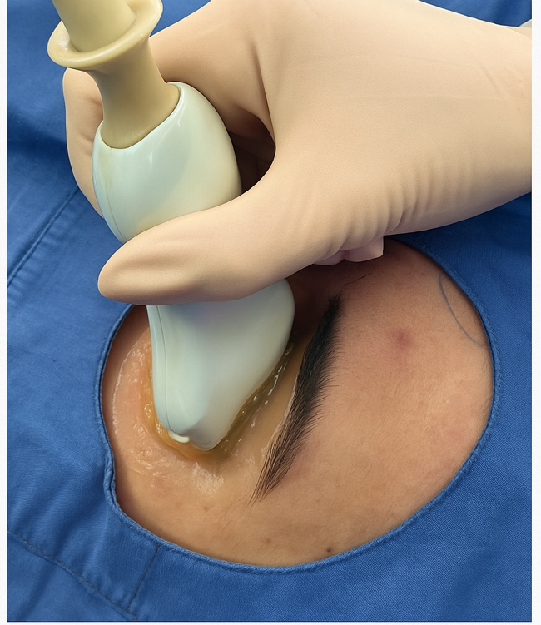
Figure 1. Imaging method of the optic nerve sheath.

Table 1. Demographic data and surgical information of patients
Variable | Value
Sex, n (%) | Male 13 (23.6%) / Female 42 (76.4%)
ASA physical status, n (%) | I 6 (10.9%) / II 41 (74.5%) / III 8 (14.5%)
Age (years), mean ± SD | 50.8 ± 14.8
Body mass index (kg/m²)* | 27 (23.4 – 30.1)
Operation time (minutes)mean ± SD | 101.5 ± 31.9
Anesthesia time (minutes)* | 121.2 (100 – 135)
Intraoperative fluid (mL)* | 1500 (1100 – 2000)
Surgical procedure, n (%) | Nissen 18 (32.7%) /  Cholecystectomy 37 (67.3%)
ASA: American Society of Anesthesiologists
* median (IQR), IQR: Interquartile range , n: Count

Table 2. Pairwise comparisons between time points
Comparison | Parameter | Mean difference | p-value
T₀ – T₁ | ONSD-Right (mm) | −1.118 | < 0.001ᵃ
T₀ – T₂ | ONSD-Right (mm) | −1.755 | < 0.001ᵃ
T₀ – T₃ | ONSD-Right (mm) | −0.909 | 0.001ᵃ
T₃ – T₂ | ONSD-Right (mm) | 0.845 | 0.004ᵃ
T₀ – T₁ | ONSD-Left (mm) | −1.318 | < 0.001ᵃ
T₀ – T₂ | ONSD-Left (mm) | −1.700 | < 0.001ᵃ
T₀ – T₃ | ONSD-Left (mm) | −0.836 | 0.004ᵃ
T₃ – T₂ | ONSD-Left (mm) | 0.864 | 0.003ᵃ

T₀: After induction T₁: 10 minutes after pneumoperitoneum , T₂: 60 minutes after pneumoperitoneum ,T₃: 10 minutes after desufflation
ᵃ Statistically significant (p < 0.05).

Table 3. Intraoperative respiratory hemodynamic and ONSD changes
Parameter | T₀ (IQR) | T₁ (IQR) | T₂ (IQR) | T₃ (IQR) | p-value | Pairwise comparison
ONSD-Right (mm) | 4.60 (4.2–4.9) | 4.8 (4.5–5.2) | 5.1 (4.7–5.4) | 4.8 (4.4–5.2) | < 0.001ᵃ | T0 < T1; T0 < T2; T0 < T3; T2 > T3
ONSD-Left (mm) | 4.6 (4.1–4.9) | 4.9 (4.6–5.2) | 5.1 (4.8–5.3) | 4.9 (4.4–5.1) | < 0.001ᵃ | T0 < T1; T0 < T2; T0 < T3; T2 > T3
EtCO₂ (mmHg) | 31 (29–33) | 32 (29–34) | 32 (31–34) | 31 (30–33) | 0.006 | T0 < T2
Peak pressure (cmH₂O) | 19 (17–23) | 25 (22–27) | 24 (22–28) | 22 (19–24) | < 0.001ᵃ | T0 < T1; T0 < T2; T1 > T3; T2 > T3
Plateau pressure (cmH₂O) | 17 (14–20) | 21 (18–24) | 20 (18–23) | 17 (15–20) | < 0.001ᵃ | T0 < T1; T0 < T2; T1 > T3; T2 > T3
Compliance (mL/cmH₂O) | 48 (36–67) | 38 (30–47) | 37.6 (31–45) | 46 (40–56) | < 0.001ᵃ | T0 > T1; T0 > T2; T1 < T3; T2 < T3
HR (bpm) | 80 (71–90) | 69 (65–83) | 70 (63–81) | 69 (59–76) | < 0.001ᵃ | T0 > T1; T0 > T3
MAP (mmHg) | 86 (72–102) | 87 (75–104) | 83 (77–92) | 82 (74–88) | 0.086 | NS
ᵃ Statistically significant (p < 0.05). HR: Heart rate, MAP: Mean arterial pressure, * median (IQR), IQR: Interquartile range, a; Friedmen’s two-way ANOVA with Dunn’s test, T₀: After induction T₁: 10 minutes after, pneumoperitoneum , T₂: 60 minutes after pneumoperitoneum ,T₃: 10 minutes after desufflation

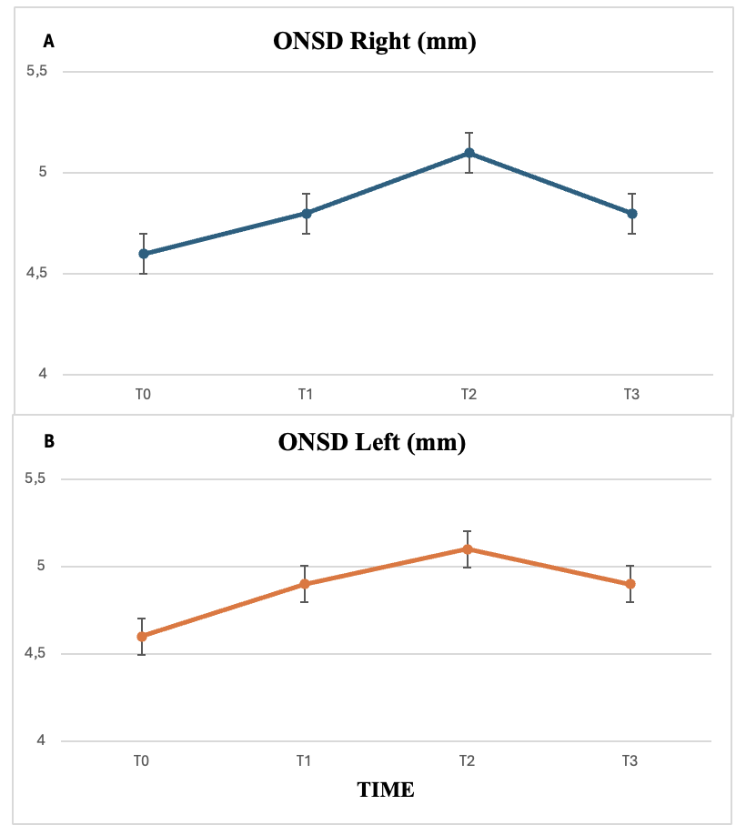

Figure 2: Changes in right (A) and left (B) optic nerve sheath diameter over time. Data are presented as median (IQR). Error bars represent 25th–75th percentiles.

