Supplementary appendix

This supplementary material for the article entitled:
Remimazolam-Based Total Intravenous vs. Sevoflurane-Based Balanced General Anesthesia on Perioperative Outcomes in Adult Surgical Patients: A Systematic Review and Meta-Analysis

Contents
Supplementary Table 1: PRISMA 2020 checklist 4
Supplementary Table 1-A: PRISMA 2020 for Abstracts checklist 4
Supplementary Table 1-B: PRISMA 2020 for manuscripts checklist 5
Supplementary Table 2: AMSTAR 2 checklist 8
Supplementary Table 3: Search Strategy 12
Supplementary Table 4: Definitions of outcomes 14
Supplementary Table 5: List of excluded studies and justification 20
Supplementary Table 6. Baseline characteristics of the included studies 23
Supplementary Table 7: Summary of findings: 25
Supplementary Table 7-A: Summary of the primary analysis: 25
Supplementary Table 7-B: Summary of the RCTs-only analysis 27
Supplementary Table 7-C: Summary of the comparison in heterogeneity between Primary and RCTs -only analysis 29
Supplementary Table 7-D: Summary of relevant Leave-one-out results 30
Supplementary Table 8: GRADE Assessment of Certainty of Evidence for Main Outcomes 31
Supplementary Figure 1: Cochrane risk of bias (ROB2) assessment results 34
Supplementary Figure 2: (ROBINS-I) Risk of bias assessment results 35
Primary analysis: 36
Supplementary Figure 3: MAP at 30 minutes after the start of surgery 36
Supplementary Figure 4: MAP at 1 hour after the start of surgery. 36
Supplementary Figure 5: MAP in the PACU 36
Supplementary Figure 6: HR at 30 minutes after the start of surgery 36
Supplementary Figure 7: HR at 1 hour after the start of surgery 37
Supplementary Figure 8: HR in the PACU 37
Supplementary Figure 9: Nausea and vomiting in the PACU 37
Supplementary Figure 10: Incidence of rescue anti-emetics administration 37
Supplementary Figure 11: Anesthesia time 38
Supplementary Figure 12: Operation time 38
Supplementary Figure 13: Extubation time 38
Supplementary Figure 14: Eye-opening time 39
Supplementary Figure 15: Postoperative length of stay 39
Supplementary Figure 16: length of stay at the PACU 39
Supplementary Figure 17: Global QoR score on POD 1 39
Supplementary Figure 18: Time to Aldrete score >9 40
Supplementary Figure 19: Total fluid intake 40
Supplementary Figure 20: blood loss 40
Supplementary Figure 21: Urine output 40
RCTs only Subgroup analysis: 41
Supplementary Figure 22: MAP at the start of surgery – RCTs only 41
Supplementary Figure 23: MAP at 30 minutes after the start of surgery – RCTs only 41
Supplementary Figure 24: MAP at the end of surgery – RCTs only 41
Supplementary Figure 25: MAP in the PACU – RCTs only 41
Supplementary Figure 26: HR at the start of surgery RCTs only – RCTs only 42
Supplementary Figure 27: HR at 30 minutes after the start of surgery – RCTs only 42
Supplementary Figure 28: HR at the end of surgery – RCTs only 42
Supplementary Figure 29: HR in the PACU – RCTs only 42
Supplementary Figure 30: Incidence of intraoperative hypotension – RCTs only 43
Supplementary Figure 31: Incidence of vasopressor use – RCTs only 43
Supplementary Figure 32: Incidence of postoperative nausea and vomiting – RCTs only 43
Supplementary Figure 33: Anesthesia time – RCTs only 44
Supplementary Figure 34: Operation time – RCTs only 44
Supplementary Figure 35: Extubation time – RCTs only 44
Supplementary Figure 36: Postoperative length of stay – RCTs only 45
Supplementary Figure 37: Total fluid intake – RCTs only 45
Supplementary Figure 38: Blood loss – RCTs only 45
Excluding ASA4 analysis: 46
Supplementary Figure 39: MAP at the start of surgery – Excluding ASA4 46
Supplementary Figure 40: MAP at the end of surgery – Excluding ASA4 46
Supplementary Figure 41: HR at the start of surgery – Excluding ASA4 46
Supplementary Figure 42: HR at the end of surgery – Excluding ASA4 47
Supplementary Figure 43: Intraoperative hypotension – Excluding ASA4 47
Supplementary Figure 44: Vasopressor use – Excluding ASA4 47
Supplementary Figure 45: Anesthesia time – Excluding ASA4 48
Supplementary Figure 46: Operation time – Excluding ASA4 48
Supplementary Figure 47: Blood loss – Excluding ASA4 48
Supplementary Figure 48: Total fluid intake – Excluding ASA4 49
Leave-one-out sensitivity analysis: 50
Supplementary Figure 49: MAP at the start of surgery - Leave one out analysis 50
Supplementary Figure 50: MAP at 30 minutes after the start of surgery- Leave one out analysis 50
Supplementary Figure 51: MAP at 1 hour after the start of surgery- Leave one out analysis 50
Supplementary Figure 52: MAP at the end of surgery- Leave one out analysis 51
Supplementary Figure 53: MAP in the PACU- Leave one out analysis 51
Supplementary Figure 54: HR at the start of surgery- Leave one out analysis 51
Supplementary Figure 55: HR at 30 minutes after the start of surgery- Leave one out analysis 52
Supplementary Figure 56: HR at 1 hour after the start of surgery- Leave one out analysis 52
Supplementary Figure 57: HR at the end of surgery- Leave one out analysis 52
Supplementary Figure 58: HR in the PACU- Leave one out analysis 53
Supplementary Figure 59: Incidence of intraoperative hypotension- Leave one out analysis 53
Supplementary Figure 60: Incidence of vasopressor use- Leave one out analysis 53
Supplementary Figure 61: Delirium- Leave one out analysis 53
Supplementary Figure 62: PONV - Leave one out analysis 54
Supplementary Figure 63: Nausea and vomiting in the PACU- Leave one out analysis 54
Supplementary Figure 64: Incidence of rescue anti-emetics administration- Leave one out analysis 54
Supplementary Figure 65: Anesthesia time- Leave one out analysis 55
Supplementary Figure 66: Operation time- Leave one out analysis 55
Supplementary Figure 67: Extubation time- Leave one out analysis 55
Supplementary Figure 68: Eye-opening time- Leave one out analysis 56
Supplementary Figure 69: Postoperative length of stay- Leave one out analysis 56
Supplementary Figure 70: length of stay at the PACU- Leave one out analysis 56
Supplementary Figure 71: Global QoR score on POD 1- Leave one out analysis 56
Supplementary Figure 72: Time to Aldrete score >9- Leave one out analysis 57
Supplementary Figure 73: Total fluid intake- Leave one out analysis 57
Supplementary Figure 74: blood loss- Leave one out analysis 57
Supplementary Figure 75: Urine output- Leave one out analysis 57
Funnel plots: 58
Supplementary Figure 76: Anesthesia time 58
Supplementary Figure 77: Operation time 58

Supplementary Table 1: PRISMA 2020 checklist

Supplementary Table 1-A: PRISMA 2020 for Abstracts checklist
Section and Topic | Item # | Checklist item | Reported (Yes/No)
TITLE
Title | 1 | Identify the report as a systematic review. | Yes
BACKGROUND
Objectives | 2 | Provide an explicit statement of the main objective(s) or question(s) the review addresses. | Yes
METHODS
Eligibility criteria | 3 | Specify the inclusion and exclusion criteria for the review. | Yes
Information sources | 4 | Specify the information sources (e.g. databases, registers) used to identify studies and the date when each was last searched. | Yes
Risk of bias | 5 | Specify the methods used to assess risk of bias in the included studies. | Yes
Synthesis of results | 6 | Specify the methods used to present and synthesise results. | Yes
RESULTS
Included studies | 7 | Give the total number of included studies and participants and summarise relevant characteristics of studies. | Yes
Synthesis of results | 8 | Present results for main outcomes, preferably indicating the number of included studies and participants for each. If meta-analysis was done, report the summary estimate and confidence/credible interval. If comparing groups, indicate the direction of the effect (i.e. which group is favoured). | Yes
DISCUSSION
Limitations of evidence | 9 | Provide a brief summary of the limitations of the evidence included in the review (e.g. study risk of bias, inconsistency and imprecision). | Yes
Interpretation | 10 | Provide a general interpretation of the results and important implications. | Yes
OTHER
Funding | 11 | Specify the primary source of funding for the review. | Yes
Registration | 12 | Provide the register name and registration number. | Yes

Supplementary Table 1-B: PRISMA 2020 for manuscripts checklist
Section and Topic | Item # | Checklist item | Location where item is reported
TITLE
Title | 1 | Identify the report as a systematic review. | 1
ABSTRACT
Abstract | 2 | See the PRISMA 2020 for Abstracts checklist. | 2-3
INTRODUCTION
Rationale | 3 | Describe the rationale for the review in the context of existing knowledge. | 4-5
Objectives | 4 | Provide an explicit statement of the objective(s) or question(s) the review addresses. | 5
METHODS
Eligibility criteria | 5 | Specify the inclusion and exclusion criteria for the review and how studies were grouped for the syntheses. | 6
Information sources | 6 | Specify all databases, registers, websites, organisations, reference lists and other sources searched or consulted to identify studies. Specify the date when each source was last searched or consulted. | 6
Search strategy | 7 | Present the full search strategies for all databases, registers and websites, including any filters and limits used. | 6
Selection process | 8 | Specify the methods used to decide whether a study met the inclusion criteria of the review, including how many reviewers screened each record and each report retrieved, whether they worked independently, and if applicable, details of automation tools used in the process. | 6
Data collection process | 9 | Specify the methods used to collect data from reports, including how many reviewers collected data from each report, whether they worked independently, any processes for obtaining or confirming data from study investigators, and if applicable, details of automation tools used in the process. | 6
Data items | 10a | List and define all outcomes for which data were sought. Specify whether all results that were compatible with each outcome domain in each study were sought (e.g. for all measures, time points, analyses), and if not, the methods used to decide which results to collect. | 7
Data items | 10b | List and define all other variables for which data were sought (e.g. participant and intervention characteristics, funding sources). Describe any assumptions made about any missing or unclear information. | 6
Study risk of bias assessment | 11 | Specify the methods used to assess risk of bias in the included studies, including details of the tool(s) used, how many reviewers assessed each study and whether they worked independently, and if applicable, details of automation tools used in the process. | 7
Effect measures | 12 | Specify for each outcome the effect measure(s) (e.g. risk ratio, mean difference) used in the synthesis or presentation of results. | 7
Synthesis methods | 13a | Describe the processes used to decide which studies were eligible for each synthesis (e.g. tabulating the study intervention characteristics and comparing against the planned groups for each synthesis (item #5)). | 6
Synthesis methods | 13b | Describe any methods required to prepare the data for presentation or synthesis, such as handling of missing summary statistics, or data conversions. | 6-7
Synthesis methods | 13c | Describe any methods used to tabulate or visually display results of individual studies and syntheses. | 7
Synthesis methods | 13d | Describe any methods used to synthesize results and provide a rationale for the choice(s). If meta-analysis was performed, describe the model(s), method(s) to identify the presence and extent of statistical heterogeneity, and software package(s) used. | 7
Synthesis methods | 13e | Describe any methods used to explore possible causes of heterogeneity among study results (e.g. subgroup analysis, meta-regression). | 8
Synthesis methods | 13f | Describe any sensitivity analyses conducted to assess robustness of the synthesized results. | 8
Reporting bias assessment | 14 | Describe any methods used to assess risk of bias due to missing results in a synthesis (arising from reporting biases). | 8
Certainty assessment | 15 | Describe any methods used to assess certainty (or confidence) in the body of evidence for an outcome. | 7
RESULTS
Study selection | 16a | Describe the results of the search and selection process, from the number of records identified in the search to the number of studies included in the review, ideally using a flow diagram. | 8
Study selection | 16b | Cite studies that might appear to meet the inclusion criteria, but which were excluded, and explain why they were excluded. | S Table 4
Study characteristics | 17 | Cite each included study and present its characteristics. | 8, Table 2
Risk of bias in studies | 18 | Present assessments of risk of bias for each included study. | 9
Results of individual studies | 19 | For all outcomes, present, for each study: (a) summary statistics for each group (where appropriate) and (b) an effect estimate and its precision (e.g. confidence/credible interval), ideally using structured tables or plots. | 9-11
Results of syntheses | 20a | For each synthesis, briefly summarise the characteristics and risk of bias among contributing studies. | 9
Results of syntheses | 20b | Present results of all statistical syntheses conducted. If meta-analysis was done, present for each the summary estimate and its precision (e.g. confidence/credible interval) and measures of statistical heterogeneity. If comparing groups, describe the direction of the effect. | 9-11
Results of syntheses | 20c | Present results of all investigations of possible causes of heterogeneity among study results. | 12
Results of syntheses | 20d | Present results of all sensitivity analyses conducted to assess the robustness of the synthesized results. | 12
Reporting biases | 21 | Present assessments of risk of bias due to missing results (arising from reporting biases) for each synthesis assessed. | 13
Certainty of evidence | 22 | Present assessments of certainty (or confidence) in the body of evidence for each outcome assessed. | 9-11
DISCUSSION
Discussion | 23a | Provide a general interpretation of the results in the context of other evidence. | 13-15
Discussion | 23b | Discuss any limitations of the evidence included in the review. | 15-16
Discussion | 23c | Discuss any limitations of the review processes used. | NA
Discussion | 23d | Discuss implications of the results for practice, policy, and future research. | 15
OTHER INFORMATION
Registration and protocol | 24a | Provide registration information for the review, including register name and registration number, or state that the review was not registered. | 3
Registration and protocol | 24b | Indicate where the review protocol can be accessed, or state that a protocol was not prepared. | 3
Registration and protocol | 24c | Describe and explain any amendments to information provided at registration or in the protocol. | NA
Support | 25 | Describe sources of financial or non-financial support for the review, and the role of the funders or sponsors in the review. | 18
Competing interests | 26 | Declare any competing interests of review authors. | 18
Availability of data, code and other materials | 27 | Report which of the following are publicly available and where they can be found: template data collection forms; data extracted from included studies; data used for all analyses; analytic code; any other materials used in the review. | 18

Supplementary Table 2: AMSTAR 2 checklist

1. Did the research questions and inclusion criteria for the review include the components of PICO?
For Yes:   Population   Intervention   Comparator group   Outcome |  | Optional (recommended)   Timeframe for follow-up |  Yes   No
2. Did the report of the review contain an explicit statement that the review methods were established prior to the conduct of the review and did the report justify any significant deviations from the protocol?
 | For Partial Yes:  The authors state that they had a written protocol or guide that included ALL the following:   review question(s)   a search strategy   inclusion/exclusion criteria   a risk of bias assessment | For Yes:  As for partial yes, plus the protocol should be registered and should also have specified:   a meta-analysis/synthesis plan, if appropriate, and   a plan for investigating causes of heterogeneity   justification for any deviations from the protocol |  Yes   Partial Yes   No
3. Did the review authors explain their selection of the study designs for inclusion in the review?
 | For Yes, the review should satisfy ONE of the following:   Explanation for including only RCTs   OR Explanation for including only NRSI   OR Explanation for including both RCTs and NRSI |  |  Yes   No
4. Did the review authors use a comprehensive literature search strategy?
 | For Partial Yes (all the following):   searched at least 2 databases (relevant to research question)   provided key word and/or search strategy   justified publication restrictions (e.g. language) | For Yes, should also have (all the following):   searched the reference lists / bibliographies of included studies   searched trial/study registries   included/consulted content experts in the field   where relevant, searched for grey literature   conducted search within 24 months of completion of the review |  Yes   Partial Yes   No
 | 5. Did the review authors perform study selection in duplicate?
 | For Yes, either ONE of the following:   at least two reviewers independently agreed on selection of eligible studies and achieved consensus on which studies to include   OR two reviewers selected a sample of eligible studies and achieved good agreement (at least 80 percent), with the remainder selected by one reviewer. |  |  Yes   No

6. Did the review authors perform data extraction in duplicate?
For Yes, either ONE of the following:   at least two reviewers achieved consensus on which data to extract from included studies   OR two reviewers extracted data from a sample of eligible studies and achieved good agreement (at least 80 percent), with the remainder extracted by one reviewer. |  |  |  Yes   No
7. Did the review authors provide a list of excluded studies and justify the exclusions?
 | For Partial Yes:   provided a list of all potentially relevant studies that were read  in full-text form but excluded from the review | For Yes, must also have:   Justified the exclusion from the review of each potentially relevant study |  Yes   Partial Yes   No
8. Did the review authors describe the included studies in adequate detail?
 | For Partial Yes (ALL the following):   described populations   described interventions   described comparators   described outcomes   described research designs | For Yes, should also have ALL the following:   described population in detail   described intervention in detail (including doses where relevant)   described comparator in detail (including doses where relevant)   described study’s setting   timeframe for follow-up |  Yes   Partial Yes   No
9. Did the review authors use a satisfactory technique for assessing the risk of bias (RoB) in individual studies that were included in the review?
 | RCTs  For Partial Yes, must have assessed RoB from   unconcealed allocation, and   lack of blinding of patients and assessors when assessing outcomes (unnecessary for objective outcomes such as all-  cause mortality) | For Yes, must also have assessed RoB from:   allocation sequence that was not truly random, and   selection of the reported result from among multiple measurements or analyses of a specified outcome |  Yes   Partial Yes   No   Includes only NRSI
 | NRSI  For Partial Yes, must have assessed RoB:   from confounding, and   from selection bias  10. Did the review authors report o | For Yes, must also have assessed RoB:   methods used to ascertain exposures and outcomes, and   selection of the reported result from among multiple measurements or analyses of a specified outcome  n the sources of funding for the studies inc |  Yes   Partial Yes   No   Includes only RCTs  luded in the review?
For Yes
 Must have reported on the sources of funding for individual studies included  Yes in the review. Note: Reporting that the reviewers looked for this information  No but it was not reported by study authors also qualifies

11. If meta-analysis was performed did the review authors use appropriate methods for statistical combination of results?
 | RCTs  For Yes:   The authors justified combining the data in a meta-analysis   AND they used an appropriate weighted technique to combine study results and adjusted for heterogeneity if present.   AND investigated the causes of any heterogeneity |  Yes   No   No meta-analysis conducted
 | For NRSI  For Yes:   The authors justified combining the data in a meta-analysis   AND they used an appropriate weighted technique to combine study results, adjusting for heterogeneity if present   AND they statistically combined effect estimates from NRSI that were adjusted for confounding, rather than combining raw data, or justified combining raw data when adjusted effect estimates were not available   AND they reported separate summary estimates for RCTs and NRSI separately when both were included in the review |  Yes   No   No meta-analysis conducted
12. If meta-analysis was performed, did the review authors assess the potential impact of RoB in individual studies on the results of the meta-analysis or other evidence synthesis?
 | For Yes:   included only low risk of bias RCTs   OR, if the pooled estimate was based on RCTs and/or NRSI at variable RoB, the authors performed analyses to investigate possible impact of RoB on summary estimates of effect. |  Yes   No   No meta-analysis conducted
13. Did the review authors account for RoB in individual studies when interpreting/ discussing the results of the review?
 | For Yes:   included only low risk of bias RCTs   OR, if RCTs with moderate or high RoB, or NRSI were included the review provided a discussion of the likely impact of RoB on the results |  Yes   No
14. Did the review authors provide a satisfactory explanation for, and discussion of, any heterogeneity observed in the results of the review?
 | For Yes:   There was no significant heterogeneity in the results   OR if heterogeneity was present the authors performed an investigation of sources of any heterogeneity in the results and discussed the impact of this on the results of the review |  Yes   No
15. If they performed quantitative synthesis did the review authors carry out an adequate investigation of publication bias (small study bias) and discuss its likely impact on the results of the review?
 | For Yes:   performed graphical or statistical tests for publication bias and discussed the likelihood and magnitude of impact of publication bias |  Yes   No   No meta-analysis conducted

16. Did the review authors report any potential sources of conflict of interest, including any funding they received for conducting the review?
 | For Yes:   The authors reported no competing interests OR   The authors described their funding sources and how they managed potential conflicts of interest |  Yes   No

Supplementary Table 3: Search Strategy
Initial search (Jan 2025)
Database | Search terms | Results
Pubmed | ("remimazolam" [Supplementary Concept] OR remimazolam OR “ONO 2745” OR “ONO2745” OR “ONO-2745” OR “CNS 7056” OR “CNS7056” OR CNS-7056 OR “byfavo” OR “anerem” OR “rf10007” OR “rf-10007”) | 810
Scopus* | (remimazolam) OR (ONO 2745) OR (ONO2745) OR (ONO-2745) OR (CNS 7056) OR (anerem) OR (byfavo) OR (CNS-7056) OR (CNS7056) OR (rf10007) OR (rf 10007) | 822
Cochrane** | (remimazolam) OR (ONO 2745) OR (ONO2745) OR (ONO-2745) OR (CNS 7056) OR (anerem) OR (byfavo) OR (CNS-7056) OR (CNS7056) OR (rf10007) OR (rf 10007) | 1122
Embase | exp Remimazolam | 923
Web of Science* | (remimazolam) OR (ONO 2745) OR (ONO2745) OR (ONO-2745) OR (CNS 7056) OR (anerem) OR (byfavo) OR (CNS-7056) OR (CNS7056) OR (rf10007) OR (rf 10007) | 795
Updated search (May 2025)
Database | Search terms | Results
Pubmed | ("remimazolam" [Supplementary Concept] OR remimazolam OR “ONO 2745” OR “ONO2745” OR “ONO-2745” OR “CNS 7056” OR “CNS7056” OR CNS-7056 OR “byfavo” OR “anerem” OR “rf10007” OR “rf-10007”) | 179
Scopus* | (remimazolam) OR (ONO 2745) OR (ONO2745) OR (ONO-2745) OR (CNS 7056) OR (anerem) OR (byfavo) OR (CNS-7056) OR (CNS7056) OR (rf10007) OR (rf 10007) | 146
Cochrane** | (remimazolam) OR (ONO 2745) OR (ONO2745) OR (ONO-2745) OR (CNS 7056) OR (anerem) OR (byfavo) OR (CNS-7056) OR (CNS7056) OR (rf10007) OR (rf 10007) | 126
Embase | exp Remimazolam | 204
Web of Science* | (remimazolam) OR (ONO 2745) OR (ONO2745) OR (ONO-2745) OR (CNS 7056) OR (anerem) OR (byfavo) OR (CNS-7056) OR (CNS7056) OR (rf10007) OR (rf 10007) | 143
*Title OR abstract only. **Title,abstract,keyword

Supplementary Table 4: Definitions of outcomes
MAP at the start
Author | Definition | Use of Webplotdigitizer
Bahn Lee 2022 | Initiation of CO2 pneumoperitoneum combined with head-up positioning | Yes
Chun Gon Park 2023 | 1 min after pneumoperitoneum | Yes
Jiwon Lee 2024 | At surgical incision | Yes
Jizheng Zhang 2023 | At the beginning of surgery | No
Sangho Lee 2024 | At surgical incision | No
Sangho Lee 2023 | At surgical incision | Yes
Takayuki Katsuragawa 2023 | At the start of surgery | No
Eunji Ko 2024 | Start of operation | Yes
MAP at 30 minutes
Author | Definition | Use of Webplotdigitizer
Bahn Lee 2022 | 30 minutes after initiation of CO2 pneumoperitoneum | Yes
Chun Gon Park 2023 | 30 min after pneumoperitoneum | Yes
Sangho Lee 2024 | 30 minutes after surgical incision | No
Sangho Lee 2023 | 30 minutes after surgical incision | Yes
Hyunyoung Seong 2024 | 30 minutes after the start of operation | Yes
MAP at 1 hour
Author | Definition | Use of Webplotdigitizer
Bahn Lee 2022 | 1 hour after the initiation of CO2 pneumoperitoneum | Yes
Jiwon Lee 2024 | 1 hour after surgical incision | Yes
Sangho Lee 2023 | 1 hour after surgical incision | Yes
MAP at the end of surgery
Author | Definition | Use of Webplotdigitizer
Bahn Lee 2022 | End of operation | Yes
Chun Gon Park 2023 | End of surgery | Yes
Jizheng Zhang 2023 | End of surgery | No
Sangho Lee 2024 | After supine | No
Sangho Lee 2023 | Tourniquet deflation | Yes
Takayuki Katsuragawa 2023 | End of surgery | No
Eunji Ko 2024 | End of operation | Yes
Hyunyoung Seong 2024 | End of surgery | Yes
MAP in PACU
Author | Use of Webplotdigitizer
Chun Gon Park 2023 | Yes
Jiwon Lee 2024 | Yes
Sangho Lee 2024 | No
Sangho Lee 2023 | Yes
Hyunyoung Seong 2024 | Yes
Cheol lee 2023 | Yes
HR at the start
Author | Definition | Use of Webplotdigitizer
Chun Gon Park 2023 | 1 min after pneumoperitoneum | Yes
Jiwon Lee 2024 | at surgical incision | Yes
Jizheng Zhang 2023 | at the beginning of surgery | No
Sangho Lee 2024 | at surgical incision | No
Sangho Lee 2023 | At surgical incision | Yes
Takayuki Katsuragawa 2023 | at the start of surgery | No
Eunji Ko 2024 | Operation start | Yes
HR at 30 minutes
Author | Definition | Use of Webplotdigitizer
Bahn Lee 2022 | 30 minutes after initiation of CO2 pneumoperitoneum | Yes
Chun Gon Park 2023 | 30 min after pneumoperitoneum | Yes
Sangho Lee 2024 | 30 minutes after surgical incision | No
Sangho Lee 2023 | 30 minutes after surgical incision | Yes
Hyunyoung Seong 2024 | 30 minutes after the start of operation | Yes
HR at 1 hour
Author | Definition | Use of Webplotdigitizer
Bahn Lee 2022 | 1 hour after initiation of CO2 pneumoperitoneum | Yes
Jiwon Lee 2024 | 1 hour after surgical incision | Yes
Sangho Lee 2023 | 1 hour after surgical incision | Yes
HR at the end of surgery
Author | Definition | Use of Webplotdigitizer
Bahn Lee 2022 | End of operation | Yes
Chun Gon Park 2023 | End of surgery | Yes
Jizheng Zhang 2023 | End of surgery | No
Sangho Lee 2024 | After supine | No
Sangho Lee 2023 | Tourniquet deflation
Takayuki Katsuragawa 2023 | End of surgery | No
Eunji Ko 2024 | End of operation | Yes
Hyunyoung Seong 2024 | End of surgery | Yes
HR in PACU
Author | Use of Webplotdigitizer
Chun Gon Park 2023 | Yes
Jiwon Lee 2024 | Yes
Sangho Lee 2024 | No
Sangho Lee 2023 | Yes
Hyunyoung Seong 2024 | Yes
Cheol lee 2023 | Yes
Extubation time
Author | Definition
Bahn Lee 2022 | Time from anesthetic discontinuation to the time of extubation
Chun Gon Park 2023 | NA
Jiwon Lee 2024 | NA
Sangho Lee 2024 | Time from the administration of a neuromuscular blocker reversal agent to endotracheal tube extubation.
Sangho Lee 2023 | NA
Kyoung-Ho Ryu 2024 | Time to remove i-gel was defined by the time from the anesthetic drug discontinuation to i-gel removal
Eunji Ko 2024 | Time from the end of intervention to extubation
Hyunyoung Seong 2024 | NA
Seung Cheol Lee 2023 | Time from cessation of anesthetic to extubation
Operation time
Author | Definition
Bahn Lee 2022 | NA
Chun Gon Park 2023 | NA
Jiwon Lee 2024 | Duration of surgery
Jizheng Zhang 2023 | Duration of surgery
Sangho Lee 2024 | Surgical time
Sangho Lee 2023 | Surgical time
Takayuki Katsuragawa 2023 | Operation time
Kyoung-Ho Ryu 2024 | Duration of operation
Hyunyoung Seong 2024 | Operation time
Seung Cheol Lee 2023 | Duration of surgery
Cheol lee 2023 | Duration of surgery
Jimin Kim 2025 | Operation duration
Intraoperative hypotension
Author | Definition
Sangho Lee 2024 | A decrease in systolic BP to <20% of the baseline BP
Takayuki Katsuragawa 2023 | Mean blood pressure < 65 mmHg occurring for a cumulative duration of at least 10 minutes
Eunji Ko 2024 | Mean arterial blood pressure fell below 65 mmHg or the optimal range for 60 seconds
Seung Cheol Lee 2023 | MAP < 65 mmHg
Types of vasopressors used
Author | Type
Chun Gon Park 2023 | Ephedrine and phenylephrine
Jiwon Lee 2024 | Ephedrine and norepinephrine
Sangho Lee 2024 | Ephedrine and phenylephrine
Takayuki Katsuragawa 2023 | Ephedrine, phenylephrine, dopamine, and noradrenaline
Eunji Ko 2024 | Phenylephrine and Ephedrine
Hyunyoung Seong 2024 | Ephedrine, phenylephrine and noradrenaline
Postoperative Nausea and vomiting
Author | Follow-up duration
Bahn Lee 2022 | PACU
Chun Gon Park 2023 | PACU
Jizheng Zhang 2023 | NA
Sangho Lee 2024 | Until postoperative day 2
Sangho Lee 2023 | Until postoperative day 2
Yeong Min Yoo 2024 | First 24 hrs
Kyoung-Ho Ryu 2024 | First 24 hrs
Seung Cheol Lee 2023 | Until postoperative day 2
Postoperative rescue antiemetics
Author | Follow-up duration
Chun Gon Park 2023 | PACU
Jiwon Lee 2024 | First 48 hrs
Yeong Min Yoo 2024 | First 24 hrs
Seung Cheol Lee 2023 | NA

Supplementary Table 5: List of excluded studies and justification
Study | Reason for exclusion
Park JH, Soh S, Lee B  EP015 Comparison of remimazolam-based monitored anesthesia care with inhalation general anesthesia under the guidance of an ANI monitor during TURBT: a randomized controlled trial  Regional Anesthesia & Pain Medicine 2024;49:A70. | Abstract/Poster
Fujimoto, D., Obata, N. & Mizobuchi, S. Effectiveness of remimazolam in preventing postoperative delirium in elderly patients with proximal femoral fractures. J Anesth 38, 475–482 (2024). https://doi.org/10.1007/s00540-024-03339-z | Wrong comparator (R vs multiple)
Liu T, Lai T, Chen J, Lu Y, He F, Chen Y, Xie Y. Effect of remimazolam induction on hemodynamics in patients undergoing valve replacement surgery: A randomized, double-blind, controlled trial. Pharmacol Res Perspect. 2021 Oct;9(5):e00851. doi: 10.1002/prp2.851. PMID: 34390228; PMCID: PMC8363771. | Wrong comparator (R vs Propofol)
Liu T, Lai T, Chen J, Lu Y, He F, Chen Y, Xie Y. Effect of remimazolam induction on hemodynamics in patients undergoing valve replacement surgery: A randomized, double-blind, controlled trial. Pharmacol Res Perspect. 2021 Oct;9(5):e00851. doi: 10.1002/prp2.851. PMID: 34390228; PMCID: PMC8363771. | Duplicate of already excluded study
Aoki, Y., Kurita, T., Nakajima, M. et al. Association between remimazolam and postoperative delirium in older adults undergoing elective cardiovascular surgery: a prospective cohort study. J Anesth 37, 13–22 (2023). https://doi.org/10.1007/s00540-022-03119-7 | Wrong comparator (R vs multiple)
Wang S et al.(2024) INVESTIGATING NEUROPROTECTIVE STRATEGIES OF REMIMAZOLAM TOSILATE IN ELDERLY ATHLETES UNDERGOING ENDOSCOPIC SURGERY FOR COLORECTAL TUMORS.Revista Internacional de Medicina y Ciencias de la Actividad Física y el Deporte vol. 24 (98) pp. 174-193.DOI:https://doi.org/10.15366/rimcafd2024.98.012 | Wrong outcomes
Cho SA, Ahn SM, Kwon W, Sung TY. Comparison of remimazolam and desflurane in emergence agitation after general anesthesia for nasal surgery: a prospective randomized controlled study. Korean J Anesthesiol. 2024 Aug;77(4):432-440. doi: 10.4097/kja.23953. Epub 2024 May 7. PMID: 38711267; PMCID: PMC11294877. | Wrong comparator (R vs Desflurane)
Cho SA, Ahn SM, Kwon W, Sung TY. Comparison of remimazolam and desflurane in emergence agitation after general anesthesia for nasal surgery: a prospective randomized controlled study. Korean J Anesthesiol. 2024 Aug;77(4):432-440. doi: 10.4097/kja.23953. Epub 2024 May 7. PMID: 38711267; PMCID: PMC11294877. | Duplicate of already excluded study
Cho SA, Ahn SM, Kwon W, Sung TY. Comparison of remimazolam and desflurane in emergence agitation after general anesthesia for nasal surgery: a prospective randomized controlled study. Korean J Anesthesiol. 2024 Aug;77(4):432-440. doi: 10.4097/kja.23953. Epub 2024 May 7. PMID: 38711267; PMCID: PMC11294877. | Duplicate of already excluded study
Shimizu T, Kanazawa T, Yoshida T, Sakura T, Shimizu K, Iwasaki T, Morimatsu H. A Retrospective Comparative Study of the Frequency of Hypotension in Pediatric Cardiac Catheterization under General Anesthesia: Remimazolam versus Sevoflurane. J Cardiothorac Vasc Anesth. 2024 Dec;38(12):3118-3126. doi: 10.1053/ | Pediatric population
Yim, S., Choi, C.I., Park, I. et al. Remimazolam to prevent hemodynamic instability during catheter ablation under general anesthesia: a randomized controlled trial. Can J Anesth/J Can Anesth 71, 1067–1077 (2024). https://doi.org/10.1007/s12630-024-02735-z | Wrong comparator (R vs Desflurane)
Remimazolam: A Retrospective Study of Initial Safety and Recovery Data in Diverse Procedural Sedation  Johnson, Kelsey L. et al.  Clinical Therapeutics, Volume 46, Issue 2, 90 - 95 | Wrong study design
Remimazolam: A Retrospective Study of Initial Safety and Recovery Data in Diverse Procedural Sedation  Johnson, Kelsey L. et al.  Clinical Therapeutics, Volume 46, Issue 2, 90 - 95 | Duplicate of already excluded study
Song JW. Efficacy of remimazolam in reducing postoperative nausea and vomiting: a superior alternative anesthetic for total intravenous anesthesia? Korean J Anesthesiol. 2024 Aug;77(4):409-410. doi: 10.4097/kja.24465. Epub 2024 Jul 18. PMID: 39020505; PMCID: PMC11294880. | Wrong study design
Song JW. Efficacy of remimazolam in reducing postoperative nausea and vomiting: a superior alternative anesthetic for total intravenous anesthesia? Korean J Anesthesiol. 2024 Aug;77(4):409-410. doi: 10.4097/kja.24465. Epub 2024 Jul 18. PMID: 39020505; PMCID: PMC11294880. | Duplicate of already excluded study
Lu, Y., Xu, Q., Dai, H. et al. Remimazolam for the prevention of emergence agitation in adults following nasal surgery under general anesthesia: a prospective randomized clinical controlled trial. BMC Anesthesiol 25, 8 (2025). https://doi.org/10.1186/s12871-024-02875-1 | Wrong study design
Lu, Y., Xu, Q., Dai, H. et al. Remimazolam for the prevention of emergence agitation in adults following nasal surgery under general anesthesia: a prospective randomized clinical controlled trial. BMC Anesthesiol 25, 8 (2025). https://doi.org/10.1186/s12871-024-02875-1 | Duplicate of already excluded study
Takaki R, Yokose M, Mihara T, Saigusa Y, Tanaka H, Yamamoto N, Masui K, Goto T. Hypotension after general anaesthesia induction using remimazolam or propofol in geriatric patients undergoing sevoflurane anaesthesia with remifentanil: a single-centre, double-blind, randomised controlled trial. Br J Anaesth. 2024 Jul;133(1):24-32. doi: 10.1016/j.bja.2024.04.013. Epub 2024 May 22. PMID: 38777646. | Wrong study design
Shi F, Tang R, Du X, Li X, Wu G. Application of remimazolam-0.6% sevoflurane anesthesia for flash visual evoked potential monitoring during pituitary adenoma resection: a non-inferiority randomized controlled trial. BMC Anesthesiol. 2024 Feb 29;24(1):85. doi: 10.1186/s12871-024-02466-0. PMID: 38424486; PMCID: PMC10903035. | Wrong comparator (R vs Propofol)
Shi F, Tang R, Du X, Li X, Wu G. Application of remimazolam-0.6% sevoflurane anesthesia for flash visual evoked potential monitoring during pituitary adenoma resection: a non-inferiority randomized controlled trial. BMC Anesthesiol. 2024 Feb 29;24(1):85. doi: 10.1186/s12871-024-02466-0. PMID: 38424486; PMCID: PMC10903035. | Duplicate of already excluded study
Miyoshi H, Watanabe T, Kido K, Kamiya S, Otsuki S, Narasaki S, Toyota Y, Kondo T, Horikawa YT, Saeki N, Tsutsumi YM. Remimazolam Requires Less Vasopressor Support during Induction and Maintenance of General Anesthesia in Patients with Severe Aortic Stenosis Undergoing Transcatheter Aortic Valve Replacement: A Retrospective Analysis from a Single Center. Biomed Res Int. 2022 Oct 22;2022:6386606. doi: 10.1155/2022/6386606. PMID: 36317114; PMCID: PMC9617702. | Non-surgical procedure (TAVI)
Miyoshi H, Watanabe T, Kido K, Kamiya S, Otsuki S, Narasaki S, Toyota Y, Kondo T, Horikawa YT, Saeki N, Tsutsumi YM. Remimazolam Requires Less Vasopressor Support during Induction and Maintenance of General Anesthesia in Patients with Severe Aortic Stenosis Undergoing Transcatheter Aortic Valve Replacement: A Retrospective Analysis from a Single Center. Biomed Res Int. 2022 Oct 22;2022:6386606. doi: 10.1155/2022/6386606. PMID: 36317114; PMCID: PMC9617702. | Duplicate of already excluded study
Harimochi S, Godai K, Nakahara M, Matsunaga A. Comparison of remimazolam and sevoflurane for general anesthesia during transcatheter aortic valve implantation: a randomized trial. Can J Anaesth. 2025 Mar;72(3):397-408. doi: 10.1007/s12630-024-02900-4. Epub 2024 Dec 23. PMID: 39715979; PMCID: PMC11961503. | Non-surgical procedure (TAVI)
Harimochi S, Godai K, Nakahara M, Matsunaga A. Comparison of remimazolam and sevoflurane for general anesthesia during transcatheter aortic valve implantation: a randomized trial. Can J Anaesth. 2025 Mar;72(3):397-408. doi: 10.1007/s12630-024-02900-4. Epub 2024 Dec 23. PMID: 39715979; PMCID: PMC11961503. | Duplicate of already excluded study
Bahn Lee 2022 | Duplicate of already included study
Park 2023 | Duplicate of already included study
Jiwon Lee 2024 | Duplicate of already included study
Zhang 2023 | Duplicate of already included study
Sangho Lee 2024 | Duplicate of already included study
Sangho Lee 2023 | Duplicate of already included study
Katsuragawa 2023 | Duplicate of already included study
Yoo 2024 | Duplicate of already included study
Ryu 2024 | Duplicate of already included study
Ko 2024 | Duplicate of already included study
Seong 2024 | Duplicate of already included study
Seung Cheol Lee 2023 | Duplicate of already included study
Cheol lee 2023 | Duplicate of already included study

Supplementary Table 6. Baseline characteristics of the included studies
Study | Sample size  n |  | Male  n (%) |  | BMI  mean (SD), or median (IQR) |  | HTN  n (%) |  | DM  n (%)
Study | R | S | R | S | R | S | R | S | R | S
Bahn Lee 2022 Korea | 52 | 52 | 48 (92) | 47 (90) | 23 (22-24) | 22 (20-24) | 36 (69) | 37 (71) | 4 (8) | 5 (10)
Park 2023 Korea | 30 | 30 | All females |  | 23.6 (2.6) | 24.4 (3.7) | 6 (20) | 5 (16.7) | 5 (16.7) | 3 (10)
Jiwon Lee 2024 Korea | 36 | 36 | 18 (50) | 22 (61) | NA | NA | 6 (16.7) | 8 (22.2) | 6 (16.7) | 3 (8.3)
Zhang 2023 China | 76 | 79 | 76 (100) | 79 (100) | 23.72 (21.81-25.03) | 23.36 (21.73-24.61) | 38 (50) | 39 (49.37) | 14 (18.42) | 13(16.46)
Sangho Lee 2024 Korea | 39 | 39 | 25 (64.1) | 24 (61.5) | 25 (3.1) | 25.1 (2.8) | NA | NA | 6 (15.4) | 9 (23.1)
Sangho Lee 2023 Korea | 39 | 39 | 6 (15) | 5 (12) | 24.3 (22.5-26.6) | 23.6 (22.4-27.3) | 32 (82.1) | 30 (76.9) | 13 (33.3) | 9 (23.1)
Katsuragawa 2023 Japan | 141 | 141 | 73 (51.8) | 70 (49.6) | 22 (19.4-24.7) | 22.2 (19.7-24.6) | NA | NA | 10 (7.1) | 10 (7.1)
Yoo 2024 Korea | 20 | 20 | 9 (45) | 10 (50) | 24.9 (3.9) | 27.1 (3.8) | NA | NA | NA | NA
Ryu 2024 Korea | 17 | 17 | 12 (70.6) | 15 (88.2) | 25.4 (23.8-26.5) | 25.1 (23.4-26.4) | NA | NA | NA | NA
Ko 2024 Korea | 15 | 15 | 11 (73.3) | 8 (53.3) | 23.8 (2.6) | 24.1 (2.6) | 11 (73.3) | 8 (53.3) | 3 (20) | 3 (20)
Seong 2024 Korea | 164 | 164 | All females |  | 23.6 (20.9-26.8) | 23.1 (20.8- 26.8) | 24 (14.6) | 21(12.8) | 12 (7.3) | 10 (6.1)
Seung Cheol Lee 2023 Korea | 38 | 38 | 18 (47.4) | 15 (39.5) | 24.7 (3) | 25.2 (3) | 10 (26.3) | 9 (23.7) | 7 (18.4) | 8 (21.1)
Cheol lee 2023 Korea | 36 | 34 | All females |  | 23.8 (0.9) | 24 (0.6) | NA | NA | NA | NA
Kim 2025 Korea | 93 | 93 | 27 (29) | 31 (33) | NA | NA | 71 (76.3) | 68 (73.1) | 32 (34.4) | 33 (35.5)

R: Remimazolam, S: Sevoflurane, ASA-PS: American Society of Anesthesiologists physical status, HTN: Hypertension, DM: Diabetes mellitus.

Supplementary Table 7: Summary of findings:

Supplementary Table 7-A: Summary of the primary analysis:
Outcome | No. of Studies | No. of patients | Effect Estimate [95% CI] | Tau2 | Chi2 | df | I² (%) | Test for overall effect: Z (p value)
Primary outcomes
MAP - Start of surgery | 8 | 859 | MD = 3.91 [1.45, 6.38] | 6.2336 | 15.83 | 7 (p=0.0268) | 55.8 | 3.11 (P=0.0019)
MAP - 30 min | 5 | 648 | MD = 7.91 [4.99, 10.83] | 4.7144 | 7.12 | 4 (P=0.1297) | 43.8 | 5.31 (P<0.0001)
MAP - 1 hr | 3 | 254 | MD = 8.28 [3.87, 12.69] | 9.4696 | 5.37 | 2(P=0.0683) | 62.7 | 3.68 (P=0.0002)
MAP - End of surgery | 8 | 1115 | MD = 5.70 [2.76, 8.64] | 10.9708 | 30.42 | 7 (P<0.0001) | 77.0 | 3.80 (P=0.0001)
MAP - PACU | 6 | 686 | MD = 3.18 [0.26, 6.09] | 7.1733 | 13.51 | 5(P=0.0190) | 63.0 | 2.14 (P=0.0326)
HR - Start of surgery | 7 | 755 | MD = 3.99 [0.87, 7.11] | 10.7219 | 18.52 | 6(P=0.0051) | 67.6 | 2.51 (P=0.0121)
HR - 30 min | 5 | 648 | MD = 7.37 [5.46, 9.28] | 0 | 1.3 | 4(P=0.8612) | 0 | 7.57 (P<0.0001)
HR - 1 hr | 3 | 254 | MD = 6.23 [3.21, 9.25] | 0 | 1.99 | 2(P=0.3704) | 0 | 4.04 (P<0.0001)
HR - End of surgery | 8 | 1115 | MD = 6.31 [3.07, 9.54] | 14.5738 | 27.73 | 7(P=0.0002) | 74.8 | 3.82 (P=0.0001)
HR - PACU | 6 | 686 | MD = 2.03 [-0.31, 4.37] | 3.3219 | 8.50 | 5(P=0.1309) | 41.2 | 1.70 (P=0.0887)
Incidence of intraoperative hypotension | 4 | 466 | RR = 0.41 [0.14, 1.19] | 0.9695 | 29.92 | 3(P<0.0001) | 90.0 | -1.64 (P=0.1004)
Incidence of vasopressor use | 6 | 850 | RR = 0.38 [0.15, 0.99] | 1.0960 | 48.45 | 5(P<0.0001) | 89.7 | -1.97 (P=0.0485)
POD | 3 | 298 | RR = 1.08 [0.73, 1.59] | 0 | 1.53 | 2(P=0.7048) | 0 | 0.38 (P=0.7048)
PONV | 8 | 625 | RR = 0.61 [0.42, 0.89] | 0.0526 | 8.59 | 7(P=0.2831) | 18.6 | -2.57 (P=0.0101)
Incidence of Nausea and Vomiting in the PACU | 3 | 204 | RR = 0.25 [0.07, 0.85] | 0.1169 | 2.2 | 2(P=0.3328) | 9.1 | -2.22 (P=0.0265)
Incidence of Rescue anti-emetics | 4 | 248 | RR = 0.34 [0.15, 0.76] | 0 | 2.31 | 3(P=0.5106) | 0 | -2.61 (P= 0.0092)
Secondary outcomes
Anesthesia time | 12 | 1360 | MD = -1.24 [-4.78, 2.29] | 12.1843 | 20.93 | 11(P=0.0341) | 47.4 | -0.69 (P=0.4914)
Operation time | 12 | 1523 | MD = -0.59 [-3.00, 1.82] | 0 | 9.94 | 11(P=0.5353) | 0 | -0.48 (P=0.6335)
Extubation time | 9 | 860 | MD = -58.44 [-137.95, 21.06] | 12492.1372 | 87.20 | 8(P<0.0001) | 90.8 | -1.44 (P=0.1497)
Eye-opening time | 3 | 309 | MD = - 121.87 [-164.20, -79.55] | 0 | 0.92 | 2(P=0.6302) | 0 | -5.64 (P<0.0001)
Postop length of stay | 5 | 664 | MD = - 0.14 [-0.30, 0.02] | 0 | 1.79 | 4(P=0.7741) | 0 | -1.72 (P=0.0863)
PACU discharge time | 3 | 236 | MD = - 0.24 [-7.71, 7.22] | 36.1447 | 15.14 | 2(P=0.0005) | 86.8 | -0.06 (P=0.9494)
Global QoR Day 1 | 3 | 146 | MD = - 0.10 [-8.20, 8.00] | 27.77 | 4.43 | 2(P=0.109) | 54.9 | -0.02 (P=0.9805)
Time to Aldrete score >9 | 3 | 232 | MD = 0.24 [-1.39, 1.87] | 0 | 1.74 | 2(P=0.4198) | 0 | 0.29 (P=0.7755)
Total fluid intake | 9 | 938 | MD = 22.07 [-55.12, 99.27] | 9041.6785 | 45.77 | 8(P<0.0001) | 82.5 | 0.56 (P=0.5752)
Blood loss | 7 | 955 | MD = 5.31 [-1.01, 11.63] | 20.4332 | 8.87 | 6(P=0.1813) | 32.3 | 1.65 (P=0.0998)
Urine output | 3 | 458 | MD = -37.20 [-99.40, 25.01] | 1650.7084 | 4.88 | 2(P=0.0870) | 59.0 | -1.17 (P=0.2412)
All effect estimates are reported as Risk Ratio (M-H, Random, 95% CI) or as Mean Difference (IV, Random, 95% CI)

Supplementary Table 7-B: Summary of the RCTs-only analysis
Outcome | No. of Studies | No. of patients | Effect Estimate [95% CI] | Tau2 | Chi2 | df | I² (%) | Test for overall effect: Z (p value)
Primary outcomes
MAP - Start of surgery | 5 | 318 | MD = 4.97 [0.82, 9.13] | 12.2291 | 9.36 | 4 (p=0.0526) | 57.3 | 2.35 (P=0.0189)
MAP - 30 min | 3 | 216 | MD = 10.41 [7.20, 13.61] | 0 | 1.23 | 2 (P=0.5405) | 0 | 6.36 (P<0.0001)
MAP - End of surgery | 4 | 246 | MD = 6.35 [2.65, 10.04] | 0 | 1.96 | 3 (P=0.5812) | 0 | 3.37 (P=0.0008)
MAP - PACU | 5 | 358 | MD = 3.40 [0.01, 6.79] | 7.9332 | 9.81 | 4(P=0.0438) | 59.2 | 1.96 (P=0.0494)
HR - Start of surgery | 5 | 318 | MD = 4.82 [0.41, 9.22] | 14.7843 | 10.08 | 4(P=0.0391) | 60.3 | 2.14 (P=0.0321)
HR - 30 min | 3 | 216 | MD = 7.12 [4.03, 10.21] | 0 | 1.11 | 2(P=0.5745) | 0 | 4.52 (P<0.0001)
HR - End of surgery | 4 | 246 | MD = 9.68 [5.46, 13.90] | 7.4323 | 5.10 | 3(P=0.1646) | 41.2 | 4.50 (P<0.0001)
HR – PACU | 5 | 358 | MD = 2.84 [0.20, 5.49] | 2.5447 | 5.56 | 4(P=0.2348) | 28 | 2.11 (P=0.0347)
Incidence of intraoperative hypotension | 3 | 186 | RR = 0.32 [0.14, 0.75] | 0.2736 | 4.18 | 2(P=1239) | 52.1 | -2.63 (P=0.0085)
Incidence of vasopressor use | 4 | 240 | RR = 0.40 [0.24, 0.65] | 0 | 1.67 | 3(P=0.6436) | 0 | -3.60 (P=0.0003)
PONV | 6 | 366 | RR = 0.65 [0.43, 0.97] | 0.0612 | 6.71 | 5(P=0.2428) | 25.5 | -2.11 (P=0.0352)
Incidence of Rescue anti-emetics± | 4 | 248 | RR = 0.34 [0.15, 0.76] | 0 | 2.31 | 3(P=0.5106) | 0 | -2.61 (P= 0.0092)
Secondary outcomes
Anesthesia time | 8 | 442 | MD = -0.52 [-4.68, 3.64] | 14.5806 | 17.17 | 7(P=0.0163) | 59.2 | -0.24 (P=0.8074)
Operation time | 7 | 468 | MD = 0.74 [-2.16, 3.65] | 0 | 5.56 | 6(P=0.4746) | 0 | 0.50 (P=0.6154)
Extubation time | 7 | 428 | MD = -29.62 [-87.86, 28.61] | 3905.9824 | 19.40 | 6(P=0.0035) | 69.1 | -1.00 (P=0.3187)
Postoperative length of stay | 3 | 232 | MD = - 0.22 [-0.62, 0.19] | 0 | 0.50 | 2(P=0.7794) | 0 | -1.04 (P=0.2979)
Global QoR Day 1± | 3 | 146 | MD = - 0.10 [-8.20, 8.00] | 27.77 | 4.43 | 2(P=0.109) | 54.9 | -0.02 (P=0.9805)
Time to Aldrete score >9± | 3 | 232 | MD = 0.24 [1.87, -1.39] | 0 | 1.74 | 2(P=0.4198) | 0 | 0.29 (P=0.7755)
Total fluid intake | 6 | 366 | MD = -20.55 [-78.77, 37.68] | 2971.1523 | 16.11 | 5(P=0.0065) | 69 | -0.69 (P=0.4892)
Blood loss | 3 | 228 | MD = 5.93 [-4.41, 16.27] | 35.6986 | 3.63 | 2(P=0.1630) | 44.9 | 1.12 (P=0.2612)
All effect estimates are reported as Risk Ratio (M-H, Random, 95% CI) or as Mean Difference (IV, Random, 95% CI)
±Primary analysis already included only RCTs

Supplementary Table 7-C: Summary of the comparison in heterogeneity between Primary and RCTs -only analysis
Outcome | Primary Analysis – I² (%) | RCT-only Analysis – I² (%) | Change
MAP – Start of surgery | 55.8 | 57.3 | ↔ Similar
MAP – 30 min | 43.8 | 0 | ↓ Lower
MAP – End of surgery | 77.0 | 0 | ↓ Much lower
MAP – PACU | 63.0 | 59.2 | ↔ Slightly lower
HR – Start of surgery | 67.6 | 60.3 | ↓ Lower
HR – 30 min | 0 | 0 | ↔ No change
HR – End of surgery | 74.8 | 41.2 | ↓ Markedly lower
HR – PACU | 41.2 | 28.0 | ↓ Lower
Intraoperative hypotension | 90.0 | 52.1 | ↓ Substantially lower
Vasopressor use | 89.7 | 0 | ↓ Much lower
PONV | 18.6 | 25.5 | ↑ Slightly higher
Anesthesia time | 47.4 | 59.2 | ↑ Higher
Operation time | 0 | 0 | ↔ No change
Extubation time | 90.8 | 69.1 | ↓ Lower
Length of stay | 0 | 0 | ↔ No change
Total fluid intake | 82.5 | 69.0 | ↓ Lower
Blood loss | 32.3 | 44.9 | ↑ Slightly Higher

Supplementary Table 7-D: Summary of relevant Leave-one-out results
Outcome | Study Omitted | P-value After Omission | I² before omission | I² after omission
HR at the start | Katsuragawa 2023* | 0.0625 | 67.6 | 68.6
MAP in the PACU | Jiwon Lee 2024 | 0.1444 | 63 | 69.8
MAP in the PACU | Cheol Lee 2023 | 0.0692 | 63 | 0
HR in the PACU | Jiwon Lee 2024 | 0.0223 | 41.2 | 29.1
HR in the PACU | Seong 2024* | 0.0347 | 41.2 | 28
PONV | Cheol Lee 2023 | 0.0970 | 18.6 | 28.1
Nausea and Vomiting in the PACU | Bahn Lee 2022* | 0.1888 | 9.1 | 55.2
Nausea and Vomiting in the PACU | Yoo 2024 | 0.1154 | 9.1 | 0
Intraoperative Hypotension | Sangho Lee 2024 | 0.1714 | 90 | 90.4
Intraoperative Hypotension | Ko 2024 | 0.1871 | 90 | 90.8
Intraoperative Hypotension | Cheol Lee 2023 | 0.1742 | 90 | 82.5
Vasopressor use | Park 2023 | 0.0615 | 89.7 | 91.5
Vasopressor use | Jiwon Lee 2024 | 0.0671 | 89.7 | 91.4
Vasopressor use | Sangho Lee 2024 | 0.1233 | 89.7 | 89.7
Vasopressor use | Ko 2024 | 0.0954 | 89.7 | 89
Vasopressor use | Seong 2024* | 0.0634 | 89.7 | 77.7
Postoperative Length of Stay | Bahn Lee 2022* | 0.0397 | 0 | 0
Urine Output | Bahn Lee 2022* | 0.0419 | 59 | 13.6
Blood Loss | Zhang 2023* | 0.0439 | 32.3 | 22.9
*Observational studies

Supplementary Table 8: GRADE Assessment of Certainty of Evidence for Main Outcomes

Outcome | No. of Studies | Study Design | Risk of Bias | Inconsistency | Indirectness | Imprecision | Publication Bias | Other Considerations | Overall Certainty | Summary of Findings / Justification
Intraoperative Mean Arterial Pressure (MAP) | 9 | RCTs + Observational | Not serious | Serious | Not serious | Not serious | Unlikely | None | Moderate | Precise increase in MAP at all timepoints; robust across subgroups.
Intraoperative Heart Rate (HR) | 8 | RCTs + Observational | Not serious | Not serious | Not serious | Not serious | Unlikely | None | High | Consistent, precise effect across studies and timepoints.
Intraoperative Hypotension (IOH) | 4 | RCTs + Observational | Not serious | Serious (I² = 90%) | Not serious | Serious (wide CI, few events) | Unlikely | Large effect | Low | High heterogeneity and wide CI; uncertainty about true effect.
Vasopressor Use | 6 | RCTs + Observational | Not serious | Serious (I² = 89.7%) | Not serious | Serious (borderline CI) | Unlikely | Large effect | Low | Effect direction consistent but imprecise and heterogeneous.
Postoperative Delirium (POD) | 3 | RCTs + Observational | Not serious | Not serious (I² = 0%) | Not serious | Serious (few studies) | Unlikely | None | Moderate | Consistent but limited evidence and wide CI.
Postoperative Nausea and Vomiting (PONV) | 8 | RCTs + Observational | Not serious | Not serious (I² = 18.6%) | Not serious | Not serious | Unlikely | None | High | Robust and consistent reduction with low heterogeneity.
Rescue Antiemetic Use | 4 | RCTs | Not serious | Not serious (I² = 0%) | Not serious | Not serious | Unlikely | Large effect | High | Consistent reduction across all studies.
Anesthesia Time | 6 | RCTs + Observational | Not serious | Not serious (I² = 47%) | Not serious | Not serious | Unlikely | None | High | No difference; consistent across studies with low heterogeneity.
Operation Time | 8 | RCTs + Observational | Not serious | Not serious (I² = 0%) | Not serious | Not serious | Unlikely | None | High | No difference; results consistent and precise.
Extubation Time | 6 | RCTs + Observational | Not serious | Serious (I² = 90.8%) | Not serious | Serious | Unlikely | None | Low | Heterogeneity and imprecision reduce certainty.
Eye-Opening Time | 3 | RCTs + Observational | Not serious | Not serious (I² = 0%) | Not serious | Not serious | Unlikely | Large effect | High | Large, consistent reduction across studies.
Postoperative Length of Stay (PLOS) | 5 | RCTs + Observational | Not serious | Not serious (I² = 0%) | Not serious | Not serious | Unlikely | None | High | Consistent non-significant findings across studies.
PACU Stay Duration | 4 | RCTs + Observational | Not serious | Serious (I² = 86.8%) | Not serious | Serious | Unlikely | None | Low | High heterogeneity and imprecision.
Global Quality of Recovery (QoR) Score at POD1 | 3 | RCTs | Not serious | Serious (I² = 54.9%) | Not serious | Serious (wide CI) | Unlikely | None | Low | Limited by few studies and moderate inconsistency.
Time to Aldrete Score >9 | 3 | RCTs | Not serious | Not serious (I² = 0%) | Not serious | Not serious | Unlikely | None | High | Consistent and precise results across studies.
Total Fluid Intake | 4 | RCTs + Observational | Not serious | Serious (I² = 82.5%) | Not serious | Serious | Unlikely | None | Low | High heterogeneity and imprecision.
Blood Loss | 4 | RCTs + Observational | Not serious | Not serious (I² = 32%) | Not serious | Serious | Unlikely | None | Moderate | Narrow CI but small sample size limits certainty.
Urine Output | 4 | RCTs + Observational | Not serious | Serious (I² = 59%) | Not serious | Serious | Unlikely | None | Low | Moderate heterogeneity and wide CI.

Supplementary Figure 1: Cochrane risk of bias (ROB2) assessment results
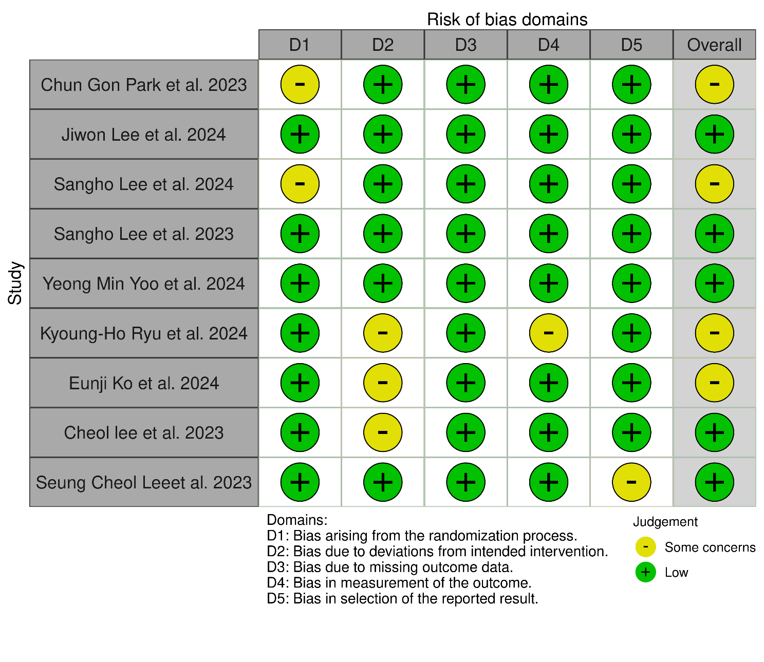
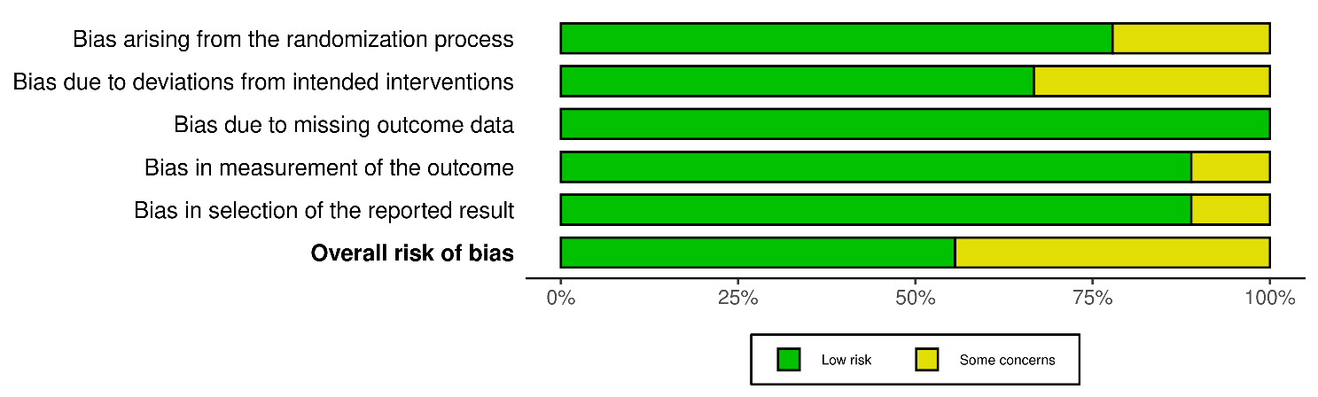

Supplementary Figure 2: (ROBINS-I) Risk of bias assessment results
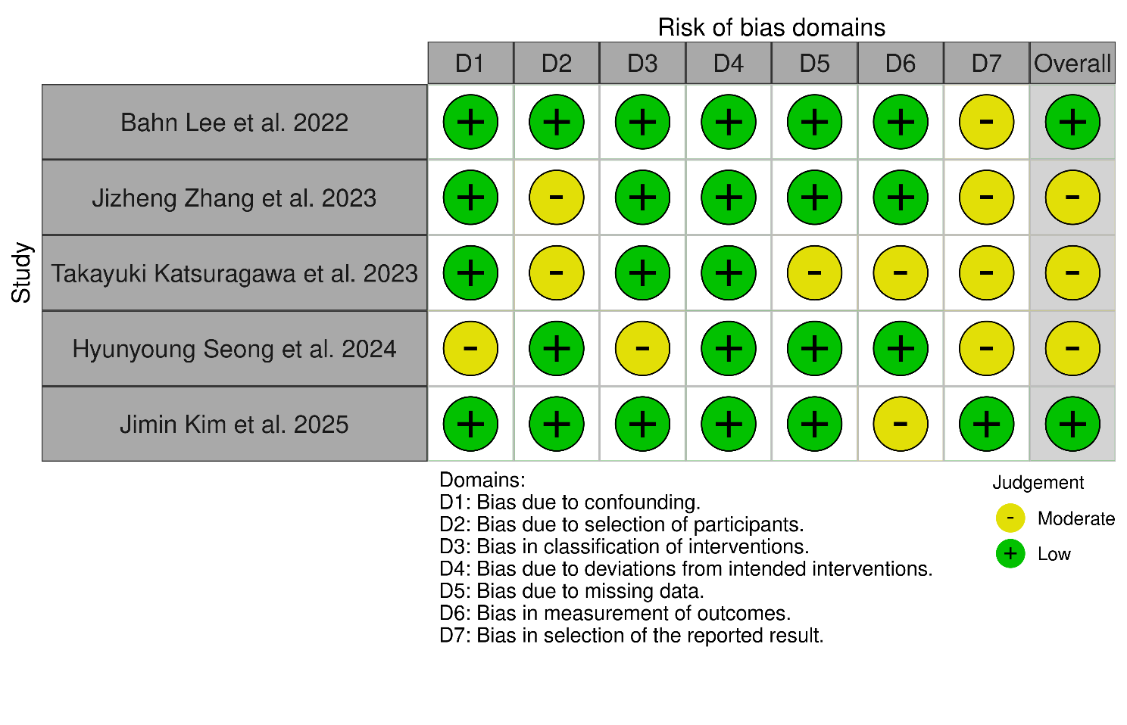
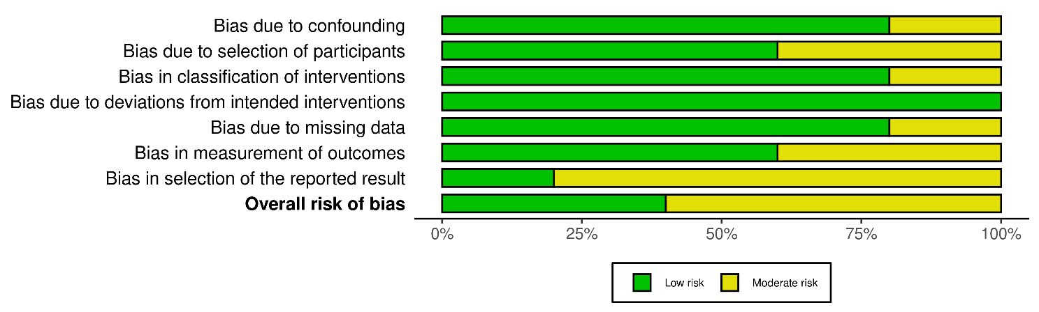

Primary analysis:

Supplementary Figure 3: MAP at 30 minutes after the start of surgery
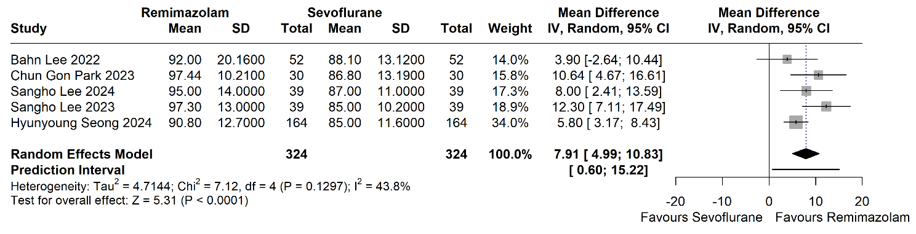

Supplementary Figure 4: MAP at 1 hour after the start of surgery.
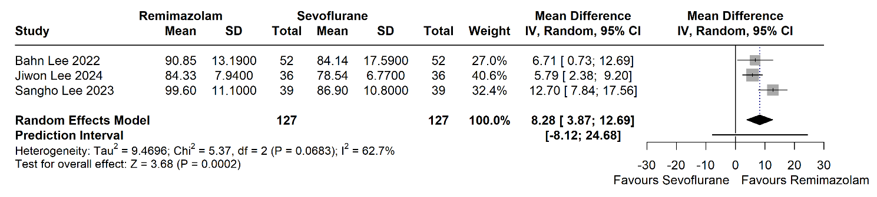

Supplementary Figure 5: MAP in the PACU
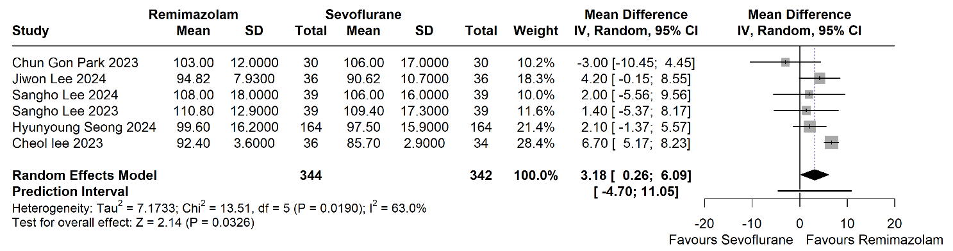

Supplementary Figure 6: HR at 30 minutes after the start of surgery
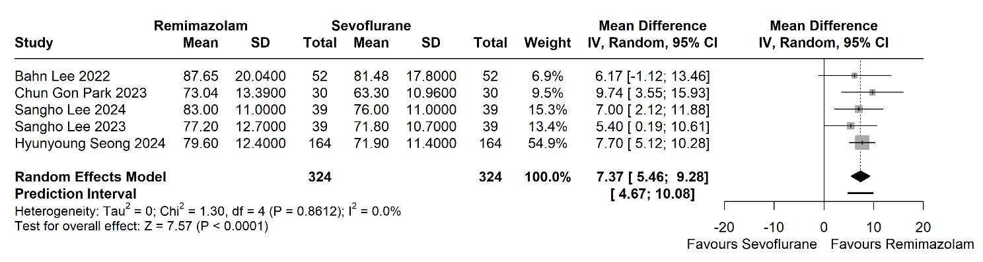

Supplementary Figure 7: HR at 1 hour after the start of surgery
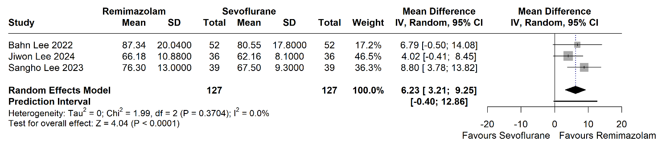

Supplementary Figure 8: HR in the PACU
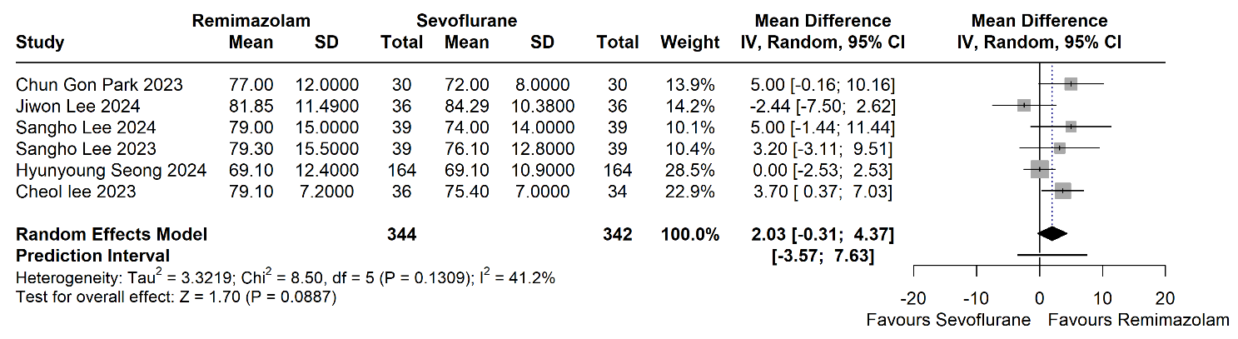

Supplementary Figure 9: Nausea and vomiting in the PACU
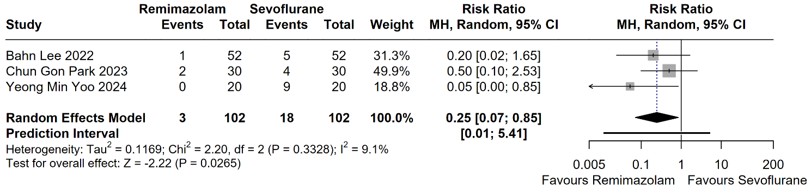

Supplementary Figure 10: Incidence of rescue anti-emetics administration
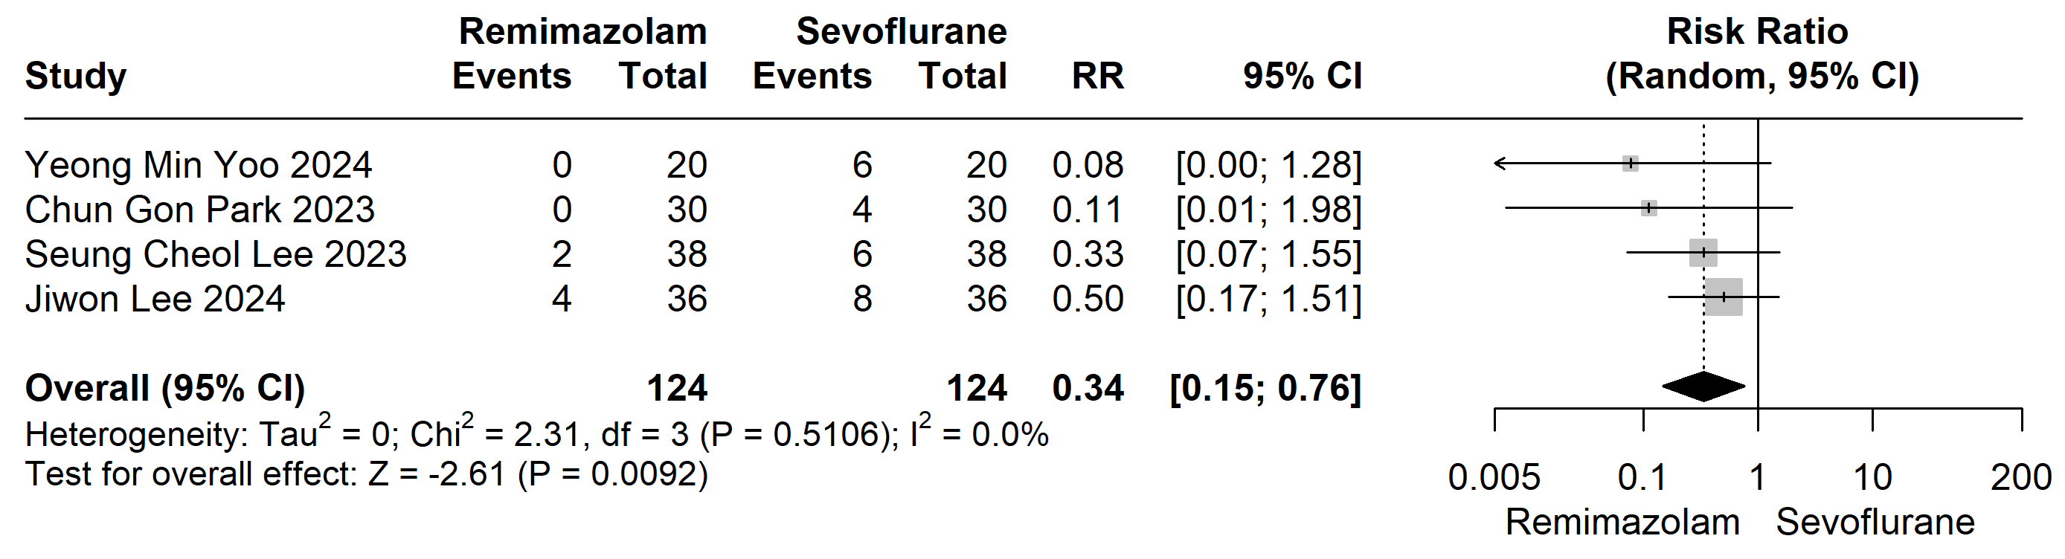

Supplementary Figure 11: Anesthesia time
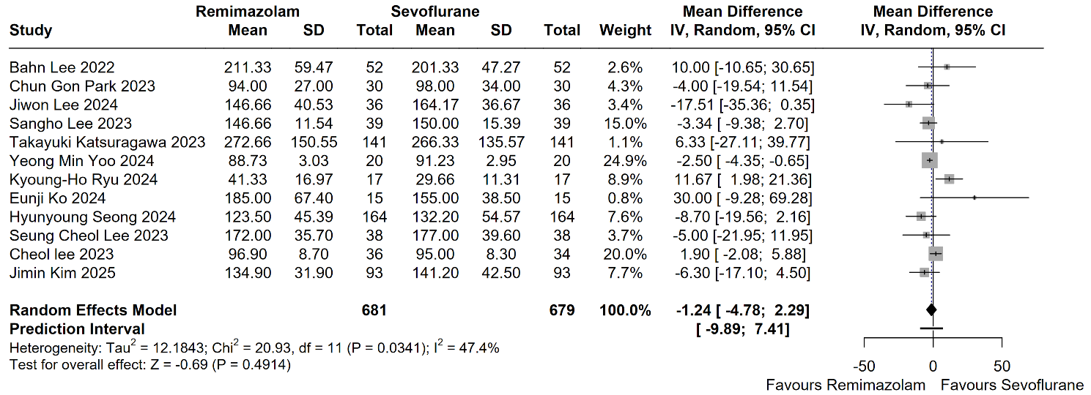

Supplementary Figure 12: Operation time
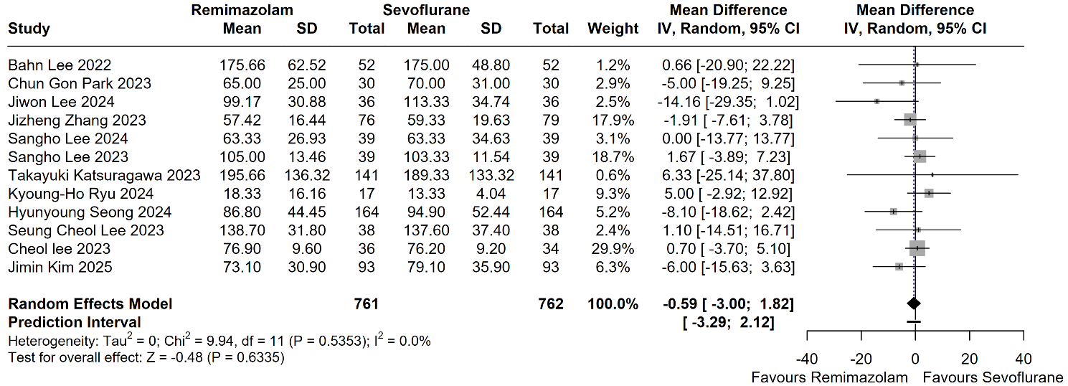

Supplementary Figure 13: Extubation time
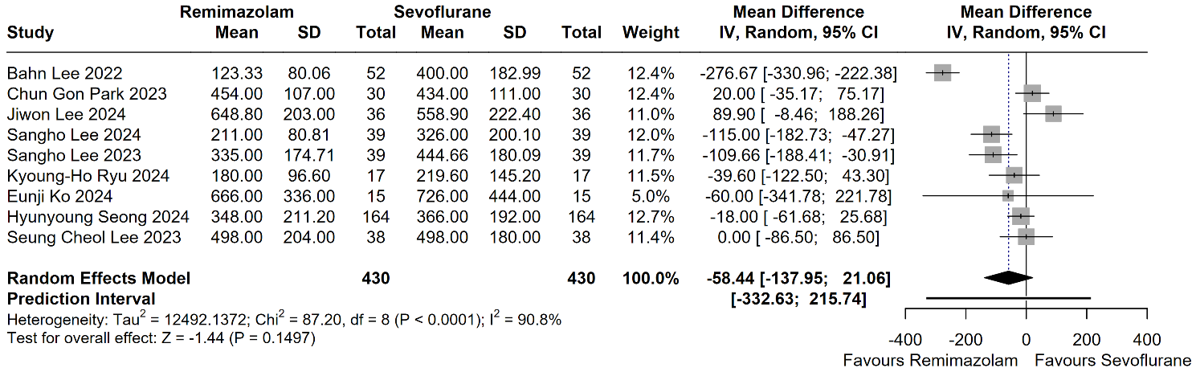

Supplementary Figure 14: Eye-opening time
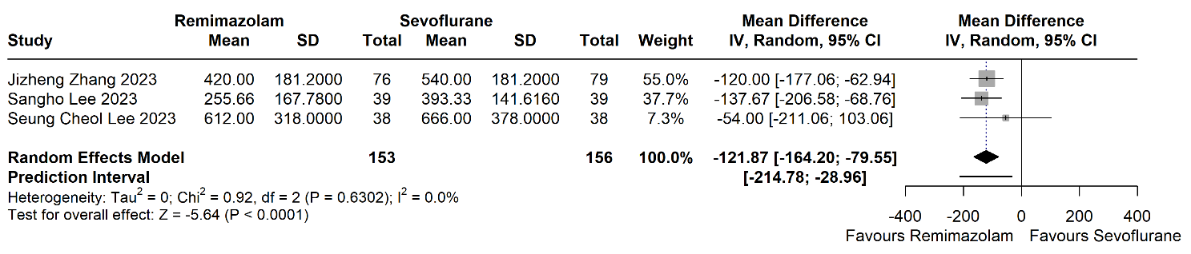

Supplementary Figure 15: Postoperative length of stay
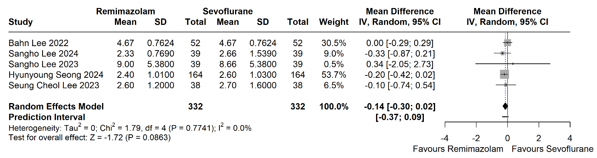

Supplementary Figure 16: length of stay at the PACU
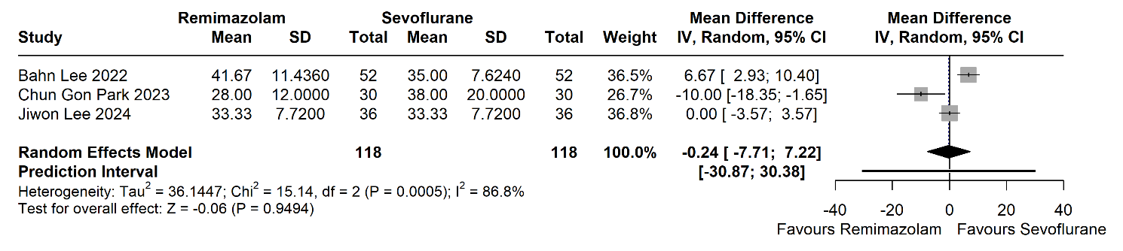

Supplementary Figure 17: Global QoR score on POD 1
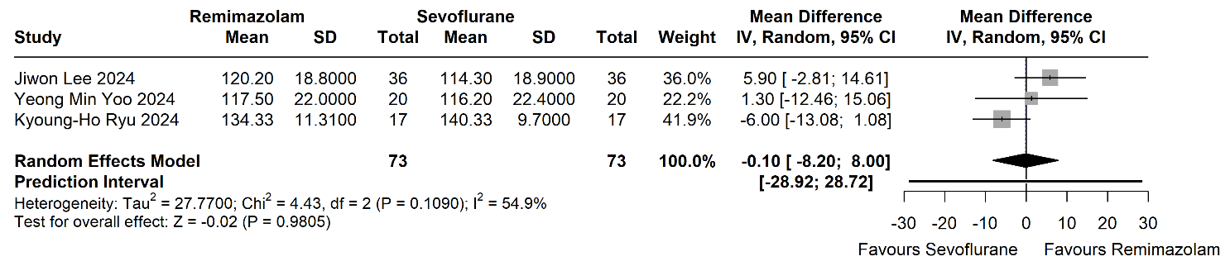

Supplementary Figure 18: Time to Aldrete score >9
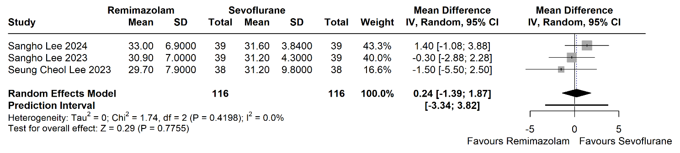

Supplementary Figure 19: Total fluid intake
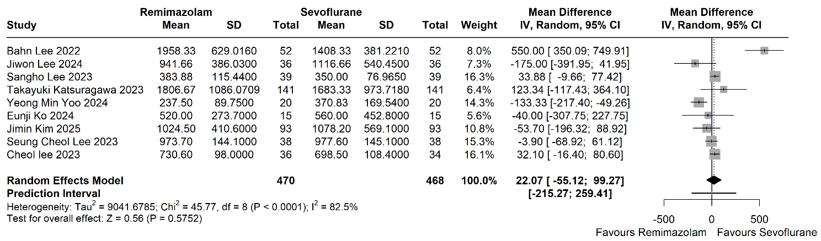

Supplementary Figure 20: blood loss
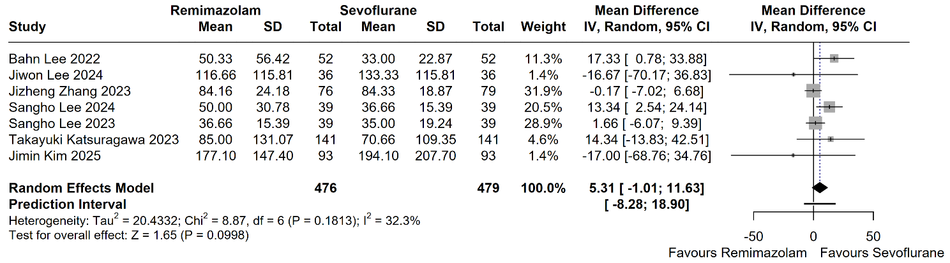

Supplementary Figure 21: Urine output
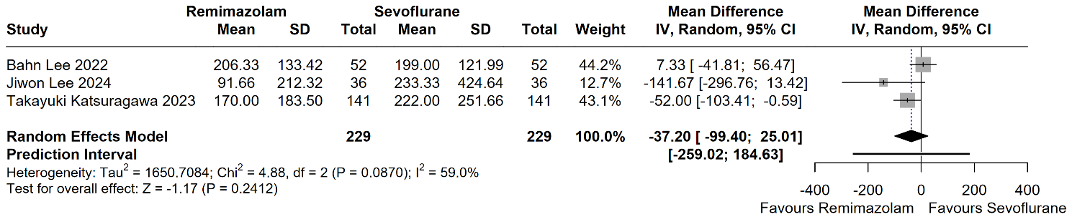

RCTs only Subgroup analysis:

Supplementary Figure 22: MAP at the start of surgery – RCTs only
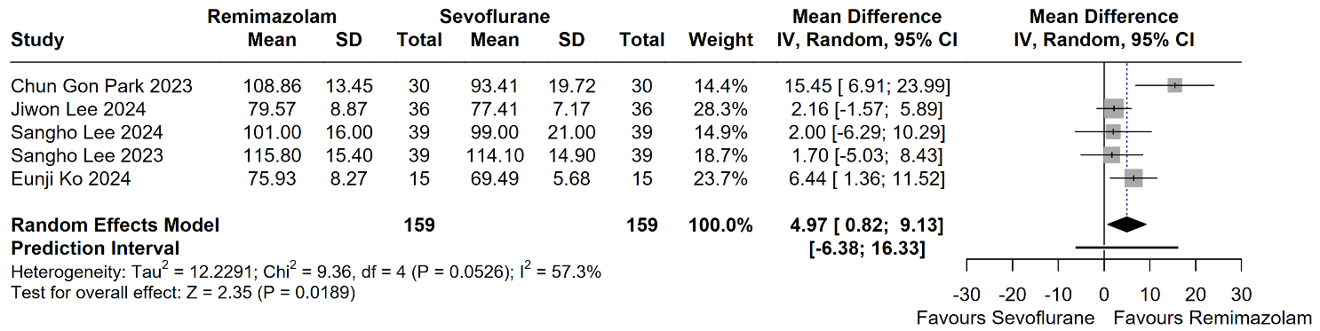

Supplementary Figure 23: MAP at 30 minutes after the start of surgery – RCTs only
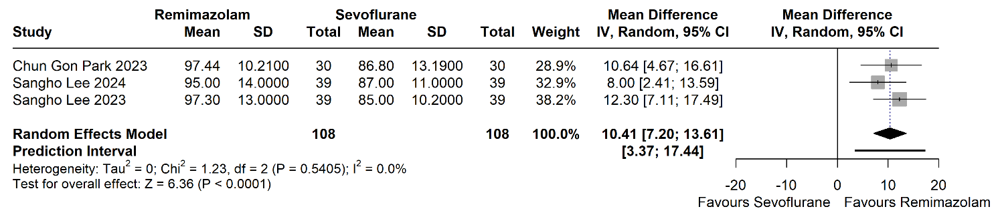

Supplementary Figure 24: MAP at the end of surgery – RCTs only
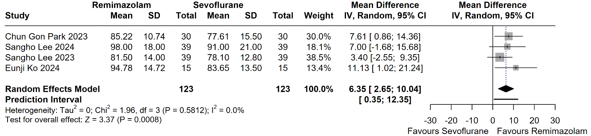

Supplementary Figure 25: MAP in the PACU – RCTs only
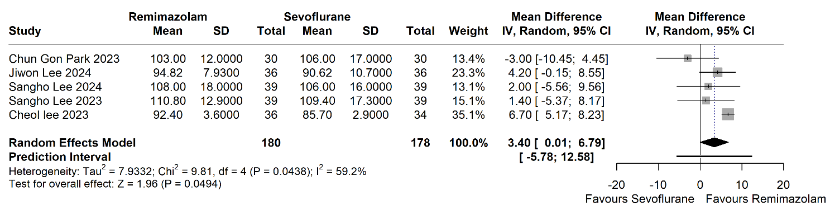

Supplementary Figure 26: HR at the start of surgery RCTs only – RCTs only
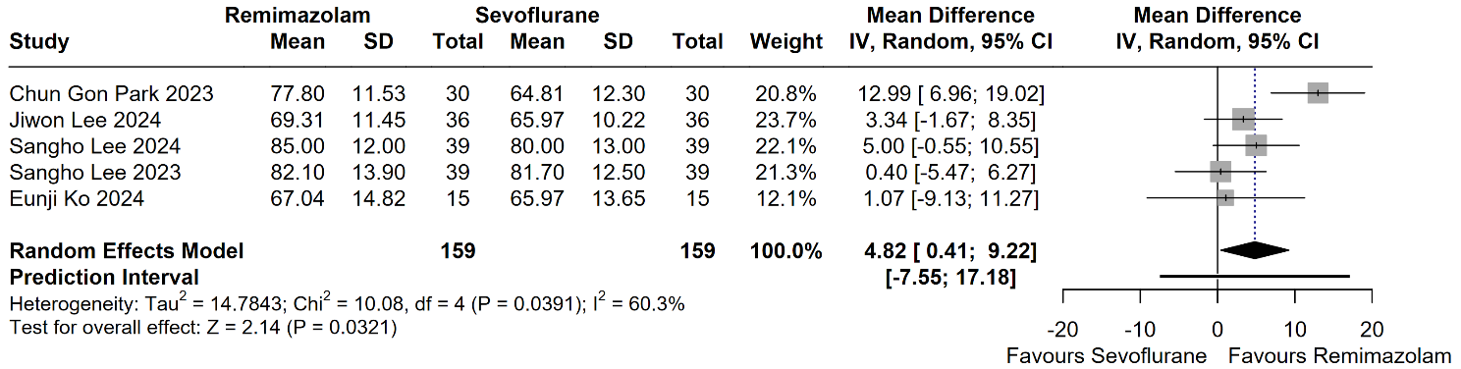

Supplementary Figure 27: HR at 30 minutes after the start of surgery – RCTs only
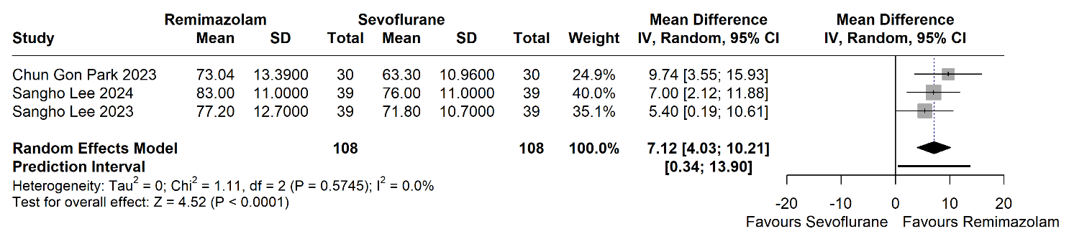

Supplementary Figure 28: HR at the end of surgery – RCTs only
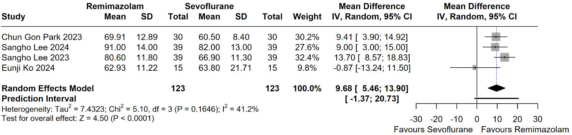

Supplementary Figure 29: HR in the PACU – RCTs only
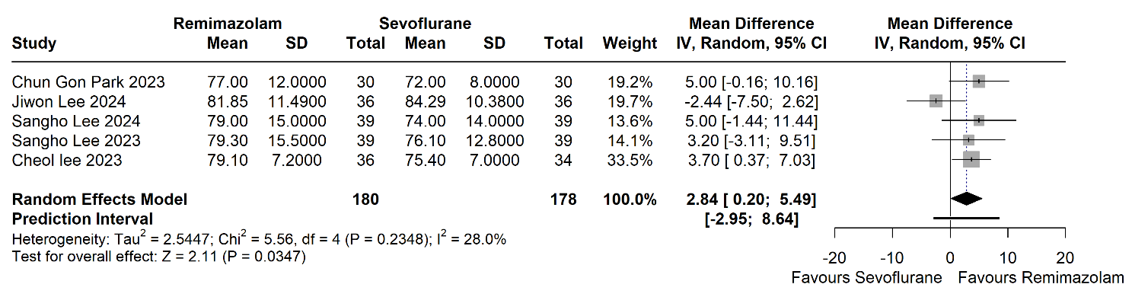

Supplementary Figure 30: Incidence of intraoperative hypotension – RCTs only
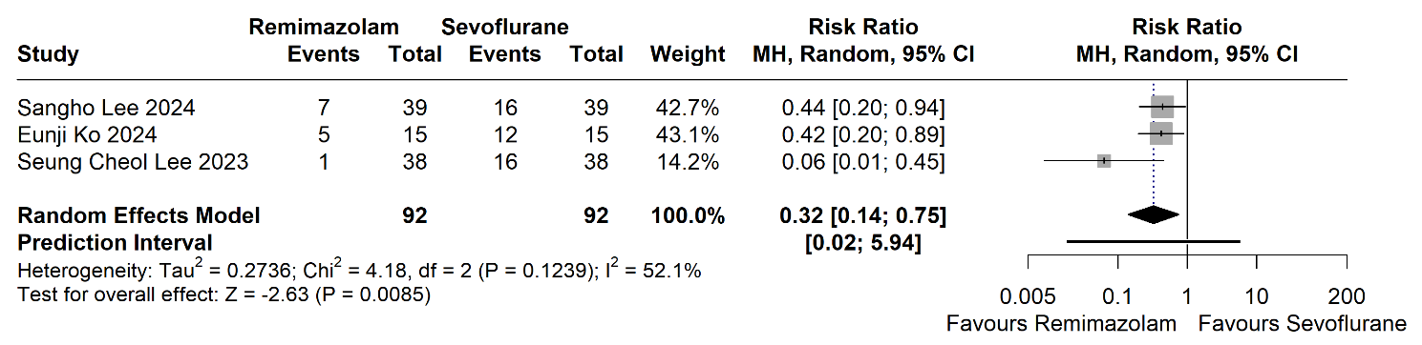

Supplementary Figure 31: Incidence of vasopressor use – RCTs only
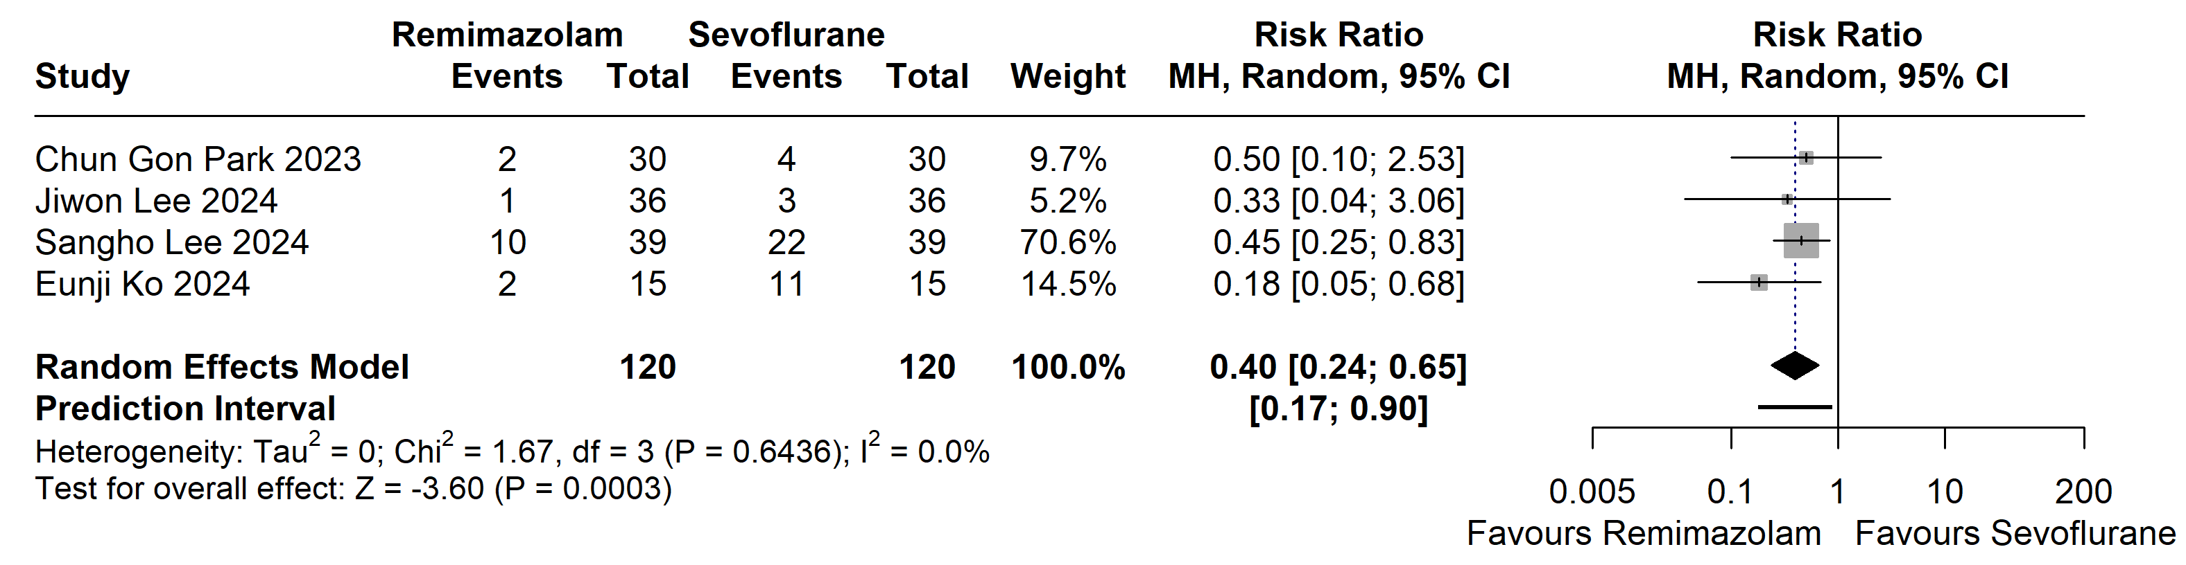

Supplementary Figure 32: Incidence of postoperative nausea and vomiting – RCTs only
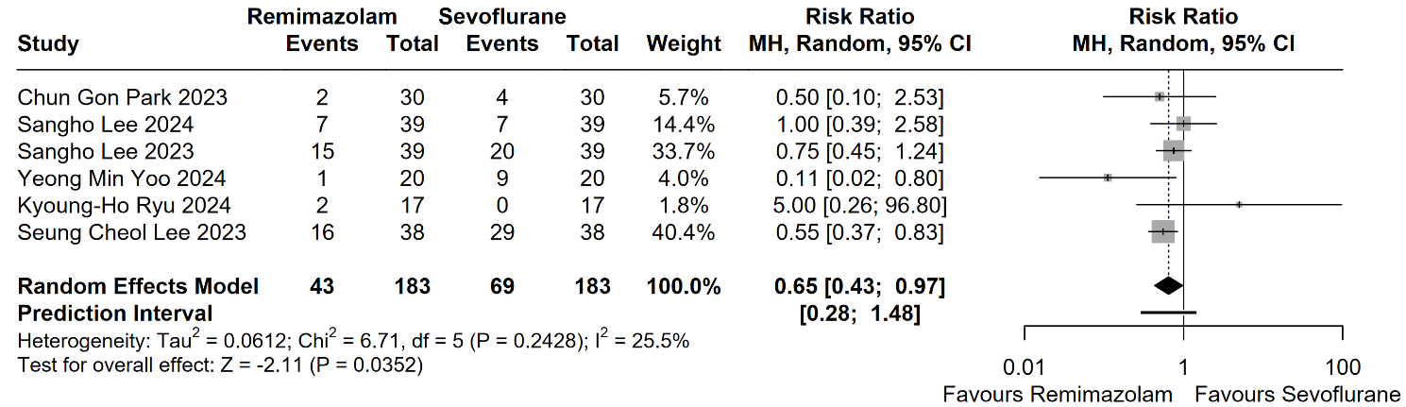

Supplementary Figure 33: Anesthesia time – RCTs only
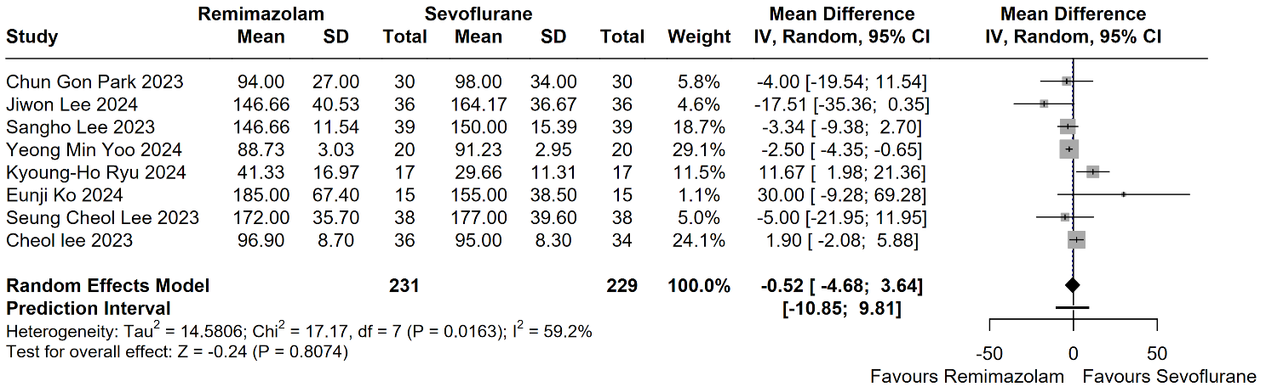

Supplementary Figure 34: Operation time – RCTs only
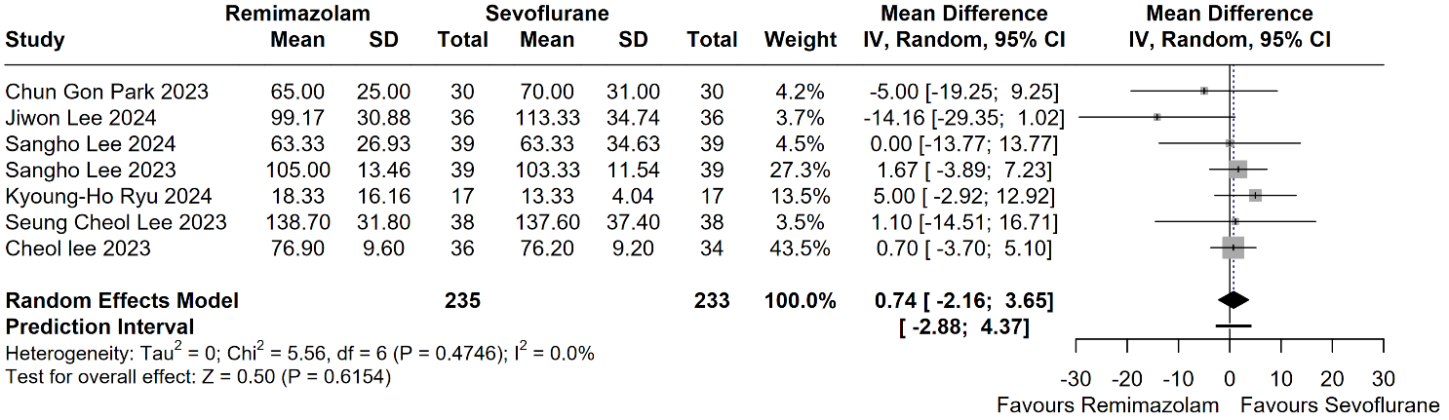

Supplementary Figure 35: Extubation time – RCTs only
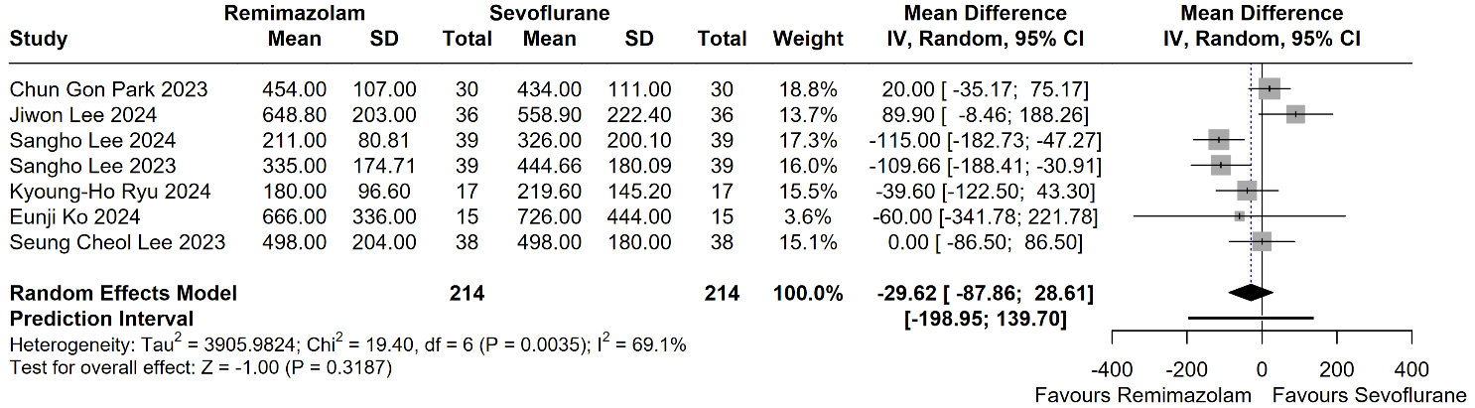

Supplementary Figure 36: Postoperative length of stay – RCTs only
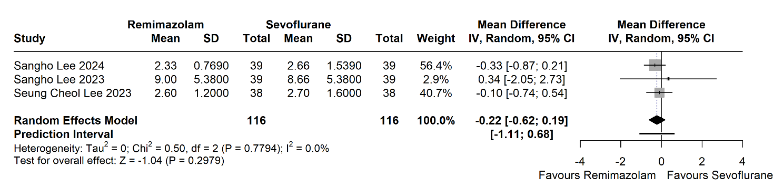

Supplementary Figure 37: Total fluid intake – RCTs only
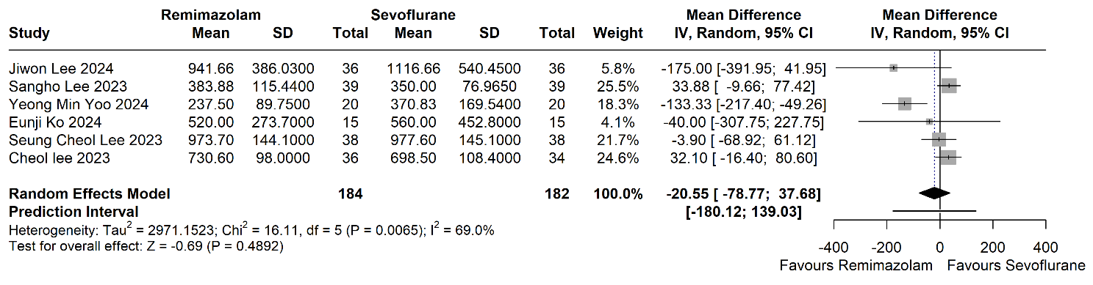

Supplementary Figure 38: Blood loss – RCTs only
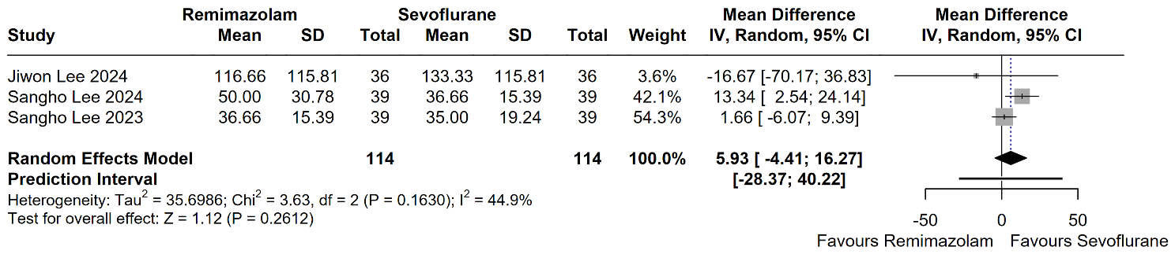

Excluding ASA4 analysis:

Supplementary Figure 39: MAP at the start of surgery – Excluding ASA4
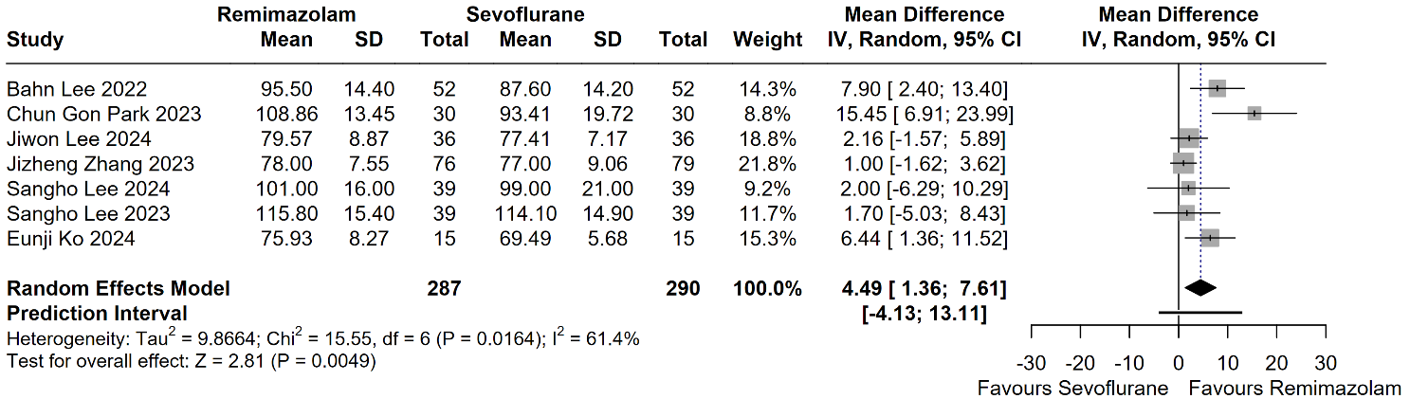

Supplementary Figure 40: MAP at the end of surgery – Excluding ASA4
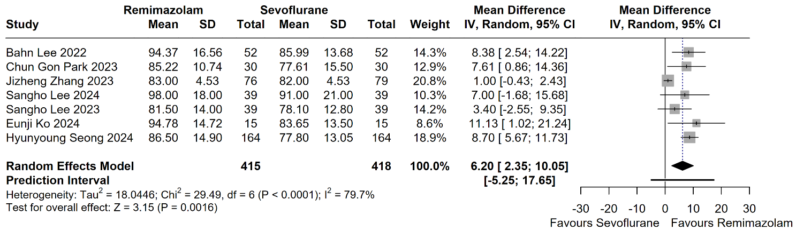

Supplementary Figure 41: HR at the start of surgery – Excluding ASA4
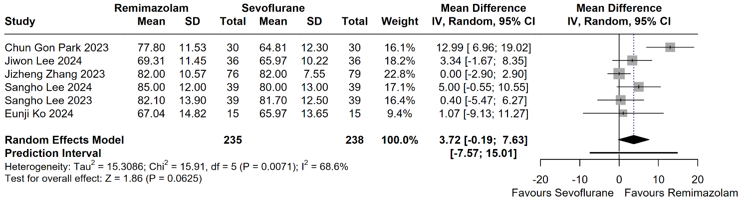

Supplementary Figure 42: HR at the end of surgery – Excluding ASA4
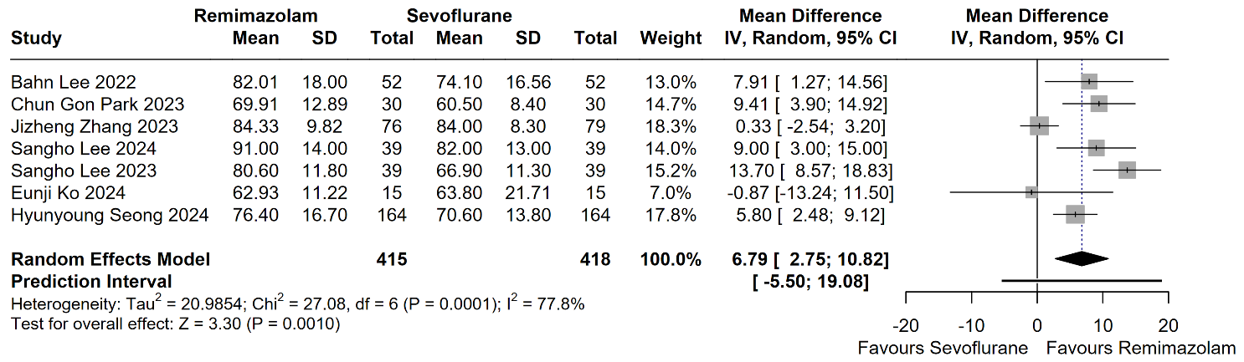

Supplementary Figure 43: Intraoperative hypotension – Excluding ASA4
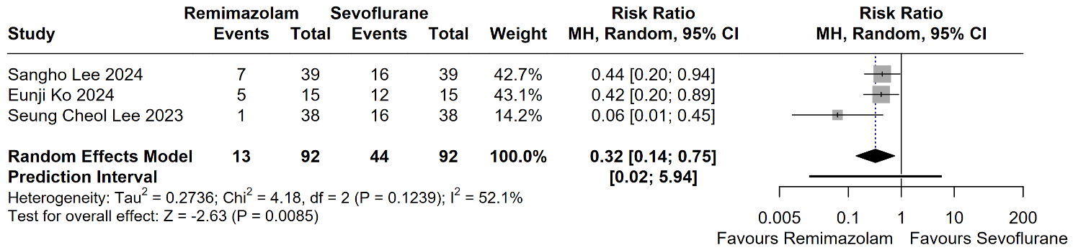

Supplementary Figure 44: Vasopressor use – Excluding ASA4
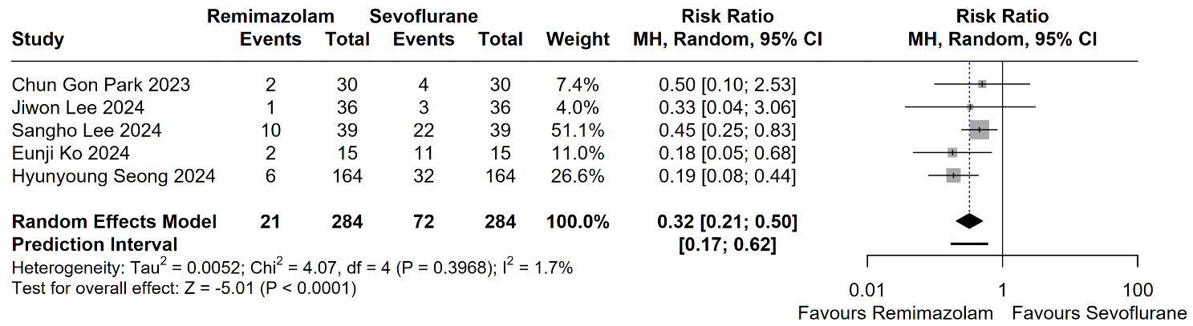

Supplementary Figure 45: Anesthesia time – Excluding ASA4
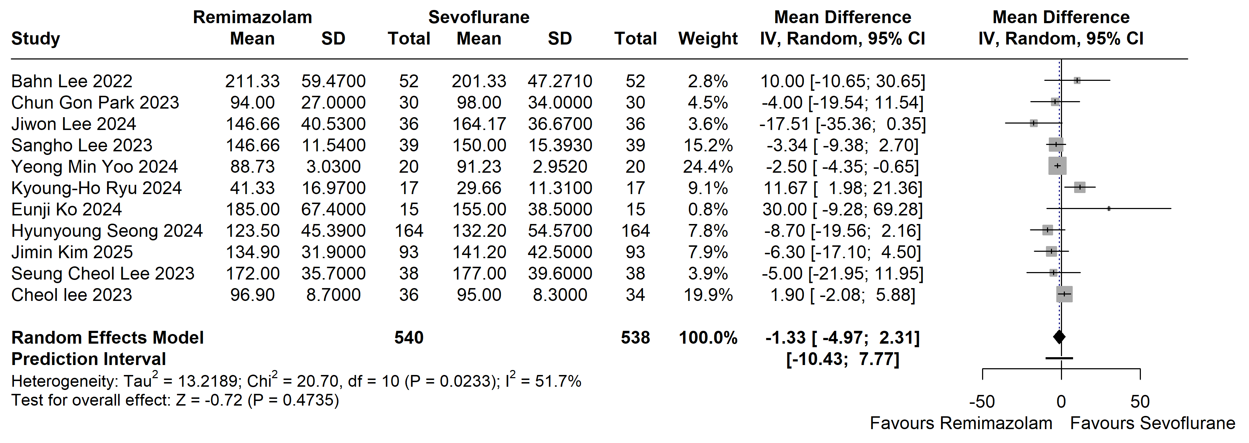

Supplementary Figure 46: Operation time – Excluding ASA4
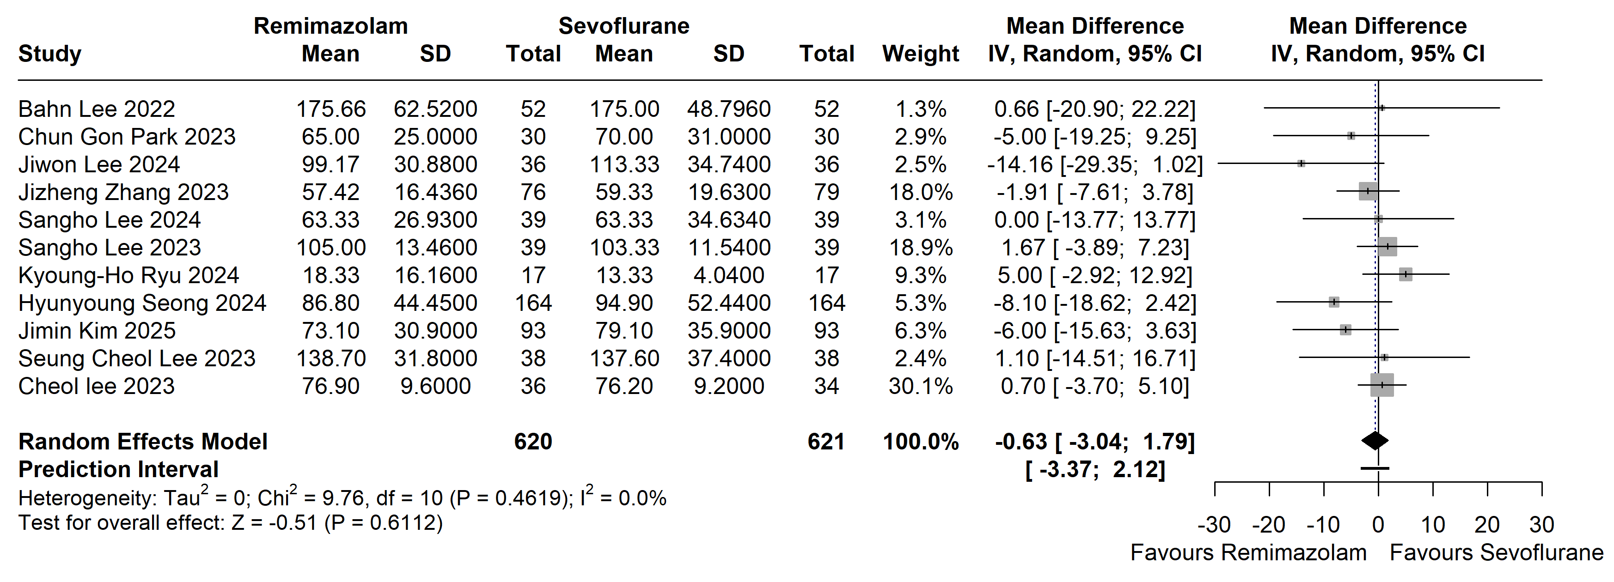

Supplementary Figure 47: Blood loss – Excluding ASA4
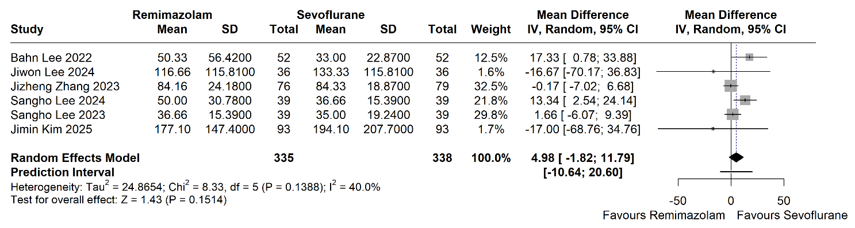

Supplementary Figure 48: Total fluid intake – Excluding ASA4
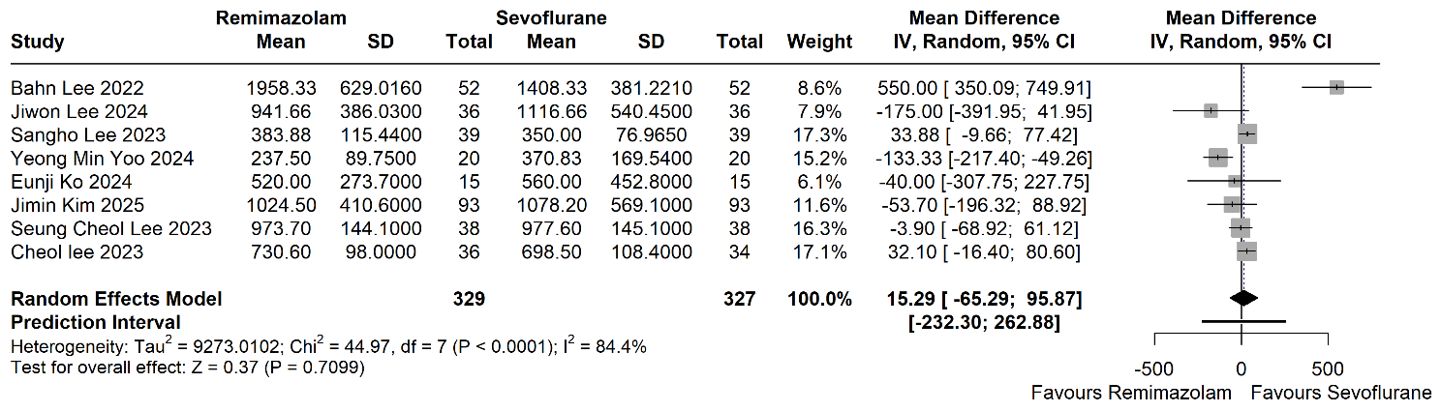

Leave-one-out sensitivity analysis:

Supplementary Figure 49: MAP at the start of surgery - Leave one out analysis
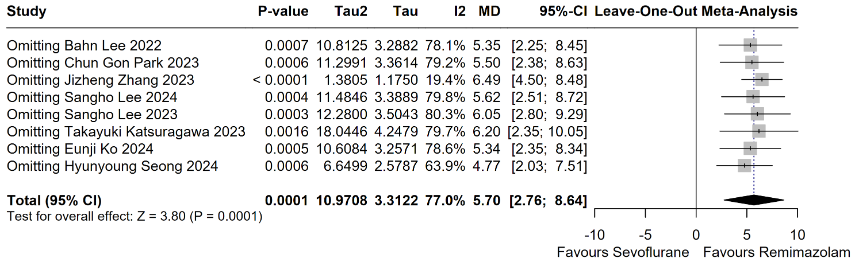

Supplementary Figure 50: MAP at 30 minutes after the start of surgery- Leave one out analysis
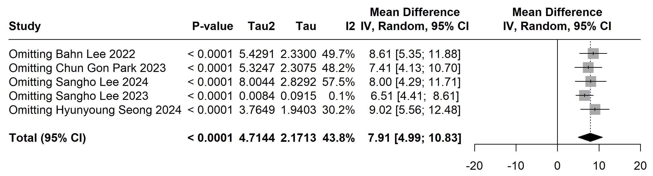

Supplementary Figure 51: MAP at 1 hour after the start of surgery- Leave one out analysis
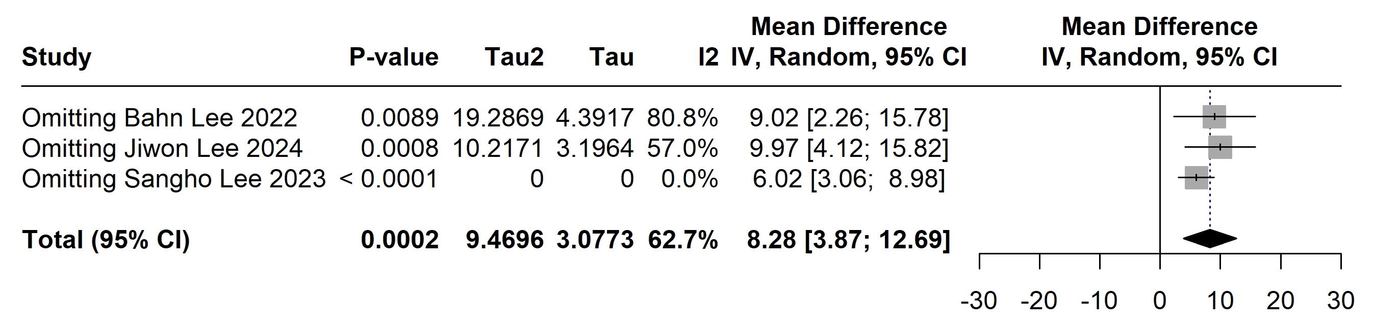

Supplementary Figure 52: MAP at the end of surgery- Leave one out analysis

Supplementary Figure 53: MAP in the PACU- Leave one out analysis
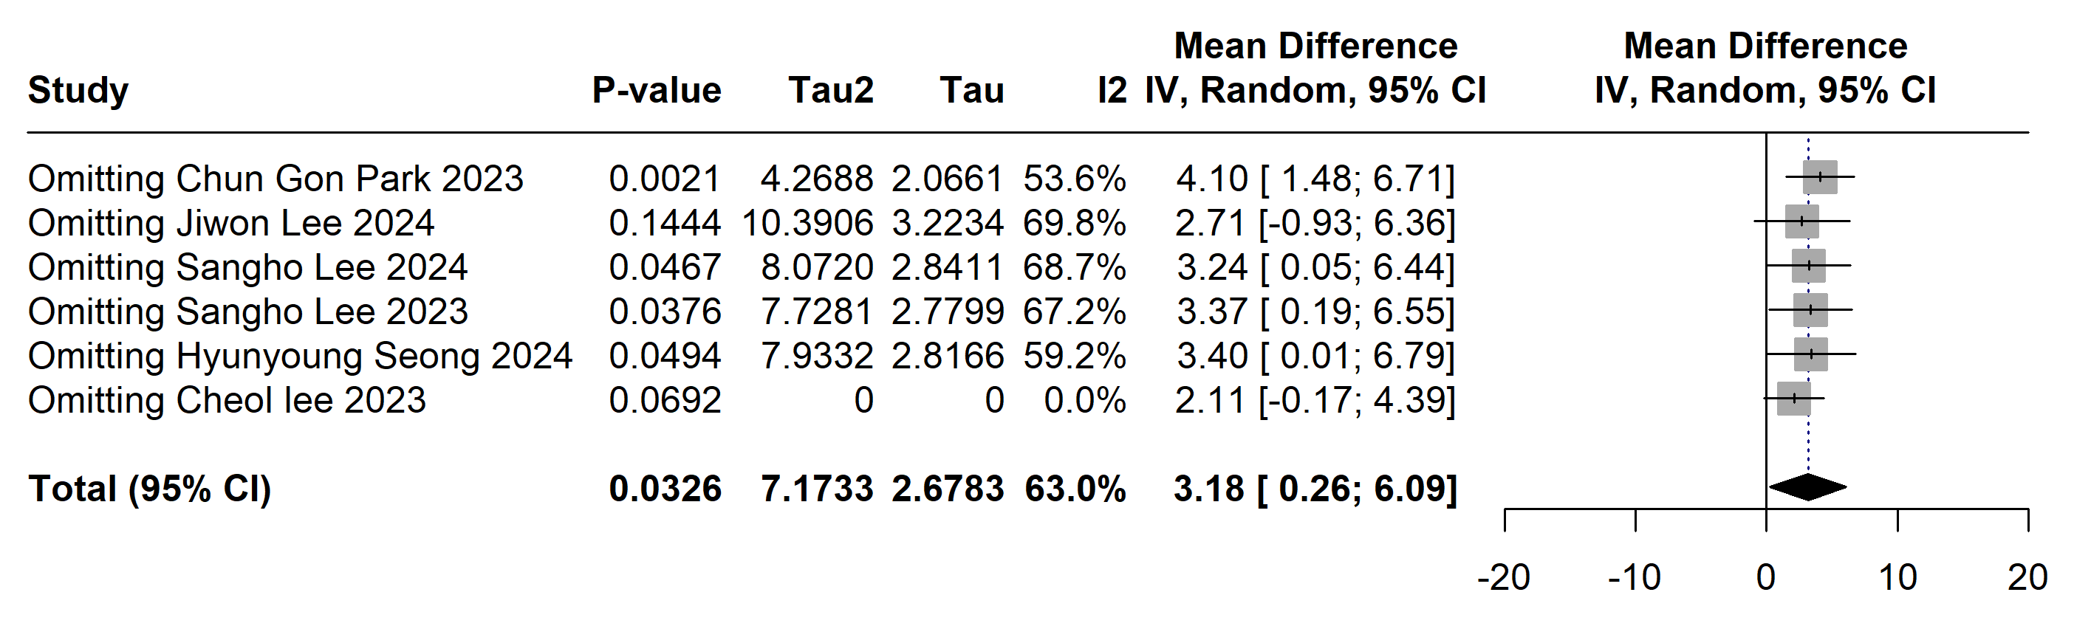

Supplementary Figure 54: HR at the start of surgery- Leave one out analysis
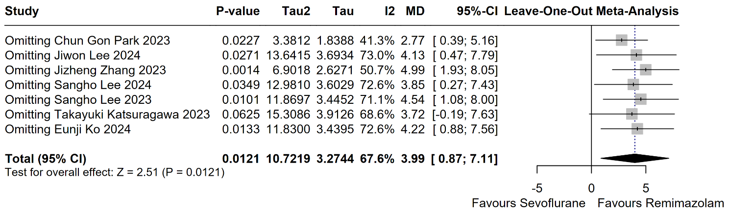

Supplementary Figure 55: HR at 30 minutes after the start of surgery- Leave one out analysis
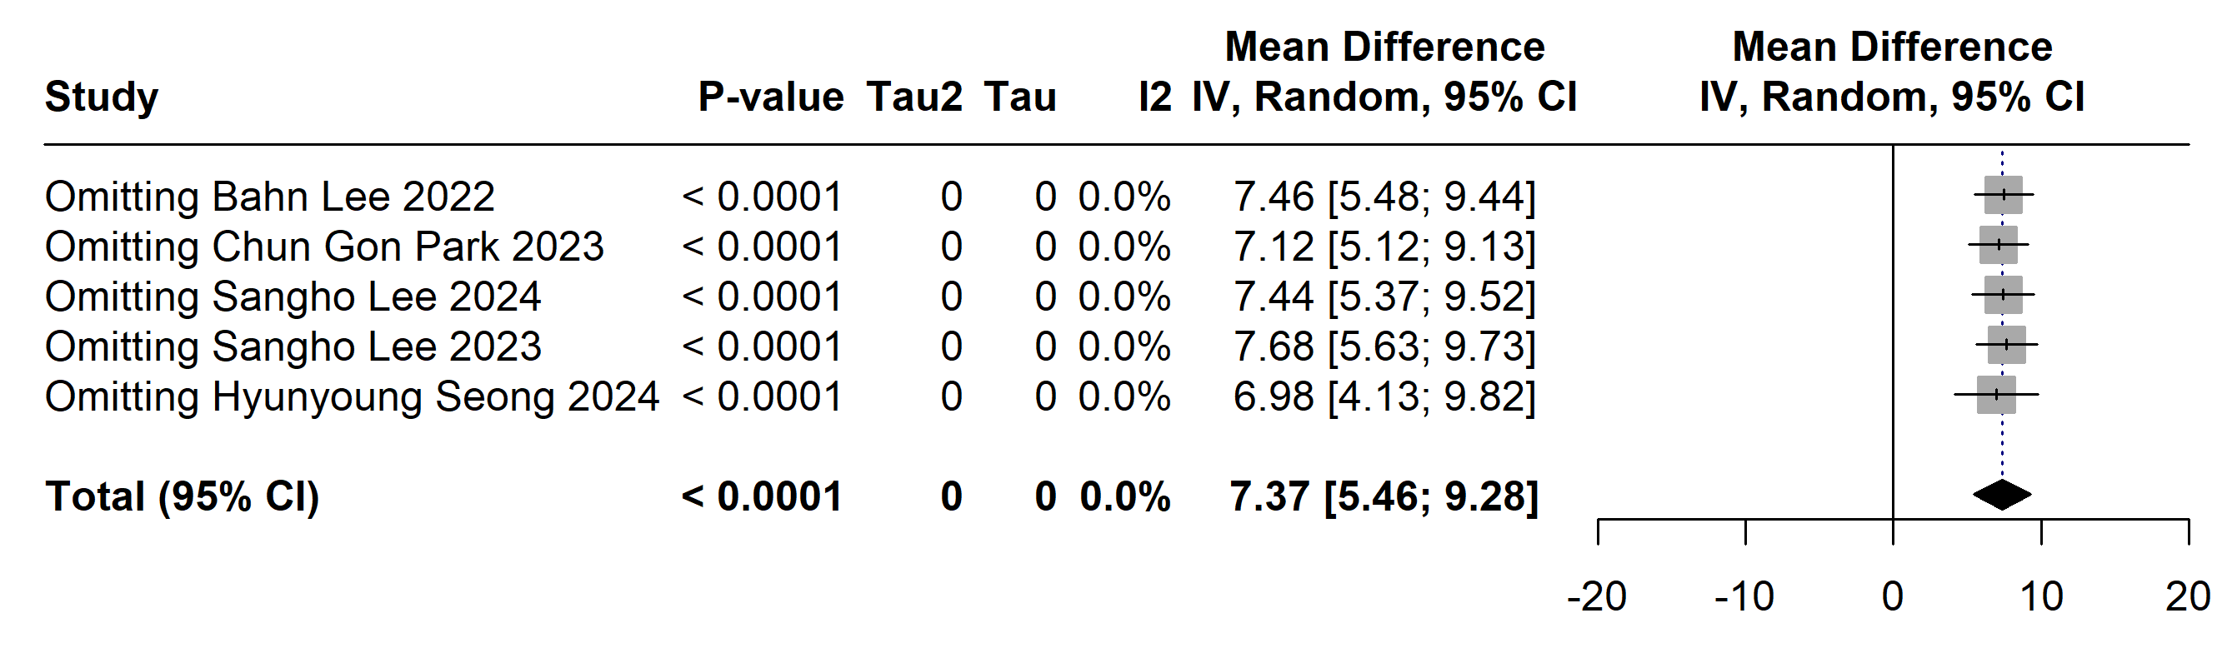

Supplementary Figure 56: HR at 1 hour after the start of surgery- Leave one out analysis
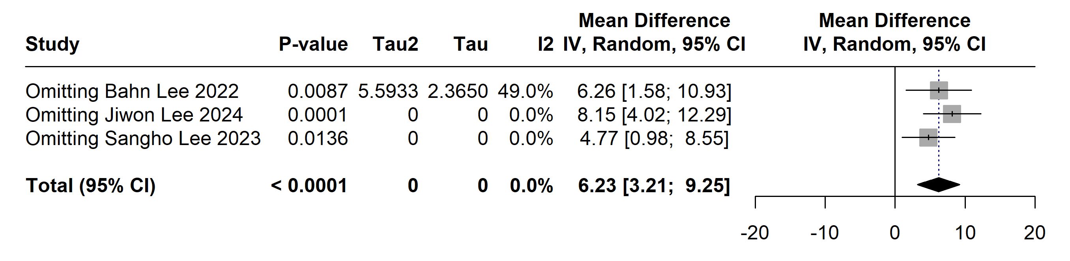

Supplementary Figure 57: HR at the end of surgery- Leave one out analysis
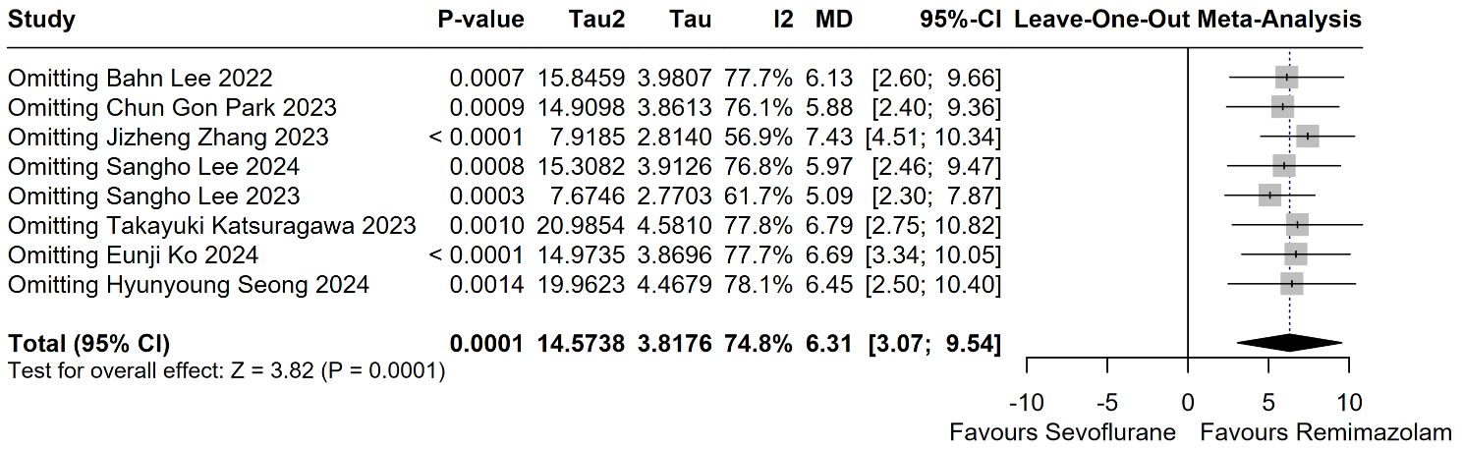

Supplementary Figure 58: HR in the PACU- Leave one out analysis
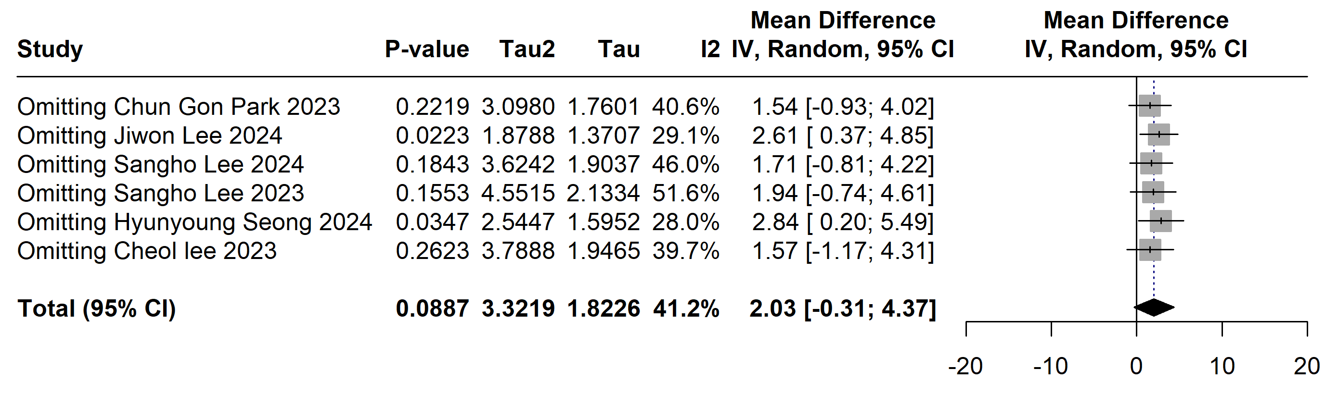

Supplementary Figure 59: Incidence of intraoperative hypotension- Leave one out analysis
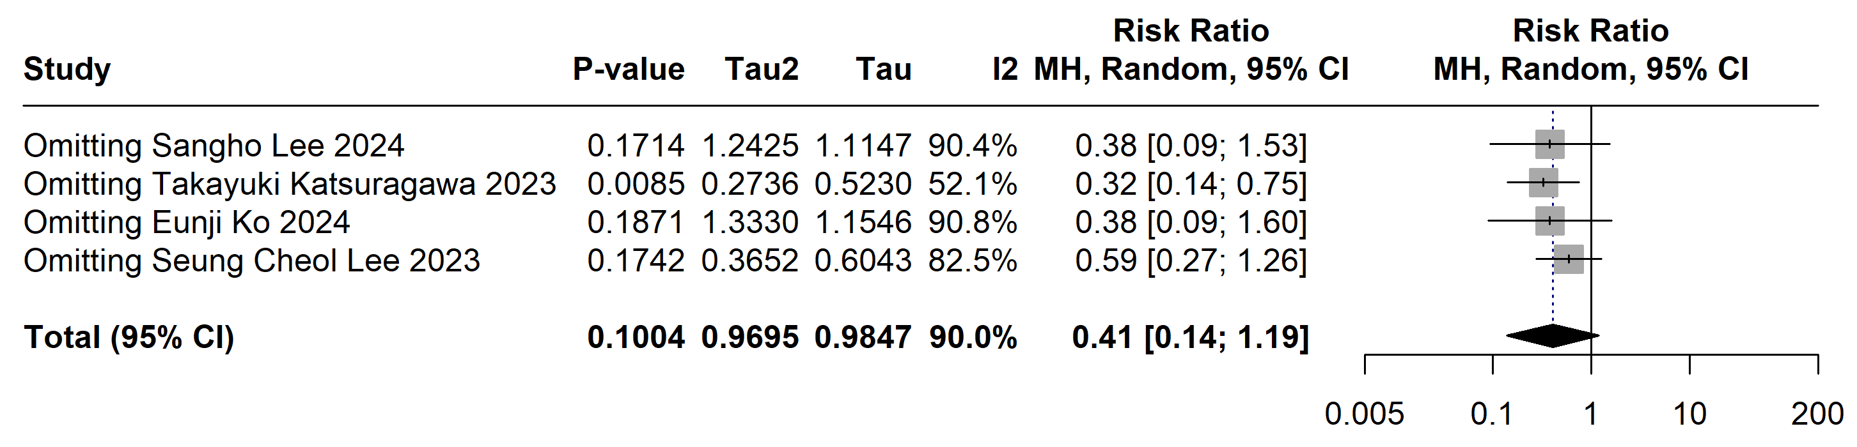

Supplementary Figure 60: Incidence of vasopressor use- Leave one out analysis
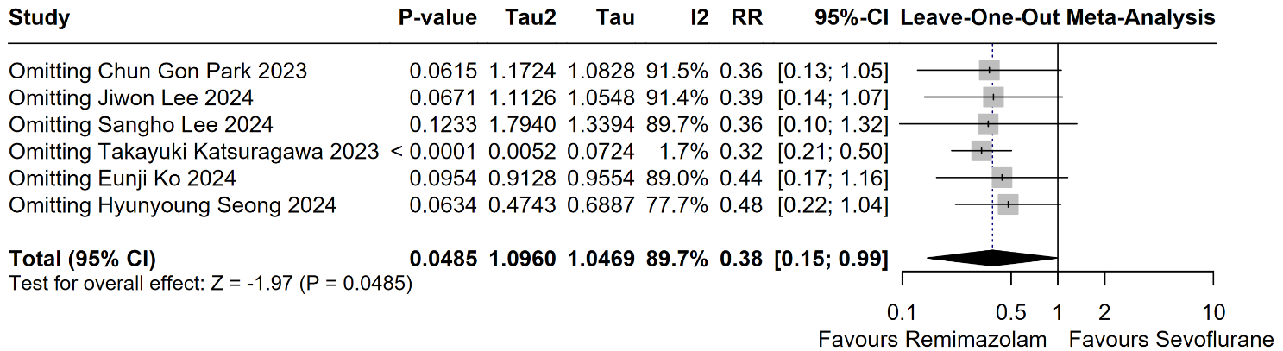

Supplementary Figure 61: Delirium- Leave one out analysis
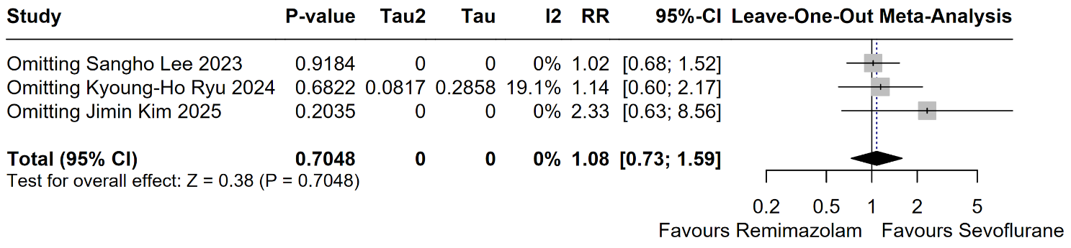

Supplementary Figure 62: PONV - Leave one out analysis
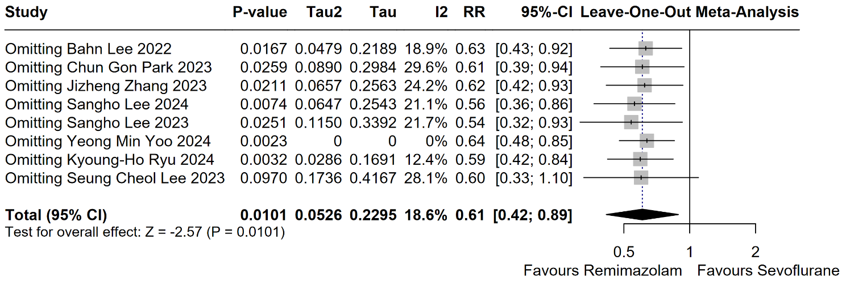

Supplementary Figure 63: Nausea and vomiting in the PACU- Leave one out analysis
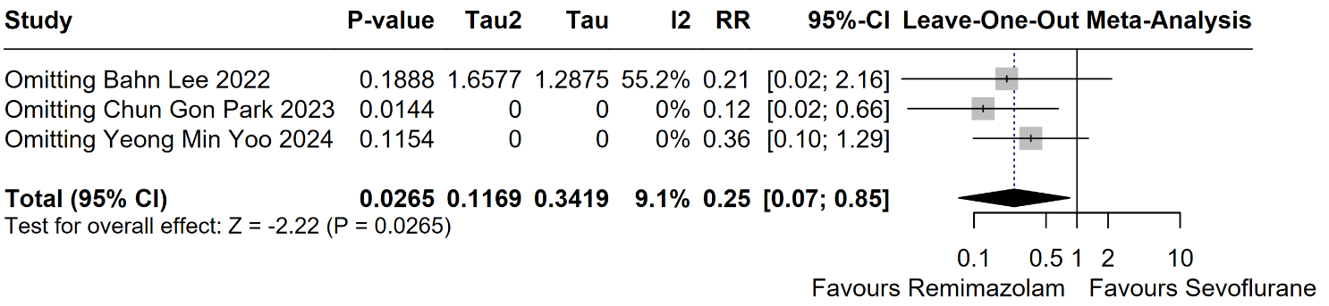

Supplementary Figure 64: Incidence of rescue anti-emetics administration- Leave one out analysis
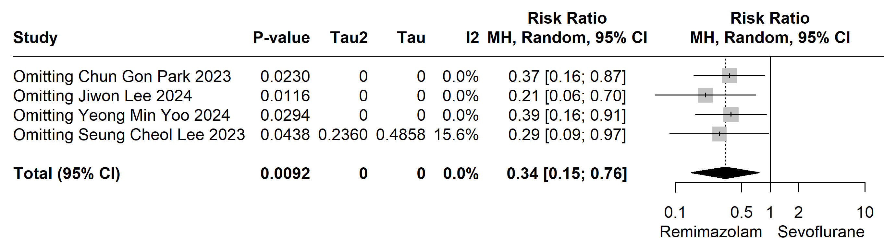

Supplementary Figure 65: Anesthesia time- Leave one out analysis
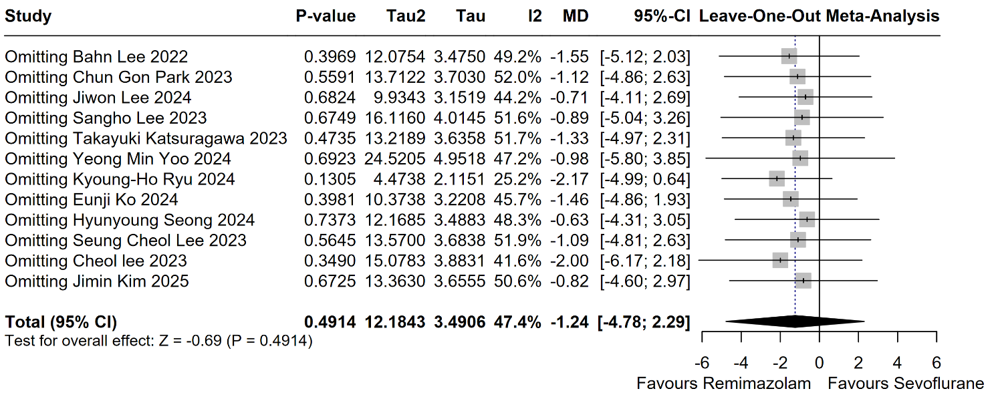

Supplementary Figure 66: Operation time- Leave one out analysis
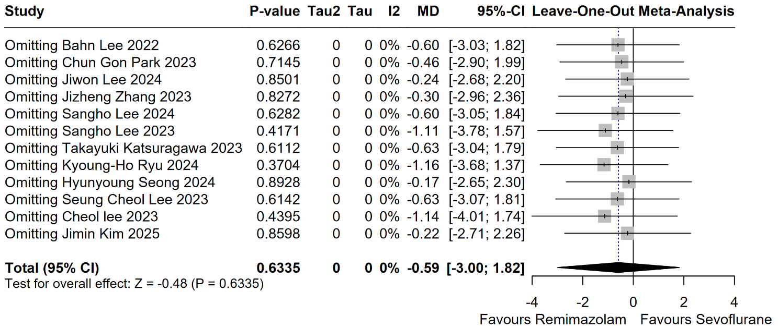

Supplementary Figure 67: Extubation time- Leave one out analysis
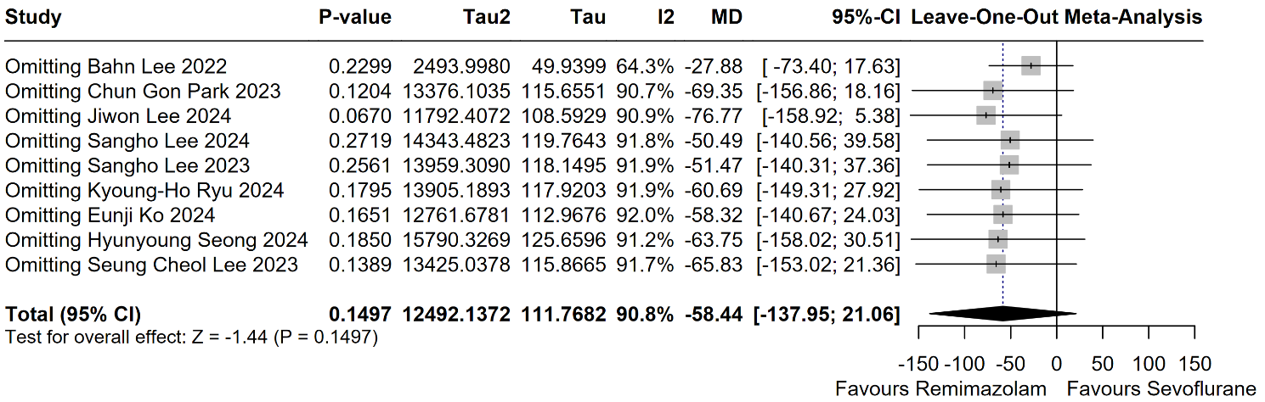

Supplementary Figure 68: Eye-opening time- Leave one out analysis
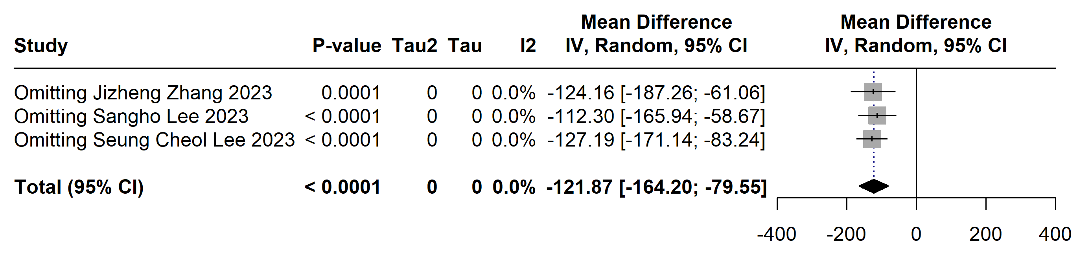

Supplementary Figure 69: Postoperative length of stay- Leave one out analysis
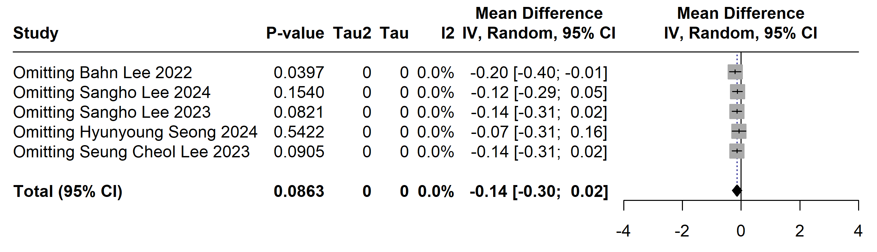

Supplementary Figure 70: length of stay at the PACU- Leave one out analysis
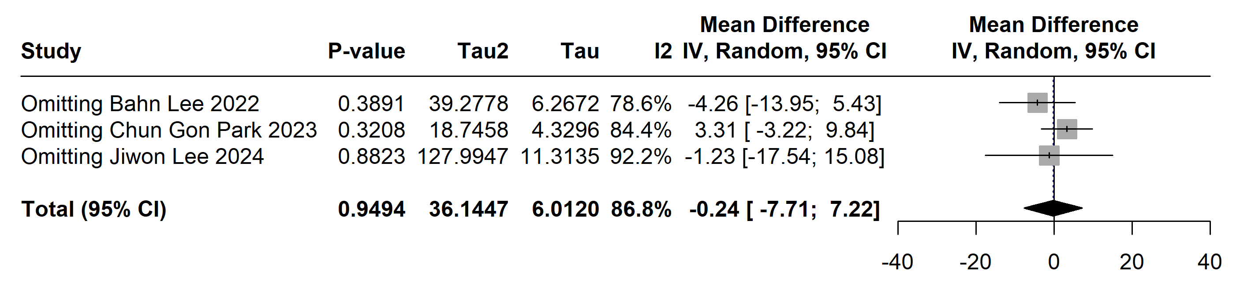

Supplementary Figure 71: Global QoR score on POD 1- Leave one out analysis
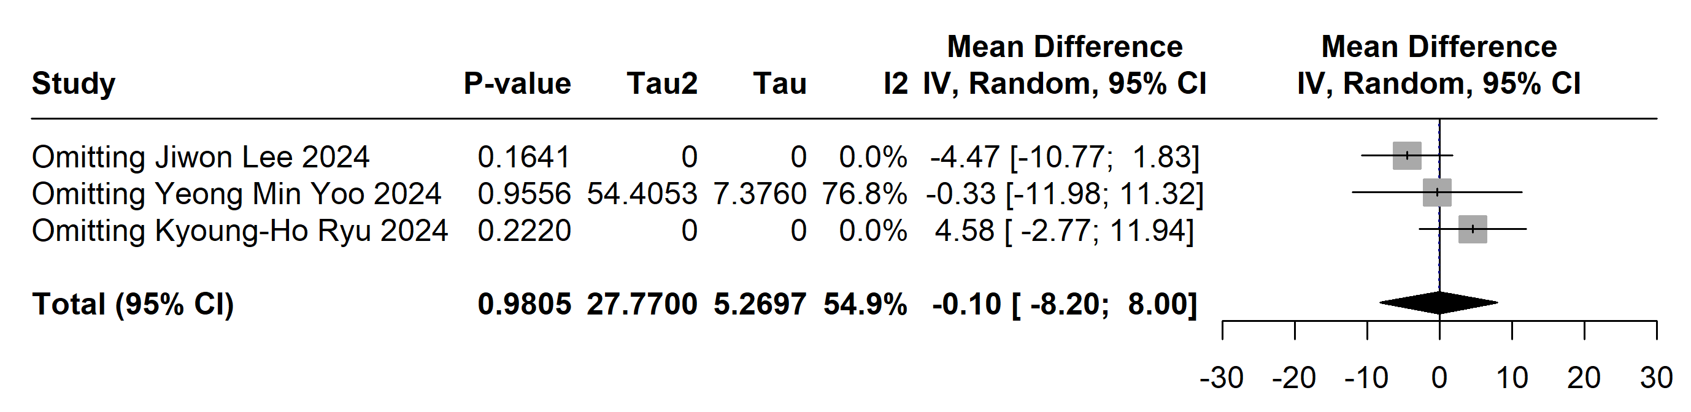

Supplementary Figure 72: Time to Aldrete score >9- Leave one out analysis
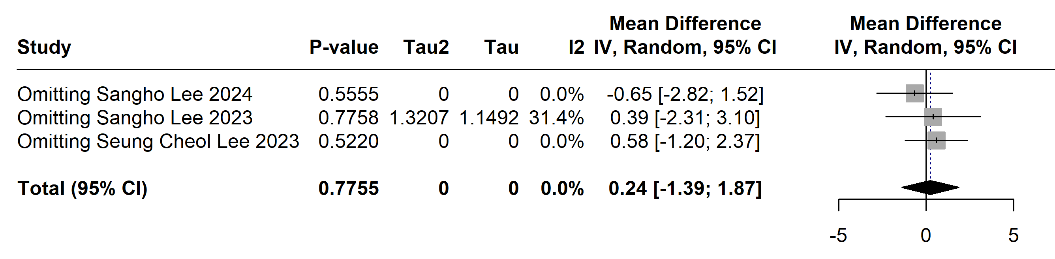

Supplementary Figure 73: Total fluid intake- Leave one out analysis
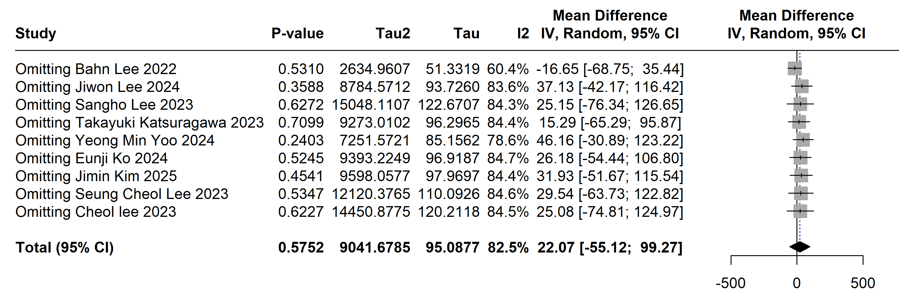

Supplementary Figure 74: blood loss- Leave one out analysis
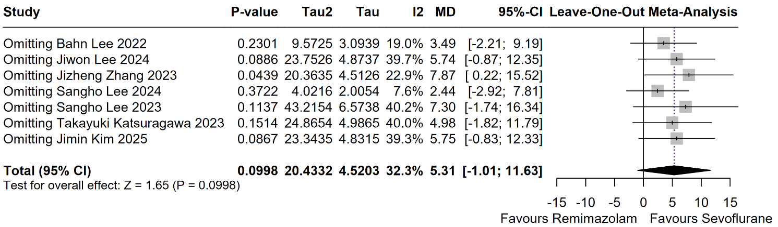

Supplementary Figure 75: Urine output- Leave one out analysis
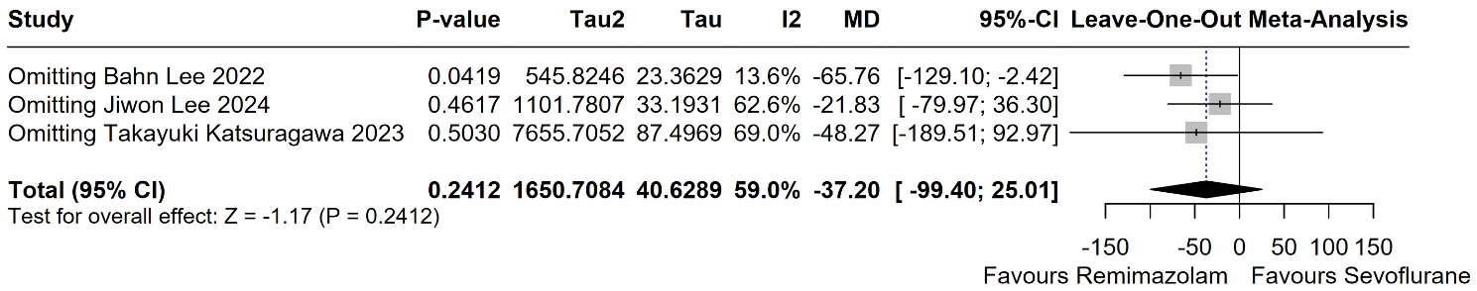

Funnel plots:

Supplementary Figure 76: Anesthesia time
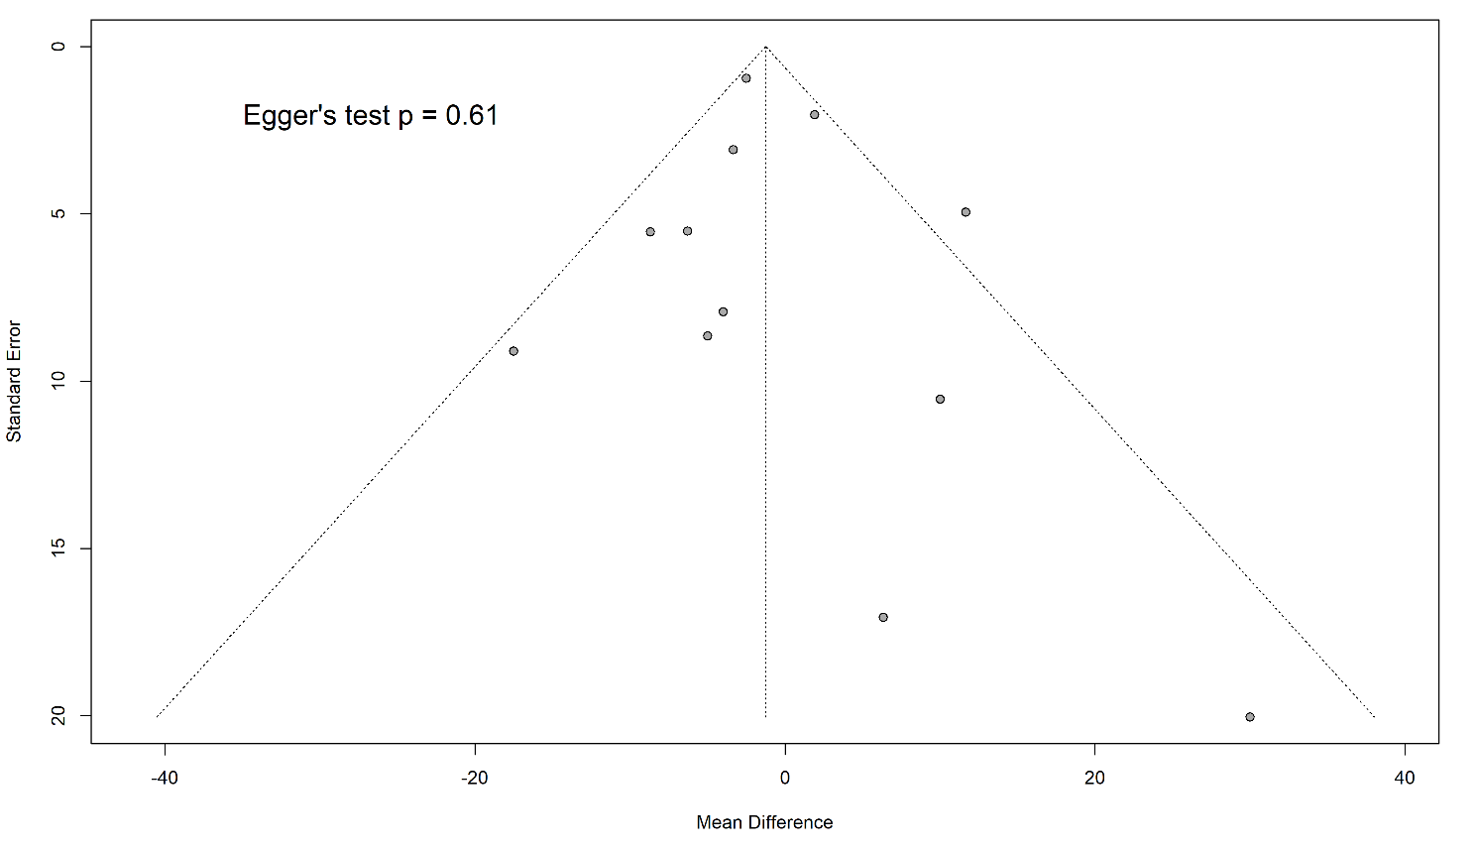

Supplementary Figure 77: Operation time

