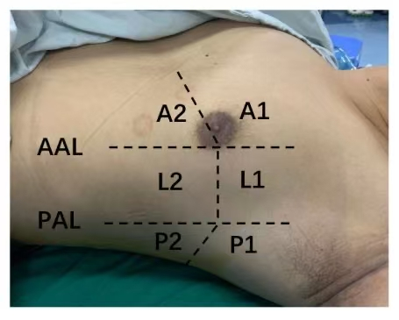
Supplementary Figure S1. LUS zones. AAL,Axillary Line; PAL,Posterior Axillary Line; A1, anterosuperior; A2, Anteroinferior; L1, Laterosuperior; L2, Lateroinferior; P1,Posterosuperior; P2, Posteroinferior.

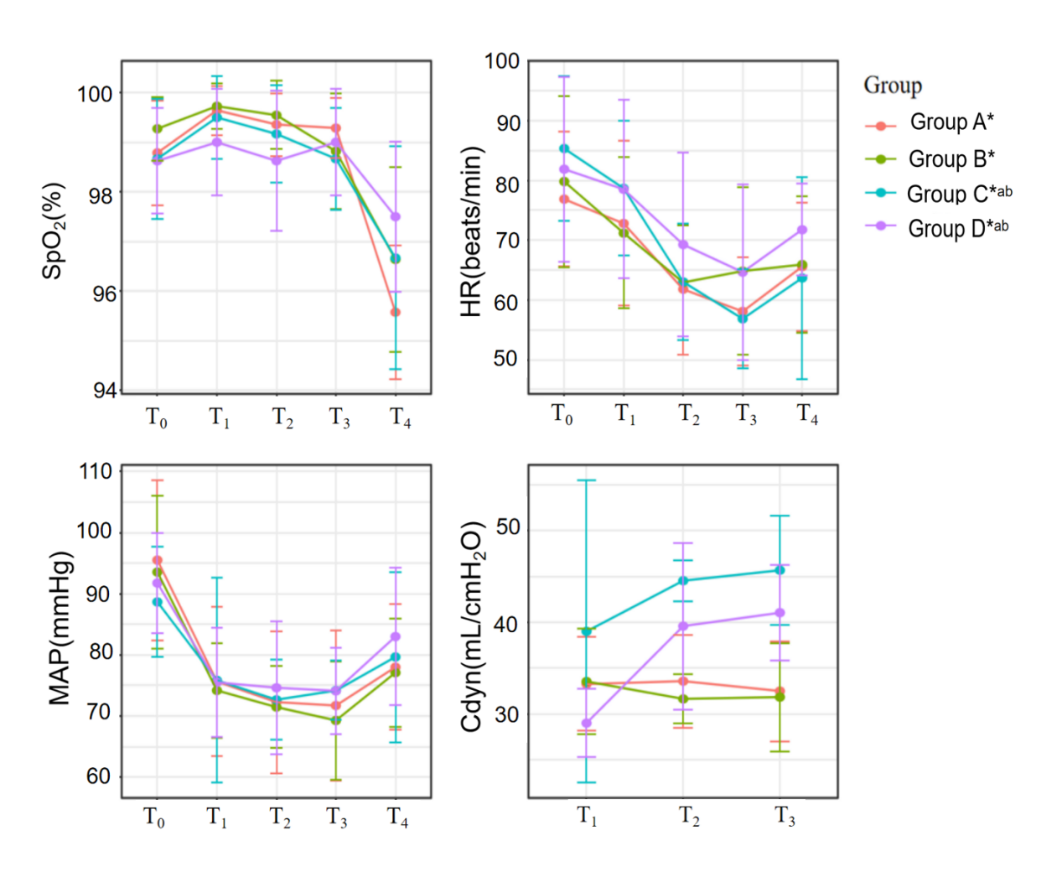
Supplementary Figure S2. Comparison of vital signs and dynamic pulmonary compliance of four groups of patients at different time points.*P < 0.05 compared with baseline (T₀) within the same group.ªP < 0.05 compared with Group A at the corresponding time point.
^{b}P < 0.05 compared with Group B at the corresponding time point.

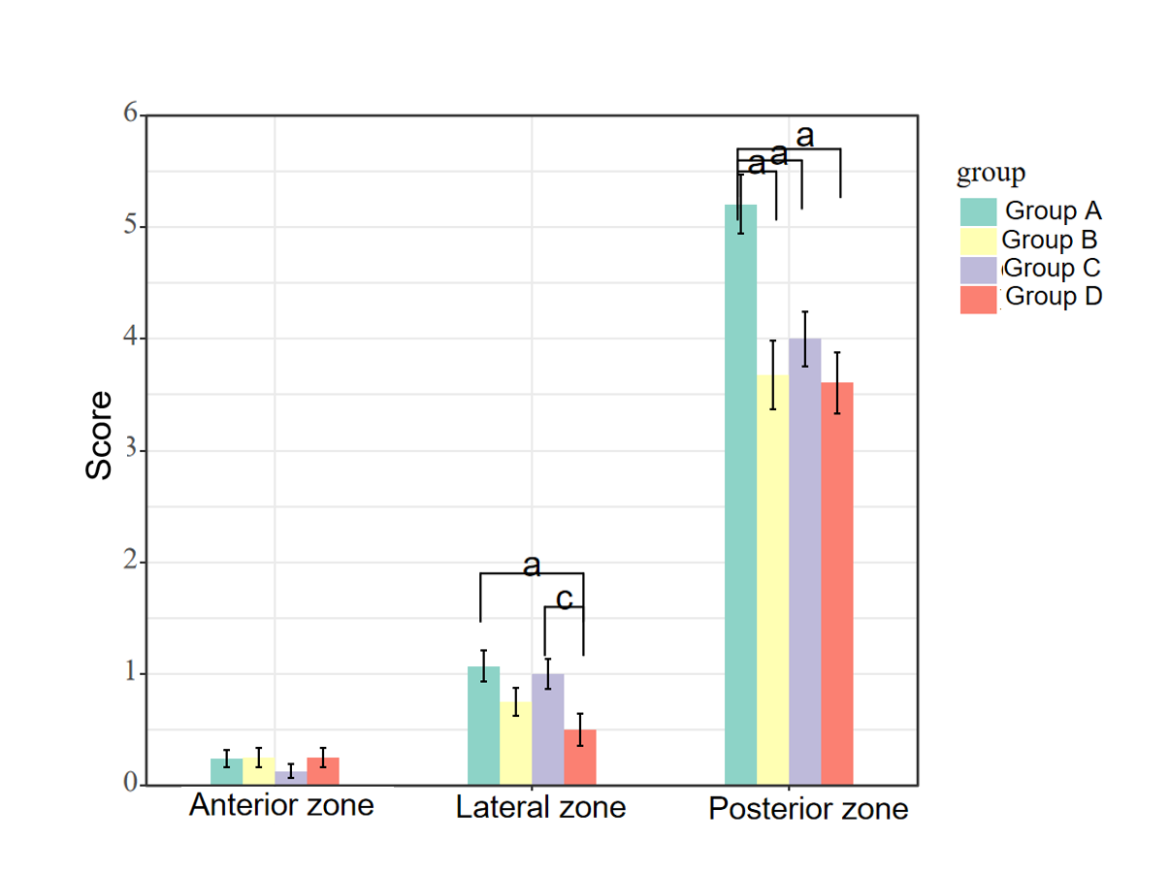
Supplementary Figure S3.Average LUS score of each region of the four groups.ªP < 0.05 compared with Group A.^{c}P < 0.05 compared with Group C.
.

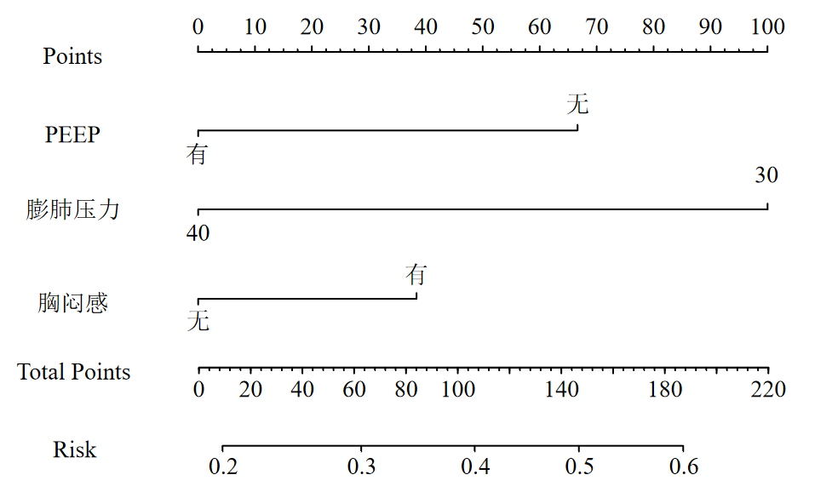





Supplementary Figure S4. Nomogram for atelectasis risk.

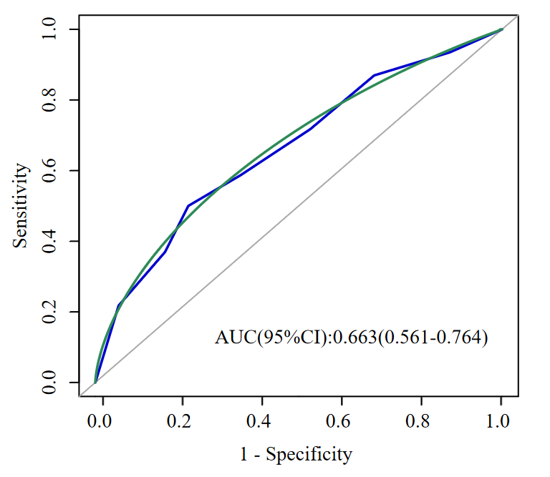
Supplementary Figure S5. ROC curve of individual score of atelectasis risk.

