Appendix
Supplemental Table 1. Search strategy for Cochrane 1
Supplemental Table 2. Search strategy for Embase 2
Supplemental Table 3. Search strategy for PubMed 3
Supplemental Table 4. Search strategy for Wanfang database 5
Supplemental Figure 1. Forest plot of sensitivity analysis for total opioid consumption within the first 24 postoperative hours in studies using local anesthetics alone. 6
Supplemental Figure 2. Forest plot of sensitivity analysis for total opioid consumption within the first 24 postoperative hours in studies using infra-inguinal fascia iliaca compartment block. 7
Supplemental Figure 3. Forest plot of sensitivity analysis for pain scores at rest at 24 hours after surgery in studies using local anesthetic alone. 8
Supplemental Figure 4. Forest plot of sensitivity analysis for pain scores at rest at 24 hours after surgery in studies using infra-inguinal fascia iliaca compartment block. 9
Supplemental Figure 5. Forest plot of sensitivity analysis for pain scores at rest at 24 hours after surgery in studies using postoperative multimodal analgesia. 10
Supplemental Figure 6. Forest plot of subgroup analysis of pain scores at 24 hours postoperatively. 11
Supplemental Figure 7. Forest plot of pain scores at rest at 6 hours after surgery. 12
Supplemental Figure 8. Forest plot of pain scores at rest at 12 hours after surgery. 13
Supplemental Figure 9. Area under the curve for resting pain scores during the first 24 postoperative hours. 14
Supplemental Figure 10. Forest plot of time to first analgesic request. 15
Supplemental Figure 11. Forest plot of length of hospital stay. 16
Supplemental Figure 12. Forest plot of cumulative opioid-related adverse events. 17
Supplemental Figure 13. Funnel plot of pain scores at rest at 24 hours after surgery. 18
Supplemental Figure 14. Egger’s test for pain scores at rest at 24 hours after surgery. 19

Supplemental Table 1. Search strategy for Cochrane
#ID | Query | Results
#1 | MeSH descriptor: [Nerve Block] explode all trees | 6262
#2 | (Nerve block OR Peripheral nerve block OR Fascia iliaca block OR Fascia iliaca nerve block OR Fascia iliaca compartment block OR Fascia iliac block OR Fascia iliac nerve block OR Fascia iliac compartment block OR FICB OR FIB):ti,ab,kw | 22149
#3 | #1 or #2 | 22420
#4 | MeSH descriptor: [Hip Fractures] explode all trees | 2626
#5 | (hip OR femor* OR femur OR trochant* OR pertrochant* OR intertrochant* OR subtrochant* OR intracapsular* OR extracapsular*):ti,ab,kw | 54326
#6 | (fracture*):ti,ab,kw | 32938
#7 | #5 and #6 | 11479
#8 | #4 or #7 | 11495
#9 | #3 and #8 | 1100

Supplemental Table 2. Search strategy for Embase
#ID | Query | Results
#1 | 'nerve block'/exp | 63878
#2 | 'nerve block':ab,ti OR 'peripheral nerve block':ab,ti OR 'fascia iliaca block':ab,ti OR 'fascia iliaca nerve block':ab,ti OR 'fascia iliaca compartment block':ab,ti OR 'fascia iliac block':ab,ti OR 'fascia iliac nerve block':ab,ti OR 'fascia iliac compartment block':ab,ti OR ficb:ab,ti OR fib:ab,ti | 33663
#3 | #1 OR #2 | 80647
#4 | 'hip fracture'/exp | 66013
#5 | hip:ab,ti OR femor*:ab,ti OR femur:ab,ti OR trochant*:ab,ti OR pertrochant*:ab,ti OR intertrochant*:ab,ti OR subtrochant*:ab,ti OR intracapsular*:ab,ti OR extracapsular*:ab,ti | 519372
#6 | fracture*:ab,ti | 425549
#7 | #5 AND #6 | 109046
#8 | #4 OR #7 | 124493
#9 | 'crossover procedure':de OR 'double-blind procedure':de OR 'randomized controlled trial':de OR 'single-blind procedure':de OR random*:de,ab,ti OR factorial*:de,ab,ti OR crossover*:de,ab,ti OR ((cross NEXT/1 over*):de,ab,ti) OR placebo*:de,ab,ti OR ((doubl* NEAR/1 blind*):de,ab,ti) OR ((singl* NEAR/1 blind*):de,ab,ti) OR assign*:de,ab,ti OR allocat*:de,ab,ti OR volunteer*:de,ab,ti | 3837319
#10 | #3 AND #8 AND #9 | 670

Supplemental Table 3. Search strategy for PubMed
#ID | Query | Results
#1 | Nerve Block[MeSH] | 28602
#2 | Nerve block[Title/Abstract] OR Peripheral nerve block[Title/Abstract] OR Fascia iliaca block[Title/Abstract] OR Fascia iliaca nerve block[Title/Abstract] OR Fascia iliaca compartment block[Title/Abstract] OR Fascia iliac block[Title/Abstract] OR Fascia iliac nerve block[Title/Abstract] OR Fascia iliac compartment block[Title/Abstract] OR FICB[Title/Abstract] OR FIB[Title/Abstract] | 23229
#3 | (Nerve Block[MeSH]) OR (Nerve block[Title/Abstract] OR Peripheral nerve block[Title/Abstract] OR Fascia iliaca block[Title/Abstract] OR Fascia iliaca nerve block[Title/Abstract] OR Fascia iliaca compartment block[Title/Abstract] OR Fascia iliac block[Title/Abstract] OR Fascia iliac nerve block[Title/Abstract] OR Fascia iliac compartment block[Title/Abstract] OR FICB[Title/Abstract] OR FIB[Title/Abstract]) | 43677
#4 | Hip Fractures[MeSH] | 31888
#5 | (hip[Title/Abstract] OR femor*[Title/Abstract] OR femur[Title/Abstract] OR trochant*[Title/Abstract] OR pertrochant*[Title/Abstract] OR intertrochant*[Title/Abstract] OR subtrochant*[Title/Abstract] OR intracapsular*[Title/Abstract] OR extracapsular*[Title/Abstract]) AND fracture*[Title/Abstract] | 81404
#6 | (Hip Fractures[MeSH]) OR ((hip[Title/Abstract] OR femor*[Title/Abstract] OR femur[Title/Abstract] OR trochant*[Title/Abstract] OR pertrochant*[Title/Abstract] OR intertrochant*[Title/Abstract] OR subtrochant*[Title/Abstract] OR intracapsular*[Title/Abstract] OR extracapsular*[Title/Abstract]) AND fracture*[Title/Abstract]) | 85520
#7 | (randomized controlled trial[pt] OR controlled clinical trial[pt] OR randomized[tiab] OR placebo[tiab] OR clinical trials as topic[mesh:noexp] OR randomly[tiab] OR trial[ti]) NOT (animals [mh] NOT (humans [mh] AND animals[mh])) | 1611604
#8 | (((Nerve Block[MeSH]) OR (Nerve block[Title/Abstract] OR Peripheral nerve block[Title/Abstract] OR Fascia iliaca block[Title/Abstract] OR Fascia iliaca nerve block[Title/Abstract] OR Fascia iliaca compartment block[Title/Abstract] OR Fascia iliac block[Title/Abstract] OR Fascia iliac nerve block[Title/Abstract] OR Fascia iliac compartment block[Title/Abstract] OR FICB[Title/Abstract] OR FIB[Title/Abstract])) AND ((Hip Fractures[MeSH]) OR ((hip[Title/Abstract] OR femor*[Title/Abstract] OR femur[Title/Abstract] OR trochant*[Title/Abstract] OR pertrochant*[Title/Abstract] OR intertrochant*[Title/Abstract] OR subtrochant*[Title/Abstract] OR intracapsular*[Title/Abstract] OR extracapsular*[Title/Abstract]) AND fracture*[Title/Abstract]))) AND ((randomized controlled trial[pt] OR controlled clinical trial[pt] OR randomized[tiab] OR placebo[tiab] OR clinical trials as topic[mesh:noexp] OR randomly[tiab] OR trial[ti]) NOT (animals [mh] NOT (humans [mh] AND animals[mh]))) | 260

Supplemental Table 4. Search strategy for Wanfang database
Query | Results
主题:(髂筋膜间隙阻滞) AND主题:(髋部骨折 OR 髋骨骨折 OR 髋关节骨折) AND 全部:(随机) | 165
English translation of search terms:
Subject: (Fascia iliaca compartment block) AND Subject: (Hip fracture OR hip bone fracture OR hip joint fracture) AND All: (Random)

Supplemental Figure 1. Forest plot of sensitivity analysis for total opioid consumption within the first 24 postoperative hours in studies using local anesthetics alone.
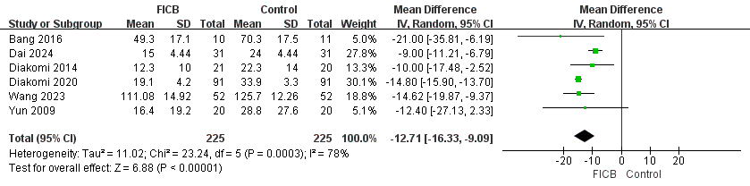
Supplemental Figure 2. Forest plot of sensitivity analysis for total opioid consumption within the first 24 postoperative hours in studies using infra-inguinal fascia iliaca compartment block.

Supplemental Figure 3. Forest plot of sensitivity analysis for pain scores at rest at 24 hours after surgery in studies using local anesthetic alone.

Supplemental Figure 4. Forest plot of sensitivity analysis for pain scores at rest at 24 hours after surgery in studies using infra-inguinal fascia iliaca compartment block.
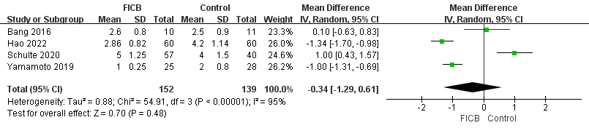

Supplemental Figure 5. Forest plot of sensitivity analysis for pain scores at rest at 24 hours after surgery in studies using postoperative multimodal analgesia.

Supplemental Figure 6. Forest plot of subgroup analysis of pain scores at 24 hours postoperatively.

Supplemental Figure 7. Forest plot of pain scores at rest at 6 hours after surgery.

Supplemental Figure 8. Forest plot of pain scores at rest at 12 hours after surgery.

Supplemental Figure 9. Area under the curve for resting pain scores during the first 24 postoperative hours.

Supplemental Figure 10. Forest plot of time to first analgesic request.

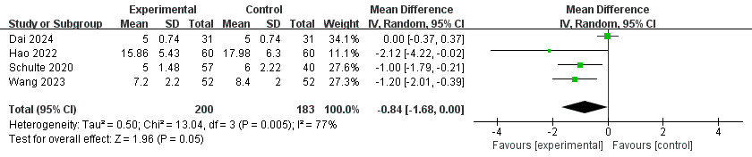

Supplemental Figure 11. Forest plot of length of hospital stay.

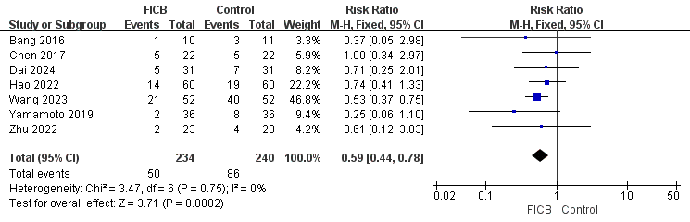

Supplemental Figure 12. Forest plot of cumulative opioid-related adverse events.

Supplemental Figure 13. Funnel plot of pain scores at rest at 24 hours after surgery.
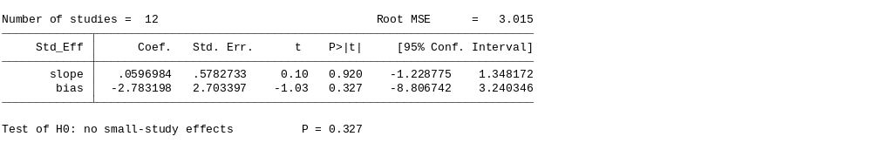
Supplemental Figure 14. Egger’s test for pain scores at rest at 24 hours after surgery.

