Appendix 1 – Intervention protocol

Monitoring
Continuous monitoring included ECG, SpO₂, NIBP, EtCO₂, processed EEG (NeuroSENSE®, NeuroWave Systems Inc., Beachwood, OH, USA), and quantitative neuromuscular transmission.

Premedication
None

Preoxygenation
3 min with 100% O₂, aiming for end-tidal O₂ ≥ 90%.

Induction of anesthesia
- Sufentanil 0.1 µg/kg IV at start of preoxygenation
- Propofol TIVA (Schnider model), initial Ce 4 µg/mL, titrated to clinical effect (loss of ciliary reflex)
- Lidocaine 1 mg/kg IV and Rocuronium 0.6 mg/kg IV at loss of consciousness

Maintenance of anesthesia
Propofol TIVA titrated to maintain slow and alpha EEG activity, absence of burst-suppression (suppression ratio = 0), and BIS 40–60.

Hemodynamic Management
Arterial blood pressure maintained >65 mmHg. Ephedrine (3–9 mg IV boluses) was used first-line; if inadequate, phenylephrine or norepinephrine infusion was initiated at the anesthesiologist’s discretion.

Airway Management
Direct laryngoscopy and tracheal intubation (ID 8.0 mm for men, 7.0 mm for women).

Ventilation (VCV mode, initial settings)
Tidal volume 7 mL/kg IBW; PEEP 5 cmH₂O; FiO₂ 0.5; respiratory rate adjusted to maintain EtCO₂ 35–40 mmHg.

Positioning
Supine, head in neutral alignment.

Interventional Arms
Procedures common to both groups
- General anesthesia.
- Femoral vascular access by interventional cardiologist.
- Transseptal puncture guided by TEE in collaboration with anesthesiologist.
- Left atrial ABG obtained after successful access.
- Ventilation strategy adjusted according to randomized allocation.
- If SpO₂ decreased below 90%, FiO₂ was increased at the discretion of the attending anesthesiologist.

Arm 1: High-Frequency Jet Ventilation (HFJV)
Device: Monsoon III (Acutronic Medical Systems AG, Hirzel, Switzerland).
Cannula/connection: 40 cm LaserJet® cannula (Acutronic) via Sheridan® Sher-I-Swiv® connector (Teleflex).
Circuit: Breathing circuit disconnected between HME filter and swivel connector.
Initial settings:
- Working pressure: 0.02 bar/kg IBW (≈ 0.2 kPa/kg IBW, ≈ 0.29 PSI/kg IBW)
- Frequency: 150 cycles/min
- FiO₂: 0.5
- I:E ratio: 0.3
- PPmax alarm: 10 mbar
- PIP max alarm: 15 mbar
- Humidification setting: 3

EtCO₂ monitoring and adjustment (every 30 min, starting 5 min after HFJV initiation):
- Pause HFJV.
- Reconnect standard anesthesia ventilator.
- Deliver 5 VCV breaths (7 mL/kg IBW).
- Measure EtCO₂
- If >40 mmHg: increase working pressure by 0.1 bar (1.45 PSI).
- If <30 mmHg: decrease working pressure by 0.1 bar (1.45 PSI).
- Resume HFJV with adjusted settings if applicable.

Arm 2: Volume-Controlled Ventilation (VCV)
Device: Zeus® ventilator (Dräger Medical Belgium, Wemmel, Belgium).
Initial settings:
- Tidal volume: 7 mL/kg IBW
- Respiratory rate: 10–20 breaths/min, titrated to maintain EtCO₂ 30–40 mmHg
- PEEP: 5 cmH₂O
- FiO₂: 0.5

End of Intervention
Upon completion of the ablation procedure:
- Discontinue HFJV (intervention group only)
- Obtain final left atrial ABG sample before catheter removal
- Withdraw jet cannula and transition to conventional ventilation (intervention group only)
- Reverse neuromuscular block with sugammadex (2–4 mg/kg IV), under quantitative monitoring
- Perform emergence and extubation according to standard criteria (adequate spontaneous breathing, responsiveness, protective airway reflexes)
- Admit patient to Post-Anesthesia Care Unit (PACU) for routine postoperative monitoring.

A  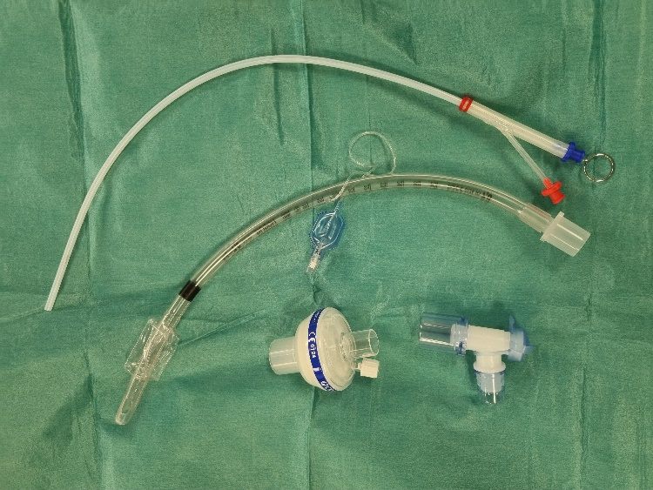 | B  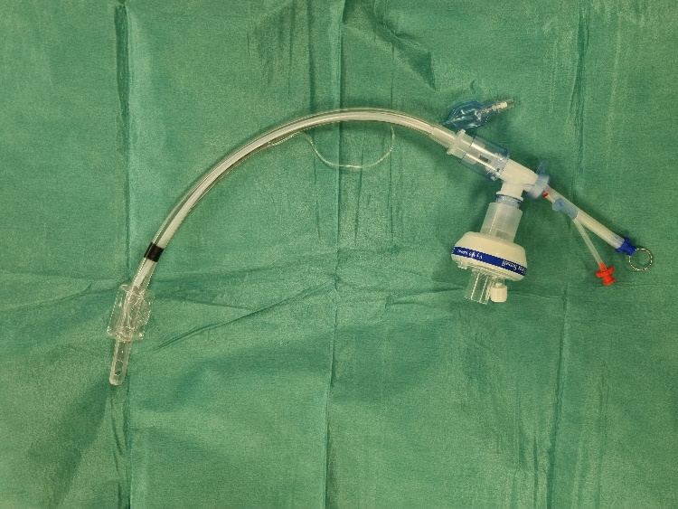
Figure 1. High-Frequency Jet Ventilation setup via endotracheal tube. (A) Components before assembly. (B) Fully assembled configuration: swivel connector with HME filter, ETT (7.0–8.0 mm ID), and 40 cm LaserJet® cannula.

