Gastric ultrasound exam (GUS) technique¹

Using an ultrasound machine (Sonosite X-Porte for Maisonneuve-Rosemont Hospital and GE Vivid IQ for Montreal Heart Institute) with a curved array low-frequency abdominal probe (2-5 MHz) with the patient in right lateral decubitus position, the gastric antrum was identified in a sagittal plane inferior to the xyphoid process, immediately inferior to the left lobe of the liver and anterior to the body of the pancreas (in a standardized plane at the level of the aorta). The stomach was considered empty if the antrum appeared flat or round with anterior and posterior walls collapsed (“target” pattern). Normal gastric secretions and clear fluids have an anechoic or hypoechoic aspect on ultrasonography. Solid or thick fluids have a hyperechoic aspect and can create “ring-down” artifacts blurring gastric content, its posterior wall, the pancreas and the aorta. In case of solid or thick fluid content, the exam was considered positive for increased residual gastric content (RGC). Following qualitative examination, quantitative assessment was performed if there was presence of clear fluids. The cross-sectional area (CSA) was measured between peristaltic motions using a free-tracing tool following the serosa of the antrum (with three measurements to calculate a mean value). The CSA was then used to predict gastric volume using the following equation:

Gastric volume (mL) = 27 + [14.6 × right lateral cross-sectional area (in cm2)] - [1.28 × age (in years)]

The presence of increased clear liquid RGC and thus increased regurgitation and aspiration risk was then assessed using 1.5 mL/kg of body weight as a prespecified cut-off.

Supplementary Figure S1 - Empty stomach on GUS

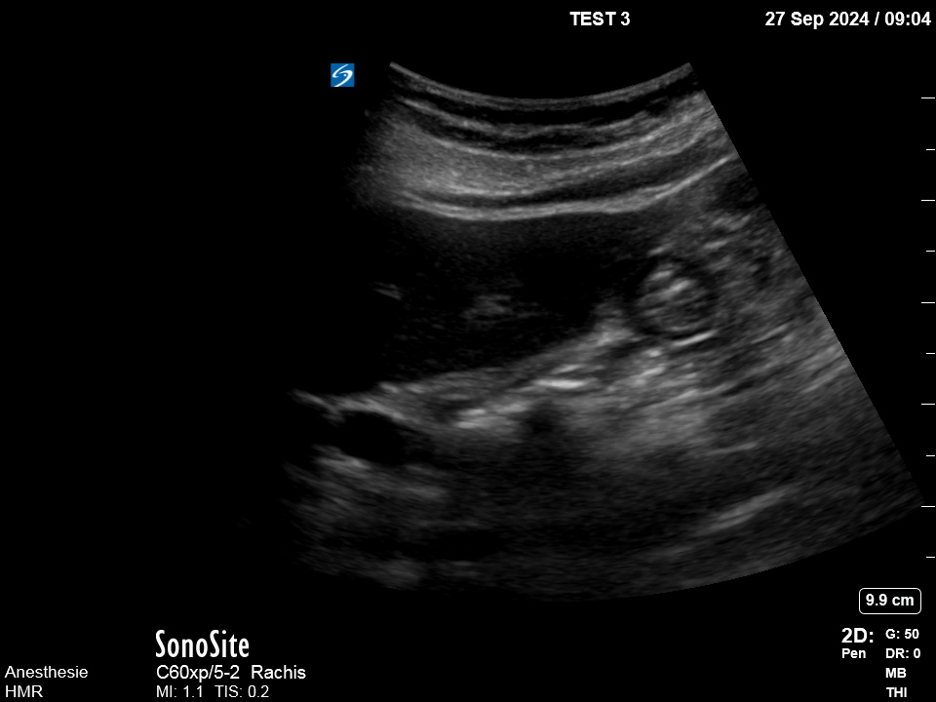

Supplementary Figure S2 - Solid content on GUS

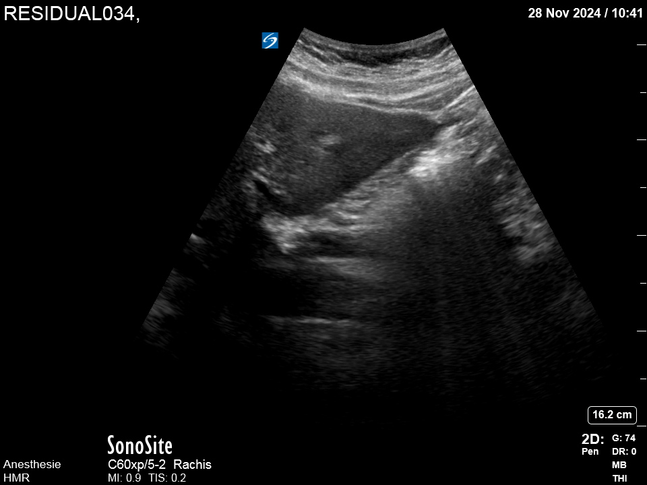

Supplementary Figure S3 - Clear liquid content on GUS with CSA measurement

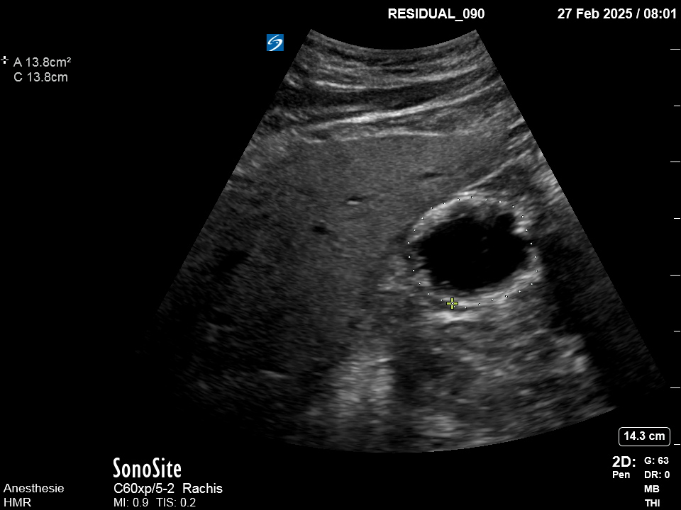

Supplementary Figure S4 - Flowchart of Patient Screening and Inclusion
Patients Eligible for Inclusion (n=132)
├── GLP-1RA Users (n=64)
│ ├── Not Contacted (n=2)
│ ├── Screened (n=62)
│ │ ├── Excluded (n=4):
│ │ │ ├── Last dose <7d (n=2)
│ │ │ ├── Treatment <1mo (n=1)
│ │ │ └── No consent (n=1)
│ │ ├── Eligible for GUS (n=58)
│ │ ├── GUS not performed (n=6)
│ │ └── Final GLP-1RA with GUS (n=52)
│
└── Control Group (n=68)
├── Not Contacted (n=12)
├── Screened (n=56)
│ ├── Excluded (n=11):
│ │ ├── Refused (n=6)
│ │ ├── Positioning issue (n=1)
│ │ ├── Language barrier (n=2)
│ │ ├── No consent (n=1)
│ │ └── Other study (n=1)
│ ├── Eligible for GUS (n=45)
│ ├── GUS not performed (n=4)
│ └── Final Control with GUS (n=41)
Supplementary Figure S5 - Propensity score distribution

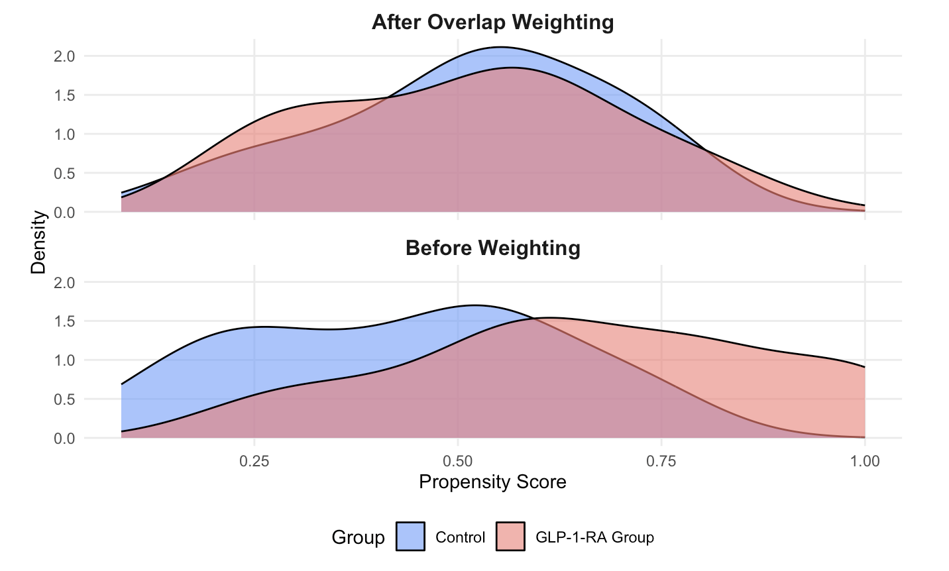

Supplementary Figure S6 - Standardized mean differences in primary analysis (overlap weighting (OW))

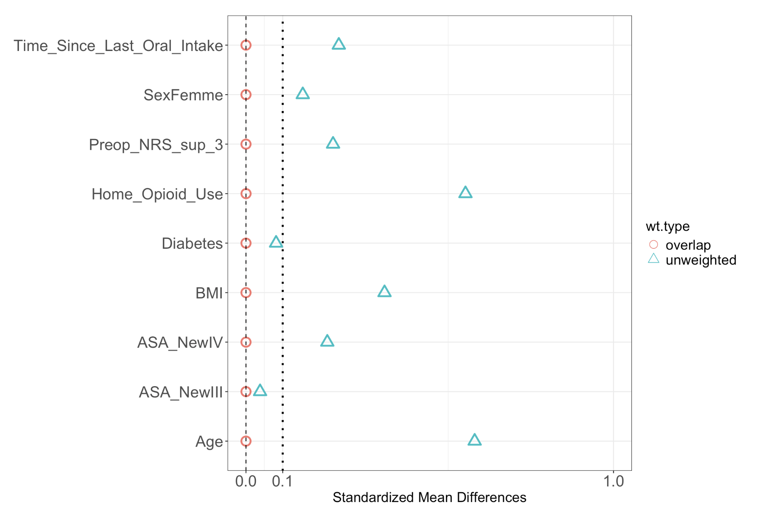

Supplementary Figure S7 - Standardized mean differences in primary analysis (augmented inverse probability weighting (AIPW))

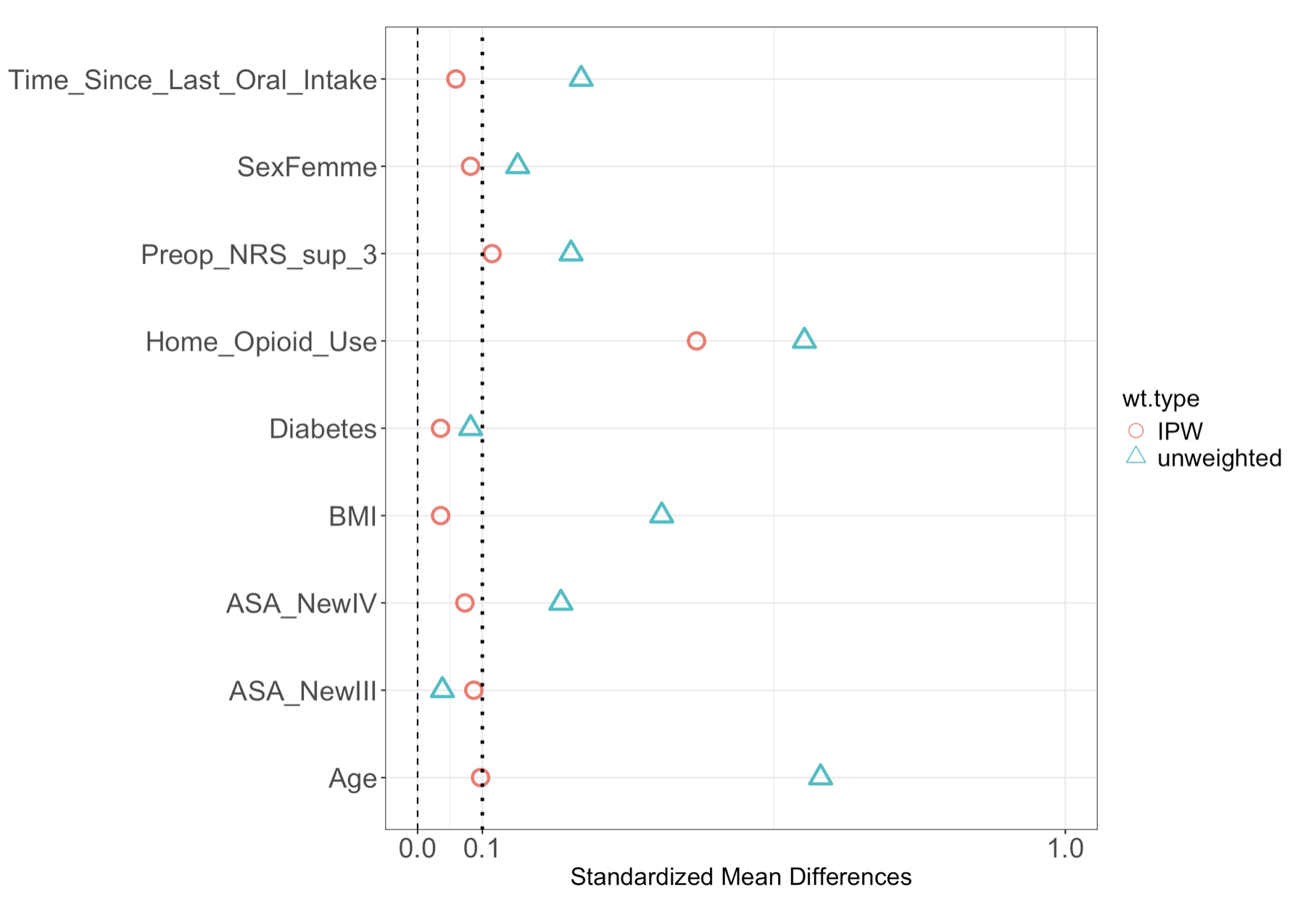

Supplementary Figure S8 - Distribution of days since last dose of drug in GLP-1 RA patients

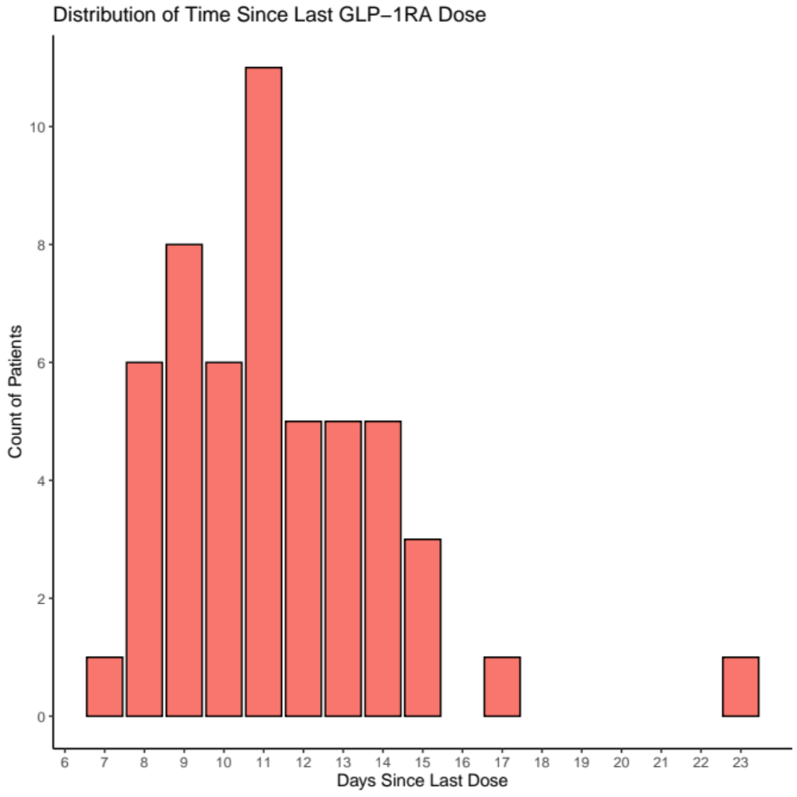

Supplementary Figure S9 - Marginal effects of time since last GLP-1 RA dose and the prevalence of increased RGC

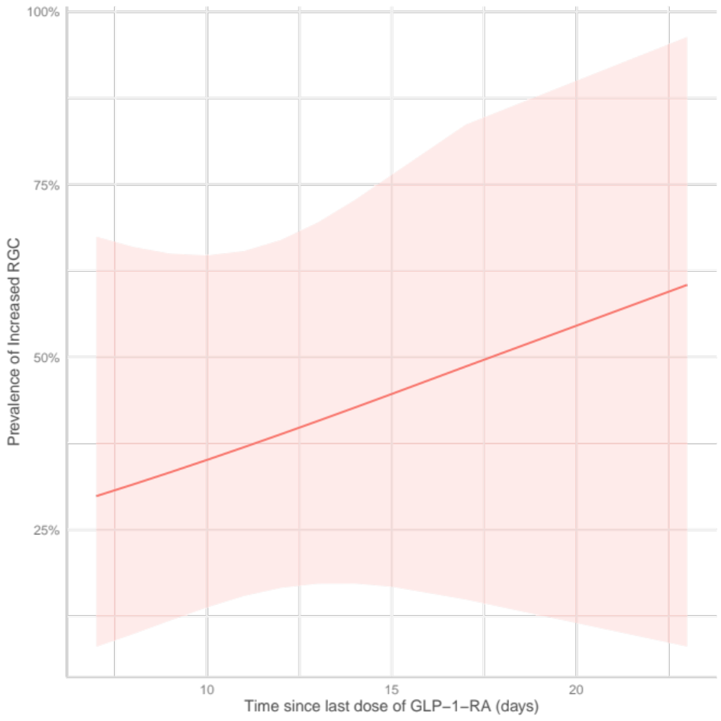

Supplementary Figure S10 - Marginal effects of time since last oral intake and the prevalence of increased RGC

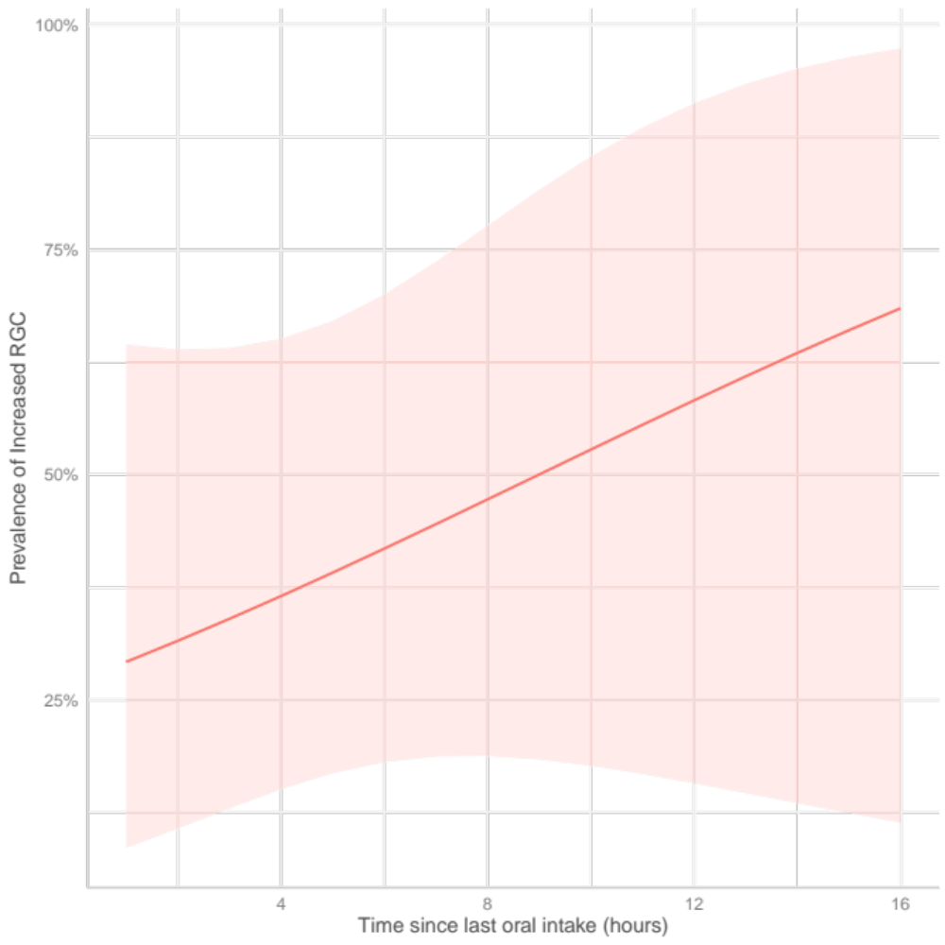

Supplementary Figure S11 - Marginal effects of semaglutide dose and the prevalence of increased RGC

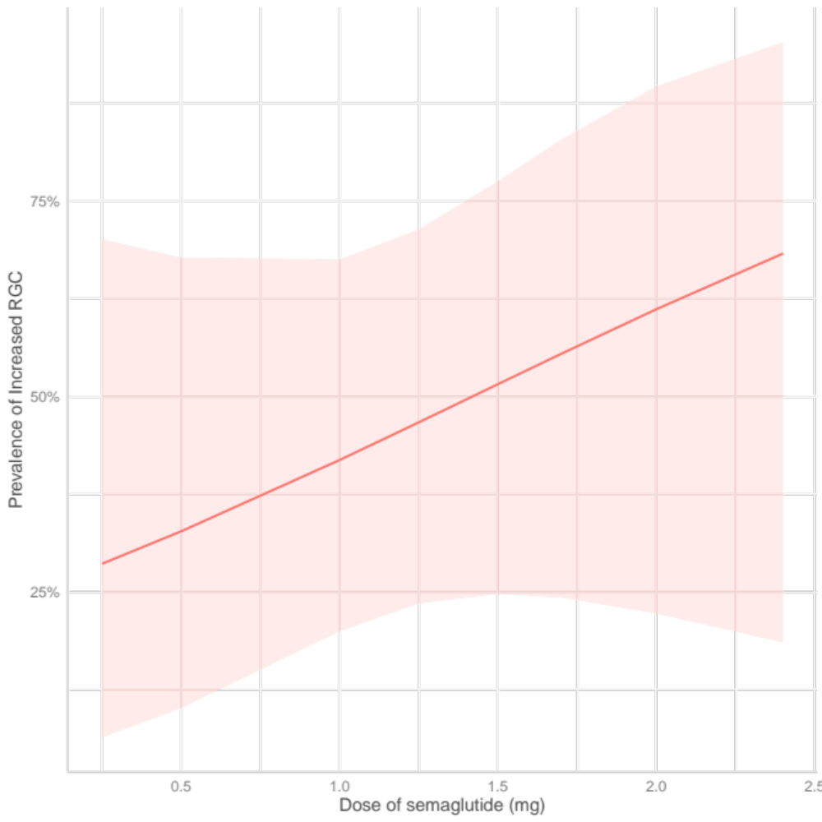

Supplementary Table S1 – Association between the time since last dose of GLP-1 RA, time since last oral intake and increased RGC (N = 52)

 | Adjusted OR | CI 95% | P-value
Age | 0.91 | 0.84 to 0.98 | 0.017
Sex (F) | 0.74 | 0.26 to 4.02 | 0.675
ASA physical status III | 1.73 | 0.41 to 7.9 | 0.464
ASA physical status IV | 1.61 | 0.2 to 12.9 | 0.646
BMI (per 1 kg.m⁻²) | 0.86 | 0.75 to 0.95 | < 0.001
Preoperative Pain moderate to severe | 0.33 | 0.06 to 1.63 | 0.189
Home opioid use | 0.60 | 0.07 to 4.3 | 0.609
Time since last oral intake (per hour) | 1.12 | 0.90 to 1.46 | 0.354
Time since last dose of GLP-1RA (per day) | 1.08 | 0.86 to 1.39 | 0.497
GLP-1 RA: glucagon-like peptide-1 receptor agonist, RGC: residual gastric content, ASA: American Society of Anesthesiologists, BMI: body mass index.

Supplementary Table S2 – Association between the dose of semaglutide and increased RGC (N = 50)

 | Adjusted OR | CI 95% | P-value
Age | 0.96 | 0.89 to 1.02 | 0.187
Sex (F) | 1.02 | 0.26 to 4.02 | 0.976
ASA physical status III | 0.95 | 0.24 to 3.8 | 0.941
ASA physical status IV | 0.95 | 0.13 to 0.64 | 0.958
Preoperative Pain moderate to severe | 0.44 | 0.09 to 1.87 | 0.282
Time since last dose of semaglutide (per day) | 1.15 | 0.91 to 1.51 | 0.267
Dose of semaglutide (per mg) | 2.19 | 0.47 to 12.7 | 0.336
RGC: residual gastric content, ASA: American Society of Anesthesiologists, BMI: body mass index

References

1. Perlas A, Arzola C, Van de Putte P: Point-of-care gastric ultrasound and aspiration risk assessment: a narrative review. Can J Anaesth 2018; 65: 437-448

