Supplementary:
Appendix 1: Complete Search strategy:
Pubmed [MeSH]
Search string | Keywords
#1 | ((“Dexmedetomidine Hydrochloride” OR “Hydrochloride, Dexmedetomidine” OR “MPV-1440”OR “DEX” OR “Precedex” OR “Igalmi” OR “Sedadex” OR “Sileo” OR “Cepedex” OR “Dexdor” OR “Dexdomitor” OR “Imidazole” OR “medetomidine” OR “Levomedetomidine” OR “Medetomidine Hydrochloride” OR “Hydrochloride, Medetomidine” OR “MPV-785” OR “MPV785” OR "dexmedetomidine"[MeSH Terms] OR "dexmedetomidine"[All Fields] OR dexmedetomidine[Text Word])
#2 | [("magnesium"[MeSH Terms] OR “magnesium”[All Fields] OR “magnesium sulphate”[MeSH Terms] OR “magnesium sulphate”[All Fields])]
#3 | ("diskectomy"[MeSH Terms] OR "diskectomy"[All Fields] OR "laminectomy"[MeSH Terms] OR "laminectomy"[All Fields] OR "Spine/surgery"[Mesh] OR "spine"[MeSH Terms] OR “fusion”[MeSH Terms] OR “discectomy”[MeSH Terms] OR "discectomy"[All Fields] OR "spine surgery"[All Fields] OR "spine operation"[All Fields] OR "spine fusion"[All Fields] OR “lumbar fusion"[All Fields] OR “back surgery”)).
#4 | #1 AND #2 AND #3

GOOGLE Scholar
Search string | Keywords
#1 | ((“Dexmedetomidine” OR “DEX” OR “Precedex” OR “Dexmedetomidine HCl”)
#2 | ( “magnesium sulfate” OR “MAGNESIUM”)
#3 | ("discectomy" OR “spine surgery” OR "spine operation" OR "spine fusion" OR “lumbar fusion" OR “back surgery” OR “laminectomy”)).
#4 | #1 AND #2 AND #3

SCOPUS
Search string | Keywords
#1 | TITLE-ABS-KEY (‘DEX’ OR ‘ Dexmedetomidine’ OR ‘Precedex’)
#2 | TITLE-ABS-KEY (‘magnesium’ OR ‘magnesium sulfate’)
#3 | TITLE-ABS-KEY ('spine AND surgery' OR 'spine AND operation' OR 'spine AND fusion' OR 'laminectomy')
#4 | #1 AND #2 AND #3

International Web of Science
Search string | Keywords
#1 | ((“dexmedetomidine”)
#2 | (“magnesium sulfate” OR “magnesium”)
#3 | (“spine surgery” OR “discectomy” OR “laminectomy” OR “fusion”)).
#4 | #1 AND #2 AND #3

Appendix 2:
Table S1: Supplementary preferred reporting items for systematic reviews and meta-analyses (PRISMA 2020) checklist.
Section and Topic | Item # | Checklist item | Location where item is reported
TITLE
Title | 1 | Effects of Dexmedetomidine vs Magnesium Sulfate on Hemodynamics in Spine Surgeries: A Systematic Review and Meta-Analysis | Title Page
ABSTRACT
Abstract | 2 | Background/objectives: Blood loss and hemodynamic instability are common challenges in spine surgery, often managed with controlled hypotension. Dexmedetomidine and magnesium sulfate are commonly used for this purpose, but their comparative efficacy and safety remain unclear. This comprehensive systematic review and meta-analysis aim to critically evaluate and compare the impact of both drugs on hemodynamics in spine surgeries. Methods: We searched PubMed, Scopus, Web of Science, and Google Scholar up to August 15, 2025. We identified randomized controlled trials comparing intravenous Dexmedetomidine and magnesium sulfate in spine surgeries. Outcomes included blood loss, changes in mean arterial pressure, heart rate, systolic blood pressure, and diastolic blood pressure, recovery time, first time to analgesic needs, total opioid consumption, extubation time, and incidence of bradycardia/tachycardia. Effect sizes were pooled using random-effects models. Results: Analysis of 9 RCTs involving 463 patients showed that DEX significantly reduced intraoperative blood loss (MD = –1.447; p = 0.009), SBP (MD = –0.448; p = 0.012), tachycardia (RR = 0.330; p = 0.004), and prolonged the time to first analgesic request (MD = 1.409; p = 0.004). Dexmedetomidine was associated with an increased risk of bradycardia (RR = 4.819; p = 0.001) and delayed MAP recovery (p = 0.030). Several outcomes showed high heterogeneity. Conclusions: Dexmedetomidine offers superior blood-sparing and analgesic effects compared to magnesium sulfate but carries a higher risk of bradycardia and delayed MAP recovery. | Abstract  P.1&2
INTRODUCTION
Rationale | 3 | Spine surgeries often result in significant blood loss, so controlled hypotension, which reduces mean arterial pressure to a set range (typically 55-65 mmHg), is commonly used to address this risk. This technique enhances surgical field visibility, supports precise maneuvers, and may reduce operative time and blood loss. Dexmedetomidine (DEX), a highly selective α2-adrenoceptor agonist, is increasingly used in anesthesia for its sedative, analgesic, and sympatholytic effects. In spine surgery, DEX effectively induces controlled hypotension, helping maintain target MAP and improve surgical field visibility. Both mild and severe bradycardia are more common with DEX use. Magnesium sulfate stabilizes cell membranes, enhances the activity of Na⁺- ATPase and Ca⁺⁺- ATPase enzymes, and inhibits the release of norepinephrine by blocking N-type calcium pathways. This reduces arterial blood pressure, which is needed in spine surgeries to minimize blood loss and improve the surgical field.  The comparative efficacy and safety of dexmedetomidine and magnesium sulfate in achieving controlled hypotension and maintaining hemodynamic stability during spinal surgery are the subject of ongoing research; therefore, this systematic review and meta-analysis were conducted. | Introduction  P.3&4
Objectives | 4 | P: Adult patients undergoing spine surgery. I: Intravenous dexmedetomidine. C: Intravenous magnesium sulfate. O: Hemodynamic parameters (e.g., Mean Arterial Pressure (MAP), Heart Rate (HR)), intraoperative bleeding, opioid consumption, recovery time, and adverse events (e.g., bradycardia). S: Randomized Controlled Trials (RCTs). | Introduction  P.4
METHODS
Eligibility criteria | 5 | Inclusion criteria: encompassed (a) comparative studies of effects of dexmedetomidine vs magnesium sulfate on hemodynamics in spine surgeries and (b) cohort studies and/or clinical trials of effects of dexmedetomidine vs magnesium sulfate on hemodynamics in spine surgeries. (c) adults above 18 years old. Exclusion criteria: included articles not written in English, review articles, case reports, letters, and conference abstracts.  Only English full texts included. | Methods  P.4&5
Information sources | 6 | A comprehensive search was conducted for studies published through August 15, 2025, across the PubMed, Scopus, Google Scholar, and Web of Science databases. This search focused on retrieving studies that compare the effects of dexmedetomidine and magnesium sulfate on hemodynamics during spine surgeries. | Methods  P.4
Search strategy | 7 | The search strategy employed the following combination of terms: ((“dexmedetomidine” OR “Medetomidine” OR “MPV 1440”) AND (“Magnesium Sulfate”) AND (“spin*” OR “spine surgery” OR “discectomy” OR “laminectomy” OR “fusion”)). Full strategy provided in Supplementary Material. | Methods P. 4 & Supplementary file
Selection process | 8 | Study Selection: Two reviewers (B.R. and S.H.) manually screened the studies by title and abstract, followed by another two reviewers (M.K.E. and O.S.) who screened them based on the full text. An independent reviewer (E.T.) then verified the results to ensure accuracy and to resolve any disagreements. | Methods  P.5
Data collection process | 9 | Data Extraction: Two independent reviewers (E.T. and A.A.) extracted relevant information from each included study, with subsequent verification by an independent reviewer (A.O.) to ensure accuracy. | Methods  P.5
Data items | 10a | Extracted data included: Primary Outcomes: SBP, DBP, MAP, and HR. Secondary Outcomes: Intraoperative blood loss, time to restore MAP, recovery time, extubation time, time to first analgesic request, postoperative total opioid consumption, duration of surgery, and incidence of bradycardia/ tachycardia. | Methods  P.5
Data items | 10b | Other Variables: year of publication, country of origin, study design, sample size, patient demographics, ASA status, and type of spine surgery | P.5
Study risk of bias assessment | 11 | The Cochrane risk-of-bias tool for randomized trials (ROB2) was used to assess the risk of bias of the included studies. Each study was analyzed based on these criteria. Two independent reviewers conducted the quality assessment, and any discrepancies were resolved through discussion. | Methods  P.5
Effect measures | 12 | Mean difference (MD) with 95% confidence intervals (CIs) was pooled for continuous outcomes (MAP, HR, and blood loss) and risk ratio (RR) for dichotomous outcomes (as incidence of bradycardia/tachycardia). A p-value > 0.05 was considered statistically significant for overall effect estimates. | Methods  P.5&6
Synthesis methods | 13a | The DerSimonian and Laird random-effects model was applied. Heterogeneity was assessed using the Cochran Q test and I² statistics, with p > 0.10 and I² < 25% considered indicative of significant heterogeneity, following Cochrane’s guidelines. Statistical analyses were performed using Comprehensive Meta-Analysis (CMA) Version 4 (Biostat, Englewood, NJ, 2022). | Methods  P.5&6
Synthesis methods | 13b | All continuous outcomes were converted to mean difference, and all binary outcomes to risk ratio. Creating a data extraction sheet: Capture study identifiers, design, population, interventions, outcomes, sample sizes, follow-up, and all effect estimates with CIs or SEs. Prepare a clean dataset with one row per study and one column per variable (effect estimate, SE, sample size). Risk-of-bias judgments and funding sources as separate fields were prepared to be displayed later. Assemble data into formats required by meta-analysis software (random effects models). Predefined how to handle missing data and perform sensitivity analyses to see how the choice affects results. For assessing robustness: plan subgroup analyses to explore how data preparation choices influence findings. | P.5&6
Synthesis methods | 13c | Using tables to show study characteristics and outcomes. The forest plot showed: each study’s effect estimates and its confidence interval, plotted as a horizontal line with a dot, plus a central line for no effect. A summary (pooled) estimate may appear at the bottom. Visually, it compares study effects and sees whether results are consistent or heterogeneous; it shows the weight of each study. The risk of bias figure was also involved. And subgroup forest plots were seen. | Tables 1,2&3  &  Figure and supplementary files
Synthesis methods | 13d | Model: random-effects model (DerSimonian-Laird). Methods to identify statistical heterogeneity: (Cochran’s Q test and I-squared statistic), they interpreted heterogeneity (e.g., low/moderate/high I² thresholds) and if heterogeneity was substantial, subgroup analyses or leave-one-out methods were used. Software package: Comprehensive Meta-Analysis (CMA) Version 4 (Biostat, Englewood, NJ, 2022). | P.5&6
Synthesis methods | 13e | A subgroup analysis and Leave-one-out methods were used to investigate possible causes of heterogeneity. | P.6
Synthesis methods | 13f | Sensitivity analysis was conducted by excluding high-risk-of-bias and outlier studies using random-effects models. | P.6
Reporting bias assessment | 14 | Publication bias was not evaluated with funnel plots and Egger’s test, as our meta-analysis included only 9 studies. | P. 6
Certainty assessment | 15 | We used the five GRADE considerations (study limitations, consistency of effect, imprecision, indirectness, and publication bias) to assess the certainty of the body of evidence as it related to the studies that contributed data to the meta-analyses for the prespecified outcomes. We assessed the certainty of evidence as high, moderate, low, or very low. We considered the following criteria for upgrading the certainty of evidence, if appropriate: large effect, dose-response gradient, and plausible confounding effect. We used the methods and results described in sections 2.8 and 3.4, and chapters 11 and 12, of the Cochrane Handbook for Systematic Reviews of Interventions. We used GRADEpro GDT online software to prepare the 'Summary of findings' table. We justified all decisions to down- or upgrade the certainty of studies using footnotes. | Methods P. 6  &  Results P. 9
RESULTS
Study selection | 16a | A total of 154 articles were identified. After removing 35 duplicate studies, 116 articles were screened based on their titles and abstracts to assess their eligibility. Of these, 15 articles were found to be suitable for full-text review. During the full-text screening, 6 studies were excluded, and 9 articles were included in this review. | Results P.7  &  Figure 1 (PRISMA Flow Diagram)
Study selection | 16b | Nine articles were included in this review, all of which accounted for comorbidities. Six studies were excluded for reasons including non-English language, review articles, and non-open-access status. | Results  P.7
Study characteristics | 17 | "Table of Included Studies" that summarizes the PICO elements for each study: first author/year, country, surgery type, sample size, patient characteristics, and specific intervention/comparison details. | Results P.7  &  Table 1
Risk of bias in studies | 18 | Present the RoB 2 judgments for each domain for every included study. A "traffic light" plot (generated by RevMan) is the standard and most effective way to visualize this. | Results P.7  &  Figure 2  (Risk of Bias Summary)
Results of individual studies | 19 | This information is presented within the forest plots in our meta-analyses. The plot itself shows the effect estimate and confidence interval (CI) for each study. A supplementary table can provide the raw numbers (e.g., mean/SD for each group). | Results P. 7- 9  & Figures file
Results of syntheses | 20a | Four studies were included in the meta-analysis assessing the mean change in MAP. The pooled effect size did not show a statistically significant difference between groups, although a trend favoring dexmedetomidine was observed (MD = –0.606; 95% CI: –1.376 to 0.163; p = 0.122). Substantial heterogeneity was detected (I² = 85.43%). Three studies were included in the analysis of time to restore MAP. Dexmedetomidine was associated with a significantly longer restoration time (MD = 0.336; 95% CI: 0.033 to 0.640; p = 0.030). Heterogeneity was high (I² = 90.53%). Four studies assessed bradycardia incidence. Dexmedetomidine was associated with a significantly higher incidence of bradycardia (RR = 4.819; 95% CI: 2.614 to 8.883; p = 0.001), with no heterogeneity (I² = 0%). | Results P.7- 9  &  Figures 6&7
Results of syntheses | 20b | A meta-analysis of five studies was performed to evaluate intraoperative blood loss. The pooled analysis demonstrated a statistically significant reduction in blood loss in the dexmedetomidine group (mean difference (MD) = –1.447; 95% CI: –2.526 to –0.368; p = 0.009). Heterogeneity was considerable (I² = 93.55%).  Four studies were included in the meta-analysis assessing the mean change in Mean Arterial Pressure (MAP). The pooled effect size did not show a statistically significant difference between groups, although a trend favoring dexmedetomidine was observed (MD = –0.606; 95% CI: –1.376 to 0.163; p = 0.122). Substantial heterogeneity was detected (I² = 85.43%).  Five studies were analyzed for the mean change in heart rate (HR). No statistically significant difference was observed between the two groups (MD = –0.458; 95% CI: –1.558 to 0.642; p = 0.414). Heterogeneity was considerable (I² = 94.22%).  Four studies assessed bradycardia incidence. Dexmedetomidine was associated with a significantly higher incidence of bradycardia (RR = 4.819; 95% CI: 2.614 to 8.883; p = 0.001), with no heterogeneity (I² = 0%).  Three studies were included in the analysis of time to restore MAP. Dexmedetomidine was associated with a significantly longer restoration time (MD = 0.336; 95% CI: 0.033 to 0.640; p = 0.030). Heterogeneity was high (I² = 90.53%).  Three studies assessed the time to first analgesic request. Dexmedetomidine significantly prolonged this interval (MD = 1.409; 95% CI: 0.448 to 2.369; p = 0.004). Heterogeneity was high (I² = 93.55%).  Two studies assessed postoperative opioid consumption. Although dexmedetomidine was associated with a reduction in consumption (effect size = –2.162; 95% CI: –5.081 to 0.757; p = 30.147), the result was not statistically significant. Heterogeneity was high (I² = 93.97%).  Two studies compared the need for ephedrine as a rescue drug. No significant difference was observed (MD = 0.945; 95% CI: 0.056 to 16.044; p = 0.969), with high heterogeneity (I² = 90.83%).  Two studies assessed recovery time. No significant difference was observed between groups (MD = 0.504; 95% CI: –1.627 to 2.635; p = 0.643). Heterogeneity was considerable (I² = 93.55%).  Extubation time was evaluated in two studies; there was a trend toward a shorter extubation time in the dexmedetomidine group, but this trend was not statistically significant (MD = –1.251; 95% CI: –2.520 to 0.019; p = 0.054), and there was a high level of heterogeneity (I² = 89.69%). | Results P.7- 9  &  Figures 3-8  (Figures and supplementary files)
Results of syntheses | 20c | Possible causes of heterogeneity include the methodological variations in study designs, patient populations, or anesthetic methods that affect the pooled results. | Results  7- 9
Results of syntheses | 20d | Regarding intraoperative blood loss, a subgroup analysis based on sample size per group was performed to investigate the heterogeneity observed. Notably, in studies with fewer than 25 patients per group, heterogeneity remained high (I² = 80.16%), whereas in studies with more than 25 patients per group, heterogeneity markedly decreased (I² = 6.22%).  Regarding the mean change in MAP, Sensitivity analysis using the leave-one-out method showed that omitting the study by Kabir et al. reduced heterogeneity to (I² = 62.86%).  Regarding time to restore MAP, Sensitivity analysis revealed that excluding the study by Kabir et al. reduced heterogeneity to (I² = 0).  Regarding the time to the first request of analgesia, Sensitivity analysis revealed that excluding the study by Refaat et al. reduced heterogeneity to (I² = 70.91%), indicating that this study was a major source of variability. | Results  P.7- 9
Reporting biases | 21 | The funnel plot analysis was not conducted as our meta-analysis included only 9 studies. | Results
Certainty of evidence | 22 | There was moderate certainty for the mean change in MAP, mean change in HR, and mean change in intraoperative blood loss. While high certainty was shown for the incidence of bradycardia. Downgrading was owed to serious inconsistency resulting from heterogeneity. Studies exhibited a low risk of publication bias; the effect size was not large, and in some cases, the results showed considerable variability. | Results P. 9  & Table 4 (Tables file)
DISCUSSION
Discussion | 23a | Interpretation: Our review suggests dexmedetomidine provides better hemodynamic control but may be associated with a higher incidence of bradycardia. Our meta-analysis demonstrated a statistically significant reduction in intraoperative blood loss in the dexmedetomidine group compared to the magnesium sulfate group (MD = –1.447; 95% CI: –2.526 to –0.368; p = 0.009). This finding is consistent with previous studies that have highlighted the blood-sparing effects of dexmedetomidine in various surgical settings, including spine surgery by Wang M et al. 2024 & Srivastava VK et al. 2016.  Our meta-analysis of four trials evaluating the mean change in MAP revealed a trend towards dexmedetomidine (MD = –0.606; 95% CI: –1.376 to 0.163; p = 0.122), but no statistically significant difference between groups. Previous meta-analyses on dexmedetomidine in spine surgery have reported aligns with results regarding its effect on MAP. Dexmedetomidine raises the incidence of intraoperative hypotension, according to some research by Wang M et al. 2024 & Li Z et al. 2021, particularly when used as a loading dose. On the other hand, some proposed that it can reduce stress responses following surgery, hence promoting hemodynamic stability by Abdallah FW et al. 2013. The discrepancy might arise from variations in dosing regimens, patient comorbidities, and the type of anesthesia used. For instance, a study by Tian et al. 2023.  There was no statistically significant difference between the two groups, regarding our meta-analysis of five trials assessing mean change in HR (effect MD = –0.458; 95% CI: –1.558 to 0.642; p = 0.414). Significant heterogeneity was noted, likewise in MAP (I² = 94.22%). This finding contrasts with the well-established pharmacological profile of dexmedetomidine, which is known to cause bradycardia because of its central sympatholytic effects as mentioned by Weerink MA et al. 2017. The substantial heterogeneity, which refers to the results of individual studies differing greatly, may have contributed to the pooled analysis's lack of a significant difference in mean HR change. This fluctuation may be caused by variables like the precise dosage of dexmedetomidine, the duration of the infusion, and the administration of other drugs that alter heart rate.  For instance, a meta-analysis by Wang et al. 2024 specifically noted that dexmedetomidine increases the incidence of intraoperative bradycardia in major spine surgery, especially when a loading dosage is used. This is consistent with our results; there was a higher incidence of bradycardia among the dexmedetomidine group (RR = 4.819; 95% CI: 2.614 to 8.883; p = 0.001), without heterogeneity (I² = 0%). This is a well-known and expected side effect of dexmedetomidine due to its potent α2-adrenergic agonism, leading to decreased sympathetic tone and increased vagal activity.  Magnesium sulfate, on the other hand, is generally not associated with significant changes in heart rate at therapeutic doses, but at high doses can lead to bradycardia, noted by Lysakowski et al. 2007. The lack of a significant difference in HR between the two groups in our meta-analysis, despite dexmedetomidine's known bradycardic effect, may be attributed to other mitigating factors affecting the mean HR, as the included studies might have had a low incidence of severe bradycardia requiring intervention, which would have minimized changes in the mean HR.  Our analysis revealed that dexmedetomidine was associated with a significantly longer time to restore MAP (MD = 0.336; 95% CI: 0.033 to 0.640; p = 0.030). This finding is critical, as prolonged hypotension can lead to adverse outcomes. The high heterogeneity (I² = 90.53%) suggests variability across studies, and the sensitivity analysis indicates that removing the Kabir study reduced heterogeneity to (I² = 0%), highlighting the influence of individual study characteristics on this outcome. This prolonged restoration time is likely a direct consequence of dexmedetomidine's sustained hypotensive effect, due to its prolonged half-life and sustained α2-adrenergic agonism as noted by Weerink MA et al. 2017.  Our meta-analysis of two studies evaluating recovery time found no significant difference between dexmedetomidine and magnesium sulfate (MD = 0.504; 95% CI: –1.627 to 2.635; p = 0.643). The very high heterogeneity (I² = 93.55%) suggests that recovery duration is influenced by multiple perioperative factors beyond the anesthetic agent itself, including surgical type and length, patient comorbidities, and anesthetic protocols. This is consistent with results by Sen S et al. 2013& Campos J et al. 2024.  The time to first analgesic request was significantly extended by dexmedetomidine (MD = 1.409; p = 0.004). Its simultaneous sedative and analgesic effects are highlighted by this action, which is consistent with its α2-adrenergic agonism; this aligns with Unlugenc H et al. 2005& Na HS et al. 2010.  Our pooled analysis of postoperative opioid consumption showed a non-significant reduction with dexmedetomidine (MD = –2.162; p = 0.147), with high heterogeneity (I² = 93.97%). Although both drugs are recognized for their opioid-sparing effects, this is consistent with Unlugenc H et al. 2005, Clarke RJ et al. 2013& Wu L et al. 2015. The small number of included studies and methodological variability precluded the strength of our conclusions. | Discussion  P. 10- 14
Discussion | 23b | Limitations of Evidence: The limitations of our meta-analysis include high heterogeneity across outcomes, small study numbers reducing power, and potential publication bias. Absolute effect estimation was limited because comparisons were only made between dexmedetomidine and magnesium sulfate, not a placebo. There is limited generalizability. | Discussion  P. 14
Discussion | 23c | Limitations of Review: Language restrictions (only written in English included), exclusion of non-open-access RCTs, review articles, case reports, letters, and conference abstracts. | Discussion
Discussion | 23d | Implications: Our findings suggest that both dexmedetomidine and magnesium sulfate have distinct hemodynamic profiles and clinical benefits. Dexmedetomidine appears to be more effective in reducing blood loss and providing prolonged analgesia, but its use is associated with a higher risk of bradycardia. Conversely, magnesium sulfate may not offer superior hemodynamic stability but is valuable for its analgesic and muscle relaxant effects. To validate results and strengthen conclusions, larger, well-designed randomized studies are required to detect the optimal dosing and duration for the best therapeutic management and the least side effects. Worldwide research to include all varieties in patients from developed to developing countries is recommended. | Conclusion  P.14
OTHER INFORMATION
Registration and protocol | 24a | This systematic review was registered in PROSPERO, registration number (CRD420251149274). | Methods P. 4
Registration and protocol | 24b | The protocol was not prepared. | -
Registration and protocol | 24c | During registration on PROSPERO,4 amendments were made due to minor and major revisions. | -
Support | 25 | The authors received no specific funding for this work. | Declarations  P. 15
Competing interests | 26 | All authors have no conflicts of interest to disclose. | Declarations  P. 14
Availability of data, code, and other materials | 27 | All data generated and analyzed throughout this study were included either in this article or its supplementary information file. | Declarations  P. 14 / Data Availability Statement

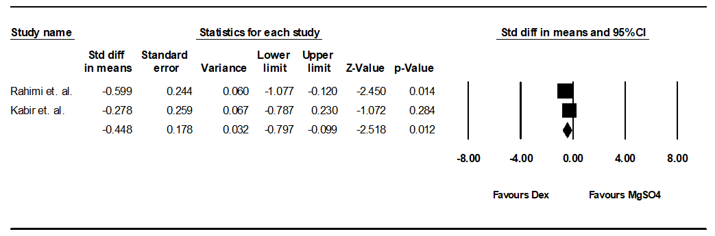

Fig. Supplementary: Forest plot of mean change in systolic blood pressure (SBP) mean difference (MD).

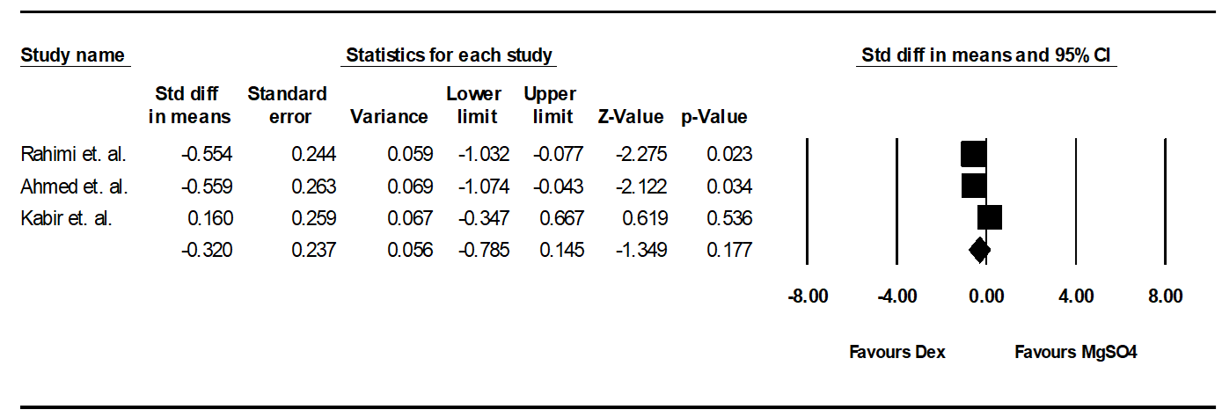

Fig. Supplementary: Forest plot of mean change in diastolic blood pressure (DBP) mean difference (MD).

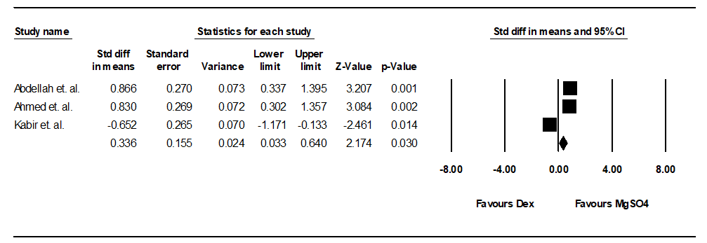

Fig. Supplementary: Forest plot of time to restore mean arterial pressure (MAP) mean difference (MD).

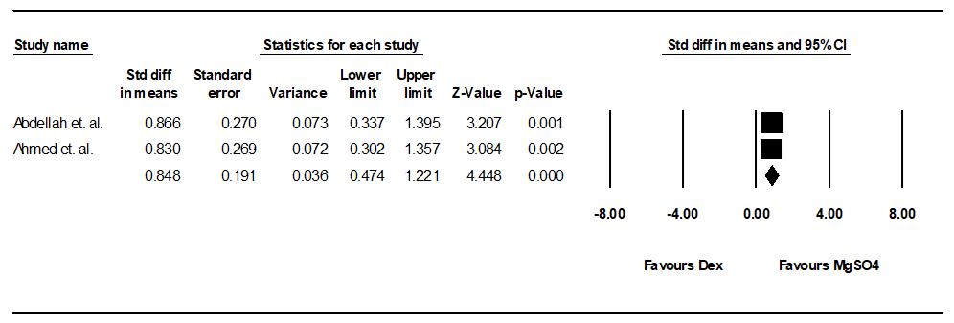

Fig. Supplementary: Forest plot of time to restore mean arterial pressure (MAP) sensitivity analysis.

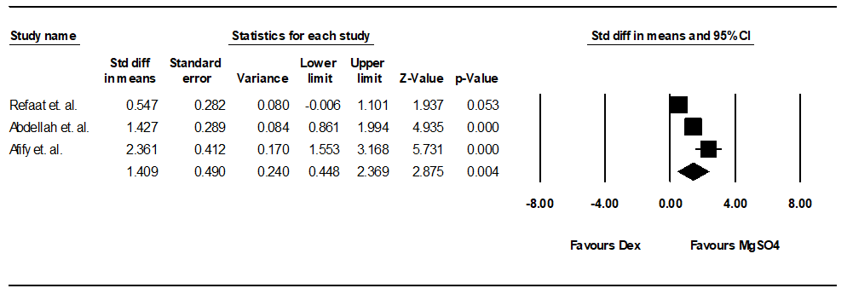

Fig. Supplementary: Forest plot of time to first analgesic request mean difference (MD).

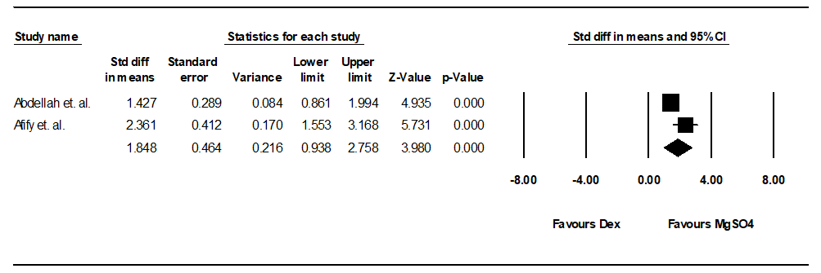

Fig. Supplementary: Forest plot of time to first analgesic request sensitivity analysis

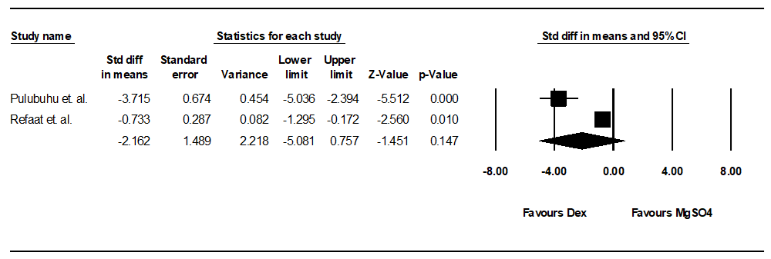

Fig. Supplementary: Forest plot of postoperative opioid requirement mean difference (MD).

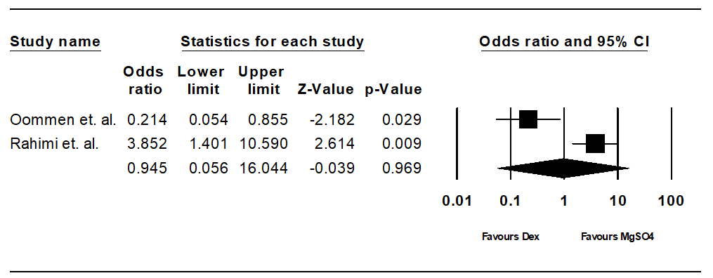

Fig. Supplementary: Forest plot of need for ephedrine Risk Ratio (RR).

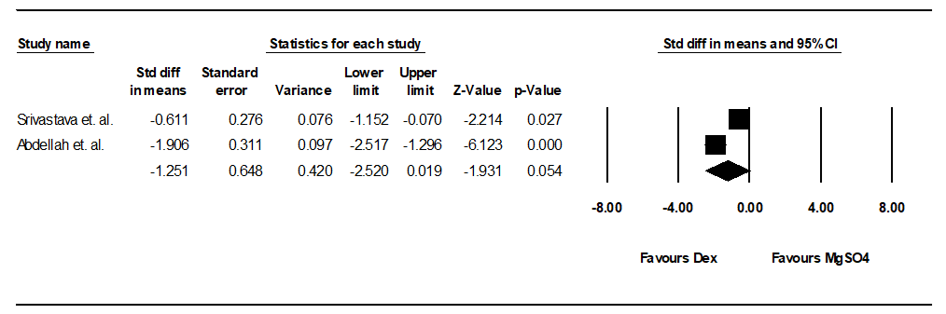

Fig. Supplementary: Forest plot of extubation time mean difference (MD).

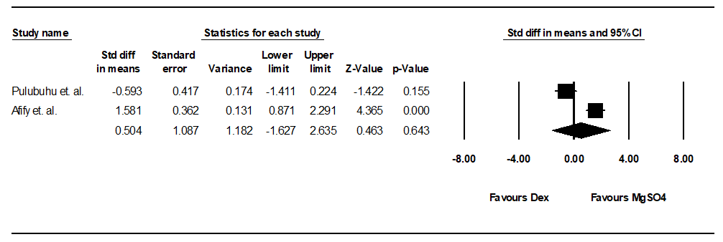

Fig. Supplementary: Forest plot of recovery time mean difference (MD).

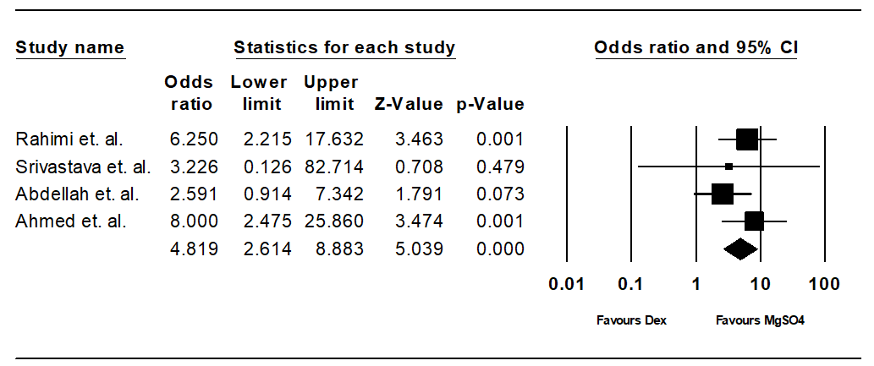

Fig. Supplementary: Forest plot of bradycardia Risk Ratio (RR).

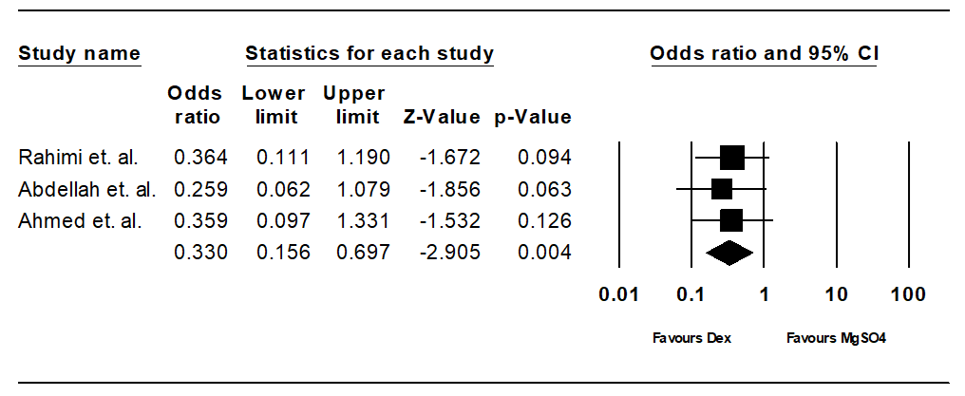

Fig. Supplementary: Forest plot of tachycardia Risk Ratio (RR).

Table Supplementary: Outcomes of Dexmedetomidine vs Magnesium Sulfate.
Study ID | Post-operative opioid requirement (mg) |  |  |  |  |  | Recovery time (min)
Study ID | Dexmedetomidine |  |  | Magnesium Sulfate |  |  | Dexmedetomidine |  |  | Magnesium Sulfate
Study ID | Mean | SD | Total | Mean | SD | Total | Mean | SD | Total | Mean | SD | Total
Oommen et. al. | N/A | N/A | N/A | N/A | N/A | N/A | N/A | N/A | N/A | N/A | N/A | N/A
Pulubuhu et. al. | 67.5 | 5.29 | 12 | 110 | 15.29 | 12 | 9.75 | 1.36 | 12 | 10.67 | 1.72 | 12
Rahimi et. al. | N/A | N/A | N/A | N/A | N/A | N/A | N/A | N/A | N/A | N/A | N/A | N/A
Refaat et. al. | 14.29 | 6.76 | 26 | 20.27 | 9.34 | 26 | N/A | N/A | N/A | N/A | N/A | N/A
Srivastava et. al. | N/A | N/A | N/A | N/A | N/A | N/A | N/A | N/A | N/A | N/A | N/A | N/A
Abdellah et. al. | N/A | N/A | N/A | N/A | N/A | N/A | N/A | N/A | N/A | N/A | N/A | N/A
Afify et. al. | N/A | N/A | N/A | N/A | N/A | N/A | 11.5 | 2.13 | 20 | 8.1 | 2.17 | 20
Ahmed et. al. | N/A | N/A | N/A | N/A | N/A | N/A | N/A | N/A | N/A | N/A | N/A | N/A
Kabir et. al. | N/A | N/A | N/A | N/A | N/A | N/A | N/A | N/A | N/A | N/A | N/A | N/A

Data expressed as mean ± SD (standard deviation) for continuous data, N/A: not applicable

Table Supplementary: Outcomes of Dexmedetomidine vs Magnesium Sulfate.
Study ID | Time to first analgesic request (min) |  |  |  |  |  | Extubation time (min)
Study ID | Dexmedetomidine |  |  | Magnesium Sulfate |  |  | Dexmedetomidine |  |  | Magnesium Sulfate
Study ID | Mean | SD | Total | Mean | SD | Total | Mean | SD | Total | Mean | SD | Total
Oommen et. al. | N/A | N/A | N/A | N/A | N/A | N/A | N/A | N/A | N/A | N/A | N/A | N/A
Pulubuhu et. al. | N/A | N/A | N/A | N/A | N/A | N/A | N/A | N/A | N/A | N/A | N/A | N/A
Rahimi et. al. | N/A | N/A | N/A | N/A | N/A | N/A | N/A | N/A | N/A | N/A | N/A | N/A
Refaat et. al. | 368.57 | 195.02 | 26 | 265.91 | 179.86 | 26 | N/A | N/A | N/A | N/A | N/A | N/A
Srivastava et. al. | N/A | N/A | N/A | N/A | N/A | N/A | 11.19 | 3.55 | 27 | 13.39 | 3.65 | 28
Abdellah et. al. | 19.8 | 1.23 | 30 | 18.2 | 1 | 30 | 12.59 | 0.54 | 30 | 13.75 | 0.67 | 30
Afify et. al. | 95.5 | 12 | 20 | 65.6 | 13.3 | 20 | N/A | N/A | N/A | N/A | N/A | N/A
Ahmed et. al. | 20 | 0 | 30 | 18.17 | 1.26 | 30 | N/A | N/A | N/A | N/A | N/A | N/A
Kabir et. al. | N/A | N/A | N/A | N/A | N/A | N/A | N/A | N/A | N/A | N/A | N/A | N/A

Data expressed as mean ± SD (standard deviation) for continuous data, N/A: not applicable

Table Supplementary: Outcomes of Dexmedetomidine vs Magnesium Sulfate.
Study ID | Time to Restore MAP (minutes) |  |  |  |  |  | Mean change in MAP s(mmHg)
Study ID | Dexmedetomidine |  |  | Magnesium Sulfate |  |  | Dexmedetomidine |  |  | Magnesium Sulfate
Study ID | Mean | SD | Total | Mean | SD | Total | Mean | SD | Total | Mean | SD | Total
Oommen et. al. | N/A | N/A | N/A | N/A | N/A | N/A | N/A | N/A | N/A | N/A | N/A | N/A
Pulubuhu et. al. | N/A | N/A | N/A | N/A | N/A | N/A | -24 | 8.9 | 12 | -21.25 | 7.718 | 12
Rahimi et. al. | N/A | N/A | N/A | N/A | N/A | N/A | -15.97 | 6.155 | 35 | -9.78 | 8.06 | 35
Refaat et. al. | N/A | N/A | N/A | N/A | N/A | N/A | -16.73 | 12.189 | 26 | -0.81 | 8.881 | 26
Srivastava et. al. | N/A | N/A | N/A | N/A | N/A | N/A | N/A | N/A | N/A | N/A | N/A | N/A
Abdellah et. al. | 16.93 | 1.1 | 30 | 16.04 | 0.95 | 30 | N/A | N/A | N/A | N/A | N/A | N/A
Afify et. al. | N/A | N/A | N/A | N/A | N/A | N/A | N/A | N/A | N/A | N/A | N/A | N/A
Ahmed et. al. | 17.7 | 2.36 | 30 | 15.67 | 2.53 | 30 | N/A | N/A | N/A | N/A | N/A | N/A
Kabir et. al. | 34.5 | 22.68 | 30 | 46 | 10.37 | 30 | -28.43 | 9.574 | 30 | -31.06 | 10.707 | 30

Data expressed as mean ± SD (standard deviation) for continuous data, N/A: not applicable, MAP: mean arterial pressure

Table Supplementary: Outcomes of Dexmedetomidine vs Magnesium Sulfate.
Study ID | Mean change in SBP (mmHg) |  |  |  |  |  | Mean change in DBP (mmHg)
Study ID | Dexmedetomidine |  |  | Magnesium Sulfate |  |  | Dexmedetomidine |  |  | Magnesium Sulfate
Study ID | Mean | SD | Total | Mean | SD | Total | Mean | SD | Total | Mean | SD | Total
Oommen et. al. | N/A | N/A | N/A | N/A | N/A | N/A | N/A | N/A | N/A | N/A | N/A | N/A
Pulubuhu et. al. | N/A | N/A | N/A | N/A | N/A | N/A | N/A | N/A | N/A | N/A | N/A | N/A
Rahimi et. al. | -16.28 | 7.438 | 35 | -11.91 | 7.161 | 35 | -15.91 | 12.53 | 35 | -8.9 | 12.767 | 35
Refaat et. al. | N/A | N/A | N/A | N/A | N/A | N/A | N/A | N/A | N/A | N/A | N/A | N/A
Srivastava et. al. | N/A | N/A | N/A | N/A | N/A | N/A | N/A | N/A | N/A | N/A | N/A | N/A
Abdellah et. al. | N/A | N/A | N/A | N/A | N/A | N/A | N/A | N/A | N/A | N/A | N/A | N/A
Afify et. al. | N/A | N/A | N/A | N/A | N/A | N/A | N/A | N/A | N/A | N/A | N/A | N/A
Ahmed et. al. | N/A | N/A | N/A | N/A | N/A | N/A | -16 | 12.263 | 30 | -9 | 12.795 | 30
Kabir et. al. | -29.24 | 12.446 | 30 | -26.03 | 10.566 | 30 | -20.6 | 7.614 | 30 | -21.97 | 9.4 | 30

Data expressed as mean ± SD (standard deviation) for continuous data, N/A: not applicable, SBP: systolic blood pressure, DBP: diastolic blood pressure

Table Supplementary: Outcomes of Dexmedetomidine vs Magnesium Sulfate.
Study ID | Mean change in HR |  |  |  |  |  | Need for ephedrine
Study ID | Dexmedetomidine |  |  | Magnesium Sulfate |  |  | Dexmedetomidine |  | Magnesium Sulfate
Study ID | Mean | SD | Total | Mean | SD | Total | Event | Total | Event | Total
Oommen et. al. | N/A | N/A | N/A | N/A | N/A | N/A | 4 | 21 | 11 | 21
Pulubuhu et. al. | -16.25 | 7.951 | 12 | -19.25 | 4.567 | 12 | N/A | N/A | N/A | N/A
Rahimi et. al. | -21.95 | 9.414 | 35 | -3.86 | 9.156 | 35 | 20 | 35 | 9 | 35
Refaat et. al. | -10.15 | 9.582 | 26 | 3.97 | 10.782 | 26 | N/A | N/A | N/A | N/A
Srivastava et. al. | N/A | N/A | N/A | N/A | N/A | N/A | N/A | N/A | N/A | N/A
Abdellah et. al. | N/A | N/A | N/A | N/A | N/A | N/A | N/A | N/A | N/A | N/A
Afify et. al. | N/A | N/A | N/A | N/A | N/A | N/A | N/A | N/A | N/A | N/A
Ahmed et. al. | 11.7 | 11.942 | 30 | -1.46 | 13.881 | 30 | N/A | N/A | N/A | N/A
Kabir et. al. | -18.33 | 6.342 | 30 | -15.67 | 6.775 | 30 | N/A | N/A | N/A | N/A

Data expressed as mean ± SD (standard deviation) for continuous data and as event and total for dichotomous data. N/A: not applicable, HR: heart rate

Table Supplementary: Outcomes of Dexmedetomidine vs Magnesium Sulfate.
Study ID | Bradycardia |  |  |  | Tachycardia
Study ID | Dexmedetomidine |  | Magnesium Sulfate |  | Dexmedetomidine |  | Magnesium Sulfate
Study ID | Event | Total | Event | Total | Event | Total | Event | Total
Oommen et. al. | N/A | N/A | N/A | N/A | N/A | N/A | N/A | N/A
Pulubuhu et. al. | N/A | N/A | N/A | N/A | N/A | N/A | N/A | N/A
Rahimi et. al. | 25 | 35 | 10 | 35 | 5 | 35 | 11 | 35
Refaat et. al. | N/A | N/A | N/A | N/A | N/A | N/A | N/A | N/A
Srivastava et. al. | 1 | 27 | 0 | 28 | 0 | 27 | 0 | 28
Abdellah et. al. | 18 | 30 | 11 | 30 | 3 | 30 | 9 | 30
Afify et. al. | N/A | N/A | N/A | N/A | N/A | N/A | N/A | N/A
Ahmed et. al. | 24 | 30 | 10 | 30 | 4 | 30 | 9 | 30
Kabir et. al. | N/A | N/A | N/A | N/A | N/A | N/A | N/A | N/A

Data expressed as event and total for dichotomous data, N/A: not applicable

