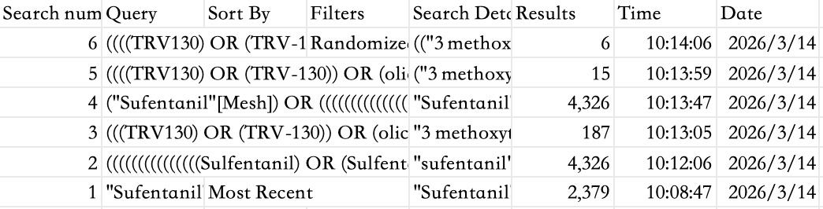
Figure 1. Search strategies for PubMed

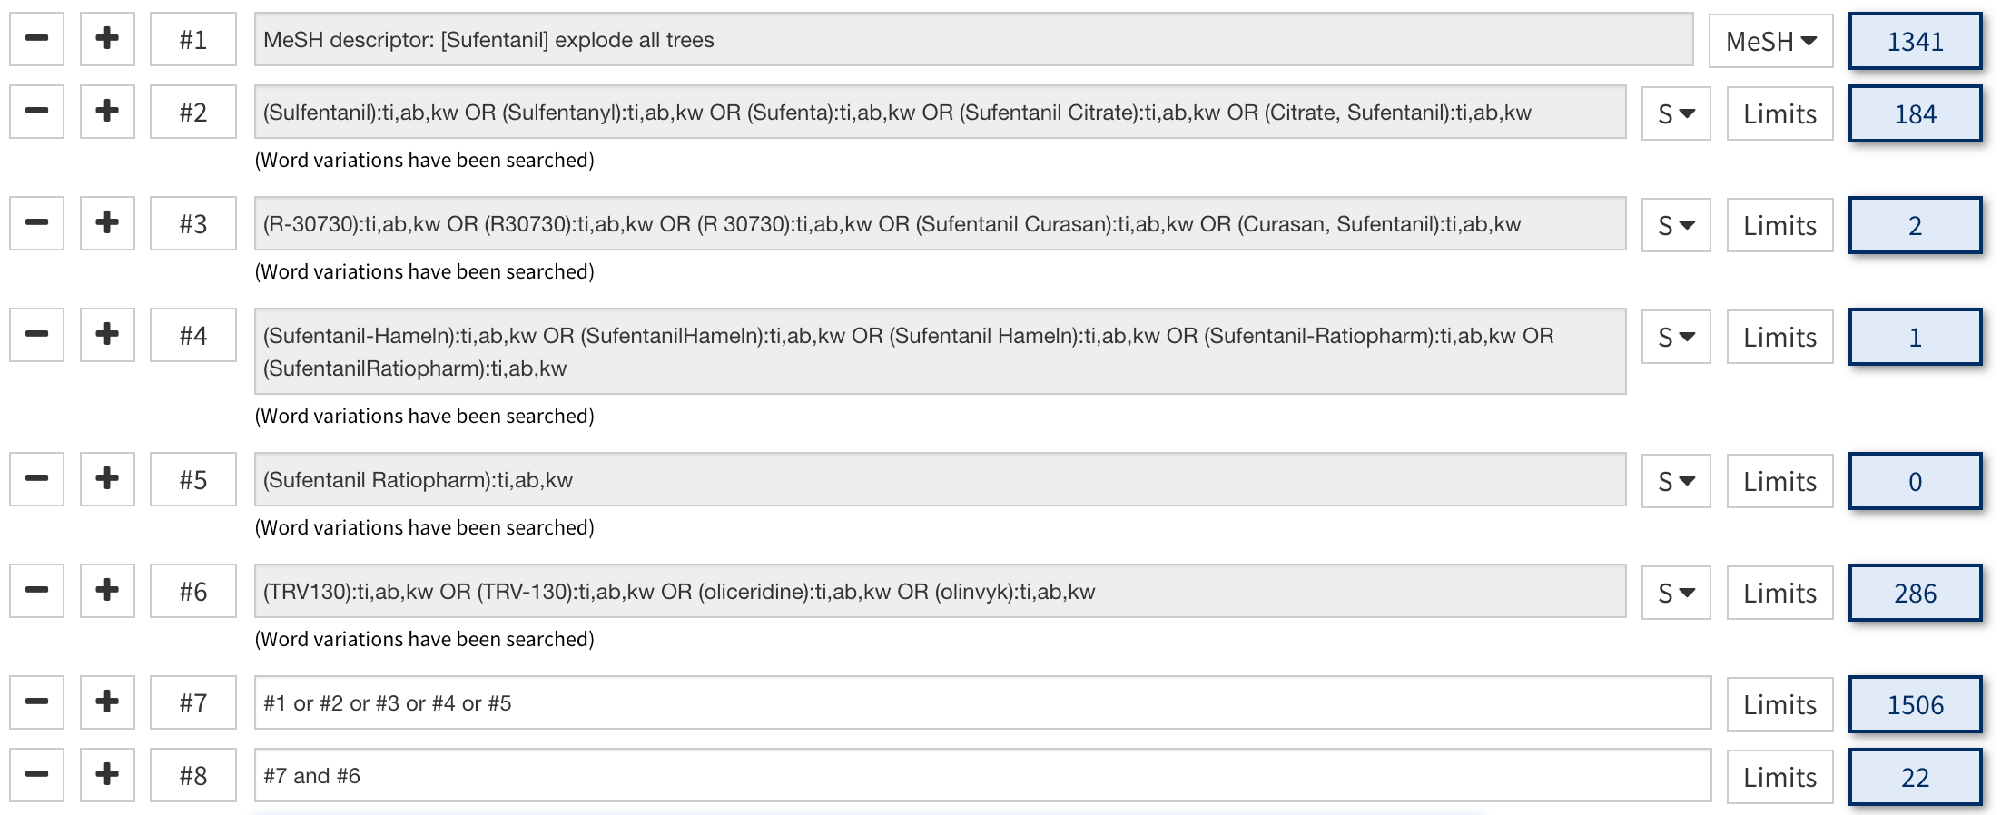
Figure 2. Search strategies for the Cochrane Library

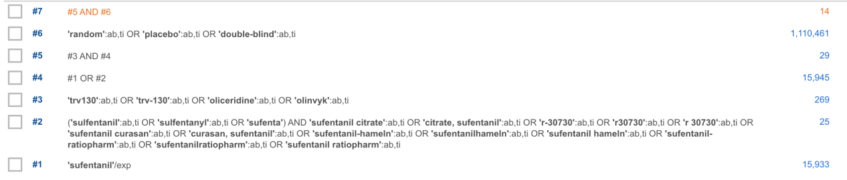
Figure 3. Search Strategies for Embase

