SUPPLEMENTARY MATERIALS

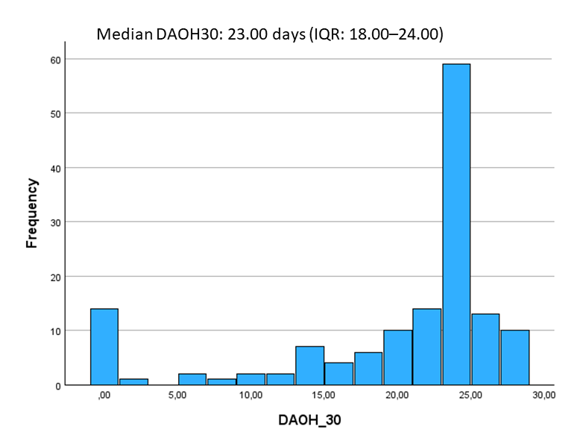
Supplementary Figure 1: Distribution of days alive out of hospital at 30 days.
DAOH30, days alive out of hospital at 30 days; IQR, interquartile range

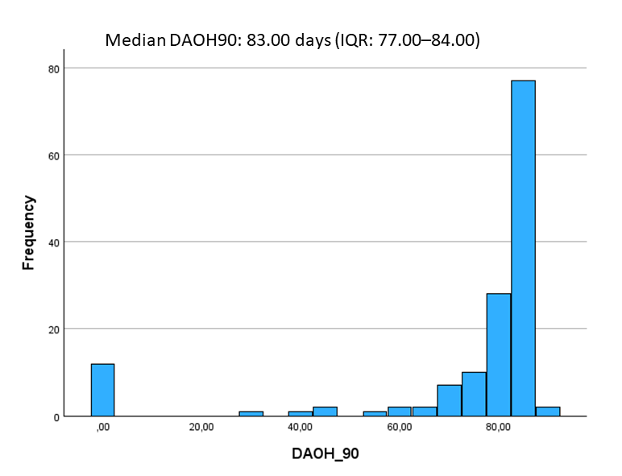
Supplementary Figure 2: Distribution of days alive out of hospital at 90 days.
DAOH90, days alive out of hospital at 90 days; IQR, interquartile range

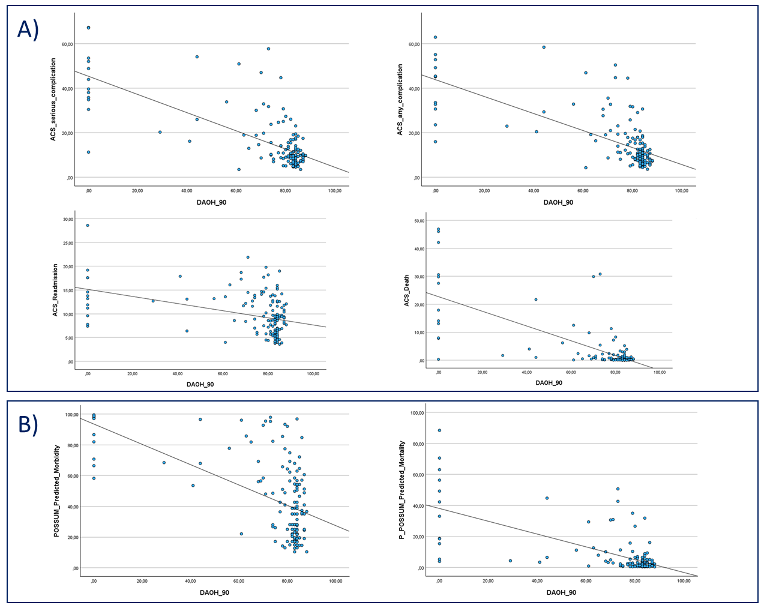
Supplementary Figure 3: Scatter plots illustrating the correlations between surgical risk prediction model estimates and DAOH90.
(A) Correlations between ACS serious complication, any complication, readmission, and death risk estimates and DAOH90 (rho = −0.549, rho = −0.637, rho = −0.338, and rho = −0.486, respectively; all p-values < 0.001).
(B) Correlations between POSSUM-predicted morbidity, P-POSSUM-predicted mortality estimates, and DAOH90 (rho = −0.460 and rho = −0.437, respectively; both p-values < 0.001).
Abbreviations: DAOH90, days alive out of hospital at 90 days; ACS, American College of Surgeons; POSSUM, Physiological and Operative Severity Score for the Enumeration of Mortality and Morbidity; P-POSSUM, Portsmouth Physiological and Operative Severity Score for the Enumeration of Mortality.

Supplementary Table 1: Multivariable regression analyses of perioperative factors, including ACS-readmission, ACS-death, and P-POSSUM-mortality, associated with low DAOH30 (DAOH30 <23 days).
 |  | Multivariable analysis (ACS-readmission) |  | Multivariable analysis (ACS-death) |  | Multivariable analysis (P-POSSUM-mortality)
Parameter | Comparison | OR (95% CI) | p-value | OR (95% CI) | p-value | OR (95% CI) | p-value
ACS-readmission | +1 percentage point | 1.091 (0.957-1.244) | 0.194 | Not included |  | Not included
ACS-death | +1 percentage point | Not included |  | 1.235 (0.958-1.592) | 0.104 | Not included
P-POSSUM-mortality | +1 percentage point | Not included |  | Not included |  | 1.046 (0.990-1.105) | 0.109
Emergency | Emergent vs elective | 2.569 (0.947-6.972) | 0.064 | 1.629 (0.559-4.746) | 0.371 | 1.724 (0.594-5.005) | 0.317
ASA physical status | 3-4-5 vs 1-2 | 2.508 (0.873-7.209) | 0.088 | 2.013 (0.740-5.481) | 0.171 | 2.533 (0.971-6.607) | 0.057
Surgical approach | Laparotomy vs Laparoscopy | 1.418 (0.538-3.735) | 0.480 | 1.413 (0.535-3.730) | 0.485 | 1.538 (0.605-3.909) | 0.366
Operative duration, hours | +1 hours | 2.438 (1.614-3.680) | <0.001 | 2.338 (1.556-3.515) | <0.001 | 2.355 (1.573-3.526) | <0.001
Three separate multivariable models were constructed, each including ACS-readmission, ACS-death, and P-POSSUM mortality risk estimates. Each model was adjusted for emergency surgery, ASA physical status, surgical approach, and operative duration (variables were identical to those in the main analysis).
-Risk prediction model parameters were not included in the same multivariable model due to multicollinearity and conceptual overlap between risk estimation systems.
Model ACS-readmission: Nagelkerke R² = 0.429; Hosmer–Lemeshow test p = 0.844.
Model ACS-death: Nagelkerke R² = 0.466; Hosmer–Lemeshow test p = 0.990.
Model P-POSSUM-mortality: Nagelkerke R² = 0.441; Hosmer–Lemeshow test p = 0.451.
Abbreviations: DAOH30, days alive out of hospital at 30 days; OR, odds ratio; CI, confidence interval; ACS, American College of Surgeons; POSSUM, Physiological and Operative Severity Score for the Enumeration of Mortality and Morbidity; P-POSSUM, Portsmouth Physiological and Operative Severity Score for the Enumeration of Mortality; ASA, American Society of Anesthesiologists.

