Supplementary Figure 1. Meta-analysis funnel plot of the sleep quality scores.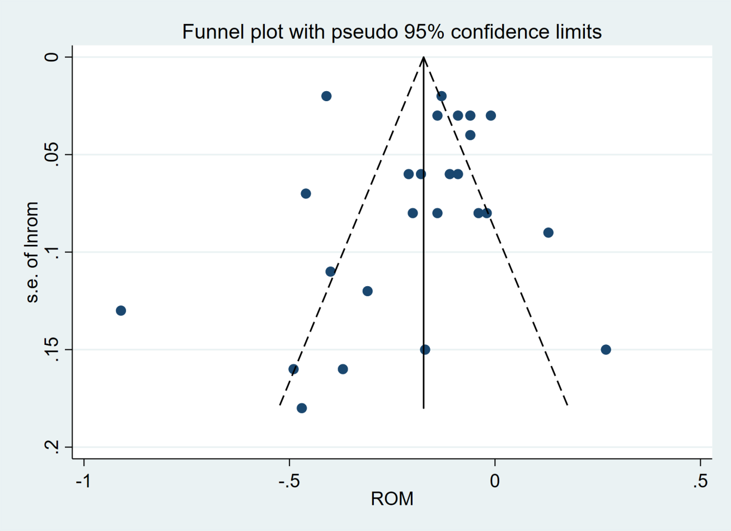
Funnel plot for ratio of means (ROM) of postoperative sleep quality scores (esketamine vs control) to assess publication bias. ROM, Ratio of Means.

Supplementary Figure 2. Egger’s test for postoperative sleep quality scores. 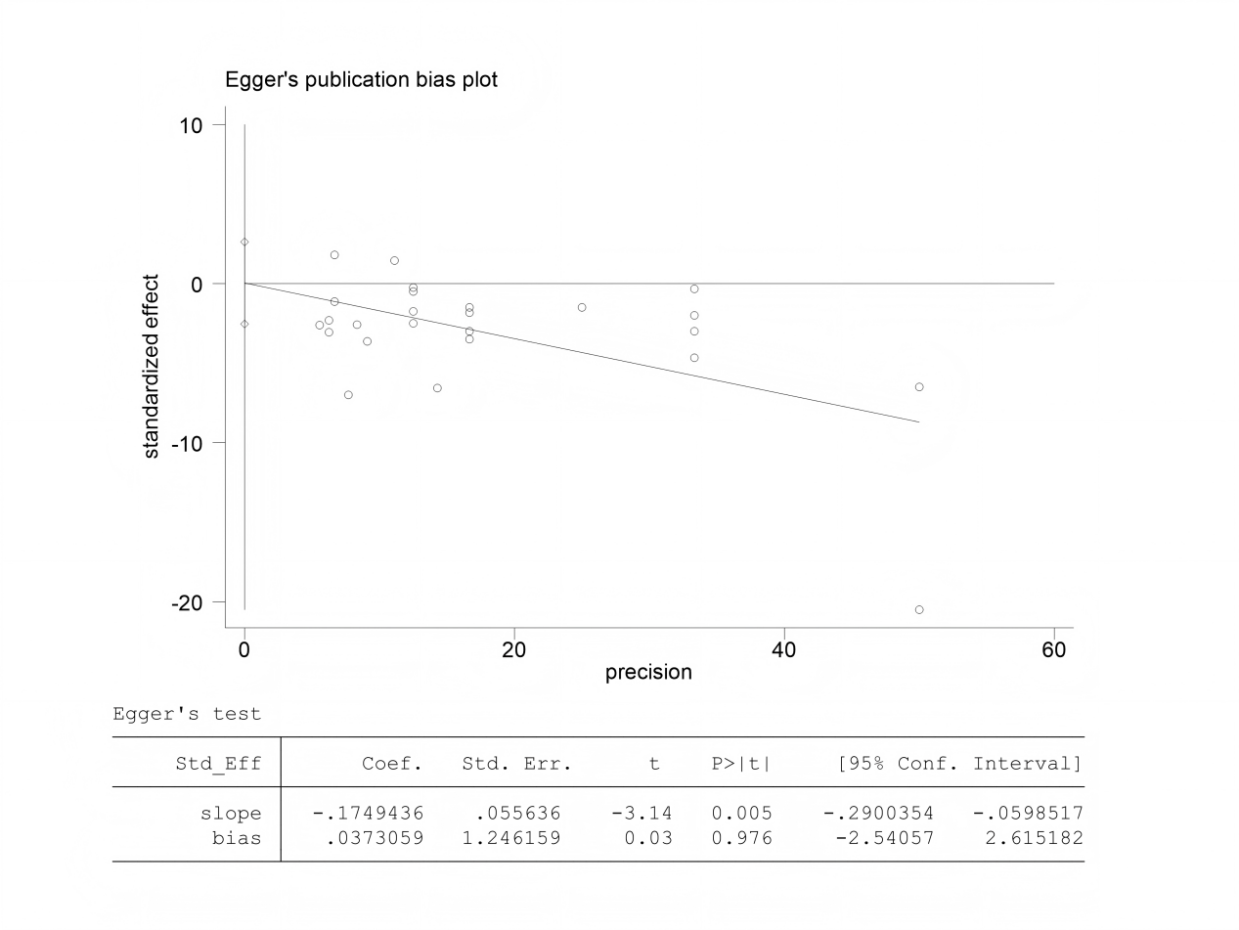
Egger’s test for publication bias of ratio of means (ROM) estimates for postoperative sleep quality scores (esketamine vs control); the plot shows the standard error of the ROM against the ROM with regression line and 95% confidence limits.

Supplementary Figure 3. The effects of perioperative application of esketamine on postoperative pain.
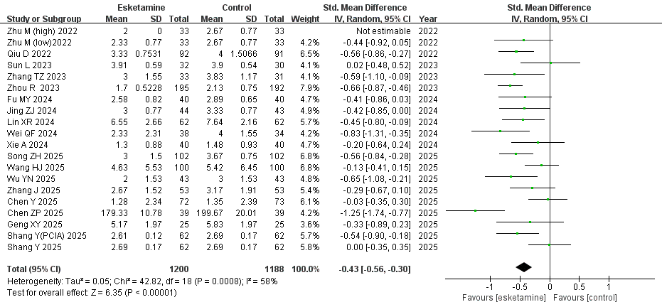
Random-effects meta-analysis. SD, standard deviation; CI, confidence interval; df, degrees of freedom.

Supplementary Figure 4. The effects of perioperative application of esketamine on postoperative depression. 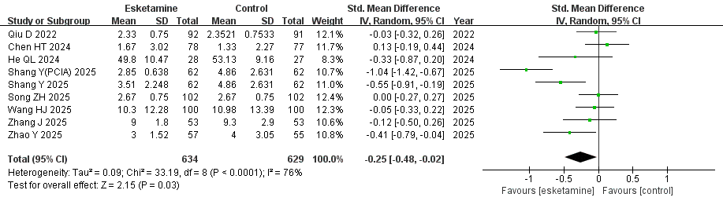
Random-effects meta-analysis. SD, standard deviation; CI, confidence interval; df, degrees of freedom.

Supplementary Figure 5. The effects of different doses of esketamine on postoperative sleep quality.
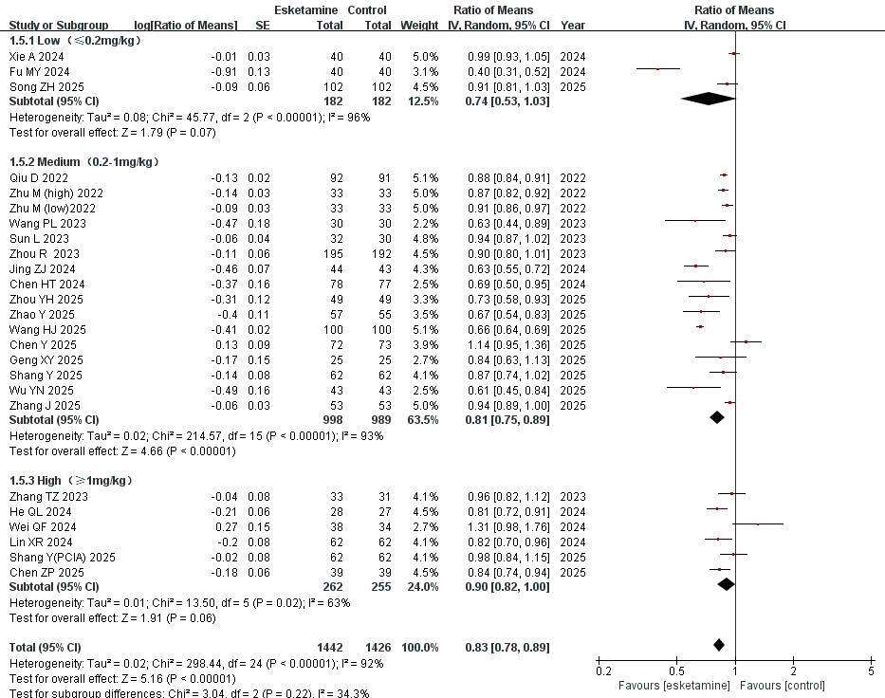
Random-effects meta-analysis. SE, standard error; CI, confidence interval; df, degrees of freedom.

Supplementary Figure 6. The effects of different infusion ways of esketamine on postoperative sleep quality.
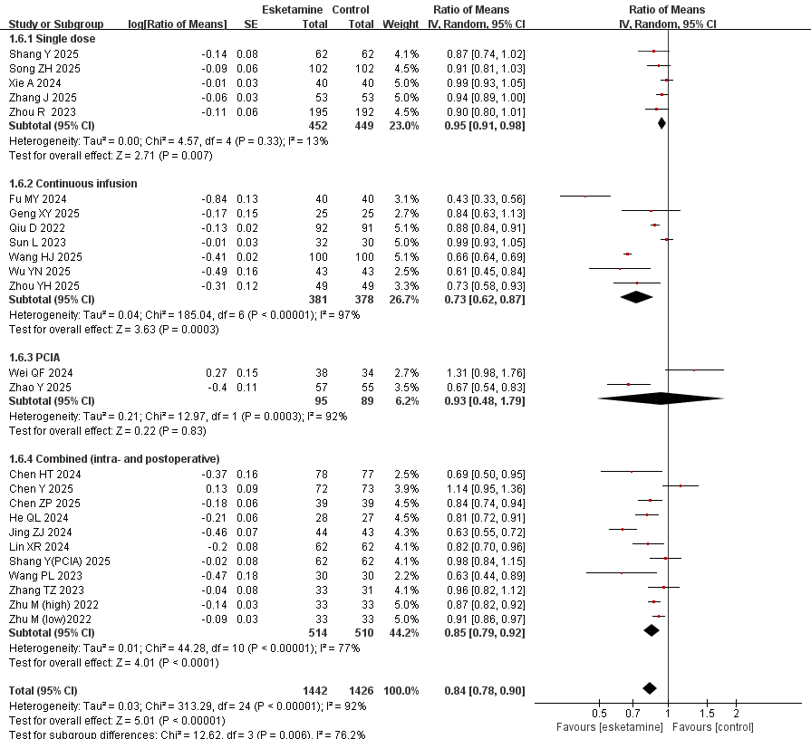
Random-effects meta-analysis. PCIA, patient-controlled intravenous analgesia; SE, standard error; CI, confidence interval; df, degrees of freedom.

Supplementary Figure 7. The effects of esketamine application across different surgery types on postoperative sleep quality.
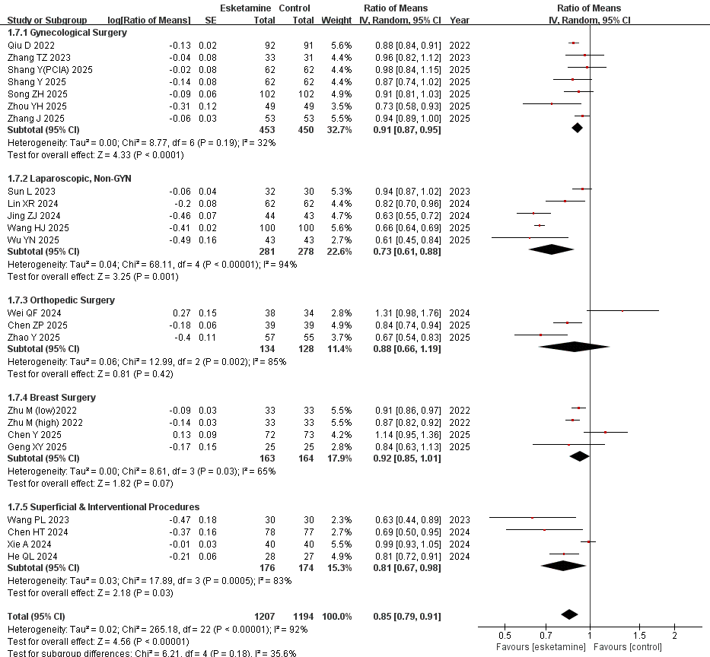
Random-effects meta-analysis. Non-GYN, non-gynecological surgery; SE, standard error; CI, confidence interval; df, degrees of freedom.

Supplementary Figure 8. The effects of esketamine application across different age groups on postoperative sleep quality.
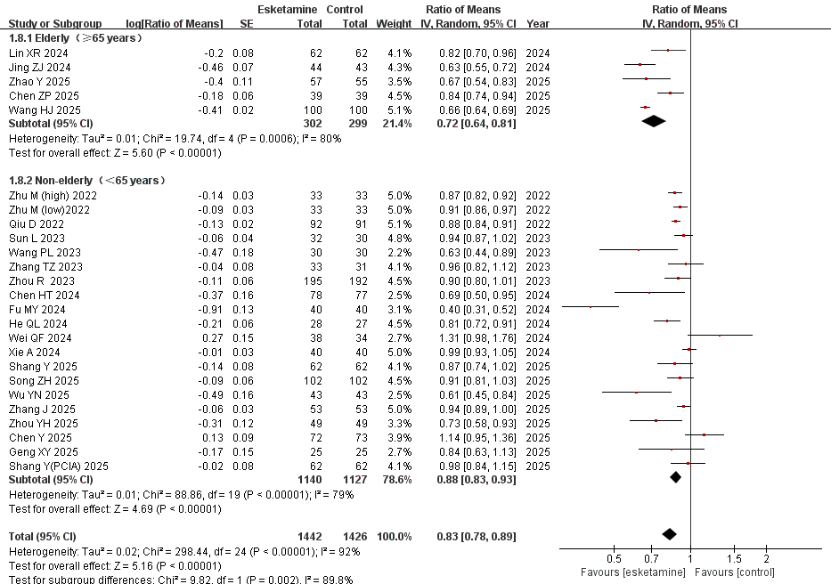
Random-effects meta-analysis. SE, standard error; CI, confidence interval; df, degrees of freedom.
Supplementary Figure 9. The effects of esketamine application across different sex distributions on postoperative sleep quality. 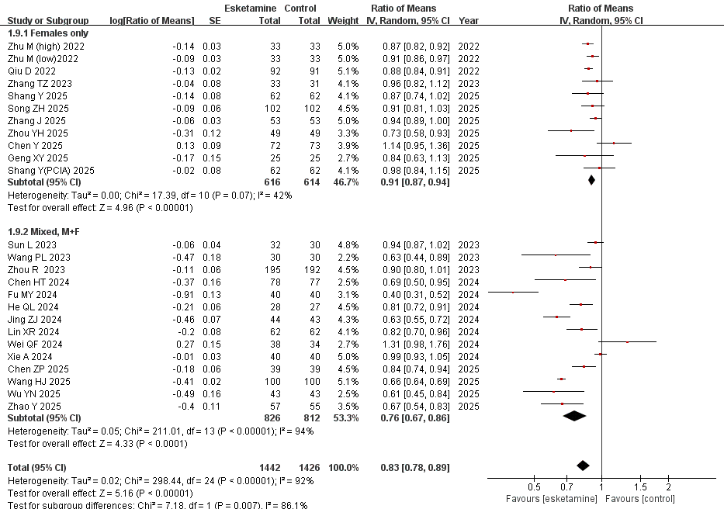
Random-effects meta-analysis. SE, standard error; CI, confidence interval; df, degrees of freedom.

Supplementary Figure 10. The effects of esketamine application across different sleep assessment scales on postoperative sleep quality.
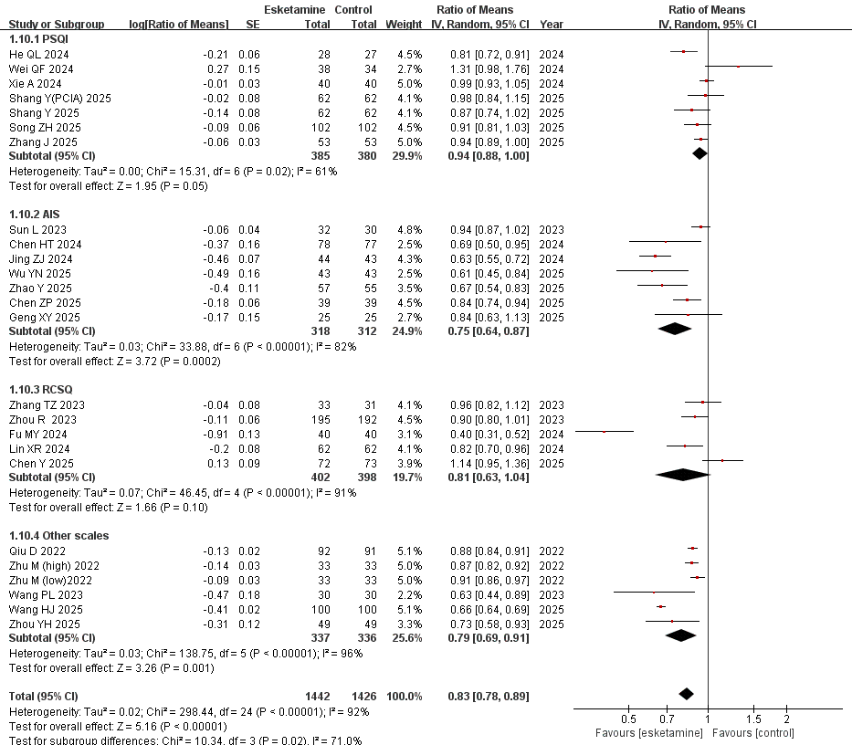
Random-effects meta-analysis. PSQI, Pittsburgh Sleep Quality Index; AIS, Athens Insomnia Scale; RCSQ, Richards-Campbell Sleep Questionnaire; SE, standard error; CI, confidence interval; df, degrees of freedom.

Supplementary Figure 11. The effects of esketamine application across different pre-existing PSD statuses on postoperative sleep quality.
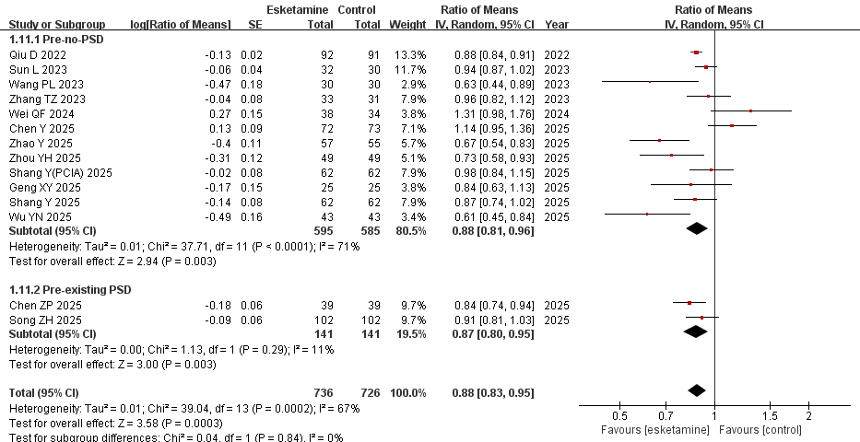
Random-effects meta-analysis. PSD, postoperative sleep disturbance; SE, standard error; CI, confidence interval; df, degrees of freedom.

Supplementary Figure 12. Sensitivity analysis for postoperative sleep quality scores. 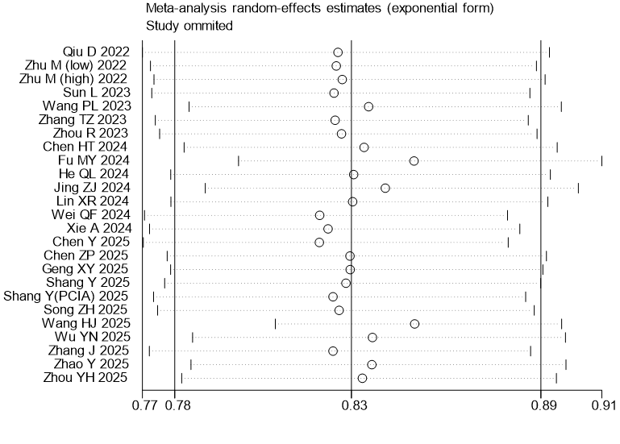
Each row represents the pooled ratio of means (ROM) and its 95% confidence interval when the corresponding study was omitted from the analysis.

Supplementary Figure 13. GRADE evidence for postoperative sleep quality scores.
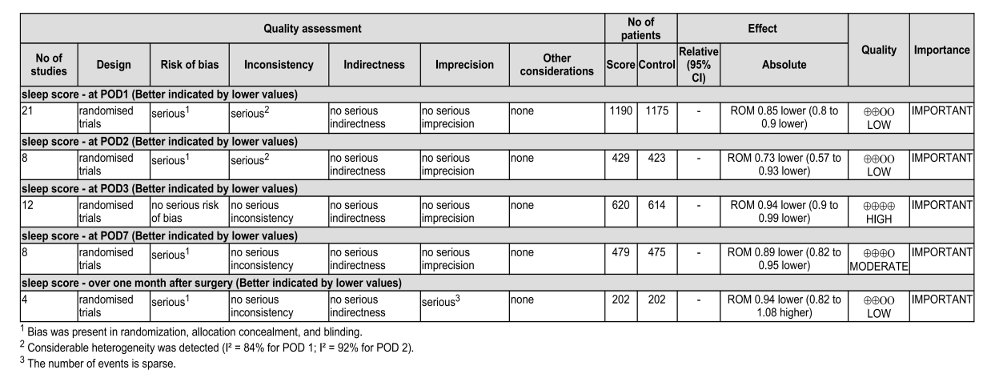
All effect estimates are presented as the ratio of means (ROM). ROM < 1 indicates lower postoperative sleep scores in the esketamine group, reflecting better sleep quality. ROM, Ratio of Means.

