Supplementary Table 2. A detailed description of search strategies and results.
Database | Search strategies | Date | Results
Pubmed | 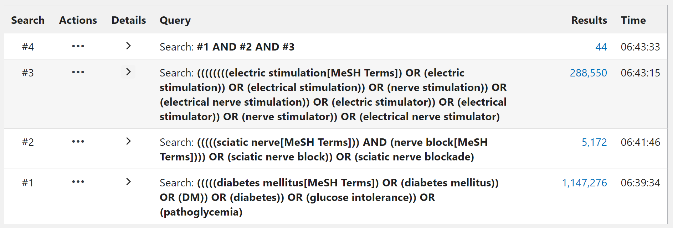 | 10/11/2025 | 44
Embase | 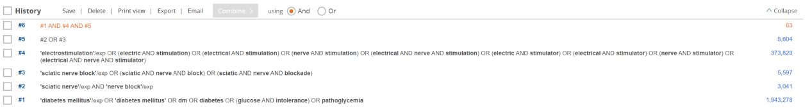 | 10/11/2025 | 63
Web of Science | 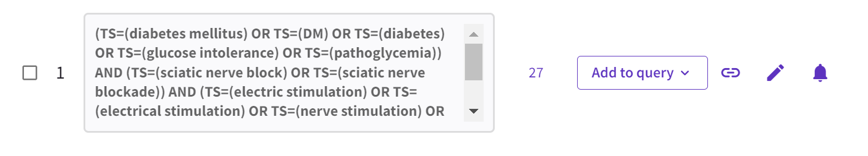 | 10/11/2025 | 27
Cochrane Library | 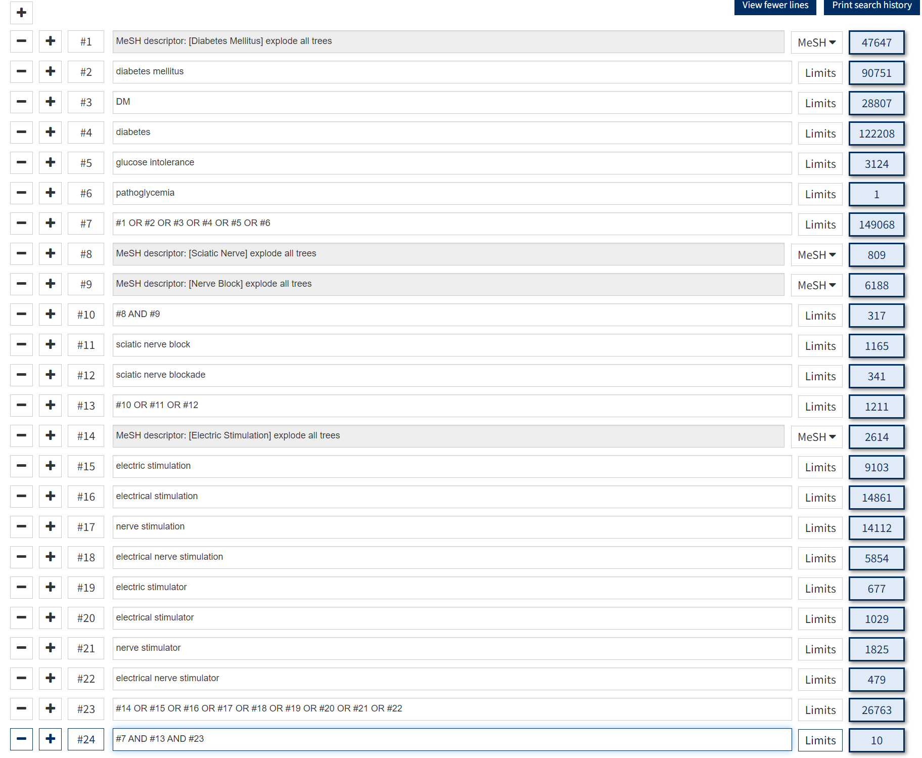 | 10/11/2025 | 10
Scopus | 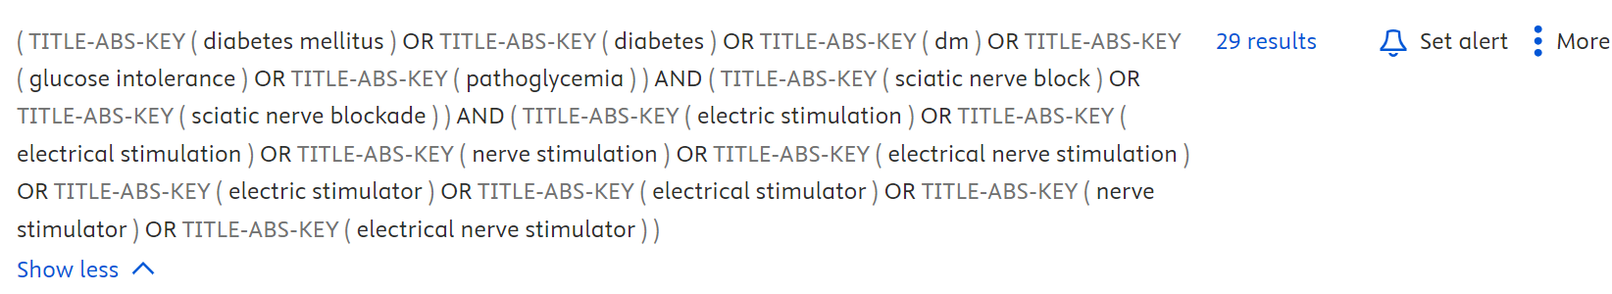 | 10/11/2025 | 29
Total | No records were identified from the CNKI and Wanfang databases. |  | 173

