Supplementary information
I. Supplementary Methods: Trial Sequential Analysis (TSA) Parameters
TSA controlled for random errors and sparse data bias using the O'Brien-Fleming α-spending function with two-sided α=0.05 and β=0.20 (80% power). The primary required information size was calculated based on a clinically relevant 20% relative risk reduction (RRR) with the control group event rate determined by the pooled incidence across included studies. We also performed a prespecified sensitivity TSA using a more conservative 10% RRR. Heterogeneity was incorporated via D²-based adjustment, where D² = I²/(1+I²) adjusts the information size for between-trial variability. All analyses utilized TSA software (version 0.9; Copenhagen Trial Unit), with crossing of monitoring boundaries interpreted as conclusive evidence when the cumulative Z-curve surpassed the adjusted significance threshold.
II. Supplementary Tables
eTable 1. PRISMA 2020 Checklist
Section and Topic | Item # | Checklist item | Location where item is reported
TITLE
Title | 1 | Identify the report as a systematic review. | Title page, p. 1
ABSTRACT
Abstract | 2 | See the PRISMA 2020 for Abstracts checklist. | Abstract, pp. 1-3
INTRODUCTION
Rationale | 3 | Describe the rationale for the review in the context of existing knowledge. | Introduction, pp. 3-4
Objectives | 4 | Provide an explicit statement of the objective(s) or question(s) the review addresses. | Introduction, p. 4
METHODS
Eligibility criteria | 5 | Specify the inclusion and exclusion criteria for the review and how studies were grouped for the syntheses. | Methods: Eligibility criteria, p. 4
Information sources | 6 | Specify all databases, registers, websites, organisations, reference lists and other sources searched or consulted to identify studies. Specify the date when each source was last searched or consulted. | Methods: Information sources and search strategy, p. 5
Search strategy | 7 | Present the full search strategies for all databases, registers and websites, including any filters and limits used. | Methods: Information sources and search strategy, p. 5; Supplementary eTable 2
Selection process | 8 | Specify the methods used to decide whether a study met the inclusion criteria of the review, including how many reviewers screened each record and each report retrieved, whether they worked independently, and if applicable, details of automation tools used in the process. | Methods: Information sources and search strategy, p. 5
Data collection process | 9 | Specify the methods used to collect data from reports, including how many reviewers collected data from each report, whether they worked independently, any processes for obtaining or confirming data from study investigators, and if applicable, details of automation tools used in the process. | Methods: Data extraction and management, pp. 5-6
Data items | 10a | List and define all outcomes for which data were sought. Specify whether all results that were compatible with each outcome domain in each study were sought (e.g. for all measures, time points, analyses), and if not, the methods used to decide which results to collect. | Methods: Outcomes, p. 6; Data extraction and management, pp. 5-6
Data items | 10b | List and define all other variables for which data were sought (e.g. participant and intervention characteristics, funding sources). Describe any assumptions made about any missing or unclear information. | Methods: Data extraction and management, pp. 5-6; Table 1, pp. 22-23
Study risk of bias assessment | 11 | Specify the methods used to assess risk of bias in the included studies, including details of the tool(s) used, how many reviewers assessed each study and whether they worked independently, and if applicable, details of automation tools used in the process. | Methods: Risk of bias assessment and effect measures, p. 6; Results: Risk of bias and sensitivity analysis, p. 10; eFigure 1
Effect measures | 12 | Specify for each outcome the effect measure(s) (e.g. risk ratio, mean difference) used in the synthesis or presentation of results. | Methods: Risk of bias assessment and effect measures, pp. 6-7
Synthesis methods | 13a | Describe the processes used to decide which studies were eligible for each synthesis (e.g. tabulating the study intervention characteristics and comparing against the planned groups for each synthesis (item #5)). | Methods: Eligibility criteria, p. 4; Data extraction and management, pp. 5-6; Table 1, pp. 22-23
Synthesis methods | 13b | Describe any methods required to prepare the data for presentation or synthesis, such as handling of missing summary statistics, or data conversions. | Methods: Data extraction and management, pp. 5-6; Outcomes, p. 6; Synthesis and heterogeneity, p. 7
Synthesis methods | 13c | Describe any methods used to tabulate or visually display results of individual studies and syntheses. | Results: Synthesis of results, pp. 9-10; Figures 2-3, pp. 20-21; Tables 1-2, pp. 22-24
Synthesis methods | 13d | Describe any methods used to synthesize results and provide a rationale for the choice(s). If meta-analysis was performed, describe the model(s), method(s) to identify the presence and extent of statistical heterogeneity, and software package(s) used. | Methods: Synthesis and heterogeneity, p. 7
Synthesis methods | 13e | Describe any methods used to explore possible causes of heterogeneity among study results (e.g. subgroup analysis, meta-regression). | Methods: Subgroups and sensitivity analyses, p. 7; Results: Subgroup analysis, p. 10; Table 2, pp. 23-24
Synthesis methods | 13f | Describe any sensitivity analyses conducted to assess robustness of the synthesized results. | Methods: Subgroups and sensitivity analyses, p. 7; Results: Risk of bias and sensitivity analysis, p. 10; Table 2, pp. 23-24
Reporting bias assessment | 14 | Describe any methods used to assess risk of bias due to missing results in a synthesis (arising from reporting biases). | Methods: Trial sequential analysis and certainty, p. 7; Results: Risk of bias and sensitivity analysis, p. 10; eFigure 3
Certainty assessment | 15 | Describe any methods used to assess certainty (or confidence) in the body of evidence for an outcome. | Methods: Trial sequential analysis and certainty, p. 7; Results: Risk of bias and sensitivity analysis, p. 10; eFigure 2
RESULTS
Study selection | 16a | Describe the results of the search and selection process, from the number of records identified in the search to the number of studies included in the review, ideally using a flow diagram. | Results: Study selection and characteristics, p. 8; Figure 1, p. 20
Study selection | 16b | Cite studies that might appear to meet the inclusion criteria, but which were excluded, and explain why they were excluded. | Not reported as a cited excluded-study list in the main manuscript; exclusion flow/counts in Results, p. 8 and Figure 1, p. 20
Study characteristics | 17 | Cite each included study and present its characteristics. | Results: Study selection and characteristics, p. 8; Table 1, pp. 22-23
Risk of bias in studies | 18 | Present assessments of risk of bias for each included study. | Results: Risk of bias and sensitivity analysis, p. 10; eFigure 1
Results of individual studies | 19 | For all outcomes, present, for each study: (a) summary statistics for each group (where appropriate) and (b) an effect estimate and its precision (e.g. confidence/credible interval), ideally using structured tables or plots. | Results: Synthesis of results, pp. 9-10; Figure 2, p. 20; eTable 3
Results of syntheses | 20a | For each synthesis, briefly summarise the characteristics and risk of bias among contributing studies. | Results: Synthesis of results and Risk of bias and sensitivity analysis, pp. 9-10; Table 2, pp. 23-24
Results of syntheses | 20b | Present results of all statistical syntheses conducted. If meta-analysis was done, present for each the summary estimate and its precision (e.g. confidence/credible interval) and measures of statistical heterogeneity. If comparing groups, describe the direction of the effect. | Results: Primary outcome and Secondary outcomes, p. 9; Figure 2, p. 20; Figure 3, p. 21; Table 2, pp. 23-24
Results of syntheses | 20c | Present results of all investigations of possible causes of heterogeneity among study results. | Results: Subgroup analysis, p. 10; Table 2, pp. 23-24
Results of syntheses | 20d | Present results of all sensitivity analyses conducted to assess the robustness of the synthesized results. | Results: Risk of bias and sensitivity analysis, p. 10; Table 2, pp. 23-24
Reporting biases | 21 | Present assessments of risk of bias due to missing results (arising from reporting biases) for each synthesis assessed. | Results: Risk of bias and sensitivity analysis, p. 10; eFigure 3
Certainty of evidence | 22 | Present assessments of certainty (or confidence) in the body of evidence for each outcome assessed. | Results: Risk of bias and sensitivity analysis, p. 10; eFigure 2
DISCUSSION
Discussion | 23a | Provide a general interpretation of the results in the context of other evidence. | Discussion, pp. 11-12
Discussion | 23b | Discuss any limitations of the evidence included in the review. | Discussion: limitations paragraph, p. 13
Discussion | 23c | Discuss any limitations of the review processes used. | Discussion: limitations paragraph, p. 13
Discussion | 23d | Discuss implications of the results for practice, policy, and future research. | Discussion, pp. 12-14; Conclusion, p. 14
OTHER INFORMATION
Registration and protocol | 24a | Provide registration information for the review, including register name and registration number, or state that the review was not registered. | Methods: Protocol and registration, p. 4 (PROSPERO CRD420251181784)
Registration and protocol | 24b | Indicate where the review protocol can be accessed, or state that a protocol was not prepared. | Methods: Protocol and registration, p. 4
Registration and protocol | 24c | Describe and explain any amendments to information provided at registration or in the protocol. | Methods: Protocol and registration, p. 4; Supplementary Methods
Support | 25 | Describe sources of financial or non-financial support for the review, and the role of the funders or sponsors in the review. | Declarations: Funding, p. 15
Competing interests | 26 | Declare any competing interests of review authors. | Declarations: Competing interests, p. 15
Availability of data, code and other materials | 27 | Report which of the following are publicly available and where they can be found: template data collection forms; data extracted from included studies; data used for all analyses; analytic code; any other materials used in the review. | Declarations: Availability of data and materials, p. 15

eTable 2. Search Strategy - Database inception to June 30, 2025 for all databases
Database | Search Terms
PubMed | ("respiration, artificial"[MeSH Terms] OR "mechanical ventilation"[Text Word] OR "Respiratory Insufficiency"[MeSH Terms] OR "Respiratory Failure" OR "Pulmonary Failure" OR "Respiratory Distress") AND (("Conservative Oxygen*") OR ("Low Oxygen*") OR ("Oxygen* Restriction") OR ("Oxygen* Limitation") OR ("Permissive Hypoxemia") OR Normoxia OR ("Liberal Oxygen* Therapy") OR ("Hyperoxia") OR ("Oxygen* Target") OR ("Oxygen* Saturation Range")) NOT (Children OR Pregnancy OR Obstetrics OR Mice OR Mouse OR Vitro OR Rodent OR Rat OR Neonat OR Newborn) AND "randomized controlled trial"[Publication Type]
Embase | ('artificial respiration'/exp OR 'mechanical ventilation'/exp OR 'respiratory failure'/exp OR 'respiratory insufficiency'/exp OR 'respiratory failure' OR 'pulmonary failure' OR 'respiratory distress') AND ('conservative oxygen*' OR 'low oxygen*' OR 'oxygen* restriction' OR 'oxygen* limitation' OR 'permissive hypoxemia' OR normoxia OR 'liberal oxygen* therapy' OR hyperoxia OR 'oxygen* target' OR 'oxygen* saturation range') NOT ('child'/exp OR 'pregnancy'/exp OR 'obstetrics'/exp OR 'mouse'/exp OR 'mice'/exp OR 'rodent'/exp OR 'rat'/exp OR 'neonate'/exp OR 'newborn'/exp OR 'in vitro'/exp) AND 'randomized controlled trial'/exp
Web of Science | TS=("respiration, artificial" OR "mechanical ventilation" OR "Respiratory Insufficiency" OR "Respiratory Failure" OR "Pulmonary Failure" OR "Respiratory Distress") AND TS=("Conservative Oxygen*" OR "Low Oxygen*" OR "Oxygen* Restriction" OR "Oxygen* Limitation" OR "Permissive Hypoxemia" OR Normoxia OR "Liberal Oxygen* Therapy" OR "Hyperoxia" OR "Oxygen* Target" OR "Oxygen* Saturation Range") NOT TS=(Children OR Pregnancy OR Obstetrics OR Mice OR Mouse OR Vitro OR Rodent OR Rat OR Neonat OR Newborn)
Cochrane Library | ("respiration, artificial" OR "mechanical ventilation" OR "respiratory insufficiency" OR "respiratory failure" OR "pulmonary failure" OR "respiratory distress") AND (("conservative NEXT oxygen*") OR ("low NEXT oxygen*") OR ("oxygen* NEXT restriction") OR ("oxygen* NEXT limitation") OR ("permissive NEXT hypoxemia") OR normoxia OR ("liberal NEXT oxygen* NEXT therapy") OR hyperoxia OR ("oxygen* NEXT target") OR ("oxygen* NEXT saturation NEXT range")) NOT (children OR pregnancy OR obstetrics OR mice OR mouse OR "in vitro" OR rodent OR rat OR neonate OR newborn) AND ("randomized controlled trial")

eTable 3. Prescribed Targets and Achieved Oxygen Exposure
Study | Prescribed lower strategy | Prescribed higher strategy | Achieved lower exposure | Achieved higher exposure
Young et al., 2014 | SpO₂ 90-94% | Standard care; SpO₂ >95% | Prehospital SpO₂ 79.5% [75.8-90.3]; ICU SpO₂ 94-97% at 6-24 h; ICU PaO₂ 72-84 mm Hg at 6-24 h | Prehospital SpO₂ 95.8% [92.3-96.5]; ICU SpO₂ 99-100% at 6-24 h; ICU PaO₂ 75-106.5 mm Hg at 6-24 h
Girardis et al., 2016 | PaO₂ 70-100 mm Hg or SpO₂ 94-98% | PaO₂ up to 150 mm Hg; SpO₂ 97-100% | Time-weighted PaO₂ 87 [79-97] mm Hg; FiO₂ 0.36 [0.30-0.40] | Time-weighted PaO₂ 102 [88-116] mm Hg; FiO₂ 0.39 [0.35-0.42]
Panwar et al., 2016 | SpO₂ 88-92% | SpO₂ ≥96% | Mean AUC SpO₂ 93.4%; SaO₂ 93.5%; PaO₂ 70 mm Hg; FiO₂ 0.26 | Mean AUC SpO₂ 97.0%; SaO₂ 96.8%; PaO₂ 92 mm Hg; FiO₂ 0.36
Asfar et al., 2017 | SaO₂ 88-95% with FiO₂ titration | FiO₂ 1.0 for 24 h | PaO₂/FiO₂ values significantly lower; exact summary PaO₂ not tabulated | FiO₂ fixed at 1.0; PaO₂ and PaO₂/FiO₂ significantly higher
Jakkula et al., 2018 | PaO₂ 10-15 kPa; SpO₂ 95-98% | PaO₂ 20-25 kPa | FiO₂ 35% [30-40%]; PaO₂ near assigned lower range | FiO₂ 50% [45-59%]; clearly higher PaO₂
Lång et al., 2018 | FiO₂ 0.40 | FiO₂ 0.70 | Mean FiO₂ 0.42; PaO₂ 16.59 ± 5.66 kPa | Mean FiO₂ 0.68; PaO₂ 29.09 ± 12.34 kPa
Barrot et al., 2020 | PaO₂ 55-70 mm Hg; SpO₂ 88-92% | PaO₂ 90-105 mm Hg; SpO₂ ≥96% | Achieved PaO₂/FiO₂ lower; exact overall summary not tabulated | Achieved PaO₂/FiO₂ higher
Mackle et al., 2020 | SpO₂ 90-97%; stop O₂ at FiO₂ 0.21 | Usual oxygen; no upper SpO₂ alarm | FiO₂ 0.21: 29 [5-78] h; SpO₂ ≥97%: 27 [11-63.5] h | FiO₂ 0.21: 1 [0-17] h; SpO₂ ≥97%: 49 [22-112] h
Martin et al., 2021 | SpO₂ 88-92% | Initially SpO₂ ≥96%; later usual care | Time-weighted SpO₂ 91% [90-92%] | Time-weighted SpO₂ 97% [96-97%]
HOT-ICU, 2021 | PaO₂ 60 mm Hg | PaO₂ 90 mm Hg | PaO₂, SaO₂, FiO₂ lower throughout; overall summaries graphical | PaO₂, SaO₂, FiO₂ higher throughout
Yang et al., 2021 | PaO₂ 70-100 mm Hg or SpO₂ 90-92% | PaO₂ >150 mm Hg or SpO₂ >96% | Concise achieved summary not recoverable | Concise achieved summary not recoverable
Schmidt et al., 2022 | PaO₂ 9-10 kPa (68-75 mm Hg) | PaO₂ 13-14 kPa (98-105 mm Hg) | Early clear separation; near upper restrictive boundary | Early clear separation at higher PaO₂
Semler et al., 2022 | SpO₂ 90% (88-92%) | SpO₂ 98% (96-100%) | Median patient-level mean SpO₂ 94%; FiO₂ 0.31 | Median patient-level mean SpO₂ 97%; FiO₂ 0.45
Martin et al., 2025 | SpO₂ 90% (88-92%) | Usual oxygen therapy | SpO₂ 93.3% ± 2.8%; PaO₂ 71.5 ± 13.9 mm Hg; FiO₂ 0.31 ± 0.14 | SpO₂ 95.1% ± 2.4%; PaO₂ 79.5 ± 17.9 mm Hg; FiO₂ 0.35 ± 0.15
Abbreviations: AUC, area under the curve; FiO₂, fraction of inspired oxygen; PaO₂, partial pressure of arterial oxygen; SaO₂, arterial oxygen saturation; SpO₂, peripheral oxygen saturation. Values are mean ± SD or median [IQR].

eTable 4. Outcome denominators and reasons for reduced sample sizes
Study | Randomized/analyzed population | Outcome-specific denominator(s) | Reason for reduction/difference
Young et al., 2014 | 18 randomized; 17 analyzed | Mortality denominator not explicitly tabulated; feasibility outcomes for 17 | One participant not analyzed; stopped after 18/42 planned.
Girardis et al., 2016 | 480 randomized; 434 mITT; 478 ITT | ICU mortality 434 mITT or 478 ITT; analyzed IMV-at-admission subgroup 291 | mITT excluded ICU stay <72 h (35), inadequate ABG data (9), and consent withdrawal (2). The meta-analysis used the IMV subgroup (n=291).
Panwar et al., 2016 | 104 randomized; 103 analyzed | ICU and 90-day mortality: 103 | One consent withdrawal; no subsequent loss to follow-up.
Asfar et al., 2017 | 442 assigned; 434 analyzed | 28- and 90-day mortality: 434 | Eight not included in treated oxygen comparison; stopped early for safety.
Jakkula et al., 2018 | 123 randomized; 120 analyzed | 30-day mortality: 120 | Three not included in reported factorial comparison; additional variable-level missingness.
Lång et al., 2018 | 65 randomized/analyzed | Death and 6-month outcome: 65 | No reduction reported.
Barrot et al., 2020 | 205 enrolled; 201 analyzed | 28-day, ICU, and 90-day mortality: 201 | Four not included; stopped early for safety/futility.
Mackle et al., 2020 | 1,000 randomized; 965 ITT | 90-day: 959; 180-day: 951 | 35 withdrew data consent; additional outcome-specific missingness.
Martin et al., 2021 | 34 randomized | ICU/hospital: 34; 30-day: 33; 90-day: 32 | One 30-day and two 90-day outcomes missing; intervention withdrawals also occurred.
HOT-ICU, 2021 | 2,928 randomized; 2,888 primary | Full-trial 90-day: 2,888. Analyzed IMV subgroup: 1,689, deaths 380/378 | Forty were excluded for consent/follow-up. The meta-analysis used the baseline invasive-ventilation subgroup (n=1,689).
Yang et al., 2021 | 110 selected; 106 analyzed | ICU mortality: 106 | Four excluded; report indicates short ICU stay and inadequate daily ABG assessment.
Schmidt et al., 2022 | 802 enrolled; 789 ITT | 90-day mortality: 789 | 12 declined consent; one duplicate removed; two lost and censored days 12/13.
Semler et al., 2022 | 2,987 enrolled; 2,541 primary | Lower vs higher: 1,682; 28-day in-hospital death complete | 446 washout/COVID exclusions; intermediate arm n=859 omitted from comparison.
Martin et al., 2025 | 16,500 randomized; 16,394 primary | 90-day 16,394; 30-day 15,022; ICU 14,787; hospital 14,793; 60-day 15,022; 1-year 11,391 | Primary linkage unavailable for 106; secondary linkage/consent and database-lock follow-up reduced denominators.

eTable 5. Source and Eligibility of IMV-Specific Data
Trial | Population structure | IMV subgroup definition | Source | IMV denominator | Eligibility and independence
Girardis et al., 2016 | Mixed ICU population; invasive ventilation was not required for trial entry | Mechanical ventilation at study admission | Supplementary eTable 1 | Conservative: 143; conventional: 148; total: 291 | Baseline IMV status defines a mutually exclusive subgroup
HOT-ICU, 2021 | Mixed respiratory-support population: invasive ventilation, NIV/CPAP, and open oxygen systems | Invasive mechanical ventilation at baseline | Supplementary Table S3 | Lower target: 826; higher target: 863; total: 1,689 | Baseline invasive-ventilation yes/no strata were mutually exclusive

eTable 6. Meta-analyses of Composite Adverse Events
Group | No. of trials | No. of Patients | Risk ratio (95% CI) | P value | I², % | P value of I²
Respiratory system
Atelectasis | 2^{[1, 2]} | 499 | 0.76 [0.34, 1.70] | 0.50 | 75 | 0.04
Pneumothorax | 3^{[1, 3, 4]} | 17924 | 0.66 [0.40, 1.09] | 0.11 | 0 | 0.59
Pneumonia | 2^{[2, 5]} | 266 | 0.91 [0.56, 1.49] | 0.71 | 0 | 0.34
Hypoxemia | 3^{[4, 6, 7]} | 17433 | 2.25 [0.76, 6.60] | 0.14 | 0 | 0.95
ARDS | 3^{[2, 8, 9]} | 288 | 1.27 [0.65, 2.47] | 0.48 | 16 | 0.30
Overall | 9^{[1-9]} | 19412 | 0.80 [0.59, 1.09] | 0.15 | 22 | 0.25
Cardiovascular System
Arrhythmia | 5^{[1, 3, 5, 7, 10]} | 2514 | 1.08 [0.90, 1.31] | 0.41 | 0 | 0.73
Atrial fibrillation | 2^{[4, 5]} | 16635 | 1.34 [0.84, 2.14] | 0.22 | 0 | 0.35
Myocardial  ischemia/infarction | 2^{[3, 4]} | 17490 | 1.64 [0.98, 2.73] | 0.06 | 0 | 0.85
Cardiac arrest | 2^{[3, 4]} | 17490 | 1.18 [0.71, 1.94] | 0.52 | 0 | 0.56
Overall | 6^{[1, 3-5, 7, 10]} | 18948 | 1.19 [1.00, 1.42] | 0.05 | 12 | 0.57
Neurological System
Stroke | 4^{[3-6]} | 18656 | 1.20 [0.63, 2.29] | 0.57 | 0 | 0.50
Delirium | 2^{[5, 7]} | 235 | 0.95 [0.45, 1.99] | 0.89 | 0 | 0.56
Overall | 5^{[3-7]} | 18690 | 1.09 [0.67, 1.77] | 0.72 | 0 | 0.81
Gastrointestinal System
Mesenteric ischaemia | 3^{[1, 4, 5]} | 17069 | 3.54 [0.27, 46.23] | 0.33 | 74 | 0.02

III. Supplementary Figures
eFigure 1. Risk of Bias Assessment (RoB 2.0)
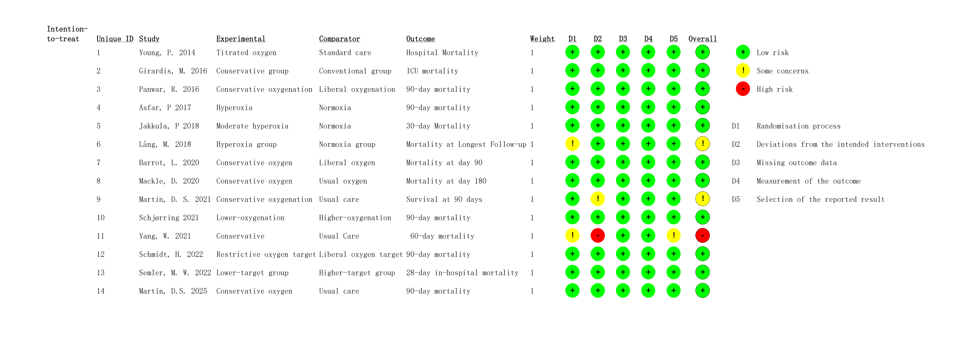
eFigure 2. GRADE Assessment for Mortality
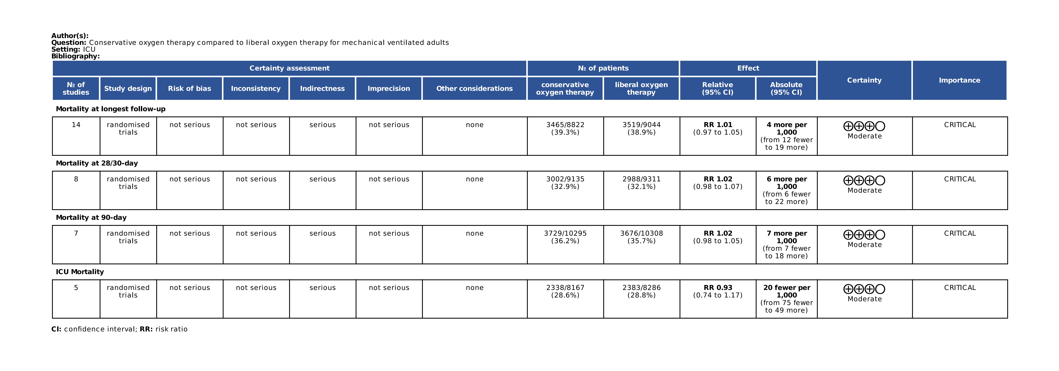

eFigure 3. Funnel plot for Mortality at Longest Follow-up
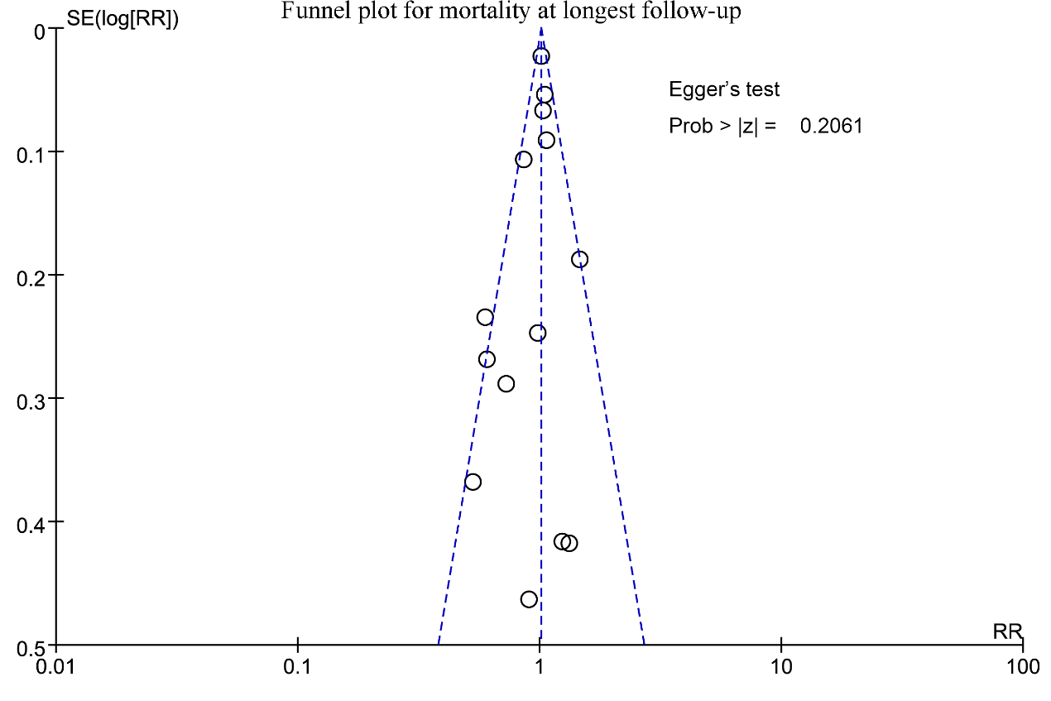

eFigure 4. Leave-one-out Meta-analysis for Mortality at Longest Follow-up
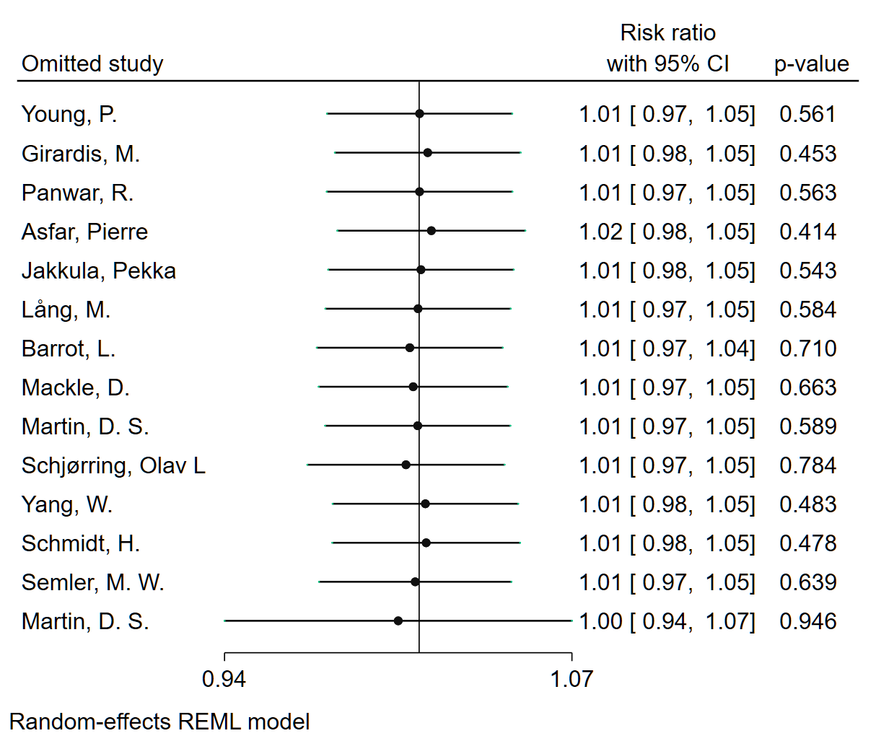

eFigure 5. TSA with 10% RRR for mortality outcomes and cardiac adverse events. (a) Mortality at longest follow-up, (b) mortality at 28/30-day, (c) mortality at 90-day, (d) ICU mortality, and (e) overall cardiovascular adverse events.
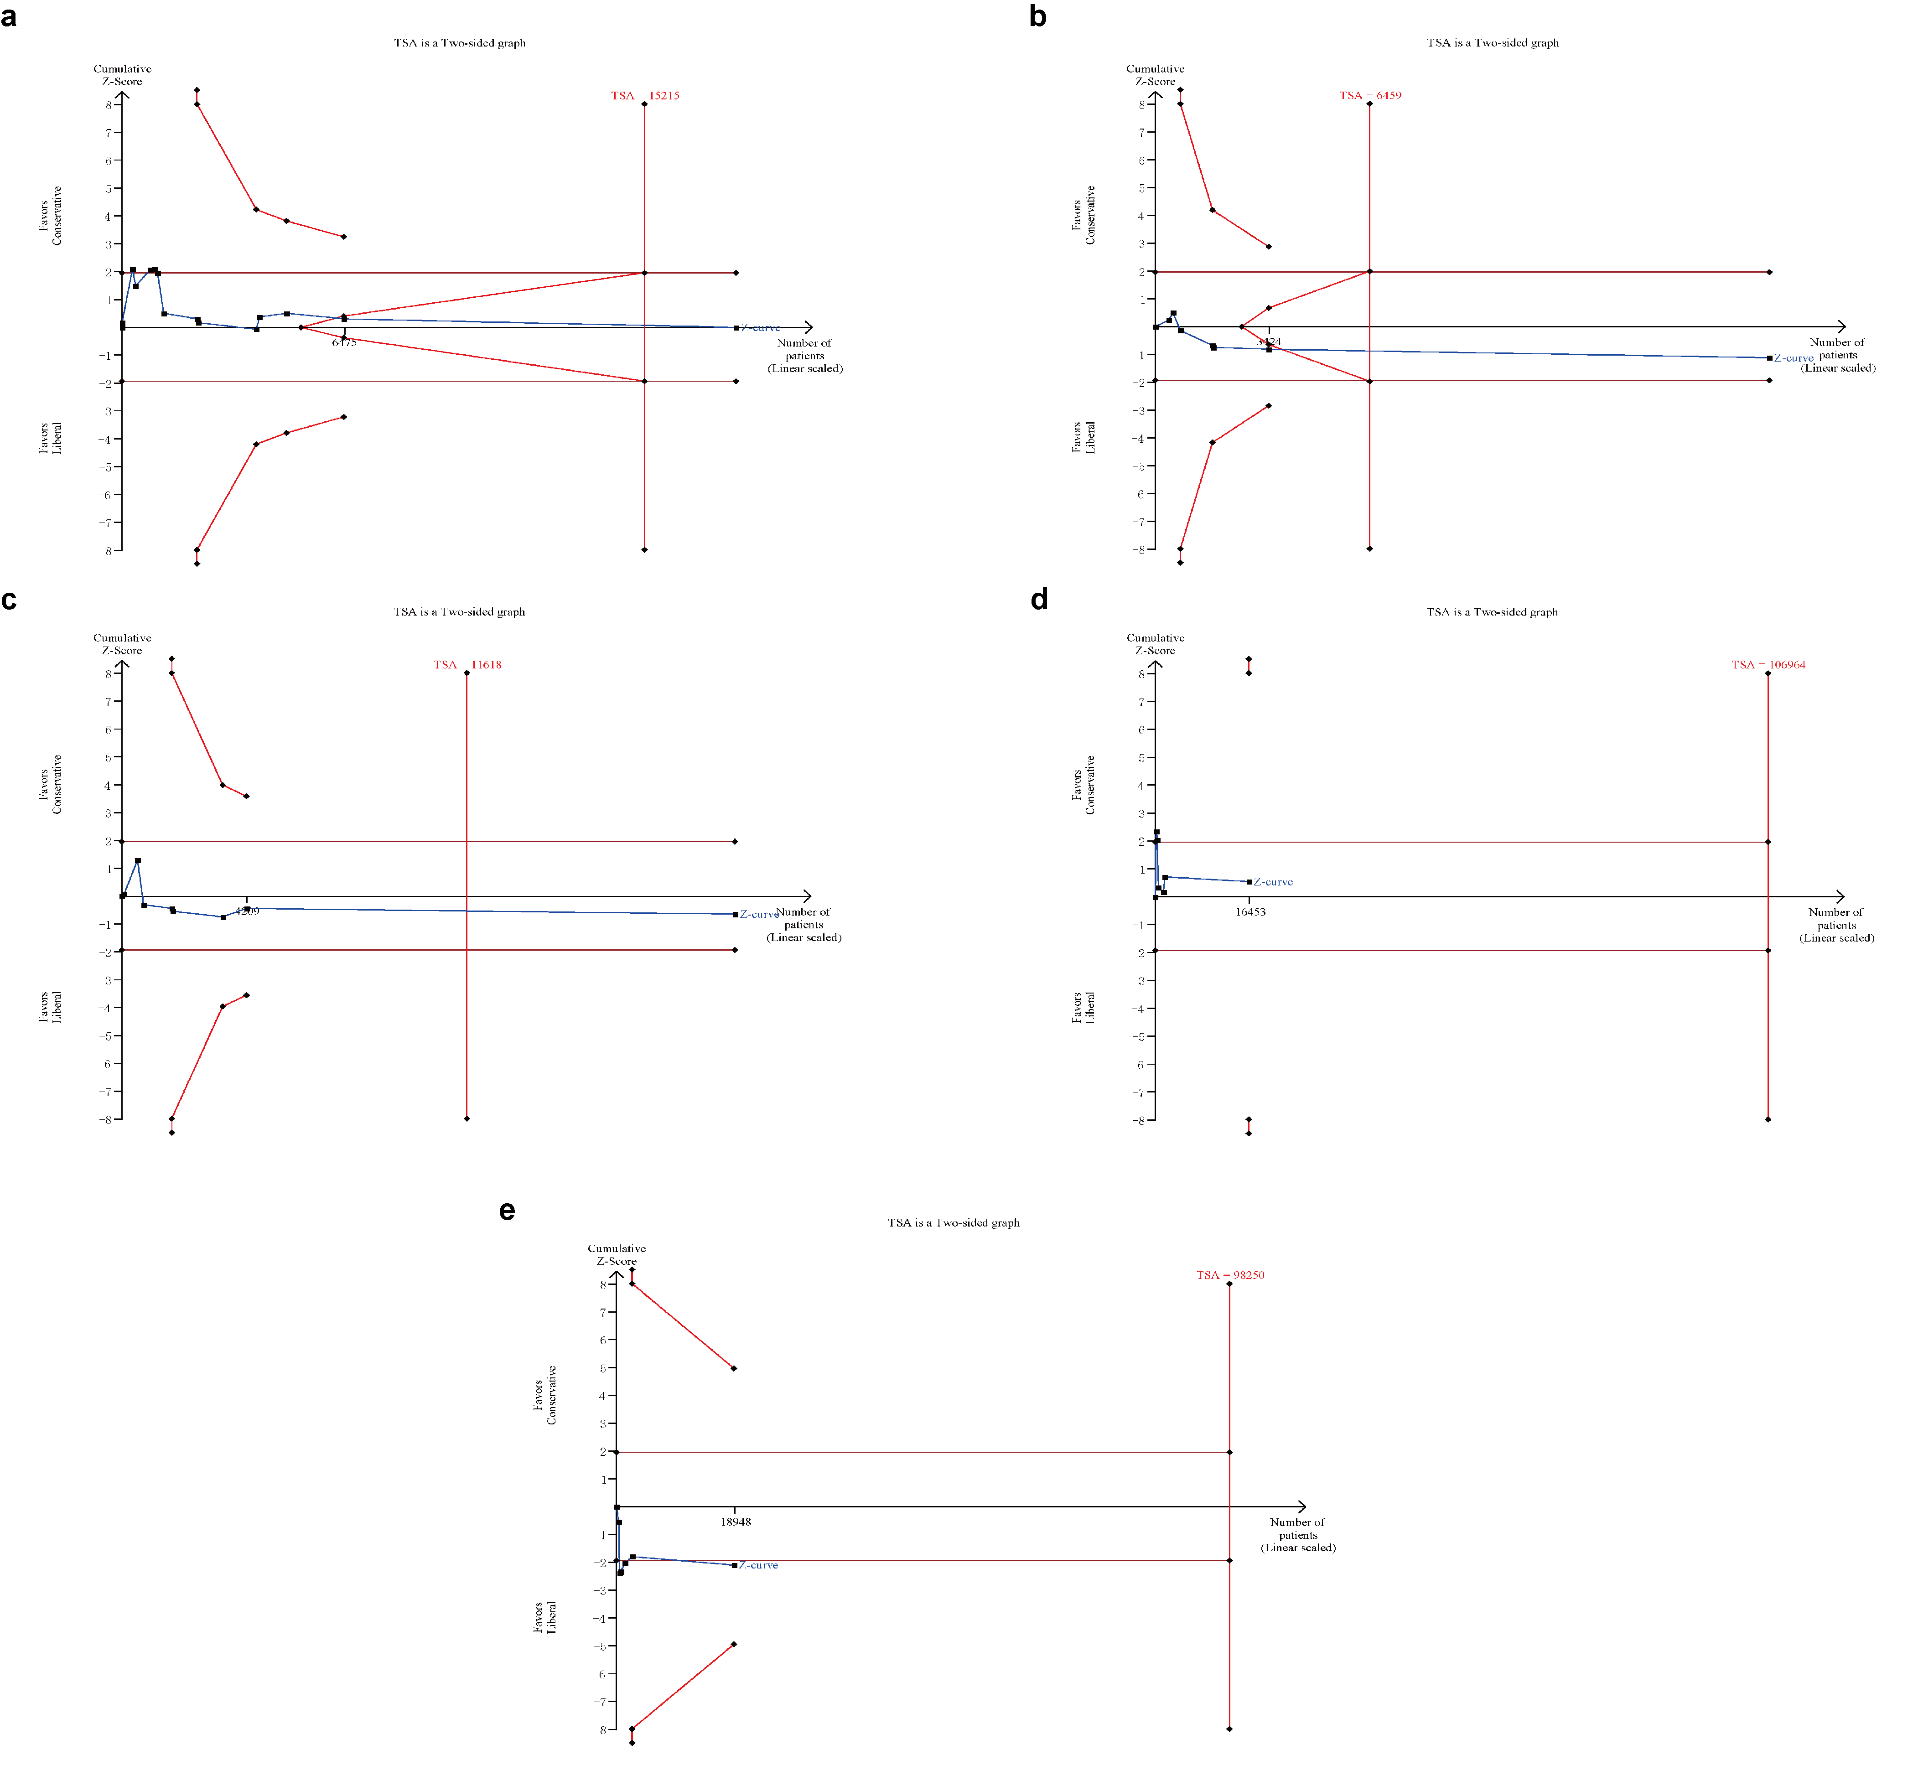

eFigure 6. TSA with 20% RRR for (a) Gastrointestinal Adverse Events, (c) Neurological Adverse Events, (e) Respiratory Adverse Events; and 10% RRR for (b) Gastrointestinal Adverse Events, (d) Neurological Adverse Events, (f) Respiratory Adverse Events.
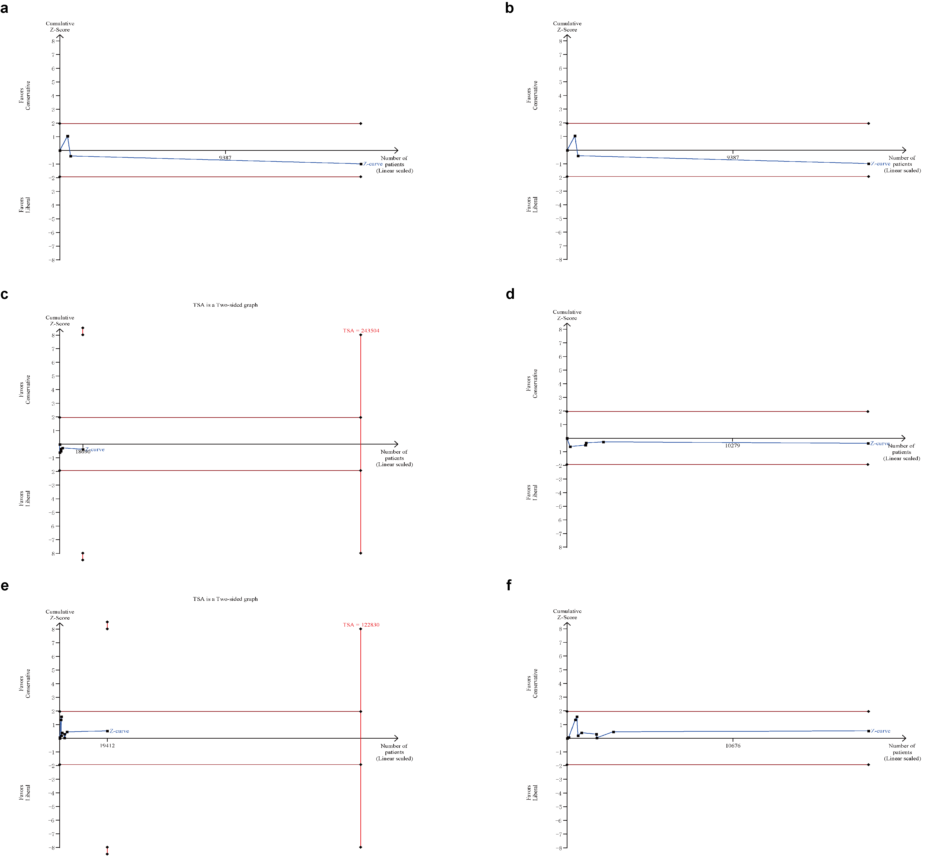

References
1. Asfar, P., et al., Hyperoxia and hypertonic saline in patients with septic shock (HYPERS2S): a two-by-two factorial, multicentre, randomised, clinical trial. The Lancet Respiratory Medicine, 2017. 5(3): p. 180–190.
2. Lång, M., et al., A pilot study of hyperoxemia on neurological injury, inflammation and oxidative stress. Acta Anaesthesiol Scand, 2018. 62(6): p. 801–810.
3. Semler, M.W., et al., Oxygen-Saturation Targets for Critically Ill Adults Receiving Mechanical Ventilation. N Engl J Med, 2022. 387(19): p. 1759–1769.
4. Martin, D.S., et al., Conservative oxygen therapy in mechanically ventilated critically ill adult patients: the UK-ROX randomized clinical trial. JAMA, 2025.
5. Barrot, L., et al., Liberal or Conservative Oxygen Therapy for Acute Respiratory Distress Syndrome. N Engl J Med, 2020. 382(11): p. 999–1008.
6. Investigators, I.-R., et al., Conservative Oxygen Therapy during Mechanical Ventilation in the ICU. N Engl J Med, 2020. 382(11): p. 989–998.
7. Martin, D.S., et al., A feasibility randomised controlled trial of targeted oxygen therapy in mechanically ventilated critically ill patients. Journal of the Intensive Care Society, 2021. 22(4): p. 280–287.
8. Panwar, R., et al., Conservative versus Liberal Oxygenation Targets for Mechanically Ventilated Patients. A Pilot Multicenter Randomized Controlled Trial. Am J Respir Crit Care Med, 2016. 193(1): p. 43–51.
9. Jakkula, P., et al., Targeting two different levels of both arterial carbon dioxide and arterial oxygen after cardiac arrest and resuscitation: a randomised pilot trial. Intensive care medicine, 2018. 44: p. 2112–2121.
10. Schmidt, H., et al., Oxygen Targets in Comatose Survivors of Cardiac Arrest. New England Journal of Medicine, 2022. 387(16): p. 1467–1476.

