Supplementary materials

Supplemental Table 1. Data sources
Source type | Source
Electronic databases (all via Ovid unless otherwise stated) | - MEDLINE and MEDLINE In-Process  - Embase  - Cochrane Central Register of Controlled Trials (CENTRAL)
Other sources | Hand-searching the bibliographies of relevant systematic literature reviews/meta-analyses identified by the sponsor
Clinical trial registries | ClinicalTrials.gov was searched to identify ongoing clinical trials and/or trials with results not published elsewhere.

Supplemental Table 2. Search strategies
Search strategy – structure and sources
Eligibility criteria | Search criteria | Source
Population | Exploded heading surgical procedures, operative/to capture the various surgical options | -
Intervention | Fibrinogen concentrate | -
Comparators | Cryoprecipitate (included as a keyword; not available as a Medical Subject Heading) | -
Outcomes | [No terms] | -
Study design | - Randomized controlled trial design terms  - Additional design terms: “pragmatic” and “pilot” | Cochrane 2024
Date restrictions | 2009 to present | -
Language restrictions | [No terms] | -
Other limits | Removal of non-human animal studies | -

Embase search strategy (via Ovid) – search date: February 28, 2025
# | Search terms | Search hits
1 | exp fibrinogen concentrate/ | 1,601
2 | (fibrinogen adj3 concentrate*).tw. | 1,589
3 | (riastap* or haemocomplettan).tw. | 315
4 | (fybriga or fibclot or fibryga or Intercept fibrinogen complex).tw. | 91
5 | or/1-4 | 2,227
6 | exp cryoprecipitate/ | 6,423
7 | (cryoprecipitate* or ristofact).tw. | 5,098
8 | (cryo* and AHF).tw. | 65
9 | (intercept and cryo*).tw. | 60
10 | or/6-9 | 8,169
11 | 5 and 10 | 611
12 | exp surgery/ | 6,380,281
13 | (surg* or operative or operation* or procedure* or bleed* or coagul*).tw. | 5,580,513
14 | su.fs. | 2,474,277
15 | or/12-14 | 9,026,056
16 | 11 and 15 | 555
17 | Randomization/ | 100,166
18 | Double Blind Procedure/ or Single Blind Procedure/ | 283,563
19 | Placebo/ | 421,964
20 | Control Group/ | 109,439
21 | Crossover Procedure/ | 81,031
22 | (random* or sham or placebo*).ti,ab,hw,kf. | 2,787,075
23 | ((singl* or doubl* or tripl* or trebl*) adj (blind* or dumm* or mask*)).ti,ab,hw,kf. | 389,500
24 | (control* adj3 (study or studies or trial* or group*)).ti,ab,hw,kf. | 11,923,139
25 | ((crossover or cross-over) adj3 (study or studies or trial*)).ti,ab,hw,kf. | 73,645
26 | ((equivalence or superiority or non-inferiority or noninferiority or pragmatic or pilot*) adj3 (study or studies or trial*)).ti,ab,hw,kf. | 326,395
27 | or/17-26 | 12,947,795
28 | 16 and 27 | 239
29 | limit 28 to yr=2009-Current | 232

MEDLINE search strategy (via Ovid) – search date: February 28, 2025
# | Search terms | Search hits
1 | fibrinogen/ | 35,339
2 | (fibrinogen adj3 concentrate*).ti,ab. | 839
3 | (riastap* or haemocomplettan).ti,ab. | 36
4 | (fybriga or fibclot or fibryga or Intercept fibrinogen complex).ti,ab. | 21
5 | or/1-4 | 35,654
6 | (cryoprecipitate* or ristofact).ti,ab. | 2,848
7 | (cryo* and AHF).ti,ab. | 40
8 | (intercept and cryo*).ti,ab. | 29
9 | or/6-8 | 2,874
10 | 5 and 9 | 636
11 | exp surgical procedures, operative/ | 3,701,428
12 | (surg* or operative or operation* or procedure* or bleed* or coagul*).ti,ab. | 4,176,752
13 | su.fs. | 2,372,290
14 | or/11-13 | 6,650,369
15 | 10 and 14 | 459
16 | exp randomized controlled trial/ | 634,093
17 | controlled clinical trial.pt. | 95,679
18 | randomized.ab. | 680,846
19 | placebo.ab. | 256,213
20 | drug therapy.fs. | 2,784,187
21 | randomly.ab. | 453,711
22 | trial.ab. | 739,297
23 | groups.ab. | 2,811,986
24 | or/16-23 | 6,212,749
25 | exp animals/ not humans/ | 5,309,750
26 | 24 not 25 | 5,443,632
27 | (pragmatic or pilot).ti,ab. | 247,200
28 | 26 or 27 | 5,593,824
29 | 15 and 28 | 167
30 | limit 29 to yr="2009 -Current" | 115

Cochrane Central Register of Controlled Trials search strategy (via Evidence-Based Medicine Reviews) – search date: February 28, 2025
# | Search terms | Search hits
1 | fibrinogen/ | 1,497
2 | (fibrinogen adj3 concentrate*).ti,ab. | 291
3 | (riastap* or haemocomplettan).ti,ab. | 61
4 | (fybriga or fibclot or fibryga or Intercept fibrinogen complex).ti,ab. | 19
5 | or/1-4 | 1,734
6 | (cryoprecipitate* or ristofact).ti,ab. | 292
7 | (cryo* and AHF).ti,ab. | 1
8 | (intercept and cryo*).ti,ab. | 2
9 | or/6-8 | 293
10 | 5 and 9 | 116
11 | exp surgical procedures, operative/ | 175,080
12 | (surg* or operative or operation* or procedure* or bleed* or coagul*).ti,ab. | 449,656
13 | su.fs. | 89,761
14 | or/11-13 | 527,039
15 | 10 and 14 | 112
16 | limit 15 to yr="2009 -Current" | 100

Supplemental Table 3. PICOS inclusion/exclusion criteria
Inclusion criteria | Exclusion criteria
Population*
- Patients with surgical bleeding (elective surgery)  - Subgroups of interest:  - Age: adults vs. pediatrics*  - Type of surgery | - Trauma patients undergoing surgery (tagged at title and abstract screening for later retrieval, but were not included)  - Post-partum hemorrhage  - Populations not listed in the inclusion criteria column  - Studies evaluating a mixed population, but results were not reported for relevant types of post-surgery bleeding
Interventions
Fibrinogen | Any other than those listed
Comparisons
Head-to-head comparisons of cryoprecipitate | Dose-finding or dose-comparison studies
Outcomes
Safety:  - Mortality (all-cause and operative)  - AEs (all-cause and serious)  - Select individual AEs: blood transfusion reactions (e.g., transfusion-related acute lung injury, transfusion-associated circulatory overload)  - TEEs (frequency/severity) including:  - Acute myocardial infarction  - Stroke (hemorrhagic or ischemic)  - Transient ischemic attack  - Peripheral artery occlusion  - Deep venous thrombosis  - Pulmonary embolism  - Re-bleeding  - Length of hospital/ICU stay | - Any other outcome data  - Only qualitatively described results (e.g., a p-value without any quantitative data)
Study design
- RCTs | - Non-randomized/single-arm trials  - Non-SLRs (e.g., targeted and narrative reviews)  - SLRs†  - Non-human studies  - Pharmacodynamic studies  - Preclinical studies  - Case reports  - Commentaries, editorials, and letters  - Consensus reports
Additional limits
Timeframe
- Full texts: since 2009  - Conference abstracts: since 2022 | - Studies published prior to 2009  - Conference abstracts published prior to 2022
Language
English | Full-text articles not published in English
Geography
None | None
*Studies were considered eligible if at least 80% of the study population met the inclusion criteria or if relevant subgroup data were available. The 80% threshold is based on recommendations by Institute for Quality and Efficiency in Health Care [38] and is frequently applied in SLRs for HTA submission.
†Previously published SLRs/meta-analyses/network meta-analyses were used for reference checking only but otherwise were not included in the current SLR (and no data were extracted from these publications) to avoid double-counting of studies.
Abbreviations: AE, adverse event; ICU, intensive care unit; PICOS, population, intervention, comparators, outcomes, and study design; RCT, randomized controlled trial; SLR, systematic literature review; TEE, thromboembolic event.

Supplemental Figure 1. PRISMA diagram
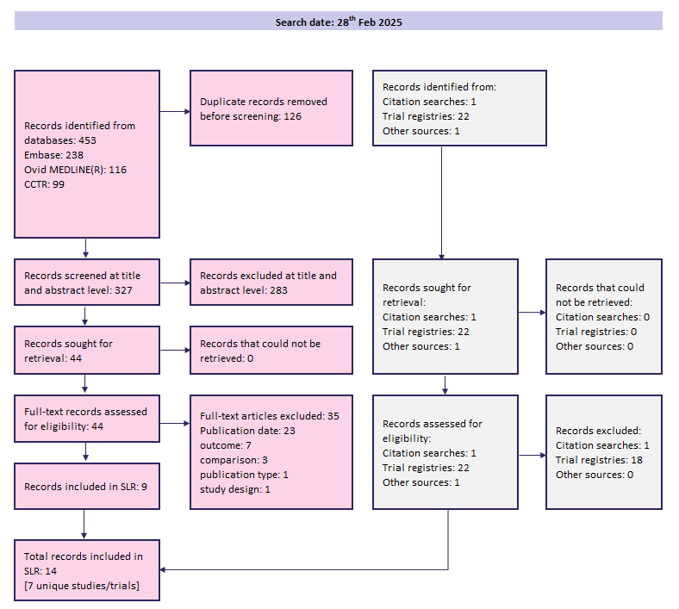
Abbreviations: CCTR, Cochrane Central Register of Controlled Trials; PRISMA, Preferred Reporting Items for Systematic Reviews and Meta-Analyses; SLR, systematic literature review.

Supplemental Table 4. Cochrane Risk of Bias 2.0 assessment
Callum, 2019 [13] | Roy, 2020 [34] | Downey, 2025 [32] | Downey, 2020 [31] | Galas, 2014 [33] | Ayaganov, 2024 [30] | Rahe-Meyer, 2025 [35]
Trial identification
NCT03037424 | 2016‐003749‐27 | NCT03932240 | NCT03014700 | NCT01187225 | - | 2017‐001163‐20
Domain 1. Randomization process
Low | Low | Some concerns | Some concerns | Some concerns | Low | Low
Domain 2. Deviations from intended interventions
Low | Low | Low | Low | Low | Low | Low
Domain 3. Missing outcome data
Low | Low | Low | Low | Low | Low | Low
Domain 4. Measurement of the outcome
Low | Low | Low | Low | Low | Some concerns | Low
Domain 5. Selection of the reported result
Low | Low | Low | Low | Low | Some concerns | Low
Overall
Low | Low | Some concerns | Some concerns | Some concerns | High | Low

Supplemental Table 5. Overview of definitions of all thromboembolic events across studies
Publication | Definition of all thromboembolic events
Galas, 2014 [33] | Stroke/deep vein thrombosis/pulmonary embolism/arterial occlusion/death
Callum, 2019 [13] | Any of: stroke, transient ischemic attack, deep vein thrombosis, pulmonary embolism, myocardial infarction, other vessel thrombosis, amaurosis fugax, disseminated intravascular coagulation, thrombophlebitis
Downey, 2020 [31] | Thrombosis requiring intervention
Roy, 2020 [34] | Thromboembolic events
Downey, 2025 [32] | Thrombosis
Rahe-Meyer, 2025 [35] | Thrombosis or thromboembolic events

Supplemental Figure 2. Forest plot of All TEEs – surgery subgroups
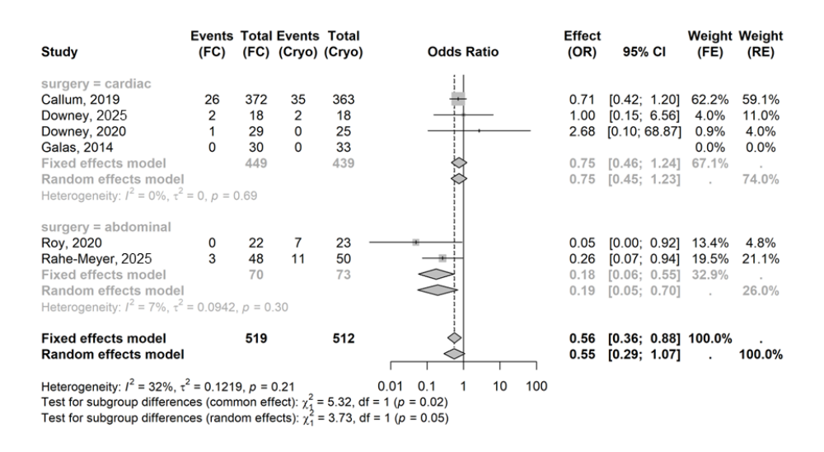
Abbreviations: CI, confidence interval; cryo, cryoprecipitate; FC, fibrinogen concentrate; FE, fixed effects; OR, odds ratio; RE, random effects; TEE, thromboembolic event.

Supplemental Figure 3. Forest plot of All TEEs – age subgroups
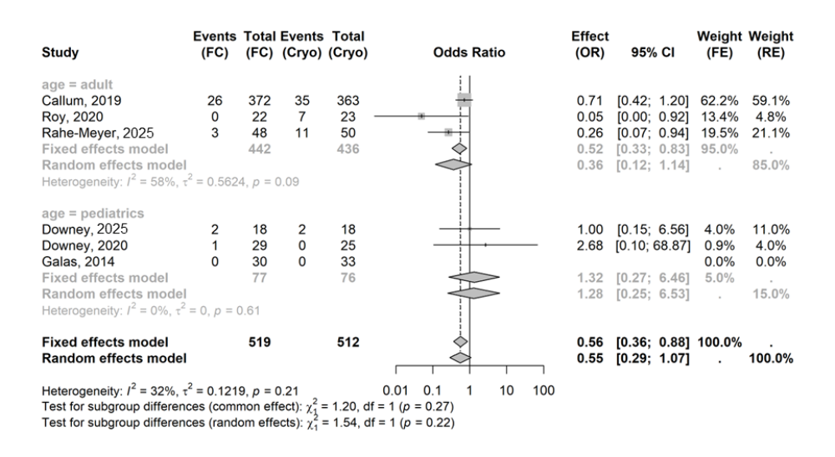
Abbreviations: CI, confidence interval; cryo, cryoprecipitate; FC, fibrinogen concentrate; FE, fixed effects; OR, odds ratio; RE, random effects; TEE, thromboembolic event.

Supplemental Figure 4. Forest plot of All TEEs – sensitivity analysis 1: excluding Callum 2019
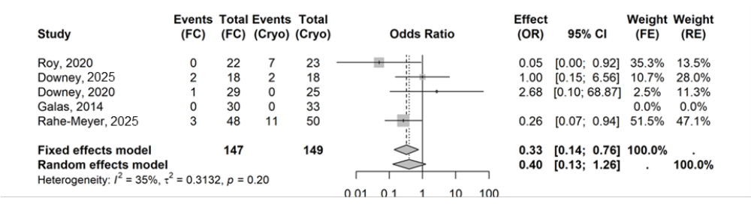
Abbreviations: CI, confidence interval; cryo, cryoprecipitate; FC, fibrinogen concentrate; FE, fixed effects; OR, odds ratio; RE, random effects; TEE, thromboembolic event.

Supplemental Figure 5. Forest plot of All TEEs – sensitivity analysis 2: use per-protocol population in Downey 2025
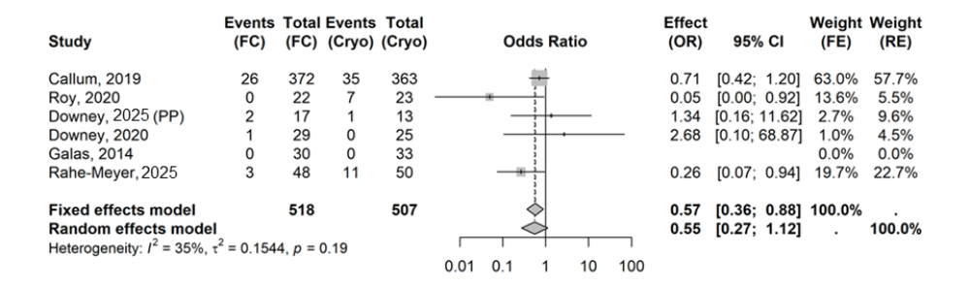
Abbreviations: CI, confidence interval; cryo, cryoprecipitate; FC, fibrinogen concentrate; FE, fixed effects; OR, odds ratio; PP, per protocol; RE, random effects; TEE, thromboembolic event.

Supplemental Figure 6. Forest plot of All TEEs – sensitivity analysis 3: Hartung-Knapp adjustment for RE models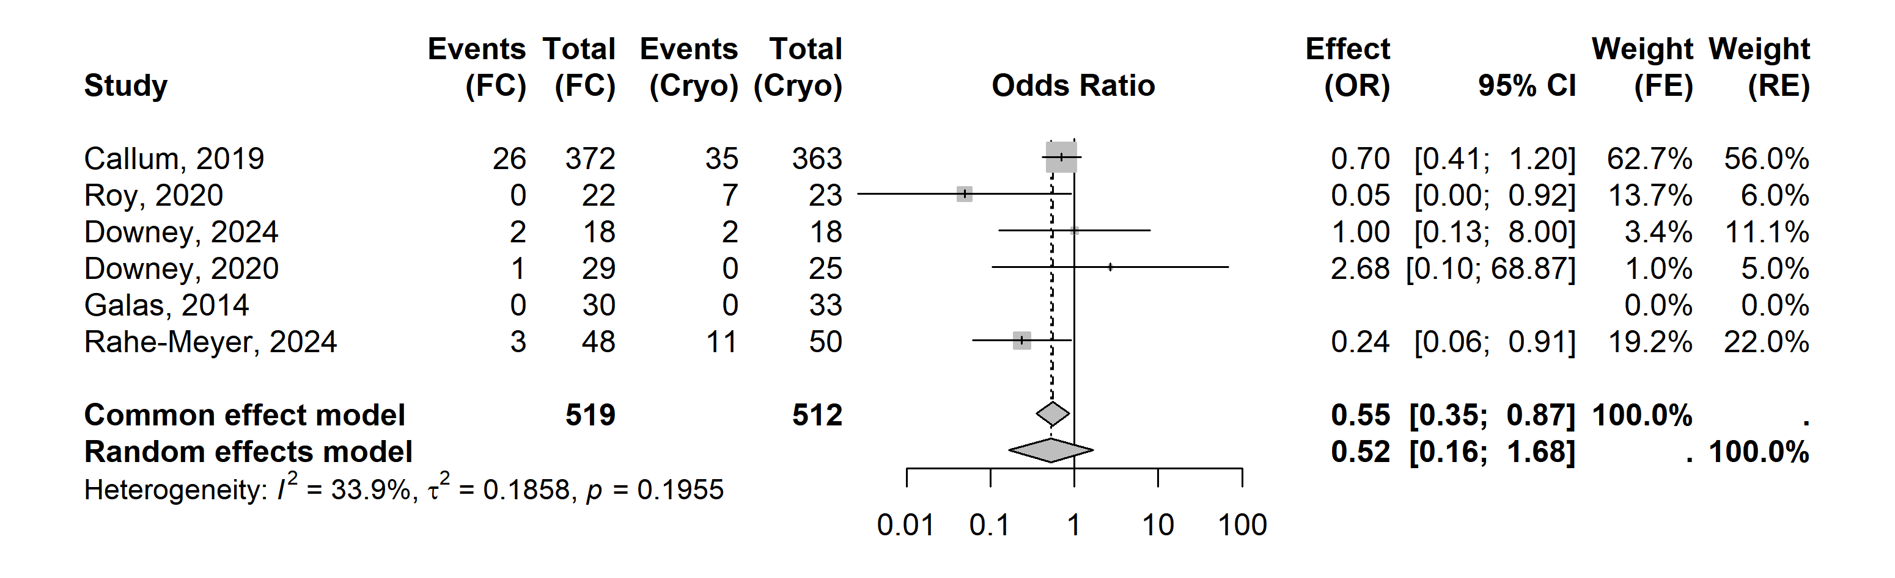
Abbreviations: CI, confidence interval; cryo, cryoprecipitate; FC, fibrinogen concentrate; FE, fixed effects; OR, odds ratio; RE, random effects; TEE, thromboembolic event.

Supplemental Figure 7. Forest plot of All TEEs – sensitivity analysis 4: Peto OR
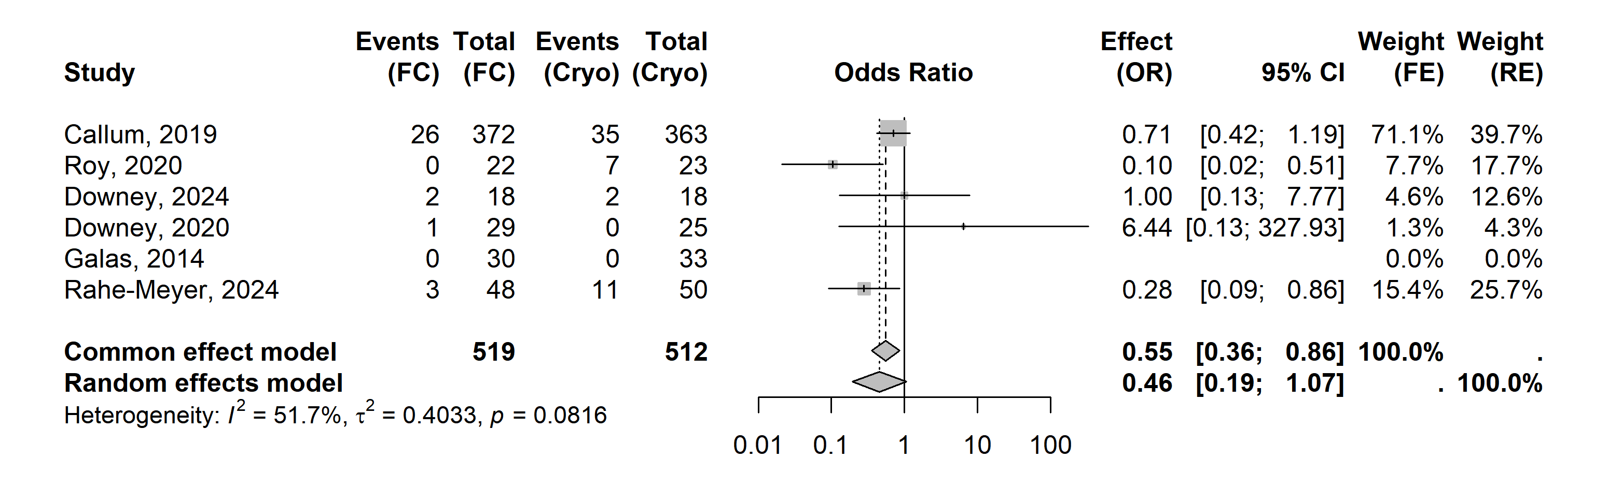
Abbreviations: CI, confidence interval; cryo, cryoprecipitate; FC, fibrinogen concentrate; FE, fixed effects; OR, odds ratio; RE, random effects; TEE, thromboembolic event.

Supplemental Figure 8. Forest plot of DVT – surgery subgroups
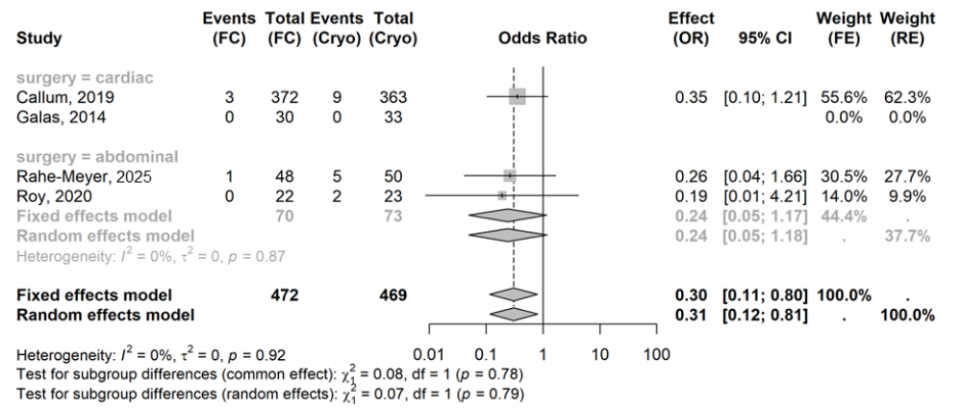
Abbreviations: CI, confidence interval; cryo, cryoprecipitate; DVT, deep vein thrombosis; FC, fibrinogen concentrate; FE, fixed effects; OR, odds ratio; RE, random effects.

Supplemental Figure 9. Forest plot of DVT – sensitivity analysis 1: excluding Callum 2019
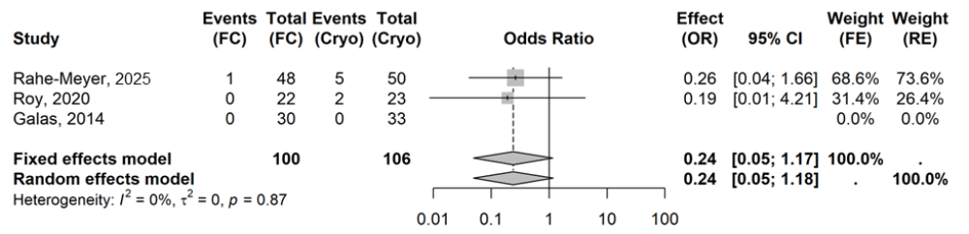
Abbreviations: CI, confidence interval; cryo, cryoprecipitate; DVT, deep vein thrombosis; FC, fibrinogen concentrate; FE, fixed effects; OR, odds ratio; RE, random effects.

Supplemental Figure 10. Forest plot of DVT – sensitivity analysis 2: Hartung-Knapp adjustment for RE models
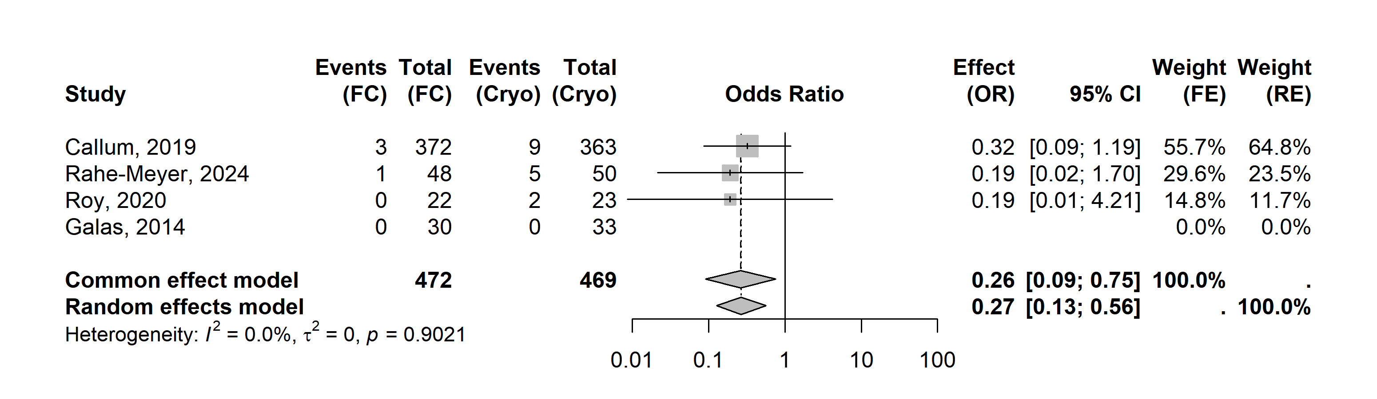
Abbreviations: CI, confidence interval; cryo, cryoprecipitate; DVT, deep vein thrombosis; FC, fibrinogen concentrate; FE, fixed effects; OR, odds ratio; RE, random effects.

Supplemental Figure 11. Forest plot of DVT – sensitivity analysis 3: Peto OR
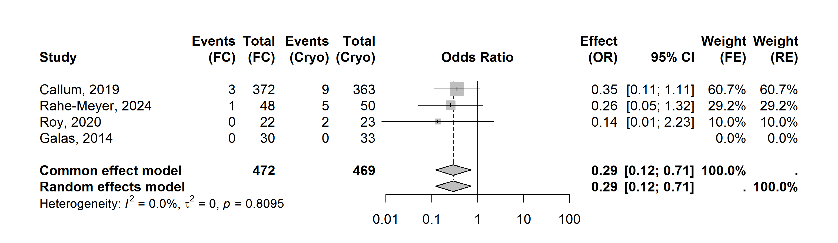
Abbreviations: CI, confidence interval; cryo, cryoprecipitate; DVT, deep vein thrombosis; FC, fibrinogen concentrate; FE, fixed effects; OR, odds ratio; RE, random effects.

Supplemental Figure 12. Forest plot of PE – surgery subgroups
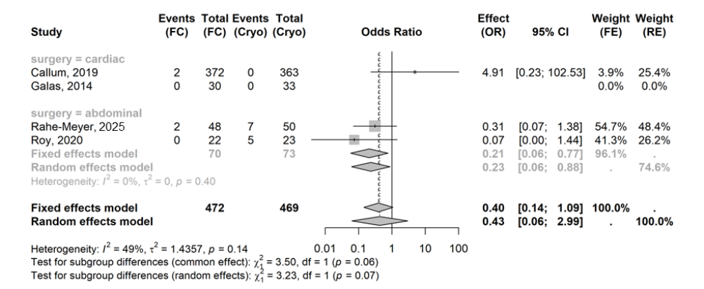
Abbreviations: CI, confidence interval; cryo, cryoprecipitate; FC, fibrinogen concentrate; FE, fixed effects; OR, odds ratio; PE, pulmonary embolism; RE, random effects.

Supplemental Figure 13. Forest plot of PE – sensitivity analysis 1: excluding Callum 2019
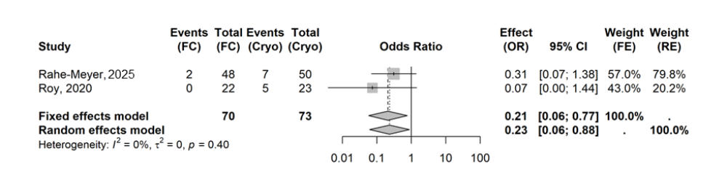
Abbreviations: CI, confidence interval; cryo, cryoprecipitate; FC, fibrinogen concentrate; FE, fixed effects; OR, odds ratio; PE, pulmonary embolism; RE, random effects.

Supplemental Figure 14. Forest plot of PE – sensitivity analysis 2: Hartung-Knapp adjustment for RE models
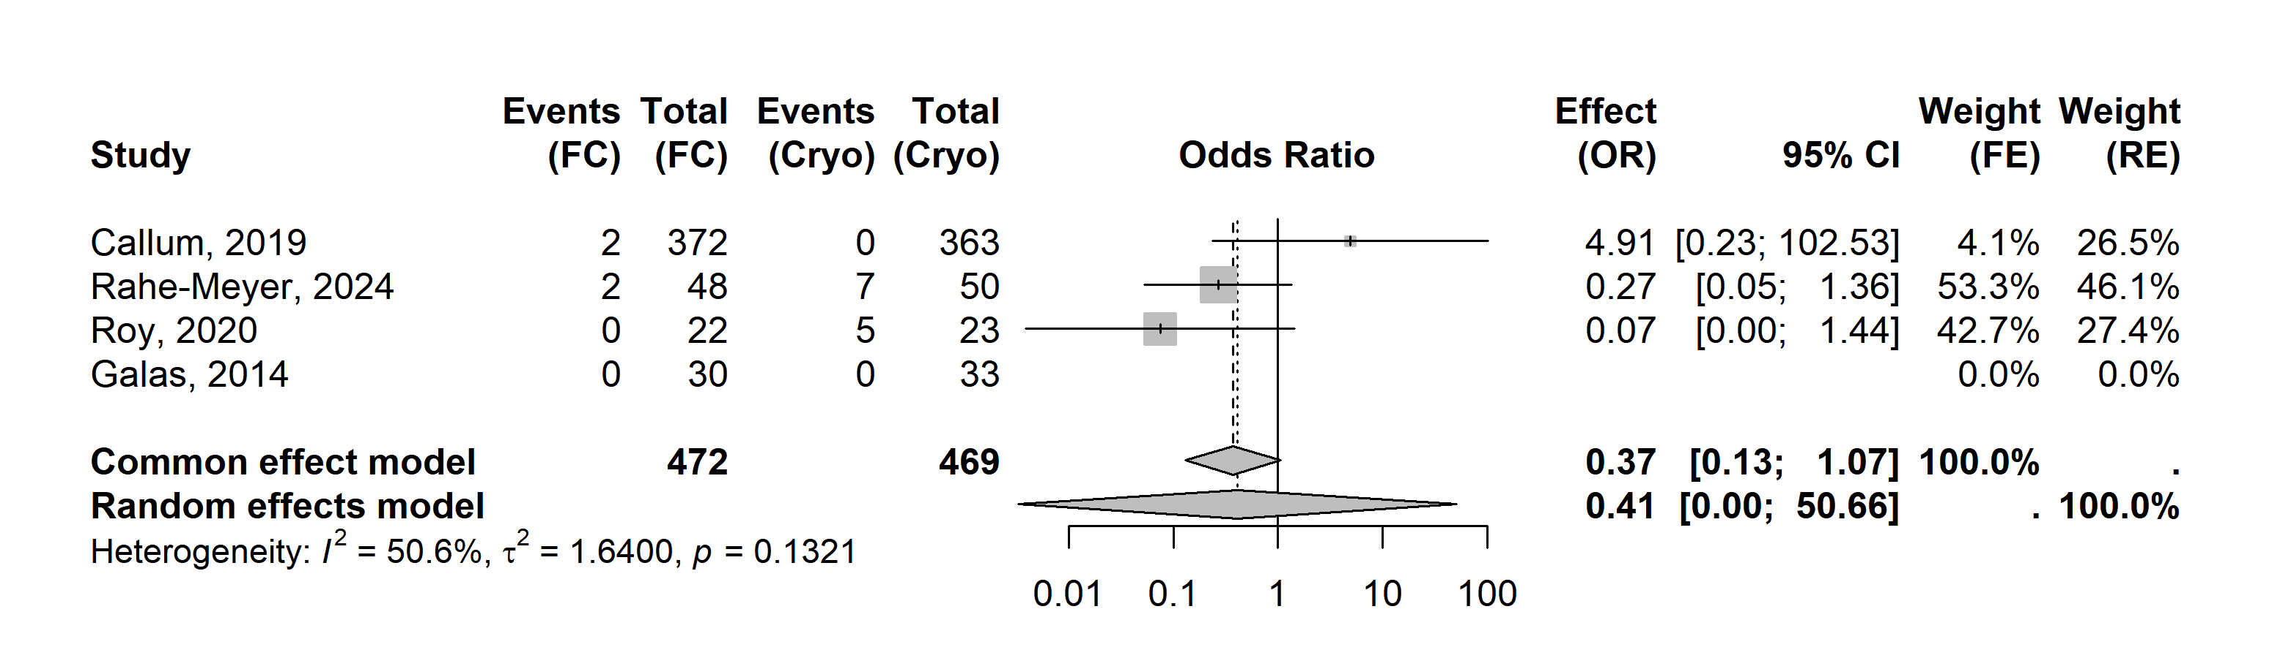
Abbreviations: CI, confidence interval; cryo, cryoprecipitate; FC, fibrinogen concentrate; FE, fixed effects; OR, odds ratio; PE, pulmonary embolism; RE, random effects.

Supplemental Figure 15. Forest plot of PE – sensitivity analysis 3: Peto OR
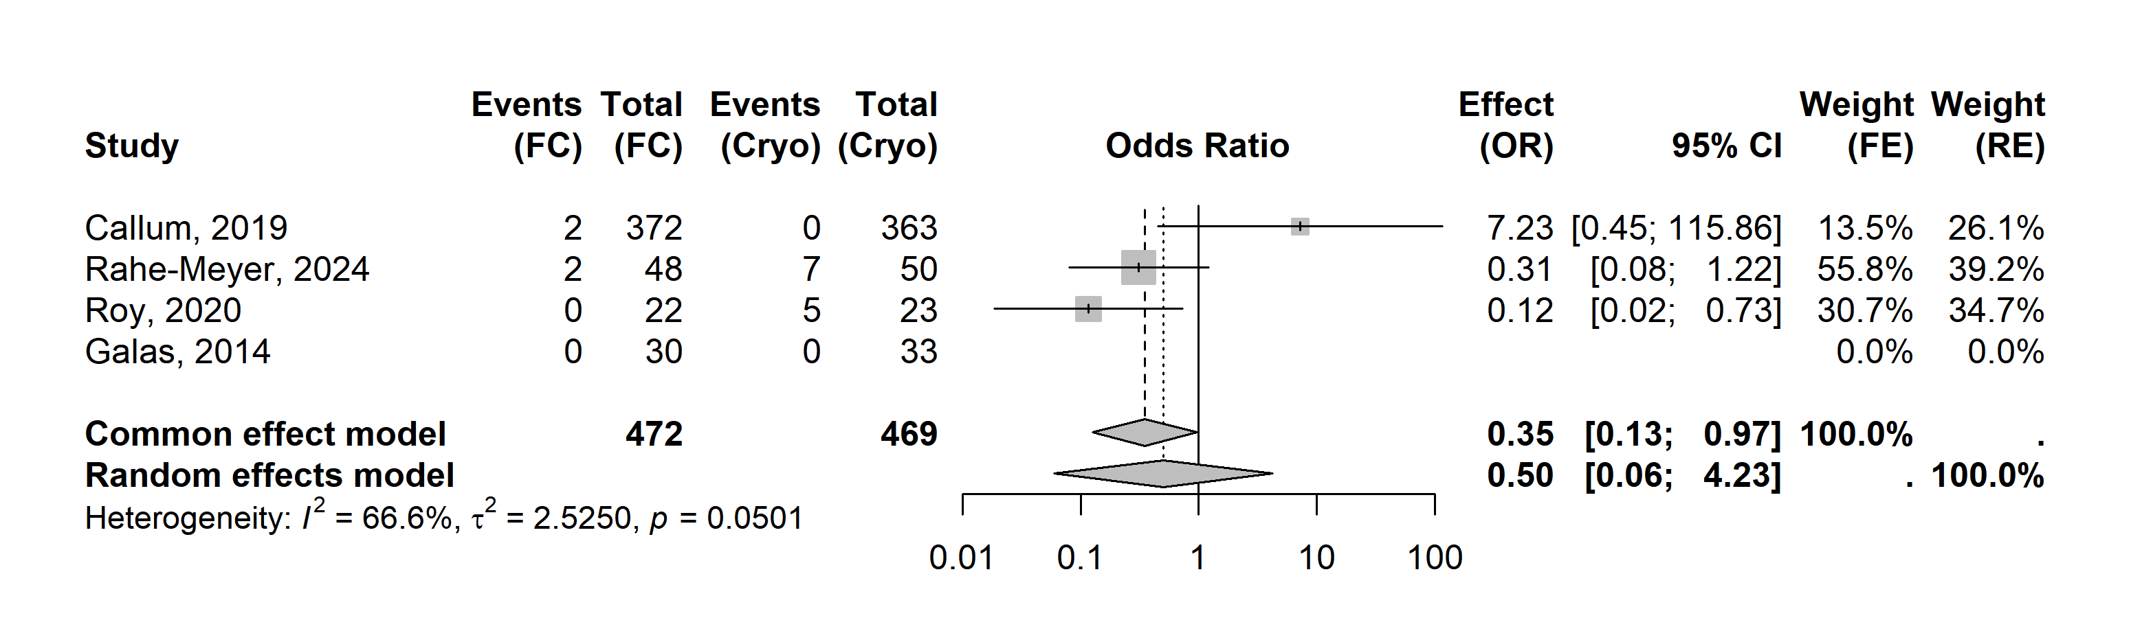
Abbreviations: CI, confidence interval; cryo, cryoprecipitate; FC, fibrinogen concentrate; FE, fixed effects; OR, odds ratio; PE, pulmonary embolism; RE, random effects.

Supplemental Figure 16. Forest plot of Any AEs – surgery subgroups
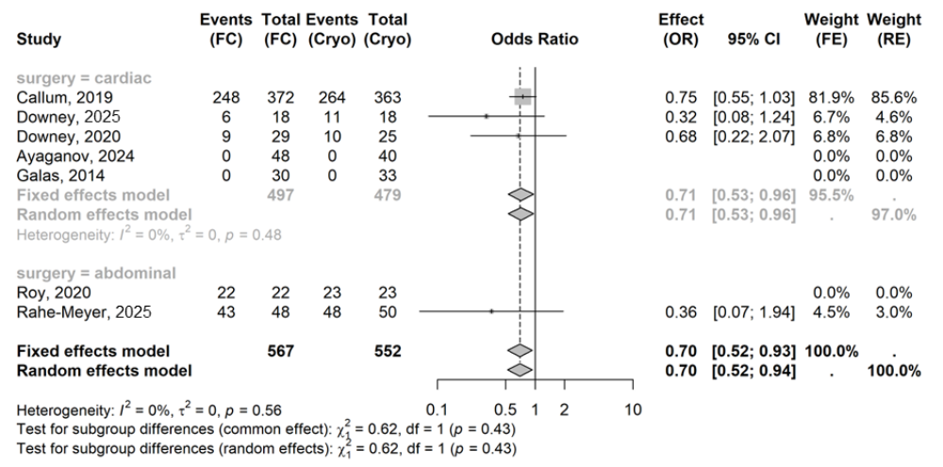
Abbreviations: AE, adverse event; CI, confidence interval; cryo, cryoprecipitate; FC, fibrinogen concentrate; FE, fixed effects; OR, odds ratio; RE, random effects.

Supplemental Figure 17. Forest plot of Any AEs – age subgroups
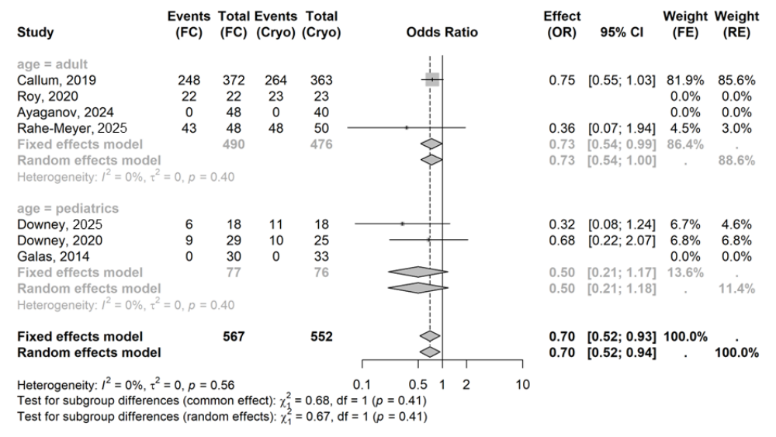
Abbreviations: AE, adverse event; CI, confidence interval; cryo, cryoprecipitate; FC, fibrinogen concentrate; FE, fixed effects; OR, odds ratio; RE, random effects.

Supplemental Figure 18. Forest plot of Any AEs – sensitivity analysis 1: excluding Callum 2019
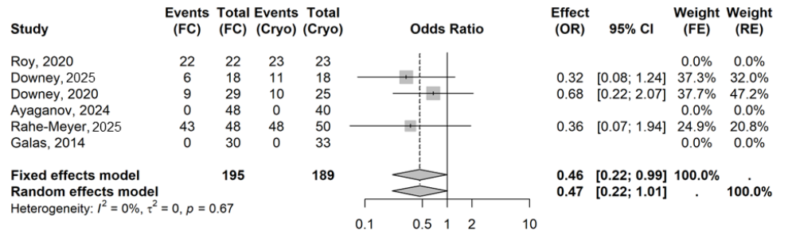
Abbreviations: AE, adverse event; CI, confidence interval; cryo, cryoprecipitate; FC, fibrinogen concentrate; FE, fixed effects; OR, odds ratio; RE, random effects.

Supplemental Figure 19. Forest plot of Any AEs – sensitivity analysis 2: use per-protocol population in Downey 2025
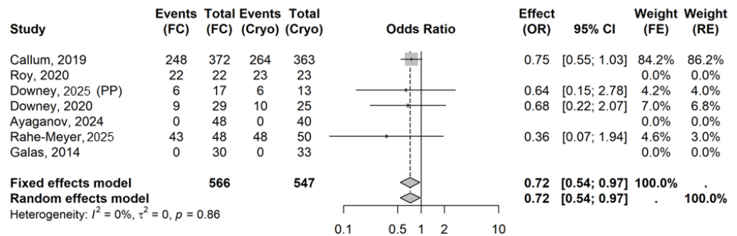
Abbreviations: AE, adverse event; CI, confidence interval; cryo, cryoprecipitate; FC, fibrinogen concentrate; FE, fixed effects; OR, odds ratio; PP, per protocol; RE, random effects.

Supplemental Figure 20. Forest plot of Any AEs – sensitivity analysis 3: excluding Ayaganov 2024
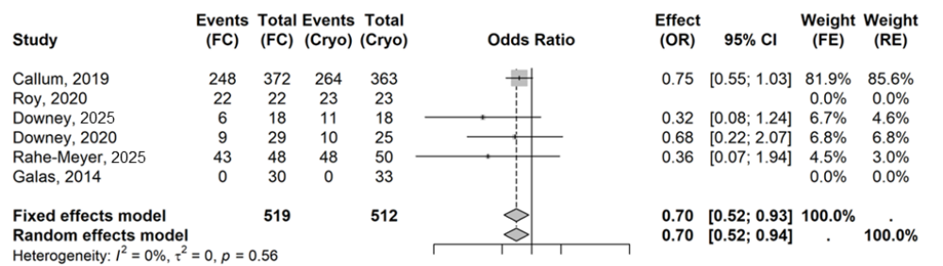
Abbreviations: AE, adverse event; CI, confidence interval; cryo, cryoprecipitate; FC, fibrinogen concentrate; FE, fixed effects; OR, odds ratio; RE, random effects.

Supplemental Figure 21. Forest plot of Any AEs – sensitivity analysis 4: Hartung-Knapp adjustment for RE models
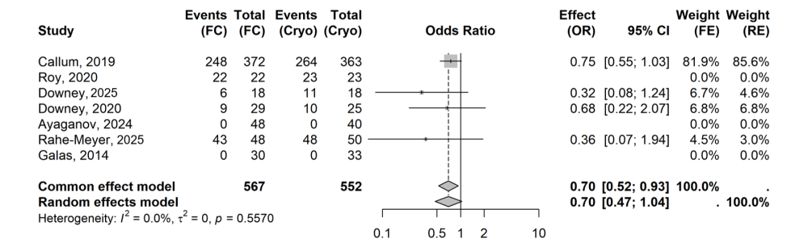
Abbreviations: AE, adverse event; CI, confidence interval; cryo, cryoprecipitate; FC, fibrinogen concentrate; FE, fixed effects; OR, odds ratio; RE, random effects.

Supplemental Figure 22. Forest plot of Any AEs – sensitivity analysis 5: Peto OR
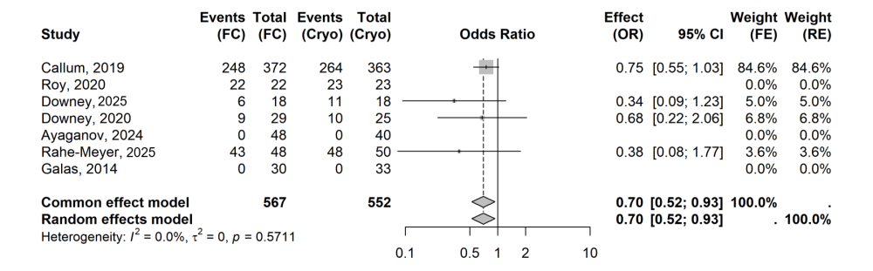
Abbreviations: AE, adverse event; CI, confidence interval; cryo, cryoprecipitate; FC, fibrinogen concentrate; FE, fixed effects; OR, odds ratio; RE, random effects.

Supplemental Figure 23. Forest plot of SAEs – surgery subgroups
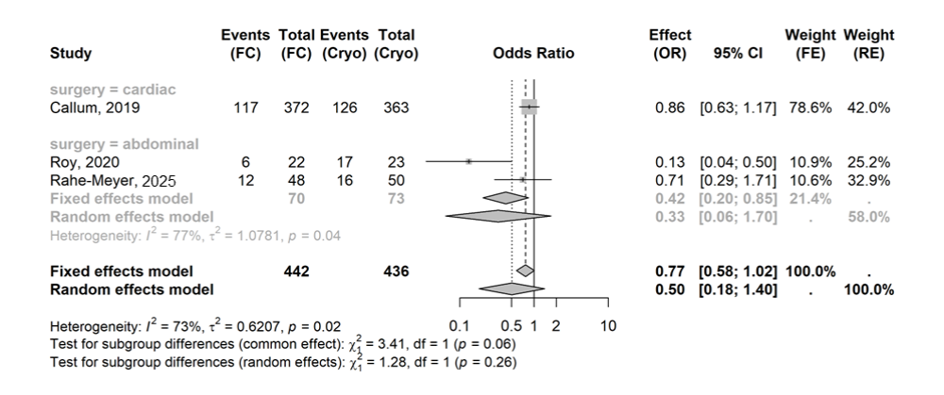
Abbreviations: CI, confidence interval; cryo, cryoprecipitate; FC, fibrinogen concentrate; FE, fixed effects; OR, odds ratio; RE, random effects; SAE, serious adverse event.

Supplemental Figure 24. Forest plot of SAEs – sensitivity analysis 1: excluding Callum 2019
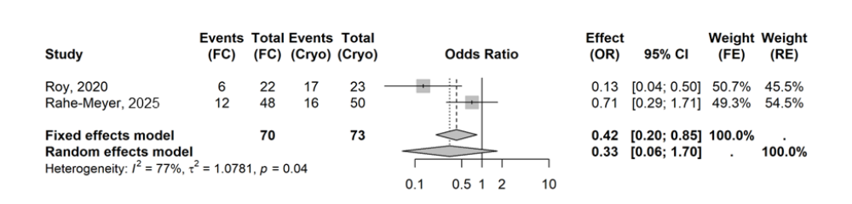
Abbreviations: CI, confidence interval; cryo, cryoprecipitate; FC, fibrinogen concentrate; FE, fixed effects; OR, odds ratio; RE, random effects; SAE, serious adverse event.

Supplemental Figure 25. Forest plot of SAEs – sensitivity analysis 2: Hartung-Knapp adjustment for RE models
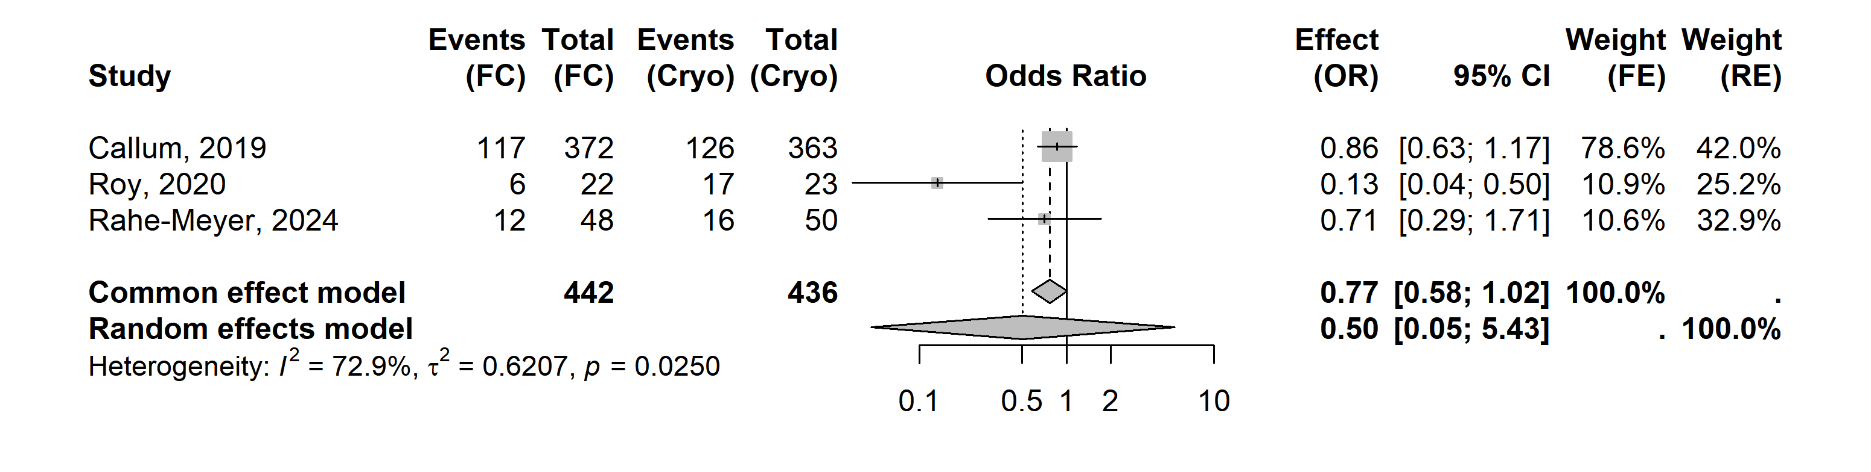Abbreviations: CI, confidence interval; cryo, cryoprecipitate; FC, fibrinogen concentrate; FE, fixed effects; OR, odds ratio; RE, random effects; SAE, serious adverse event.

Supplemental Table 6. Summary of certainty of evidence per Grading of Recommendations Assessment, Development and Evaluation (GRADE)
Certainty assessment |  |  |  |  |  |  | № of patients |  | Effect |  | Certainty | Importance
№ of studies | Study design | Risk of bias | Inconsistency | Indirectness | Imprecision | Other considerations | Fibrinogen concentrate | Cryoprecipitate | Relative  (95% CI) | Absolute  (95% CI) | Certainty | Importance
All TEEs (follow-up: range 4 days to 36 days)
6 | Randomised trials | Not seriousª | Not serious^{b} | not serious^{c} | Serious^{d} | None^{e} | 32/519 (6.2%) | 55/512 (10.7%) | OR 0.55  (0.29 to 1.07) | 5 fewer per 100  (from 7 fewer to 1 more) | ⨁⨁⨁◯  Moderate^{a,b,c,d,e} | CRITICAL
DVT (follow-up: range 7 days to 36 days)
4 | Randomised trials | Not seriousª | Not serious^{f} | Not serious^{c} | Serious^{g} | None^{e} | 4/472 (0.8%) | 16/469 (3.4%) | OR 0.31  (0.12 to 0.81) | 2 fewer per 100  (from 3 fewer to 1 fewer) | ⨁⨁⨁◯  Moderate^{a,c,e,f,g} | CRITICAL
PE (follow-up: range 7 days to 36 days)
4 | Randomised trials | Not seriousª | Serious^{h} | Not serious^{c} | Very serious^{i} | None^{e} | 4/472 (0.8%) | 12/469 (2.6%) | OR 0.43  (0.06 to 2.99) | 1 fewer per 100  (from 2 fewer to 5 more) | ⨁◯◯◯  Very low^{a,c,e,h,i} | CRITICAL
Any AEs (follow-up: range 2 days to 28 days)
7 | Randomised trials | Not seriousª | Not serious^{f} | Not serious^{c} | Not serious^{j} | None^{e} | 328/567 (57.8%) | 356/552 (64.5%) | OR 0.70  (0.52 to 0.94) | 9 fewer per 100  (from 16 fewer to 1 fewer) | ⨁⨁⨁⨁  High^{a,c,e,f,j} | IMPORTANT
SAEs (follow-up: range 28 days to 36 days)^{k}
3 | Randomised trials | Not serious^{l} | Serious^{m} | Not serious^{c} | Very serious^{n} | None^{e} | 135/442 (30.5%) | 159/436 (36.5%) | OR 0.50  (0.18 to 1.40) | 14 fewer per 100  (from 27 fewer to 8 more) | ⨁◯◯◯  Very low^{c,e,l,m,n} | CRITICAL
a. Studies with majority of the weight or all of the weight had a low risk of bias.
b. Statistical heterogeneity was low to moderate (I2=32%, τ2=0.1219, p=0.21). Although point estimates varied in magnitude and one small study favoured cryoprecipitate, confidence intervals overlapped substantially, and the discordant estimate was based on only one event. No downgrade was applied.
c. Because the PICO intentionally includes any patients with bleeding risk, the cardiac and abdominal surgery populations and the adult and paediatric populations fall within the prespecified target population. Their inclusion is not indirect simply because they differ from one another.
d. Downgraded one level for serious imprecision because the random-effects confidence interval was wide and encompassed both a substantial reduction in TEEs and little or no difference between treatments (OR 0.55; 95% CI 0.29–1.07).
e. Publication bias was not strongly suspected because the search included multiple bibliographic databases, reference-list searching and ClinicalTrials.gov to identify ongoing or unpublished trials. Statistical assessment of publication bias was not feasible because fewer than 10 studies contributed to the outcome. No downgrade was applied.
f. No serious inconsistency was identified. Effect estimates were directionally consistent, confidence intervals overlapped.
g. Downgraded one level for serious imprecision because only 20 DVT events occurred across the included studies and the confidence interval remained wide, resulting in substantial uncertainty regarding the magnitude of benefit despite excluding no effect.
h. Downgraded one level for serious inconsistency because effect estimates differed substantially in magnitude and direction across studies, with moderate observed heterogeneity (I2=49%). Although confidence intervals were wide and overlapping, the limited number of studies and events prevented a reliable explanation of the observed variation.
i. Downgraded two levels for very serious imprecision because very few events occurred and the random-effects confidence interval was extremely wide, encompassing a very large reduction in PE, no effect and an approximately threefold increase in PE with FC (OR 0.43; 95% CI 0.06–2.99).
j. No serious imprecision was identified because the confidence interval excluded no effect and did not encompass clinically important harm.
k. Follow-up ranged from 28 to 36 days in studies reporting follow-up; follow-up was not reported in one study.
l. All studies included had a low risk of bias
m. Downgraded one level for serious inconsistency because substantial heterogeneity was present (I2=73%, τ2=0.6207, p=0.02), with treatment-effect estimates differing considerably in magnitude across studies. Although all point estimates favoured FC, the particularly large effect in Roy 2020 was not observed in the other trials.
n. Downgraded two levels for very serious imprecision because the random-effects confidence interval was very wide and encompassed a very large reduction in SAEs, no effect and a potentially clinically important increase in SAEs with FC (OR 0.50; 95% CI 0.18–1.40).
Abbreviations: AE, adverse event; CI, confidence interval; cryo, cryoprecipitate; DVT, deep vein thrombosis; OR, odds ratio; PE, pulmonary embolism; SAE, serious adverse event; TEE, thromboembolic event.

Other outcomes – stroke
In the base case, pooled analysis from three studies [13,31,32] resulted in an odds ratio (OR) of 0.92 (95% confidence interval [CI]: 0.47, 1.77), indicating numerically lower stroke incidence in patients in fibrinogen concentrate (FC) compared with the cryoprecipitate groups.

Supplemental Figure 26. Forest plot of stroke – base case
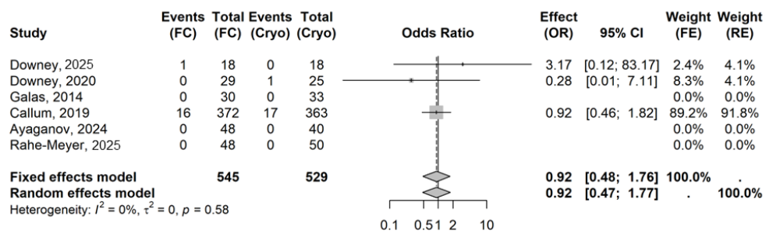
Abbreviations: CI, confidence interval; cryo, cryoprecipitate; FC, fibrinogen concentrate; FE, fixed effects; OR, odds ratio; RE, random effects.

Only subgroup analysis on stroke events in pediatric patients was feasible (based on three studies [31-33]). The pooled OR under the random-effects (RE) model was 0.93 (95% CI: 0.09, 10.15), indicating numerically lower stroke incidence in pediatric patients receiving FC versus cryoprecipitate. This result was similar to base-case analysis but was accompanied by substantial uncertainty, reflected by the wide CI, likely attributable to the small number of events and limited sample size in this subgroup.

Supplemental Figure 27. Forest plot of stroke – age subgroups
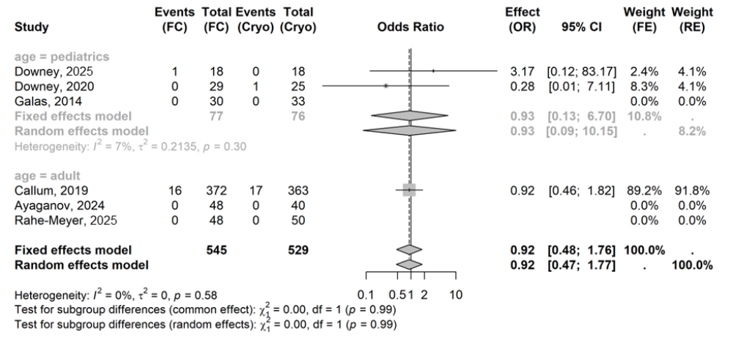
Abbreviations: CI, confidence interval; cryo, cryoprecipitate; FC, fibrinogen concentrate; FE, fixed effects; OR, odds ratio; RE, random effects.

In the sensitivity analysis which excluded Callum 2019 [13], the pooled OR was similar to the base case, indicating the robustness of the base-case analysis.

Supplemental Figure 28. Forest plot of stroke – sensitivity analysis 1: excluding Callum 2019
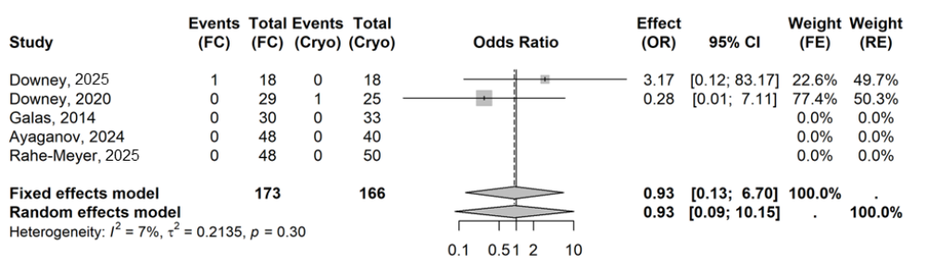
Abbreviations: CI, confidence interval; cryo, cryoprecipitate; FC, fibrinogen concentrate; FE, fixed effects; OR, odds ratio; RE, random effects.

Sensitivity analysis was also conducted by using the per-protocol population instead of the intent-to-treat (ITT) population in Downey 2025 [32]. The result confirmed the robustness of the base-case analysis.

Supplemental Figure 29. Forest plot of stroke – sensitivity analysis 2: use per-protocol population in Downey 2025
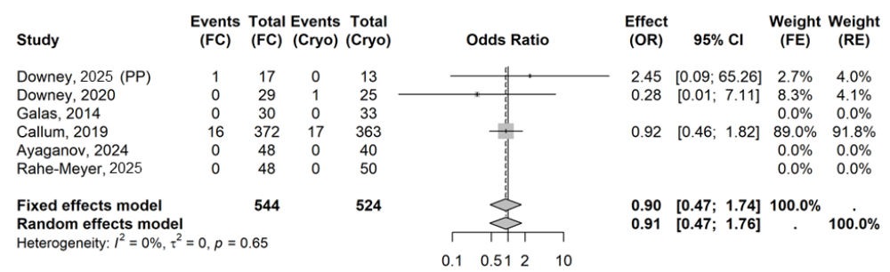
Abbreviations: CI, confidence interval; cryo, cryoprecipitate; FC, fibrinogen concentrate; FE, fixed effects; OR, odds ratio; PP, per protocol; RE, random effects.

Other outcomes – acute myocardial infarction
In the base case, the pooled OR from three studies [13,33,35] for acute myocardial infarction (AMI) was 0.56 (95% CI: 0.18, 1.75), indicating numerically lower AMI incidence in patients in the FC group than the cryoprecipitate group. Due to the limited number of studies included for the AMI outcome, no subgroup or sensitivity analyses were conducted.

Supplemental Figure 30. Forest plot of AMI – base case
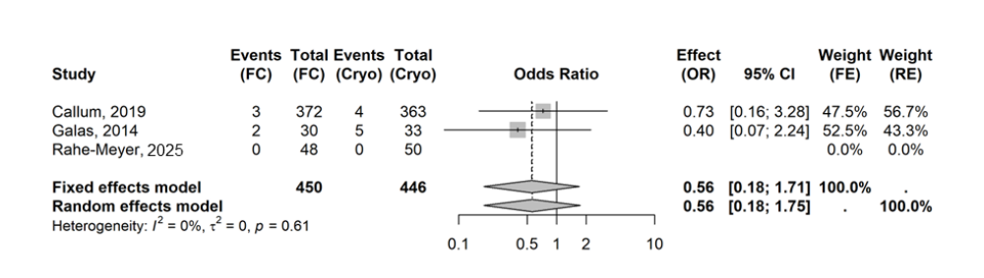
Abbreviations: CI, confidence interval; cryo, cryoprecipitate; FC, fibrinogen concentrate; FE, fixed effects; OR, odds ratio; RE, random effects.

Other outcomes – all-cause mortality
Pooled data from seven studies [13,30-35] showed similar all-cause mortality rates between FC and cryoprecipitate groups in the base case (OR: 1.00 [95% CI: 0.55, 1.81]).

Supplemental Figure 31. Forest plot of all-cause mortality – base case
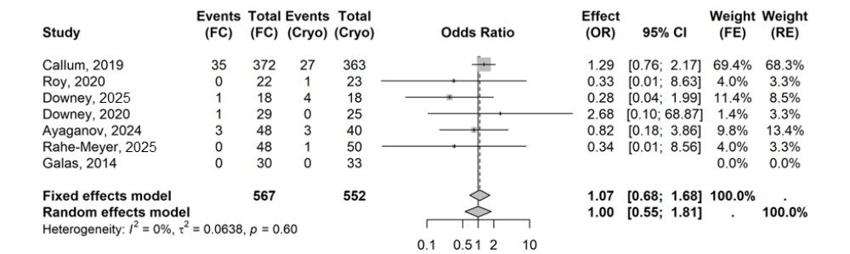
Abbreviations: CI, confidence interval; cryo, cryoprecipitate; FC, fibrinogen concentrate; FE, fixed effects; OR, odds ratio; RE, random effects.

In pooled data from five studies [13,30-33] in the cardiac surgery subgroup, the all-cause mortality rate was numerically higher in the FC group than in the cryoprecipitate group (OR: 1.15 [95% CI: 0.71, 1.84]). In the major abdominal subgroup, pooled analysis of two studies [34,35] estimated an OR of 0.34 (95% CI: 0.03, 3.33), indicating a numerically lower all-cause mortality rate in the patients of the FC group than in the cryoprecipitate group.

Supplemental Figure 32. Forest plot of all-cause mortality – surgery subgroups
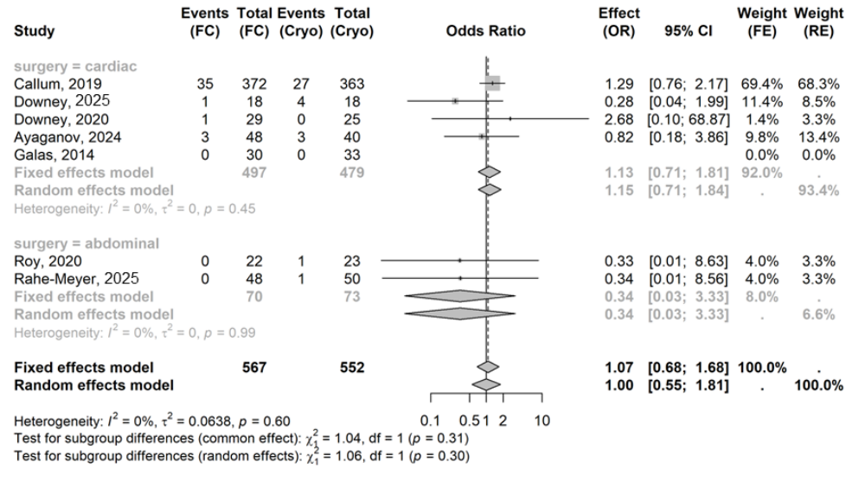
Abbreviations: CI, confidence interval; cryo, cryoprecipitate; FC, fibrinogen concentrate; FE, fixed effects; OR, odds ratio; RE, random effects.

In the adult subgroup based on pooled analysis of four studies [13,30,34,35], the OR was 1.16 (95% CI: 0.72, 1.88), indicating a numerically higher all-cause mortality rate for patients in the FC group than in the cryoprecipitate group. The pooled OR in the adult subgroup was strongly driven by Callum 2019, which contributed the largest weights.
In the pediatric subgroup, the pooled OR was 0.59 (95% CI: 0.07, 4.81), indicating that the all-cause mortality rate was numerically lower in the pediatric patients in the FC group than in the cryoprecipitate group. The point estimates of the two studies [31,32] included in this subgroup were in opposite directions; therefore, these subgroup results should be interpreted with caution.
The subgroup analysis showed inconsistent results within both age and surgery type subgroups corresponding to results from the base-case analysis. The pooled results in the cardiac and adult subgroups were strongly driven by an individual study with a large sample size (Callum 2019 [13]).

Supplemental Figure 33. Forest plot of all-cause mortality – age subgroups
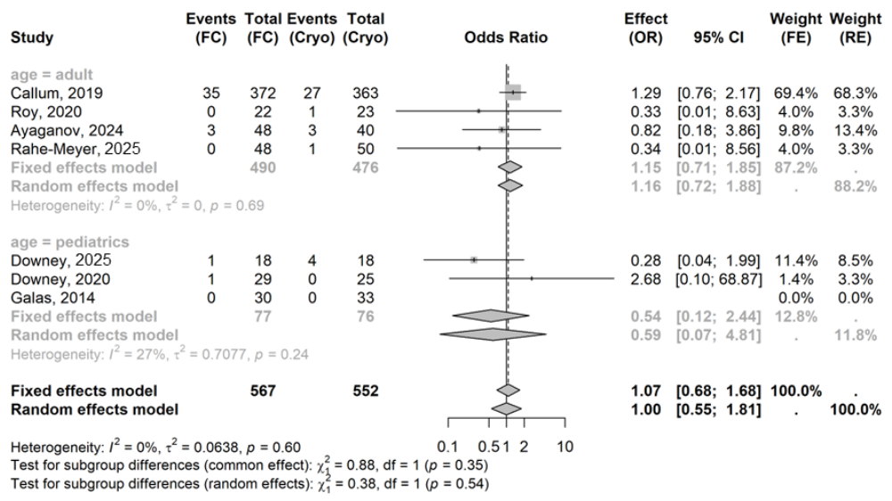
Abbreviations: CI, confidence interval; cryo, cryoprecipitate; FC, fibrinogen concentrate; FE, fixed effects; OR, odds ratio; RE, random effects.

Three sensitivity analyses were conducted. The first, which excluded Callum 2019 [13], showed a pooled OR (0.58 [95% CI: 0.21, 1.61]) shifted slightly in favor FC versus the base case, indicating base-case results were strongly driven by this study. The results of the sensitivity analysis using the per-protocol population in Downey 2025 [32], indicated that this study slightly impacted the base-case results. Finally, in the sensitivity analysis excluding Ayaganov 2024 [30], a slight shift in favor of FC was observed (OR: 0.90 [95% CI: 0.38, 2.10]) compared with the base case, indicating this study slightly impacted the base-case results.

Supplemental Figure 34. Forest plot of all-cause mortality – sensitivity analysis 1: excluding Callum 2019
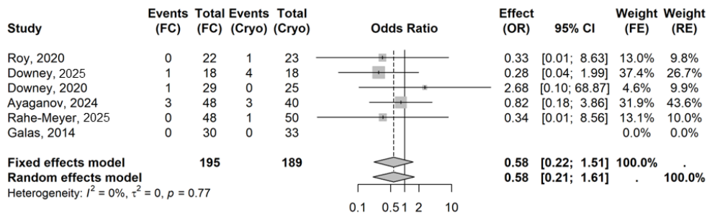
Abbreviations: CI, confidence interval; cryo, cryoprecipitate; FC, fibrinogen concentrate; FE, fixed effects; OR, odds ratio; RE, random effects.

Supplemental Figure 35. Forest plot of all-cause mortality – sensitivity analysis 2: use per-protocol population in Downey 2025
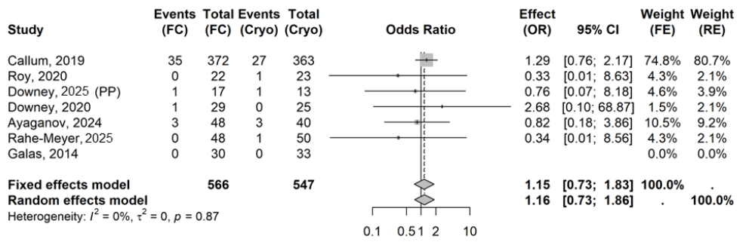
Abbreviations: CI, confidence interval; cryo, cryoprecipitate; FC, fibrinogen concentrate; FE, fixed effects; OR, odds ratio; PP, per-protocol; RE, random effects.

Supplemental Figure 36. Forest plot of all-cause mortality – sensitivity analysis 3: excluding Ayaganov 2024
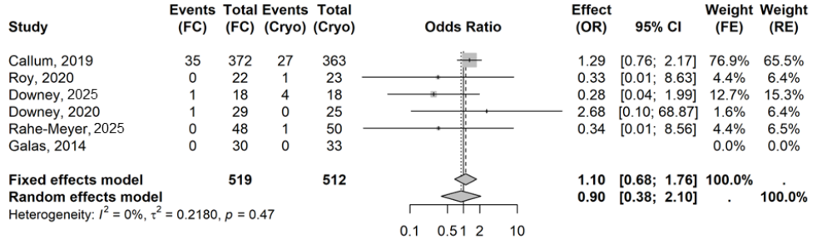
Abbreviations: CI, confidence interval; cryo, cryoprecipitate; FC, fibrinogen concentrate; FE, fixed effects; OR, odds ratio; RE, random effects.

Other outcomes – duration of hospital stay
In the base case, six studies [13,31-35] assessed mean hospital stay (days) in patients receiving FC versus cryoprecipitate. The pooled mean difference (MD) under the RE model was -0.38 (95% CI: -1.27, 0.52), indicating that the hospital stays were numerically shorter in the FC group compared with cryoprecipitate. To ensure the reliability of the pooled estimates, Roy 2020 [34] was excluded from the base-case analysis. This was because data on hospital stays for patients in the cryoprecipitate group were highly skewed, and using the mean under such conditions may introduce bias.

Supplemental Figure 37. Forest plot of MD in hospital stay (days) – base case
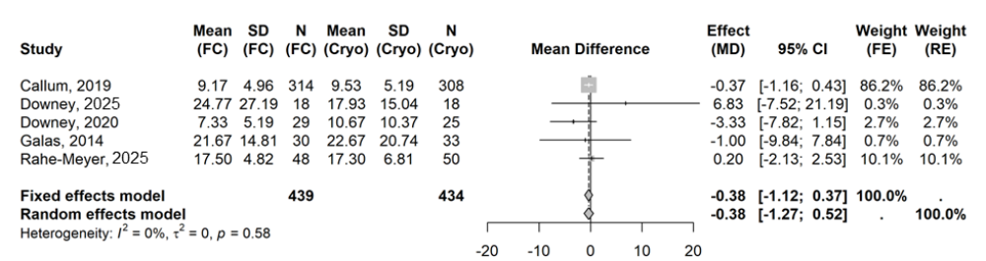
Abbreviations: CI, confidence interval; cryo, cryoprecipitate; FC, fibrinogen concentrate; FE, fixed effects; MD, mean difference; N, sample size; RE, random effects; SD, standard deviation.
Subgroup analysis by surgery type was only feasible for the cardiac surgery subgroup. Hospital stays were numerically shorter in patients receiving FC compared with cryoprecipitate (MD -0.48 days [95% CI: -1.98, 1.01]).

Supplemental Figure 38. Forest plot of MD in hospital stays (days) – surgery subgroups
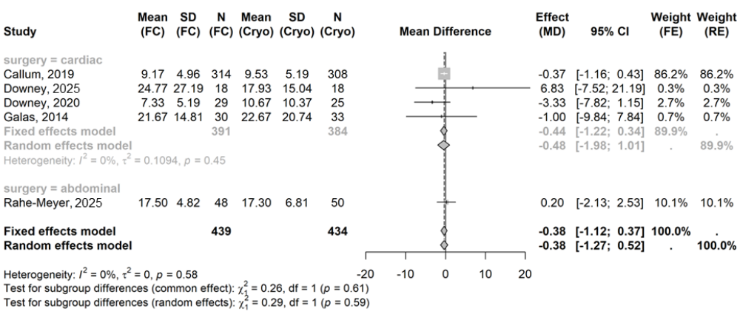
Abbreviations: CI, confidence interval; cryo, cryoprecipitate; FC, fibrinogen concentrate; FE, fixed effects; MD, mean difference; N, sample size; RE, random effects; SD, standard deviation.

The results were generally consistent between adults and pediatrics in subgroup analysis. The pooled MD was less than 0, with the value of null effect (i.e., 0) being included in the 95% CI, suggesting numerically shorter hospital stays in the patients in the FC group than in the cryoprecipitate group.

Supplemental Figure 39. Forest plot of MD in hospital stays (days) – age subgroup
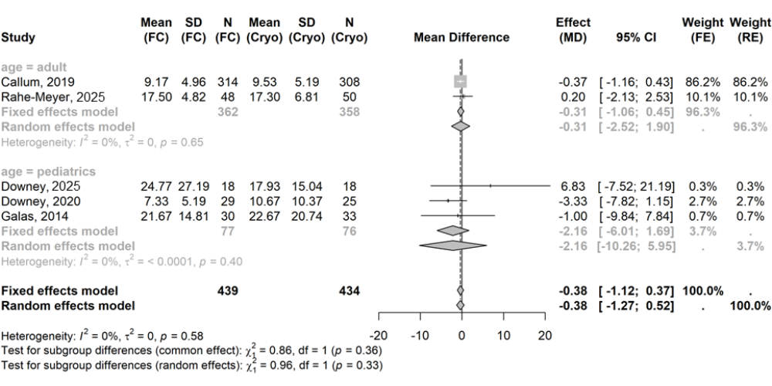
Abbreviations: CI, confidence interval; cryo, cryoprecipitate; FC, fibrinogen concentrate; FE, fixed effects; MD, mean difference; N, sample size; RE, random effects; SD, standard deviation.

Two sensitivity analyses were conducted. The first included Roy 2020 [34] and showed a pooled MD under the RE model of -3.03 (95% CI: -12.47, 6.41), indicating that the results were driven by this study. Mean hospital stay and SD were not reported in Roy 2020, and the approximation of the mean hospital stay using median and range can be highly biased due to the skewed data. Therefore, sensitivity analysis results should be interpreted with caution.
The second sensitivity analysis excluded Callum 2019 [13], making Rahe-Meyer 2025 [35] the study with the largest weight. Compared with the MD in the base case (i.e., -0.38 [95% CI: -1.27, 0.52]), the pooled MD under the RE model in the sensitivity analysis (i.e., -0.57 [95% CI: -4.16, 3.04]), was shifted further in favor of the FC group with a wider 95% CI. This result further demonstrated that the base-case results were driven by Callum 2019; therefore, the base-case results should be interpreted with caution.
Supplemental Figure 40. Forest plot of MD in hospital stays (days) – sensitivity analysis 1: including Roy 2020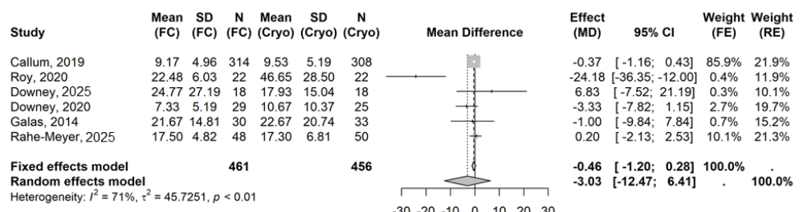
Abbreviations: CI, confidence interval; cryo, cryoprecipitate; FC, fibrinogen concentrate; FE, fixed effects; MD, mean difference; N, sample size; RE, random effects; SD, standard deviation.

Supplemental Figure 41. Forest plot of MD in hospital stay (days) – sensitivity analysis 2: excluding Callum 2019
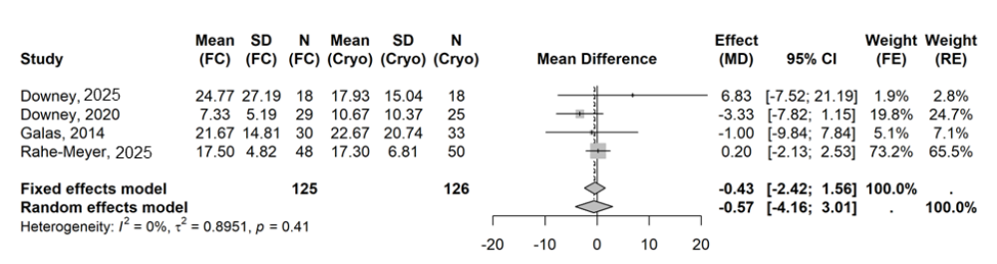
Abbreviations: CI, confidence interval; cryo, cryoprecipitate; FC, fibrinogen concentrate; FE, fixed effects; MD, mean difference; N, sample size; RE, random effects; SD, standard deviation.

Other outcomes – length of intensive care unit stay
In the base case, five studies [13,31-34] evaluated mean intensive care unit (ICU) stay (days) in patients receiving FC versus cryoprecipitate. The pooled MD under the RE model was 0.12 (95% CI: -0.04, 0.27), suggesting that ICU stays were numerically longer in patients in the FC group than the cryoprecipitate group. Similar to the rationale in the previous section, Roy 2020 [34] was excluded from the base-case analysis.

Supplemental Figure 42. Forest plot of MD in ICU stays (days) – base case
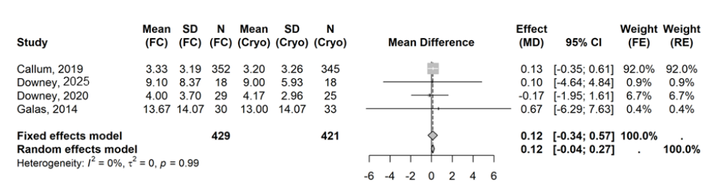
Abbreviations: CI, confidence interval; cryo, cryoprecipitate; FC, fibrinogen concentrate; FE, fixed effects; MD, mean difference; N, sample size; RE, random effects; SD, standard deviation.

Across three studies pooled for analysis of the pediatric subgroup [31-33], numerically shorter ICU stays were observed in the FC group versus the cryoprecipitate group (MD: -0.09 [95% CI: -0.70, 0.52]). The pooled point estimate showed opposite directions of effect compared with the base case, although the differences were considered minor. No analysis was possible for the adult subgroup.

Supplemental Figure 43. Forest plot of MD in ICU stays (days) – age subgroups
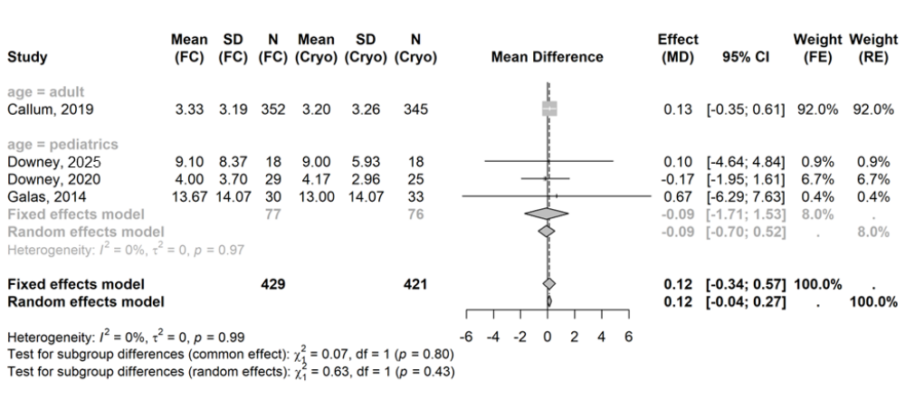
Abbreviations: CI, confidence interval; cryo, cryoprecipitate; FC, fibrinogen concentrate; FE, fixed effects; MD, mean difference; N, sample size; RE, random effects; SD, standard deviation.

The pooled estimates in the two sensitivity analyses conducted for this outcome shifted toward numerically shorter ICU stays with FC compared with cryoprecipitate. A highly biased approximation for ICU stay in Roy 2020 [34] was the primary driver of change in effect in the first analysis. In the analysis excluding Callum 2019 [13], the increased weight of the Downey 2020 [31] study reversed the direction of effect. Overall, both sensitivity analyses indicated that the base‑case findings were sensitive to the influence of individual studies and warrant cautious interpretation.

Supplemental Figure 44. Forest plot of MD in ICU stay (days) – sensitivity analysis 1: including Roy 2020
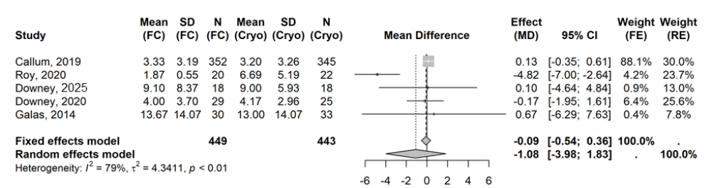
Abbreviations: CI, confidence interval; cryo, cryoprecipitate; FC, fibrinogen concentrate; FE, fixed effects; MD, mean difference; N, sample size; RE, random effects; SD, standard deviation.

Supplemental Figure 45. Forest plot of MD in ICU stay (days) – sensitivity analysis 2: excluding Callum 2019
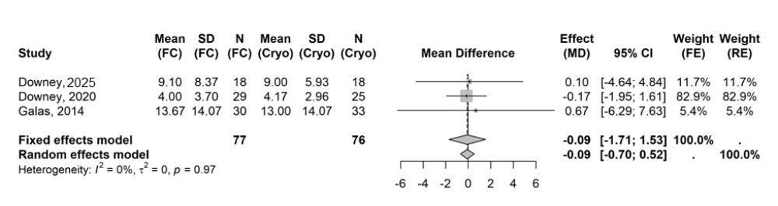
Abbreviations: CI, confidence interval; cryo, cryoprecipitate; FC, fibrinogen concentrate; FE, fixed effects; MD, mean difference; N, sample size; RE, random effects; SD, standard deviation.

Exploratory analyses
Exploratory analyses using empirical Bayesian (EB) methods were conducted for All thromboembolic events (TEE), any adverse events (AE), and all-cause mortality outcomes.
In situations when the number of studies was >5, Bayesian meta-analysis can provide more stable and robust estimates than conventional frequentist methods [25]. However, Bayesian analysis depends on the choice of prior distribution, which must be carefully selected and justified. In a fully Bayesian setting, priors are pre-specified, based on external knowledge or assumptions [39]; in the EB method, the prior is estimated from the observed data [40]. The EB approach shrinks the estimates toward the overall mean, stabilizing the results when limited information is available. In a previous meta-analysis on FC, Gomes 2024 applied the EB method estimator for RE pooling; this approach was incorporated into the present study [15]. However, Bayesian meta-analysis does not offer substantial advantages over frequentist meta-analysis when the number of studies is <5, particularly in the case of just two studies, which was the case for several endpoints evaluated in this research [25].
The results indicated that the use of this method did not improve the precision, with pooled estimates still influenced by dominant studies and limited by sparse data. These findings further emphasized that advanced statistical techniques cannot compensate for fundamental limitations in evidence quantity and event rates, reinforcing the need for additional primary research rather than alternative modeling approaches alone.

All TEEs
In the base case, pooled analysis from five studies [13,31,32,34,35] resulted in an EB OR of 0.49 (95% credible interval [CrI]: 0.19, 1.28), which was similar to the pooled frequentist OR under the RE model (0.55 [95% CI: 0.29, 1.07]). Both pooled EB OR and frequentist OR were primarily driven by Callum 2019 [13].

Supplemental Figure 46. Forest plot of EB OR for All TEEs – base case
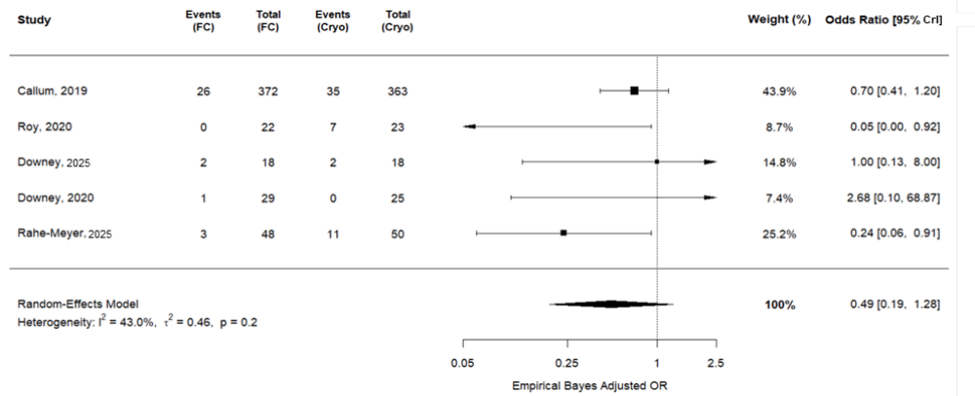
Abbreviations: CrI, credible interval; cryo, cryoprecipitate; FC, fibrinogen concentrate; FE, fixed effect, OR, odds ratio; RE, random effects.

Six studies [13,31-35] were included in the first sensitivity analysis. The pooled EB OR under the RE model was 0.54 (95% CrI: 0.26, 1.12), which aligned with the base case (0.49 [95% CrI: 0.19, 1.28]. EB OR results across the sensitivity analysis and base case were primarily driven by Callum 2019 [13]; furthermore, the exclusion of Galas 2014 [33] did not greatly impact the base-case results.

Supplemental Figure 47. Forest plot of EB OR for All TEEs – sensitivity analysis 1: including Galas 2014
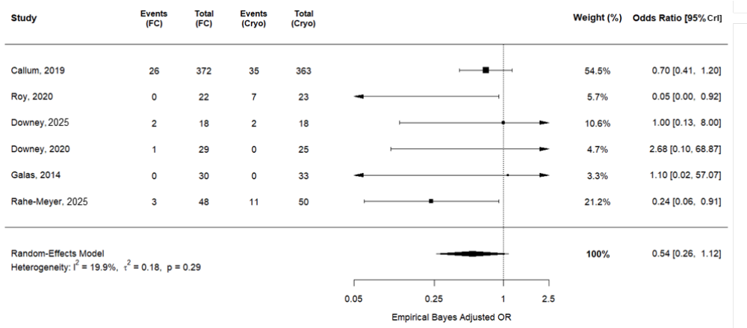
Abbreviations: CrI, credible interval; cryo, cryoprecipitate; FC, fibrinogen concentrate; OR, odds ratio.

The second sensitivity analysis further demonstrated that the base-case results were driven by Callum 2019 [13], while the exclusion of Callum 2019 introduced more variability in the estimated effect.

Supplemental Figure 48. Forest plot of EB OR for All TEEs – sensitivity analysis 2: excluding Callum 2019
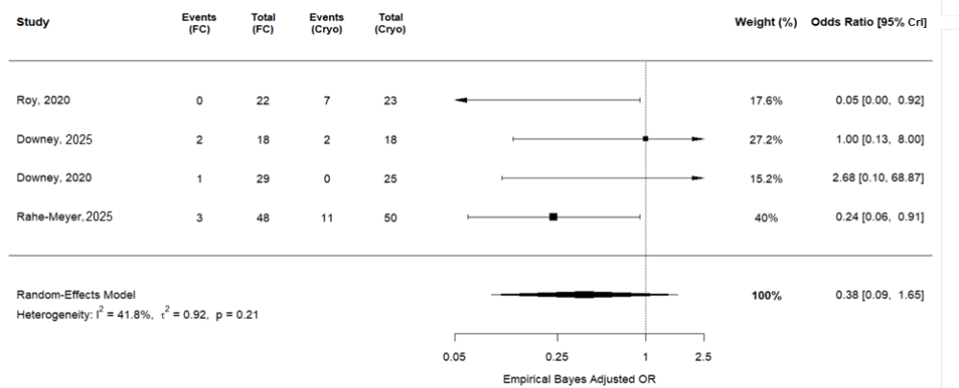
Abbreviations: CrI, credible interval; cryo, cryoprecipitate; FC, fibrinogen concentrate; OR, odds ratio.

Any AEs
Four studies [13,31,32,35] contributed to the pooled estimates of Any AEs in patients in the FC group and the cryoprecipitate group. The results were similar between the EB OR (0.70 [95% CrI: 0.52, 0.94]) and the frequentist OR (0.70 [95% CI: 0.52, 0.94]), and both estimates were primarily driven by Callum 2019 [13].

Supplemental Figure 49. Forest plot of EB OR for Any AEs – base case
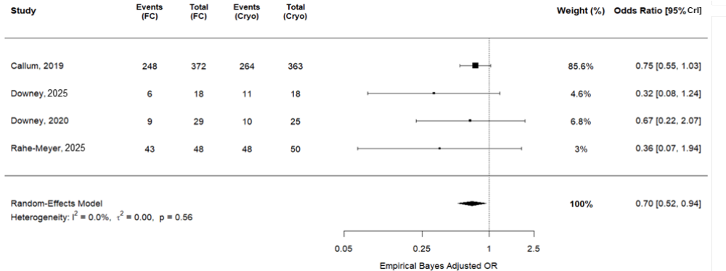
Abbreviations: CrI, credible interval; cryo, cryoprecipitate; FC, fibrinogen concentrate; OR, odds ratio.

The results of the sensitivity analysis including Roy 2020 [34], Galas 2014 [33], and Ayaganov 2024 [30], aligned with base-case findings, both of which were primarily driven by Callum 2019 [13]. In addition, the exclusion of Roy 2020, Galas 2014 and Ayaganov 2024 did not greatly impact the base-case results.

Supplemental Figure 50. Forest plot of EB OR for Any AEs – sensitivity analysis 1: including Roy 2020, Galas 2014, and Ayaganov 2024
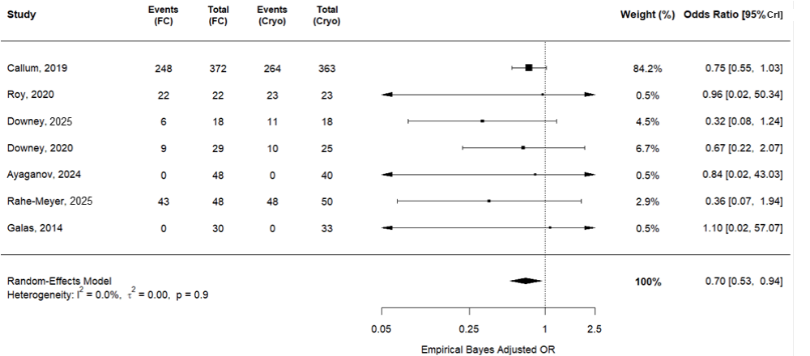

Abbreviations: CrI, credible interval; cryo, cryoprecipitate; FC, fibrinogen concentrate; OR, odds ratio.

In the sensitivity analysis excluding Callum 2019 which pooled data from three studies [31,32,35], the EB OR was shifted further in favor of the FC group. The 95% CrI was wider compared with the base case, indicating increased posterior uncertainty. The sensitivity analysis further demonstrated that the base-case results were driven by Callum 2019 [13], while the exclusion of Callum 2019 introduced more variability in the estimated effect.

Supplemental Figure 51. Forest plot of EB OR for Any AEs – sensitivity analysis 2: excluding Callum 2019
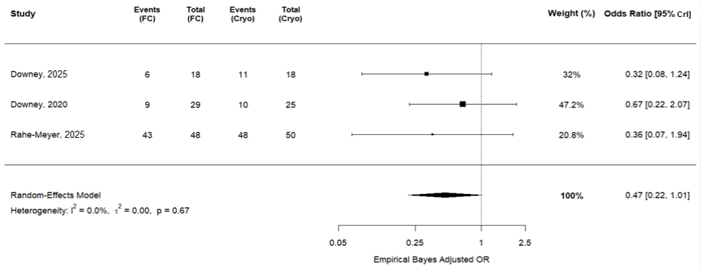
Abbreviations: CrI, credible interval; cryo, cryoprecipitate; FC, fibrinogen concentrate; OR, odds ratio.

All-cause mortality
In the base case, pooled analysis of six studies [13,30-32,34,35] showed an EB OR of 1.11 (95% CrI: 0.69, 1.77), which was slightly shifted in favor of cryoprecipitate compared with the pooled frequentist OR (1.00 [95% CI: 0.55, 1.81]). The Callum 2019 study [13] was the primary driver in each approach (i.e., EB and frequentist).

Supplemental Figure 52. Forest plot of EB OR for all-cause mortality – base case
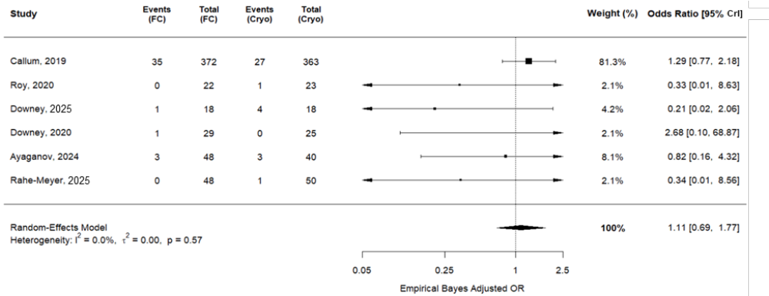
Abbreviations: CrI, credible interval; cryo, cryoprecipitate; FC, fibrinogen concentrate; OR, odds ratio.

In the sensitivity analysis including Galas 2014 [13,30-35], the pooled EB OR under the RE model was 1.11 (95% CrI: 0.69, 1.77), which was the same as EB OR under the RE model in the base case. Both the sensitivity analysis and the base-case results were primarily driven by Callum 2019. In addition, the exclusion of Galas 2014 did not impact the base-case results.
In the sensitivity analysis excluding Callum 2019 [30-32,34,35], the pooled EB OR was 0.56 (95% CrI: 0.19, 1.68). Compared with the pooled EB OR in the base case (1.11 [95% CrI: 0.69, 1.77]), the pooled EB OR of the sensitivity analysis shifted further in favor of FC. The 95% CrI was wider compared with the base case, indicating increased posterior uncertainty. The sensitivity analysis further demonstrated that the base-case results were driven by Callum 2019, while the exclusion of Callum 2019 introduced more variability in the estimated effect.

Supplemental Figure 53. Forest plot of EB OR for all-cause mortality – sensitivity analysis 1: including Galas 2014
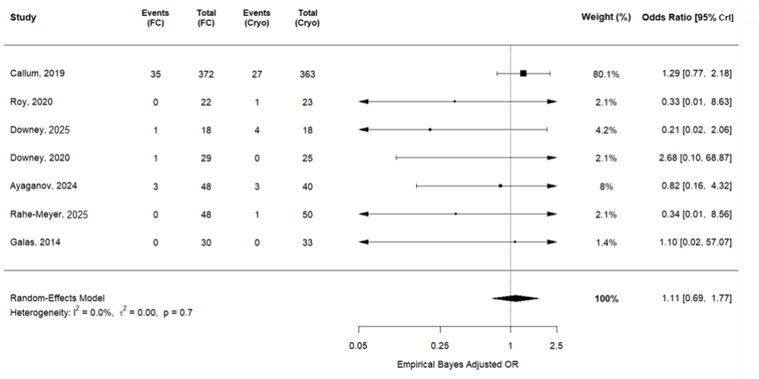
Abbreviations: CrI, credible interval; cryo, cryoprecipitate; FC, fibrinogen concentrate; OR, odds ratio.

Supplemental Figure 54. Forest plot of EB OR for all-cause mortality – sensitivity analysis 2: excluding Callum 2019
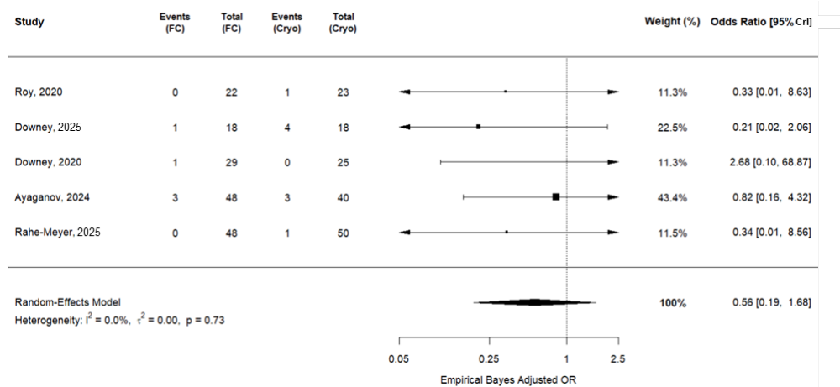
Abbreviations: CrI, credible interval; cryo, cryoprecipitate; FC, fibrinogen concentrate; OR, odds ratio.

