Supplementary materials
Supplementary Table S1. TRIPOD+AI checklist.
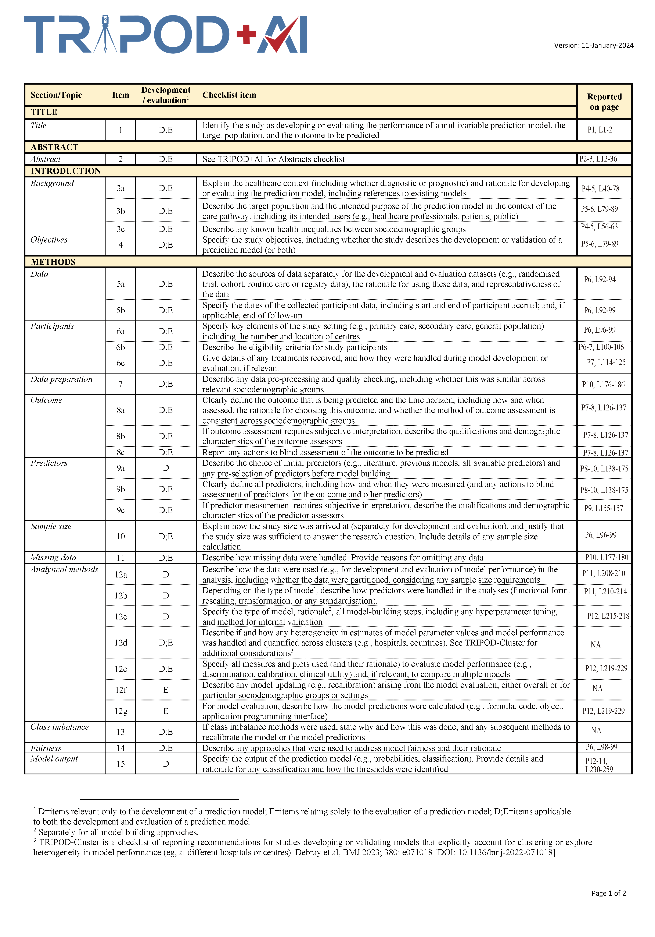
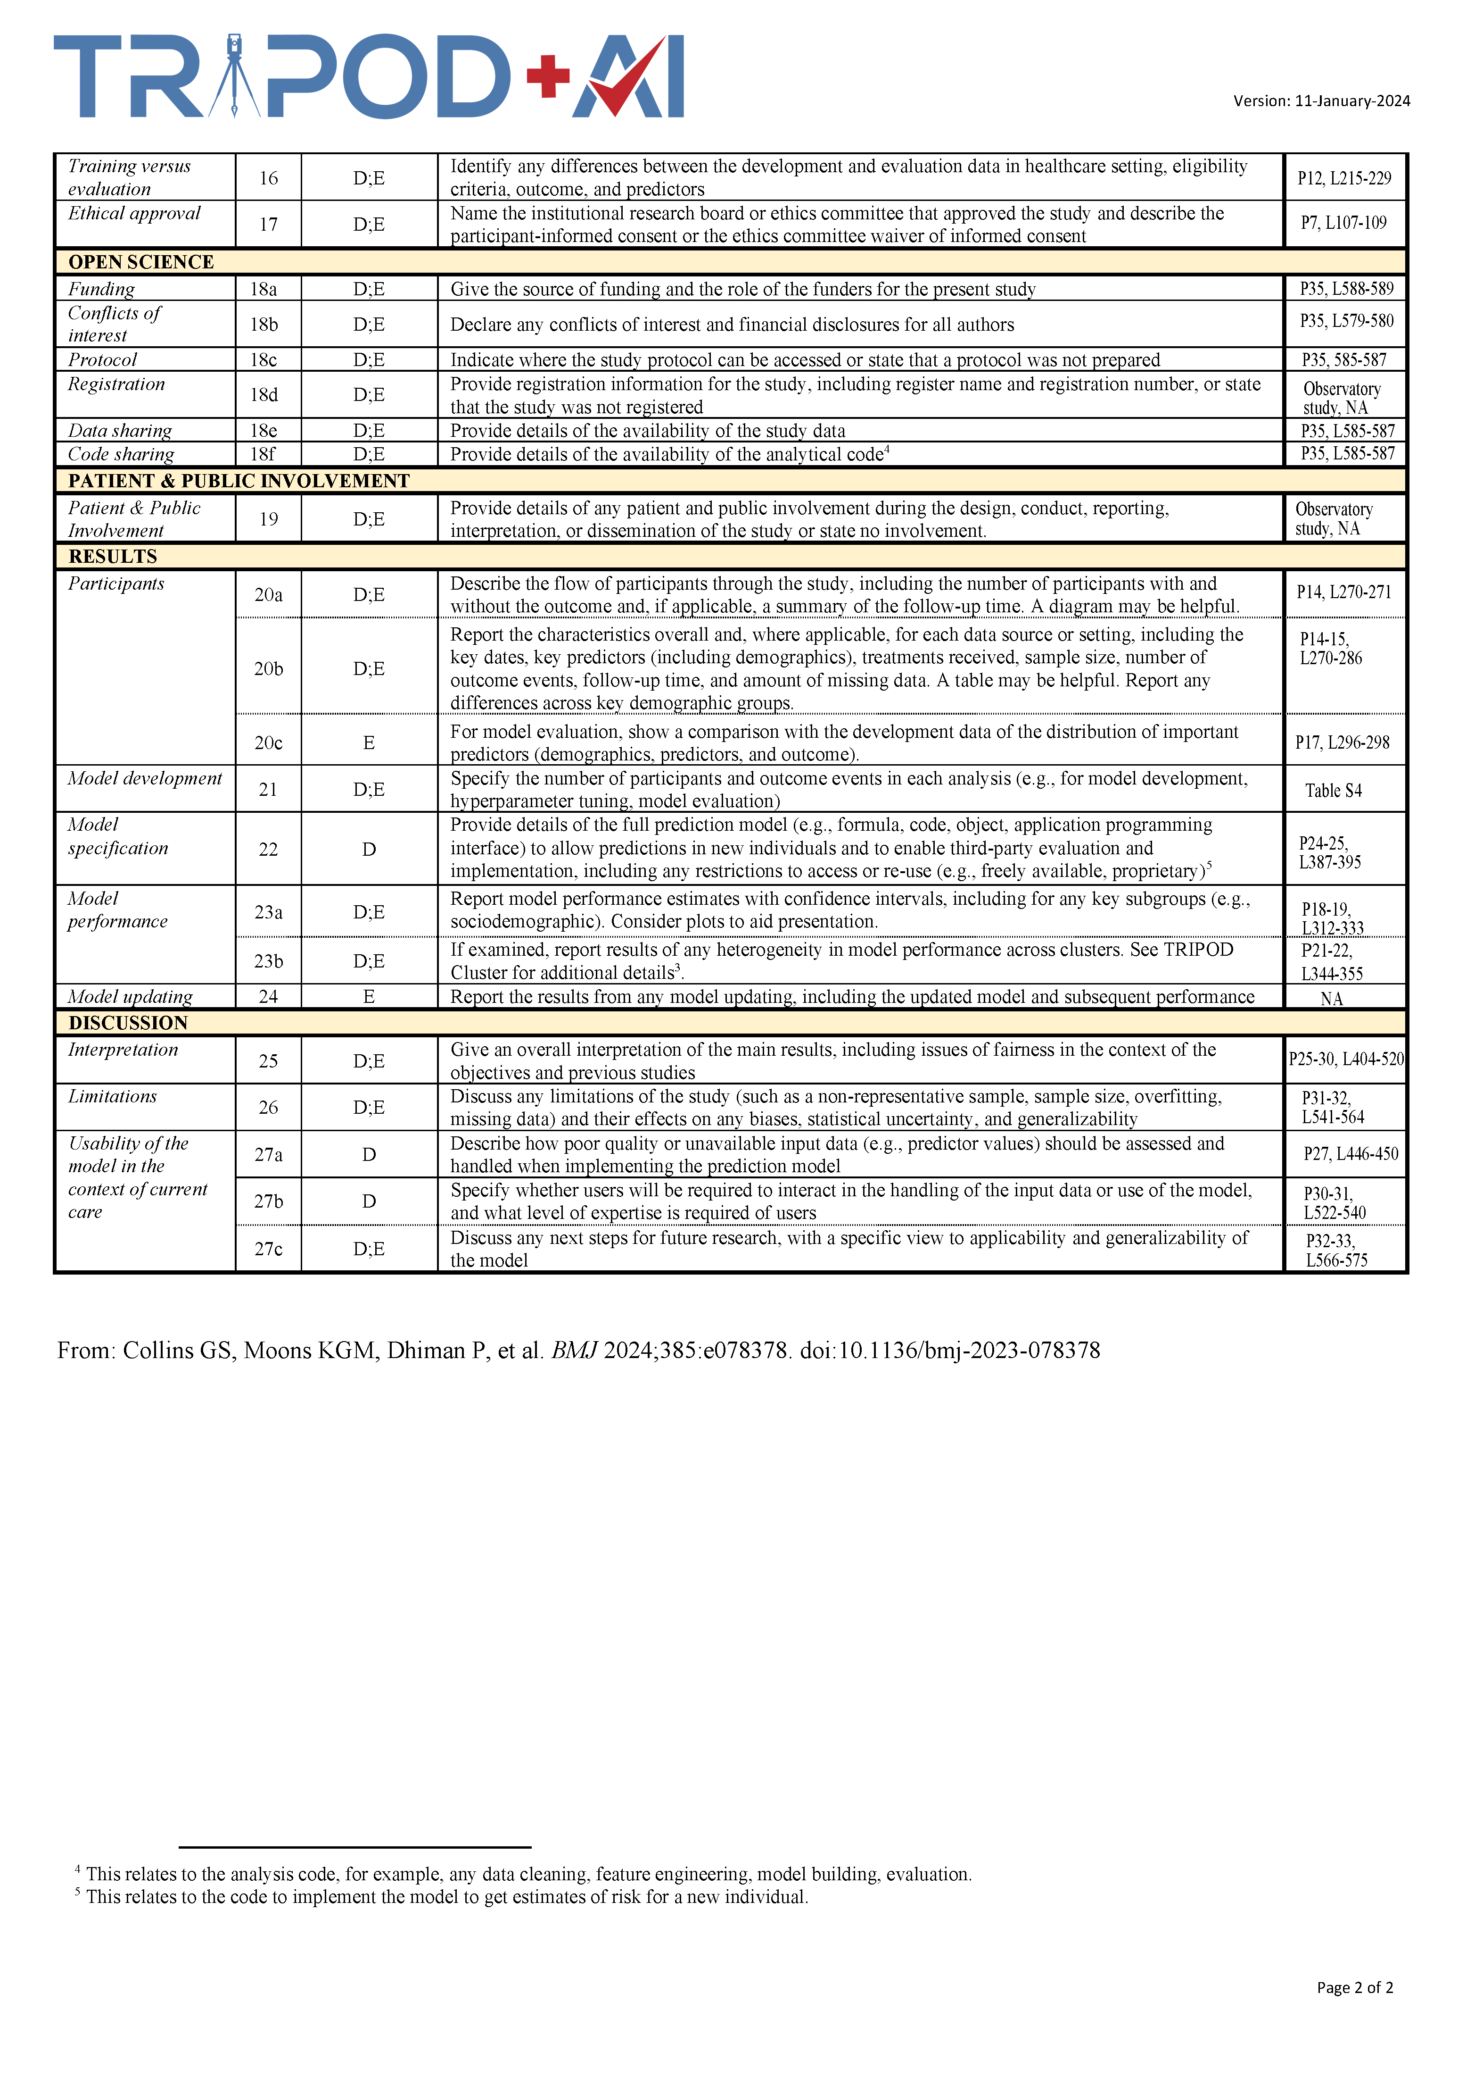

Supplementary Table S2. Hyperparameter Search Grid for Machine Learning Models
Model | Hyperparameter | Description | Search Space (Grid)
Logistic Regression (LR) | Alpha | Mixing percentage (L1 vs L2) | 0.3, 0.5, 0.8
Logistic Regression (LR) | Lambda | Regularization strength | 0.001, 0.01, 0.05
Random Forest (RF) | ntree | Number of trees | 400
Random Forest (RF) | mtry | Number of variables candidates | 2, 4
Random Forest (RF) | nodesize | Minimum size of terminal nodes | 40, 45
Random Forest (RF) | maxnodes | Maximum number of terminal nodes | 20, 30
Random Forest (RF) | sampsize | Sample size for each tree | 200
LightGBM (LGBM) | num_leaves | Maximum tree leaves | 2
LightGBM (LGBM) | learning_rate | Shrinkage rate | 0.01, 0.02
LightGBM (LGBM) | reg_lambda | L2 regularization term | 30, 50
LightGBM (LGBM) | colsample_bytree | Subsample ratio of columns | 0.5
K-Nearest Neighbors (KNN) | k | Number of neighbors | 1、3、5、7、9、13、15、20、25、30、35、40
Adaptive Boosting (AdaBoost) | n.trees | Number of boosting iterations | 50, 100, 150
Adaptive Boosting (AdaBoost) | interaction.depth | Tree depth | 1
Adaptive Boosting (AdaBoost) | shrinkage | Learning rate | 0.05, 0.1
Adaptive Boosting (AdaBoost) | n.minobsinnode | Min. observations in node | 60, 70, 80
Extra Trees (ET) | num.trees | Number of trees | 300, 500
Extra Trees (ET) | mtry | Number of variables candidates | 2
Extra Trees (ET) | min.node.size | Minimum node size | 40, 50, 60
Extra Trees (ET) | sample.fraction | Fraction of observations to sample | 0.5, 0.6
Extra Trees (ET) | replace | Sampling with replacement | FALSE
Support Vector Machine (SVM) | $C$ (Cost) | Cost of constraints violation | 0.2, 0.5, 1, 2
Support Vector Machine (SVM) | $\sigma$ (Sigma) | RBF Kernel coefficient | 0.01, 0.03, 0.05, 0.08
Neural Network (NNet) | Size | Number of units in hidden layer | 1, 4, 6
Neural Network (NNet) | Decay | Weight decay | 0.01, 0.5, 1, 3, 5

Supplementary Table S3. Distribution of FRAIL scores in the development cohort.
FRAIL score or category | Total (n = 922) | POD group (n = 301) | Non-POD group (n = 621)
FRAIL score, median [IQR] | 4 [2–4] | 4 [3–4] | 3 [1–4]
FRAIL score distribution, n (%)
0 | 60 (6.5) | 12 (4.0) | 48 (7.7)
1 | 167 (18.1) | 18 (6.0) | 149 (24.0)
2 | 54 (5.9) | 7 (2.3) | 47 (7.6)
3 | 169 (18.3) | 80 (26.6) | 89 (14.3)
4 | 313 (33.9) | 132 (43.9) | 181 (29.1)
5 | 159 (17.2) | 52 (17.3) | 107 (17.2)
FRAIL classification, n (%)
Normal, score 0 | 60 (6.5) | 12 (4.0) | 48 (7.7)
Prefrail, scores 1–2 | 221 (24.0) | 25 (8.3) | 196 (31.6)
Frail, scores 3–5 | 641 (69.5) | 264 (87.7) | 377 (60.7)
Notes: Data are presented as median [interquartile range] or n (%). FRAIL scores range from 0 to 5. Scores of 0, 1–2, and ≥3 indicate normal, pre-frail, and frail status, respectively.
Supplementary Table S4. Demographic and clinical characteristics of participants in the training and testing cohorts.
Variables | Total (n = 922) | Training set  (n = 646) | Testing set  (n = 276) | Statistics | p-value
Age (year) | 74.07 ± 5.35 | 73.95 ± 5.43 | 74.34 ± 5.16 | 1.036 | 0.301
BMI (kg/m²) | 22.8 [19.4, 26.4] | 22.75 [19.50, 26.13] | 23.00 [19.30, 27.10] | -0.722 | 0.471
Gender, n (%)
Male | 559 (60.6%) | 390 (60.4%) | 169 (61.2%) | 0.060 | 0.807
female | 363 (39.4%) | 256 (39.6%) | 107 (38.8%)
Marital status, n (%)
Married | 624 (67.7%) | 432 (66.9%) | 192 (69.6%) | 0.641 | 0.423
Single/divorced/widowed | 298 (32.3%) | 214 (33.1%) | 84 (30.4%)
Educational level, n (%)
Primary grades or below | 548 (59.4%) | 380 (58.8%) | 168 (60.9%) | 0.336 | 0.562
Junior high school or above | 374 (40.6%) | 266 (41.2%) | 108 (39.1%)
Living condition, n (%)
With partner | 675 (73.2%) | 464 (71.8%) | 211 (76.4%) | 2.684 | 0.261
Nursing home | 147 (15.9%) | 111 (17.2%) | 36 (13.0%)
Living alone | 100 (10.8%) | 71 (11.0%) | 29 (10.5%)
Smoking history, n (%) | 171 (18.5%) | 126 (19.5%) | 45 (16.3%) | 1.311 | 0.252
Drinking history, n (%) | 187 (20.3%) | 128 (19.8%) | 59 (21.4%) | 0.292 | 0.589
Abdominal surgery history, n (%) | 93 (10.1%) | 66 (10.2%) | 27 (9.8%) | 0.040 | 0.841
Hypertension, n (%) | 383 (41.5%) | 268 (41.5%) | 115 (41.7%) | 0.003 | 0.959
Diabetes, n (%) | 255 (27.7%) | 182 (28.2%) | 73 (26.4%) | 0.287 | 0.592
Cerebrovascular disease, n (%) | 119 (12.9%) | 91 (14.1%) | 28 (10.1%) | 2.673 | 0.102
Cardiovascular disease, n (%) | 77 (8.4%) | 52 (8.0%) | 25 (9.1%) | 0.257 | 0.612
Liver disease, n (%) | 48 (5.2%) | 39 (6.0%) | 9 (3.3%) | 3.020 | 0.082
Pulmonary disease, n (%) | 59 (6.4%) | 46 (7.1%) | 13 (4.7%) | 1.876 | 0.171
Renal insufficiency, n (%) | 133 (14.4%) | 86 (13.3%) | 47 (17.0%) | 2.164 | 0.141
Time since diagnosis (month) | 5.00 [3.00, 8.00] | 6.00 [3.00, 8.00] | 5.00 [3.00, 8.00] | -0.788 | 0.431
Primary cancer site, n (%)
Colon | 655 (71.0%) | 458 (70.9%) | 197 (71.4%) | 0.022 | 0.883
Rectum | 267 (29.0%) | 188 (29.1%) | 79 (28.6%)
TNM stage, n (%)
I-II | 526 (57.0%) | 366 (56.7%) | 160 (58.0%) | 0.136 | 0.712
III | 396 (43.0%) | 280 (43.3%) | 116 (42.0%)
ASA classification, n (%)
I-II | 724 (78.5%) | 509 (78.8%) | 215 (77.9%) | 0.092 | 0.762
III-IV | 198 (21.5%) | 137 (21.2%) | 61 (22.1%)
Surgical method, n (%)
Laparoscopic | 860 (93.3%) | 606 (93.8%) | 254 (92.0%) | 0.976 | 0.323
Open | 62 (6.7%) | 40 (6.2%) | 22 (8.0%)
Surgical duration (min) | 189.35 ± 71.13 | 189.01 ± 71.71 | 190.16 ± 69.89 | 0.224 | 0.823
Anesthesia duration (min) | 260.59 ± 70.73 | 260.87 ± 71.34 | 259.91 ± 69.41 | -0.189 | 0.850
Intraoperative blood loss (mL) | 122.00 [88.00, 204.25] | 122.00 [88.00, 202.25] | 126.00 [88.25, 207.75] | -0.382 | 0.703
Blood transfusion, n (%) | 123 (13.3%) | 88 (13.6%) | 35 (12.7%) | 0.148 | 0.700
Intraoperative hypotension, n (%) | 163 (17.7%) | 113 (17.5%) | 50 (18.1%) | 0.052 | 0.820
ICU admission, n (%) | 117 (12.7%) | 85 (13.2%) | 32 (11.6%) | 0.427 | 0.514
Preoperative laboratory test
Hemoglobin (g/L) | 127.00 [107.00, 140.00] | 126.00 [107.75, 140.00] | 129.00 [106.00, 140.75] | -0.485 | 0.628
BUN (mmol/L) | 5.80 [4.60, 6.80] | 5.80 [4.68, 6.70] | 5.80 [4.50, 6.90] | -0.387 | 0.699
Creatinine (μmol/L) | 77.50 [62.00, 92.00] | 76.00 [61.00, 92.00] | 80.00 [64.00, 92.00] | -1.548 | 0.122
Sodium (mmol/L) | 134.00 [126.00, 141.00] | 134.00 [126.00, 141.00] | 133.00 [124.00, 140.00] | -1.397 | 0.162
Potassium (mmol/L) | 3.60 [2.70, 4.50] | 3.55 [2.70, 4.50] | 3.60 [2.70, 4.60] | -0.595 | 0.552
WBC (10⁹/L) | 5.90 [4.30, 7.40] | 6.00 [4.30, 7.50] | 5.70 [4.50, 7.20] | -0.579 | 0.563
Albumin (g/L) | 35.00 [28.00, 43.00] | 35.00 [28.00, 43.00] | 35.00 [27.00, 43.00] | -0.552 | 0.581
Neutrophil (10⁹/L) | 4.20 [3.00, 5.30] | 4.20 [3.00, 5.40] | 4.25 [3.00, 5.18] | -0.553 | 0.581
Platelet (10⁹/L) | 189.00 [143.75, 240.25] | 184.50 [141.75, 237.25] | 198.00 [147.50, 247.00] | -1.862 | 0.063
Monocyte (10⁹/L) | 0.45 [0.27, 0.61] | 0.46 [0.28, 0.62] | 0.42 [0.24, 0.58] | -1.913 | 0.056
Lymphocyte (10⁹/L) | 1.39 [1.01, 1.93] | 1.39 [1.03, 1.93] | 1.38 [0.96, 1.94] | -0.845 | 0.398
PNI | 42.53 [35.25, 51.00] | 42.65 [35.46, 51.16] | 42.28 [35.06, 50.34] | -0.68 | 0.496
PLR | 136.22 [84.62, 199.00] | 133.03 [84.28, 192.95] | 143.81 [87.55, 214.66] | -1.645 | 0.1
NLR | 2.92 [1.96, 4.23] | 2.94 [1.95, 4.17] | 2.87 [2.00, 4.39] | -0.481 | 0.631
MLR | 0.30 [0.19, 0.47] | 0.30 [0.19, 0.48] | 0.30 [0.18, 0.45] | -0.624 | 0.533
Frailty, n (%) | 641 (69.5%) | 447 (69.2%) | 194 (70.3%) | 0.109 | 0.741
Sleep disturbance, n (%) | 555 (60.2%) | 391 (60.5%) | 164 (59.4%) | 0.099 | 0.753
Anxiety, n (%) | 385 (41.8%) | 273 (42.3%) | 112 (40.6%) | 0.225 | 0.636
Depression, n (%) | 427 (46.3%) | 305 (47.2%) | 122 (44.2%) | 0.705 | 0.401
Cognitive impairment, n (%) | 317 (34.4%) | 218 (33.7%) | 99 (35.9%) | 0.386 | 0.534
POD, n (%) | 301 (32.6%) | 219 (33.9%) | 82 (29.7%) | 1.545 | 0.214
Notes. Continuous data were presented as mean ± standard deviation or median [interquartile ranges].
Abbreviations: BMI: body mass index; TNM: tumor-node-metastasis; ASA: American Society of Anesthesiologists; ICU: intensive care unit; BUN: blood urea nitrogen; WBC: white blood cell; PNI: prognostic nutritional index; PLR: platelet-to-lymphocyte ratio; NLR: neutrophil-to-lymphocyte ratio; MLR: monocyte-to-lymphocyte ratio; POD: postoperative delirium.

Supplementary Table S5. Predictive performance of eight machine learning algorithms.
Model | Accuracy | AUC (95% CI) | Sensitivity | Specificity | PPV | NPV | F1-score | Log-loss | Brier  score | Calibration  slope | Calibration  intercept
Training set
LR | 0.788 | 0.860 (0.831-0.889) | 0.557 | 0.906 | 0.753 | 0.800 | 0.640 | 0.449 | 0.145 | 1.293 | -0.100
RF | 0.777 | 0.835 (0.802-0.869) | 0.489 | 0.925 | 0.770 | 0.779 | 0.598 | 0.502 | 0.153 | 1.074 | 0.033
LGBM | 0.768 | 0.849 (0.819-0.880) | 0.740 | 0.782 | 0.635 | 0.854 | 0.684 | 0.518 | 0.170 | 1.502 | -0.345
KNN | 0.797 | 0.852 (0.822-0.883) | 0.562 | 0.918 | 0.778 | 0.803 | 0.653 | 0.455 | 0.149 | 1.305 | -0.067
AdaBoost | 0.789 | 0.838 (0.807-0.869) | 0.553 | 0.911 | 0.761 | 0.799 | 0.640 | 0.466 | 0.153 | 1.147 | -0.031
ET | 0.802 | 0.859 (0.829-0.888) | 0.562 | 0.925 | 0.794 | 0.804 | 0.658 | 0.472 | 0.153 | 1.515 | -0.175
SVM | 0.782 | 0.858 (0.828-0.887) | 0.731 | 0.808 | 0.661 | 0.854 | 0.694 | 0.450 | 0.148 | 0.853 | 0.007
NNet | 0.796 | 0.861 (0.832-0.890) | 0.603 | 0.895 | 0.746 | 0.814 | 0.667 | 0.442 | 0.142 | 1.190 | -0.067
Testing set | Accuracy | AUC (95% CI) | Sensitivity | Specificity | PPV | NPV | F1-score | Log-loss | Brier  score | Calibration  slope | Calibration  intercept
LR | 0.801 | 0.832 (0.779-0.886) | 0.561 | 0.902 | 0.708 | 0.829 | 0.626 | 0.464 | 0.149 | 1.202 | -0.118
RF | 0.808 | 0.815 (0.760-0.871) | 0.537 | 0.923 | 0.746 | 0.825 | 0.624 | 0.475 | 0.152 | 0.990 | 0.013
LGBM | 0.717 | 0.794 (0.737-0.851) | 0.683 | 0.732 | 0.519 | 0.845 | 0.589 | 0.567 | 0.191 | 1.294 | -0.307
KNN | 0.775 | 0.823 (0.770-0.876) | 0.500 | 0.892 | 0.661 | 0.808 | 0.569 | 0.474 | 0.154 | 1.156 | -0.075
AdaBoost | 0.797 | 0.806 (0.748-0.865) | 0.573 | 0.892 | 0.691 | 0.832 | 0.627 | 0.486 | 0.157 | 1.039 | -0.055
ET | 0.793 | 0.811 (0.756-0.866) | 0.537 | 0.902 | 0.698 | 0.822 | 0.607 | 0.493 | 0.161 | 1.311 | -0.159
SVM | 0.775 | 0.830 (0.777-0.882) | 0.720 | 0.799 | 0.602 | 0.871 | 0.656 | 0.489 | 0.160 | 0.822 | -0.029
NNet | 0.808 | 0.841 (0.789-0.892) | 0.634 | 0.881 | 0.693 | 0.851 | 0.662 | 0.451 | 0.144 | 1.140 | -0.096
Temporal validation | Accuracy | AUC (95% CI) | Sensitivity | Specificity | PPV | NPV | F1-score | Log-loss | Brier  score | Calibration  slope | Calibration  intercept
LR | 0.812 | 0.887 (0.855-0.920) | 0.554 | 0.939 | 0.818 | 0.810 | 0.661 | 0.422 | 0.134 | 1.422 | -0.135
RF | 0.799 | 0.870 (0.832-0.907) | 0.485 | 0.955 | 0.840 | 0.790 | 0.615 | 0.439 | 0.140 | 1.172 | 0.014
LGBM | 0.789 | 0.862 (0.825-0.899) | 0.715 | 0.826 | 0.669 | 0.855 | 0.691 | 0.506 | 0.163 | 1.619 | -0.382
KNN | 0.807 | 0.880 (0.844-0.915) | 0.538 | 0.939 | 0.814 | 0.805 | 0.648 | 0.432 | 0.139 | 1.379 | -0.076
AdaBoost | 0.802 | 0.865 (0.828-0.901) | 0.546 | 0.928 | 0.789 | 0.806 | 0.645 | 0.438 | 0.142 | 1.292 | -0.065
ET | 0.807 | 0.871 (0.836-0.907) | 0.531 | 0.943 | 0.821 | 0.803 | 0.645 | 0.457 | 0.148 | 1.563 | -0.176
SVM | 0.822 | 0.883 (0.850-0.917) | 0.746 | 0.860 | 0.724 | 0.873 | 0.735 | 0.403 | 0.131 | 0.932 | -0.021
NNet | 0.827 | 0.888 (0.855-0.920) | 0.654 | 0.913 | 0.787 | 0.843 | 0.714 | 0.410 | 0.130 | 1.292 | -0.096
Notes. Abbreviations: AUC: area under the curve; 95% CI: 95% confidence interval; PPV: positive predictive value; NPV: negative predictive value; LR: logistic regression; RF: random forest; LGBM: light gradient boosting machine; KNN: k-nearest neighbors; AdaBoost: adaptive boosting; ET: extra trees; SVM: support vector machine; NNet: neural network.

Supplementary Table S6. Demographic and clinical characteristics of participants in the temporal validation cohort.
Variables | Total (n = 394) | POD group  (n = 130) | Non-POD group  (n = 264) | Statistics | p-value
Age (year) | 74.21 ± 5.31 | 76.98 ± 5.36 | 72.84 ± 4.72 | -7.812 | <0.001
BMI (kg/m²) | 23.1 [19.3, 27.1] | 22.40 [18.98, 27.48] | 23.20 [19.93, 26.88] | -1.006 | 0.315
Gender, n (%)
Male | 244 (61.9%) | 79 (60.8%) | 165 (62.5%) | 0.111 | 0.739
female | 150 (38.1%) | 51 (39.2%) | 99 (37.5%)
Marital status, n (%)
Married | 257 (65.2%) | 83 (63.8%) | 174 (65.9%) | 0.163 | 0.686
Single/divorced/widowed | 137 (34.8%) | 47 (36.2%) | 90 (34.1%)
Educational level, n (%)
Primary grades or below | 244 (61.9%) | 76 (58.5%) | 168 (63.6%) | 0.989 | 0.320
Junior high school or above | 150 (38.1%) | 54 (41.5%) | 96 (36.4%)
Living condition, n (%)
With partner | 289 (73.4%) | 88 (67.7%) | 201 (76.1%) | 3.177 | 0.204
Nursing home | 60 (15.2%) | 24 (18.5%) | 36 (13.6%)
Living alone | 45 (11.4%) | 18 (13.8%) | 27 (10.2%)
Smoking history, n (%) | 75 (19.0%) | 27 (20.8%) | 48 (18.2%) | 0.378 | 0.538
Drinking history, n (%) | 90 (22.8%) | 34 (26.2%) | 56 (21.2%) | 1.207 | 0.272
Abdominal surgery history, n (%) | 34 (8.6%) | 14 (10.8%) | 20 (7.6%) | 1.127 | 0.288
Hypertension, n (%) | 179 (45.4%) | 56 (43.1%) | 123 (46.6%) | 0.434 | 0.510
Diabetes, n (%) | 129 (32.7%) | 40 (30.8%) | 89 (33.7%) | 0.343 | 0.558
Cerebrovascular disease, n (%) | 56 (14.2%) | 36 (27.7%) | 20 (7.6%) | 28.910 | <0.001
Cardiovascular disease, n (%) | 45 (11.4%) | 12 (9.2%) | 33 (12.5%) | 0.920 | 0.337
Liver disease, n (%) | 21 (5.3%) | 6 (4.6%) | 15 (5.7%) | 0.196 | 0.658
Pulmonary disease, n (%) | 23 (5.8%) | 5 (3.8%) | 18 (6.8%) | 1.400 | 0.237
Renal insufficiency, n (%) | 56 (14.2%) | 21 (16.2%) | 35 (13.3%) | 0.599 | 0.439
Time since diagnosis (month) | 5.50 [3.00, 8.00] | 5.50 [3.00, 8.00] | 5.50 [3.00, 8.00] | -0.606 | 0.545
Primary cancer site, n (%)
Colon | 277 (70.3%) | 88 (67.7%) | 189 (71.6%) | 0.634 | 0.426
Rectum | 117 (29.7%) | 42 (32.3%) | 75 (28.4%)
TNM stage, n (%)
I-II | 223 (56.6%) | 70 (53.8%) | 153 (58.0%) | 0.599 | 0.439
III | 171 (43.4%) | 60 (46.2%) | 111 (42.0%)
ASA classification, n (%)
I-II | 301 (76.4%) | 76 (58.5%) | 225 (85.2%) | 34.606 | <0.001
III-IV | 93 (23.6%) | 54 (41.5%) | 39 (14.8%)
Surgical method, n (%)
Laparoscopic | 362 (91.9%) | 113 (86.9%) | 249 (94.3%) | 6.384 | 0.012
Open | 32 (8.1%) | 17 (13.1%) | 15 (5.7%)
Surgical duration (min) | 190.00 ± 67.70 | 199.05 ± 76.46 | 185.54 ± 62.62 | -1.747 | 0.082
Anesthesia duration (min) | 260.42 ± 67.37 | 268.89 ± 66.93 | 256.25 ± 67.33 | -1.756 | 0.080
Intraoperative blood loss (mL) | 118.00 [87.00, 193.25] | 119.00 [87.75, 203.75] | 117.00 [87.00, 188.50] | -0.712 | 0.476
Blood transfusion, n (%) | 49 (12.4%) | 18 (13.8%) | 31 (11.7%) | 0.354 | 0.552
Intraoperative hypotension, n (%) | 76 (19.3%) | 31 (23.8%) | 45 (17.0%) | 2.588 | 0.108
ICU admission, n (%) | 42 (10.7%) | 24 (18.5%) | 18 (6.8%) | 12.400 | <0.001
Preoperative laboratory test
Hemoglobin (g/L) | 130.00 [107.75, 140.00] | 130.50 [111.00, 142.25] | 129.00 [107.00, 140.00] | -0.725 | 0.468
BUN (mmol/L) | 5.80 [4.60, 6.90] | 5.85 [4.70, 6.90] | 5.70 [4.50, 6.80] | -0.682 | 0.495
Creatinine (μmol/L) | 79.50 [61.00, 93.00] | 82.00 [60.00, 94.25] | 78.50 [63.00, 92.00] | -0.932 | 0.352
Sodium (mmol/L) | 134.00 [127.00, 141.00] | 134.00 [126.00, 141.00] | 134.00 [127.00, 141.75] | -0.544 | 0.586
Potassium (mmol/L) | 3.50 [2.60, 4.50] | 3.50 [2.60, 4.70] | 3.60 [2.50, 4.50] | -0.253 | 0.80
WBC (10⁹/L) | 5.75 [4.20, 7.40] | 5.80 [4.20, 7.33] | 5.70 [4.13, 7.40] | -0.586 | 0.558
Albumin (g/L) | 35.00 [28.00, 43.00] | 33.00 [26.00, 42.00] | 36.00 [29.00, 43.00] | -2.067 | 0.039
Neutrophil (10⁹/L) | 4.00 [2.80, 5.30] | 4.20 [2.78, 5.53] | 3.90 [2.80, 5.20] | -0.892 | 0.372
Platelet (10⁹/L) | 190.50 [145.00, 236.00] | 187.50 [146.00, 231.25] | 192.00 [144.00, 237.00] | -0.583 | 0.560
Monocyte (10⁹/L) | 0.46 [0.29, 0.65] | 0.43 [0.29, 0.60] | 0.48 [0.29, 0.66] | -1.081 | 0.280
Lymphocyte (10⁹/L) | 1.38 [0.99, 1.83] | 1.32 [0.92, 1.72] | 1.41 [1.00, 1.89] | -1.560 | 0.119
PNI | 42.73 [35.25, 50.48] | 40.48 [33.36, 50.16] | 43.68 [36.06, 51.10] | -2.379 | 0.017
PLR | 137.88 [89.31, 209.30] | 141.94 [94.91, 209.35] | 136.44 [86.24, 211.06] | -0.707 | 0.480
NLR | 2.99 [1.89, 4.10] | 3.40 [2.06, 4.35] | 2.88 [1.84, 4.01] | -1.713 | 0.087
MLR | 0.32 [0.20, 0.46] | 0.30 [0.21, 0.49] | 0.33 [0.20, 0.46] | -0.037 | 0.971
Frailty, n (%) | 249 (63.2%) | 110 (84.6%) | 139 (52.7%) | 38.264 | <0.001
Sleep disturbance, n (%) | 245 (62.2%) | 86 (66.2%) | 159 (60.2%) | 1.301 | 0.254
Anxiety, n (%) | 162 (41.1%) | 56 (43.1%) | 106 (40.2%) | 0.308 | 0.579
Depression, n (%) | 182 (46.2%) | 59 (45.4%) | 123 (46.6%) | 0.051 | 0.821
Cognitive impairment, n (%) | 122 (31.0%) | 74 (56.9%) | 48 (18.2%) | 61.159 | <0.001
Notes. Continuous data were presented as mean ± standard deviation or median [interquartile ranges].
Abbreviations: BMI: body mass index; TNM: tumor-node-metastasis; ASA: American Society of Anesthesiologists; ICU: intensive care unit; BUN: blood urea nitrogen; WBC: white blood cell; PNI: prognostic nutritional index; PLR: platelet-to-lymphocyte ratio; NLR: neutrophil-to-lymphocyte ratio; MLR: monocyte-to-lymphocyte ratio; POD: postoperative delirium.

