Additional file 1
Device Interrogation follow-up data

I. 14 and 28 Oct, 2015 in 4weeks post-first implant follow-up
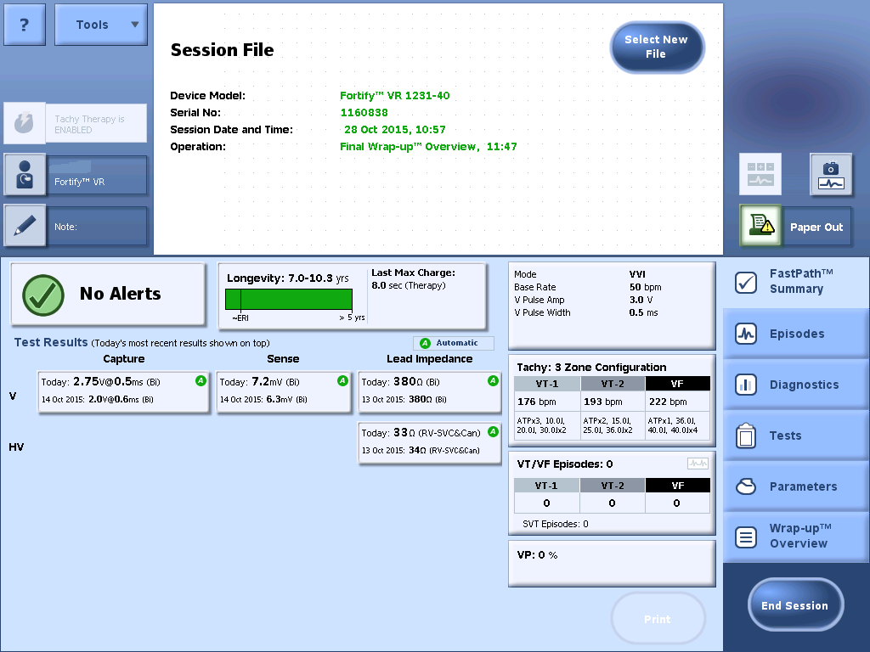

II. 16, 18, 22, 24 and 30 Nov, 2015 in 2 months post- first implant follow-up
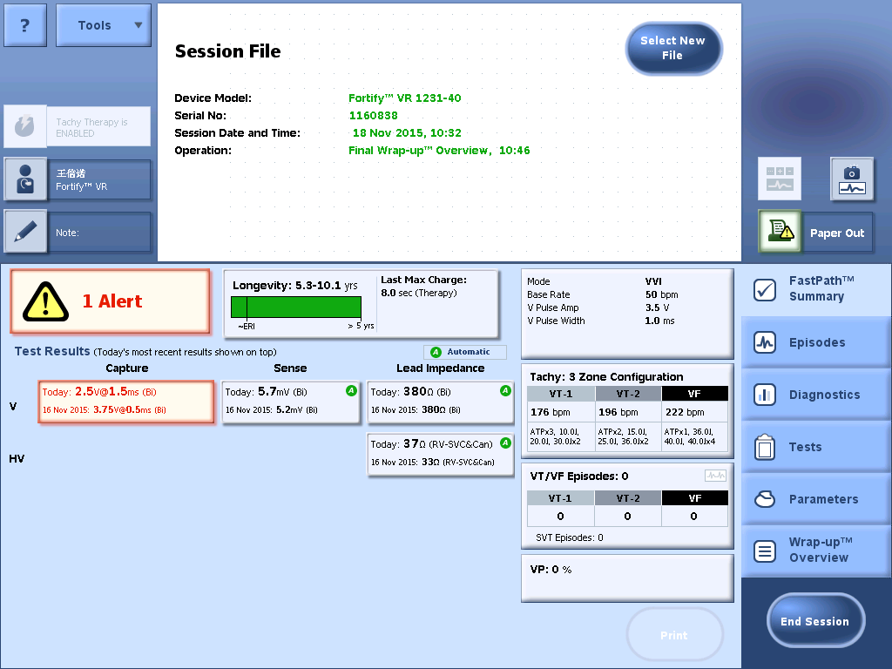

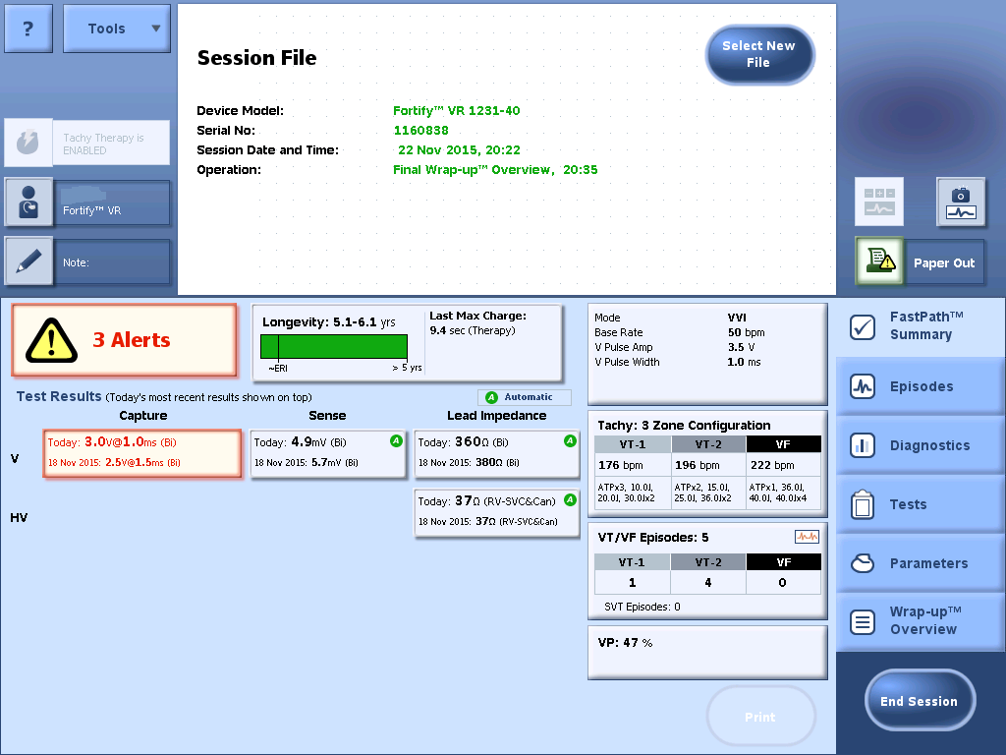

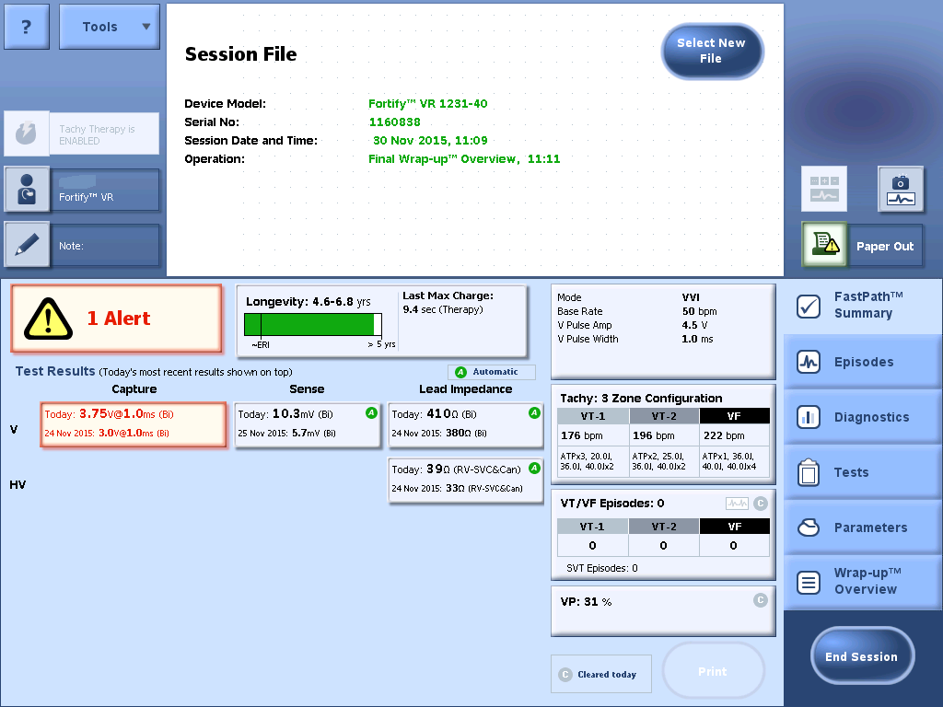

III. 1 and 3 Dec, 2015 in 2 months post- first implant follow-up

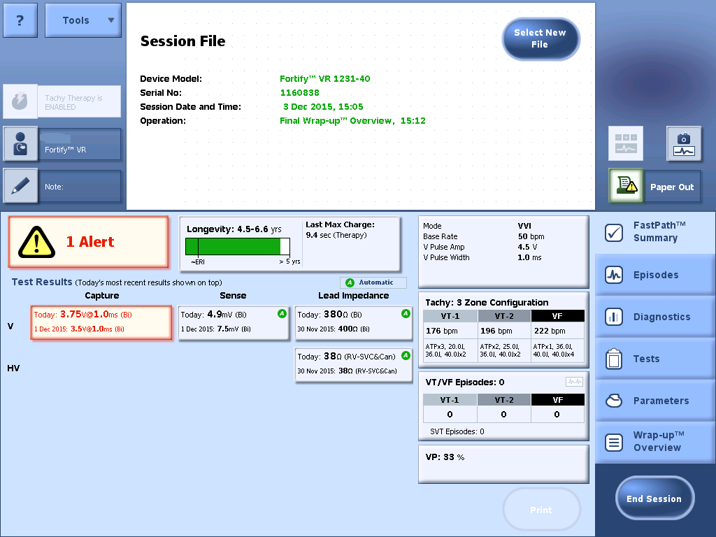

IV. 8, 9 and 16 Dec, 2015 in two weeks post- second implant follow-up
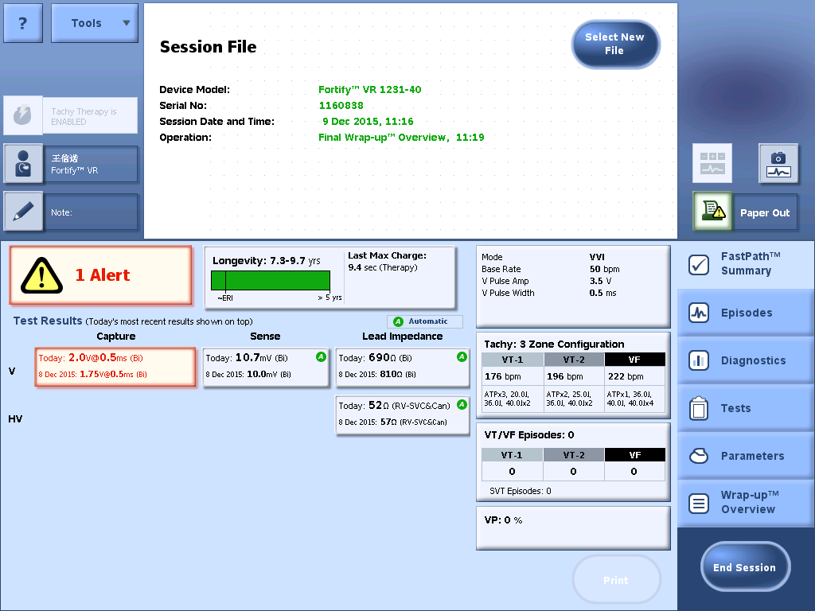

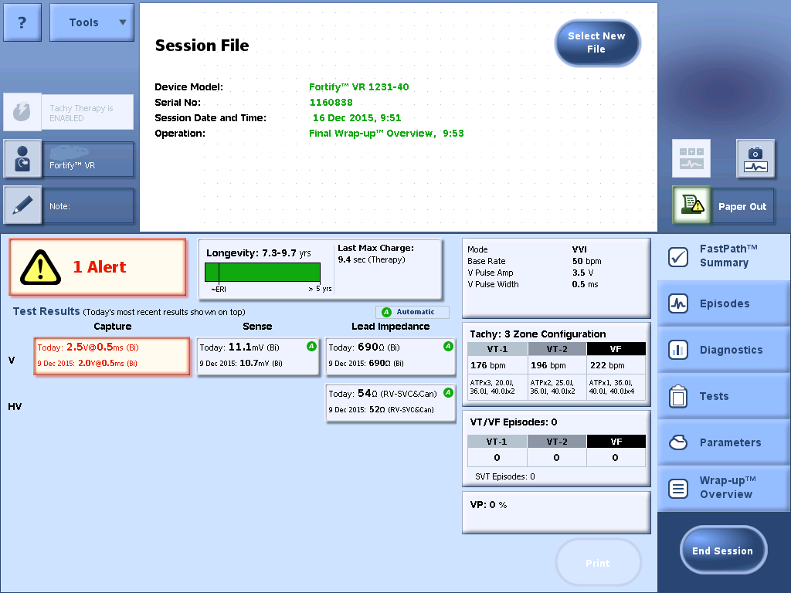

V. 9 Mar and 13 Apr, 2016 in 3-4 months post- second implant follow-up
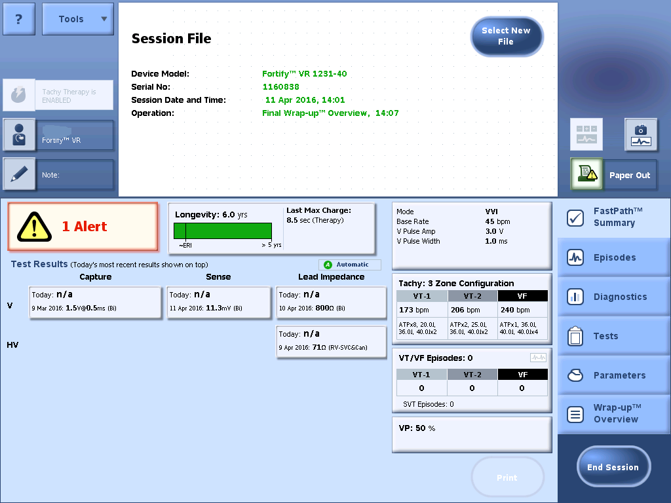

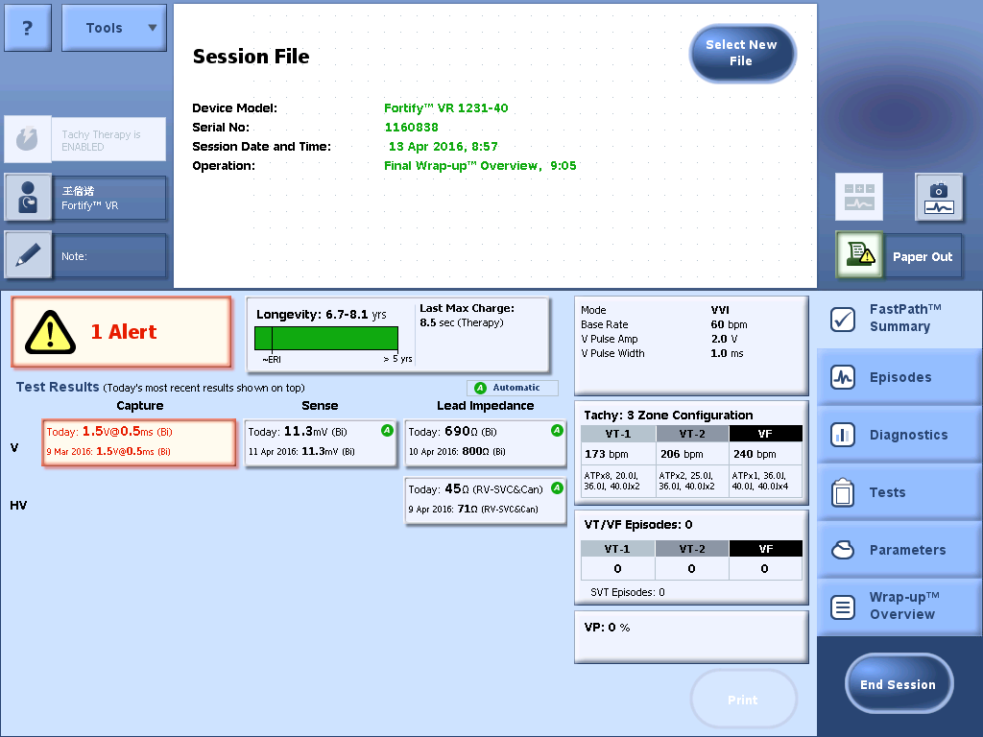

VI. 9 Nov, 2016 in 12 months post- second implant follow-up
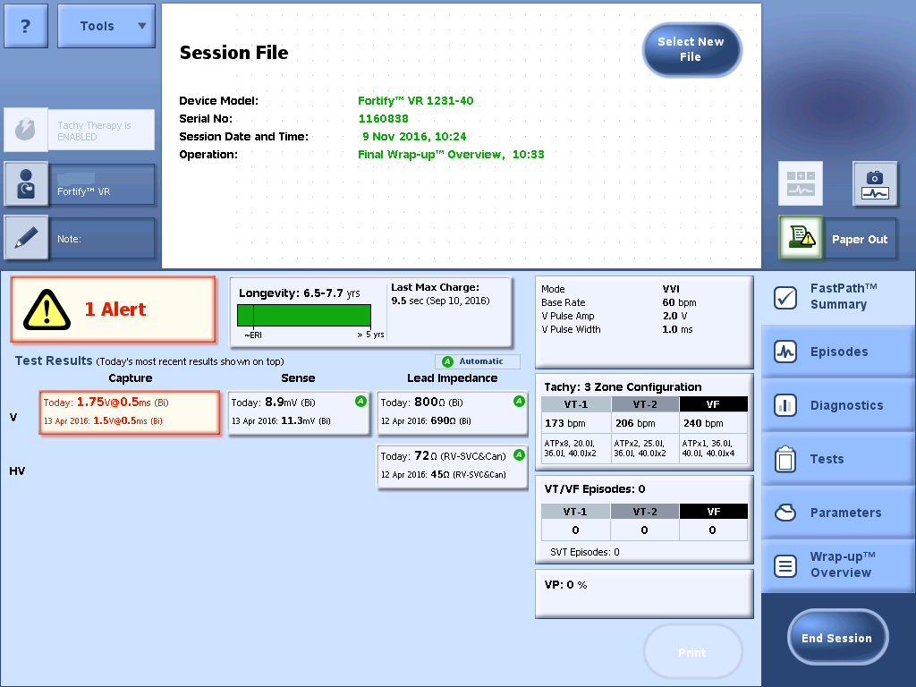

VII. 14 Jun, 2016 in 18 months post- second implant follow-up
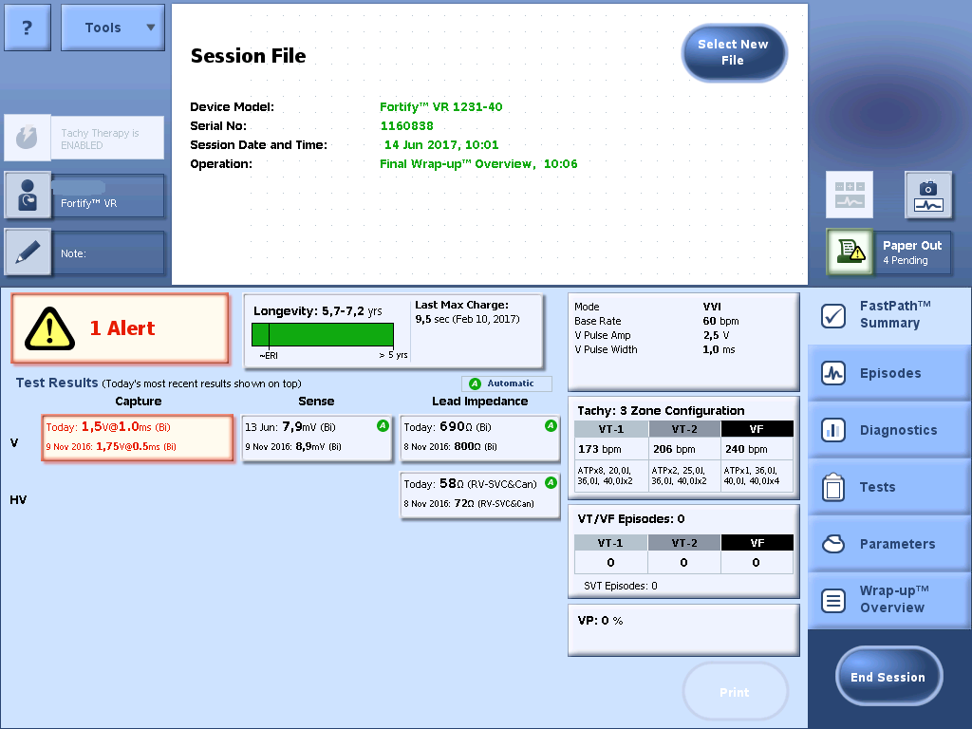

VIII. 27 Sep, 2016 in 22 months post- second implant follow-up
