DATA SUPPLEMENT
Factors associated with door-in to door-out delays among ST-segment elevation myocardial infarction (STEMI) patients transferred for primary percutaneous coronary intervention: a population-based cohort study in Ontario, Canada

Contents:

Table 1 International Classification of Diseases (ICD-10) ST-segment elevation myocardial infarction (STEMI) codes.
Table 2 ST-segment elevation myocardial infarction (STEMI) process of care measures and associated benchmarks.
Figure 1 Distribution of door-in to door-out (DIDO) times (minutes)
Table 3 Crude 30-day mortality rate for ST-segment elevation myocardial infarction (STEMI) patients with abstracted data but who received fibrinolytic therapy in the first hospital

Table S1 International Classification of Diseases (ICD) ST-segment elevation myocardial infarction (STEMI) codes

ICD-10 code | Description | Main or secondary diagnosis
I210 | Acute transmural myocardial infarction of anterior wall | Main
1211 | Acute transmural myocardial infarction of inferior wall | Main
I212 | Acute transmural myocardial infarction of other sites | Main
I213 | Acute transmural myocardial infarction of unspecified site | Main
I214 | Acute subendocardial myocardial infarction | Main
I219 | Acute myocardial infarction, unspecified | Main
I220 | Subsequent myocardial infarction of anterior wall | Main
I221 | Subsequent myocardial infarction of inferior wall | Main
I228 | Subsequent myocardial infarction of other sites | Main
I229 | Subsequent myocardial infarction of unspecified site | Main
I240 | Coronary thrombosis not resulting in myocardial infarction | Main
R9430 | Electrocardiogram suggestive of ST segment elevation myocardial infarction [STEMI] | Secondary
ICD, International Classification of Diseases.

Table S2 ST-segment elevation myocardial infarction (STEMI) process of care measures and associated benchmarks

Process of care measures | Definition | Benchmark Applied
Door-in to door-out (DIDO) time | Elapsed time between arrival at, and discharge from a STEMI referral hospital | ≤ 30 minutes
First medical contact-to-balloon time | Duration of time between first medical contact and receipt of PCI | ≤ 120 minutes from the first medical contact for patients transferred from a referral hospital
Receipt of a timely ECG | ECG administered by EMS (pre-hospital ECG) for those arriving by ambulance or upon arrival at hospital for those transporting themselves | ≤ 10 minutes
Symptom-to-first medical contact time | Elapsed time from symptom onset to being attended to by paramedics for those transported by EMS, or nurses and/or doctors after arrival at the ED for those who transported themselves to hospital | NONE
Symptom-to-door time | Length of time between symptom onset and arrival at the first hospital | NONE
Door-out to arrival at the second hospital time | Time from discharge at the first, referral hospital, to arrival at the second hospital | NONE
Second hospital to balloon time | Duration of time from arrival at the second, PCI-capable hospital, to receipt of PCI | NONE

ECG, electrocardiogram; ED, emergency department; EMS, emergency medical services; PCI, percutaneous coronary intervention; STEMI, ST-segment elevation myocardial infarction.

References
- O'Gara PT, Kushner FG, Ascheim DD, Casey DE, Chung MK, de Lemos JA, et al. 2013 ACCF/AHA Guideline for the Management of ST-Elevation Myocardial Infarction: A Report of the American College of Cardiology Foundation/American Heart Association Task Force on Practice Guidelines. Circulation. 2013; 127(4):e362-e425.
- CCN. Cardiac Care Network of Ontario. Ontario STEMI Bypass Protocol. 2015.

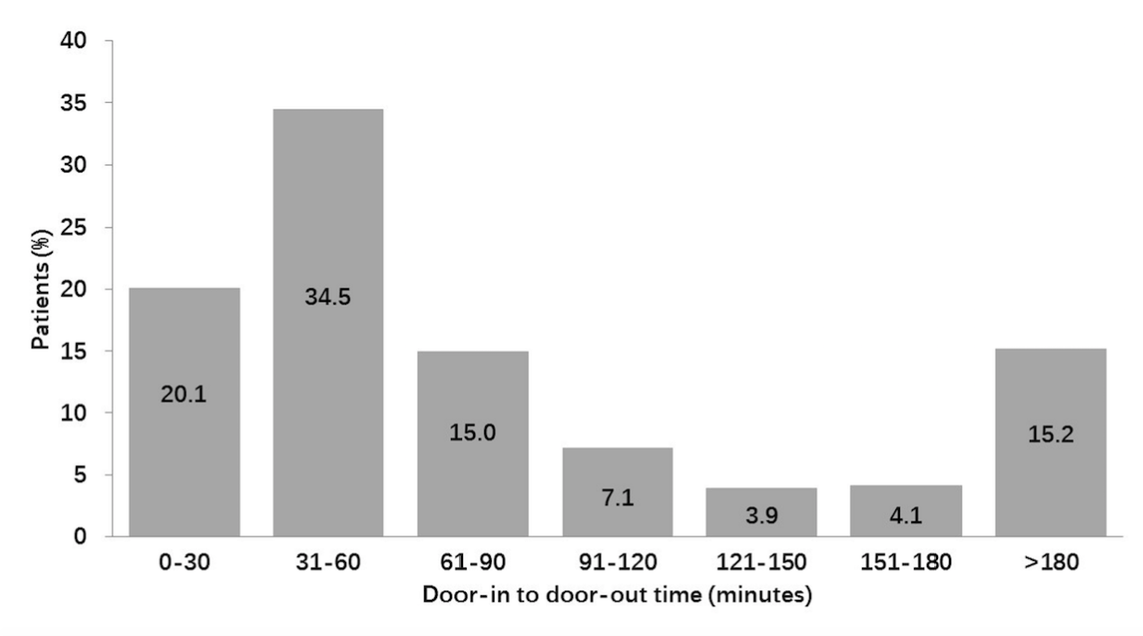

Fig. S1 Distribution of door-in to door-out times, Ontario, Canada, 2012

Table S3 Crude 30-day mortality rate for ST-segment elevation myocardial infarction (STEMI) patients with abstracted data but who received fibrinolytic therapy in the first hospital, Ontario, Canada, 2012
 | Number of events/  Patient population | Crude 30-day mortality rate (%)
Overall | 34/518 | 6.6
Timely | 14/256 | 5.5
Untimely | 20/262 | 7.6
Analysis was conducted amongst a sub-set of ST-segment elevation myocardial infarction (STEMI) patients in our study who had their charts abstracted but who were administered fibrinolytic therapy at the first hospital and as such were excluded from the final cohort used in the study used to study door-in to door-out times.

