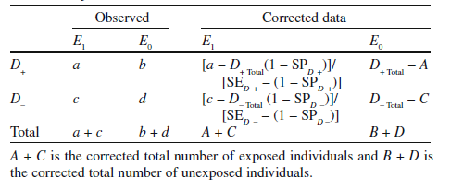

Figure 2. Equation (taken from applying quantitative bias analysis to epidemiologic data book) used for calculating expected true data given the observed data with exposure misclassification: Corrections Using Sensitivity and Specificity

eTable 4: Correction for misclassification of opium use in the study of the effects of opium consumption on myocardial infarction and ischemic heart diseases assuming non-differential misclassification

Ischemic heart diseases |  |  |  | Myocardial infarction
Corrected data |  | Observed |  | Corrected data |  | Observed
Non-user | user | Non-user | user | Non-user | user | Non-user | user
 |  |  |  |  |  |  |  | Se = 90%, Sp = 90%
592.125 | 240.875 | 557 | 276 | 142.125 | 140.875 | 142 | 141 | case
7614.75 | 1447.25 | 6998 | 2064 | 8064.75 | 1547.25 | 7413 | 2199 | control
 | 2.14 |  | 1.68 |  | 5.17 |  | 3.35 | OR
Sensitivity (Se) = probability someone exposed is classified as exposed
Specificity (Sp) = probability someone unexposed is classified as unexposed

