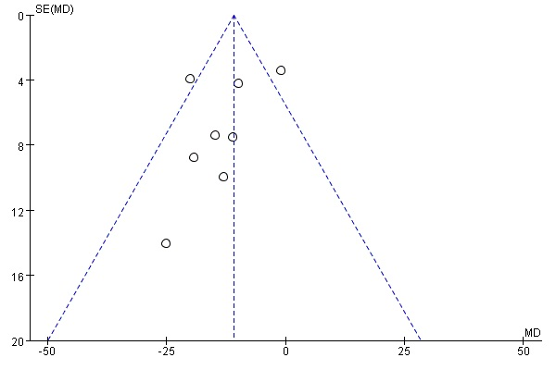
Additional file 4: Fig. S1 Funnel plot of reduction in LVESV between groups

