SUPPLEMENTARY MATERIAL for “Prognostic implications of valvular heart disease in patients with non-valvular atrial fibrillation” Samaras et al.

Supplemental Table S1. ﻿Cox proportional hazard models, including moderate/severe valve lesions, for the prediction of net clinical outcomes

Variables | All-cause death or HF-hospitalization |  |  |  | CV death or Stroke/SEE or Major bleeding |  |  |  | CV death or HF hospitalization
Variables | Univariate |  | Multivariate |  | Univariate |  | Multivariate |  | Univariate |  | Multivariate
Variables | HR (95% CI) | p value | HR (95% CI) | p value | HR (95% CI) | p value | HR (95% CI) | p value | HR (95% CI) | p value | HR (95% CI) | p value
Age (years) | 1.04 (1.03-1.05) | <0.001 | 1.02 (1.00-1.03) | 0.015 | 1.04 (1.03-1.05) | <0.001 | 1.02 (1.00-1.04) | 0.012 | 1.04 (1.03-1.05) | <0.001 | 1.02 (1.00-1.03) | 0.022
Gender (male) | 0.92 (0.75-1.11) | 0.373 |  |  | 0.91 (0.72-1.13) | 0.378 |  |  | 0.80 (0.64-1.00) | 0.05
BMI (kg/m²) | 0.98 (0.96-1.00) | 0.046 |  |  | 0.99 (0.97-1.01) | 0.268 |  |  | 1.00 (0.98-1.02) | 0.855
Paroxysmal | 0.68 (0.55-0.84) | <0.001 |  |  | 0.79 (0.62-1.00) | 0.049 |  |  | 0.67 (0.53-0.87) | 0.002
Persistent or permanent | 1.59 (1.31-1.94) | <0.001 |  |  | 1.31 (1.05-1.64) | 0.016 |  |  | 1.61 (1.28-2.02) | <0.001
Hypertension | 1.29 (1.00-1.67) | 0.054 |  |  | 1.33 (0.98-1.81) | 0.064 |  |  | 1.33 (1.02-1.86) | 0.061
Diabetes mellitus | 1.62 (1.33-1.97) | <0.001 | 1.50 (1.22-1.86) | <0.001 | 1.47 (1.17-1.84) | 0.001 | 1.35 (1.06-1.72) | 0.015 | 1.75 (1.40-2.19) | <0.001 | 1.53 (1.20-1.96) | 0.001
Heart failure | 2.78 (2.26-3.43) | <0.001 | 1.71 (1.34-2.18) | <0.001 | 2.70 (2.13-3.43) | <0.001 | 1.74 (1.32-2.29) | <0.001 | 3.25 (2.54-4.15) | <0.001 | 1.86 (1.39-2.47) | <0.001
Chronic obstructive pulmonary disease | 1.64 (1.28-2.11) | <0.001 |  |  | 1.40 (1.04-1.88) | 0.025 |  |  | 1.80 (1.36-2.38) | <0.001
Cardiomyopathy | 1.24 (1.10-1.39) | <0.001 |  |  | 1.21 (1.07-1.37) | 0.003 |  |  | 1.18 (1.03-1.35) | 0.016
Coronary artery disease | 1.42 (1.16-1.73) | <0.001 |  |  | 1.39 (1.12-1.74) | 0.003 |  |  | 1.62 (1.30-2.03) | <0.001
Prior myocardial infarction | 1.76 (1.43-2.16) | <0.001 |  |  | 1.74 (1.38-2.21) | <0.001 |  |  | 1.96 (1.55-2.48) | <0.001
Prior cardiac arrest | 2.18 (1.30-3.65) | 0.003 | 2.59 (1.50-4.48) | 0.001 | 1.47 (0.78-2.75) | 0.235 |  |  | 2.06 (1.13-3.77) | 0.019 | 2.38 (1.26-4.52) | 0.008
Non-fatal stroke or SEE | 1.30 (1.01-1.67) | 0.048 |  |  | 1.51 (1.14-1.99) | 0.004 |  |  | 1.35 (1.01-1.80) | 0.042
Non-fatal major bleeding | 1.23 (0.95-1.60) | 0.123 |  |  | 1.51 (1.13-2.01) | 0.005 | 1.41 (1.05-1.91) | 0.024 | 1.20 (0.89-1.62) | 0.244
eGFR at discharge (ml/min/1.73m²) | 0.98 (0.98-0.99) | <0.001 |  |  | 0.99 (0.98-0.99) | <0.001 |  |  | 0.98 (0.98-0.99) | <0.001
LVEF (%) | 0.96 (0.96-0.97) | <0.001 | 0.98 (0.97-0.99) | <0.001 | 0.96 (0.95-0.97) | <0.001 | 0.97 (0.96-0.98) | <0.001 | 0.96 (0.95-0.97) | <0.001 | 0.98 (0.97-0.99) | <0.001
LAVi (mL/m²) | 1.04 (1.04-1.05) | <0.001 | 1.03 (1.02-1.04) | <0.001 | 1.04 (1.03-1.05) | <0.001 | 1.03 (1.02-1.04) | <0.001 | 1.04(1.03-1.05) | <0.001 | 1.03 (1.02-1.04) | <0.001
NT-proBNP (pg/ml) | 1.00 (1.00-1.00) | <0.001 | 1.00 (1.00-1.00) | <0.001 | 1.00 (1.00-1.00) | <0.001 | 1.00 (1.00-1.00) | <0.001 | 1.00 (1.00-1.00) | <0.001 | 1.00 (1.00-1.00) | <0.001
hs-TnT (pg/ml) | 1.00 (1.00-1.00) | <0.001 | 1.00 (1.00-1.00) | 0.001 | 1.00 (1.00-1.00) | <0.001 | 1.00 (1.00-1.00) | <0.001 | 1.00 (1.00-1.00) | <0.001 | 1.00 (1.00-1.00) | 0.001
Vitamin K antagonist | 1.55 (1.26-1.90) | <0.001 |  |  | 1.60 (1.27-2.02) | <0.001 |  |  | 1.64 (1.30-2.06) | <0.001
Non-vitamin K antagonist | 0.66 (0.54-0.80) | <0.001 |  |  | 0.60 (0.48-0.75) | <0.001 |  |  | 0.67 (0.53-0.84) | <0.001
Antiarrhythmic agent | 0.69 (0.53-0.90) | 0.006 |  |  | 0.67 (0.51-0.89) | 0.006 |  |  | 0.67 (0.50-0.89) | 0.006
Moderate/Severe AS | 2.61 (1.97-3.46) | <0.001 | 1.87 (1.37-2.56) | <0.001 | 2.41 (1.74-3.32) | <0.001 | 1.56 (1.08-2.24) | 0.017 | 2.61 (1.90-3.60) | <0.001 | 1.80 (1.26-2.57) | 0.001
Moderate/Severe AR | 1.49 (1.10-2.01) | 0.009 |  |  | 1.38 (0.97-1.96) | 0.075 |  |  | 1.51 (1.08-2.12) | 0.017
Moderate/Severe MR | 2.14 (1.76-2.60) | <0.001 |  |  | 2.01 (1.61-2.50) | <0.001 |  |  | 2.37 (1.89-2.97) | <0.001
Moderate/Severe TR | 2.21 (1.81-2.68) | <0.001 |  |  | 2.16 (1.73-2.69) | <0.001 |  |  | 2.32 (1.86-2.90) | <0.001

Adjusted hazard ratios as displayed only if the respective variable in independently associated with risk of outcomes. VHD, valvular heart disease; CV, cardiovascular; HF, heart failure; AF, atrial fibrillation; BMI, body mass index; eGFR, estimated glomerular filtration rate; SEE, systemic embolic event; LVEF, left ventricular ejection fraction; LAVi, indexed left atrial volume; NT- proBNP, N- terminal pro-B-type natriuretic peptide; hs-TnT, cardiac troponin T measured with high- sensitivity assay; AS, aortic stenosis; AR, aortic regurgitation; MR, mitral regurgitation; TR, tricuspic regurgitation; HR, hazard ratio; CI, confidence interval

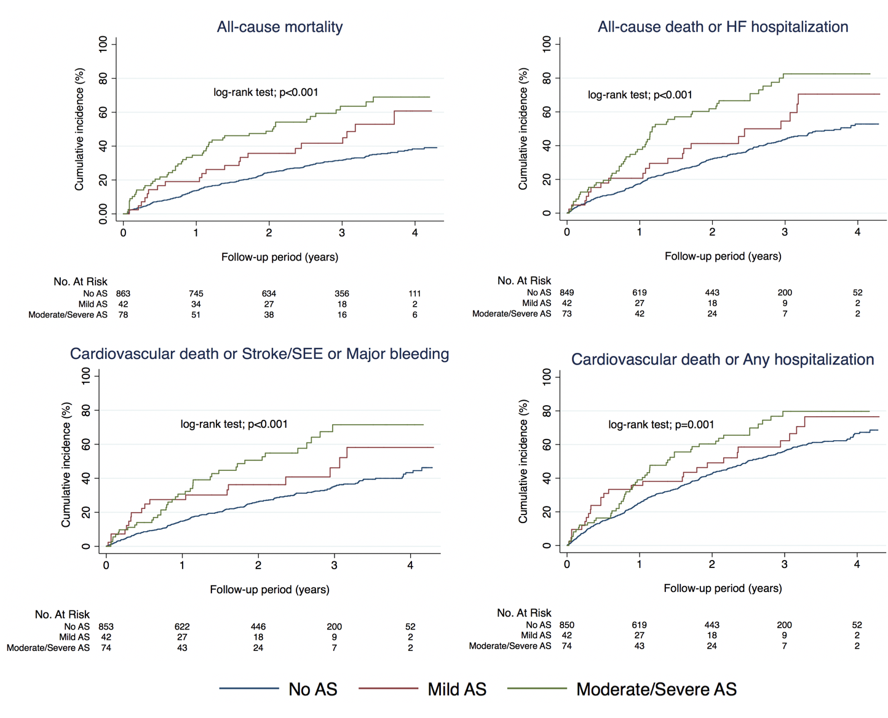

Supplemental Figure 1
Cumulative incidence of all-cause mortality and net clinical outcomes by presence and severity of AS. AS, aortic stenosis; HF, heart failure; SEE, systemic embolic event

