Figure 1. Temporal trends in first medication prescribed/dispensed among incident NVAF

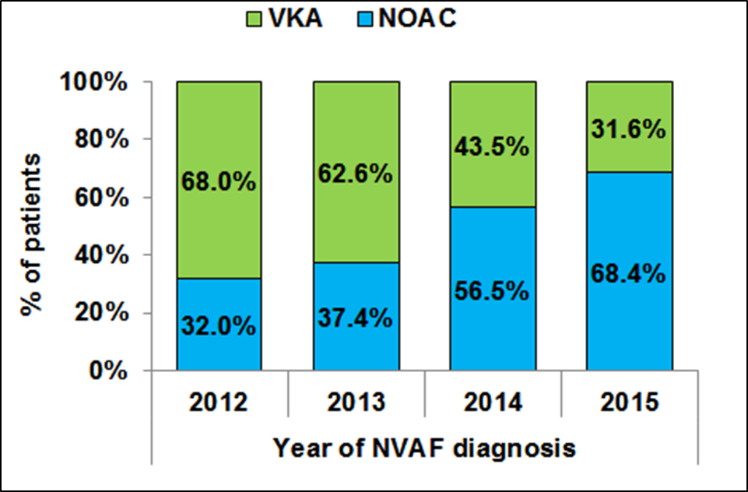
P<0.001
VKA- vitamin K antagonists; NOAC- New antagonist oral anticoagulants

Figure 2. Time (months, median [IQR]) from diagnosis to first dispense of therapy among incident patients according to the year of diagnosis

