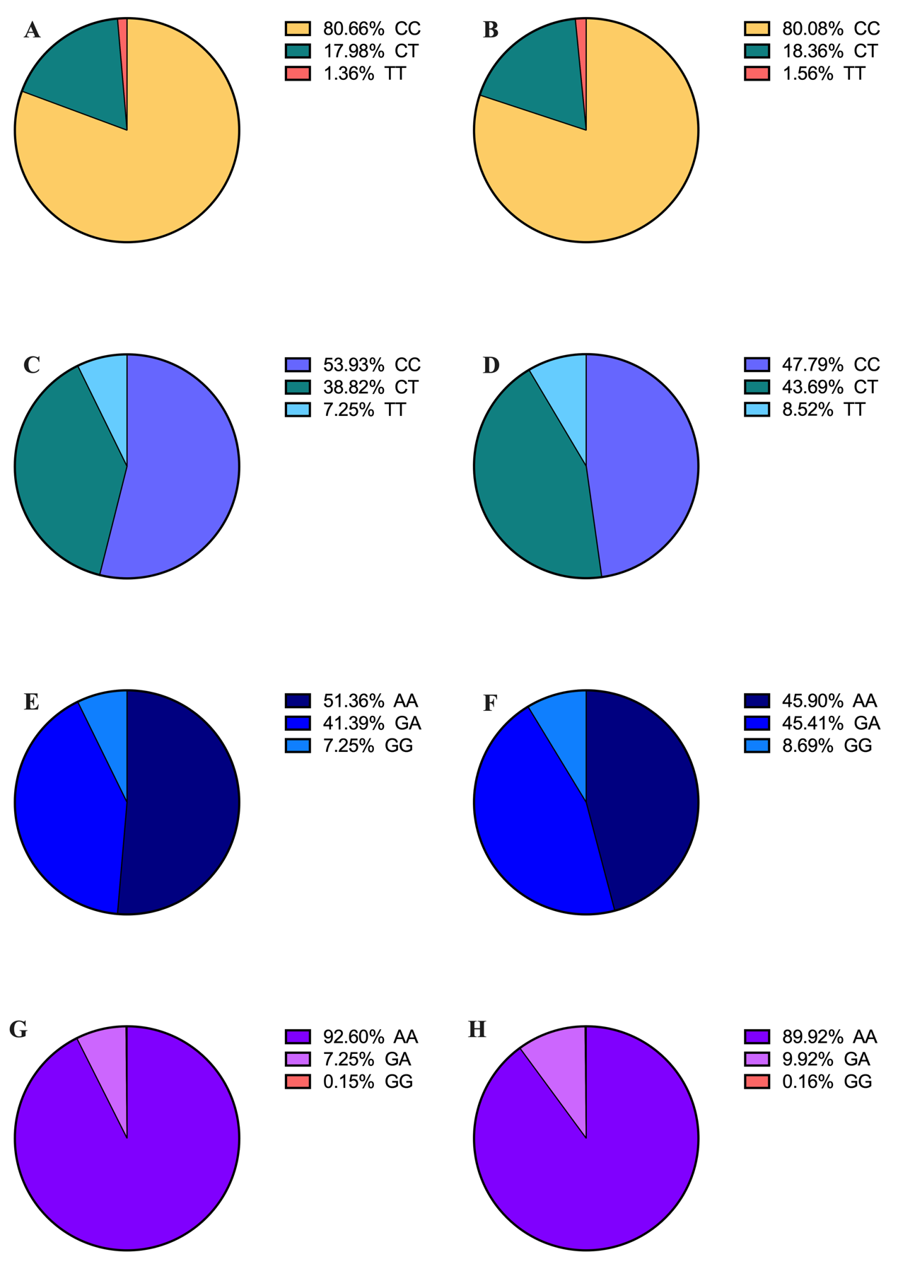
Figure S1 The distribution of four SNPs genotypes in the case and control group. A and B: rs11583680 genotypes in case and control group. C and D: rs2483205 genotypes in case and control group. E and F: rs2495477 genotypes in case and control group. G and H: rs562556 genotypes in case and control group.
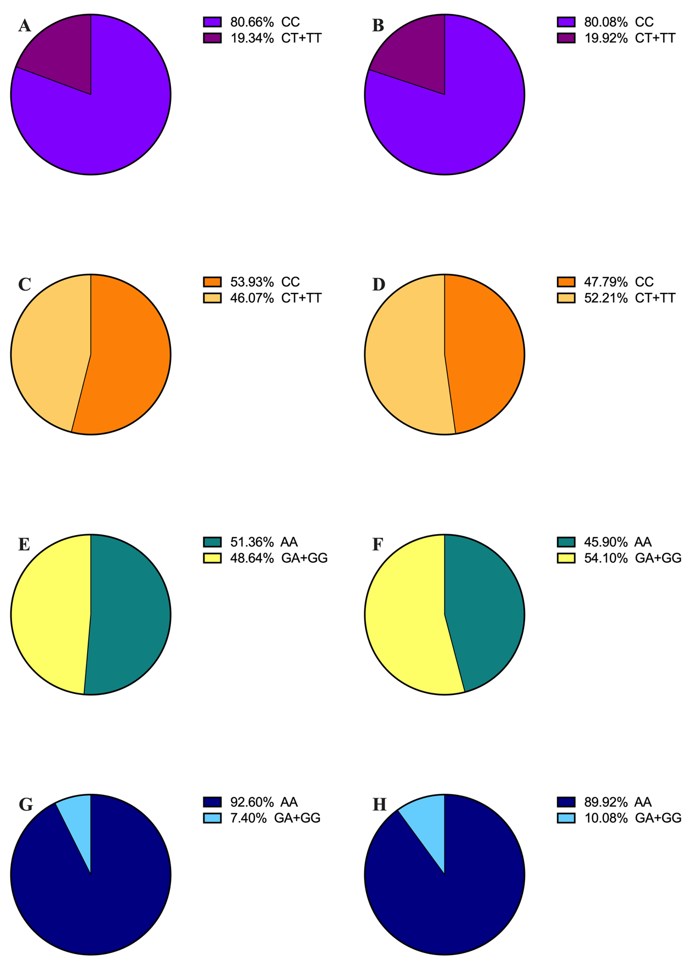
Figure S2 Distribution of dominant models of four SNPs in cases and controls.
A and B: The proportion of rs11583680 dominant model in case and control group. C and D: The proportion of rs2483205 dominant mode in case and control group. E and F: The proportion of rs2495477 dominant mode in case and control group. G and H: The proportion of rs562556 dominant mode in case and control group.
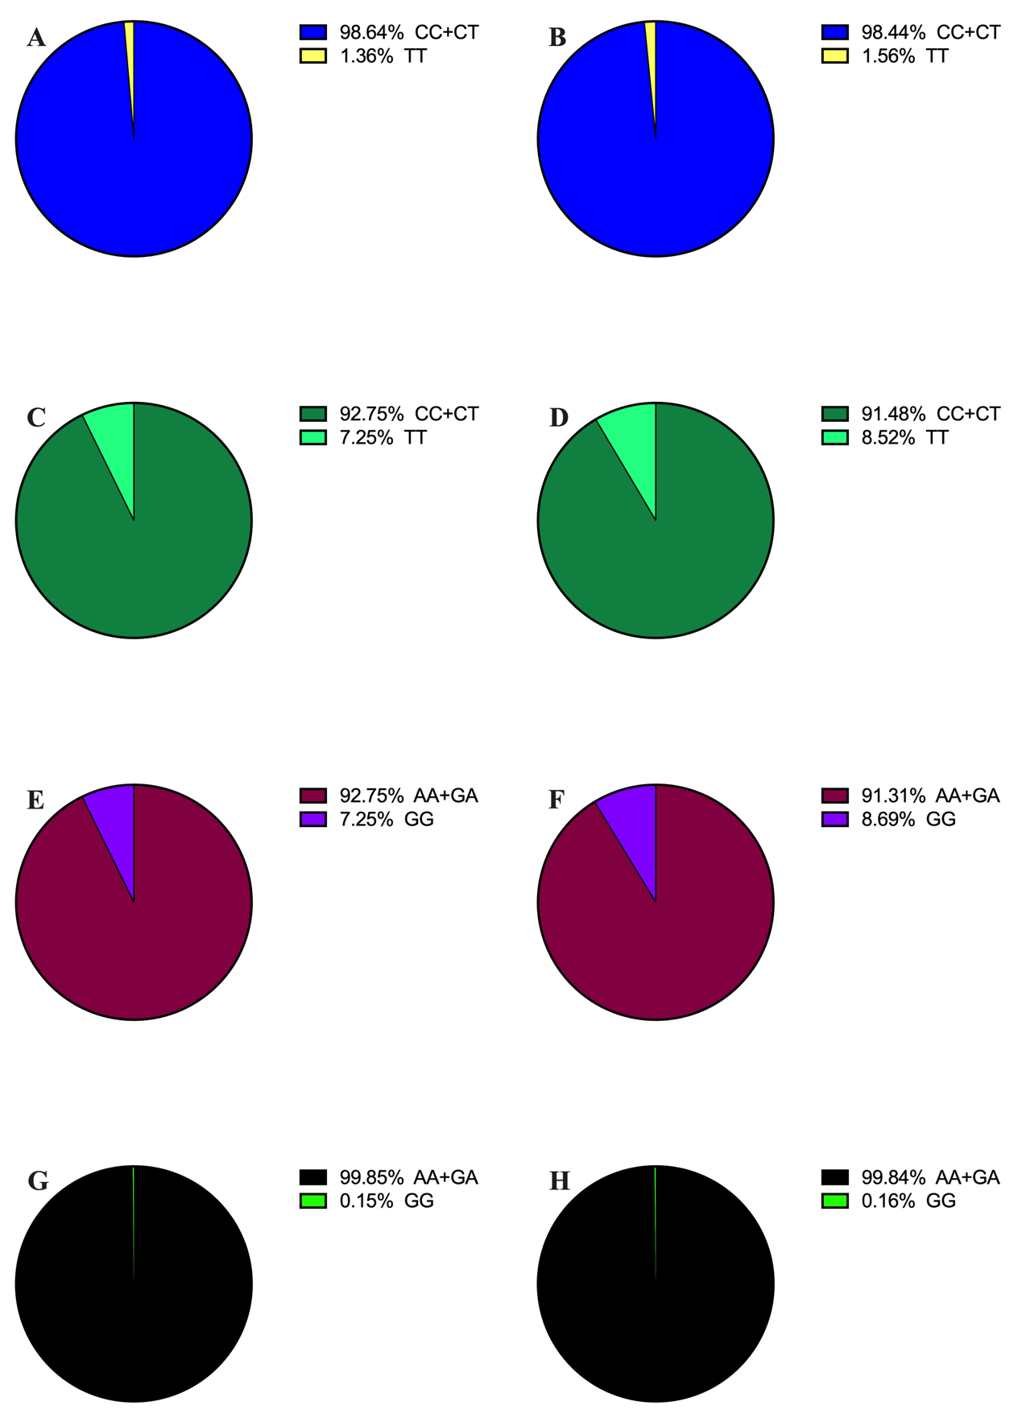
Figure S3 Distribution of recessive models of four SNPs in cases and controls.
A and B: The proportion of rs11583680 recessive model in case and control group. C and D: The proportion of rs2483205 recessive mode in case and control group. E and F: The proportion of rs2495477 recessive mode in case and control group. G and H: The proportion of rs562556 recessive mode in case and control group.

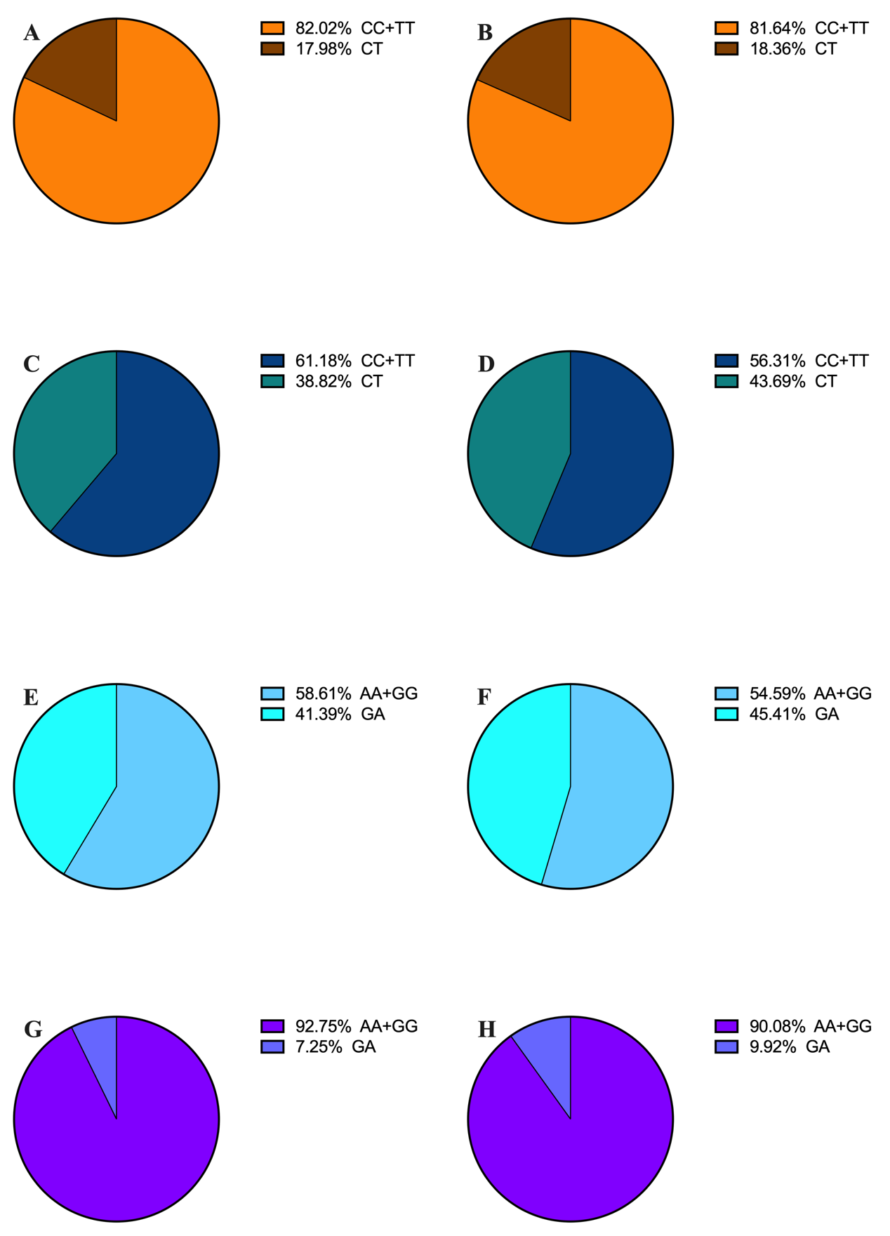
Figure S4 Distribution of overdominant models of four SNPs in cases and controls.
A and B: The proportion of rs11583680 overdominant model in case and control group. C and D: The proportion of rs2483205 overdominant mode in case and control group. E and F: The proportion of rs2495477 overdominant mode in case and control group. G and H: The proportion of rs562556 overdominant mode in case and control group.

