Supplementary Figure 1. Flow chart of the study population enrollment.
MIMIC, Medical Information Mart for Intensive Care; ICU, intensive care unit; CABG, coronary artery bypass graft surgery; LDH, lactate dehydrogenase; NLR, neutrophil-lymphocyte ratio; LMR, lymphocyte-monocyte ratio; PLR, platelet-lymphocyte ratio; SAPS, simplified acute physiology score.
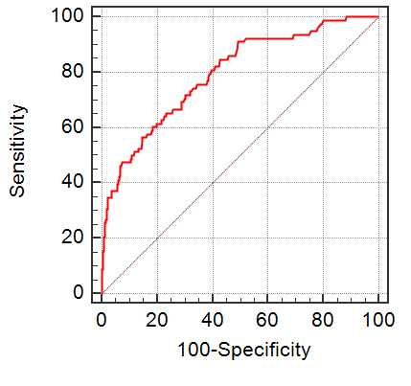
Supplementary Figure 2. The receiver operating characteristic curve of LDH for predicting in-hospital mortality in MIMIC III. The best cut-off value was > 328u/l. Area under the curve was 0.795 and the sensitivity, specificity, 95%CI lower and 95%CI upper were 65.4%, 76.6%, 0.778 and 0.811, respectively. LDH, lactate dehydrogenase; 95% CI, 95% confidence interval; MIMIC, Medical Information Mart for Intensive Care.
.

