P<0.001
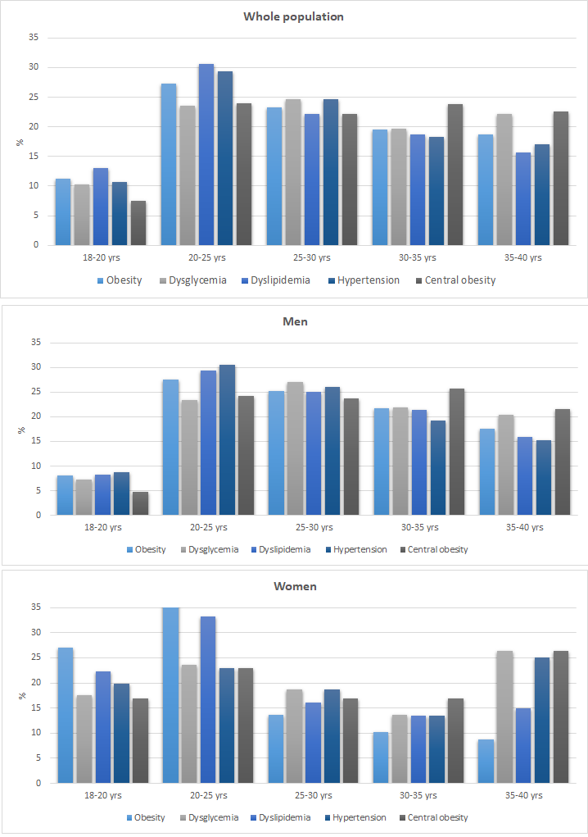
Supplementary Figure 1: Cardiometabolic risk factors across age groups of the UAE Healthy Future Study Participants.
P value 0.00

