Supplementary Table 1 Single-factor Cox regression analysis of covariates and all-cause mortality
Variables | 30-day all-cause mortality |  | 90-day all-cause mortality |  | 1-year all-cause mortality
Variables | HR (95% CI) | P-Value | HR (95% CI) | P-Value | HR (95% CI) | P-Value
Age (years) | 1.04 (1.03, 1.05) | < 0.001 | 1.04 (1.04, 1.05) | < 0.001 | 1.04 (1.04, 1.04) | < 0.001
Sex
Female | 1.0 |  | 1.0 |  | 1.0
Male | 0.79 (0.71, 0.88) | < 0.001 | 0.79 (0.72, 0.86) | < 0.001 | 0.78 (0.72, 0.84) | < 0.001
Race
Other | 1.0 |  | 1.0 |  | 1.0
White | 0.76 (0.67, 0.85) | < 0.001 | 0.8 (0.73, 0.88) | < 0.001 | 0.94 (0.86, 1.02) | 0.124
Hypertension
No | 1.0 |  | 1.0 |  | 1.0
Yes | 0.67 (0.61, 0.75) | < 0.001 | 0.61 (0.56, 0.68) | < 0.001 | 0.59 (0.54, 0.64) | < 0.001
Diabetes
No | 1.0 |  | 1.0 |  | 1.0
Yes | 0.96 (0.86, 1.07) | 0.461 | 1.02 (0.92, 1.12) | 0.743 | 1.11 (1.02, 1.2) | 0.013
CHF
No | 1.0 |  | 1.0 |  | 1.0
Yes | 1.39 (1.25, 1.54) | < 0.001 | 1.48 (1.35, 1.62) | < 0.001 | 1.57 (1.46, 1.7) | < 0.001
PVD
No | 1.0 |  | 1.0 |  | 1.0
Yes | 1.05 (0.91, 1.21) | 0.476 | 1.11 (0.99, 1.25) | 0.078 | 1.17 (1.06, 1.29) | 0.001
Cerebrovascular disease
No | 1.0 |  | 1.0 |  | 1.0
Yes | 1.63 (1.44, 1.84) | < 0.001 | 1.51 (1.35, 1.69) | < 0.001 | 1.42 (1.3, 1.56) | < 0.001
CPD
No | 1.0 |  | 1.0 |  | 1.0
Yes | 1.04 (0.93, 1.16) | 0.502 | 1.08 (0.98, 1.19) | 0.108 | 1.16 (1.07, 1.25) | < 0.001
Renal disease
No | 1.0 |  | 1.0 |  | 1.0
Yes | 1.56 (1.4, 1.74) | < 0.001 | 1.67 (1.52, 1.83) | < 0.001 | 1.76 (1.63, 1.9) | < 0.001
Liver disease
No | 1.0 |  | 1.0 |  | 1.0
Yes | 2.48 (2.15, 2.85) | < 0.001 | 2.42 (2.14, 2.74) | < 0.001 | 2.16 (1.93, 2.41) | < 0.001
Malignancy
No | 1.0 |  | 1.0 |  | 1.0
Yes | 1.98 (1.74, 2.25) | < 0.001 | 2.15 (1.93, 2.4) | < 0.001 | 2.38 (2.17, 2.61) | < 0.001
Sepsis
No | 1.0 |  | 1.0 |  | 1.0
Yes | 2.49 (2.2, 2.82) | < 0.001 | 2.23 (2.01, 2.48) | < 0.001 | 1.83 (1.68, 1.98) | < 0.001
AHF
No | 1.0 |  | 1.0 |  | 1.0
Yes | 1.33 (1.18, 1.49) | < 0.001 | 1.42 (1.29, 1.57) | < 0.001 | 1.53 (1.41, 1.66) | < 0.001
Stroke
No | 1.0 |  | 1.0 |  | 1.0
Yes | 2.17 (1.89, 2.51) | < 0.001 | 2.02 (1.78, 2.29) | < 0.001 | 1.84 (1.64, 2.05) | < 0.001
AKI
No | 1.0 |  | 1.0 |  | 1.0
Yes | 3.13 (2.57, 3.81) | < 0.001 | 2.6 (2.23, 3.04) | < 0.001 | 1.8 (1.61, 2.01) | < 0.001
SOFA | 1.18 (1.17, 1.19) | < 0.001 | 1.15 (1.14, 1.17) | < 0.001 | 1.12 (1.11, 1.13) | < 0.001
SAPS Ⅱ | 1.05 (1.05, 1.06) | < 0.001 | 1.05 (1.04, 1.05) | < 0.001 | 1.04 (1.04, 1.04) | < 0.001
CCI | 1.22 (1.19, 1.24) | < 0.001 | 1.23 (1.21, 1.25) | < 0.001 | 1.25 (1.23, 1.26) | < 0.001
Hemoglobin (g/dL) | 1.02 (1, 1.04) | 0.087 | 0.9989 (0.9798, 1.0184) | 0.912 | 0.9908 (0.9749, 1.007) | 0.265
Platelets (×10⁹/L) | 1.0015 (1.0011, 1.0019) | < 0.001 | 1.0016 (1.0012, 1.0019) | < 0.001 | 1.0016 (1.0013, 1.0019) | < 0.001
WBC (×10⁹/L) | 1.0094 (1.0069, 1.0118) | < 0.001 | 1.0085 (1.0061, 1.0109) | < 0.001 | 1.0071 (1.0046, 1.0095) | < 0.001
RDW (%) | 1.19 (1.17, 1.2) | < 0.001 | 1.19 (1.17, 1.21) | < 0.001 | 1.2 (1.18, 1.21) | < 0.001
Anion gap (mmol/L) | 1.1 (1.09, 1.11) | < 0.001 | 1.09 (1.09, 1.1) | < 0.001 | 1.09 (1.08, 1.09) | < 0.001
BUN (mg/dL) | 1.01 (1.01, 1.02) | < 0.001 | 1.01 (1.01, 1.02) | < 0.001 | 1.01 (1.01, 1.02) | < 0.001
Creatinine (mg/dL) | 1.15 (1.12, 1.18) | < 0.001 | 1.14 (1.12, 1.17) | < 0.001 | 1.15 (1.13, 1.16) | < 0.001
Glucose (mg/dL) | 1.0015 (1.0011, 1.0018) | < 0.001 | 1.0014 (1.0011, 1.0017) | < 0.001 | 1.0013 (1.001, 1.0016) | < 0.001
HR (beats/minute) | 1.01 (1.01, 1.01) | < 0.001 | 1.01 (1.01, 1.01) | < 0.001 | 1.01 (1.01, 1.01) | < 0.001
MBP (mmHg) | 0.9982 (0.9953,1.0012) | 0.238 | 0.9972 (0.9947, 0.9998) | 0.035 | 0.9982 (0.996, 1.0003) | 0.098
RR (beats/minute) | 1.06 (1.05, 1.07) | < 0.001 | 1.06 (1.05, 1.07) | < 0.001 | 1.06 (1.05, 1.06) | < 0.001
SpO₂ (%) | 0.95 (0.95, 0.96) | < 0.001 | 0.96 (0.95, 0.96) | < 0.001 | 0.96 (0.95, 0.96) | < 0.001
Antiplatelet agents
No | 1.0 |  | 1.0 |  | 1.0
Yes | 0.51 (0.45, 0.58) | < 0.001 | 0.57 (0.52, 0.64) | < 0.001 | 0.62 (0.57, 0.68) | < 0.001
Anticoagulant agents
No | 1.0 |  | 1.0 |  | 1.0
Yes | 0.81 (0.73, 0.9) | < 0.001 | 0.89 (0.82, 0.98) | 0.013 | 0.96 (0.89, 1.03) | 0.282
Antiarrhythmic agents
No | 1.0 |  | 1.0 |  | 1.0
Yes | 0.72 (0.65, 0.8) | < 0.001 | 0.78 (0.72, 0.86) | < 0.001 | 0.82 (0.76, 0.88) | < 0.001
MV
No | 1.0 |  | 1.0 |  | 1.0
Yes | 2.15 (1.93, 2.39) | < 0.001 | 1.85 (1.69, 2.02) | < 0.001 | 1.49 (1.38, 1.61) | < 0.001
RRT
No | 1.0 |  | 1.0 |  | 1.0
Yes | 2.88 (2.5, 3.32) | < 0.001 | 2.79 (2.46, 3.16) | < 0.001 | 2.59 (2.32, 2.9) | < 0.001
Vasopressors
No | 1.0 |  | 1.0 |  | 1.0
Yes | 1.39 (1.25, 1.55) | < 0.001 | 1.17 (1.07, 1.29) | < 0.001 | 0.99 (0.92, 1.07) | 0.762
Notes: data presented are HRs and 95% CIs.
Abbreviations: HR, hazard ratio; CI, confidence interval; CHF, congestive heart failure; PVD, peripheral vascular disease; CPD, chronic pulmonary disease; AKI, acute kidney injury; AHF, acute heart failure; SOFA, sequential organ failure assessment; SAPS Ⅱ, simplified acute physiology score Ⅱ; CCI, Charlson comorbidity index; WBC, white blood cell; RDW, red cell distribution width; BUN, blood urea nitrogen; HR, heart rate; MBP, mean blood pressure; RR, respiratory rate; SpO₂, saturation of pulse oximetry; MV, mechanical ventilation; RRT, renal replacement therapy.

Supplementary Table 2 Relationship between BMI and all-cause mortality after excluding participants with incomplete data of covariates
Variables | Crude model |  | Model 1 |  | Model 2
Variables | HR (95% CI) | P-value | HR (95% CI) | P-value | HR (95% CI) | P-value
30-day all-cause mortality
BMI category
Underweight | 1.93 (1.49, 2.5) | <0.001 | 1.96 (1.51, 2.54) | <0.001 | 1.62 (1.24, 2.12) | <0.001
Normal-weight | 1.00 (Reference) |  | 1.00 (Reference) |  | 1.00 (Reference)
Overweight | 0.76 (0.66, 0.86) | <0.001 | 0.85 (0.75, 0.97) | 0.018 | 0.83 (0.72, 0.94) | 0.005
Obese | 0.61 (0.53, 0.69) | <0.001 | 0.79 (0.69, 0.91) | 0.001 | 0.8 (0.69, 0.92) | 0.002
P for trend |  | <0.001 |  | <0.001 |  | <0.001
90-day all-cause mortality
BMI category
Underweight | 1.73 (1.37, 2.17) | <0.001 | 1.76 (1.4, 2.22) | <0.001 | 1.48 (1.17, 1.88) | 0.001
Normal-weight | 1.00 (Reference) |  | 1.00 (Reference) |  | 1.00 (Reference)
Overweight | 0.7 (0.63, 0.79) | <0.001 | 0.79 (0.71, 0.88) | <0.001 | 0.77 (0.68, 0.86) | <0.001
Obese | 0.55 (0.49, 0.62) | <0.001 | 0.72 (0.64, 0.81) | <0.001 | 0.71 (0.63, 0.8) | <0.001
P for trend |  | <0.001 |  | <0.001 |  | <0.001
1-year all-cause mortality
BMI category
Underweight | 1.72 (1.41, 2.1) | <0.001 | 1.75 (1.43, 2.13) | <0.001 | 1.48 (1.21, 1.82) | <0.001
Normal-weight | 1.00 (Reference) |  | 1.00 (Reference) |  | 1.00 (Reference)
Overweight | 0.7 (0.64, 0.77) | <0.001 | 0.78 (0.71, 0.86) | <0.001 | 0.76 (0.7, 0.84) | <0.001
Obese | 0.56 (0.51, 0.62) | <0.001 | 0.72 (0.66, 0.8) | <0.001 | 0.7 (0.63, 0.78) | <0.001
P for trend |  | <0.001 |  | <0.001 |  | <0.001
Note: The sample size was 9111. Crude model was adjusted for none; Model 1 was adjusted for age, sex and race; Model 2 was further adjusted (from Model 1) for hypertension, diabetes, CHF, PVD, cerebrovascular disease, CPD, renal disease, liver disease, malignancy, sepsis, AKI, AHF, stroke, SOFA, SAPS Ⅱ, CCI, hemoglobin, WBC, platelet, RDW, anion gap, BUN, creatinine, glucose, HR, MBP, RR, SpO₂, antiplatelet agents, anticoagulant agents, antiarrhythmic agents, MV, RRT, and vasopressors.
Abbreviations: BMI, body mass index; HR, hazard ratio; CI, confidence interval; CHF, congestive heart failure; PVD, peripheral vascular disease; CPD, chronic pulmonary disease; AKI, acute kidney injury; AHF, acute heart failure; SOFA, sequential organ failure assessment; SAPS Ⅱ, simplified acute physiology score Ⅱ; CCI, Charlson comorbidity index; WBC, white blood cell; RDW, red cell distribution width; BUN, blood urea nitrogen; HR, heart rate; MBP, mean blood pressure; RR, respiratory rate; SpO₂, saturation of pulse oximetry; MV, mechanical ventilation; RRT, renal replacement therapy.

Supplementary Table 3 Threshold effect analysis of the relationship between BMI and all-cause mortality after excluding participants with incomplete data of covariates
Threshold of BMI |  | 30-day all-cause mortality |  |  | 90-day all-cause mortality |  |  | 1-year all-cause mortality
Threshold of BMI |  | HR (95%CI) | P-value |  | HR (95%CI) | P-value |  | HR (95%CI) | P-value
<30kg/m² |  | 0.937 (0.919, 0.955) | <0.001 |  | 0.931 (0.915, 0.946) | <0.001 |  | 0.932 (0.919, 0.946) | <0.001
≥30kg/m² |  | 0.995 (0.974, 1.017) | 0.663 |  | 0.992 (0.974, 1.011) | 0.417 |  | 0.996 (0.981, 1.012) | 0.62
Likelihood ratio test |  |  | <0.001 |  |  | <0.001 |  |  | <0.001
Note: HRs were adjusted for age, sex, race, hypertension, diabetes, CHF, PVD, cerebrovascular disease, CPD, renal disease, liver disease, malignancy, sepsis, AKI, AHF, stroke, SOFA, SAPS Ⅱ, CCI, hemoglobin, WBC, platelet, RDW, anion gap, BUN, creatinine, glucose, HR, MBP, RR, SpO₂, antiplatelet agents, anticoagulant agents, antiarrhythmic agents, MV, RRT, and vasopressors.
Abbreviations: BMI, body mass index; HR, hazard ratio; CI, confidence interval; CHF, congestive heart failure; PVD, peripheral vascular disease; CPD, chronic pulmonary disease; AKI, acute kidney injury; AHF, acute heart failure; SOFA, sequential organ failure assessment; SAPS Ⅱ, simplified acute physiology score Ⅱ; CCI, Charlson comorbidity index; WBC, white blood cell; RDW, red cell distribution width; BUN, blood urea nitrogen; HR, heart rate; MBP, mean blood pressure; RR, respiratory rate; SpO₂, saturation of pulse oximetry; MV, mechanical ventilation; RRT, renal replacement therapy.

Supplementary Table 4 Relationship between BMI and all-cause mortality when patients with BMI ≥ 30 kg/m² are divided into obese group and morbidly obese group
Variables | Crude model |  | Model 1 |  | Model 2
Variables | HR (95% CI) | P-value | HR (95% CI) | P-value | HR (95% CI) | P-value
30-day all-cause mortality
BMI category
Underweight | 1.89 (1.46, 2.44) | <0.001 | 1.92 (1.48, 2.48) | <0.001 | 1.58 (1.21, 2.07) | 0.001
Normal-weight | 1.00 (Reference) |  | 1.00 (Reference) |  | 1.00 (Reference)
Overweight | 0.75 (0.66, 0.85) | <0.001 | 0.84 (0.74, 0.96) | 0.011 | 0.82 (0.72, 0.93) | 0.003
Obese | 0.6 (0.52, 0.69) | <0.001 | 0.77 (0.66, 0.89) | <0.001 | 0.79 (0.68, 0.92) | 0.002
Morbidly obese | 0.59 (0.46, 0.74) | <0.001 | 0.87 (0.69, 1.11) | 0.272 | 0.77 (0.6, 0.98) | 0.034
P for trend |  | <0.001 |  | <0.001 |  | <0.001
90-day all-cause mortality
BMI category
Underweight | 1.7 (1.35, 2.14) | <0.001 | 1.73 (1.38, 2.18) | <0.001 | 1.46 (1.15, 1.85) | 0.002
Normal-weight | 1.00 (Reference) |  | 1.00 (Reference) |  | 1.00 (Reference)
Overweight | 0.7 (0.63, 0.78) | <0.001 | 0.79 (0.7, 0.88) | <0.001 | 0.76 (0.68, 0.85) | <0.001
Obese | 0.55 (0.49, 0.62) | <0.001 | 0.7 (0.62, 0.79) | <0.001 | 0.71 (0.62, 0.8) | <0.001
Morbidly obese | 0.54 (0.44, 0.66) | <0.001 | 0.8 (0.65, 0.99) | 0.036 | 0.68 (0.55, 0.84) | <0.001
P for trend |  | <0.001 |  | <0.001 |  | <0.001
1-year all-cause mortality
BMI category
Underweight | 1.69 (1.39, 2.06) | <0.001 | 1.72 (1.41, 2.09) | <0.001 | 1.45 (1.19, 1.78) | <0.001
Normal-weight | 1.00 (Reference) |  | 1.00 (Reference) |  | 1.00 (Reference)
Overweight | 0.7 (0.63, 0.76) | <0.001 | 0.78 (0.71, 0.85) | <0.001 | 0.76 (0.69, 0.83) | <0.001
Obese | 0.56 (0.5, 0.62) | <0.001 | 0.7 (0.63, 0.77) | <0.001 | 0.7 (0.62, 0.77) | <0.001
Morbidly obese | 0.58 (0.49, 0.68) | <0.001 | 0.83 (0.7, 0.99) | 0.034 | 0.7 (0.59, 0.83) | <0.001
P for trend |  | <0.001 |  | <0.001 |  | <0.001
Note: Crude model was adjusted for none; Model 1 was adjusted for age, sex and race; Model 2 was further adjusted (from Model 1) for hypertension, diabetes, CHF, PVD, cerebrovascular disease, CPD, renal disease, liver disease, malignancy, sepsis, AKI, AHF, stroke, SOFA, SAPS Ⅱ, CCI, hemoglobin, WBC, platelet, RDW, anion gap, BUN, creatinine, glucose, HR, MBP, RR, SpO₂, antiplatelet agents, anticoagulant agents, antiarrhythmic agents, MV, RRT, and vasopressors.
Abbreviations: BMI, body mass index; HR, hazard ratio; CI, confidence interval; CHF, congestive heart failure; PVD, peripheral vascular disease; CPD, chronic pulmonary disease; AKI, acute kidney injury; AHF, acute heart failure; SOFA, sequential organ failure assessment; SAPS Ⅱ, simplified acute physiology score Ⅱ; CCI, Charlson comorbidity index; WBC, white blood cell; RDW, red cell distribution width; BUN, blood urea nitrogen; HR, heart rate; MBP, mean blood pressure; RR, respiratory rate; SpO₂, saturation of pulse oximetry; MV, mechanical ventilation; RRT, renal replacement therapy.

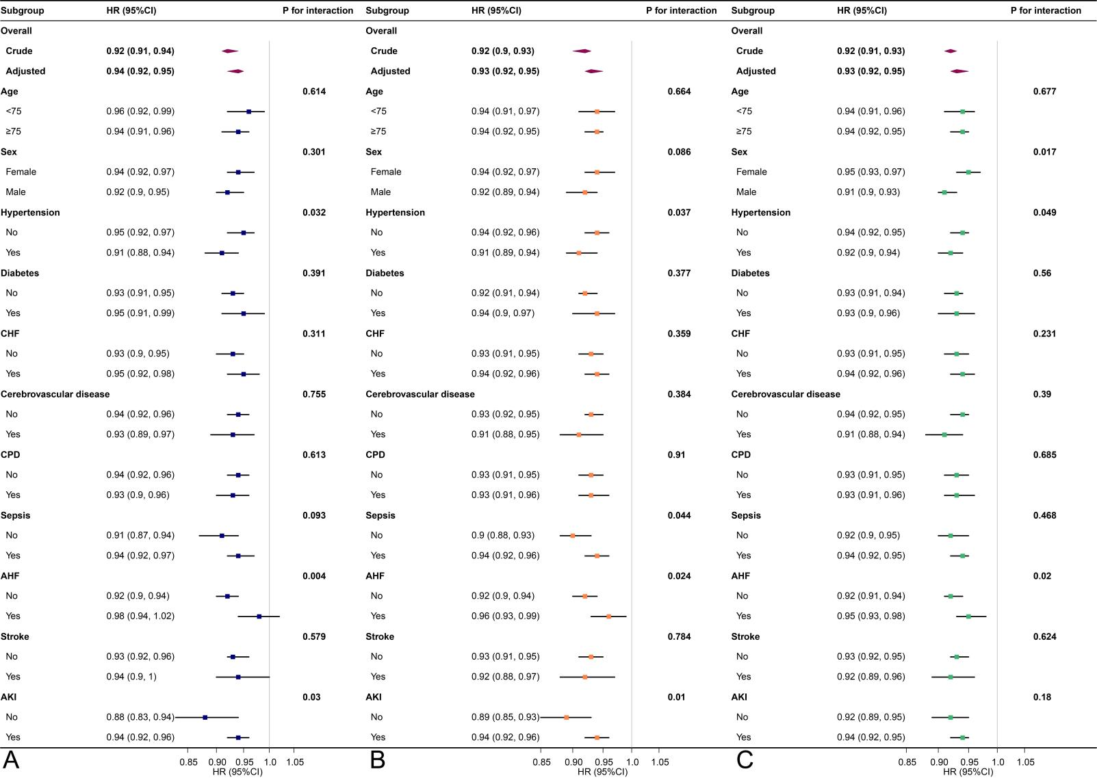
Supplementary Fig. 1 Stratified analyses of patients with BMI < 30 kg/m². The forest plot shows the results of subgroup analyses of 30-day (A), 90-day (B), and 1-year (C) mortality. HRs were adjusted for age, sex , race, hypertension, diabetes, CHF, PVD, cerebrovascular disease, CPD, renal disease, liver disease, malignancy, sepsis, AKI, AHF, stroke, SOFA, SAPS Ⅱ, CCI, hemoglobin, WBC, platelet, RDW, anion gap, BUN, creatinine, glucose, HR, MBP, RR, SpO₂, antiplatelet agents, anticoagulant agents, antiarrhythmic agents, MV, RRT, and vasopressors.
Abbreviations: BMI, body mass index; HR, hazard ratio; CI, confidence interval; CHF, congestive heart failure; PVD, peripheral vascular disease; CPD, chronic pulmonary disease; AKI, acute kidney injury; AHF, acute heart failure; SOFA, sequential organ failure assessment; SAPS Ⅱ, simplified acute physiology score Ⅱ; CCI, Charlson comorbidity index; WBC, white blood cell; RDW, red cell distribution width; BUN, blood urea nitrogen; HR, heart rate; MBP, mean blood pressure; RR, respiratory rate; SpO₂, saturation of pulse oximetry; MV, mechanical ventilation; RRT, renal replacement therapy.

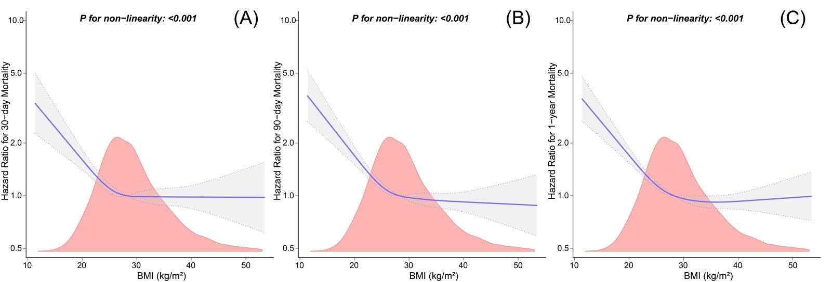
Supplementary Fig. 2 Multivariable-adjusted restricted cubic spline analyses of relationship between BMI and all-cause mortality using complete dataset. The upper limit of the BMI is restricted to 99th. The purple lines represent the estimated risk of all-cause mortality, and the gray bands represent the point-by-point 95% CI adjusted for covariates. HRs were adjusted for age, sex , race, hypertension, diabetes, CHF, PVD, cerebrovascular disease, CPD, renal disease, liver disease, malignancy, sepsis, AKI, AHF, stroke, SOFA, SAPS Ⅱ, CCI, hemoglobin, WBC, platelet, RDW, anion gap, BUN, creatinine, glucose, HR, MBP, RR, SpO₂, antiplatelet agents, anticoagulant agents, antiarrhythmic agents, MV, RRT, and vasopressors.
Abbreviations: BMI, body mass index; HR, hazard ratio; CI, confidence interval; CHF, congestive heart failure; PVD, peripheral vascular disease; CPD, chronic pulmonary disease; AKI, acute kidney injury; AHF, acute heart failure; SOFA, sequential organ failure assessment; SAPS Ⅱ, simplified acute physiology score Ⅱ; CCI, Charlson comorbidity index; WBC, white blood cell; RDW, red cell distribution width; BUN, blood urea nitrogen; HR, heart rate; MBP, mean blood pressure; RR, respiratory rate; SpO₂, saturation of pulse oximetry; MV, mechanical ventilation; RRT, renal replacement therapy.

