Appendix

Association between Raised Blood Pressure and Elevated Serum Liver Enzymes among Active-Duty Royal Thai Army Personnel in Thailand

Boonsub Sakboonyarat¹, Jaturon Poovieng², Sethapong Lertsakulbunlue³, Kanlaya Jongcherdchootrakul¹, Phutsapong Srisawat¹, Mathirut Mungthin⁴, *Ram Rangsin¹

¹Department of Military and Community Medicine, Phramongkutklao College of Medicine, Bangkok 10400, Thailand
²Department of Medicine, Phramongkutklao College of Medicine, Bangkok 10400, Thailand
³Department of Pharmacology, Phramongkutklao College of Medicine, Bangkok 10400, Thailand
⁴Department of Parasitology, Phramongkutklao College of Medicine, Bangkok 10400, Thailand

Table of contents

Figure S1. The log transformation was performed for serum liver enzymes to improve normality. | Page 3
Table S1. Multivariable logistic regression analysis for association between raised blood pressure and elevated aminotransferase in male participant, by year | Page 4
Table S2. Multivariable logistic regression analysis for association between raised blood pressure and elevated aminotransferase in female participant, by year | Page 5

Figure S1. The log transformation was performed for serum liver enzymes to improve normality.

Histogram of serum liver enzymes | Histogram of log-transformed serum liver enzymes
AST  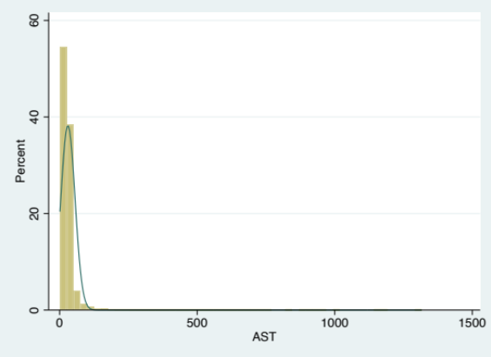 | Log-transformed AST  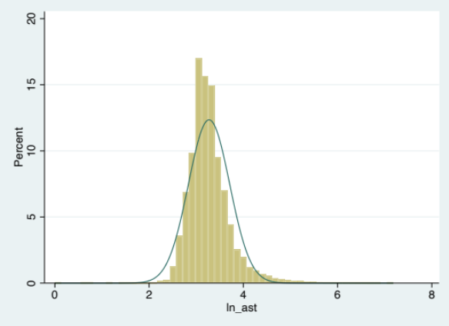
ALT  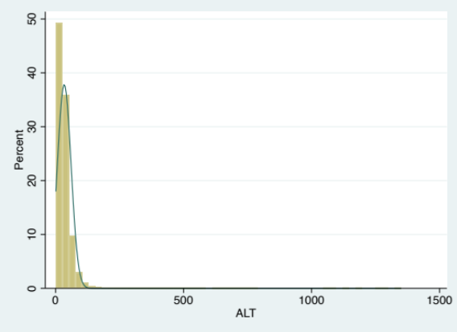 | Log-transformed ALT  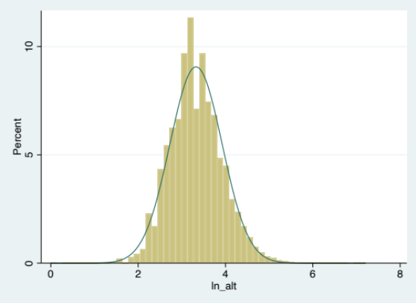

Table S1. Multivariable logistic regression analysis for association between raised blood pressure and elevated aminotransferase in male participants, by year
Blood pressure | Elevated AST |  |  | Elevated ALT
Blood pressure | AOR | 95% CI | p-value | AOR | 95% CI | p-value
Male
SBP (mmHg)
Overall (2017-2021)* | 1.02 | 1.01-1.02 | <0.001 | 1.01 | 1.01-1.01 | <0.001
2017** | 1.01 | 1.01-1.02 | <0.001 | 1.01 | 1.01-1.01 | <0.001
2018** | 1.01 | 1.01-1.02 | <0.001 | 1.01 | 1.01-1.01 | <0.001
2019** | 1.02 | 1.02-1.02 | <0.001 | 1.01 | 1.01-1.01 | <0.001
2020** | 1.02 | 1.01-1.02 | <0.001 | 1.01 | 1.01-1.01 | <0.001
2021** | 1.02 | 1.01-1.02 | <0.001 | 1.01 | 1.01-1.01 | <0.001
DBP (mmHg)
Overall (2017-2021)* | 1.02 | 1.02-1.02 | <0.001 | 1.01 | 1.01-1.01 | <0.001
2017** | 1.02 | 1.02-1.03 | <0.001 | 1.01 | 1.01-1.01 | <0.001
2018** | 1.02 | 1.02-1.02 | <0.001 | 1.01 | 1.01-1.01 | <0.001
2019** | 1.03 | 1.02-1.03 | <0.001 | 1.01 | 1.01-1.01 | <0.001
2020** | 1.02 | 1.02-1.02 | <0.001 | 1.02 | 1.01-1.02 | <0.001
2021** | 1.02 | 1.02-1.03 | <0.001 | 1.01 | 1.01-1.01 | <0.001
MAP (mmHg)
Overall (2017-2021)* | 1.02 | 1.02-1.02 | <0.001 | 1.01 | 1.01-1.01 | <0.001
2017** | 1.02 | 1.02-1.02 | <0.001 | 1.01 | 1.01-1.01 | <0.001
2018** | 1.02 | 1.02-1.02 | <0.001 | 1.01 | 1.01-1.01 | <0.001
2019** | 1.02 | 1.02-1.03 | <0.001 | 1.01 | 1.01-1.01 | <0.001
2020** | 1.02 | 1.02-1.02 | <0.001 | 1.01 | 1.01-1.02 | <0.001
2021** | 1.02 | 1.02-1.03 | <0.001 | 1.01 | 1.01-1.01 | <0.001
Blood pressure (mmHg)
Overall (2017-2021)*
SBP <120 and DBP <80 | Ref. |  |  | Ref.
SBP 120-129 or DBP 80-84 | 1.17 | 1.11-1.22 | <0.001 | 1.09 | 1.05-1.12 | <0.001
SBP 130-139 or DBP 85-89 | 1.35 | 1.30-1.42 | <0.001 | 1.22 | 1.18-1.26 | <0.001
SBP ≥140 or DBP ≥90 | 1.92 | 1.85-2.01 | <0.001 | 1.43 | 1.38-1.48 | <0.001
2017**
SBP <120 and DBP <80 | Ref. |  |  | Ref.
SBP 120-129 or DBP 80-84 | 1.17 | 1.05-1.30 | 0.004 | 1.05 | 0.97-1.14 | 0.197
SBP 130-139 or DBP 85-89 | 1.38 | 1.24-1.53 | <0.001 | 1.15 | 1.06-1.24 | 0.001
SBP ≥140 or DBP ≥90 | 1.88 | 1.70-2.07 | <0.001 | 1.34 | 1.25-1.44 | <0.001
2018**
SBP <120 and DBP <80 | Ref. |  |  | Ref.
SBP 120-129 or DBP 80-84 | 1.15 | 1.04-1.28 | 0.007 | 1.11 | 1.03-1.19 | 0.006
SBP 130-139 or DBP 85-89 | 1.30 | 1.18-1.44 | <0.001 | 1.18 | 1.10-1.27 | <0.001
SBP ≥140 or DBP ≥90 | 1.86 | 1.70-2.03 | <0.001 | 1.36 | 1.27-1.46 | <0.001
2019**
SBP <120 and DBP <80 | Ref. |  |  | Ref.
SBP 120-129 or DBP 80-84 | 1.14 | 1.03-1.26 | 0.011 | 1.01 | 0.94-1.09 | 0.706
SBP 130-139 or DBP 85-89 | 1.35 | 1.23-1.49 | <0.001 | 1.21 | 1.13-1.30 | <0.001
SBP ≥140 or DBP ≥90 | 2.01 | 1.83-2.20 | <0.001 | 1.34 | 1.26-1.44 | <0.001
2020**
SBP <120 and DBP <80 | Ref. |  |  | Ref.
SBP 120-129 or DBP 80-84 | 1.24 | 1.12-1.37 | <0.001 | 1.18 | 1.09-1.28 | <0.001
SBP 130-139 or DBP 85-89 | 1.34 | 1.22-1.48 | <0.001 | 1.34 | 1.23-1.44 | <0.001
SBP ≥140 or DBP ≥90 | 1.91 | 1.74-2.09 | <0.001 | 1.64 | 1.52-1.77 | <0.001
2021**
SBP <120 and DBP <80 | Ref. |  |  | Ref.
SBP 120-129 or DBP 80-84 | 1.13 | 1.01-1.26 | 0.030 | 1.09 | 1.01-1.18 | 0.028
SBP 130-139 or DBP 85-89 | 1.40 | 1.26-1.54 | <0.001 | 1.25 | 1.16-1.34 | <0.001
SBP ≥140 or DBP ≥90 | 1.97 | 1.79-2.17 | <0.001 | 1.50 | 1.40-1.61 | <0.001
AOR: adjusted Odds Ratio, *Adjusting for age, regions, body mass index, smoking status, alcohol use, exercise, fasting plasma glucose, total cholesterol, triglyceride and years. **Adjusting for age, regions, body mass index, smoking status, alcohol use, exercise, fasting plasma glucose, total cholesterol, triglyceride.
Table S2. Multivariable logistic regression analysis for association between raised blood pressure and elevated aminotransferase in female participants, by year
Blood pressure | Elevated AST |  |  | Elevated ALT
Blood pressure | AOR | 95% CI | p-value | AOR | 95% CI | p-value
Female
SBP (mmHg)
Overall (2017-2021)* | 1.01 | 1.01-1.01 | 0.006 | 1.01 | 1.00-1.01 | <0.001
2017** | 0.99 | 0.99-101 | 0.471 | 1.01 | 0.99-1.01 | 0.061
2018** | 1.01 | 1.00-1.02 | 0.023 | 1.01 | 1.00-1.01 | 0.005
2019** | 1.01 | 1.00-1.02 | 0.006 | 1.01 | 1.00-1.01 | 0.073
2020** | 1.00 | 1.00-1.01 | 0.421 | 1.00 | 1.00-1.01 | 0.499
2021** | 1.00 | 1.00-1.01 | 0.302 | 1.00 | 1.00-1.01 | 0.358
DBP (mmHg)
Overall (2017-2021)* | 1.01 | 1.01-1.01 | 0.001 | 1.01 | 1.01-1.02 | <0.001
2017** | 1.01 | 0.99-1.02 | 0.281 | 1.01 | 1.00-1.02 | 0.078
2018** | 1.01 | 1.00-1.03 | 0.014 | 1.01 | 1.00-1.02 | 0.014
2019** | 1.01 | 1.00-1.02 | 0.028 | 1.01 | 1.00-1.02 | 0.014
2020** | 1.01 | 1.00-1.01 | 0.276 | 1.01 | 1.01-1.02 | 0.001
2021** | 1.00 | 0.99-1.01 | 0.745 | 1.02 | 1.01-1.02 | 0.002
MAP (mmHg)
Overall (2017-2021)* | 1.01 | 1.01-1.01 | 0.001 | 1.01 | 1.01-1.01 | <0.001
2017** | 1.00 | 0.99-1.01 | 0.740 | 1.01 | 1.00-1.02 | 0.046
2018** | 1.01 | 1.00-1.03 | <0.001 | 1.01 | 1.01-1.02 | 0.004
2019** | 1.01 | 1.00-1.02 | 0.008 | 1.01 | 1.00-1.02 | 0.017
2020** | 1.00 | 1.00-1.01 | 0.282 | 1.01 | 1.00-1.02 | 0.015
2021** | 1.00 | 0.99-1.02 | 0.483 | 1.01 | 1.00-1.02 | 0.017
Blood pressure (mmHg)
Overall (2017-2021)*
SBP <120 and DBP <80 | Ref. |  |  | Ref.
SBP 120-129 or DBP 80-84 | 1.12 | 0.97-1.30 | 0.135 | 1.22 | 1.09-1.38 | 0.001
SBP 130-139 or DBP 85-89 | 1.34 | 1.16-1.55 | <0.001 | 1.36 | 1.20-1.54 | <0.001
SBP ≥140 or DBP ≥90 | 1.42 | 1.21-1.66 | <0.001 | 1.38 | 1.21-1.57 | <0.001
2017**
SBP <120 and DBP <80 | Ref. |  |  | Ref.
SBP 120-129 or DBP 80-84 | 1.15 | 0.79-1.68 | 0.479 | 1.07 | 0.79-1.45 | 0.655
SBP 130-139 or DBP 85-89 | 1.40 | 0.96-2.02 | 0.078 | 1.67 | 1.25-2.24 | 0.001
SBP ≥140 or DBP ≥90 | 1.13 | 0.76-1.68 | 0.558 | 1.34 | 0.97-1.84 | 0.073
2018**
SBP <120 and DBP <80 | Ref. |  |  | Ref.
SBP 120-129 or DBP 80-84 | 1.36 | 0.96-1.94 | 0.086 | 1.04 | 0.80-1.36 | 0.767
SBP 130-139 or DBP 85-89 | 1.77 | 1.26-2.49 | 0.001 | 1.29 | 0.99-1.67 | 0.060
SBP ≥140 or DBP ≥90 | 1.81 | 1.26-2.60 | 0.001 | 1.45 | 1.10-1.91 | 0.009
2019**
SBP <120 and DBP <80 | Ref. |  |  | Ref.
SBP 120-129 or DBP 80-84 | 1.20 | 0.85-1.68 | 0.302 | 1.14 | 0.89-1.47 | 0.302
SBP 130-139 or DBP 85-89 | 1.48 | 1.06-2.07 | 0.023 | 1.21 | 0.94-1.57 | 0.143
SBP ≥140 or DBP ≥90 | 1.84 | 1.30-2.60 | 0.001 | 1.27 | 0.97-1.67 | 0.302
2020**
SBP <120 and DBP <80 | Ref. |  |  | Ref.
SBP 120-129 or DBP 80-84 | 0.90 | 0.69-1.18 | 0.442 | 1.28 | 0.99-1.64 | 0.055
SBP 130-139 or DBP 85-89 | 1.05 | 0.80-1.38 | 0.706 | 1.22 | 0.93-1.58 | 0.145
SBP ≥140 or DBP ≥90 | 1.16 | 0.87-1.54 | 0.320 | 1.28 | 0.97-1.67 | 0.078
2021**
SBP <120 and DBP <80 | Ref. |  |  | Ref.
SBP 120-129 or DBP 80-84 | 1.23 | 0.86-1.79 | 0.240 | 1.66 | 1.26-2.21 | <0.001
SBP 130-139 or DBP 85-89 | 1.30 | 0.89-1.90 | 0.177 | 1.62 | 1.20-2.20 | 0.002
SBP ≥140 or DBP ≥90 | 1.38 | 0.93-2.03 | 0.110 | 1.62 | 1.19-2.22 | 0.002
AOR: adjusted Odds Ratio, *Adjusting for age, regions, body mass index, smoking status, alcohol use, exercise, fasting plasma glucose, total cholesterol, triglyceride and years. **Adjusting for age, regions, body mass index, smoking status, alcohol use, exercise, fasting plasma glucose, total cholesterol, triglyceride.

