Supplementary Information

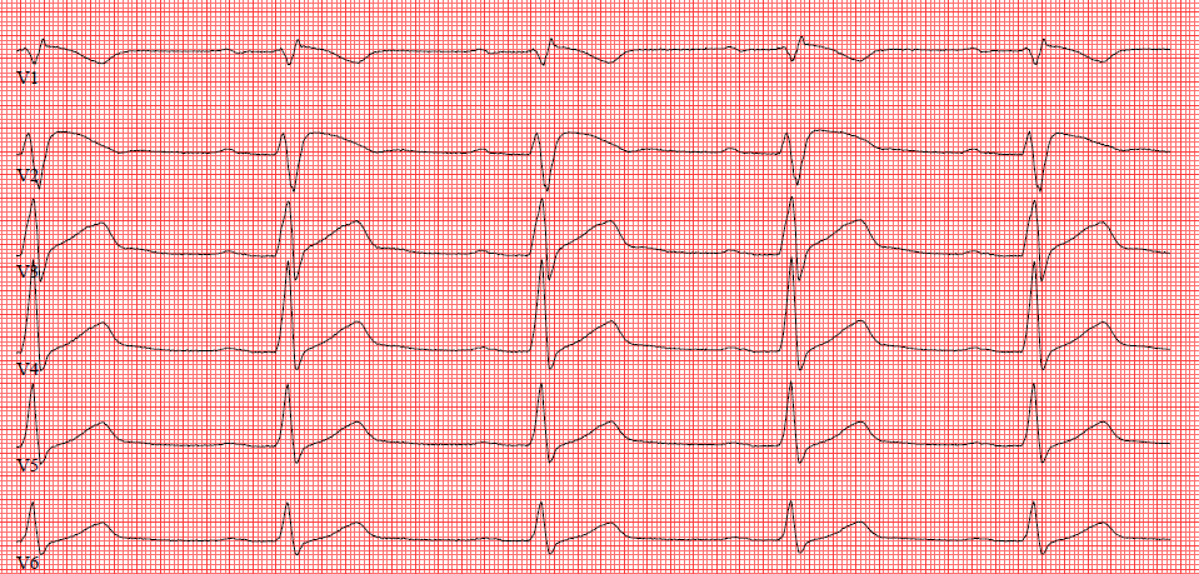
Supplementary Figure 1: Typical example of Brugada type 1 ECG obtained from the symptomatic individual after collapse.

Supplementary Table 1. Primers used for generating the plasmids.

Assay | Primer/Probe | Sequence
WT plasmid generation | Forward primer with BamHI restriction site  Reverse primer with  NotI restriction site | attaggatccgtcctgtctgactttgccgatg  taatgcggccgcgaagtcggcgagatcttcactgtg
Mutant plasmid generation | Mutagenesis sense  primer  Mutagenesis antisense  primer | tccagagagccttctgcaggcacctgctgca  tgcagcaggtgcctgcagaaggctctctgga
TaqMan SNP Genotyping  assay for allelic  imbalance determination | Forward primer  Reverse primer  Probe wild type VIC  Probe mutant FAM

Supplementary Figure 2: Simultaneous recording of action potential (AP) and video recording. (A) Spontaneous APs recording in gap-free mode. (B) Synchronization pulses indicates the duration of video recording. (C) video traces corresponding to above APs. Indication of half-width contraction and relaxation duration.

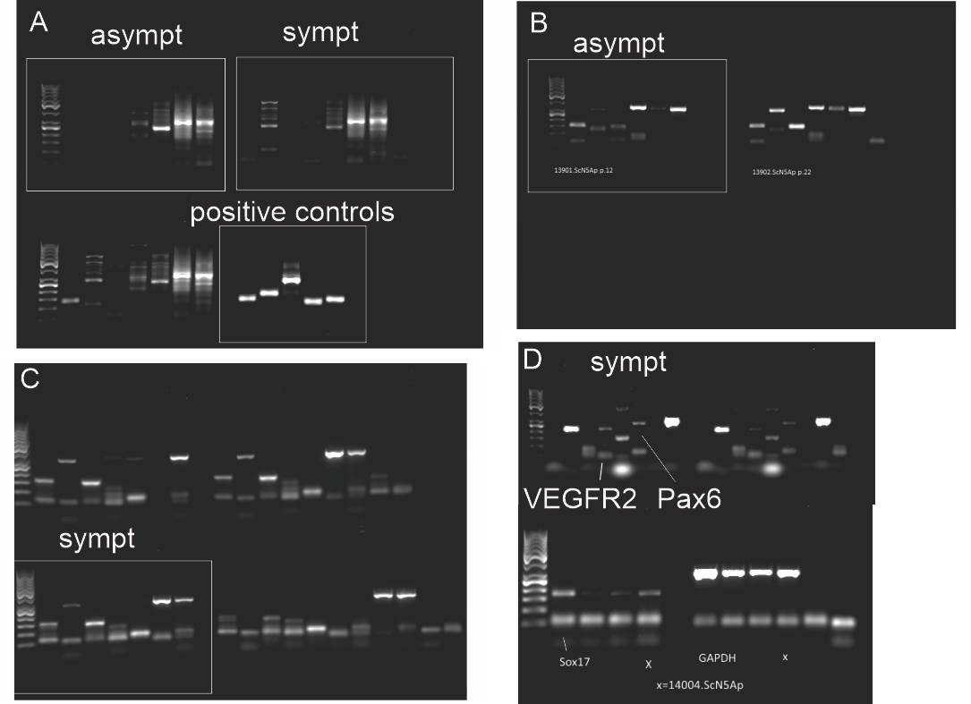

Supplementary Figure 3: iPSC charecterization full images. A) Exogenous genes are expressed in asymp-iPSC lines (Standard, Oct-3/4, Klf-4,Lin-28,Sox-2,L-Myc,GAPDH, b-actin), symp-iPSC lines (Standard, Oct-3/4, Klf-4,Lin-28,Sox-2,L-Myc,GAPDH, b-actin), and control (Oct-3/4, Klf-4,Lin-28,Sox-2,L-Myc,). B) Pluripotency markers are turned on in asympt-iPSC (Standard, Sox2, Nanog, OCT,c-myc,Rex1, GAPDH) C) Pluripotency markers are turned on in sympt-iPSC (Standard, Sox2, Nanog, OCT,c-myc,Rex1, GAPDH, B-actin) D) EBs express markers from all the three embryonic germ layers (VEGFR2, Pax6, Sox17, GAPDH).

Supplementary Table 2. Sodium current densities recorded from WT, asymptomatic and symptomatic CMs. mV represents the membrane potential. n represents the number of cells. Data are presented as mean±S.E.M. ns represents not statistically significant.

mV | WT (n=30) | asymt (n=21) | sympt (n=23) | Statistical significance
-60 | -0.2±0.1 | -0.2±0.1 | -0.1±0.1 | ns
-55 | -0.3±0.1 | -0.4±0.1 | -0.3±0.1 | ns
-50 | -0.8±0.2 | -0.8±0.2 | -0.7±0.2 | ns
-45 | -2.8±0.9 | -2.9±0.6 | -2.8±0.7 | ns
-40 | -7.7±1.9 | -8.9±1.8 | -10.1±2.1 | ns
-35 | -13.8±2.4 | -17.8±2.8 | -18.3±3.5 | ns
-30 | -17.8±2.6 | -23.1±3.1 | -23.2±3.8 | ns
-25 | -19.7±2.7 | -25.5±3.1 | -25.8±3.9 | ns
-20 | -20.1±2.6 | -26.0±2.9 | -26.2±3.7 | ns
-15 | -19.6±2.5 | -25.5±2.8 | -25.6±3.5 | ns
-10 | -18.7±2.3 | -24.2±2.6 | -24.5±3.3 | ns
-5 | -17.4±2.1 | -22.6±2.4 | -22.7±3.0 | ns
0 | -16.0±2.0 | -20.9±2.2 | -20.8±2.7 | ns
5 | -14.5±1.8 | -19.1±2.0 | -19.0±2.5 | ns
10 | -13.1±1.6 | -17.3±1.8 | -17.1±2.2 | ns
15 | -11.6±1.4 | -15.3±1.6 | -15.2±2.0 | ns
20 | -10.3±1.3 | -13.7±1.4 | -13.3±1.8 | ns
25 | -9.0±1.2 | -11.8±1.3 | -11.6±1.7 | ns
30 | -7.7±1.0 | -9.8±1.3 | -9.9±1.5 | ns
35 | -6.8±0.9 | -8.4±1.1 | -8.3±1.4 | ns
40 | -5.7±0.8 | -6.8±1.0 | -7.0±1.2 | ns
45 | -5.0±0.7 | -5.4±0.9 | -5.8±1.1 | ns
50 | -4.0±0.7 | -4.3±0.9 | -4.6±1.0 | ns
55 | -3.0±0.6 | -2.6±0.9 | -3.7±0.9 | ns
60 | -2.5±0.5 | -1.1±1.0 | -2.7±0.9 | ns
65 | -1.8±0.6 | 0.3±1.0 | -1.2±0.9 | ns
70 | -1.2±0.6 | 2.0±1.1 | -0.2±0.9 | ns
75 | -0.8±0.5 | 3.3±1.2 | 0.8±0.8 | ns
80 | -0.2±0.7 | 3.8±1.5 | 6.7±4.5 | ns

Supplementary Table 3: Voltage-dependence (in)activation for WT, asymptomatic and symptomatic CMs. n represents the number of cells. V_{1/2}, voltage of half-maximal (in)activation and k, slope factor of voltage-dependence of (in)activation. Data are presented as mean±S.E.M. ns represents not statistically significant.

 | WT | asympt | sympt | Statistical significance
- Voltage-dependence activation
 | n=16 | n=19 | n=19
V_{1/2} | -31.0±1.1 | -33.5±1.0 | -31.9±1.7 | ns
k | 6.0±0.5 | 5.4±0.4 | 5.1±0.4 | ns
- Voltage-dependence inactivation
 | n=19 | n=19 | n=18
V_{1/2} | -71.5±2.0 | -73.1±1.2 | -74.1±1.5 | ns
k | 9.9±0.4 | 10.5±0.3 | 10.3±0.3 | ns

Supplementary Table 4: Fast (τ_{fast}) and slow time (τ_{slow}) constant decay of sodium current over membrane potential (mV) calculated by fitting bi-exponential function for WT, asymptomatic and symptomatic CMs. n represents the number of cells. Data are presented as mean±S.E.M. * or # P<0.05, ** or ## P<0.01, *** or ### P<0.001 and ns, not statistically significant. * WT vs. asympt and # WT vs. sympt.

mV | WT (n=20) | asympt (n=17) | sympt (n=18) | Statistical significance
 | τ_{fast}
-35 | 2.7±0.3 | 2.4±0.2 | 2.6±0.3 | ns
-30 | 2.4±0.3 | 1.9±0.1 | 1.9±0.1 | ns
-25 | 1.9±0.2 | 1.7±0.1 | 1.7±0.1 | ns
-20 | 2.0±0.2 | 1.4±0.1 | 1.5±0.1 | ns
-15 | 1.8±0.2 | 1.3±0.1 | 1.2±0.1 | # WT vs. sympt
-10 | 1.7±0.3 | 1.1±0.1 | 1.1±0.1 | * WT vs. asympt  # WT vs. sympt
-5 | 1.7±0.3 | 1.0±0.1 | 0.9±0.1 | * WT vs. asympt  ## WT vs. sympt
0 | 1.4±0.2 | 1.0±0.1 | 0.8±0.1 | ## WT vs. sympt
5 | 1.5±0.3 | 0.9±0.1 | 0.8±0.1 | * WT vs. asympt  ## WT vs. sympt
10 | 1.3±0.2 | 1.0±0.1 | 0.7±0.1 | ### WT vs. sympt
15 | 1.0±0.1 | 1.0±0.1 | 0.9±0.1 | ns
20 | 1.0±0.1 | 0.9±0.1 | 0.8±0.1 | ns
 | τ_{slow}
-35 | 18.2±2.6 | 17.8±1.8 | 17.2±1.6 | ns
-30 | 14.9±2.4 | 12.6±1.5 | 13.9±1.9 | ns
-25 | 13.7±2.1 | 11.1±2.0 | 10.8±1.5 | ns
-20 | 10.0±1.5 | 7.3±0.5 | 8.6±0.8 | ns
-15 | 8.1±0.5 | 7.6±0.5 | 7.4±0.6 | ns
-10 | 8.1±0.6 | 7.1±0.4 | 7.9±0.9 | ns
-5 | 7.4±0.5 | 7.2±0.3 | 6,8±0,3 | ns
0 | 8.0±0.6 | 7.7±0.6 | 8.4±0.7 | ns
5 | 9.2±0.9 | 7.8±0.4 | 8.0±0.4 | ns
10 | 8.6±0.7 | 8.7±0.5 | 8.9±0.6 | ns
15 | 9.0±0.7 | 9.3±0.7 | 9.5±0.7 | ns
20 | 12.8±2.5 | 10.5±0.6 | 10.6±1.0 | ns

Supplementary Table 5. Time course of recovery from inactivation and time-course of entry into the slow inactivation state for WT, asymptomatic and symptomatic CMs. Fast (τ_{fast}) and slow time (τ_{slow}) constant decay were calculated by fitting bi-exponential function. n represents the number of cells used. Data are presented as mean±S.E.M. * P<0.05, ** P<0.01, and ns, not statistically significant. * WT vs. asympt.

 | WT | asympt | sympt | Statistical significance
A | Time-course of recovery after inactivation
 | n=7 | n=8 | n=8
τ_{fast} | 74.8±7.0 | 47.4±4.9 | 63.3±5.7 | * WT vs. asympt
τ_{slow} | 700.3±94.1 | 509.2±60.5 | 579.9±32.3 | ns
B | The time-course of entry into the slow inactivation state
 | n=9 | n=6 | n=9
τ_{fast} | 5.9±0.7 | 11.9±2.1 | 10.1±1.5 | * WT vs. asympt
τ_{slow} | 187.6±40.5 | 422.6±53.5 | 252.0±23.4 | ** WT vs. asympt

Supplementary Figure 4. I_{Kr} and Calcium current densities. A-B. Current-voltage relationships of average I_{Kr} densities. from WT, asymptomatic and symptomatic CMs. C. Current-voltage relationships of average I_{Ca,L} densities. E. Average voltage dependence of activation. D Time-course of recovery after inactivation. Peak I_{Ca,L} elicited by P2 were normalized (P2/P1) and plotted as function of the recovery interval. E. The time-course of entry into the slow inactivation state. Peak I_{Ca,L} elicited by P2 were normalized (P2/P1) and plotted as function of the duration of P1. F-G. Average fast (τ_{fast}) and slow (τ_{slow}) time constants from recovery after inactivation and entry into the slow inactivation state. Insets: Voltage-clamp protocol used in each experiment. Data are presented as mean±S.E.M.

Supplementary Table 6. Half-width contraction and relaxation duration calculated from video recording of WT, asymptomatic and symptomatic CMs. n represents the number of cells used. Data are presented as mean±S.E.M, ns, not statistically significant.

 | WT (n=27) | asympt (n=20) | sympt (n=23) | Statistical significance
Contraction duration (ms) | 106.1±9.4 | 82.3±6.9 | 78.3±4.8 | ns
Relaxation duration (ms) | 118.3±9.2 | 97.6±5.5 | 93.8±5.4 | ns

Supplementary Table 7. MEA recordings from WT, asymptomatic and symptomatic CMs. The field potential duration (FPD) is corrected for beat rate to get corrected FPD (cFPD). n represents the number of cells used. Data are presented as mean±S.E.M, ns, not statistically significant.

 | WT  (n=13) | asympt (n=6) | sympt (n=19) | Statistical significance
Beat rate (bpm) | 49.1±2.9 | 50.8±4.4 | 47.0±3.9 | ns
FPD (ms) | 839.4±44.1 | 729.6±52.0 | 930.2±96.5 | ns
cFPD (ms) | 743.6±21.7 | 659.4±32.1 | 755.2±42.5 | ns

 | Baseline |  |  |  | Adrenaline
 |  |  |  | Statistical significance |  |  |  | Statistical significance
 | WT  n=58 | asympt  n=95 | sympt  n=165 |  | WT  n=58 | asympt  n=95 | sympt  n=165
F/F0 | 2.42±0.16 | 2.07±0.23 | 1.81±0.14 | *** WT vs. sympt  ** WT vs. asympt | 1.88±0.13### | 1.82±0.20### | 1.69±0.13# | * WT vs Symp
Ca²⁺ peak duration (ms) | 1741.96±114.63 | 1206.03±78.51 | 1338.58±64.69 | ** WT vs. sympt  *** WT vs. asympt | 1406.10±95.00### | 1035.64±106.50### | 1087.82±51.18### | ** WT vs. sympt  *** WT vs. asympt
Half-width (ms) | 764.22±55.44 | 491.97±39.14 | 599.77±37.81 | ** WT vs. sympt  *** WT vs. asympt | 636.13±45.17### | 451.37±35.13## | 526.02±26.41## | ** WT vs. sympt  *** WT vs. asympt
Decay time (ms) | 1017.52±69.42 | 669.72±53.95 | 783.05±44.92 | ** WT vs. sympt  *** WT vs. asympt | 845.84±63.02### | 599.05±114.22### | 566.29±25.76### | *** WT vs. sympt  *** WT vs. asympt
Interevent interval (ms) | 3251.36±263.27 | 1967.63±131.16 | 2499.83±148.10 | ** WT vs. sympt  *** WT vs. asympt | 2352.59±173.42### | 1347.81±75.59### | 1736.78±89.03### | * sympt vs. asympt  ** WT vs. sympt  *** WT vs. asympt
Event frequency (Hz) | 0.42±0.04 | 0.74±0.05 | 0.62±0.03 | * sympt vs. asympt  ** WT vs. sympt  *** WT vs. asympt | 0.58±0.04### | 0.99±0.06### | 0.81±0.04### | * sympt vs. asympt  ** WT vs. sympt  *** WT vs. asympt

Supplementary Table 8. Comparisons of the amplitude, Ca²⁺ peak duration (Ca⁹⁰), half-width, decay time 90% to 10%, interevent interval and event frequency of WT, asymptomatic and symptomatic CMs during adrenaline perfusion. Data are presented as mean±S.E.M. * or # indicates P<0.05, ** or ## P<0.01 and *** or ### P<0.001. * indicates differences between cell lines and # indicates differences inside cell line between baseline and adrenaline.

Supplementary Table 9. Averages and SD of Ca²⁺ peak parameters of baseline and after flecainide perfusion. # indicates significant differences inside cell line between baseline and flecainide, # P<0.05, ## P<0.01, ###, P<0.001. No statistically significant differences in Ca²⁺ peak parameters were seen between WT, asymptomatic and symptomatic CMs during flecainide perfusion.

 | Baseline |  |  |  | Flecainide
 |  |  |  | Statistical significance |  |  |  | Statistical significance
 | WT  n=97 | asympt  n=48 | sympt  n=54 |  | WT  n=97 | asympt  n=48 | sympt  n=54
F/F0 | 1.74±0.13 | 1.75±0.16 | 1.83±0.12 | ns | 1.44±0.10### | 1.59±0.15# | 1.57±0.12## | ns
Duration (ms) | 1334.2±102.6 | 1177.0±99.6 | 1292.3±83.7 | ns | 1683.5±132.4### | 1220.2±82.1 | 1402.2±108.9# | ns
Half-width (ms) | 568.0±40.8 | 484.0±36.6 | 600.5±44.1 | ns | 750.7±78.1### | 514.7±36.8# | 710.6±60.9### | ns
Interevent interval (ms) | 2667.3±215.2 | 1960.4±179.9 | 2726.1±249.8 | ns | 3365.0±285.6### | 2436.3±200.3### | 3193.1±297.0## | ns
Event frequency (Hz) | 0.62±0.04 | 0.66±0.05 | 0.52±0.04 | ns | 0.49±0.03### | 0.55±0.04### | 0.47±0.04## | ns

