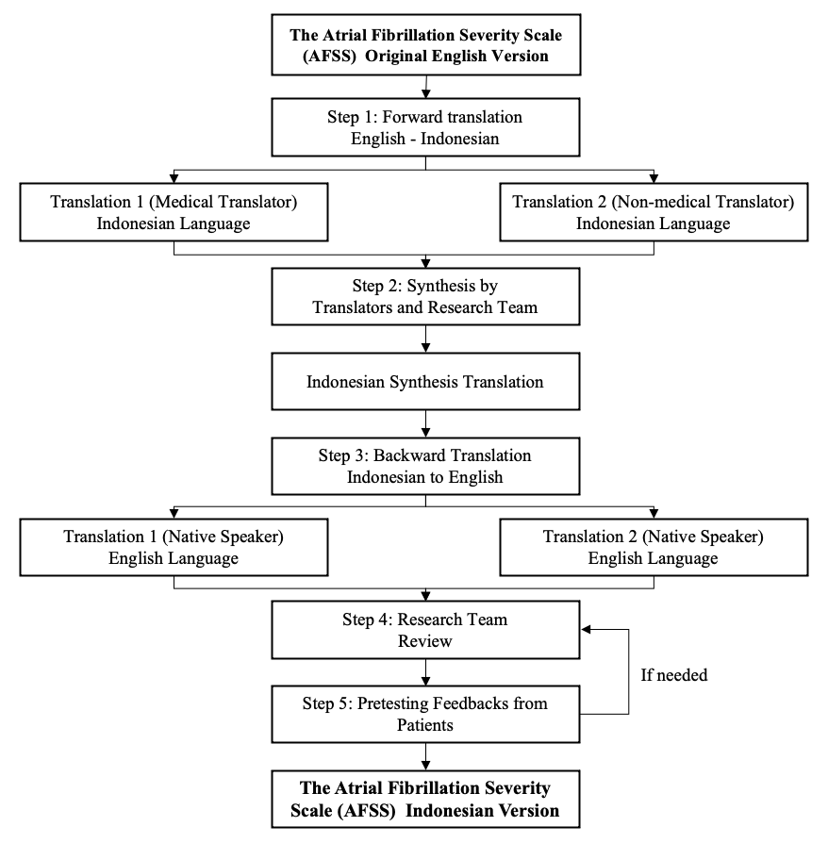
Supplementary 1 Questionnaire Translation Process

Supplementary 2 Characteristics of AF Patients
Characteristics | n=60 | %
Age
<40 | 5 | 8.3
41-50 | 8 | 13.3
51-60 | 17 | 28.4
61-70 | 19 | 31.7
>70 | 11 | 18.3
Range | 20-83
Average (SD) | 58.8 (13.6)
Duration of Diagnosis
<1 | 2 | 3.3
1-5 | 50 | 83.3
>5 | 8 | 13.3
Range | 1-27
Average (SD) | 4.3 (4.5)
Ejection Fraction (%)
<40 | 5 | 8.3
40-49 | 9 | 15.0
>50 | 46 | 76.7
Range | 23-75.9
Average (SD) | 56.8 (10.8)
CHA2DS2VASC Score
0 | 0 | 0.0
1 | 4 | 6.7
>1 | 56 | 93.3
Range | 1-7
Average (SD) | 3.2 (1.5)
HASBLED
0 | 22 | 48.3
1-2 | 36 | 50.0
>3 | 2 | 1.7
Range | 0-5
Average (SD) | 1.1 (1.1)

Supplementary 3 AFSS Score Descriptive Analysis
AFSS Category | Min | Max | Average | SD
AF Burden
Day 1
Life satisfaction | 2 | 11 | 7.13 | 1.58
AF Frequency | 1 | 12 | 6.80 | 3.17
AF duration | 1 | 11 | 6.98 | 1.83
Severity of the last AF period | 1 | 10 | 4.53 | 2.23
Severity of the first AF period | 1 | 10 | 5.70 | 2.61
Day 8-14
Life satisfaction | 2 | 11 | 7.08 | 1.52
AF Frequency | 1 | 12 | 6.42 | 3.15
AF duration | 1 | 12 | 6.83 | 2.00
Severity of the last AF period | 1 | 10 | 4.40 | 2.12
Severity of the first AF period | 1 | 10 | 5.47 | 2.85
Health Care Utilization
Day 1
Cardioversion (times) | 0 | 6 | 1.90 | 0.71
ER visit (times in a year) | 0 | 5 | 0.50 | 1.07
Hospitalization (times in a year) | 0 | 5 | 0.55 | 0.96
Outpatient visit (times in a year) | 0 | 3 | 0.37 | 0.76
Day 8-14
Cardioversion (times) | 0 | 6 | 1.92 | 0.59
ER visit (times in a year) | 0 | 5 | 0.58 | 1.06
Hospitalization (times in a year) | 0 | 5 | 0.62 | 0.96
Outpatient visit (times in a year) | 0 | 3 | 0.33 | 0.66
Symptom Severity
Day 1
Palpitation | 0 | 5 | 1.27 | 1.27
Shortness of breath at rest | 0 | 4 | 0.82 | 1.24
Shortness of breath during physical activity | 0 | 5 | 1.52 | 1.51
Fatigue during light physical activity | 0 | 5 | 1.97 | 1.53
Fatigue at rest | 0 | 4 | 0.95 | 1.35
Lightheaded/dizzy | 0 | 5 | 1.58 | 1.57
Pain or pressure in the chest | 0 | 5 | 1.30 | 1.48
Total | 0 | 27 | 9.40 | 6.54
Day 8-14
Palpitation | 0 | 5 | 1.30 | 1.21
Shortness of breath at rest | 0 | 4 | 0.77 | 1.17
Shortness of breath during physical activity | 0 | 5 | 1.40 | 1.43
Fatigue during light physical activity | 0 | 5 | 2.13 | 1.40
Fatigue at rest | 0 | 4 | 0.98 | 1.24
Lightheaded/dizzy | 0 | 5 | 1.60 | 1.62
Pain or pressure in the chest | 0 | 5 | 1.28 | 1.47
Total | 0 | 27 | 9.47 | 6.25

