Figure 1D
LOX-1（repetition 1） LOX-1（repetition 2） LOX-1（repetition 3）
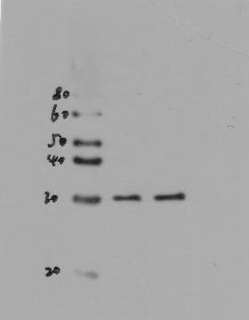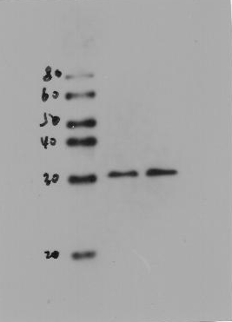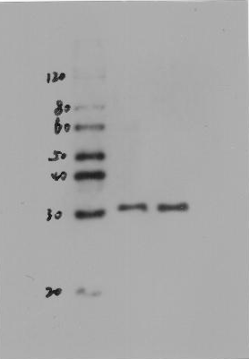

β-actin（repetition1） β-actin（repetition 2） β-actin（repetition 3）
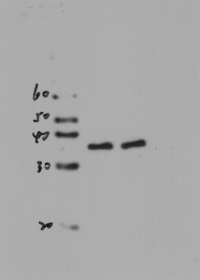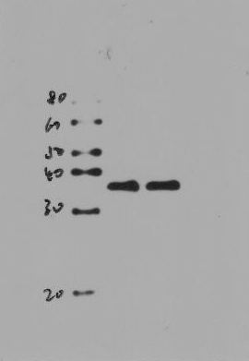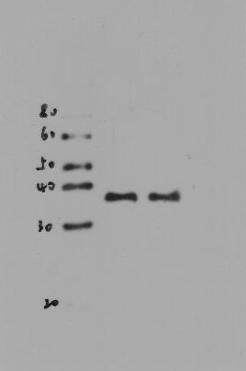

Figure 6
A
Nuclear P65 (repetition-1-2) Nuclear P65 (repetition-3)
LaminB (repetition-1-2-3)

Figure 6
B
Cytoplasmic P65(repetition-1-2-3)

GAPDH(repetition-1-2-3)

Figure 6
C
IκBα (repetition-1) IκBα(repetition-2) IκBα (repetition-3)

p-IκBα (repetition-1-2) p-IκBα (repetition-3)

GAPDH（repetition-1） GAPDH（repetition-2） GAPDH (repetition-3)

