SUPPLEMENTARY APPENDIX

Supplemental Figure 1. CONSORT flow diagram

Appendix Table 1: Baseline patient characteristics stratified by diabetes status among patients with heart failure with reduced and preserved ejection fraction

Appendix Table 2: Sensitivity analysis of cohort stratified by heart failure subtype and age group

Supplemental Figure 1. CONSORT flow diagram

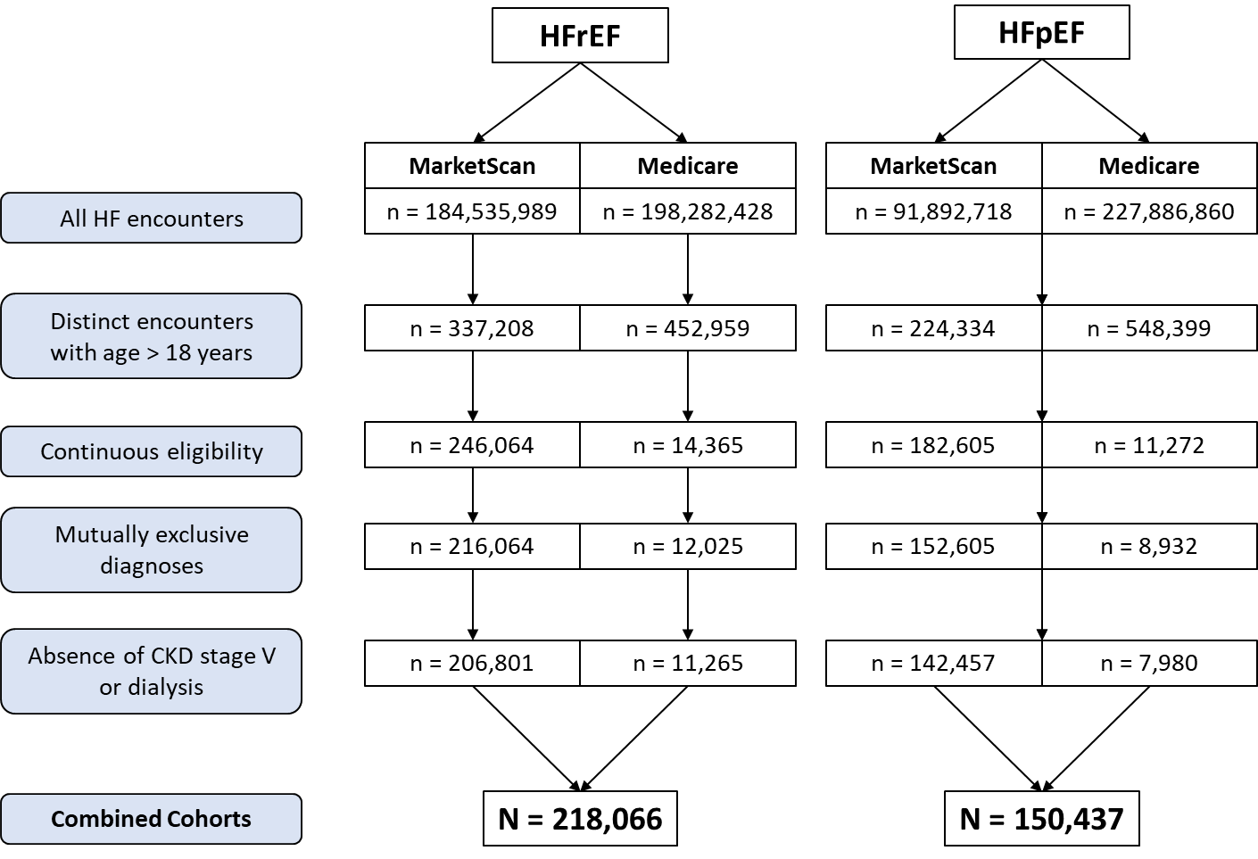

Appendix Table 1. Baseline patient characteristics among patients with heart failure with reduced and preserved ejection fraction stratified by diabetes status
Characteristic, n (%) | HFrEF  (n=218,066) |  | HFpEF  (n=150,437)
Characteristic, n (%) | Without T2DM  (n=134,231) | With T2DM  (n=83,835) | Without T2DM (n=94,204) | With T2DM  (n=76,812)
Sociodemographics
Age, mean (SD) | 53.9 (9.57) | 56.6 (7.49) | 55.6 (8.36) | 57.6 (6.70)
Male sex | 87,537 (65.2) | 57,345 (68.4) | 38,808 (45.8) | 32,831 (49.9)
Calendar year
2013 | 10,650 (7.9) | 7,187 (8.6) | 6,773 (8.0) | 5,750 (8.8)
2014 | 13,926 (10.4) | 9,577 (11.4) | 8,546 (10.1) | 7,396 (11.3)
2015 | 15,434 (11.5) | 5,838 (7.0) | 9,481 (11.2) | 4,583 (7.0)
2016 | 15,851 (11.8) | 10,600 (12.6) | 9,431 (11.1) | 7,731 (11.8)
2017 | 15,295 (11.4) | 10,251 (12.2) | 9,431 (11.1) | 7,752 (11.8)
2018 | 15,777 (11.8) | 10,292 (12.3) | 10,280 (12.1) | 8,067 (12.3)
2019 | 15,704 (11.7) | 9,993 (11.9) | 10,528 (12.4) | 8,054 (12.3)
2020 | 15,804 (11.8) | 9,971 (11.9) | 9,979 (11.8) | 8,099 (12.3)
2021 | 15,790 (11.8) | 10,126 (12.1) | 10253 (12.1) | 8,303 (12.6)
Comorbidities
MI | 16,447 (12.3) | 12,757 (15.2) | 4,386 (5.2) | 4,964 (7.6)
CKD | 9,341 (7.0) | 14,626 (17.4) | 5,917 (7.0) | 13,629 (20.7)
CVA | 10,403 (7.8) | 10,457 (12.5) | 7,818 (9.2) | 8,633 (13.1)
Medications
ACEi | 64,245 (47.9) | 39,703 (47.4) | 23,980 (28.3) | 25,412 (38.7)
ARB | 30,936 (23.0) | 23,822 (28.4) | 20,470 (24.2) | 22,271 (33.9)
ARNI | 19,807 (14.8) | 13,484 (16.1) | 610 (0.7) | 547 (0.8)
Aldosterone antagonist | 45,669 (34.0) | 31,033 (37.0) | 11,325 (13.4) | 11,949 (18.2)
Beta blocker | 112,455 (83.8) | 72,261 (86.2) | 47,228 (55.8) | 44,728 (68.0)
Digoxin | 13,466 (10.0) | 9,352 (11.2) | 2,366 (2.8) | 2,207 (3.4)
Hydralazine/ISDN | 831 (0.6) | 859 (1.0) | 135 (0.2) | 208 (0.3)
Ivabradine | 1,084 (0.8) | 1,062 (1.3) | 97 (0.1) | 83 (0.1)
Loop diuretic | 66,422 (49.5) | 54,134 (64.6) | 36,256 (42.8) | 39,954 (60.8)
SGLT2i | 16,447 (12.3) | 12,757 (15.2) | 244 (0.3) | 6,890 (10.5)
Canagliflozin | 102 (0.1) | 1,915 (2.3) | 64 (0.1) | 1,513 (2.3)
Dapagliflozin | 1,311 (1.0) | 3,918 (4.7) | 102 (0.1) | 2,153 (3.3)
Empagliflozin | 500 (0.4) | 5,491 (6.5) | 79 (0.1) | 3,420 (5.2)
Ertugliflozin | 1 (0.0) | 34 (0.0) | 2 (0.0) | 28 (0.0)
Abbreviations: ACEi: Angiotensin converting enzyme inhibitor; ARB: Angiotensin II receptor blocker; ARNI: angiotensin receptor/neprilysin inhibitor; CKD: chronic kidney disease; CVA: cerebrovascular accident; HFrEF: Heart failure with reduced ejection fraction; HFpEF: Heart failure with preserved ejection fraction; ISDN: Isosorbide dinitrate; MI: Myocardial infarction; SGLT2i: Sodium-glucose cotransporter-2 inhibitor; SD: Standard deviation

Appendix Table 2. Sensitivity analysis of cohort stratified by heart failure subtype and age group
Characteristic, n (%) | HFrEF  (n=218,066) |  | HFpEF  (n=150,437)
Characteristic, n (%) | Age <65  (n=206,680) | Age ≥65  (n=11,386) | Age <65  (n=142,222) | Age ≥65  (n=8,215)
Sociodemographics
Age | 54.3 (8.68) | 66.9 (2.06) | 55.9 (7.53) | 66.8 (2.01)
Male sex | 137,078 (66.3) | 7,804 (68.5) | 67,805 (47.7) | 3,834 (46.7)
Calendar year
2013 | 17,417 (8.4) | 420 (3.7) | 12,240 (8.6) | 283 (3.4)
2014 | 22,767 (11) | 736 (6.5) | 15,495 (10.9) | 447 (5.4)
2015 | 20,346 (9.8) | 926 (8.1) | 13,451 (9.5) | 613 (7.5)
2016 | 24,837 (12.0) | 1,614 (14.2) | 16,104 (11.3) | 1,058 (12.9)
2017 | 24,080 (11.7) | 1,466 (12.9) | 16,180 (11.4) | 1,003 (12.2)
2018 | 24,831 (12.0) | 1,238 (10.9) | 17,540 (12.3) | 807 (9.8)
2019 | 24,462 (11.8) | 1,235 (10.9) | 17,639 (12.4) | 943 (11.5)
2020 | 23,903 (11.6) | 1,872 (16.4) | 16,599 (11.7) | 1,479 (18)
2021 | 24,037 (11.6) | 1,879 (16.5) | 16,974 (11.9) | 1,582 (19.3)
Comorbidities
MI | 28,165 (13.6) | 1,039 (9.1) | 8,856 (6.2) | 494 (6.0)
CKD | 21,713 (10.5) | 2,254 (19.8) | 17,714 (12.5) | 1,832 (22.3)
CVA | 19,316 (9.3) | 1,544 (13.6) | 15,189 (10.7) | 1,262 (15.4)
T2DM | 78,133 (37.8) | 5,702 (50.1) | 61,254 (43.1) | 4,481 (54.5)
Medications
ACEi | 99,106 (48.0) | 4,842 (42.5) | 46,811 (32.9) | 2,581 (31.4)
ARB | 51,818 (25.1) | 2,940 (25.8) | 40,242 (28.3) | 2,499 (30.4)
ARNI | 31,400 (15.2) | 1,891 (16.6) | 1,079 (0.8) | 78 (0.9)
Aldosterone antagonist | 72,664 (35.2) | 4,038 (35.5) | 21,716 (15.3) | 1,558 (19.0)
Beta blocker | 174,795 (84.6) | 9,921 (87.1) | 86,253 (60.6) | 5,703 (69.4)
Digoxin | 21,308 (10.3) | 1,510 (13.3) | 4,154 (2.9) | 419 (5.1)
Hydralazine/ISDN | 1,609 (0.8) | 81 (0.7) | 317 (0.2) | 26 (0.3)
Ivabradine | 2,066 (1.0) | 80 (0.7) | 175 (0.1) | 5 (0.1)
Loop diuretic | 113,606 (55.0) | 6,950 (61.0) | 71,134 (50.0) | 5,076 (61.8)
SGLT2i | 12,191 (5.9) | 698 (6.1) | 6,762 (4.8) | 372 (4.5)
Canagliflozin | 1,881 (0.9) | 136 (1.2) | 1,482 (1.0) | 95 (1.2)
Dapagliflozin | 5,025 (2.4) | 204 (1.8) | 2,157 (1.5) | 98 (1.2)
Empagliflozin | 5,606 (2.7) | 385 (3.4) | 3,307 (2.3) | 192 (2.3)
Ertugliflozin | 34 (0.0) | 1 (0.0) | 30 (0.0) | 0 (0.0)
Abbreviations: ACEi: Angiotensin converting enzyme inhibitor; ARB: Angiotensin II receptor blocker; ARNI: angiotensin receptor/neprilysin inhibitor; CKD: chronic kidney disease; CVA: cerebrovascular accident; HFrEF: Heart failure with reduced ejection fraction; HFpEF: Heart failure with preserved ejection fraction; ISDN: Isosorbide dinitrate; MI: Myocardial infarction; SGLT2i: Sodium-glucose cotransporter-2 inhibitor; SD: Standard deviation

