Supplementary Figures
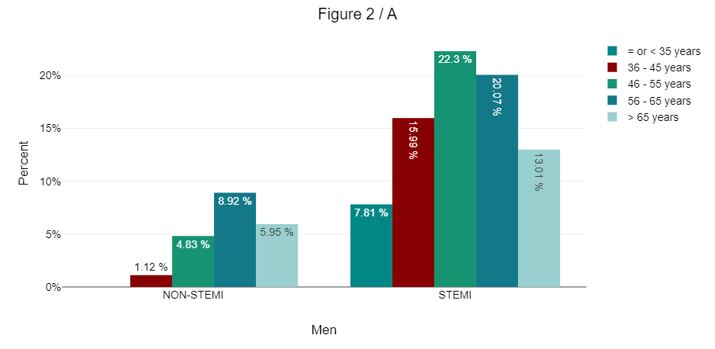
A -
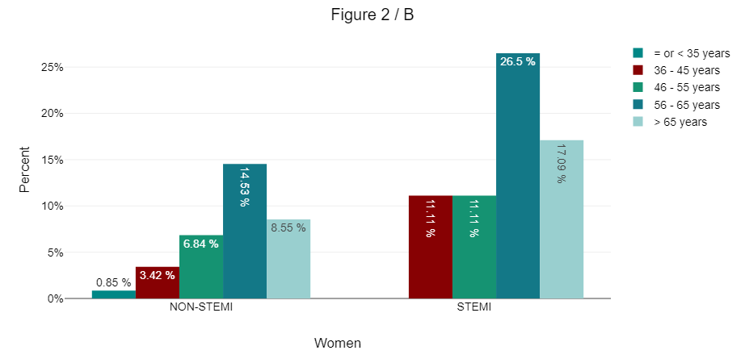
B -
- Supplementary Figure 1: Age groups among enrolled patients with STEMI and non-STEMI among men (A) and Women (B)

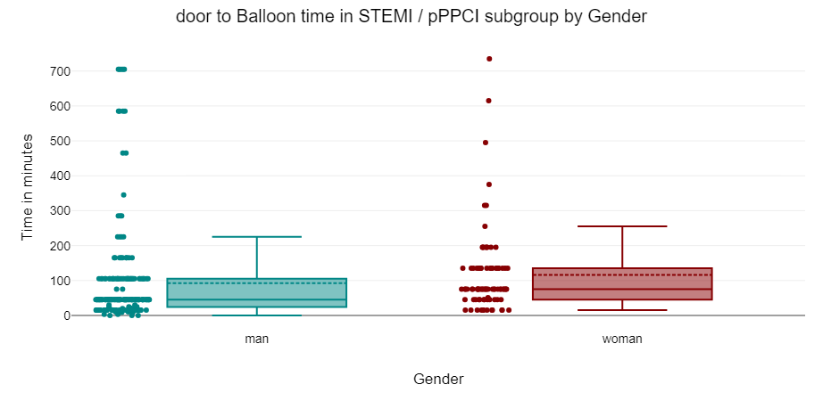
- Supplementary Figure 2: Box plots displaying the door-to-balloon times in both genders in STEMI patients who underwent primary PCI subgroup.

