Supplementary material:
Title.
Intravascular Imaging-Guided versus Angiography-Guided Percutaneous Coronary Intervention: A Systematic Review and Bayesian Network Meta-analysis of Randomized Controlled Trials.
Running Title.
Intravascular Imaging-Guided versus Angiography-Guided PCI
Authors.
Ahmed Mazen Amin¹, Yehya Khlidj², Mohamed Abuelazm³, Ahmed Sayed⁴, Ubaid Khan⁵, Mariam Mahmoud Elewidi³, Mohammad Tanashat⁶, Hesham Elharti³, Mohamed Ellabban⁷, Abdullah K. Alassiri⁸, Mohamad Alsaed⁹, Basel Abdelazeem¹⁰, Akram Kawsara¹⁰.
Affiliations.
- Faculty of Medicine, Mansoura University, Mansoura, Egypt.
- Faculty of Medicine, Algiers University, Algiers, Algeria.
- Faculty of Medicine, Tanta University, Tanta, Egypt.
- Faculty of Medicine, Ain Shams University, Cairo, Egypt.
- Division of Cardiology, University of Maryland, School of Medicine, Baltimore, USA.
- Faculty of Medicine, Yarmouk University, Irbid, Jordan.
- Faculty of Medicine, Al-Azhar University, Cairo, Egypt.
- Faculty of Medicine, King Abdulaziz University, Jeddah, Saudi Arabia.
- Department of Medicine, West Virginia University, Morgantown, West Virginia, USA.
- Department of Cardiology, West Virginia University, Morgantown, West Virginia, USA.
Keywords.
Intravascular ultrasound, optical coherence tomography, angiography, coronary artery disease, percutaneous coronary intervention.
Contents:

Tables.
Table S1: Search strategy.
Table S2: Assessments of inconsistency and heterogeneity.

Figures.
Figure S1: Forest plot of MACE (fixed effects model).
Figure S2: Forest plot of MACE (random effects model).
Figure S3: Forest plot of all-cause mortality (fixed effects model).
Figure S4: Forest plot of all-cause mortality (random effects model).
Figure S5: Forest plot of cardiac death (fixed effects model).
Figure S6: Forest plot of cardiac death (random effects model).
Figure S7: Forest plot of target vessel failure (fixed effects model).
Figure S8: Forest plot of target vessel failure (random effects model).
Figure S9: Forest plot of target lesion failure (fixed effects model).
Figure S10: Forest plot of target lesion failure (random effects model).
Figure S11: Forest plot of myocardial infarction (fixed effects model).
Figure S12: Forest plot of myocardial infarction (random effects model).
Figure S13: Forest plot of any revascularization (fixed effects model).
Figure S14: Forest plot of any revascularization (random effects model).
Figure S15: Forest plot of target-vessel-related revascularization (fixed effects model).
Figure S16: Forest plot of target-vessel-related revascularization (random effects model).
Figure S17: Forest plot of CABG (fixed effects model).
Figure S18: Forest plot of CABG (random effects model).
Figure S19: Forest plot of stent thrombosis (fixed effects model).
Figure S20: Forest plot of stent thrombosis (random effects model).
Figure S21: Forest plot of re-stenosis (fixed effects model).
Figure S22: Forest plot of re-stenosis (random effects model).
Figure S23: Funnel plot of MACE.
Figure S24: Funnel plot of all-cause mortality.
Figure S25: Funnel plot of cardiac death.
Figure S26: Funnel plot of target-vessel failure.
Figure S27: Funnel plot of target-lesion failure.
Figure S28: Funnel plot of myocardial infarction.
Figure S29: Funnel plot of any revascularization.
Figure S30: Funnel plot of target-vessel revascularization.
Figure S31: Funnel plot of CABG.
Figure S32: Funnel plot of stent thrombosis.
Figure S33: Funnel plot of re-stenosis.

Database | Search Terms | Search Field | Search Results
Pubmed | ("intravascular ultrasound" OR IVUS OR "optical coherence tomography" OR "optical frequency domain" OR OCT) AND ("percutaneous coronary intervention" OR PCI OR "stent implantation" OR "stent placement" OR "DES-implantation") Filters: Clinical Trial | All Field | 1570
Cochrane | ("intravascular ultrasound" OR IVUS OR "optical coherence tomography" OR "optical frequency domain" OR OCT) AND ("percutaneous coronary intervention" OR PCI OR "stent implantation" OR "stent placement" OR "DES-implantation") | All Field | 1358
WOS | ("intravascular ultrasound" OR IVUS OR "optical coherence tomography" OR "optical frequency domain" OR OCT) AND ("percutaneous coronary intervention" OR PCI OR "stent implantation" OR "stent placement" OR "DES-implantation") AND trial | All Field | 1410
SCOPUS | ("intravascular ultrasound" OR IVUS OR "optical coherence tomography" OR "optical frequency domain" OR OCT) AND ("percutaneous coronary intervention" OR PCI OR "stent implantation" OR "stent placement" OR "DES-implantation") AND trial | Title, Abstract, Keywords | 1569
EMBASE | #4. #1 AND #2 AND #3 504  #3. trials:ti,ab,kw 1,011,175  #2. 'percutaneous coronary intervention':ti,ab,kw OR 136,296  pci:ti,ab,kw OR 'stent implantation':ti,ab,kw OR  'stent placement':ti,ab,kw OR 'des  implantation':ti,ab,kw  #1. 'intravascular ultrasound':ti,ab,kw OR 122,430  ivus:ti,ab,kw OR 'optical coherence  tomography':ti,ab,kw OR 'optical frequency  domain':ti,ab,kw OR oct:ti,ab,kw  ....................................................... | All Field | 504
Table S1: Search Strategy

Outcome | Direct estimate of IVUS versus OCT (if available)* | Indirect estimate of IVUS versus OCT (if available)* | P-value for inconsistency between direct and indirect estimates* | N of comparisons between conventional angiography and intravascular ultrasonography | N of comparisons between conventional angiography and optical coherence tomography | N of comparisons between intravascular ultrasonography and optical coherence tomography | Heterogeneity of comparisons between conventional angiography and intravascular ultrasonography (I-squared; %)† | Heterogeneity of comparisons between conventional angiography and optical coherence tomography (I-squared; %)† | Heterogeneity of comparisons between intravascular ultrasonography and optical coherence tomography (I-squared; %)†
MACE | 0.94 (0.45 to 1.97) | 1.05 (0.64 to 1.74) | 0.81 | 16 | 7 | 2 | 24.57 | 0.00 | 0.00
All-cause mortality | 0.43 (0.20 to 0.89) | 0.75 (0.38 to 1.32) | 0.26 | 15 | 9 | 4 | 0.00 | 0.00 | 0.00
Cardiac death | 0.29 (0.11 to 0.80) | 1.30 (0.66 to 2.91) | 0.01 | 14 | 7 | 3 | 0.00 | 0.00 | 0.00
Target vessel failure | 0.71 (0.36 to 1.44) | 1.48 (0.57 to 3.56) | 0.15 | 3 | 2 | 2 | 0.00 | 0.00 | 0.00
Target lesion failure | 0.60 (0.25 to 1.62) | 1.49 (0.29 to 5.65) | 0.25 | 2 | 2 | 2 | 20.88 | 0.00 | 0.00
Myocardial infarction | 0.54 (0.25 to 1.19) | 1.28 (0.58 to 2.80) | 0.12 | 17 | 8 | 4 | 31.68 | 0.00 | 0.00
Revascularization | 0.72 (0.38 to 1.28) | 1.23 (0.67 to 2.31) | 0.18 | 6 | 4 | 3 | 7.95 | 0.00 | 0.00
Target-related revascularization | 0.50 (0.25 to 0.93) | 1.57 (1.04 to 2.26) | 0.003 | 15 | 8 | 3 | 0.00 | 0.00 | 0.00
Stent thrombosis | 0.21 (0.06 to 0.67) | 1.25 (0.46 to 2.89) | 0.03 | 14 | 9 | 3 | 0.00 | 0.00 | 0.00
CABG | 0.47 (0.10 to 2.59) | 0.86 (0.15 to 6.63) | 0.61 | 7 | 1 | 1 | 46.42 | Not applicable | Not applicable
Restenosis | Not applicable | Not applicable | Not applicable | 8 | 2 | 0 | 37.74 | 0.00 | Not applicable
*Node-splitting could not be performed for outcomes with an absent pairwise comparison or which were based on only 2 trials.
†Heterogeneity could not be assessed for outcomes with zero or 1 comparisons.
Table S2: Assessments of inconsistency and heterogeneity
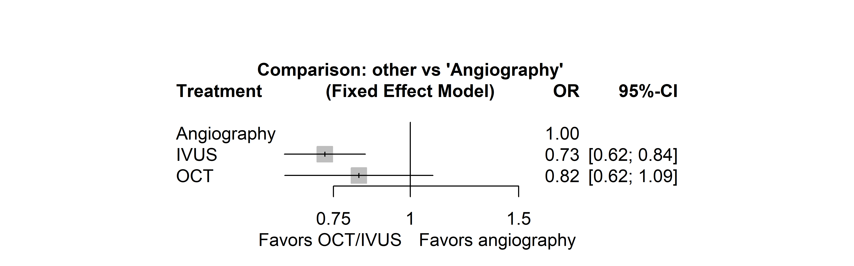
Figure S1: Forest plot of MACE (fixed effects model).

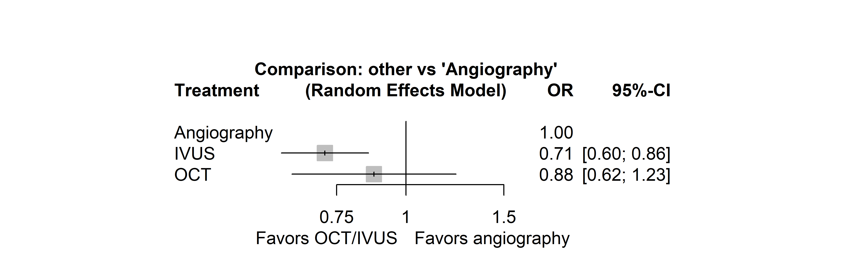
Figure S2: Forest plot of MACE (random effects model).

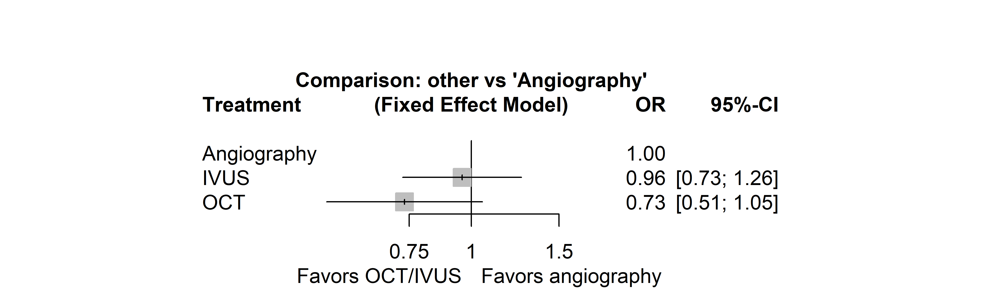
Figure S3: Forest plot of all-cause mortality (fixed effects model).

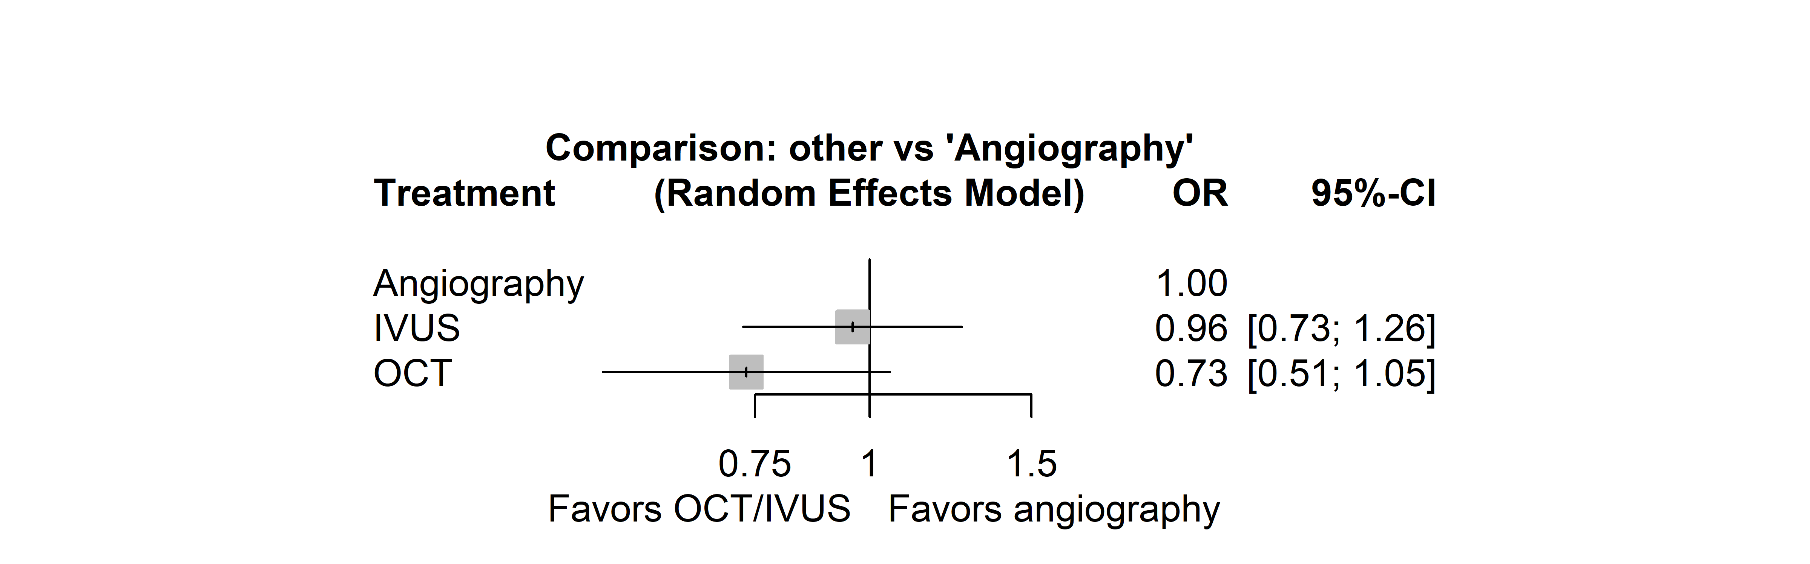
Figure S4: Forest plot of all-cause mortality (random effects model).

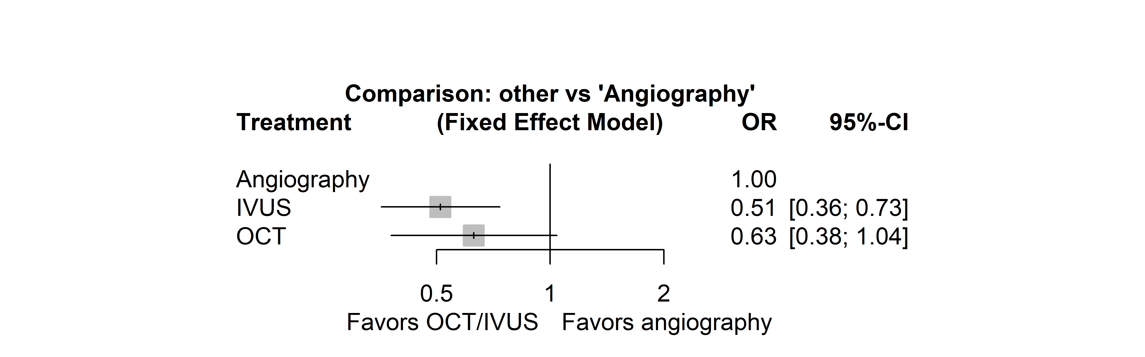
Figure S5: Forest plot of cardiac death (fixed effects model).

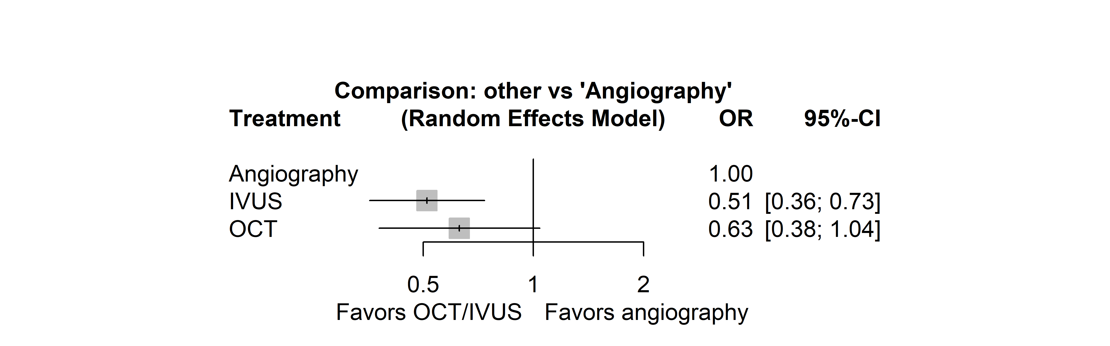
Figure S6: Forest plot of cardiac death (random effects model).

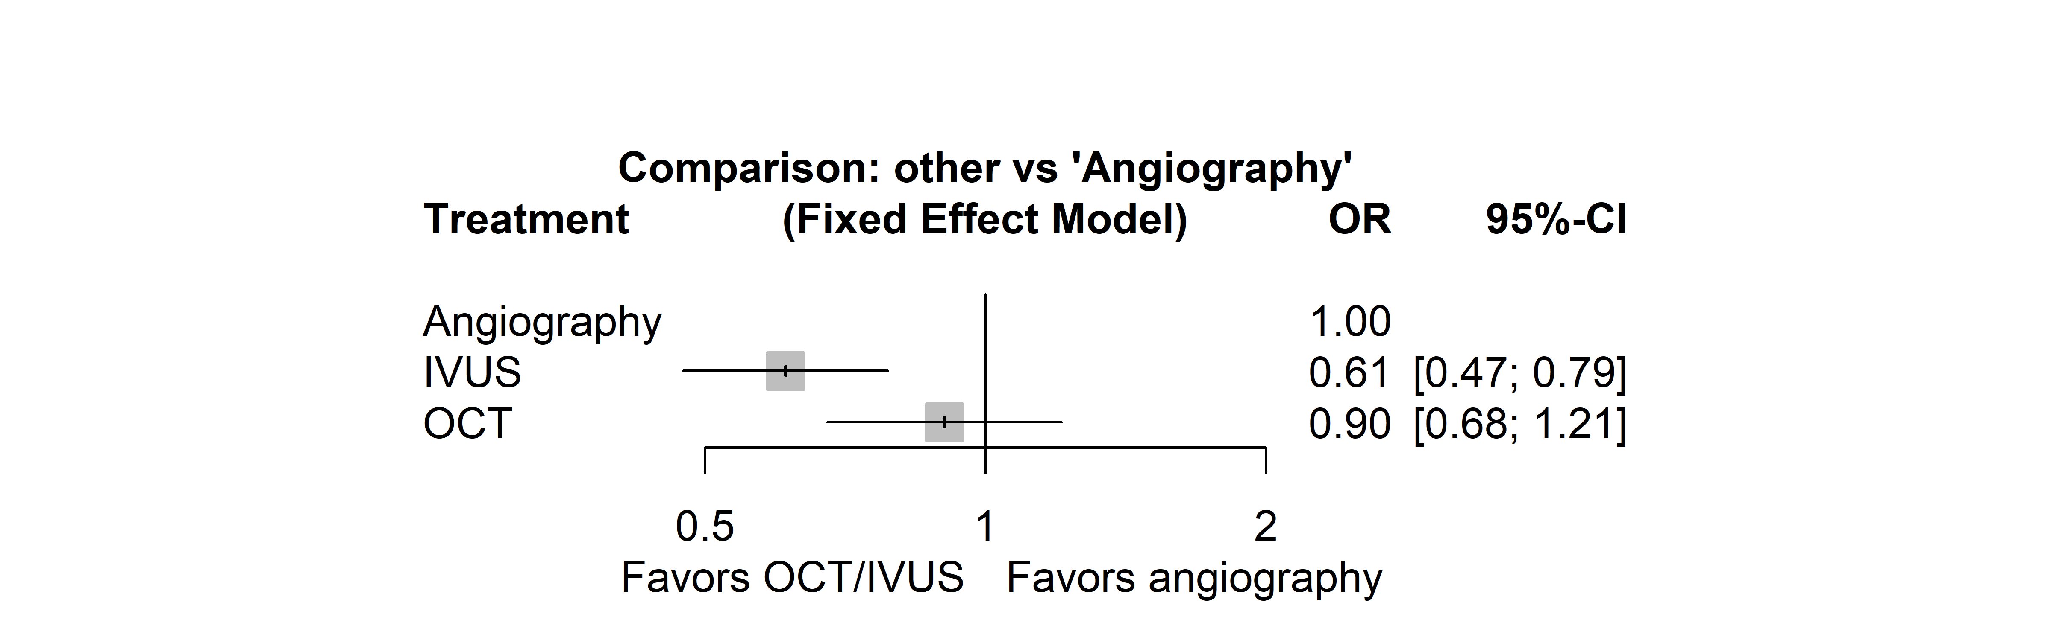
Figure S7: Forest plot of target vessel failure (fixed effects model).

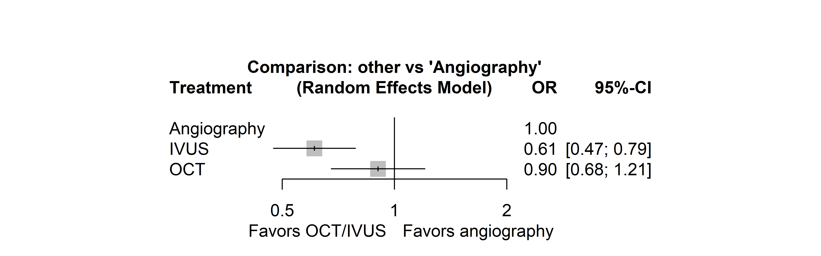
Figure S8: Forest plot of target vessel failure (random effects model).

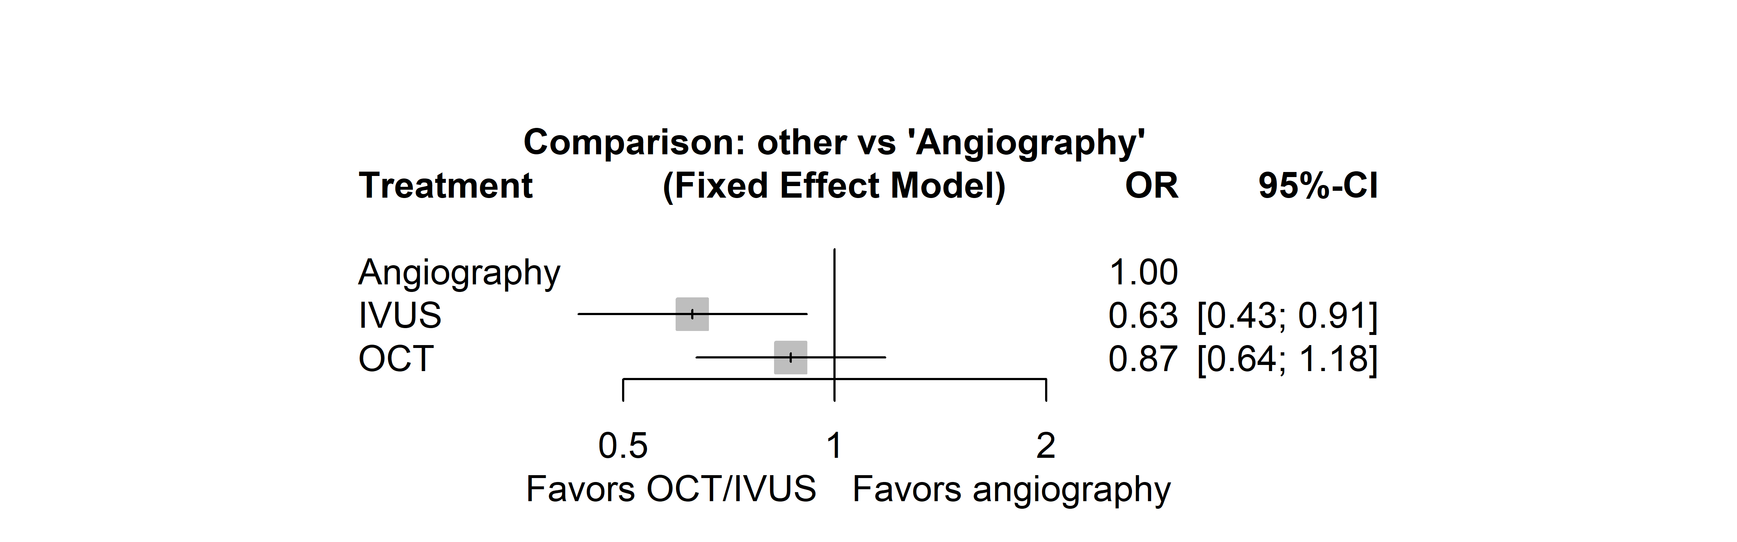
Figure S9: Forest plot of target lesion failure (fixed effects model).

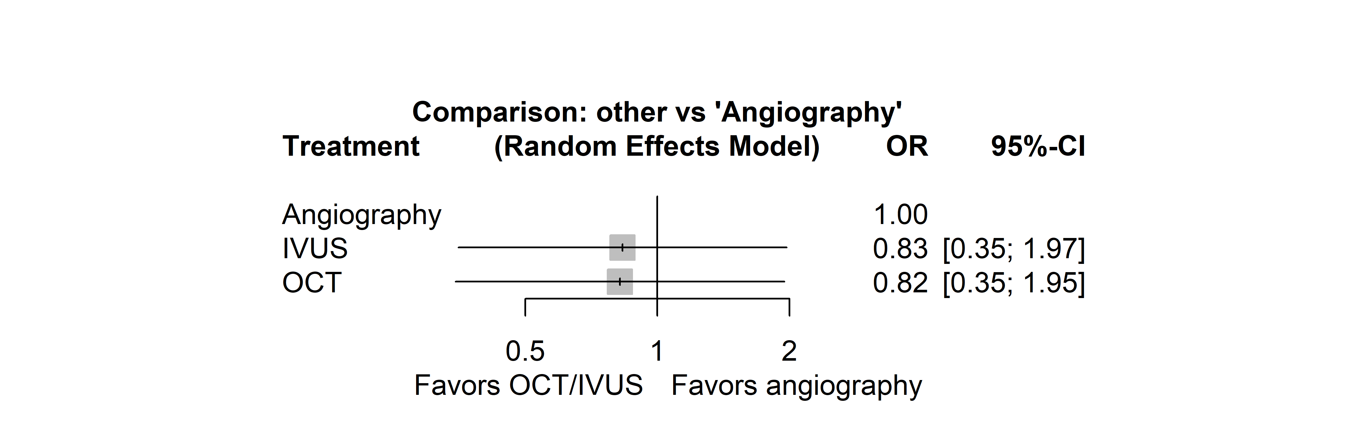
Figure S10: Forest plot of target lesion failure (random effects model).

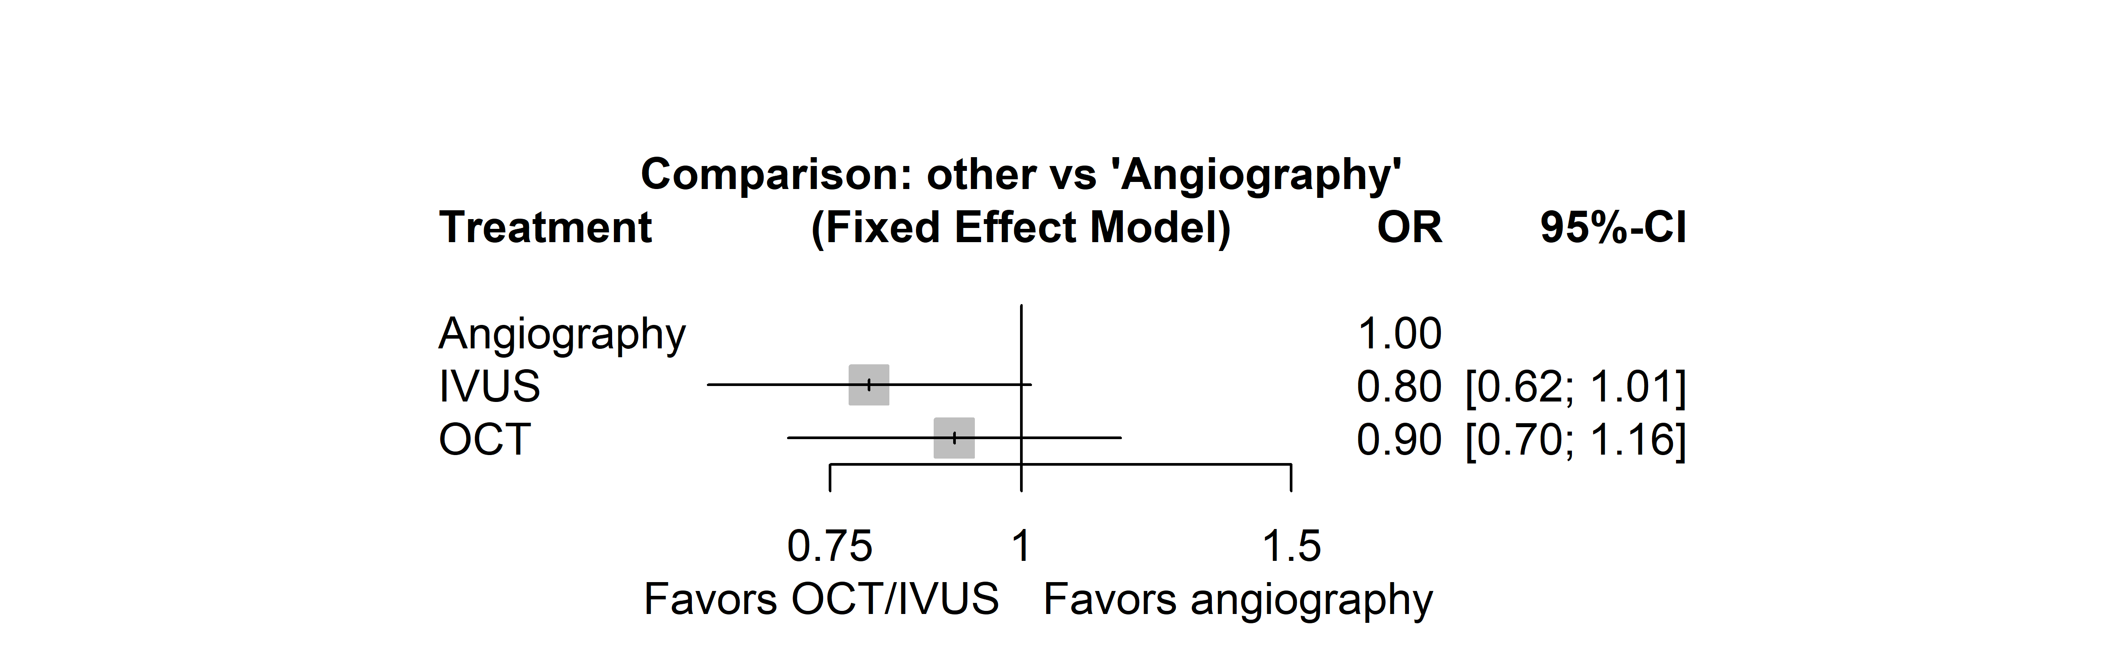
Figure S11: Forest plot of myocardial infarction (fixed effects model).

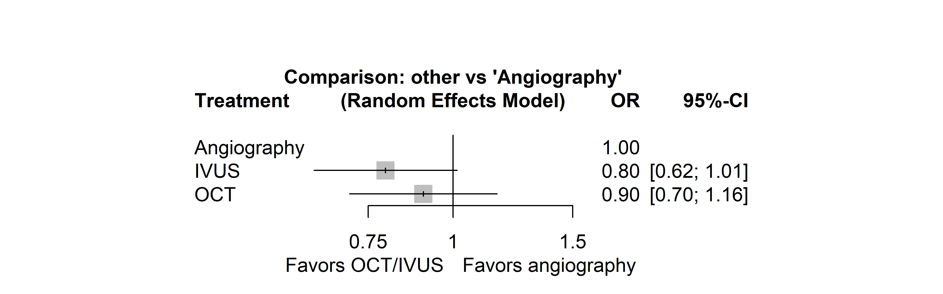
Figure S12: Forest plot of myocardial infarction (random effects model).

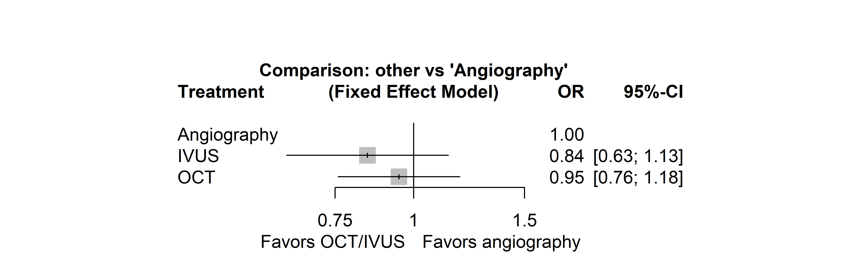
Figure S13: Forest plot of any revascularization (fixed effects model).

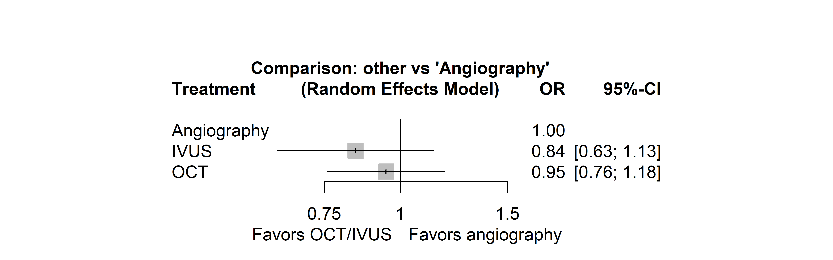
Figure S14: Forest plot of any revascularization (random effects model).

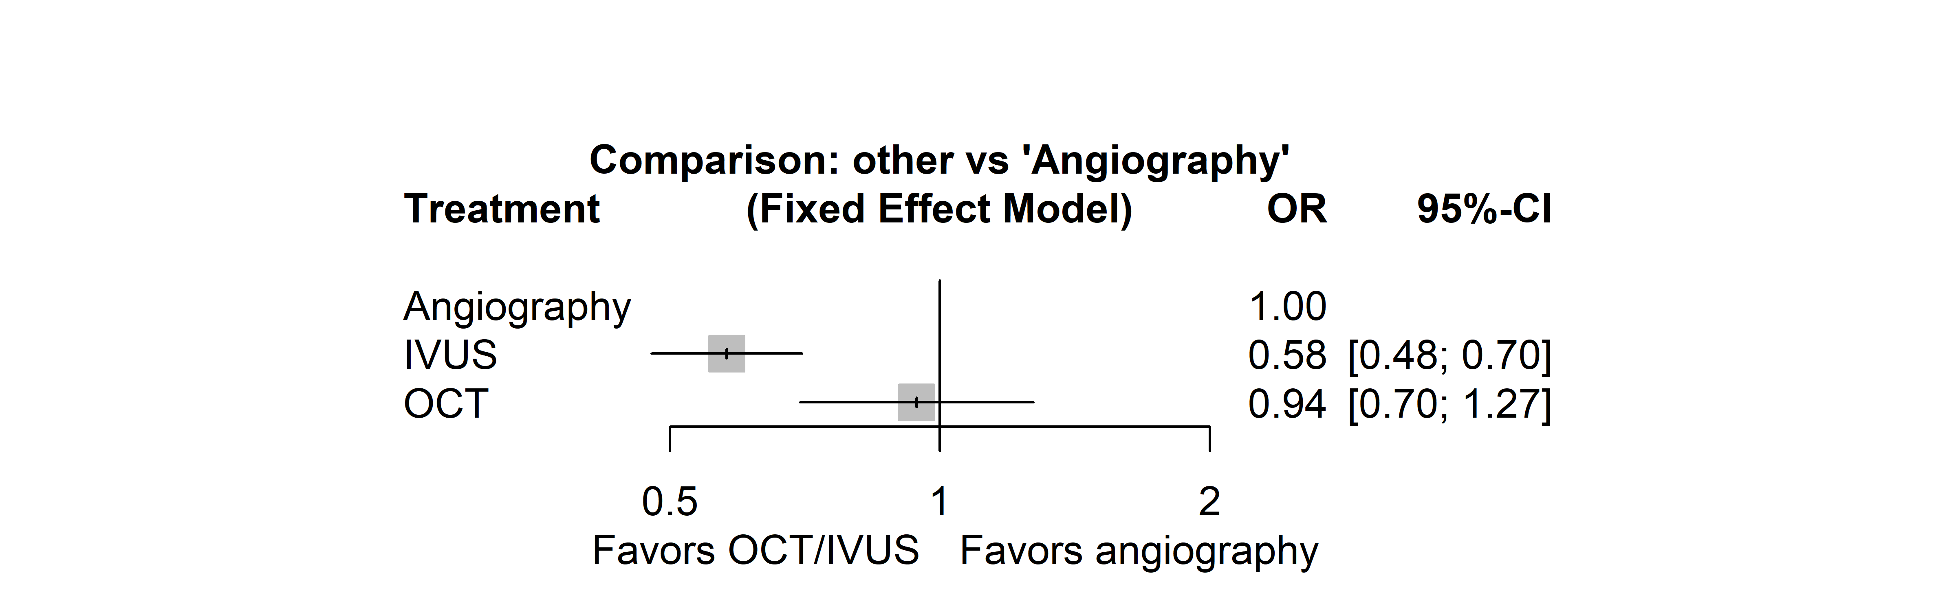
Figure S15: Forest plot of target-vessel-related revascularization (fixed effects model).

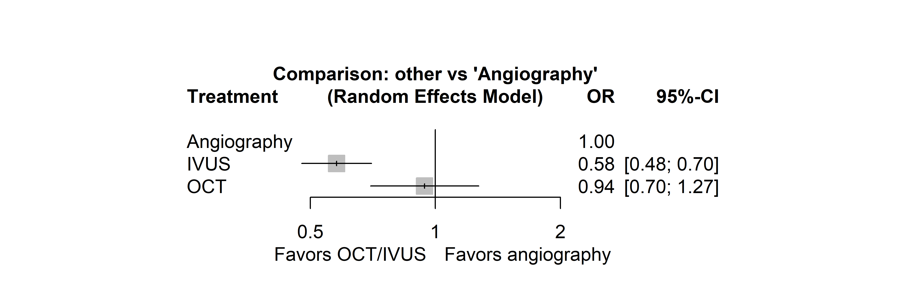
Figure S16: Forest plot of target-vessel-related revascularization (random effects model).

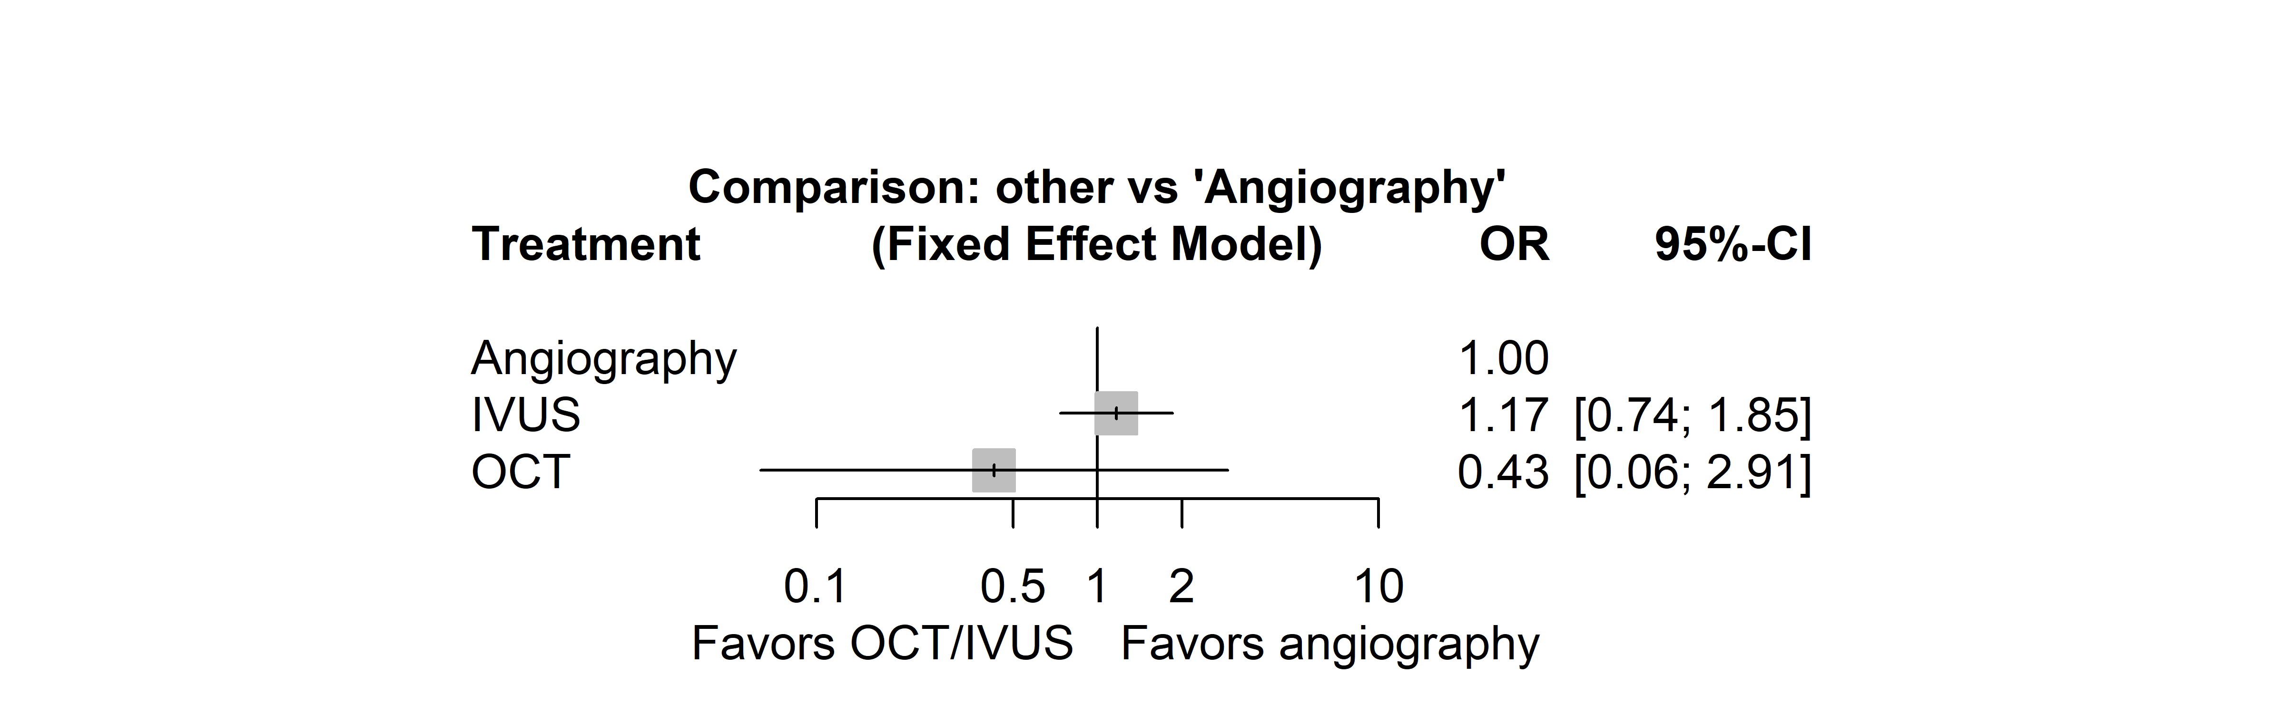
Figure S17: Forest plot of CABG (fixed effects model).

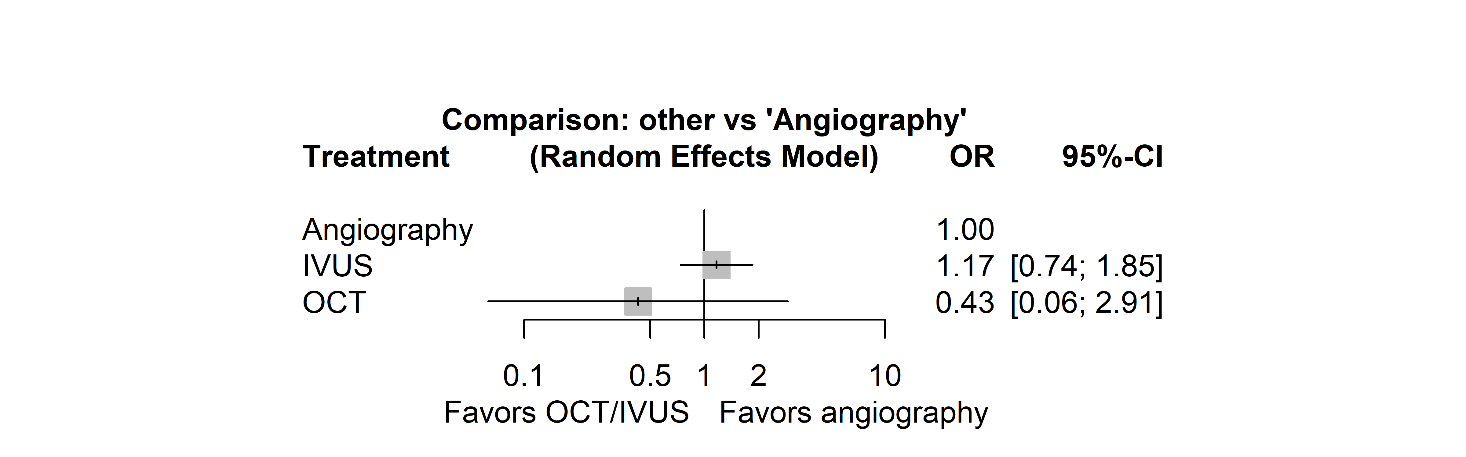
Figure S18: Forest plot of CABG (random effects model).

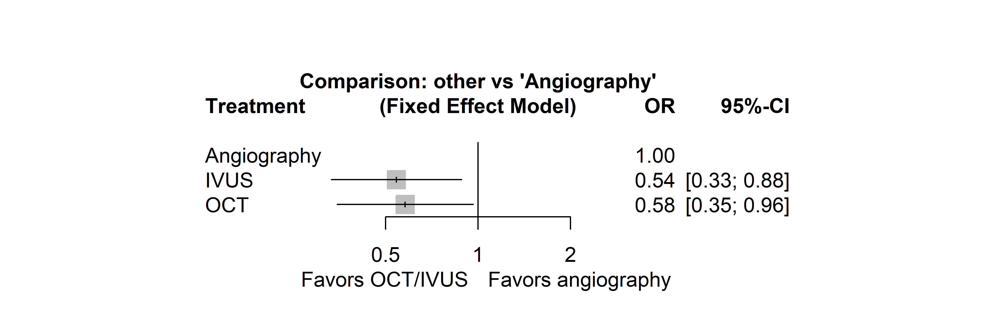
Figure S19: Forest plot of stent thrombosis (fixed effects model).

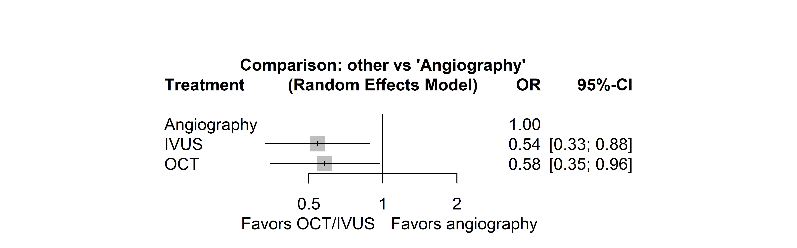
Figure S20: Forest plot of stent thrombosis (random effects model).

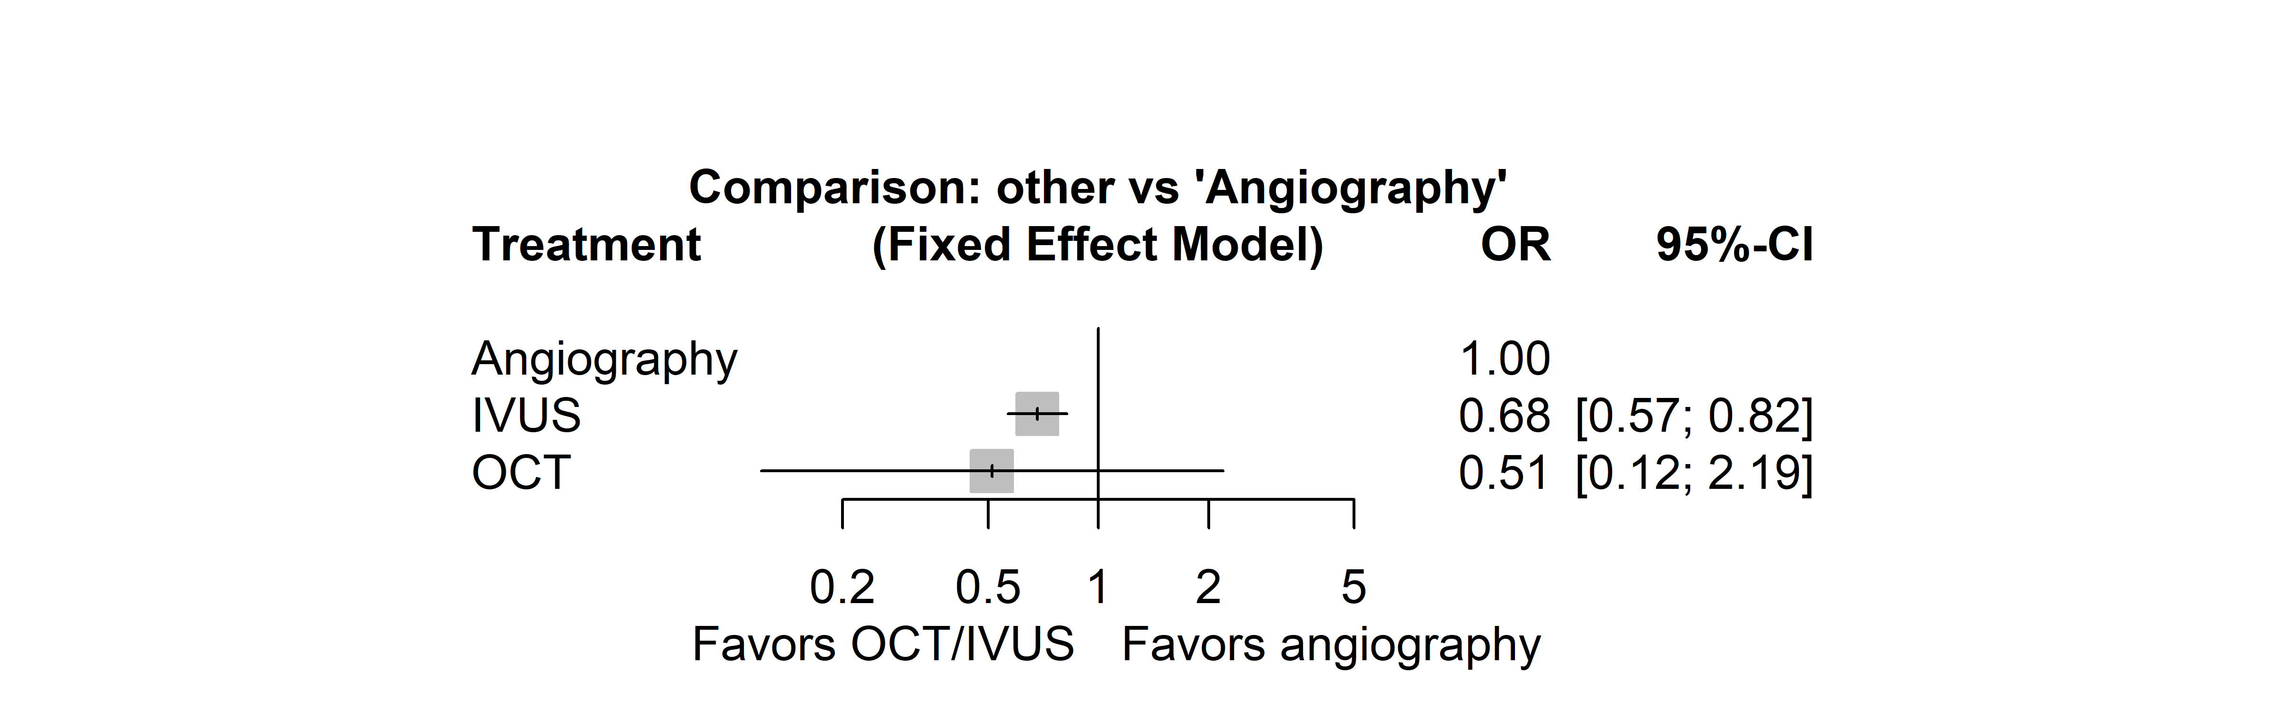
Figure S21: Forest plot of re-stenosis (fixed effects model).

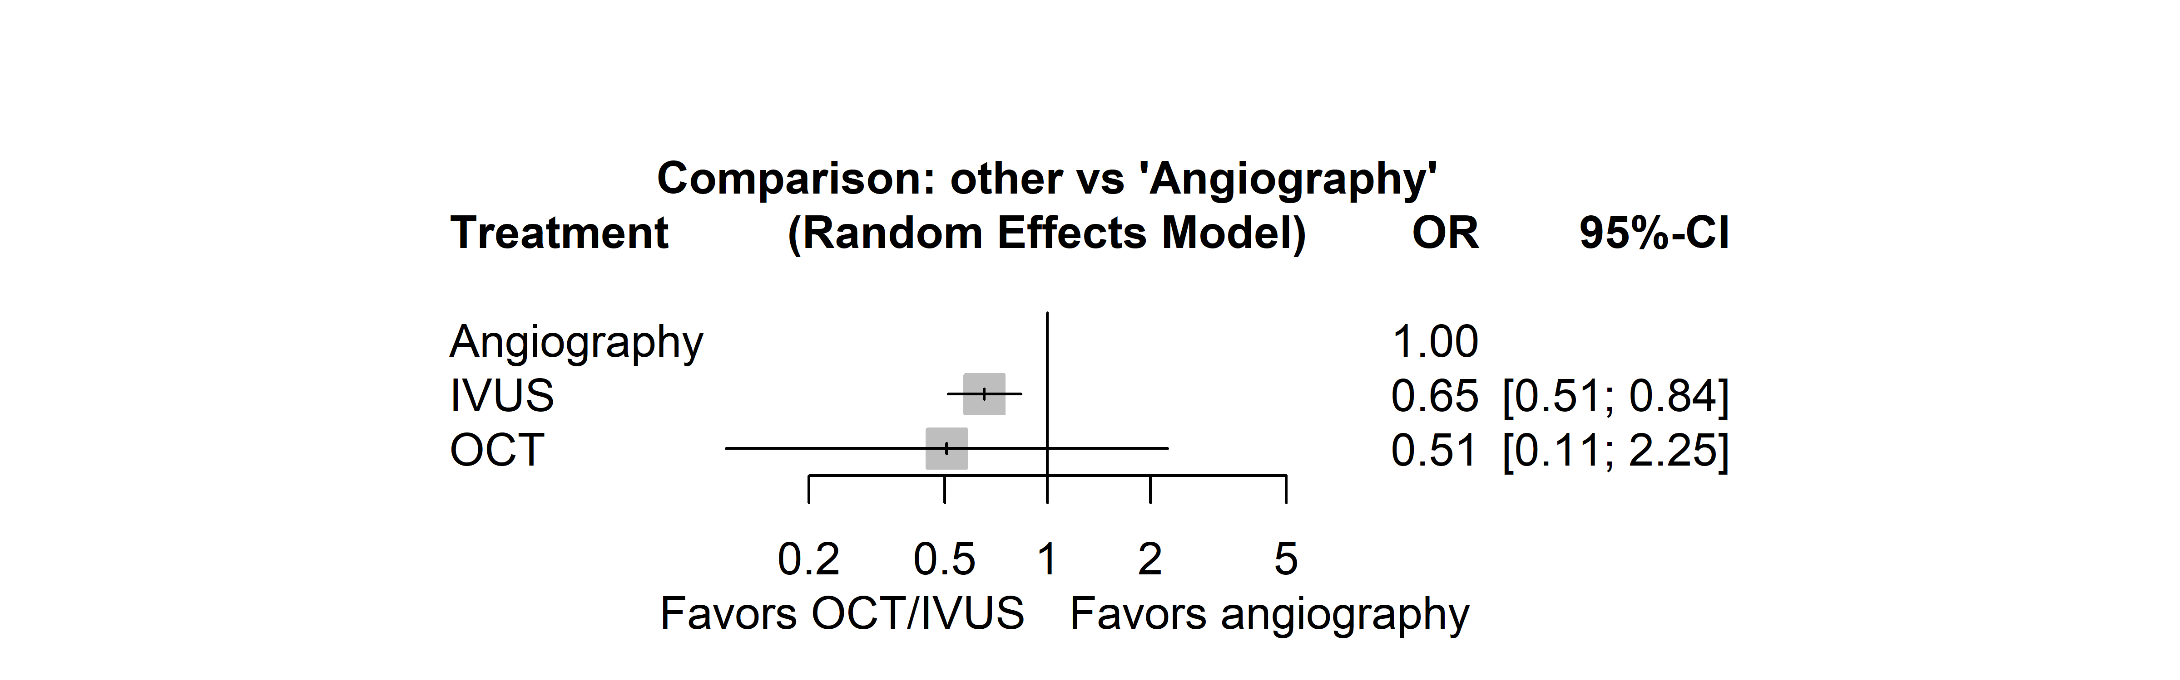
Figure S22: Forest plot of re-stenosis (random effects model).

Figure S23: Funnel plot of MACE.

Figure S24: Funnel plot of all-cause mortality.

Figure S25: Funnel plot of cardiac death.

Figure S26: Funnel plot of target vessel failure.

Figure S27: Funnel plot of target-lesion failure.

Figure S28: Funnel plot of myocardial infarction.

Figure S29: Funnel plot of any revascularization.

Figure S30: Funnel plot of target-vessel revascularization.

Figure S31: Funnel plot of CABG.

Figure S32: Funnel plot of stent thrombosis.

Figure S33: Funnel plot of re-stenosis.

