The Clinical Effectiveness and Safety of Low/Moderate-Intensity Statins & Ezetimibe Combination Therapy vs. High-Intensity Statin Monotherapy: A Systematic Review and Meta-Analysis
Search strategy:
Statin* OR "low intensity statin*" OR "moderate intensity statin*" OR "moderate-intensity statin*" OR "low-intensity statin*"

Atorvastatin OR “Atorvastatin Calcium” OR Liptonorm OR Lipitor OR “Atorvastatin Calcium Hydrate” OR “Atorvastatin Calcium Anhydrous” OR “CI 981” OR CI981 OR “Atorvastatin Calcium Trihydrate”

Rosuvastatin OR Crestor OR “Rosuvastatin Calcium” OR ZD4522 OR “ZD 4522”

Pitavastatin OR itavastatin OR “P 872441” OR “NK 104” OR “pitavastatin calcium” OR “itavastatin calcium” OR “pitavastatin lactone” OR nisvastatin

Fluvastatin OR “Fluvastatin Sodium” OR “Fluvastatin Sodium Salt” OR Fluindostatin OR Lescol OR “XU 62 320” OR XU62320 OR “XU 62320”

Lovastatin OR Mevinolin OR “Monacolin K” OR “6 Methylcompactin” OR “MK 803” OR MK803 OR Mevacor

Pravastatin OR Eptastatin OR Vasten OR CS-514 OR “CS 514” OR CS514 OR “Lin Pravastatin” OR Lipemol OR Liplat OR Nu-Pravastatin OR “Nu Pravastatin” OR Prareduct OR Mevalotin OR Pravachol OR Elisor OR Selektine OR Lipostat OR Pravacol OR Pravasin OR "Pravastatin Sodium” OR “Pravastatin Sodium Salt” OR “RMS 431” OR RMS431 OR “SQ 31000” OR SQ31000 OR “SQ 31,000” OR SQ31,000 OR “Apo Pravastatin” OR Bristacol

Simvastatin OR Zocor OR “MK 733” OR MK733 OR Synvinolin

#1 OR #2 OR #3 OR #4 OR #5 OR #6 OR #7 OR #8

Ezetimibe OR Ezetimib OR Ezetrol OR “SCH 58235” OR SCH58235 OR Zetia

#9 AND #10

Athero* OR “atherosclerotic cardiovascular disease” OR (coronary AND (atherosclerosis OR syndrome)) OR peripheral artery disease OR ACS OR PAD OR Hyperlipidem* OR Hypercholesterolem* OR Hypertriglyceridem* OR “lipid disorder*” OR “High Cholesterol Level*” OR “Elevated Cholesterol”

#11 AND #12

Pubmed: 2,523
SCOPUS: 2,249 (T/Ab search)
Web of Science: 3,133
CENTRAL: 1,268

Supplementary figures:

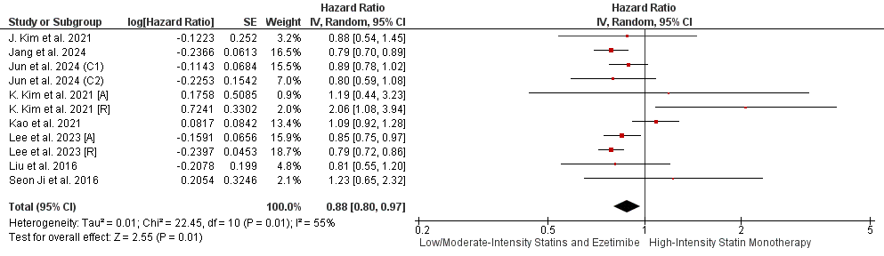

Supplementary Figure 1. Forrest plot of observational studies demonstrating All-cause death PRE-LOT.

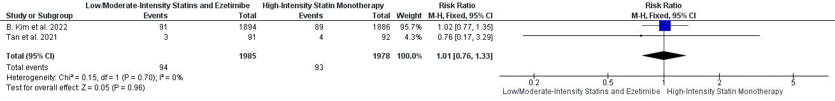

Supplementary Figure 2. Forrest plot of RCTs demonstrating Coronary Artery Revascularisation.

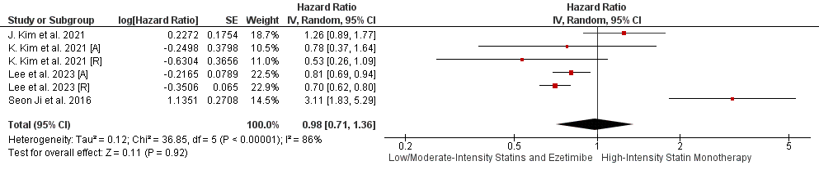

Supplementary Figure 3. Forrest plot of observational studies demonstrating Coronary Artery Revascularization.

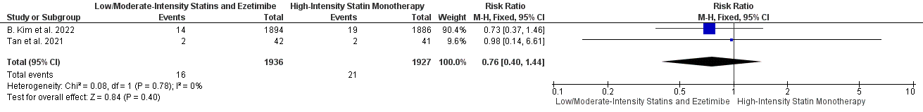

Supplementary Figure 4. Forrest plot of RCTs demonstrating Hospitalization for Heart Failure.

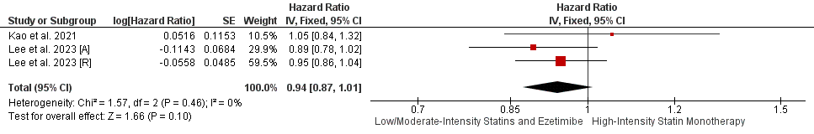

Supplementary Figure 5. Forrest plot of observational studies demonstrating Hospitalization for Heart Failure.

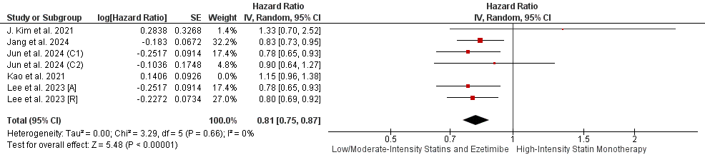

Supplementary Figure 6A. Forrest plot of observational studies demonstrating Non-fatal Stroke (Total) (POST-LOT).

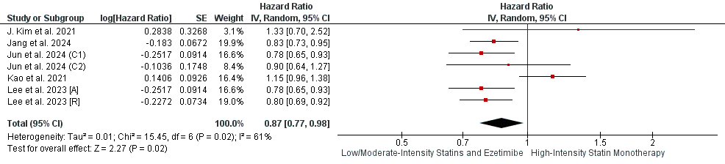

Supplementary Figure 6B. Forrest plot of observational studies demonstrating Non-fatal Stroke (Total) (PRE-LOT).

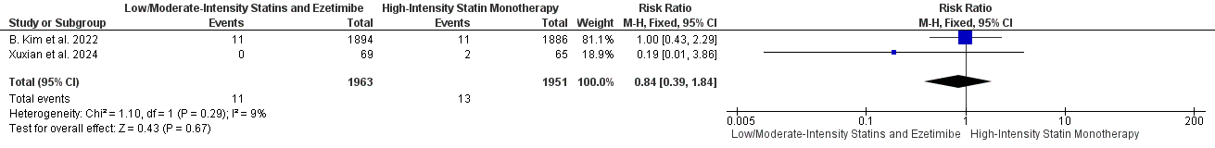

Supplementary Figure 7. Forrest plot of RCTs demonstrating Ischemic Stroke.

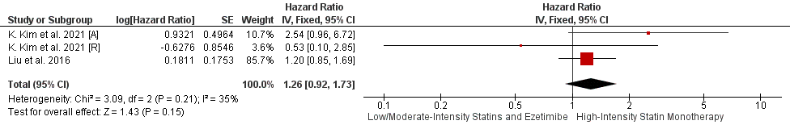

Supplementary Figure 8. Forrest plot of observational studies demonstrating Ischemic Stroke.

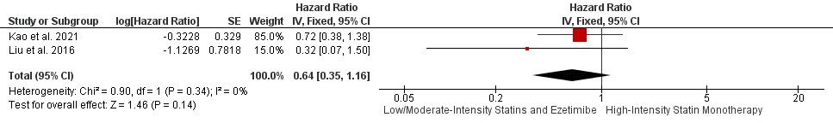

Supplementary Figure 9. Forrest plot of observational studies demonstrating Hemorrhagic Stroke.

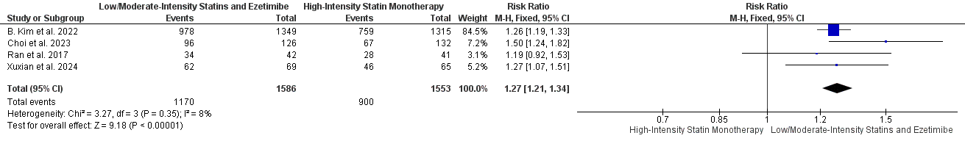

Supplementary Figure 10. Forrest plot of RCTs demonstrating No. of patients with LDL cholesterol concentrations 70 mg per dL at the end of the study.

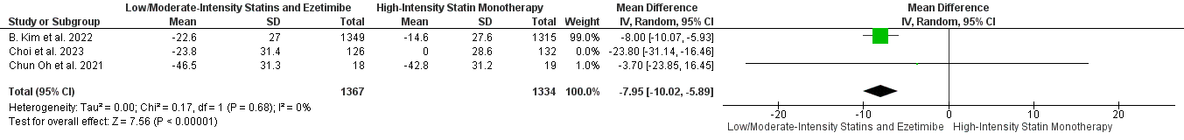

Supplementary Figure 11A. Forrest plot of RCTs demonstrating Reduction of LDL-C from baseline at the end of the study POST-LOT.

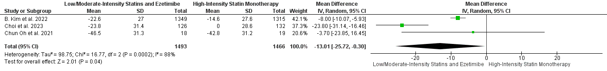

Supplementary Figure 11B. Forrest plot of RCTs demonstrating Reduction of LDL-C from baseline at the end of the study PRE-LOT.

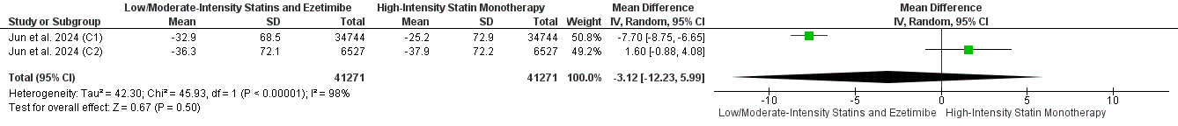

Supplementary Figure 12. Forrest plot of observational studies demonstrating Reduction of LDL-C from baseline at the end of the study.

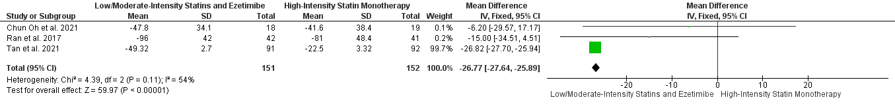

Supplementary Figure 13. Forrest plot of RCTs demonstrating Change in TC from baseline at the end of the study.

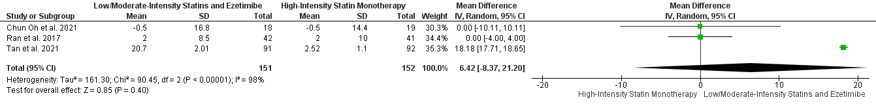

Supplementary Figure 14. Forrest plot of RCTs demonstrating Change in HDL-C from baseline at the end of the study.

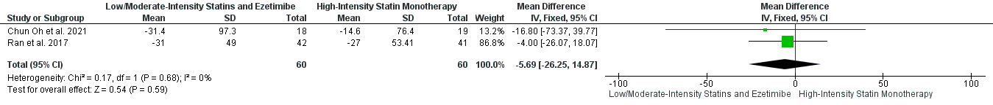

Supplementary Figure 15. Forrest plot of RCTs demonstrating Change in TG from baseline at the end of the study.

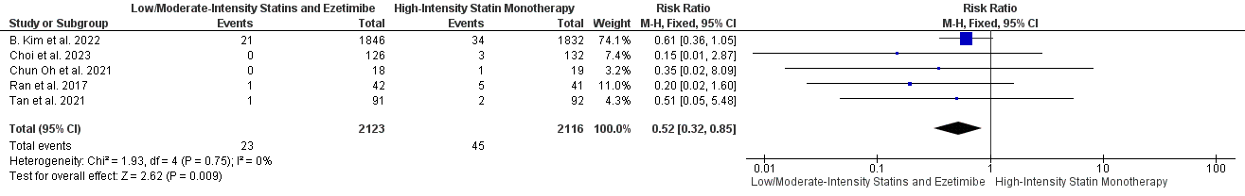

Supplementary Figure 16. Forrest plot of RCTs demonstrating Muscle-related Adverse Events.

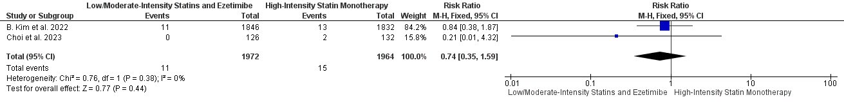

Supplementary Figure 17. Forrest plot of RCTs demonstrating Rhabdomyolysis.

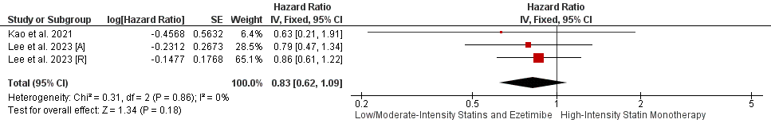

Supplementary Figure 18. Forrest plot of observational studies demonstrating Rhabdomyolysis.

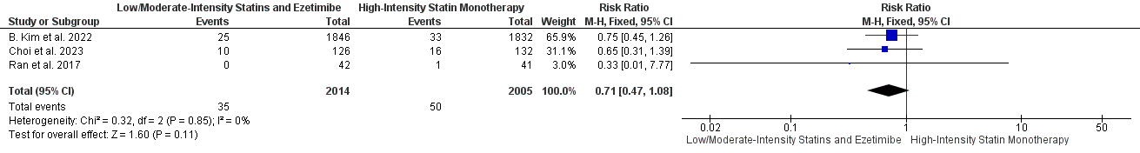

Supplementary Figure 19. Forrest plot of RCTs demonstrating No. of Patients with CK elevation.

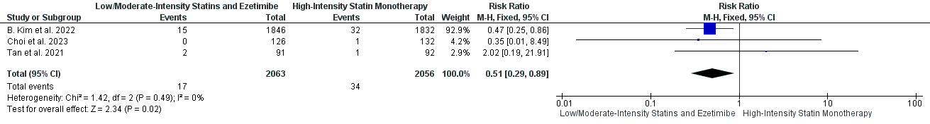

Supplementary Figure 20. Forrest plot of RCTs demonstrating No. of Patients with Liver Enzymes elevation.

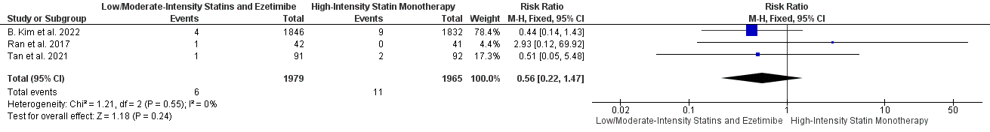

Supplementary Figure 21. Forrest plot of RCTs demonstrating Gastrointestinal symptoms.

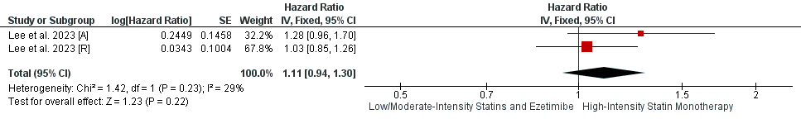
Supplementary Figure 22. Forrest plot of observational studies demonstrating Gallbladder-related adverse events.

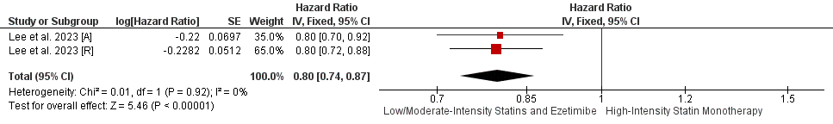
Supplementary Figure 23. Forrest plot of observational studies demonstrating New-onset diabetes with anti-diabetic medication initiation.

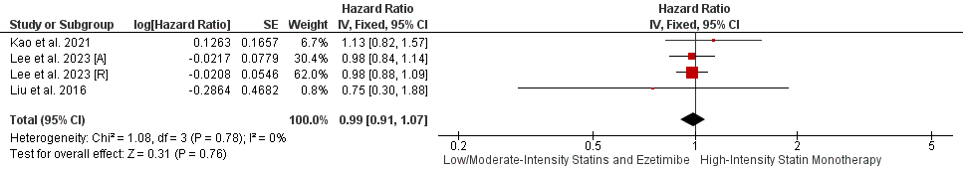

Supplementary Figure 24. Forrest plot of observational studies demonstrating Cancer diagnosis.

Supplementary Table:

Supplementary table 1. NOS
- Cohort studies (n=10)
Study | Selection |  |  |  | Comparability | Outcome |  |  | Quality Score
Study | Representativeness of the exposed cohort | Selection of the non exposed cohort | Ascertainment of exposure | Demonstration that outcome of interest was not present at start of study | Comparability of cohorts on the basis of the design or analysis | Assessment of outcome | Was follow-up long enough for outcomes to occur | Adequacy of follow up of cohorts | Quality Score
Dai et al. 2017 ²⁹ |  | * | * | * | * | * | * | * | Good
J. Kim et al. 2021 ³⁰ | * | * | * | * | * | * |  |  | Poor
Jang et al. 2024 ³¹ | * | * | * | * | ** | * |  | * | Good
Jun et al. 2024 ³² | * | * | * | * | ** | * | * | * | Good
K. Kim et al. 2021 ³³ | * | * | * | * | * | * | * | * | Good
Kao et al. 2021 ³⁴ | * | * | * | * | ** | * | * | * | Good
Lee et al. 2023 [A] ³⁵ | * | * | * | * | ** | * | * | * | Good
Lee et al. 2023 [R] ³⁶ | * | * | * | * | ** | * | * | * | Good
Liu et al. 2016 ³⁷ | * | * | * | * | ** | * | * | * | Good
Seon Ji et al. 2016 ³⁸ | * | * | * |  | ** | * | * | * | Good

