Supplementary 1

Detailed Home-Based Exercise Protocol

Research title: The Home-Based Breathing and Chest Mobility Exercise Improves Cardiorespiratory Functional Capacity in Long COVID with Cardiovascular Comorbidities: A Randomized Study

Exercise contraindications:
- Resting heart rate of >120x/minute
- Blood pressure ≥140/90 or ≤90/60 mmHg
- Oxygen saturation ≤92% without oxygen
- Loss of consciousness
- Other medical conditions that would not allow exercise to be performed

Terminate exercise when the following conditions occur:
- Body temperature >38.2 degree Celsius
- Shortness of breath that does not improve with rest
- Other symptoms: chest pain, chest tightness, excessive coughing, dizziness, headache, blurred/double vision, palpitation, cold sweats, and loss of balance.

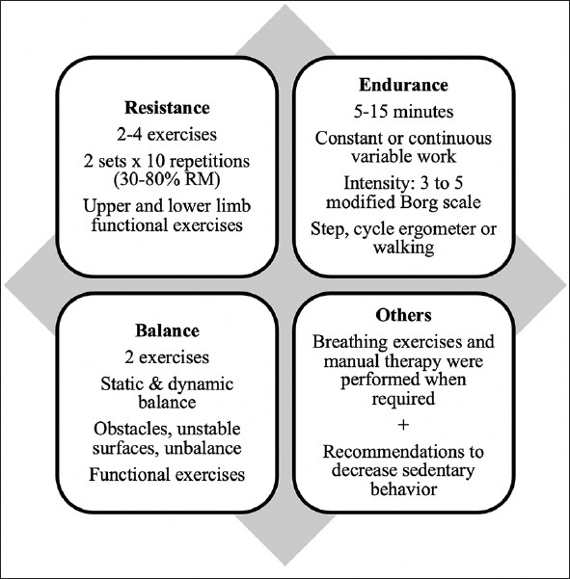
Figure 1. Scheme of the individualized multi-component therapeutic exercise intervention, combining 3 or more modalities daily

- Specific Breathing Exercises

- Breathing Control Exercise

Content | Duration and intensity | Description
Breathing control exercise with pursed lips | Continuous for 3 min | Slow and deep inhalation in a count of 1, 2, followed by exhalation through pursed lips in a longer count of 1, 2, 3, 4.  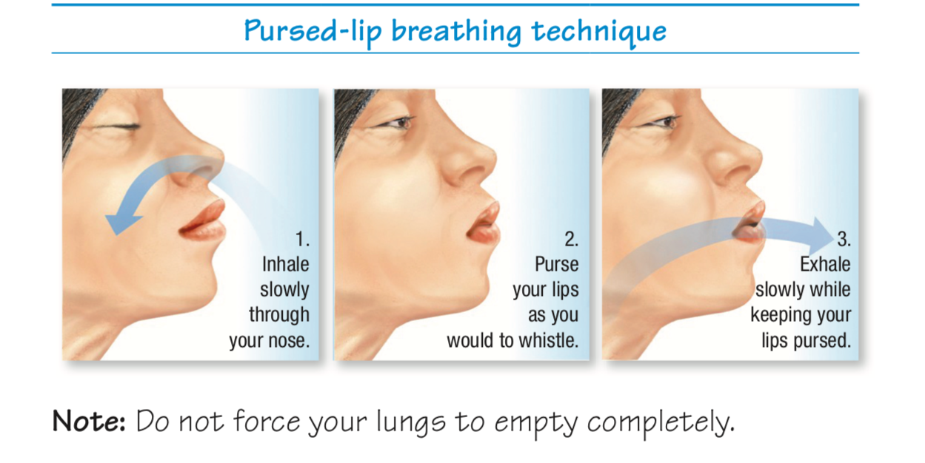
Diaphragm breathing technique with pursed lip | One set/5 reps | Using the same technique as Breathing control exercise with pursed lips but while lying down and having one arm resting on the upper chest and the other just below the rib cage.  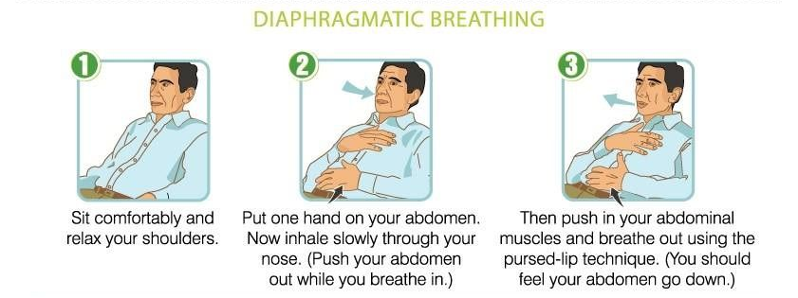
Active cycle breathing technique | One set/5 reps | A cycle between breathing control, deep breathing, and forced expiratory technique of huffs and/or coughs.  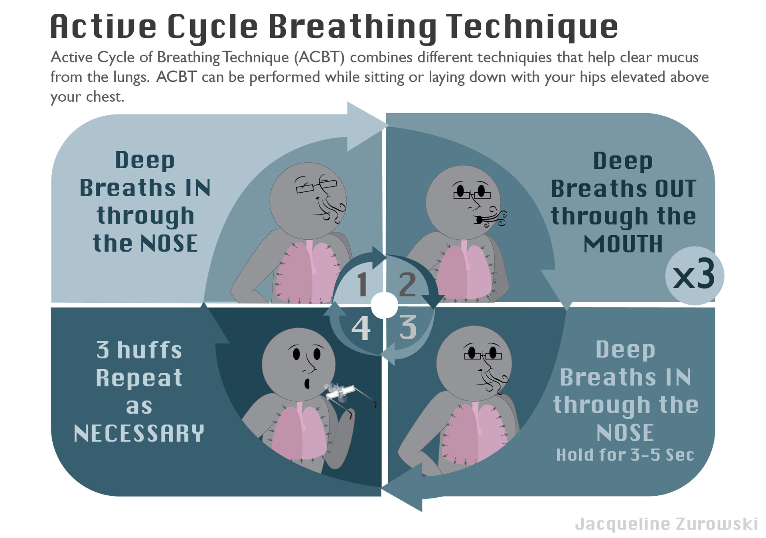
Lower thoracic expansion exercise | One set/5 reps | Using a belt to reinforce lateral costal breathing by applying resistance during expiration and assisting pressure along the rib cage during expiration.  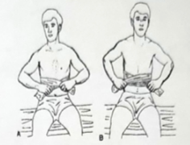

- Flexibility Exercise

Content | Duration and intensity | Description
Bilatreal neck extensor stretch | One set/3 reps | Exercise to stretch the upper trapezius, splenius, semispinalis and longissimus capitis muscles  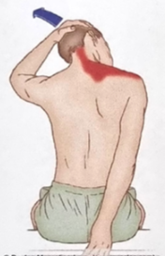
Shoulder stretch to overhead | One set/3 reps | Exercise to stretch the deltoid middle head and lateral and medial head of triceps muscles  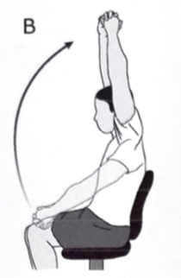
Pectoralis stretch with hands on the back | One set/3 reps | Exercise to stretch the pectoral muscles  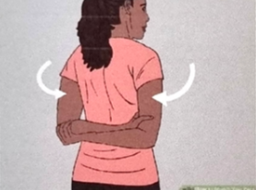
Pectoralis stretch with wall 3x | One set/3 reps | Exercise to stretch the pectoral muscles  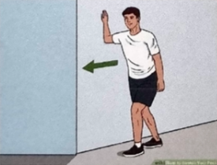

- Strengthening Exercise

Content | Duration and intensity | Description
Without added weight – Sit to standing and quadricep setting | Two sets/5 reps | Deep core strengthening and improving knee and calf muscles for better mobility  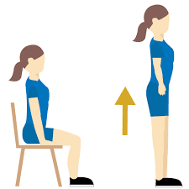  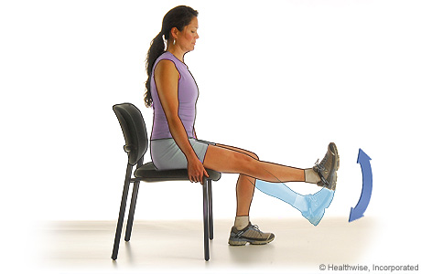
With added weight – shoulder and bicep training with 330ml/600ml water bottle | Two sets/5 reps | Arms strengthening for better mobility  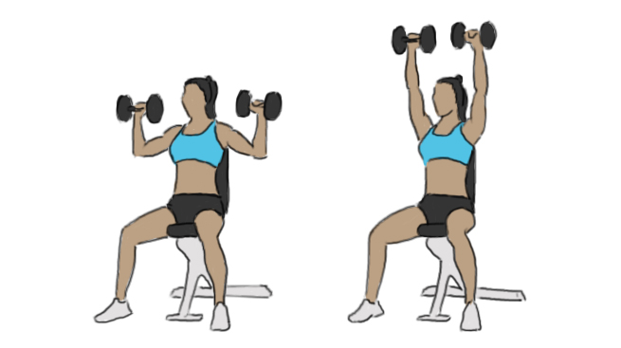  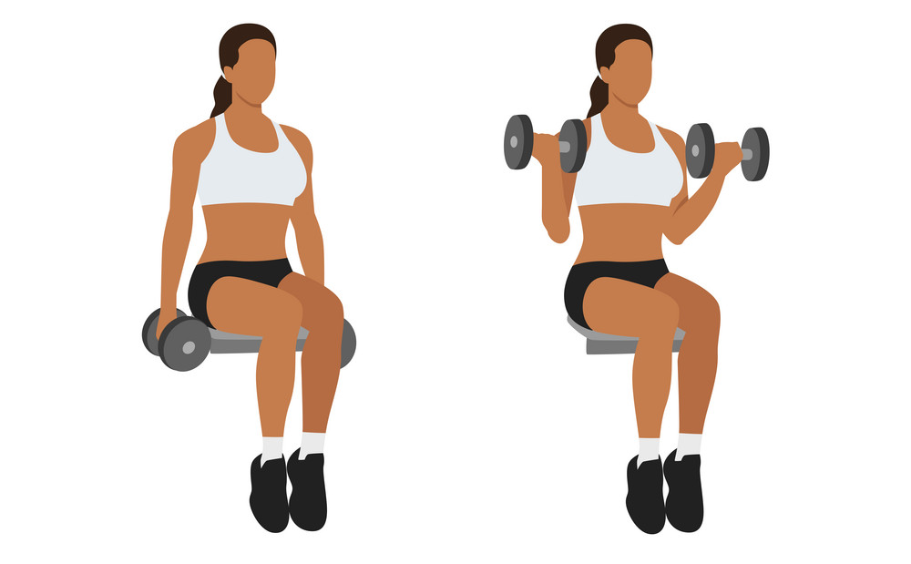

- Aerobic Exercise (5-15 minutes)

Content | Duration and intensity | Description
Aerobic exercise: | 5 times/week | 30-minute mild-to-moderate aerobic exercise program, primarily brisk walking, five times a week.  The program was tailored based on the initial exercise stress test and adjusted as per patient progress. Patients were motivated to increase their walking distance by 400 meters every 1-2 weeks.  



