Real-world evidence study on the impact of SPECT MPI, PET MPI, cCTA and stress echocardiography on downstream healthcare utilisation in patients with coronary artery disease in the US: Supplemental information

Figure S 1: Proxy pre-test CAD risk stratification method 2
Figure S 2: Patient pathways by cohort and index test (Cohorts 1 & 2) 12
Figure S 3: Patient pathways by cohort and index test (Cohorts 3 & 4) 13
Figure S 4: Patient pathways by cohort and index test (Cohort 5) 14
Figure S 5: Patient pathways by cohort and index test (Cohorts 6 & 7) 15
Figure S 6: Patient pathways by cohort and index test (Cohorts 8 & 9) 16
Figure S 7: Proportions of patients with any downstream healthcare utilisation in those who underwent combinations of imaging tests 17

Table S 1: Downstream healthcare utilisation by patient cohort 2

Supporting information
Figure S 1: Proxy pre-test CAD risk stratification method
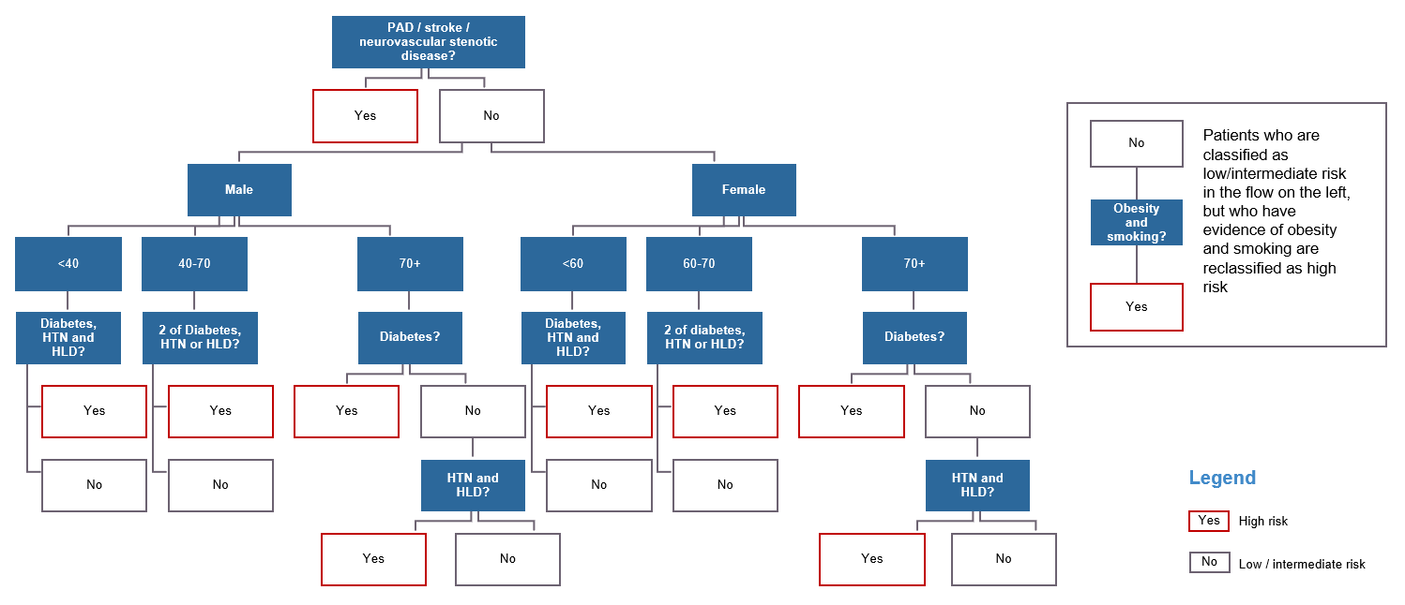
Abbreviations: HTN hypertension; HLD, hyperlipidaemia; PAD, peripheral arterial disease.

Table S 1: Downstream healthcare utilisation by patient cohort
Cohort 1 – Low pre-test risk, CAD diagnosis within 3 months of index test
 | SPECT MPI |  |  | PET MPI |  |  | cCTA |  |  | SE
Additional diagnostic imaging
Any imaging (%) | 3.5 | SE (%) | 9 | 1.7 | SE (%) | 6 | 8.0 | SE (%) | 13 | 4.2 | SE (%) | 36
Any imaging (%) | 3.5 | SPECT MPI (%) | 77 | 1.7 | SPECT MPI (%) | 38 | 8.0 | SPECT MPI (%) | 52 | 4.2 | SPECT MPI (%) | 40
Any imaging (%) | 3.5 | PET MPI (%) | 1 | 1.7 | PET MPI (%) | 25 | 8.0 | PET MPI (%) | 3 | 4.2 | PET MPI (%) | 5
Any imaging (%) | 3.5 | cCTA (%) | 12 | 1.7 | cCTA (%) | 31 | 8.0 | cCTA (%) | 32 | 4.2 | cCTA (%) | 19
Coronary angiography (%) | 31.3 |  |  | 15.4 |  |  | 17.4 |  |  | 31.0
Interventions
Total intervention (%) | 9.0 | PCI (%) | 86 | 5.8 | PCI (%) | 89 | 6.4 | PCI (%) | 92 | 10.1 | PCI (%) | 83
Total intervention (%) | 9.0 | CABG (%) | 14 | 5.8 | CABG (%) | 11 | 6.4 | CABG (%) | 8 | 10.1 | CABG (%) | 17
Cardiac-related health system encounters
Hospital inpatient (%) | 3.4 |  |  | 1.9 |  |  | 5.3 |  |  | 3.3
Hospital outpatient (%) | 4.4 |  |  | 2.6 |  |  | 4.2 |  |  | 5.4
Cardiac office (%) | 5.8 |  |  | 6.2 |  |  | 4.2 |  |  | 4.7
Emergency (%) | 1.5 |  |  | 0.8 |  |  | 1.2 |  |  | 1.1
Events
Any event (%) | 9.5 | IS (%) | 9 | 5.3 | IS (%) | 12 | 6.9 | IS (%) | 10 | 8.6 | IS (%) | 6
Any event (%) | 9.5 | TIA (%) | 1 | 5.3 | TIA (%) | 1 | 6.9 | TIA (%) | 0 | 8.6 | TIA (%) | 1
Any event (%) | 9.5 | AHF (%) | 13 | 5.3 | AHF (%) | 20 | 6.9 | AHF (%) | 13 | 8.6 | AHF (%) | 6
Any event (%) | 9.5 | ACS (%) | 77 | 5.3 | ACS (%) | 67 | 6.9 | ACS (%) | 77 | 8.6 | ACS (%) | 86

Cohort 2 – Low pre-test risk, no CAD diagnosis within 3 months of index test
 | SPECT MPI |  |  | PET MPI |  |  | cCTA |  |  | SE
Additional diagnostic imaging
Any imaging (%) | 2.1 | SE (%) | 9 | 1.3 | SE (%) | 10 | 3.6 | SE (%) | 19 | 1.8% | SE (%) | 56
Any imaging (%) | 2.1 | SPECT MPI (%) | 81 | 1.3 | SPECT MPI (%) | 33 | 3.6 | SPECT MPI (%) | 36 | 1.8% | SPECT MPI (%) | 30
Any imaging (%) | 2.1 | PET MPI (%) | 1 | 1.3 | PET MPI (%) | 37 | 3.6 | PET MPI (%) | 2 | 1.8% | PET MPI (%) | 2
Any imaging (%) | 2.1 | cCTA (%) | 9 | 1.3 | cCTA (%) | 20 | 3.6 | cCTA (%) | 44 | 1.8% | cCTA (%) | 12
Coronary angiography (%) | 2.9 |  |  | 2.2 |  |  | 1.1 |  |  | 1.3
Interventions
Total intervention (%) | Nil | PCI (%) | Nil | Nil | PCI (%) | Nil | Nil | PCI (%) | Nil | Nil | PCI (%) | Nil
Total intervention (%) | Nil | CABG (%) | Nil | Nil | CABG (%) | Nil | Nil | CABG (%) | Nil | Nil | CABG (%) | Nil
Cardiac-related health system encounters
Hospital inpatient (%) | 1.1 |  |  | 1.0 |  |  | 2.4 |  |  | 0.6
Hospital outpatient (%) | 2.1 |  |  | 2.5 |  |  | 3.0 |  |  | 1.8
Cardiac office (%) | 3.9 |  |  | 6.1 |  |  | 3.3 |  |  | 3.0
Emergency (%) | 0.7 |  |  | 0.5 |  |  | 0.9 |  |  | 0.4
Events
Any event (%) | 1.6 | IS (%) | 35 | 1.7 | IS (%) | 29 | 1.2 | IS (%) | 32 | 0.6 | IS (%) | 44
Any event (%) | 1.6 | TIA (%) | 4 | 1.7 | TIA (%) | 2 | 1.2 | TIA (%) | 2 | 0.6 | TIA (%) | 7
Any event (%) | 1.6 | AHF (%) | 26 | 1.7 | AHF (%) | 42 | 1.2 | AHF (%) | 30 | 0.6 | AHF (%) | 13
Any event (%) | 1.6 | ACS (%) | 34 | 1.7 | ACS (%) | 27 | 1.2 | ACS (%) | 36 | 0.6 | ACS (%) | 36

Cohort 3 – High pre-test risk, CAD diagnosis within 3 months of index test
 | SPECT MPI |  |  | PET MPI |  |  | cCTA |  |  | SE
Additional diagnostic imaging
Any imaging (%) | 4.7 | SE (%) | 8 | 2.8 | SE (%) | 8 | 10.1 | SE (%) | 11 | 5.0 | SE (%) | 41
Any imaging (%) | 4.7 | SPECT MPI (%) | 82 | 2.8 | SPECT MPI (%) | 36 | 10.1 | SPECT MPI (%) | 57 | 5.0 | SPECT MPI (%) | 42
Any imaging (%) | 4.7 | PET MPI (%) | 1 | 2.8 | PET MPI (%) | 31 | 10.1 | PET MPI (%) | 2 | 5.0 | PET MPI (%) | 4
Any imaging (%) | 4.7 | cCTA (%) | 9 | 2.8 | cCTA (%) | 25 | 10.1 | cCTA (%) | 29 | 5.0 | cCTA (%) | 13
Coronary angiography (%) | 38.2 |  |  | 24.2 |  |  | 21.5 |  |  | 36.5
Interventions
Total intervention (%) | 11.9 | PCI (%) | 83 | 9.6 | PCI (%) | 85 | 8.4 | PCI (%) | 85 | 13.1 | PCI (%) | 79
Total intervention (%) | 11.9 | CABG (%) | 17 | 9.6 | CABG (%) | 15 | 8.4 | CABG (%) | 15 | 13.1 | CABG (%) | 21
Cardiac-related health system encounters
Hospital inpatient (%) | 5.7 |  |  | 4.0 |  |  | 7.5 |  |  | 5.3
Hospital outpatient (%) | 5.3 |  |  | 4.1 |  |  | 5.2 |  |  | 6.6
Cardiac office (%) | 5.6 |  |  | 7.2 |  |  | 4.7 |  |  | 4.7
Emergency (%) | 2.5 |  |  | 2.0 |  |  | 2.1 |  |  | 1.9
Events
Any event (%) | 13.2 | IS (%) | 14 | 9.4 | IS (%) | 18 | 9.9 | IS (%) | 16 | 12.3 | IS (%) | 9
Any event (%) | 13.2 | TIA (%) | 1 | 9.4 | TIA (%) | 2 | 9.9 | TIA (%) | 1 | 12.3 | TIA (%) | 1
Any event (%) | 13.2 | AHF (%) | 13 | 9.4 | AHF (%) | 22 | 9.9 | AHF (%) | 13 | 12.3 | AHF (%) | 7
Any event (%) | 13.2 | ACS (%) | 71 | 9.4 | ACS (%) | 58 | 9.9 | ACS (%) | 71 | 12.3 | ACS (%) | 83

Cohort 4 – High pre-test risk, no CAD diagnosis within 3 months of index test
 | SPECT MPI |  |  | PET MPI |  |  | cCTA |  |  | SE
Additional diagnostic imaging
Any imaging (%) | 2.6 | SE (%) | 8 | 1.7 | SE (%) | 10 | 4.4 | SE (%) | 15 | 2.4 | SE (%) | 54
Any imaging (%) | 2.6 | SPECT MPI (%) | 86 | 1.7 | SPECT MPI (%) | 34 | 4.4 | SPECT MPI (%) | 45 | 2.4 | SPECT MPI (%) | 36
Any imaging (%) | 2.6 | PET MPI (%) | 1 | 1.7 | PET MPI (%) | 39 | 4.4 | PET MPI (%) | 1 | 2.4 | PET MPI (%) | 3
Any imaging (%) | 2.6 | cCTA (%) | 5 | 1.7 | cCTA (%) | 17 | 4.4 | cCTA (%) | 39 | 2.4 | cCTA (%) | 7
Coronary angiography (%) | 3.5 |  |  | 2.9 |  |  | 1.6 |  |  | 1.6
Interventions
Total intervention (%) | Nil | PCI (%) | Nil | Nil | PCI (%) | Nil | Nil | PCI (%) | Nil | Nil | PCI (%) | Nil
Total intervention (%) | Nil | CABG (%) | Nil | Nil | CABG (%) | Nil | Nil | CABG (%) | Nil | Nil | CABG (%) | Nil
Cardiac-related health system encounters
Hospital inpatient (%) | 1.8 |  |  | 1.8 |  |  | 4.2 |  |  | 1.1
Hospital outpatient (%) | 2.2 |  |  | 2.6 |  |  | 3.2 |  |  | 1.9
Cardiac office (%) | 3.5 |  |  | 4.9 |  |  | 3.9 |  |  | 2.7
Emergency (%) | 1.1 |  |  | 0.9 |  |  | 1.2 |  |  | 0.7
Events
Any event (%) | 2.8 | IS (%) | 46 | 3.1 | IS (%) | 41 | 2.9 | IS (%) | 45 | 1.4 | IS (%) | 54
Any event (%) | 2.8 | TIA (%) | 5 | 3.1 | TIA (%) | 2 | 2.9 | TIA (%) | 4 | 1.4 | TIA (%) | 7
Any event (%) | 2.8 | AHF (%) | 24 | 3.1 | AHF (%) | 36 | 2.9 | AHF (%) | 29 | 1.4 | AHF (%) | 14
Any event (%) | 2.8 | ACS (%) | 26 | 3.1 | ACS (%) | 21 | 2.9 | ACS (%) | 22 | 1.4 | ACS (%) | 25

Cohort 5 – Existing CAD diagnosis, no prior cardiac events
 | SPECT MPI |  |  | PET MPI |  |  | cCTA |  |  | SE
Additional diagnostic imaging
Any imaging (%) | 3.5 | SE (%) | 7 | 1.9 | SE (%) | 6 | 7.3 | SE (%) | 12 | 3.8 | SE (%) | 43
Any imaging (%) | 3.5 | SPECT MPI (%) | 87 | 1.9 | SPECT MPI (%) | 51 | 7.3 | SPECT MPI (%) | 55 | 3.8 | SPECT MPI (%) | 48
Any imaging (%) | 3.5 | PET MPI (%) | 1 | 1.9 | PET MPI (%) | 30 | 7.3 | PET MPI (%) | 3 | 3.8 | PET MPI (%) | 3
Any imaging (%) | 3.5 | cCTA (%) | 5 | 1.9 | cCTA (%) | 12 | 7.3 | cCTA (%) | 30 | 3.8 | cCTA (%) | 7
Coronary angiography (%) | 15 |  |  | 14.9 |  |  | 15.9 |  |  | 9.9
Interventions
Total intervention (%) | 5.3 | PCI (%) | 91 | 6.8 | PCI (%) | 93 | 6.2 | PCI (%) | 88 | 3.6 | PCI (%) | 86
Total intervention (%) | 5.3 | CABG (%) | 9 | 6.8 | CABG (%) | 7 | 6.2 | CABG (%) | 12 | 3.6 | CABG (%) | 14
Cardiac-related health system encounters
Hospital inpatient (%) | 4.1 |  |  | 3.5 |  |  | 13.6 |  |  | 3.0
Hospital outpatient (%) | 4.4 |  |  | 3.8 |  |  | 8.9 |  |  | 3.7
Cardiac office (%) | 7.6 |  |  | 11.0 |  |  | 9.3 |  |  | 5.1
Emergency (%) | 2.3 |  |  | 1.9 |  |  | 2.9 |  |  | 1.5
Events
Any event (%) | 8.0 | IS (%) | 17 | 7.7 | IS (%) | 16 | 9.0 | IS (%) | 19 | 5.1 | IS (%) | 17
Any event (%) | 8.0 | TIA (%) | 2 | 7.7 | TIA (%) | 2 | 9.0 | TIA (%) | 1 | 5.1 | TIA (%) | 2
Any event (%) | 8.0 | AHF (%) | 20 | 7.7 | AHF (%) | 24 | 9.0 | AHF (%) | 24 | 5.1 | AHF (%) | 15
Any event (%) | 8.0 | ACS (%) | 62 | 7.7 | ACS (%) | 58 | 9.0 | ACS (%) | 56 | 5.1 | ACS (%) | 66

Cohort 6 – Existing CAD diagnosis, recent prior event (0–1 year pre-index)
 | SPECT MPI |  |  | PET MPI |  |  | cCTA |  |  | SE
Additional diagnostic imaging
Any imaging (%) | 7.6 | SE (%) | 7 | 6.2 | SE (%) | 8 | 10.3 | SE (%) | 12 | 8.8 | SE (%) | 37
Any imaging (%) | 7.6 | SPECT MPI (%) | 89 | 6.2 | SPECT MPI (%) | 46 | 10.3 | SPECT MPI (%) | 58 | 8.8 | SPECT MPI (%) | 56
Any imaging (%) | 7.6 | PET MPI (%) | 2 | 6.2 | PET MPI (%) | 40 | 10.3 | PET MPI (%) | 5 | 8.8 | PET MPI (%) | 2
Any imaging (%) | 7.6 | cCTA (%) | 2 | 6.2 | cCTA (%) | 6 | 10.3 | cCTA (%) | 26 | 8.8 | cCTA (%) | 5
Coronary angiography (%) | 23.8 |  |  | 27.1 |  |  | 22.1 |  |  | 18.2
Interventions
Total intervention (%) | 11.4 | PCI (%) | 90 | 16.3 | PCI (%) | 86 | 12.5 | PCI (%) | 86 | 8.5 | PCI (%) | 86
Total intervention (%) | 11.4 | CABG (%) | 10 | 16.3 | CABG (%) | 14 | 12.5 | CABG (%) | 14 | 8.5 | CABG (%) | 14
Cardiac-related health system encounters
Hospital inpatient (%) | 12.2 |  |  | 13.6 |  |  | 27.5 |  |  | 10.4
Hospital outpatient (%) | 8.5 |  |  | 11.4 |  |  | 17.4 |  |  | 9.7
Cardiac office (%) | 8.7 |  |  | 12.2 |  |  | 13.7 |  |  | 7.5
Emergency (%) | 8.0 |  |  | 7.6 |  |  | 8.3 |  |  | 5.5
Events
Any event (%) | 31.9 | IS (%) | 15 | 36.8 | IS (%) | 11 | 36.0 | IS (%) | 16 | 25.0 | IS (%) | 14
Any event (%) | 31.9 | TIA (%) | 1 | 36.8 | TIA (%) | 1 | 36.0 | TIA (%) | 1 | 25.0 | TIA (%) | 1
Any event (%) | 31.9 | AHF (%) | 31 | 36.8 | AHF (%) | 41 | 36.0 | AHF (%) | 32 | 25.0 | AHF (%) | 28
Any event (%) | 31.9 | ACS (%) | 53 | 36.8 | ACS (%) | 47 | 36.0 | ACS (%) | 52 | 25.0 | ACS (%) | 57

Cohort 7 – Existing CAD diagnosis, recent prior event (1–2 years pre-index)
 | SPECT MPI |  |  | PET MPI |  |  | cCTA |  |  | SE
Additional diagnostic imaging
Any imaging (%) | 5.7 | SE (%) | 6 | 3.1 | SE (%) | 5 | 12.4 | SE (%) | 14 | 5.8 | SE (%) | 45
Any imaging (%) | 5.7 | SPECT MPI (%) | 90 | 3.1 | SPECT MPI (%) | 48 | 12.4 | SPECT MPI (%) | 53 | 5.8 | SPECT MPI (%) | 49
Any imaging (%) | 5.7 | PET MPI (%) | 1 | 3.1 | PET MPI (%) | 44 | 12.4 | PET MPI (%) | 3 | 5.8 | PET MPI (%) | 3
Any imaging (%) | 5.7 | cCTA (%) | 2 | 3.1 | cCTA (%) | 3 | 12.4 | cCTA (%) | 30 | 5.8 | cCTA (%) | 3
Coronary angiography (%) | 19.7 |  |  | 19.6 |  |  | 19.8 |  |  | 14.3
Interventions
Total intervention (%) | 8.0 | PCI (%) | 93 | 8.8 | PCI (%) | 89 | 8.5 | PCI (%) | 94 | 5.4 | PCI (%) | 88
Total intervention (%) | 8.0 | CABG (%) | 7 | 8.8 | CABG (%) | 11 | 8.5 | CABG (%) | 6 | 5.4 | CABG (%) | 12
Cardiac-related health system encounters
Hospital inpatient (%) | 7.6 |  |  | 7.8 |  |  | 25.5 |  |  | 5.7
Hospital outpatient (%) | 6.3 |  |  | 7.7 |  |  | 14.1 |  |  | 5.4
Cardiac office (%) | 8.4 |  |  | 15.2 |  |  | 11.6 |  |  | 6.0
Emergency (%) | 4.9 |  |  | 4.5 |  |  | 6.8 |  |  | 3.5
Events
Any event (%) | 16.8 | IS (%) | 19 | 17.9 | IS (%) | 15 | 21.4 | IS (%) | 27 | 10.9 | IS (%) | 19
Any event (%) | 16.8 | TIA (%) | 2 | 17.9 | TIA (%) | 1 | 21.4 | TIA (%) | 2 | 10.9 | TIA (%) | 2
Any event (%) | 16.8 | AHF (%) | 24 | 17.9 | AHF (%) | 29 | 21.4 | AHF (%) | 31 | 10.9 | AHF (%) | 20
Any event (%) | 16.8 | ACS (%) | 55 | 17.9 | ACS (%) | 54 | 21.4 | ACS (%) | 39 | 10.9 | ACS (%) | 60

Cohort 8 – Low pre-test risk, subsequent CAD diagnosis >3 months after index test
 | SPECT MPI |  |  | PET MPI |  |  | cCTA |  |  | SE
Additional diagnostic imaging
Any imaging (%) | 4.8 | SE (%) | 9 | 2.7 | SE (%) | 2 | 6.7 | SE (%) | 15 | 6.1 | SE (%) | 29
Any imaging (%) | 4.8 | SPECT MPI (%) | 71 | 2.7 | SPECT MPI (%) | 47 | 6.7 | SPECT MPI (%) | 49 | 6.1 | SPECT MPI (%) | 41
Any imaging (%) | 4.8 | PET MPI (%) | 2 | 2.7 | PET MPI (%) | 26 | 6.7 | PET MPI (%) | 4 | 6.1 | PET MPI (%) | 3
Any imaging (%) | 4.8 | cCTA (%) | 19 | 2.7 | cCTA (%) | 26 | 6.7 | cCTA (%) | 32 | 6.1 | cCTA (%) | 28
Coronary angiography (%) | 13.1 |  |  | 9.0 |  |  | 6.6 |  |  | 10.8
Interventions
Total intervention (%) | 2.7 | PCI (%) | 91 | 2.8 | PCI (%) | 90 | 1.0 | PCI (%) | 91 | 2.5 | PCI (%) | 88
Total intervention (%) | 2.7 | CABG (%) | 9 | 2.8 | CABG (%) | 10 | 1.0 | CABG (%) | 9 | 2.5 | CABG (%) | 12
Cardiac-related health system encounters
Hospital inpatient (%) | 3.7 |  |  | 4.1 |  |  | 5.4 |  |  | 2.8
Hospital outpatient (%) | 4.4 |  |  | 4.8 |  |  | 5.9 |  |  | 4.0
Cardiac office (%) | 6.6 |  |  | 8.5 |  |  | 6.2 |  |  | 5.0
Emergency (%) | 2.1 |  |  | 2.3 |  |  | 2.0 |  |  | 1.6
Events
Any event (%) | 7.5 | IS (%) | 16 | 6.8 | IS (%) | 16 | 5.0 | IS (%) | 10 | 5.1 | IS (%) | 13
Any event (%) | 7.5 | TIA (%) | 2 | 6.8 | TIA (%) | 2 | 5.0 | TIA (%) | 0 | 5.1 | TIA (%) | 3
Any event (%) | 7.5 | AHF (%) | 22 | 6.8 | AHF (%) | 36 | 5.0 | AHF (%) | 34 | 5.1 | AHF (%) | 10
Any event (%) | 7.5 | ACS (%) | 61 | 6.8 | ACS (%) | 46 | 5.0 | ACS (%) | 55 | 5.1 | ACS (%) | 73

Cohort 9 – High pre-test risk, subsequent CAD diagnosis >3 months after index test
 | SPECT MPI |  |  | PET MPI |  |  | cCTA |  |  | SE
Additional diagnostic imaging
Any imaging (%) | 6.0 | SE (%) | 8 | 4.0 | SE (%) | 11 | 9.1 | SE (%) | 10 | 7.1 | SE (%) | 30
Any imaging (%) | 6.0 | SPECT MPI (%) | 78 | 4.0 | SPECT MPI (%) | 44 | 9.1 | SPECT MPI (%) | 58 | 7.1 | SPECT MPI (%) | 49
Any imaging (%) | 6.0 | PET MPI (%) | 2 | 4.0 | PET MPI (%) | 26 | 9.1 | PET MPI (%) | 3 | 7.1 | PET MPI (%) | 3
Any imaging (%) | 6.0 | cCTA (%) | 13 | 4.0 | cCTA (%) | 19 | 9.1 | cCTA (%) | 29 | 7.1 | cCTA (%) | 18
Coronary angiography (%) | 14.1 |  |  | 11.5 |  |  | 8.6 |  |  | 11.9
Interventions
Total intervention (%) | 3.2 | PCI (%) | 87 | 2.6 | PCI (%) | 87 | 1.3 | PCI (%) | 89 | 3.2 | PCI (%) | 87
Total intervention (%) | 3.2 | CABG (%) | 13 | 2.6 | CABG (%) | 13 | 1.3 | CABG (%) | 11 | 3.2 | CABG (%) | 13
Cardiac-related health system encounters
Hospital inpatient (%) | 5.7 |  |  | 4.9 |  |  | 8.2 |  |  | 4.5
Hospital outpatient (%) | 4.6 |  |  | 4.7 |  |  | 7.1 |  |  | 4.3
Cardiac office (%) | 5.9 |  |  | 7.6 |  |  | 7.5 |  |  | 4.5
Emergency (%) | 3.6 |  |  | 2.1 |  |  | 3.4 |  |  | 2.7
Events
Any event (%) | 10.0 | IS (%) | 24 | 8.4 | IS (%) | 26 | 7.3 | IS (%) | 27 | 7.4 | IS (%) | 22
Any event (%) | 10.0 | TIA (%) | 3 | 8.4 | TIA (%) | 1 | 7.3 | TIA (%) | 2 | 7.4 | TIA (%) | 3
Any event (%) | 10.0 | AHF (%) | 22 | 8.4 | AHF (%) | 34 | 7.3 | AHF (%) | 25 | 7.4 | AHF (%) | 15
Any event (%) | 10.0 | ACS (%) | 52 | 8.4 | ACS (%) | 39 | 7.3 | ACS (%) | 46 | 7.4 | ACS (%) | 60
Abbreviations: ACS, acute coronary syndrome; AHF, acute heart failure; CABG, coronary artery bypass graft; cCTA, coronary computed tomography angiography; IS, ischaemic stroke; PET MPI, positron emission tomography myocardial perfusion imaging; PCI, percutaneous coronary intervention; SE, stress echocardiography; SPECT MPI, single-photon emission computed tomography myocardial perfusion imaging; TIA, transient ischaemic event.

Figure S 2: Patient pathways by cohort and index test (Cohorts 1 & 2)
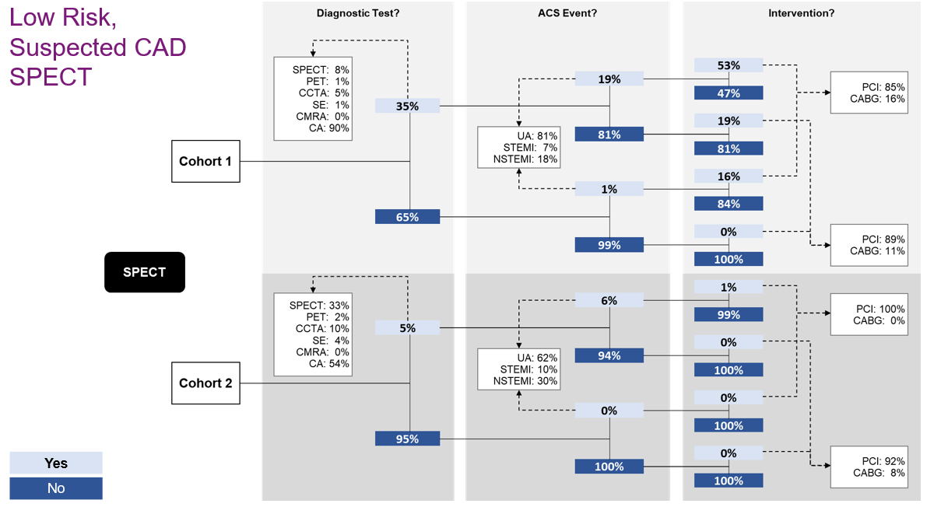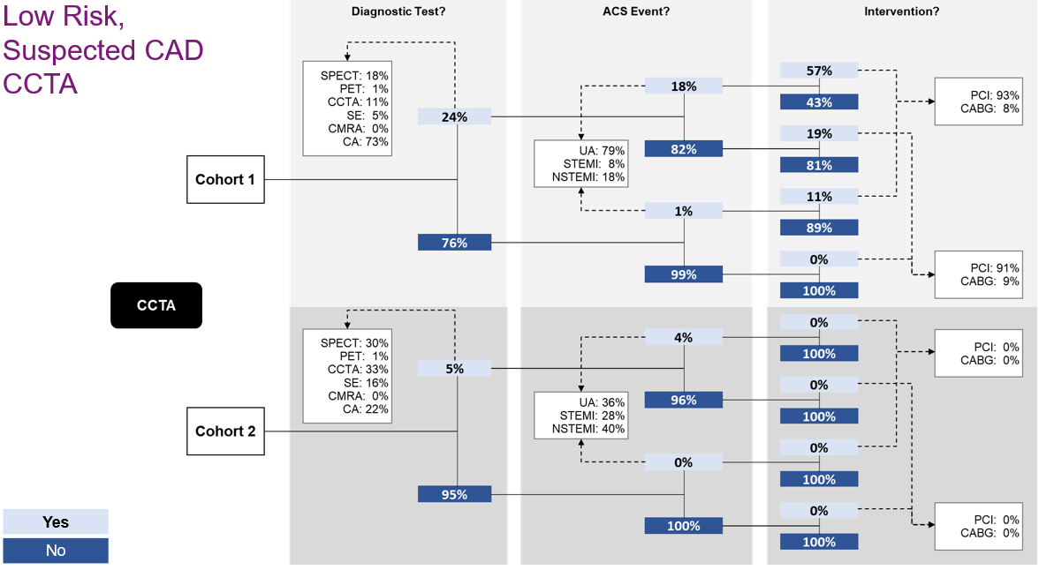
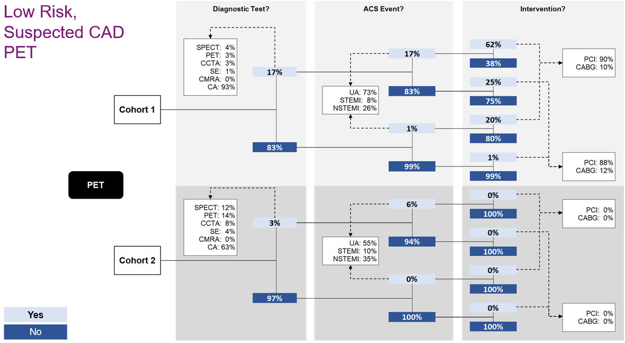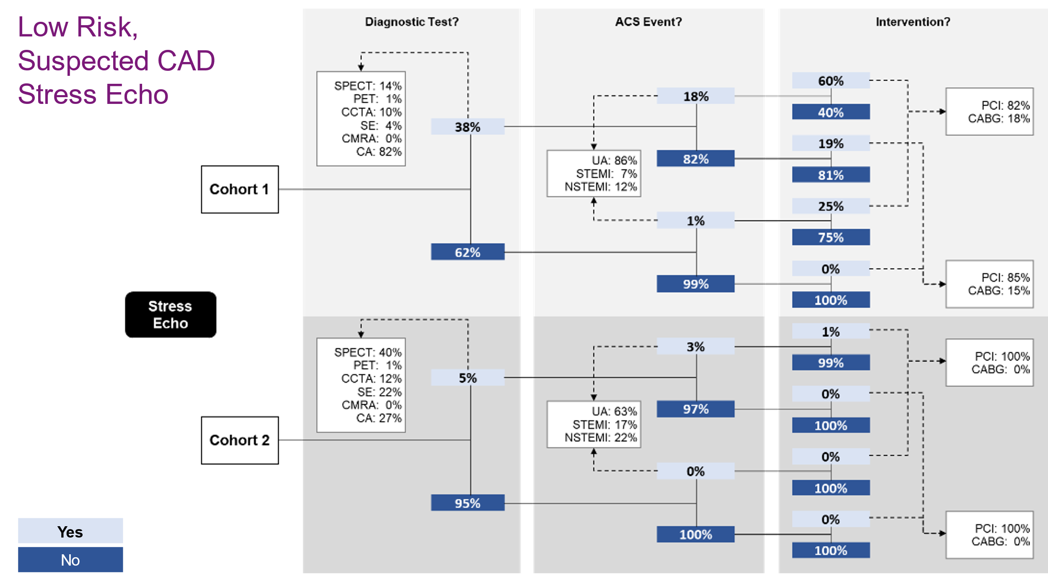
Abbreviations: ACS, acute coronary syndrome; CA, invasive coronary angiography; CABG, coronary artery bypass graft; CCTA, coronary computed tomography angiography; CMRA, coronary MR angiography; NSTEMI, non-ST-elevation myocardial infarction; PCI, percutaneous coronary intervention; PET, positron emission tomography; SE, stress echocardiography; SPECT, single-photon emission computed tomography; STEMI, ST-elevation myocardial infarction; UA, unstable angina.
Figure S 3: Patient pathways by cohort and index test (Cohorts 3 & 4)
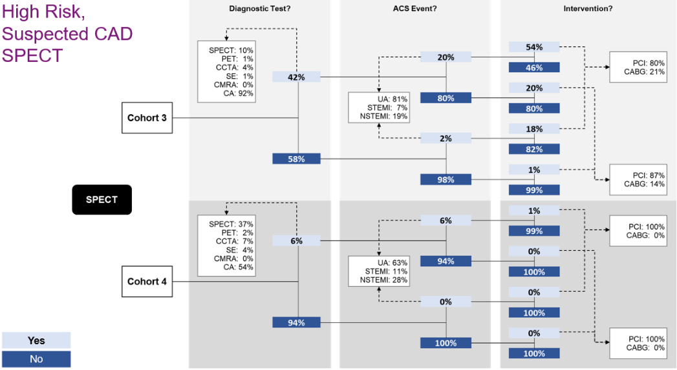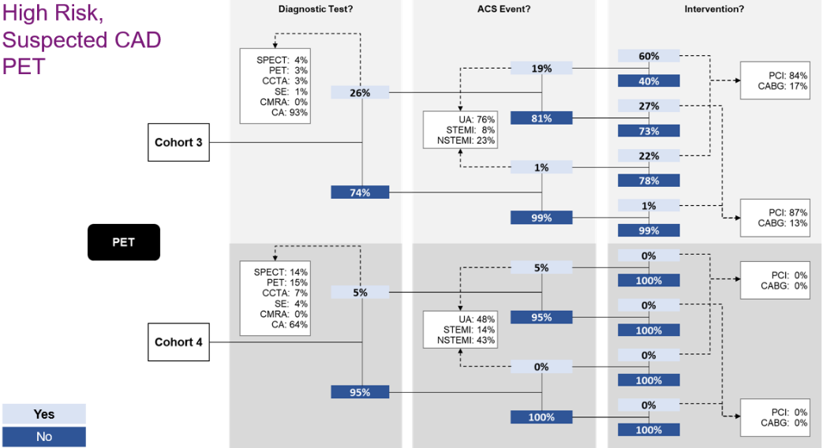
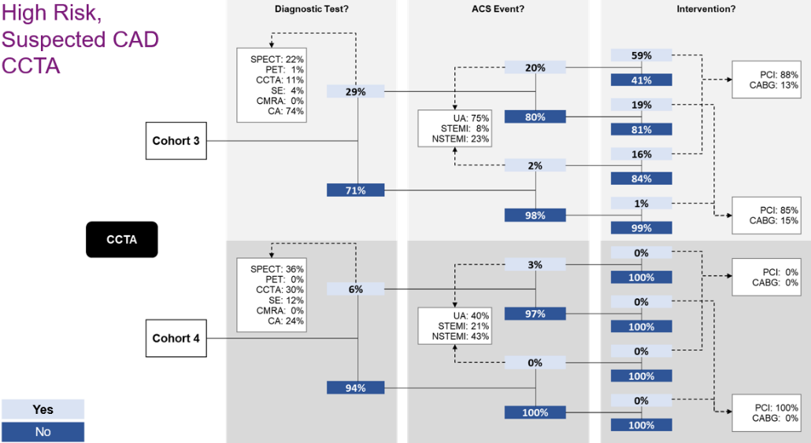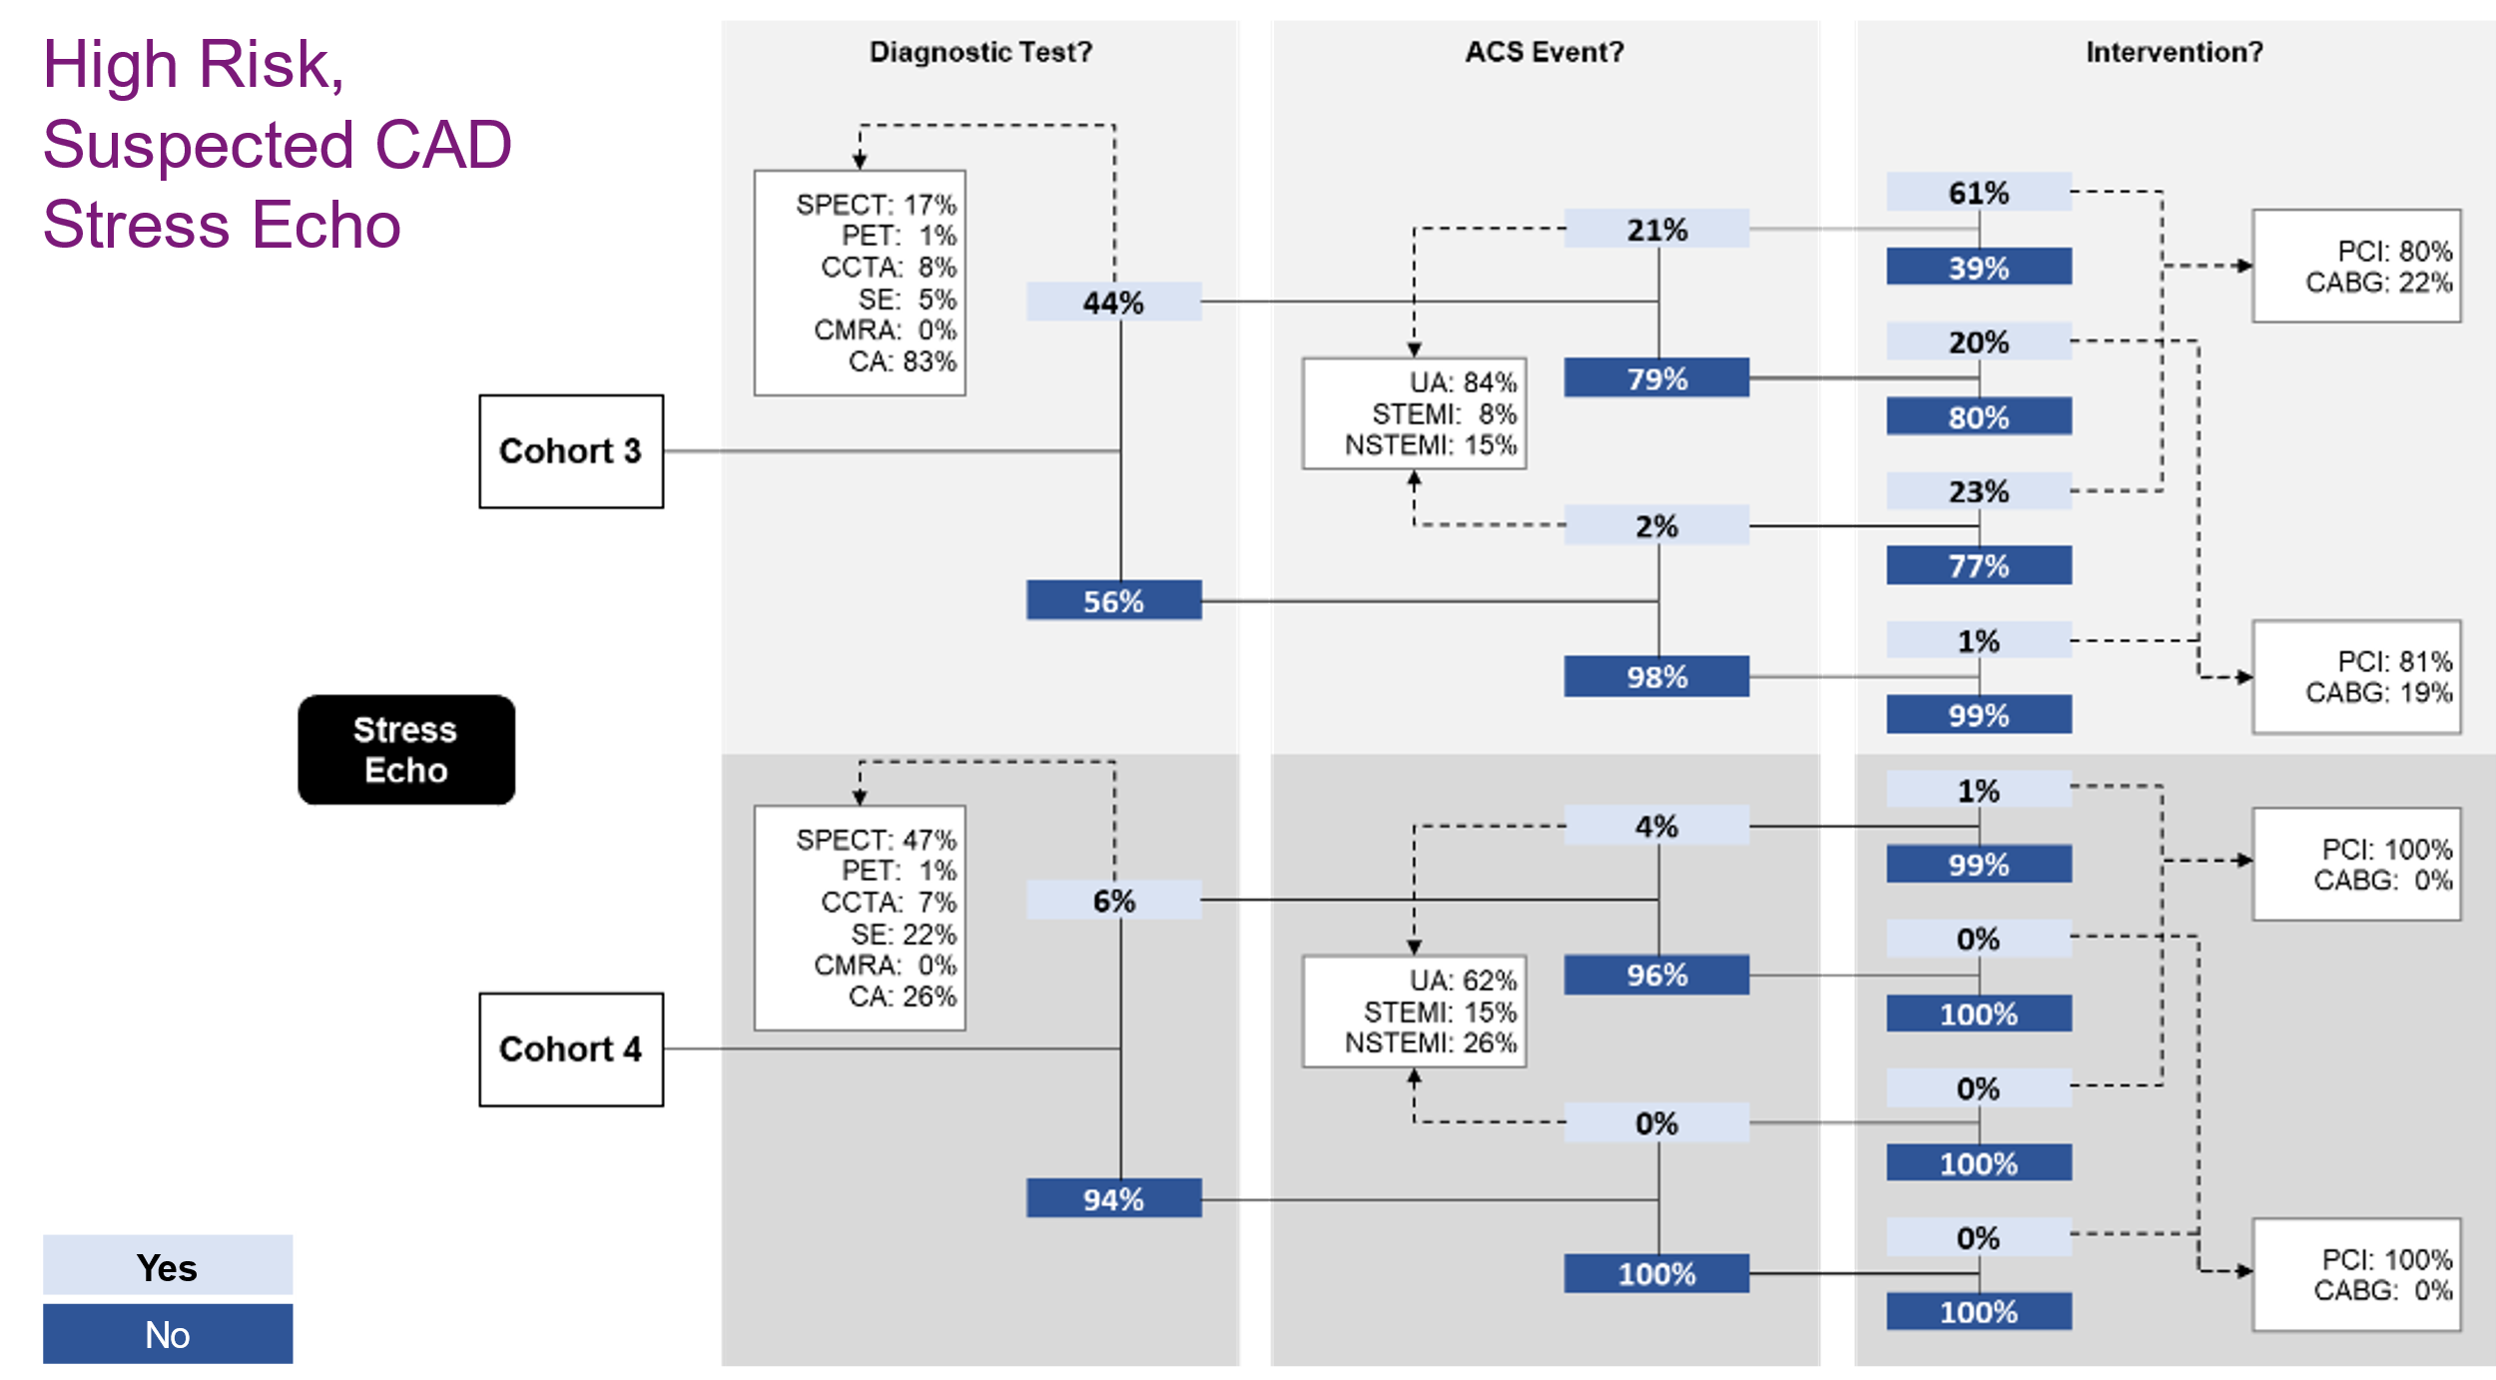
Abbreviations: ACS, acute coronary syndrome; CA, invasive coronary angiography; CABG, coronary artery bypass graft; CCTA, coronary computed tomography angiography; CMRA, coronary MR angiography; NSTEMI, non-ST-elevation myocardial infarction; PCI, percutaneous coronary intervention; PET, positron emission tomography; SE, stress echocardiography; SPECT, single-photon emission computed tomography; STEMI, ST-elevation myocardial infarction; UA, unstable angina.
Figure S 4: Patient pathways by cohort and index test (Cohort 5)
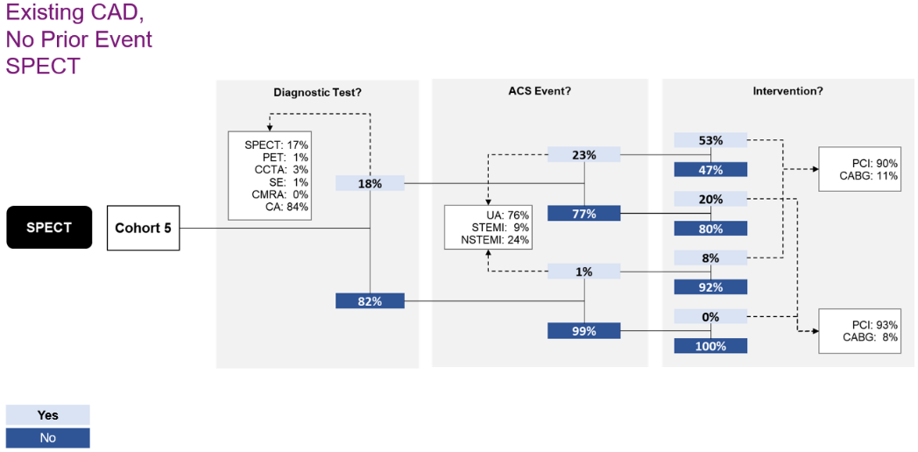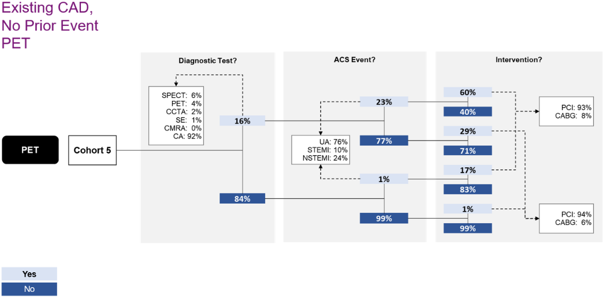
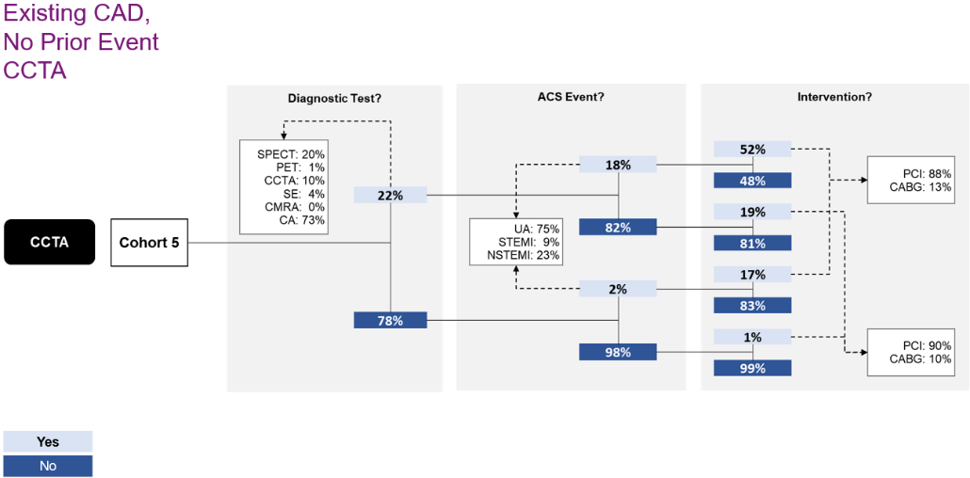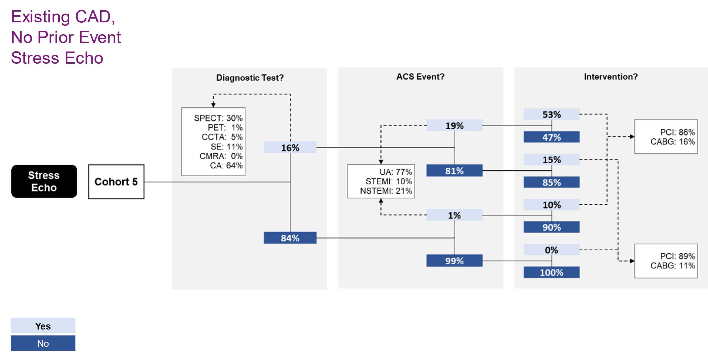
Abbreviations: ACS, acute coronary syndrome; CA, invasive coronary angiography; CABG, coronary artery bypass graft; CCTA, coronary computed tomography angiography; CMRA, coronary MR angiography; NSTEMI, non-ST-elevation myocardial infarction; PCI, percutaneous coronary intervention; PET, positron emission tomography; SE, stress echocardiography; SPECT, single-photon emission computed tomography; STEMI, ST-elevation myocardial infarction; UA, unstable angina.

Figure S 5: Patient pathways by cohort and index test (Cohorts 6 & 7)
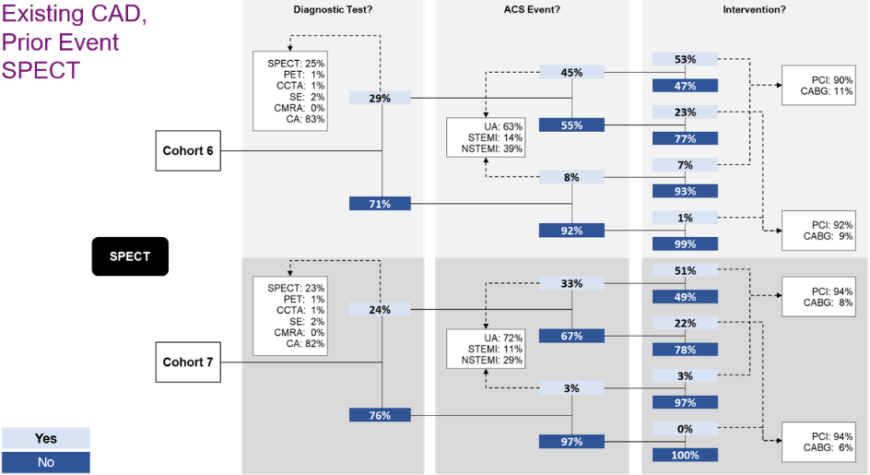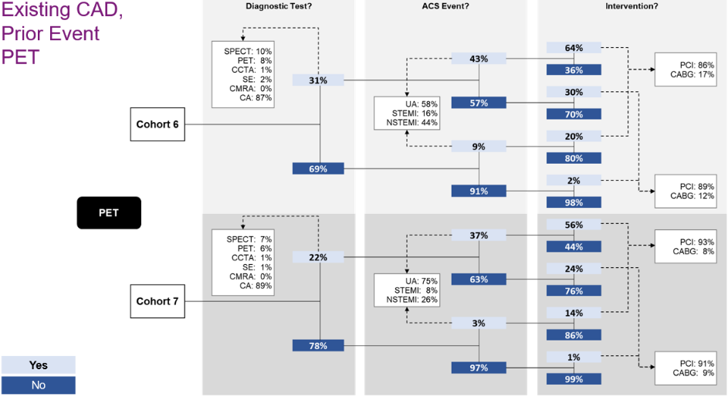
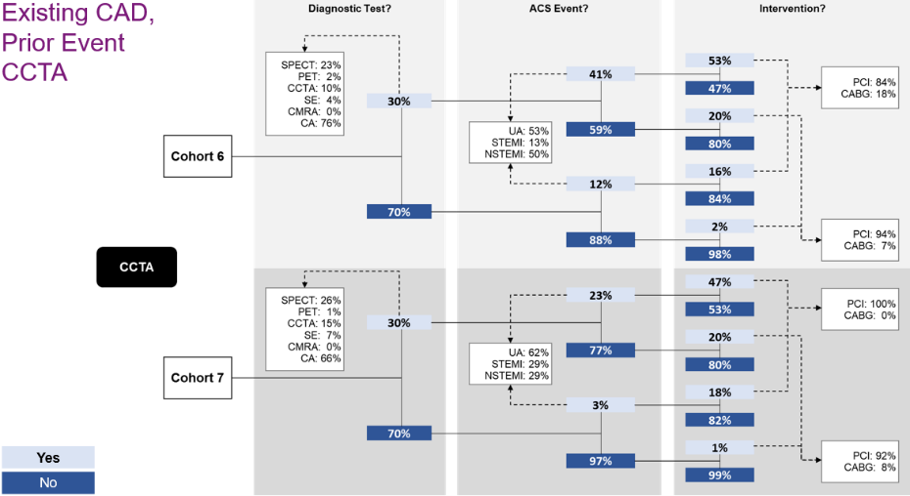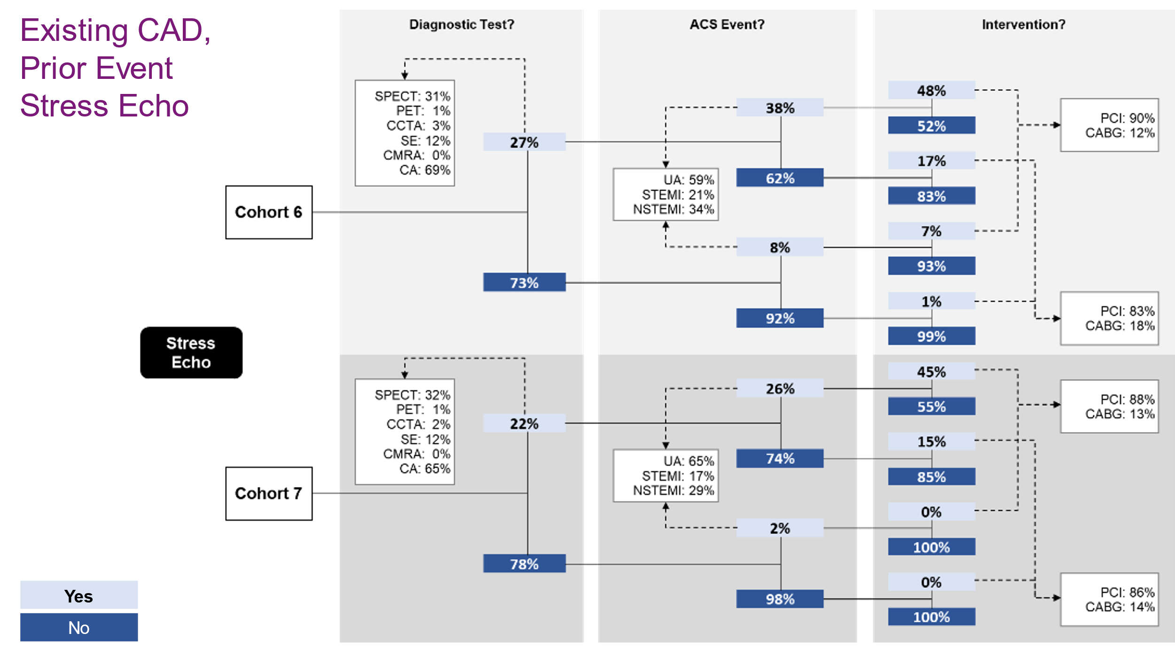
Abbreviations: ACS, acute coronary syndrome; CA, invasive coronary angiography; CABG, coronary artery bypass graft; CCTA, coronary computed tomography angiography; CMRA, coronary MR angiography; NSTEMI, non-ST-elevation myocardial infarction; PCI, percutaneous coronary intervention; PET, positron emission tomography; SE, stress echocardiography; SPECT, single-photon emission computed tomography; STEMI, ST-elevation myocardial infarction; UA, unstable angina.

Figure S 6: Patient pathways by cohort and index test (Cohorts 8 & 9)
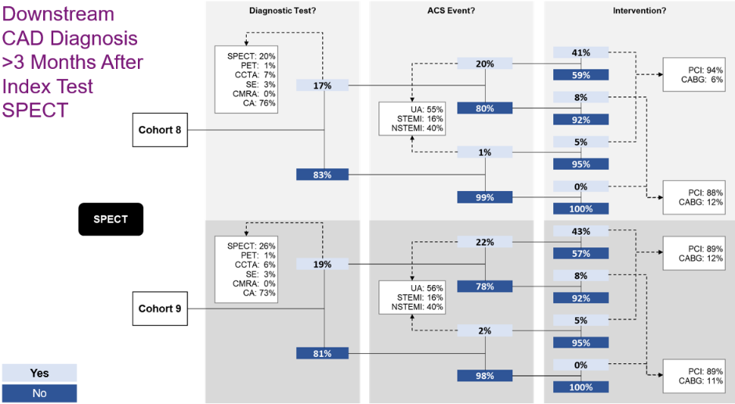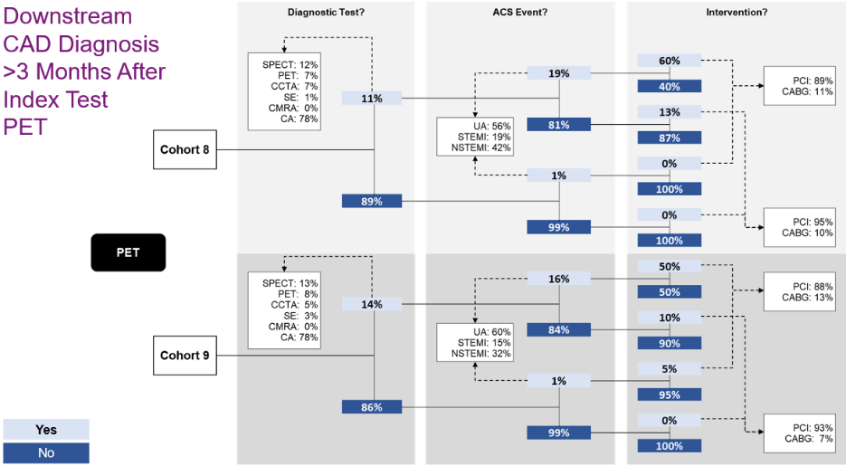
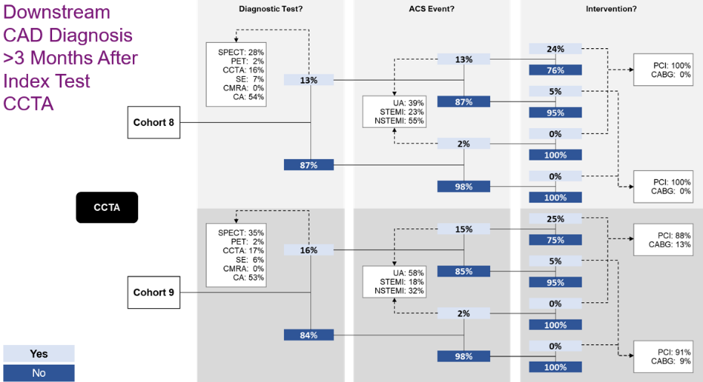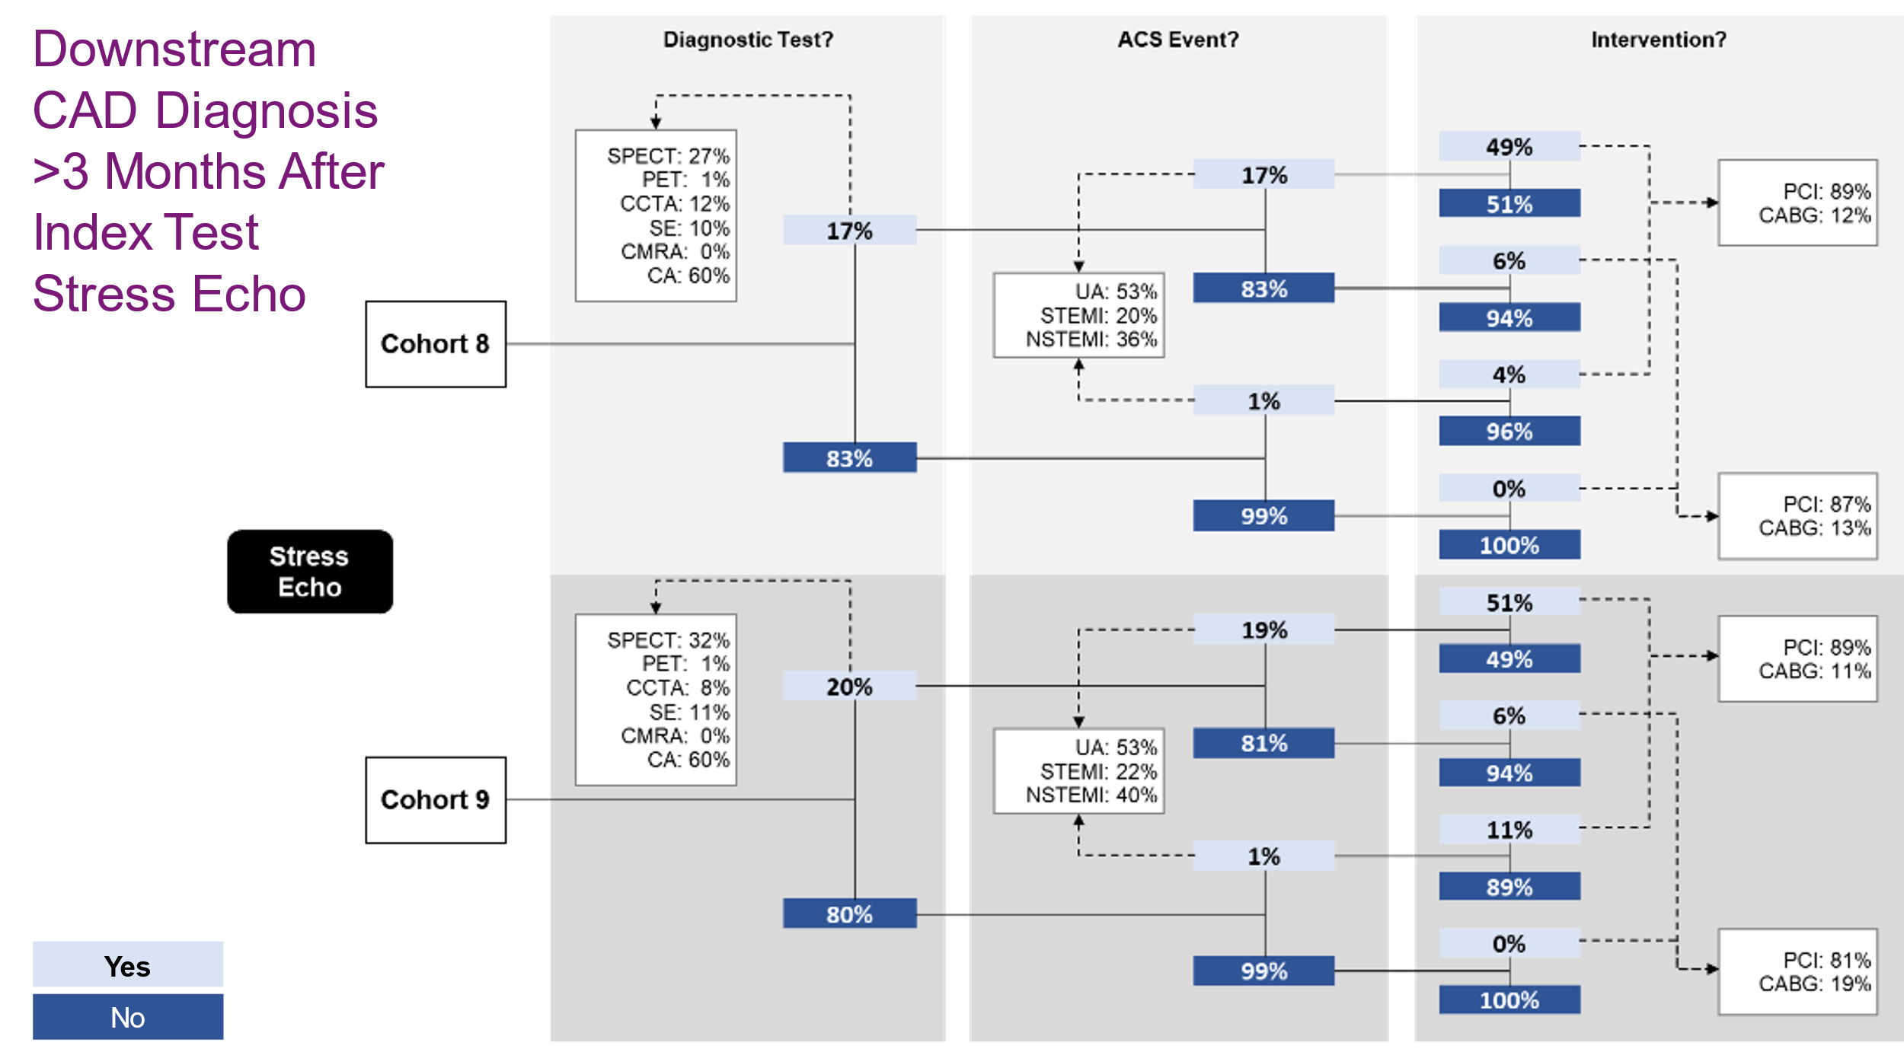
Abbreviations: ACS, acute coronary syndrome; CA, invasive coronary angiography; CABG, coronary artery bypass graft; CCTA, coronary computed tomography angiography; CMRA, coronary MR angiography; NSTEMI, non-ST-elevation myocardial infarction; PCI, percutaneous coronary intervention; PET, positron emission tomography; SE, stress echocardiography; SPECT, single-photon emission computed tomography; STEMI, ST-elevation myocardial infarction; UA, unstable angina.

Figure S 7: Proportions of patients with any downstream healthcare utilisation in those who underwent combinations of imaging tests
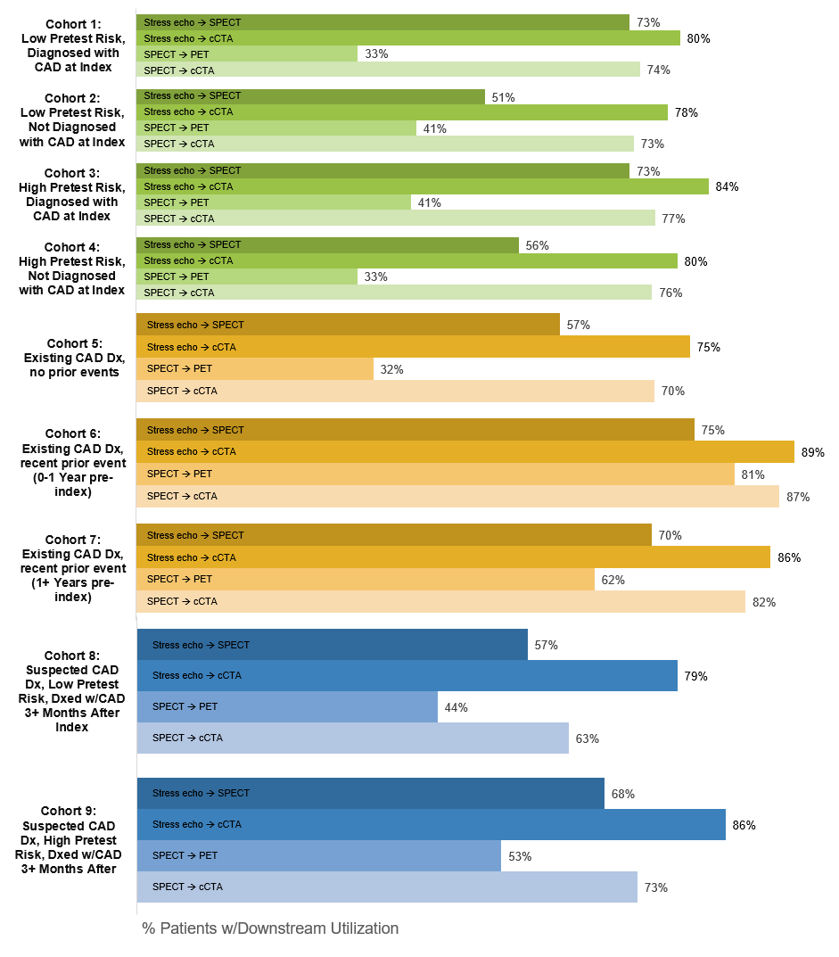
Abbreviations: CAD, coronary artery disease; cCTA, coronary computed tomography angiography; Dx, diagnosis; PET, positron emission tomography; SPECT, single-photon emission computed tomography.

