Table S1. Subgroup analysis of the association of MHR level and telomere length.
Subgroup | β (95% CI) | P | P for interaction
Overall | -0.020(-0.039, -0.002) | 0.037 | -
Sex |  |  | 0.624
Male | -0.016(-0.038,0.006) | 0.134
Female | -0.024(-0.050, 0.001) | 0.058
Age Strata |  |  | 0.729
<=47 | -0.018(-0.041,0.005) | 0.117
>47 | -0.012(-0.033,0.010) | 0.272
Race/Ethnicity |  |  | 0.657
Mexican American | -0.002(-0.033,0.029) | 0.884
Other Hispanic | -0.050(-0.122,0.023) | 0.117
Non-Hispanic White | -0.022(-0.045,0.002) | 0.066
Non-Hispanic Black | 0.007(-0.028,0.043) | 0.658
Other Race | -0.067(-0.134, -0.000) | 0.049
Poverty ratio |  |  | 0.938
≤1.30 | -0.017(-0.043,0.009) | 0.183
1.3–3.5 | -0.022(-0.051,0.006) | 0.114
>3.50 | -0.020(-0.054,0.014) | 0.222

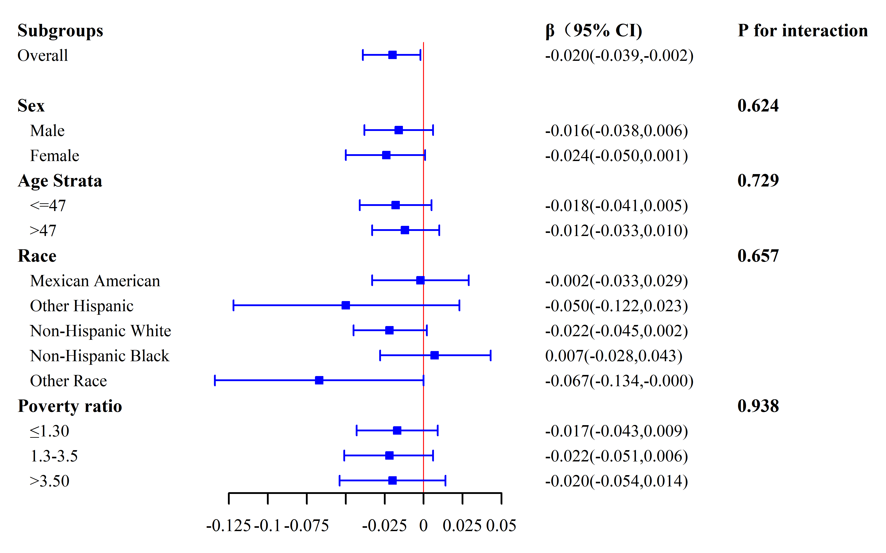
Figure 1S. Subgroup analysis of the association of MHR level and telomere length. Each stratification was adjusted for gender, age, race/ethnicity, household poverty ratio, education, BMI, total cholesterol, SII, creatinine, hypertension, diabetes, coronary heart disease, stroke, alcohol, and smoke. 95%CI, Confidence Interval. 95%CI, Confidence Interval.

