Supplementary material | Table of Contents

Supplementary Method. Search strategy in PubMed...............................................................1
Table S1. Search strategy in Embase..........................................................................................2
Table S2. Search strategy in Cochrane Library..........................................................................3
Table S3. Outcomes and their definitions...................................................................................4
Table S4. Potentially eligible studies excluded during the screening phase..............................5
Table S5. Information of included randomized controlled trials................................................6
Table S6. Cardiovascular Events outcome definitions in each trial...........................................7
Figure S1. Forest plots: Effects of aspirin on MACE when eGFR <60 mL/min per 1.73 m²...8
Figure S2. Forest plots: Effect of aspirin on CVE when eGFR <60 mL/min per 1.73 m²........9
Figure S3. Forest plots: Effect of aspirin on MI when eGFR <60 mL/min per 1.73 m²..........10
Figure S4. Sensitivity analysis of MI when eGFR <60 mL/min per 1.73 m² .........................11
Figure S5. Forest plots: Subgroup Analysis of MI: eGFR 45-59 mL/min per 1.73 m²...........12
Figure S6. Forest plots: Subgroup Analysis of MI: eGFR ＜45 mL/min per 1.73 m²...........13
Figure S7. Forest plots: Effects of aspirin on Stroke when eGFR<60mL/min per 1.73 m²....14
Figure S8. Forest plots: Effects of aspirin on all cause mortality when eGFR <60 mL/min per 1.73 m²......................................................................................................................................15
Figure S9. Forest plots: Effects of aspirin on cardiovascular mortality when eGFR <60 mL/min per 1.73 m²..................................................................................................................16
Figure S10. Forest plots: Subgroup Analysis of cardiovascular mortality: eGFR 45-59 mL/min per 1.73 m²..................................................................................................................17
Figure S11. Forest plots: Subgroup Analysis of cardiovascular mortality: eGFR <45 mL/min per 1.73 m²................................................................................................................................18
Figure S12. Forest plots: Effects of aspirin on minor bleeding when eGFR <60 mL/min per 1.73 m² per 1.73 m²...................................................................................................................19
Figure S13. Forest plots: Effects of aspirin on major bleeding when eGFR <60 mL/min per 1.73 m² per 1.73 m²...................................................................................................................20
Figure S14. Forest plots: Effects of aspirin on major bleeding in pooled HR results: eGFR <60 mL/min per 1.73 m² ..........................................................................................................21
Figure S15. Forest plots: Subgroup Analysis of major bleeding: eGFR <45 mL/min per 1.73 m² per 1.73 m²...........................................................................................................................22
Figure S16. Forest plots: Subgroup Analysis of major bleeding: eGFR 45-59 mL/min per 1.73 m² per 1.73 m²...................................................................................................................23
Figure S17. The assessment of risk of bias..............................................................................24

Supplementary Method. Search strategy in PubMed.
((((((((((((((((((((("Renal Insufficiency, Chronic"[Mesh]) OR (Renal Insufficiency, Chronic[Title/Abstract])) OR (Chronic Renal Insufficiencies[Title/Abstract])) OR (Renal Insufficiencies, Chronic[Title/Abstract])) OR (Chronic Renal Insufficiency[Title/Abstract])) OR (Kidney Insufficiency, Chronic[Title/Abstract])) OR (Chronic Kidney Insufficiency[Title/Abstract])) OR (Chronic Kidney Insufficiencies[Title/Abstract])) OR (Kidney Insufficiencies, Chronic[Title/Abstract])) OR (Chronic Kidney Diseases[Title/Abstract])) OR (Chronic Kidney Disease[Title/Abstract])) OR (Disease, Chronic Kidney[Title/Abstract])) OR (Diseases, Chronic Kidney[Title/Abstract])) OR (Kidney Disease, Chronic[Title/Abstract])) OR (Kidney Diseases, Chronic[Title/Abstract])) OR (Chronic Renal Diseases[Title/Abstract])) OR (Chronic Renal Disease[Title/Abstract])) OR (Disease, Chronic Renal[Title/Abstract])) OR (Diseases, Chronic Renal[Title/Abstract])) OR (Renal Disease, Chronic[Title/Abstract])) OR (Renal Diseases, Chronic[Title/Abstract])) AND ((((((((((((((((((("Aspirin"[Mesh]) OR (Acetylsalicylic Acid[Title/Abstract])) OR (Acetylsalicylic Acid[Title/Abstract])) OR (Acid, Acetylsalicylic[Title/Abstract])) OR (2-(Acetyloxy)benzoic Acid[Title/Abstract])) OR (Acylpyrin[Title/Abstract])) OR (Colfarit[Title/Abstract])) OR (Easprin[Title/Abstract])) OR (Ecotrin[Title/Abstract])) OR (Endosprin[Title/Abstract])) OR (Magnecyl[Title/Abstract])) OR (Micristin[Title/Abstract])) OR (Polopirin[Title/Abstract])) OR (Polopiryna[Title/Abstract])) OR (Solprin[Title/Abstract])) OR (Solupsan[Title/Abstract])) OR (Zorprin[Title/Abstract])) OR (Acetysal[Title/Abstract]))) AND (((((((((((("Cardiovascular Diseases"[Mesh]) OR (Cardiovascular Disease[Title/Abstract])) OR (Cardiovascular Diseases[Title/Abstract])) OR (Disease, Cardiovascular[Title/Abstract])) OR (Major Adverse Cardiac Events[Title/Abstract])) OR (Cardiac Events[Title/Abstract])) OR (Cardiac Event[Title/Abstract])) OR (Event, Cardiac[Title/Abstract])) OR (Adverse Cardiac Event[Title/Abstract])) OR (Adverse Cardiac Events[Title/Abstract])) OR (Cardiac Event, Adverse[Title/Abstract])) OR (Cardiac Events, Advers[Title/Abstract]))

Table S1.Search strategy in Embase.
No. | Query Results | Results
#4. | #1 AND #2 AND #3 | 235
#3. | cardiovascular diseases:ab,ti OR 'cardiovascular disease':ab,ti OR 'disease, cardiovascular':ab,ti OR 'major adverse cardiac events':ab,ti OR 'cardiac events':ab,ti OR 'cardiac event':ab,ti OR 'event, cardiac':ab,ti OR 'adverse cardiac event':ab,ti OR 'adverse cardiac events':ab,ti OR 'cardiac event, adverse':ab,ti OR 'cardiac events, advers':ab,ti | 451,877
#2. | aspirin:ab,ti OR 'acetylsalicylic acid':ab,ti OR 'acid, acetylsalicylic':ab,ti OR acylpyrin:ab,ti OR aloxiprimum:ab,ti OR colfarit:ab,ti OR dispril:ab,ti OR easprin:ab,ti OR ecotrin:ab,ti OR endosprin:ab,ti OR magnecyl:ab,ti OR micristin:ab,ti OR polopirin:ab,ti OR polopiryna:ab,ti OR solprin:ab,ti OR solupsan:ab,ti OR zorprin:ab,ti OR acetysal:ab,ti | 99,292
#1. | 'renal insufficiency, chronic':ab,ti OR 'chronic renal insufficiencies':ab,ti OR 'renal insufficiencies, chronic':ab,ti OR 'chronic renal insufficiency':ab,ti OR 'kidney insufficiency, chronic':ab,ti OR 'chronic kidney insufficiency':ab,ti OR 'chronic kidney insufficiencies':ab,ti OR 'kidney insufficiencies, chronic':ab,ti OR 'chronic kidney diseases':ab,ti OR 'chronic kidney disease':ab,ti OR 'disease, chronic kidney':ab,ti OR 'diseases, chronic kidney':ab,ti OR 'kidney disease, chronic':ab,ti OR 'kidney diseases, chronic':ab,ti OR 'chronic renal diseases':ab,ti OR 'chronic renal disease':ab,ti OR 'disease, chronic renal':ab,ti OR 'diseases,chronic renal':ab,ti OR 'renal disease, chronic':ab,ti OR 'renal diseases,chronic':ab,ti | 131,881

Table S2.Search strategy in Cochrane Library.
No. | Query Results | Results
#1. | MeSH descriptor [Renal insufficiency, Chronic] explode all trees | 8679
#2. | (Renal Insufficiency, Chronic or Chronic Renal Insufficiencies or Renal Insufficiencies, Chronic or Chronic Renal Insufficiency or Kidney Insufficiency, Chronic or Chronic Kidney Insufficiency or Chronic Kidney Insufficiencies or Kidney Insufficiencies, Chronic or Chronic Kidney Diseases or Chronic Kidney Disease or Disease, Chronic Kidney or Diseases, Chronic Kidney or Kidney Disease, Chronic or Kidney Diseases, Chronic or Chronic Renal Diseases or Chronic Renal Disease or Disease, Chronic Renal or Diseases, Chronic Renal or Renal Disease, Chronic or Renal Diseases, Chronic):ti,ab,kw | 19662
#3. | #1 or #2 | 21744
#4. | MeSH descriptor [Aspirin] explode all trees | 7115
#5. | (Acid, Acetylsalicylic or aspirin or Acetylsalicylic Acid or Acylpyrin or Aloxiprimum or Colfarit or Dispril or Easprin or Ecotrin or Endosprin or Magnecyl or Micristin or Polopirin or Polopiryna or Solprin or Solupsan or Zorprin or Acetysal):ti,ab,kw | 18346
#6. | #4 or #5 | 18346
#7. | MeSH descriptor [Cardiovascular Disease] explode all trees | 152489
#8. | (Cardiovascular Disease or cardiovascular disease or Disease, Cardiovascular or Major Adverse or Cardiac Events or Cardiac Events or Cardiac Event or Event, Cardiac or Adverse Cardiac Event or Adverse Cardiac Events or Cardiac Event, Adverse or Cardiac Events, Advers):ti,ab,kw | 160674
#9. | #7 or #8 | 152496
#10. | #3 and #6 and #9 | 247

Table S3. Outcomes and their definitions.
Outcomes | Definitions
Major Adverse Cardiovascular Events (MACE) | A composite of cardiovascular mortality, nonfatal myocardial infarction, and nonfatal stroke.
Cardiovascular Events (CVE) | The definitions of cardiovascular events in each trial are shown in Supplementary Table S6.
Myocardial Infarction (MI) | Including fatal and nonfatal myocardial infarction.
Stroke | Including fatal, nonfatal hemorrhagic, and ischemic stroke.
Cardiovascular Mortality  (CV Mortality) | Death due to cardiovascular disease, including fatal stroke, fatal myocardial infarction, fatal congestive heart failure, sudden death, or death from other cardiovascular diseases.
All-cause Mortality | Death from all causes, including cardiovascular death.
Major Bleeding | HOT: Investigator reported: fatal, life-threatening, disabling or requiring hospital admission.  JPAD: Bleeding events related to hospitalization or death.  AASER: Intracranial bleeding and bleeding associated with a haemoglobin drop of 5 g/dL or greater. Used the Global Use of Strategies to Open Coronary Arteries (GUSTO) classification.  ASPREE: Haemorrhagic stroke, symptomatic intracranial bleeding, or extracranial clinically significant bleeding (defined as bleeding requiring transfusion, hospitalization, prolonging hospitalization, or surgery or causing death. These were adjudicated by experts who were blinded to treatment).  TIPS: *Major Bleeding based on the International Society on Thrombosis and Haemostasis (ISTH) criteria, defined as: 1) fatal bleeding; 2) bleeding in a critical site or area (retroperitoneal, cardiac tamponade, hemoptysis, intraocular, intracranial, definite hemorrhagic stroke or subarachnoid hemorrhage), or 3) bleeding causing a fall in hemoglobin level of 20 g/L or more or leading to transfusion of 2 or more units of blood.
Minor Bleeding | HOT: All other reported bleeding events.  JPAD: other reported bleeding events.  AASER: Minor bleeding included spontaneous hematuria, hematemesis, and mild hemoglobin decreases less than 5 g/dl.

Table S4. Potentially eligible studies excluded during the screening phase.
Title | First author | Year | Reason for exclusion
First United Kingdom Heart and Renal Protection (UK-HARP-I) Study: Biochemical Efficacy and Safety of Simvastatin and Safety of Low-DoseAspirin in Chronic Kidney Disease | Colin Baigent | 2005 | Short follow-up time; contains kidney transplant patients
Aspirin for Primary and Secondary Prevention of Mortality, Cardiovascular Disease, and Kidney Failure in the Chronic Renal Insufficiency Cohort (CRIC) Study | Jonathan J Taliercio | 2022 | Prospective observational cohort study, not an RCT
Guideline-Directed Medical Therapy Attainment and Outcomes in Dialysis-Requiring Versus Nondialysis Chronic Kidney Disease in the ISCHEMIA-CKD Trial | Roy O Mathew | 2022 | Secondary prevention
ANTIPLATELET THERAPY FOR PRIMARY PREVENTION OF CARDIOVASCULAR DISEASE IN CHRONIC KIDNEY DISEASE AND TYPE 2 DIABETES | Yi-Cheng Lin | 2022 | Retrospective population-based cohort study, not an RCT
Effect of aspirin on primary prevention of cardiovascular disease and mortality among patients with chronic kidney disease | Hadar Haim-Pinhas | 2022 | Retrospective study, not an RCT
Low-dose aspirin was associated with an increased risk of cardiovascular events in patients with chronic kidney disease patients and low bodyweight: results from KNOW-CKD study | Yun Jung Oh | 2021 | Prospective observational cohort study, not an RCT
Association between aspirin use and cardiovascular outcomes in ALLHAT participants with and without chronic kidney disease: A post hoc analysis | Niraj Desai | 2020 | Post hoc analysis, not an RCT
The Use of Aspirin to Reduce the Risk of Thrombotic Events in Patients With End-Stage Renal Disease: Protocol for a Randomized Controlled Trial | Tiago Lemos Cerqueira | 2018 | A protocol, the results haven't been reported yet
Different impact of aspirin on renal progression in patients with predialysis advanced chronic kidney disease with or without previous stroke | Kuang-Chih Hsiao | 2017 | Prospective observational cohort study, not an RCT
Antiplatelet effects of aspirin in chronic kidney disease patients | A Polzin | 2016 | Cross-sectional study, not an RCT
Low-dose aspirin for prevention of cardiovascular disease in patients on hemodialysis: A 5-y prospective cohort study | Jun Liu | 2016 | Prospective cohort study, not an RCT
Title | Abbreviation | First author | Year | Registration | Funding | Conflict of Interest
Aspirin Is Beneficial in Hypertensive Patients  With Chronic Kidney Disease | HOT | Meg J. Jardine | 2010 | Unclear | Yes | Unclear
Low-Dose Aspirin Therapy in Patients With Type 2 Diabetes and Reduced Glomerular Filtration Rate | JPAD | YOSHIHIKO SAITO | 2011 | NCT  00110448 | Yes | Unclear
Aspirin for Primary Prevention of Cardiovascular Disease and Renal Disease Progression in Chronic Kidney Disease Patients: a Multicenter Randomized Clinical Trial (AASER Study) | AASER | Marian Goicoechea | 2018 | NCT  01709994 | Yes | None
Subgroup analysis of the ASPirin in Reducing Events in the Elderly randomized clinical  trial suggests aspirin did not improve outcomes in older adults with chronic kidney disease | ASPREE | Rory Wolfe | 2020 | NCT  01038583 | Yes | None
Effects of aspirin on cardiovascular outcomes in patients with chronic kidney disease | TIPS-3 | Johannes F.E. Mann | 2023 | NCT  01646437 | Yes | Yes
Table S5. Information of included randomized controlled trials.

Table S6. Cardiovascular Events outcome definitions in each trial.
Trial | Cardiovascular Events (CVE) outcome definitions in each trial
HOT  2010 | A composite of major cardiovascular events consisting of myocardial infarction, stroke, and death due to cardiovascular disease.
JPAD  2011 | The primary endpoint was any atherosclerotic event, which was a composite of sudden death: death from coronary, cerebrovascular, and aortic causes; nonfatal acute myocardial infarction; unstable angina; newly developed exertional angina; nonfatal ischemic and hemorrhagic stroke; transient ischemic attack; or nonfatal aortic and peripheral vascular disease (arteriosclerosis obliterans, aortic dissection, and mesenteric arterial thrombosis) during the follow-up period.
AASER  2018 | A composite of cardiovascular death, acute coronary syndrome (nonfatal MI, coronary revascularization, or unstable angina pectoris), cerebrovascular disease, heart failure, or nonfatal peripheral arterial disease (PAD).
ASPREE  2020 | A composite of death due to coronary heart disease, nonfatal myocardial infarction, and fatal and nonfatal ischemic stroke, but not including deaths from heart failure. Fatal coronary heart disease included fatal myocardial infarction, sudden cardiac death, and other deaths in which the underlying cause was considered to be coronary heart disease.
TIPS-3  2023 | A composite of CV death, nonfatal myocardial infarction (MI), or nonfatal stroke.

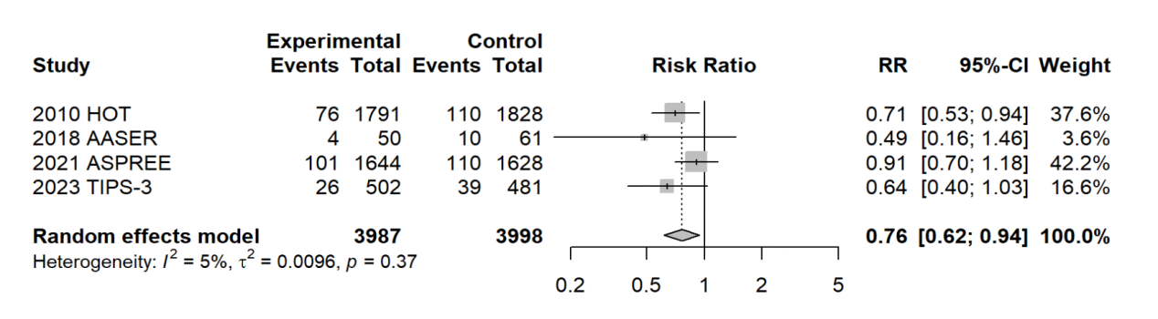
Figure S1. Forest plots: Effects of aspirin on MACE when eGFR<60mL/min per 1.73 m² (P = .0115) .

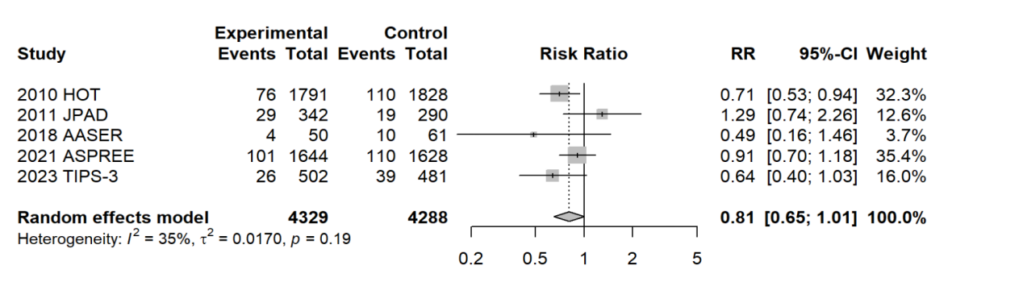
Figure S2. Forest plots: Effect of aspirin on CVE when eGFR <60 mL/min per 1.73 m² (P = .0558).

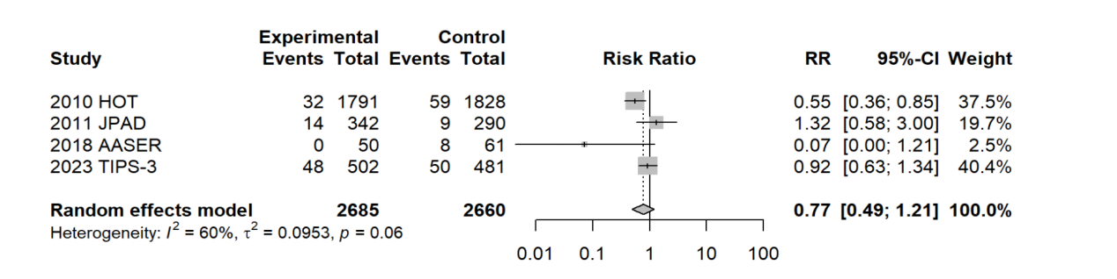
Figure S3. Forest plots: Effect of aspirin on MI when eGFR <60 mL/min per 1.73 m² (P = .2503).

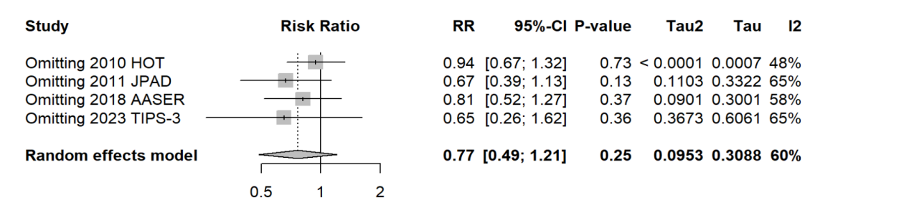
Figure S4. Sensitivity analysis of MI when eGFR <60 mL/min per 1.73 m².

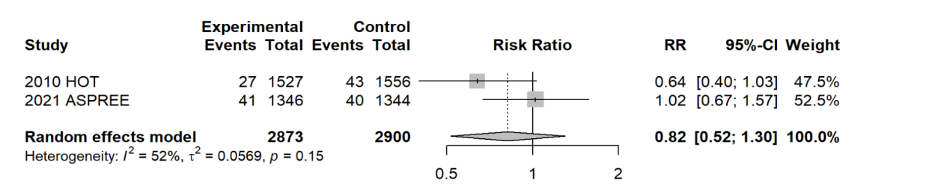
Figure S5. Forest plots: Subgroup Analysis of MI: eGFR 45-59 mL/min per 1.73 m² (P = .3942).

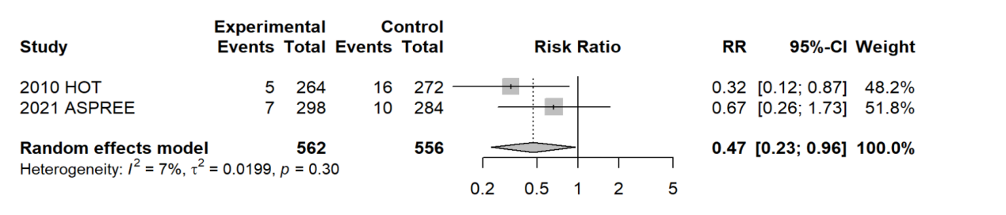

Figure S6. Forest plots: Subgroup Analysis of MI: eGFR ＜45 mL/min per 1.73 m² (P=.0378).

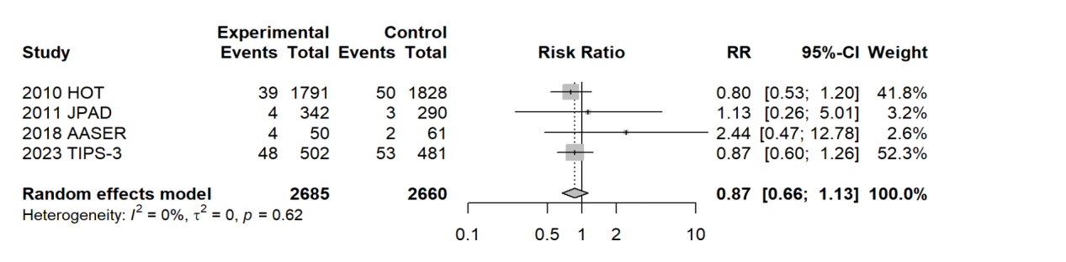
Figure S7. Forest plots: Effects of aspirin on Stroke when eGFR<60mL/min per 1.73 m² (P = .2971).

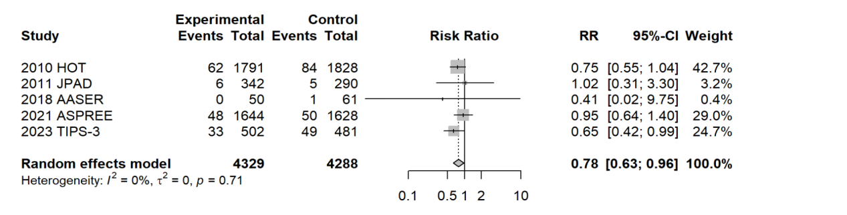
Figure S8. Forest plots: Effects of aspirin on all-cause mortality when eGFR < 60mL/min per 1.73 m² (P = .0213).

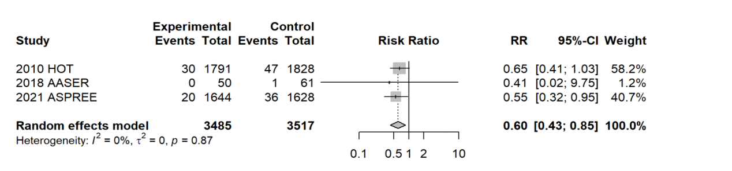Figure S9. Forest plots: Effects of aspirin on cardiovascular mortality when eGFR < 60mL/min per 1.73 m² (P=.0044).

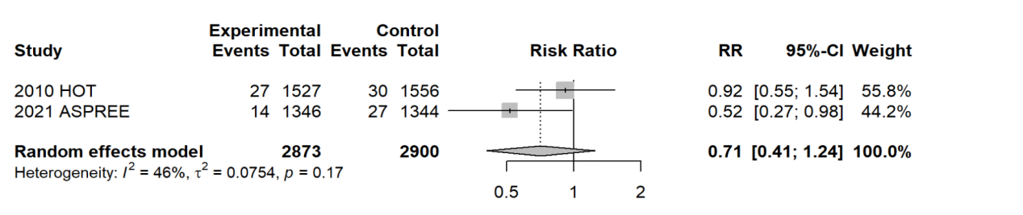
Figure S10. Forest plots: Subgroup Analysis of cardiovascular mortality: eGFR 45-59 mL/min per 1.73 m² (P = .2321).

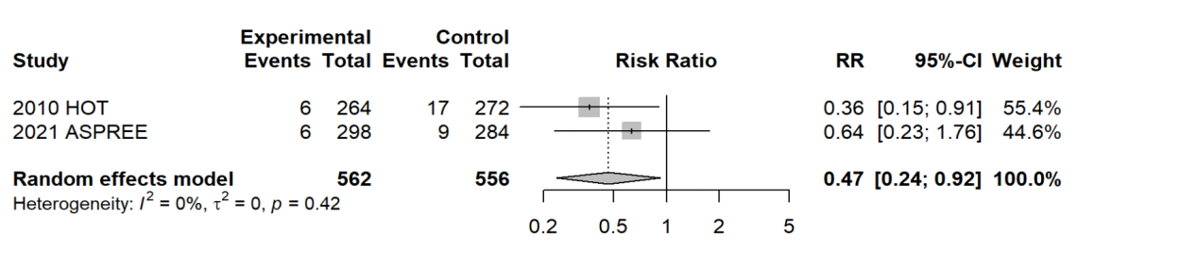
Figure S11. Forest plots: Subgroup Analysis of cardiovascular mortality: eGFR ＜45 mL/min per 1.73 m² (P = .0282).

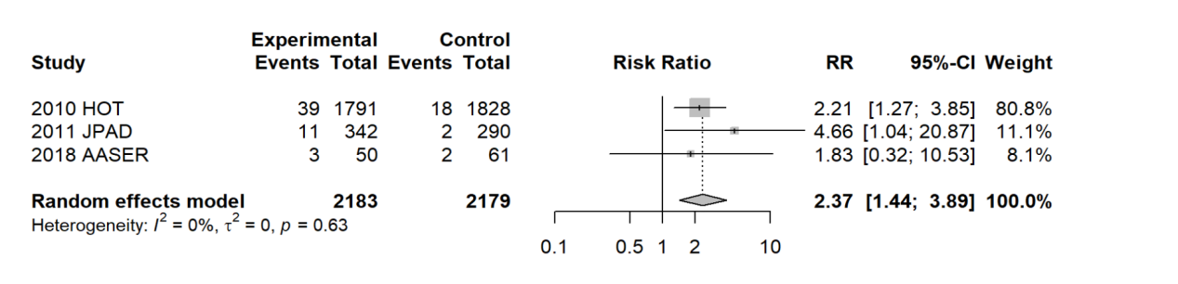
Figure S12. Forest plots: Effects of aspirin on minor bleeding when eGFR <60 mL/min per 1.73 m² (P = .0007).

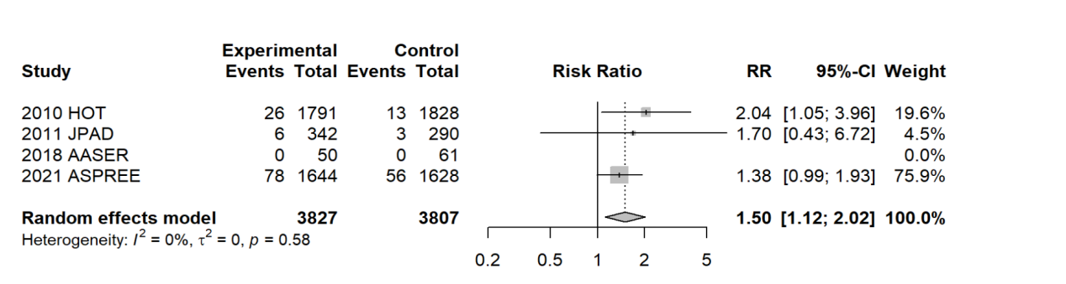Figure S13. Forest plots: Effects of aspirin on major bleeding when eGFR <60 mL/min per 1.73 m² (P = .0064).

Figure S14. Forest plots: Effects of aspirin on major bleeding in pooled HR results: eGFR <60 mL/min per 1.73 m² (P = .0100).

Figure S15. Forest plots: Subgroup Analysis of major bleeding: eGFR <45 mL/min per 1.73 m² (P = .0338).

Figure S16. Forest plots: Subgroup Analysis of major bleeding: eGFR 45-59 mL/min per 1.73 m² (P = .0780).

Figure S17. The assessment of risk of bias.

