Supplementary Material
Body Composition in Metabolically unhealthy normal weight patient With Aortic Stenosis: a prospective cohort study

Supplementary S1 The TAVR procedures, patient recruitment, and the definition of metabolic syndrome in the Study
TAVR procedures:
In this study, a standardized procedural workflow was implemented across all participating centers, with comprehensive training provided to mitigate outcome variations due to center and operator disparities. Every subject underwent a preoperative MDCT examination to measure the valve annulus size, determine the size of the pre-dilation balloon, fluoroscopy angle, valve release angle, and select the femoral artery route for surgery. The details of the TAVR procedure were determined through multidisciplinary Heart Team discussions. The valve type and size were selected based on balloon sizing, annular size, and aortic root features. The primary valves used were VenusA-Valve (Venus Medtech, Hangzhou, China), VitaFlow (Microport, Shanghai, China), Taurus One-Valve (Peijia Medical, Suzhou, China), and CoreValve (Medtronic, Minneapolis, Minnesota). TAVR procedures were performed in a hybrid operating room. Unfractionated heparin (50 to 70 U/kg) was administered to maintain an activated clotting time >250 s. Anesthesia (general or local with sedation) was chosen based on the anesthetist's evaluation.

The patient recruitment
Here are the details of our power calculation: Power Calculation: Primary Outcome: The primary outcome of our study was the occurrence of major adverse cardiac events (MACE) post-TAVR. Effect Size: Based on previous literature and preliminary data, we estimated an effect size (Hazard Ratio) of 1.5 for the association between visceral adipose tissue (VAT) index and MACE. Alpha Level: We set the alpha level (type I error rate) at 0.05 for two-sided tests. Power: We aimed for a statistical power of 80% to detect the specified effect size. Event Rate: We estimated an event rate of 20% for MACE in our study population based on prior studies. Using these parameters, we calculated the required sample size using standard statistical software. The power analysis indicated that a sample size of approximately 150 patients would be sufficient to achieve 80% power to detect a Hazard Ratio of 1.5 with an alpha level of 0.05. Given our final study cohort of 175 patients, we believe our study is adequately powered to detect significant associations. Results of Power Calculation: Estimated Sample Size Required: 150 patients. Actual Sample Size: 175 patients. Statistical Power Achieved: 80%. We will include this power calculation in the methods section of the revised manuscript to provide transparency and to ensure that readers understand the basis for our sample size determination. Thank you once again for your valuable feedback. We hope our revisions will satisfactorily address your concerns.

The metabolic risk factors include:
(1) Fasting Serum Glucose: A level of ≥110 mg/dL or the current use of blood glucose-lowering agents.
(2) Blood Pressure: A measurement of ≥130/85 mm Hg or the current use of antihypertensive drugs.
(3) Triglyceride Levels: Levels of ≥150 mg/dL or the current use of lipid-lowering drugs. High-Density Lipoprotein (HDL) Cholesterol: Levels of <40 mg/dL in men or <50 mg/dL in women, or the current use of lipid-lowering drugs.

Supplementary T2 Logistic regression analyses for second endpoint in the MUHNW group
 | Univariable logistic regression analyses for second endpoint |  | Multivariable logistic regression analyses for second endpoint
 | HR (95CI%) | P-value | HR (95CI%) | P-value
EAT | 0.98 (0.93 ~ 1.03) | 0.376
SMind | 0.67 (0.52 ~ 0.87) | 0.003 | 0.59 (0.42 ~ 0.84) | 0.004
SATind | 0.93 (0.83 ~ 1.04) | 0.203
VATind | 1.09 (0.98 ~ 1.22) | 0.114
METS‐IR | 1.10 (0.98 ~ 1.22) | 0.104
MetS Z-score | 1.31 (0.52 ~ 3.32) | 0.565
TyG index | 0.26 (0.06 ~ 1.10) | 0.068
Age | 0.99 (0.92 ~ 1.06) | 0.797
Male | 0.57 (0.20 ~ 1.59) | 0.281
Weight | 1.09 (1.01 ~ 1.17) | 0.026 | 1.22 (1.08 ~ 1.37) | 0.001
Height | 0.98 (0.92 ~ 1.06) | 0.654
BMI | 0.71 (0.51 ~ 0.98) | 0.04 | 0.71 (0.45 ~ 1.10) | 0.127
BSA | 4.72 (0.14 ~ 161.16) | 0.389
CAD | 0.76 (0.31 ~ 1.73) | 0.71
Smoker | 0.98 (0.31 ~ 3.12) | 0.972
Hypertension | 2.23 (0.81 ~ 6.12) | 0.121
Diabetes | 0.98 (0.28 ~ 3.45) | 0.976
NYHA Class | 1.04 (0.09 ~ 11.47) | 0.973
Grip, kg | 1.00 (0.93 ~ 1.07) | 0.983
STS score | 0.90 (0.72 ~ 1.12) | 0.337
TB, μmol/L | 0.93 (0.86 ~ 0.99) | 0.047 | 0.84 (0.75 ~ 0.94) | 0.002
TP, g/L | 0.92 (0.53 ~ 1.57) | 0.751
TC, mmol/L | 1.00 (0.95 ~ 1.06) | 0.972
TG, mmol/L | 1.25 (0.58 ~ 2.69) | 0.561
HDL-C, mmol/L | 0.41 (0.10 ~ 1.71) | 0.223
LDL-C, mmol/L | 1.23 (0.51 ~ 2.97) | 0.648
Hemoglobin A1, (% | 0.78 (0.26 ~ 2.32) | 0.658
Hemoglobin A1c, (% | 0.61 (0.18 ~ 2.11) | 0.434
IVSd, cm | 0.31 (0.03 ~ 3.08) | 0.317
LVEDd, cm | 1.11 (0.59 ~ 2.11) | 0.745
LVPWd, cm | 0.37 (0.04 ~ 3.63) | 0.391
LA diameter, cm | 0.74 (0.33 ~ 1.66) | 0.464
LVEF, % | 1.02 (0.98 ~ 1.05) | 0.314
Mean gradient, mmHg | 0.99 (0.97 ~ 1.01) | 0.402
Calcified | 1.02 (0.29 ~ 3.58) | 0.976

Supplementary T3 Univariate and multifactorial logistic regression was performed for the primary endpoint in all patient
 | Univariable logistic regression analyses for primary endpoint |  | Multivariable logistic regression analyses for primary endpoint
 | HR (95CI%) | P-value | HR (95CI%) | P-value
Metabolish | 2.81 (1.20 ~ 6.62) | 0.018 | 0.40 (0.10 ~ 1.67) | 0.209
EAT | 1.09 (1.04 ~ 1.13) | <.001 | 1.03 (0.97 ~ 1.11) | 0.345
SMind | 0.78 (0.69 ~ 0.89) | <.001 | 0.75 (0.61 ~ 0.93) | 0.008
SATind | 0.86 (0.78 ~ 0.95) | 0.004 | 0.71 (0.59 ~ 0.86) | <.001
VATind | 1.27 (1.15 ~ 1.41) | <.001 | 1.38 (1.18 ~ 1.61) | <.001
METS‐IR | 1.12 (1.04 ~ 1.21) | 0.003 | 1.09 (0.93 ~ 1.27) | 0.288
MetS Z-score | 4.05 (1.73 ~ 9.47) | 0.001 | 0.83 (0.18 ~ 3.72) | 0.804
TyG index | 0.82 (0.43 ~ 1.57) | 0.558
Age | 1.00 (0.94 ~ 1.06) | 0.966
Male | 1.19 (0.52 ~ 2.71) | 0.678
Weight | 1.01 (0.96 ~ 1.06) | 0.742
Height | 0.98 (0.93 ~ 1.03) | 0.427
BMI | 1.12 (0.89 ~ 1.42) | 0.321
BSA | 0.72 (0.04 ~ 12.82) | 0.825
CAD | 1.03 (0.42 ~ 2.51) | 0.945
Smoker | 3.53 (1.53 ~ 8.12) | 0.003 | 6.06 (1.64 ~ 22.36) | 0.007
Hypertension | 0.99 (0.44 ~ 2.21) | 0.975
Diabetes | 3.58 (1.41 ~ 9.10) | 0.007 | 4.61 (1.15 ~ 18.53) | 0.031
NYHA Class | 1.11 (0.63;2.10) | 0.99
Grip, kg | 0.99 (0.92 ~ 1.05) | 0.647
STS score | 1.19 (0.99 ~ 1.43) | 0.064
TB, μmol/L | 0.95 (0.88 ~ 1.03) | 0.196
TP, g/L | 0.99 (0.95 ~ 1.03) | 0.562
TC, mmol/L | 0.86 (0.51 ~ 1.45) | 0.572
TG, mmol/L | 0.93 (0.51 ~ 1.70) | 0.806
HDL-C, mmol/L | 0.50 (0.15 ~ 1.71) | 0.271
LDL-C, mmol/L | 1.00 (1.00 ~ 1.01) | 0.38
Hemoglobin A1, (% | 0.44 (0.16 ~ 1.21) | 0.11
Hemoglobin A1c, (% | 0.83 (0.50 ~ 1.38) | 0.468
IVSd, cm | 2.16 (0.33 ~ 14.20) | 0.423
LVEDd, cm | 2.74 (0.36 ~ 20.84) | 0.331
LVPWd, cm | 0.95 (0.57 ~ 1.57) | 0.83
LA diameter, cm | 1.06 (0.55 ~ 2.04) | 0.86
LVEF, % | 1.00 (0.97 ~ 1.03) | 0.961
Mean gradient, mmHg | 0.99 (0.97 ~ 1.01) | 0.43
Calcified | 1.70 (0.55 ~ 5.24) | 0.355

Supplementary T4 Logistic regression analyses for second endpoint in all patients
 | Univariable logistic regression analyses for second endpoint |  | Multivariable logistic regression analyses for second endpoint
 | HR (95CI%) | P-value | HR (95CI%) | P-value
EAT | 0.98 (0.93 ~ 1.03) | 0.376
SMind | 0.67 (0.52 ~ 0.87) | 0.003 | 0.59 (0.42 ~ 0.84) | 0.004
SATind | 0.93 (0.83 ~ 1.04) | 0.203
VATind | 1.09 (0.98 ~ 1.22) | 0.114
METS‐IR | 1.10 (0.98 ~ 1.22) | 0.104
MetS Z-score | 1.31 (0.52 ~ 3.32) | 0.565
TyG index | 0.26 (0.06 ~ 1.10) | 0.068
Age | 0.99 (0.92 ~ 1.06) | 0.797
Male | 0.57 (0.20 ~ 1.59) | 0.281
Weight | 1.09 (1.01 ~ 1.17) | 0.026 | 1.22 (1.08 ~ 1.37) | 0.001
Height | 0.98 (0.92 ~ 1.06) | 0.654
BMI | 0.71 (0.51 ~ 0.98) | 0.04 | 0.71 (0.45 ~ 1.10) | 0.127
BSA | 4.72 (0.14 ~ 161.16) | 0.389
CAD | 0.76 (0.31 ~ 1.73) | 0.71
Smoker | 0.98 (0.31 ~ 3.12) | 0.972
Hypertension | 2.23 (0.81 ~ 6.12) | 0.121
Diabetes | 0.98 (0.28 ~ 3.45) | 0.976
NYHA Class | 1.04 (0.09 ~ 11.47) | 0.973
Grip, kg | 1.00 (0.93 ~ 1.07) | 0.983
STS score | 0.90 (0.72 ~ 1.12) | 0.337
TB, μmol/L | 0.93 (0.86 ~ 0.99) | 0.047 | 0.84 (0.75 ~ 0.94) | 0.002
TP, g/L | 0.92 (0.53 ~ 1.57) | 0.751
TC, mmol/L | 1.00 (0.95 ~ 1.06) | 0.972
TG, mmol/L | 1.25 (0.58 ~ 2.69) | 0.561
HDL-C, mmol/L | 0.41 (0.10 ~ 1.71) | 0.223
LDL-C, mmol/L | 1.23 (0.51 ~ 2.97) | 0.648
Hemoglobin A1, (% | 0.78 (0.26 ~ 2.32) | 0.658
Hemoglobin A1c, (% | 0.61 (0.18 ~ 2.11) | 0.434
IVSd, cm | 0.31 (0.03 ~ 3.08) | 0.317
LVEDd, cm | 1.11 (0.59 ~ 2.11) | 0.745
LVPWd, cm | 0.37 (0.04 ~ 3.63) | 0.391
LA diameter, cm | 0.74 (0.33 ~ 1.66) | 0.464
LVEF, % | 1.02 (0.98 ~ 1.05) | 0.314
Mean gradient, mmHg | 0.99 (0.97 ~ 1.01) | 0.402
Calcified | 1.02 (0.29 ~ 3.58) | 0.976

Supplementary T5 Intra- and inter-reliability on the measurement of Body Composition Parameters
 | Reader 1 |  | Reader 2
 | ICC | 95%CI | ICC | 95%CI
Intra-observer
EAT | 0.952 | [0.949,0.969] | 0.959 | [0.959,0.969]
VATind | 0.959 | [0.942,0.959] | 0.951 | [0.951,0.959]
SMind | 0.963 | [0.953,0.971] | 0.963 | [0.963,0.971]
SATind | 0.956 | [0.945,0.963] | 0.954 | [0.953,0.963]
Inter-observer
EAT | 0.965 | [0.957,0.971]
VATind | 0.950 | [0.951,0.954]
SMind | 0.965 | [0.961,0.973]
SATind | 0.954 | [0.942,0.958]
ICC, Intra-class correlation coefficient; CI, Confidence interval, Pre-op EATV The Pre-operative Epicardial Adipose Tissue Volume, Post-op EATV The Post-operative Epicardial Adipose Tissue Volume

Supplementary F1 Correlations Between body composition and cardiometabolic risk markers in MHNW group
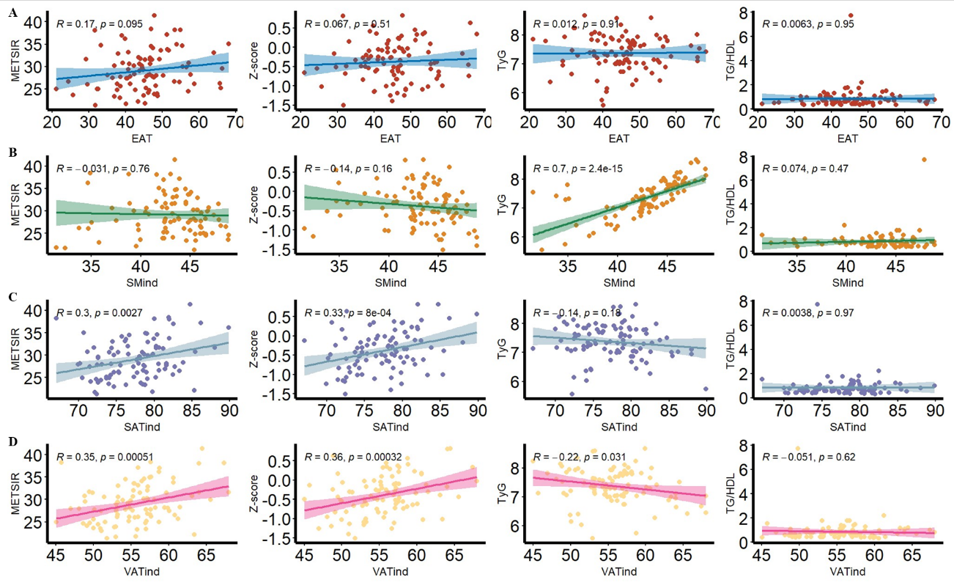

Supplementary F2 Kaplan-Meier curve analysis of Body Composition for second endpoint
