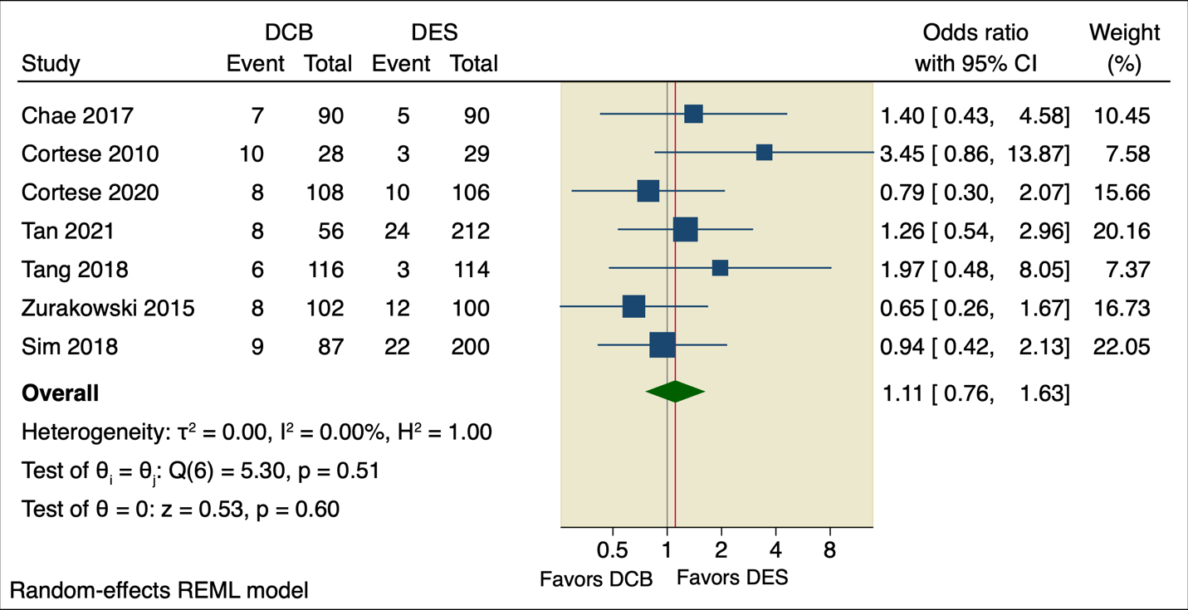
Supplementary Figure 1: Forest plot of a composite of cardiac death, MI, and TLR.

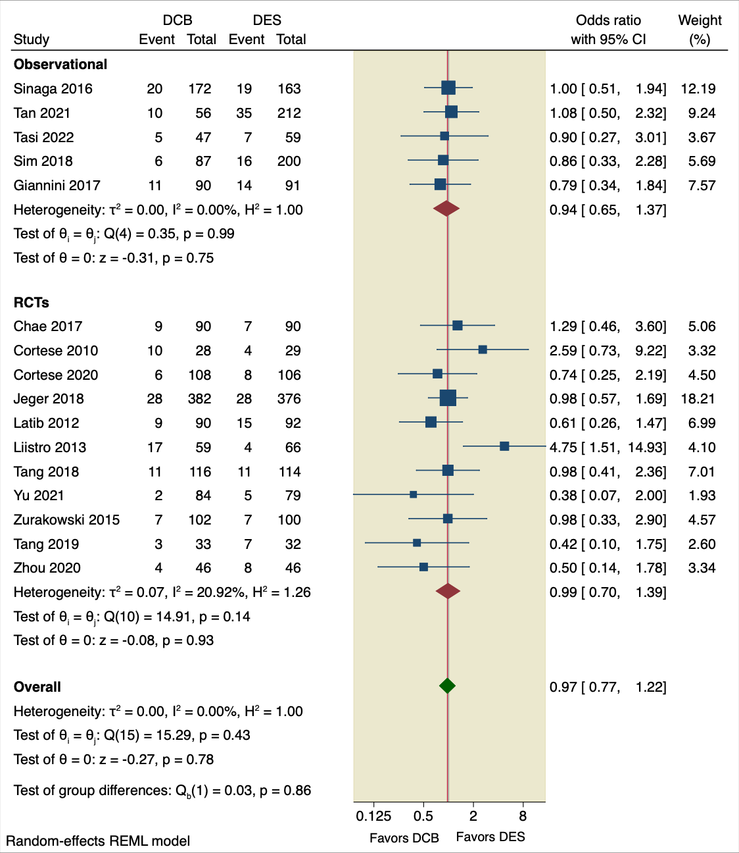
Supplementary Figure 2: Forest plot of MACE based on study design.

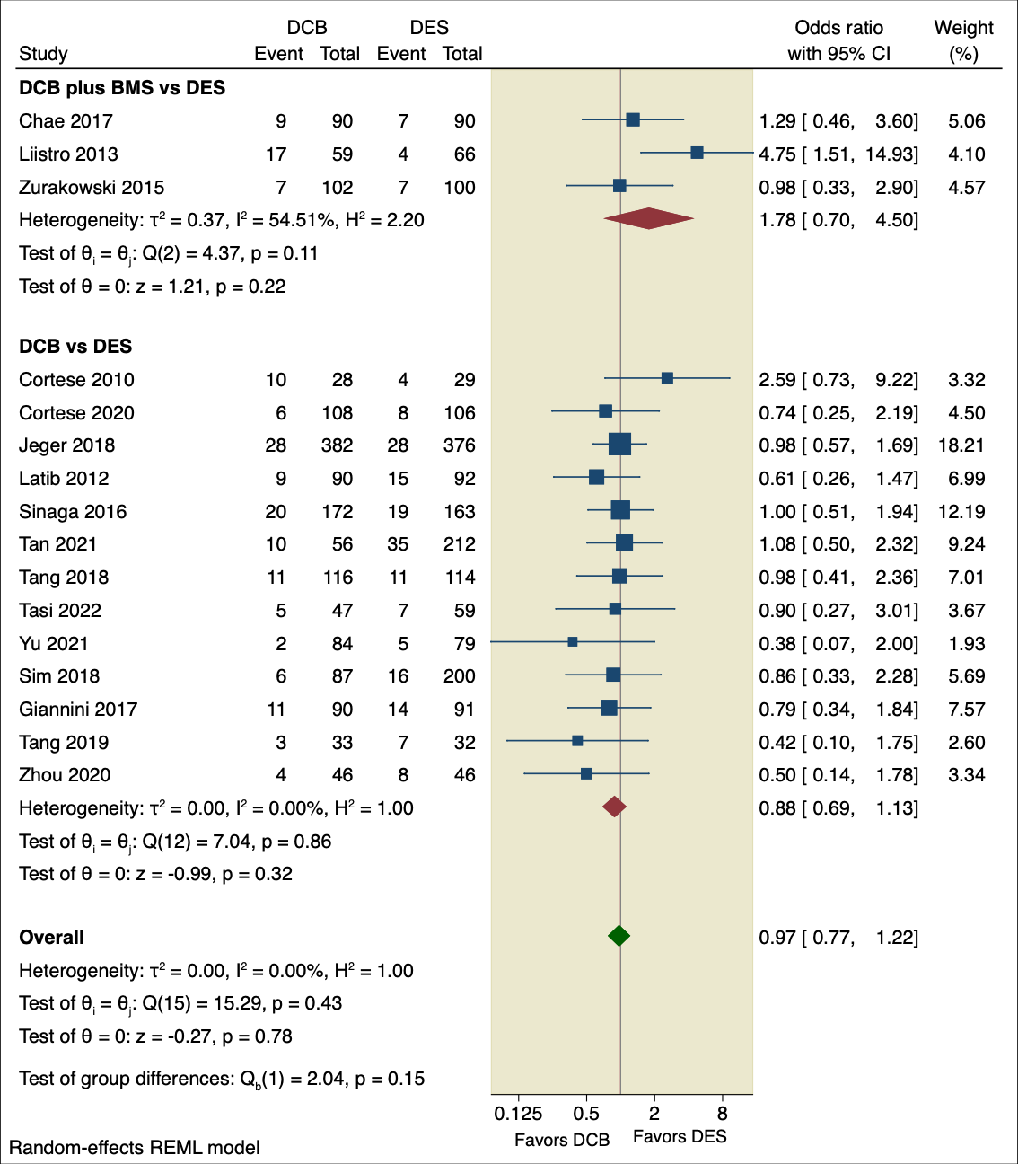
Supplementary Figure 3: Forest plot of MACE based on the intervention used.

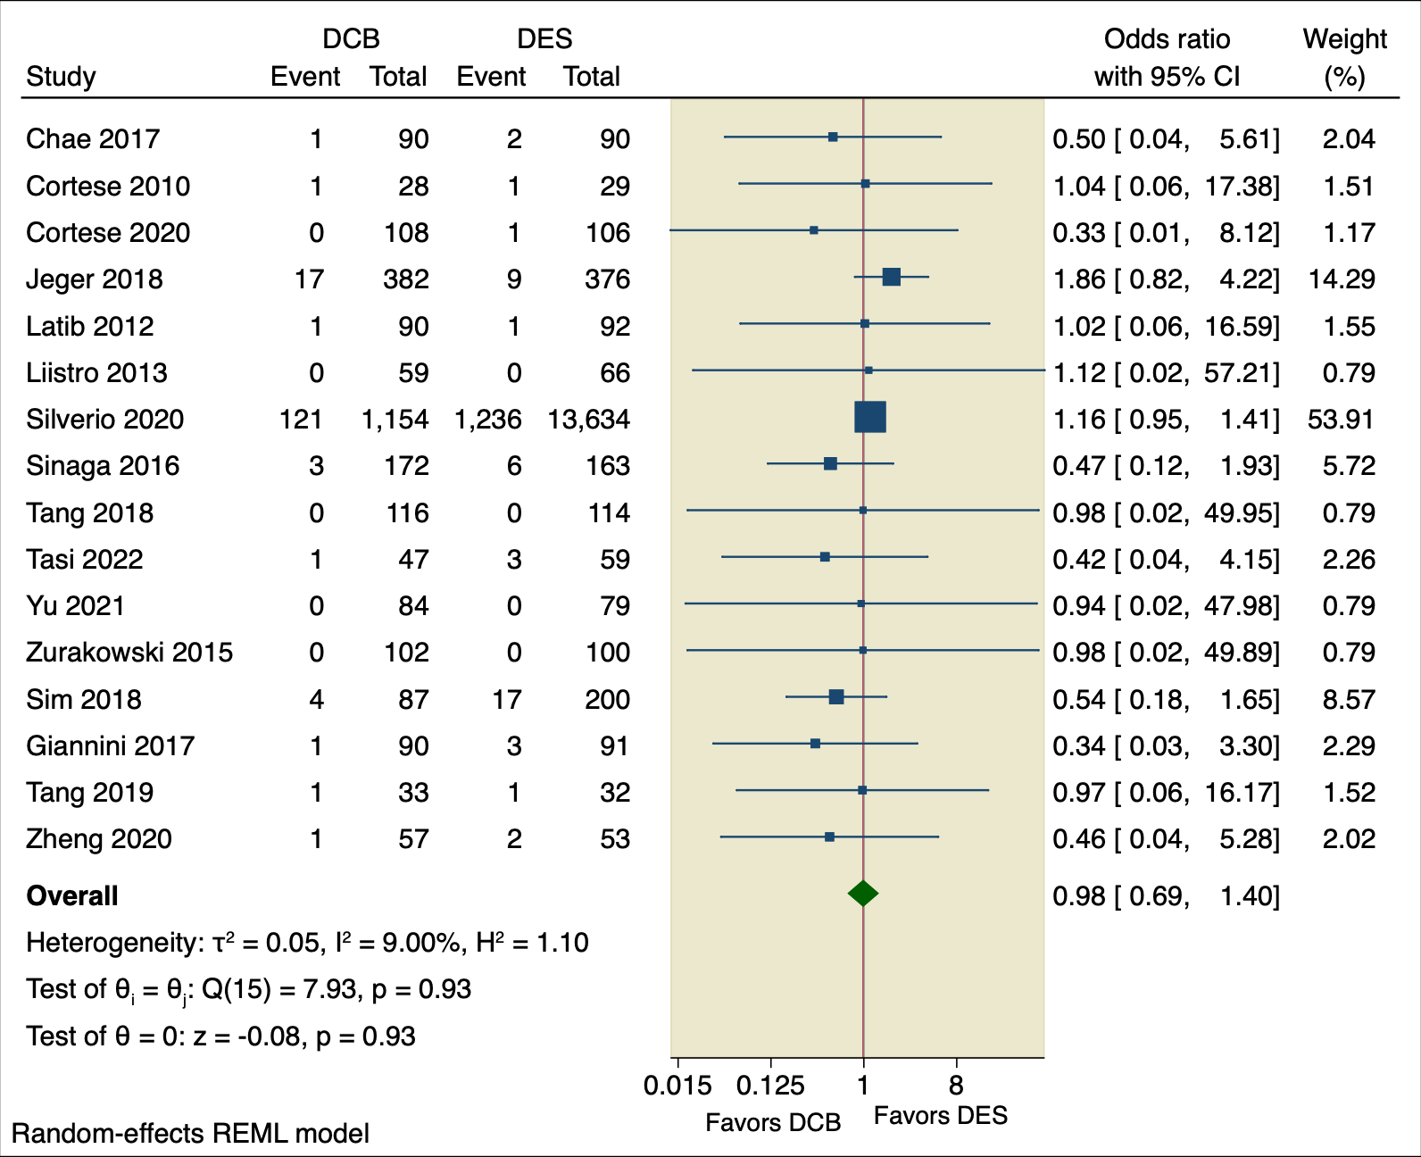
Supplementary Figure 4: Forest plot of all-cause death.

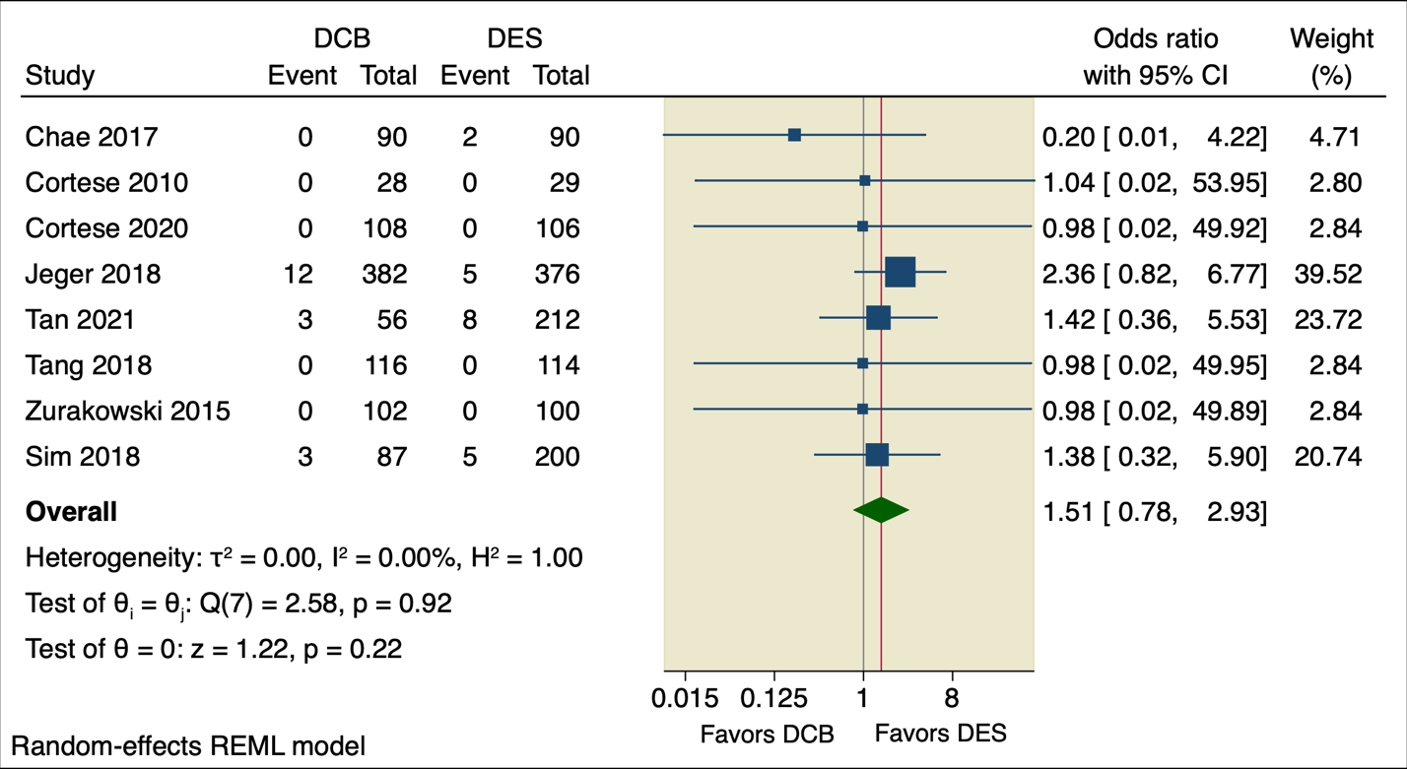
Supplementary Figure 5: Forest plot of cardiac death.

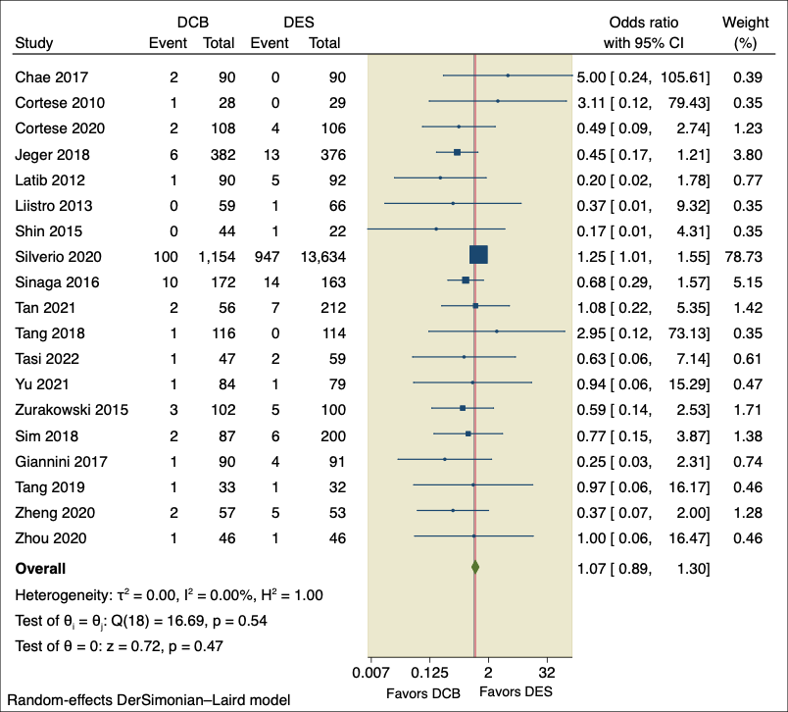
Supplementary Figure 6: Forest plot of MI.

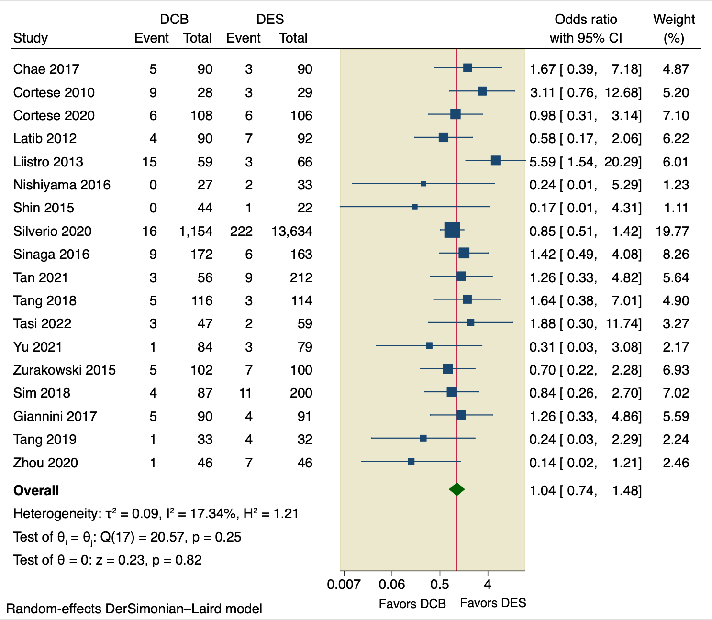
Supplementary Figure 7: Forest plot of TLR.

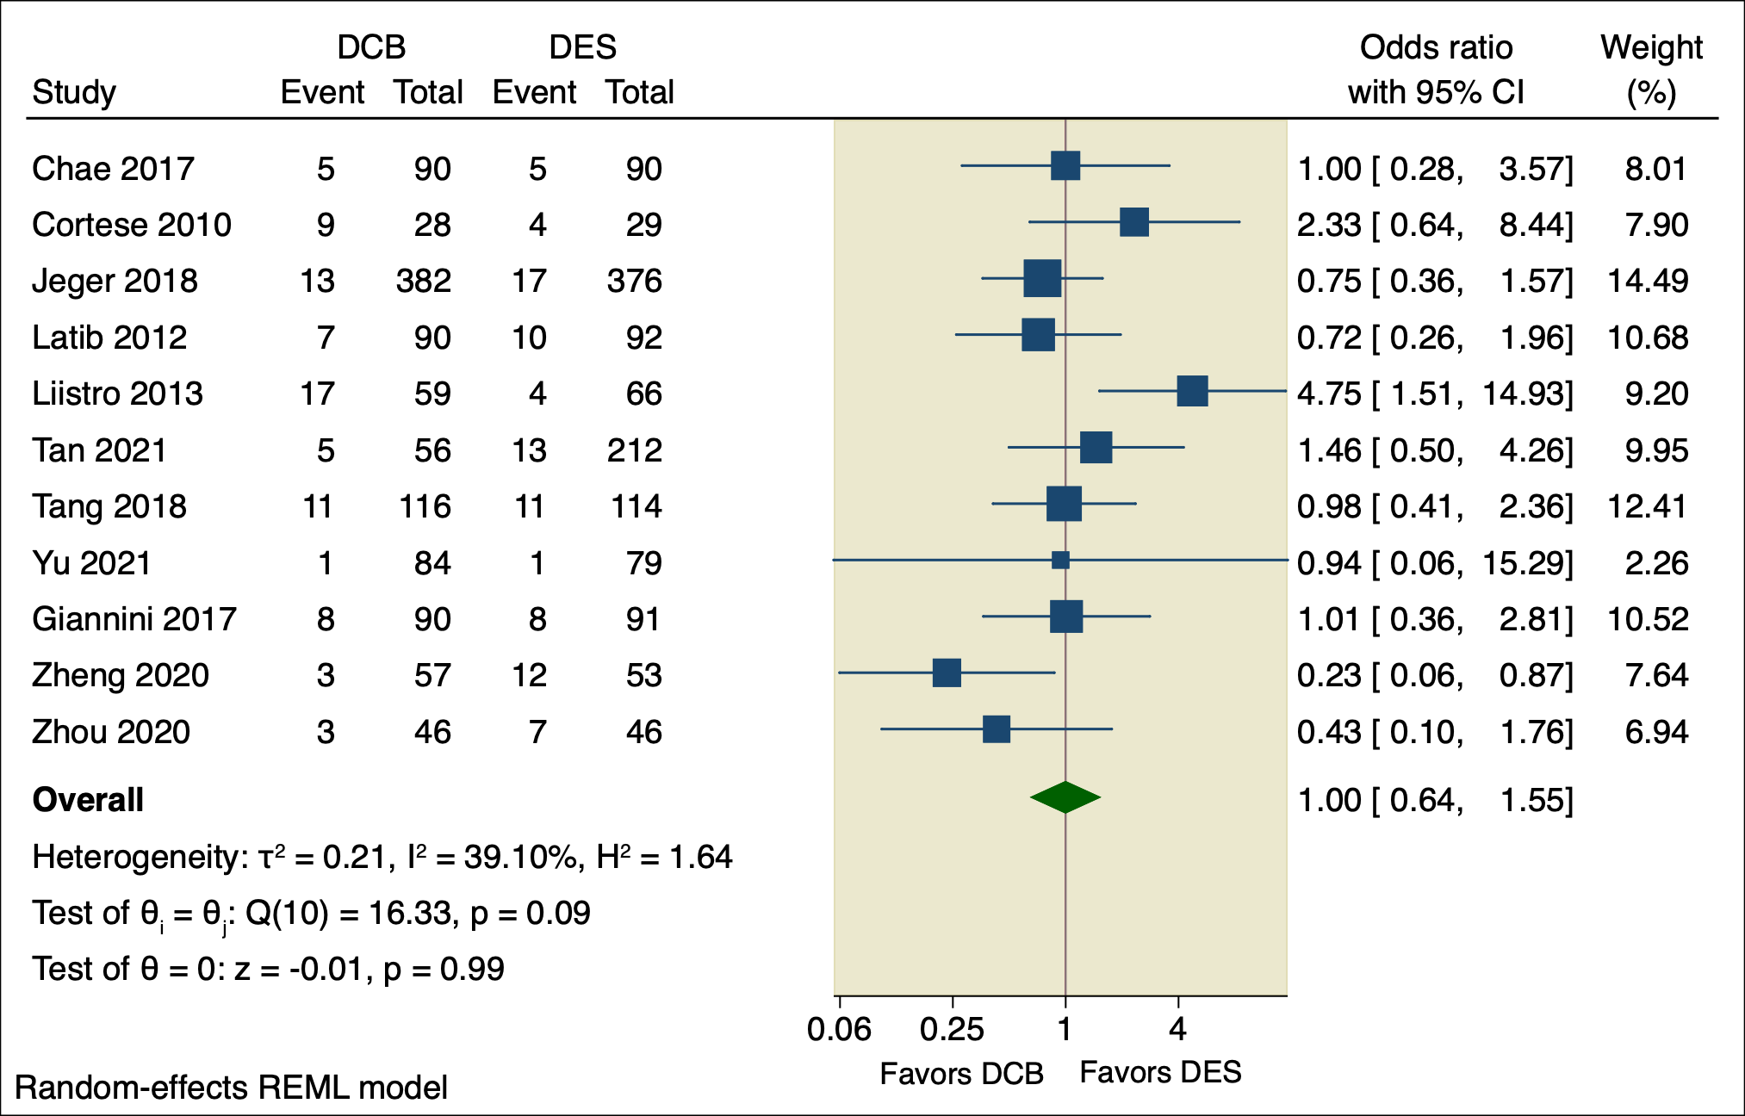
Supplementary Figure 8: Forest plot of TVR.

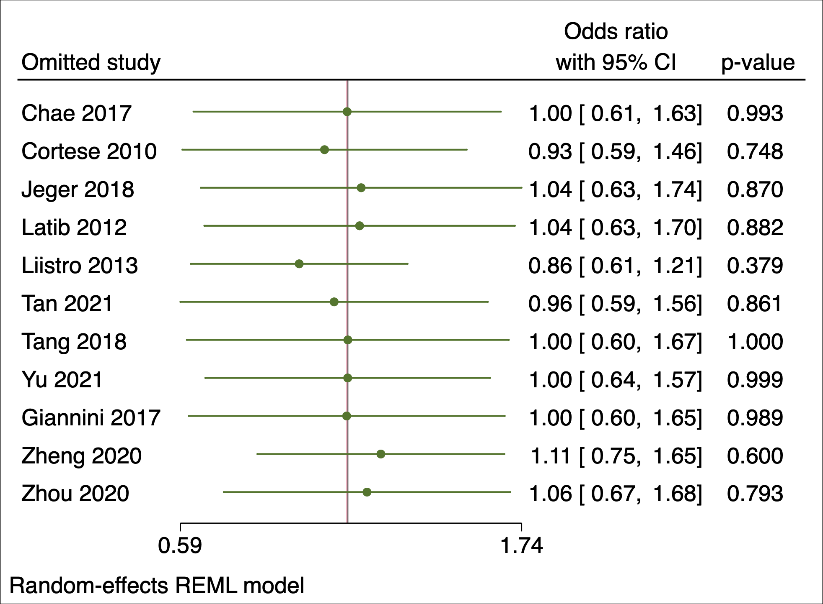
Supplementary Figure 9: Leaveoneout plot of TVR.

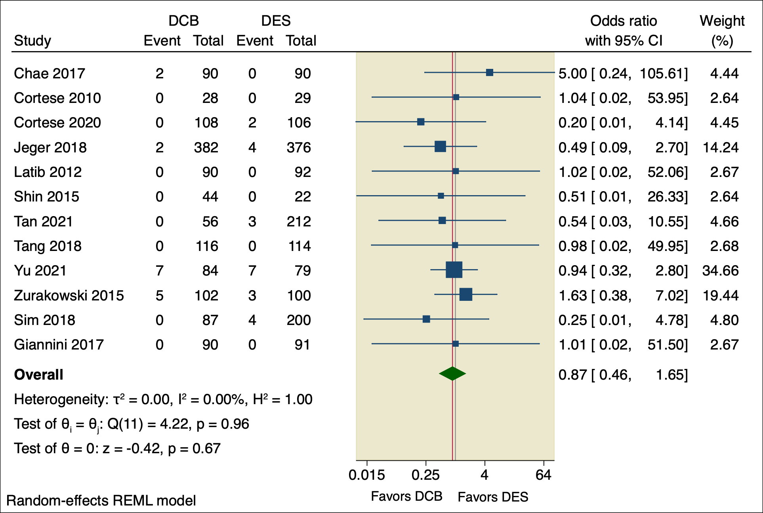
Supplementary Figure 10: Forest plot of stent thrombosis.

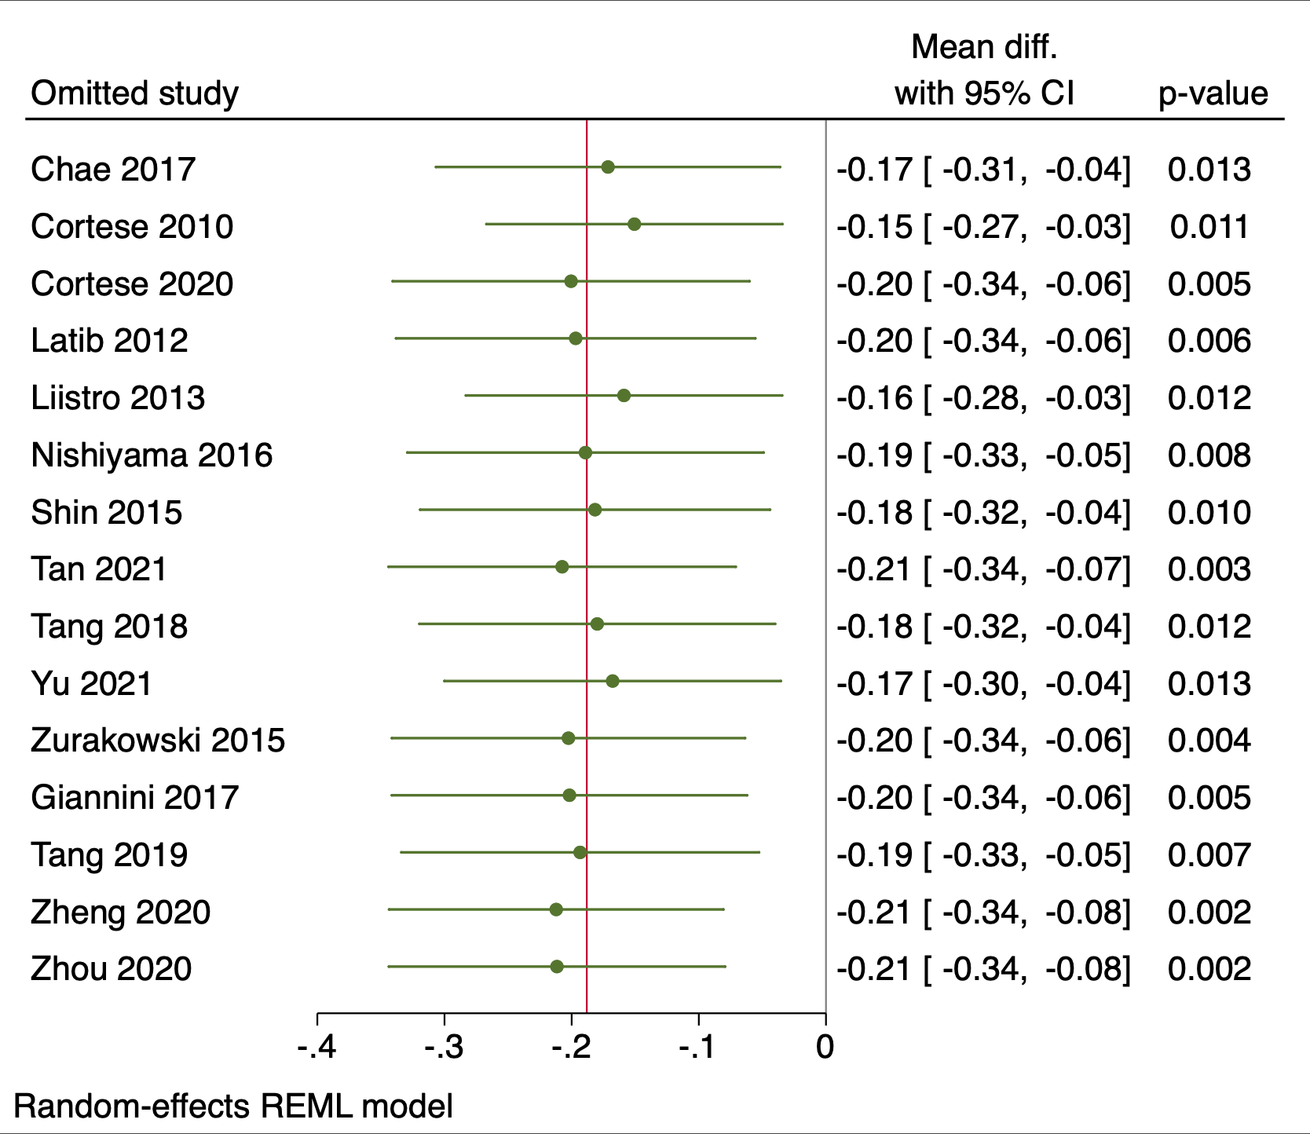
Supplementary Figure 11: Leaveoneout plot of MLD.

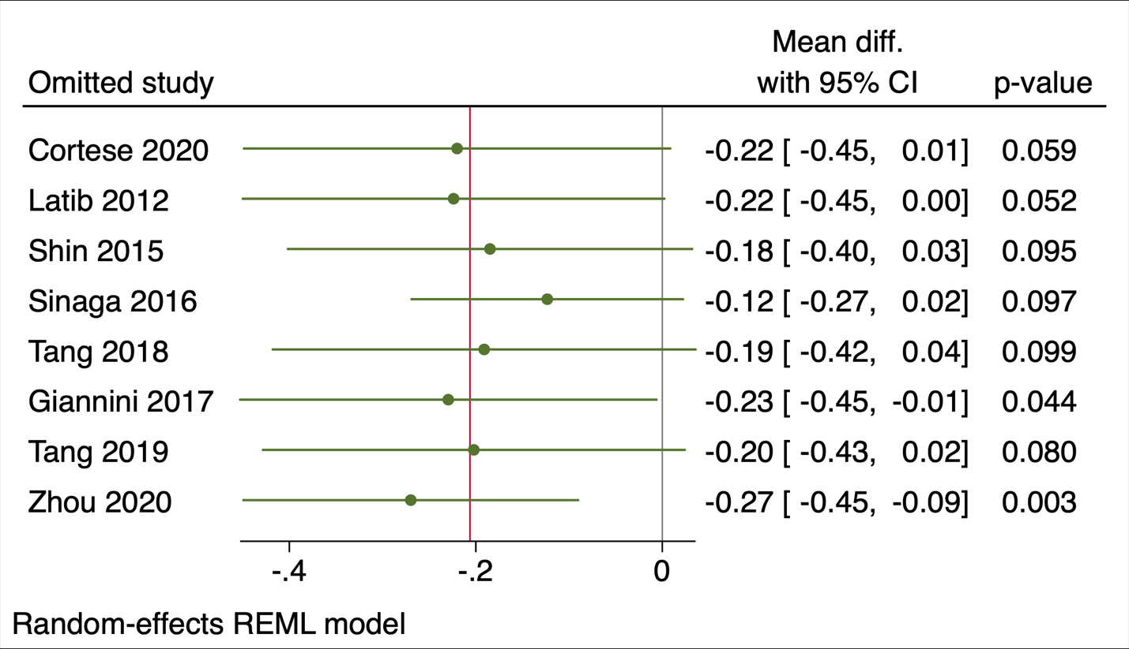
Supplementary Figure 12: Leaveoneout plot of NLG.

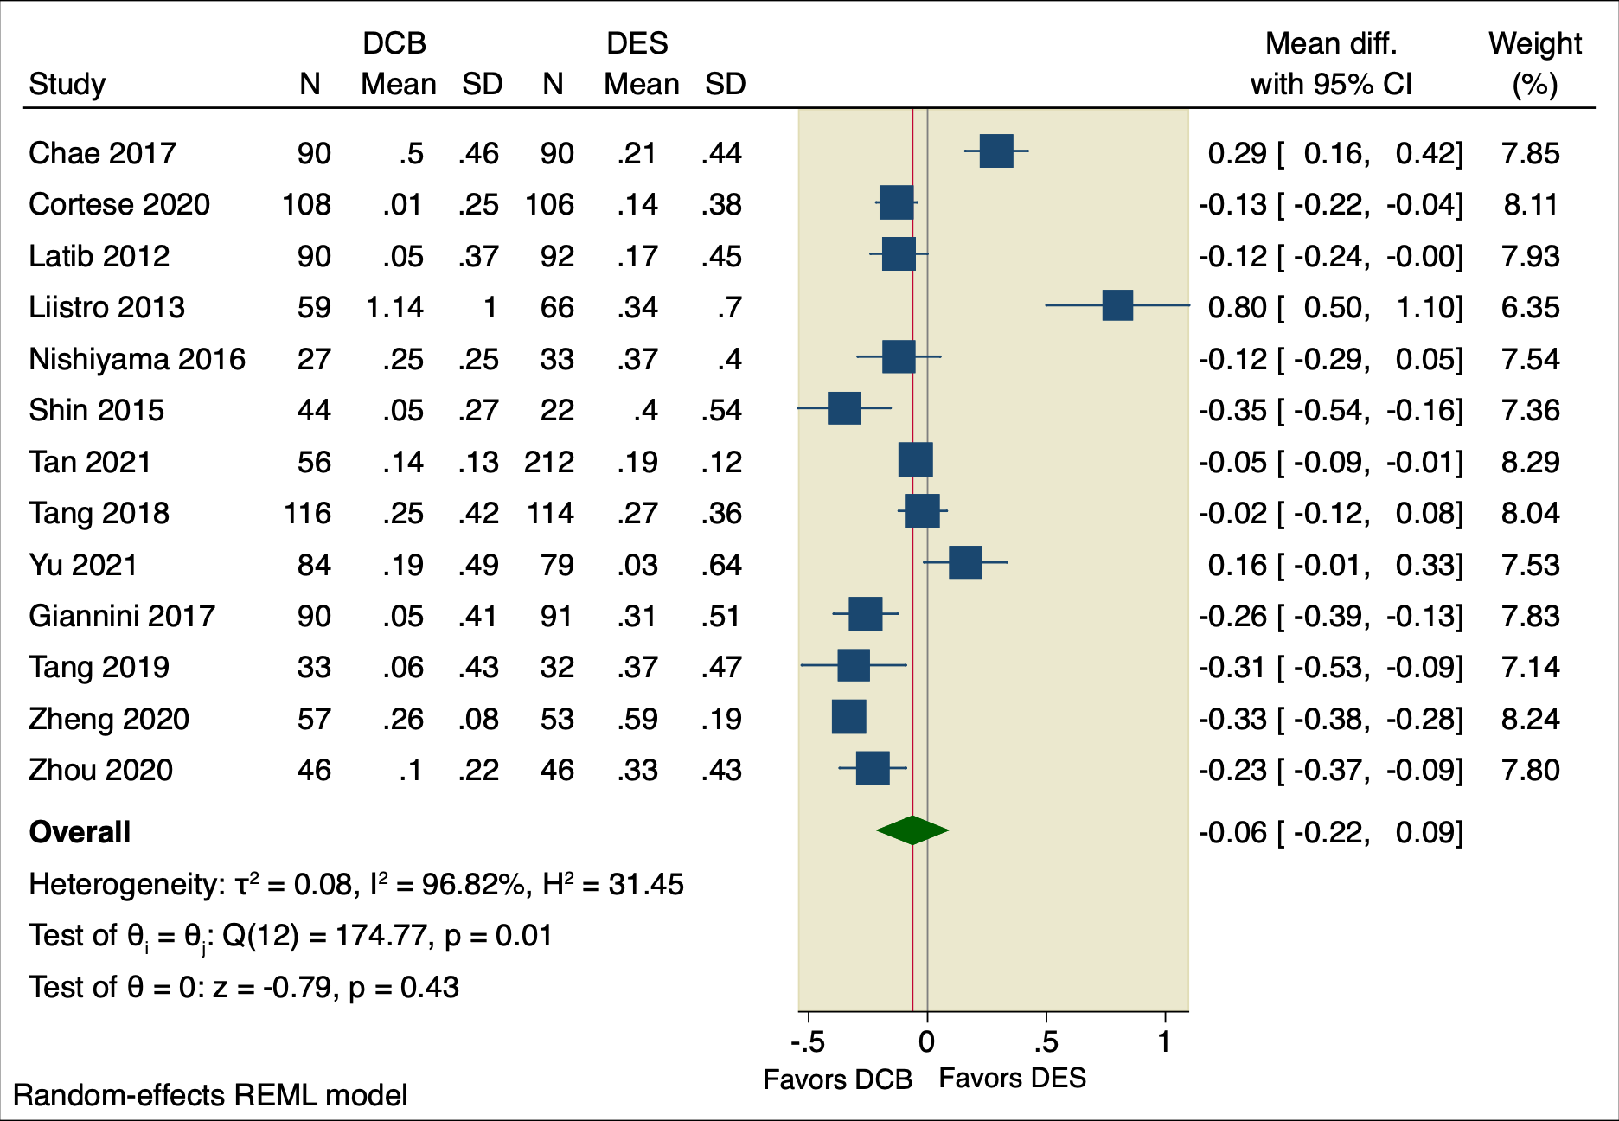
Supplementary Figure 13: Forest plot of LLL.

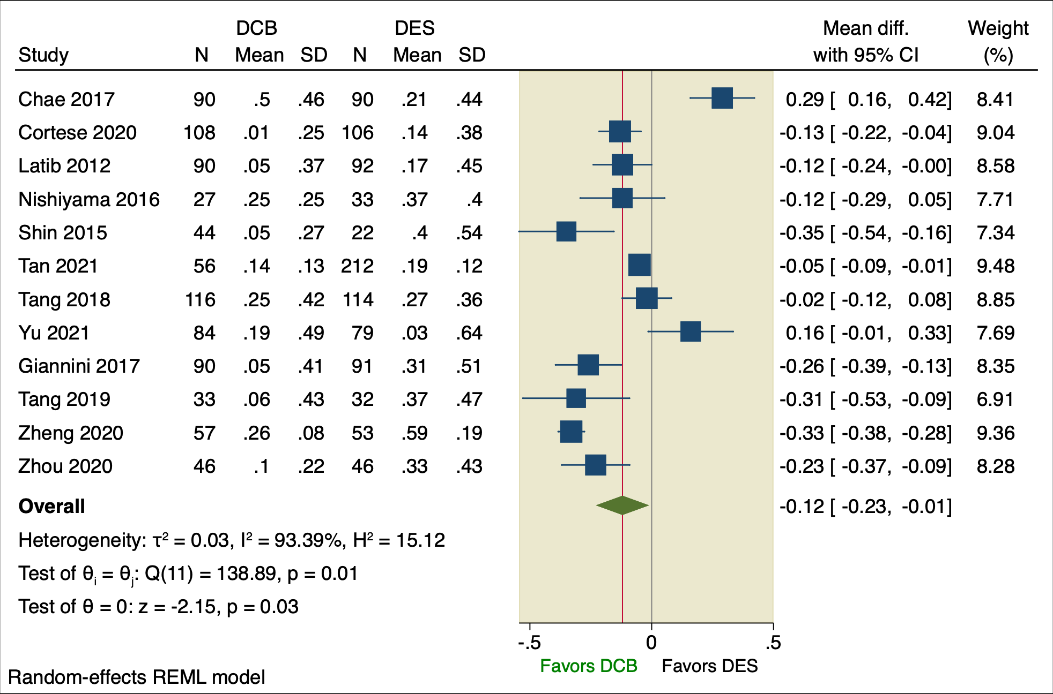
Supplementary Figure 14: Sensitivity analysis plot of LLL.

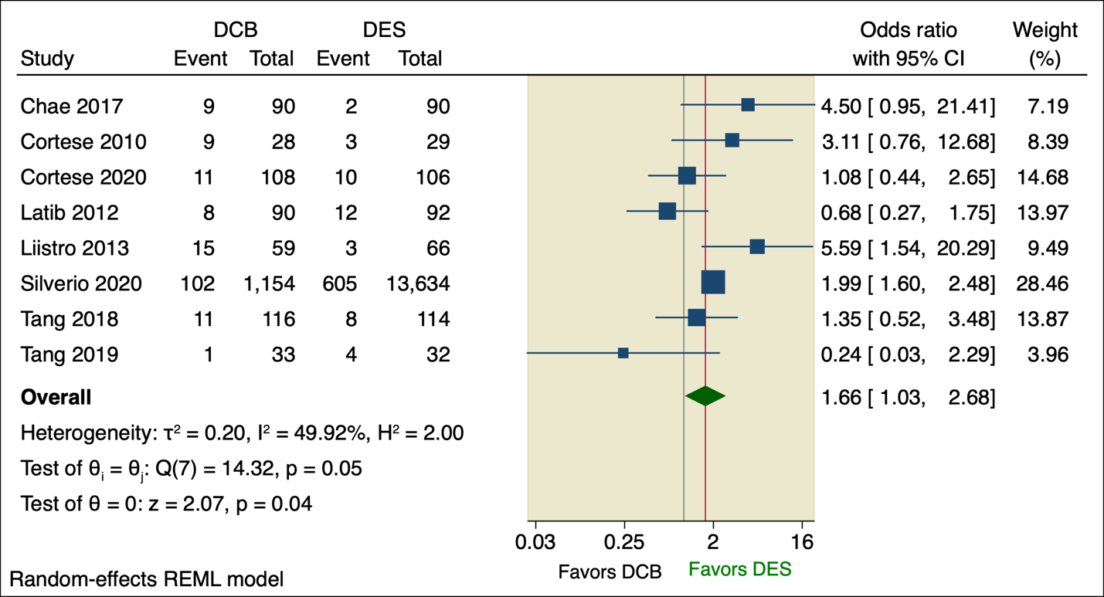
Supplementary Figure 15: Forest plot of In-segment binary restenosis.

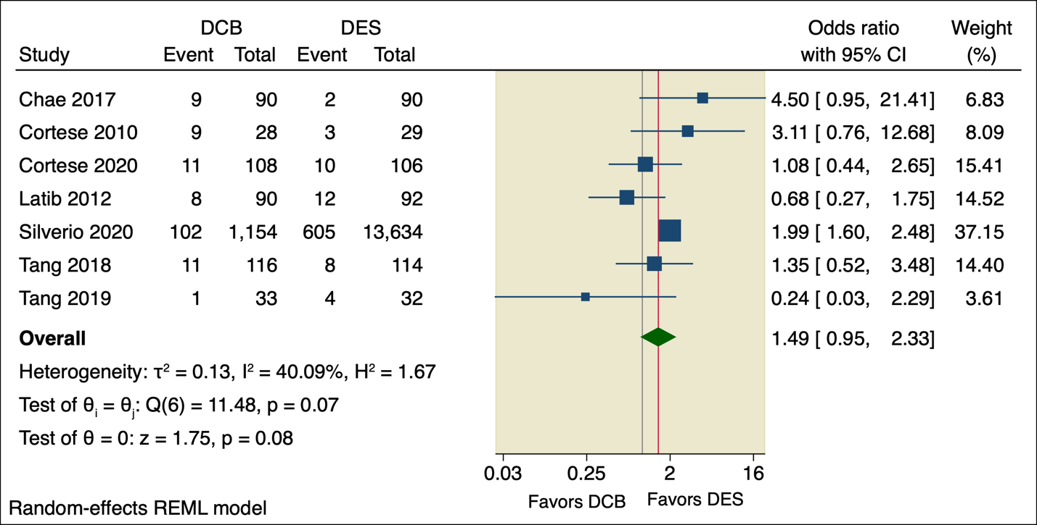
Supplementary Figure 16: Sensitivity analysis plot of In-segment binary restenosis.

