Supplementary Section: imputation of missing data 2
Supplementary Figure 1. Flowchart of including patients 3
Supplementary Figure 2. Plots of model discrimination, among development and validation groups 4
Supplementary Figure 3. Calibration of Nomogram, among development and validation groups, 5
Supplementary Table 1. Association of AKI and potential predictors. 6
Supplementary Table 2. Discrimination and calibration of prediction model among develop and validation groups 7

Supplementary Section: imputation of missing data

Imputation was performed based on regression method. In detail, considering the distribution and existing zero values in these variables, firstly we add a very small random positive value (normal distribution, mean=1/10000000) to the existing zero value before imputation. Then we built regression model to estimate the value of missing cases for each variable, with the log transferred as dependent variable, and patients’ characteristics as independent variables (including sex, age, history of smoking and drinking alcohol, and HTN, dyslipidemia, DM, CVD, CKD, etc.). After the exponential transfer we got the imputation values used in final analysis. The missing rates of each variable, and the distribution of original values and values after imputation were shown in the below table.

 | Proportion of missing | distribution before imputation | distribution after imputation
LVEF, % | 5063(9.3) | 63(58, 66) | 62(58, 65)
EGFR | 2906(5.34) | 89.55(77.17,98.19) | 89.77(76.36, 98.51)
HbA1C, % | 15222(27.97) | 6.51±1.27 | 6.46±1.13
Creatinine | 977(14.83) | 76.8(66.7, 88.7) | 76.8(66.7, 88.7)
Hemoglobin | 8522(15.66) | 138.13±18.9 | 138.02±17.73
White blood cell count | 8522(15.66) | 6.5(5.41, 7.89) | 6.48(5.61, 7.61)
Platelet count | 8527(15.67) | 21706(21666, 21741) | 21704(21673, 21735)
Mean Platelet Volume, fL | 8531(15.67) | 9.96±1.09 | 9.95±1
Prothrombin time, s | 5009(9.2) | 11.2(10.7, 11.7) | 11.2(10.8, 11.7)
Total cholesterol, mmol/L | 5620(10.33) | 4.07±1.09 | 4.05±1.04
HDL, mmol/L | 5620(10.33) | 1.06±0.27 | 1.06±0.26
LDL, mmol/L | 5620(10.33) | 2.08(1.61, 2.68) | 2.06(1.66, 2.6)
Triglyceride, mmol/L | 5620(10.33) | 1.46(1.07, 2.06) | 1.47(1.11, 1.97)
Total thyroid hormone | 8811(16.19) | 116.1(101.88, 131.9) | 115.57(104.93, 128.47)
ALT, U/L | 3245(5.96) | 20(14, 29) | 20(14, 28)
AST, U/L | 3244(5.96) | 19(16, 25) | 19(16, 25)
Hypersensitive C-reactive protein | 10103(18.56) | 1.07(0.56, 2.7) | 1.16(0.65, 2.4)
D-dimer | 5141(9.45) | 94(58, 160) | 93(58, 156)

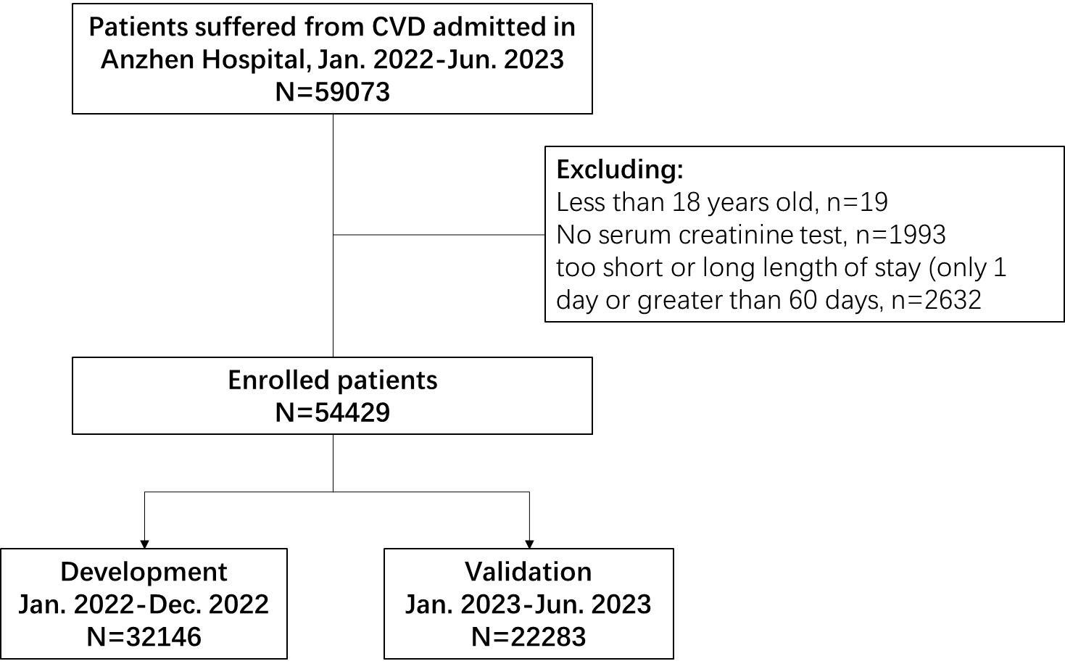

Supplementary Figure 1. Flowchart of including patients

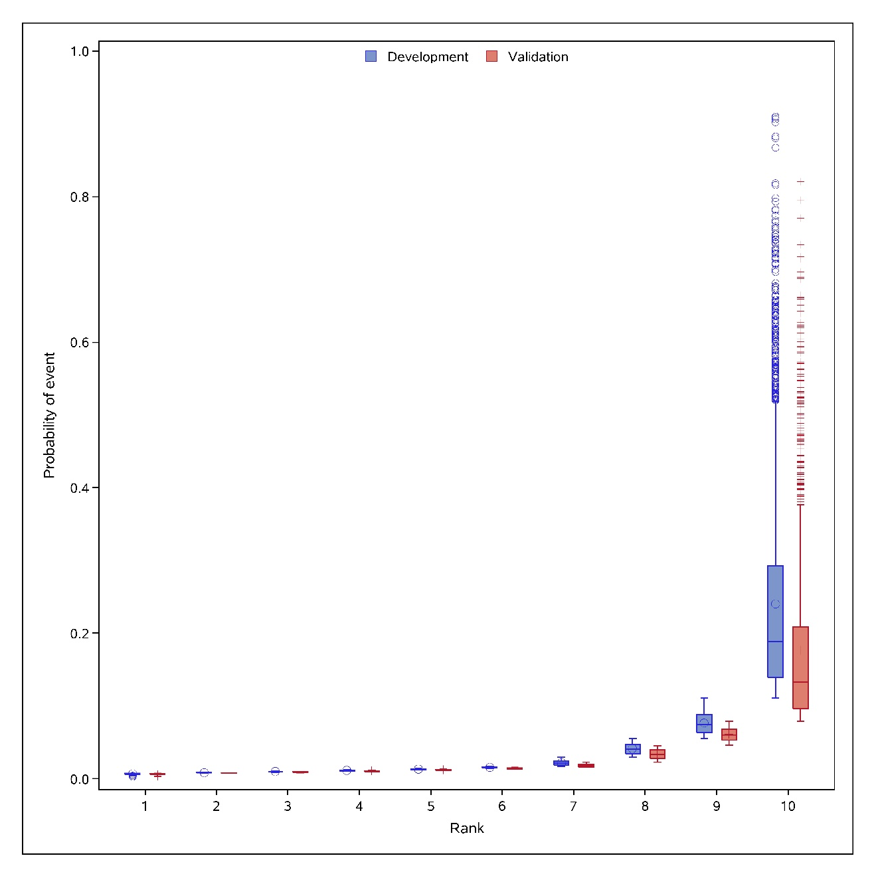

Supplementary Figure 2. Plots of model discrimination, among development and validation groups
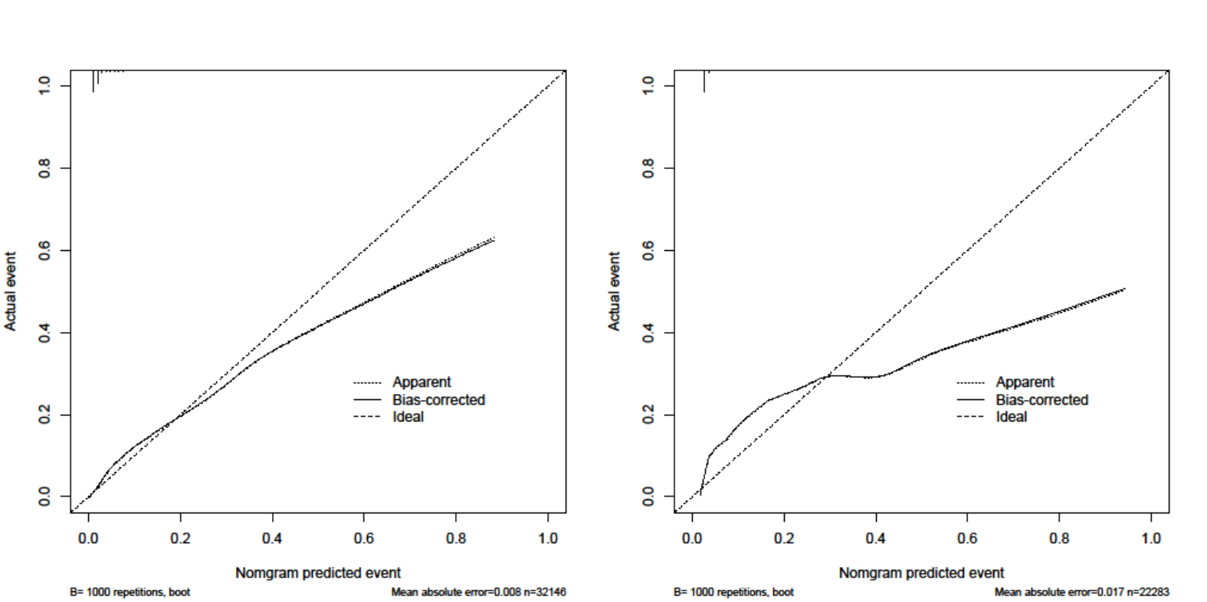

Supplementary Figure 3. Calibration of Nomogram, among development and validation groups,

Supplementary Table 1. Association of AKI and potential predictors.
 | Univariate model
 | OR (95% CI) | P value
Age, years | 1.04(1.04,1.05) | <0.01
Male | 0.86(0.77,0.97) | 0.01
Married | 0.96(0.79,1.15) | 0.65
Medical insurance | 1.29(0.64,2.62) | 0.48
Smoking | 1.05(0.94,1.17) | 0.37
Alcohol | 0.92(0.82,1.04) | 0.18
Hypertension | 1.41(1.25,1.58) | <0.01
Dyslipidemia | 0.45(0.4,0.51) | <0.01
Diabetes | 1.51(1.36,1.68) | <0.01
Myocardial infarction | 1.46(1.26,1.69) | <0.01
PCI | 0.81(0.71,0.92) | <0.01
CABG | 1.22(0.88,1.68) | 0.24
Previous stroke | 1.83(1.58,2.11) | <0.01
Congestive heart failure | 5.35(4.67,6.14) | <0.01
Atrial Fibration | 1.69(1.24,2.31) | <0.01
Chronic kidney disease | 6.7(5.97,7.53) | <0.01
Peptic ulcer | 1.22(0.85,1.74) | 0.29
Malignancy | 0.5(0.25,1) | 0.05
COPD | 1.58(0.88,2.85) | 0.13
Pacemaker or defibrillator | 2.25(1.6,3.15) | <0.01
AMI | 2.68(2.37,3.04) | <0.01
Admitted to the surgical department | 6.29(5.64,7.01) | <0.01
LVEF, % | 0.94(0.94,0.95) | <0.01
EGFR<60 | 6.98(6.22,7.83) | <0.01
Hba1C, % | 1.18(1.13,1.22) | <0.01
Creatinine | 1.01(1.01,1.01) | <0.01
Hemoglobin | 0.96(0.96,0.96) | <0.01
White blood cell count | 1.19(1.18,1.21) | <0.01
Platelet count | 1.01(1.01,1.01) | <0.01
Mean Platelet Volume, fL | 1.25(1.19,1.32) | <0.01
Prothrombin time, s | 1.11(1.1,1.13) | <0.01
Total cholesterol, mmol/L | 1.02(0.97,1.08) | 0.35
HDL, mmol/L | 0.43(0.34,0.54) | <0.01
LDL, mmol/L | 1.04(0.98,1.11) | 0.21
Triglyceride, mmol/L | 0.97(0.93,1.02) | 0.26
Total thyroid hormone | 1.01(1,1.01) | <0.01
ALT, U/L | 1(1,1) | <0.01
AST, U/L | 1(1,1) | <0.01
Hypersensitive C-reactive protein | 1.08(1.07,1.1) | <0.01
D-dimer | 1(1,1) | <0.01

Supplementary Table 2. Discrimination and calibration of prediction model among develop and validation groups

 |  |  |  |  | Discrimination |  | Calibration
Groups | Subgroups | Number of patients | Number of AKI | Rate(95% CI) of AKI | AUC(95% CI) | Predictive ability* (median rate of lowest to highest decile) | Slope (Intercept)
Development | Overall | 32146 | 1427(4.44) | 4.44(4.22-4.67) | 0.867(0.858-0.878) | 0.66%-18.89% | 0.89(0.005)
 | Age<65,years | 18316 | 570(3.11) | 3.11(2.87-3.37) | 0.879(0.865-0.892) | 0.6%-13.05% | 0.93(0.001)
 | Age>=65,years | 13830 | 857(6.20) | 6.20(5.80-6.61) | 0.838(0.830-0.855) | 0.96%-25.09% | 0.86(0.01)
 | Male | 23148 | 985(4.26) | 4.26(4.00-4.52) | 0.866(0.860-0.881) | 0.63%-17.88% | 0.89(0.005)
 | Female | 8998 | 442(4.91) | 4.91(4.47-5.38) | 0.855(0.840-0.875) | 0.79%-21.12% | 0.88(0.006)
 | eGFR<60% | 2942 | 532(18.08) | 18.08(16.71-19.52) | 0.764(0.743-0.785) | 3.56%-55.36% | 0.79(0.038)
 | eGFR>=60% | 29204 | 895(3.06) | 3.06(2.87-3.27) | 0.845(0.837-0.861) | 0.65%-12.39% | 0.91(0.003)
 | Admitted to the surgical department | 4726 | 695(14.71) | 14.71(13.71-15.75) | 0.655(0.631-0.678) | 3.93%-43.77% | 0.65(0.051)
 | Not admitted to the surgical department | 27420 | 732(2.67) | 2.67(2.48-2.87) | 0.860(0.854-0.882) | 0.64%-8.75% | 1.07(-0.002)
 | CKD history | 2879 | 512(17.78) | 17.78(16.40-19.23) | 0.774(0.753-0.794) | 2.23%-55.48% | 0.79(0.036)
 | No CKD history | 29267 | 915(3.13) | 3.13(2.93-3.33) | 0.845(0.838-0.861) | 0.65%-12.72% | 0.91(0.003)
 | AMI | 3830 | 363(9.48) | 9.48(8.57-10.45) | 0.813(0.790-0.836) | 1.53%-40.79% | 0.79(0.02)
 | Not AMI | 28316 | 1064(3.76) | 3.76(3.54-3.99) | 0.863(0.858-0.878) | 0.64%-15.9% | 0.93(0.002)
 | HF history | 1783 | 304(17.05) | 17.05(15.33-18.88) | 0.719(0.689-0.750) | 2.39%-55.32% | 0.65(0.06)
 | No HF history | 30363 | 1123(3.70) | 3.70(3.49-3.92) | 0.860(0.854-0.875) | 0.65%-14.89% | 0.96(0.002)
Validation | Overall | 22283 | 685(3.07) | 3.07(2.85-3.31) | 0.866(0.853-0.879) | 0.62%-13.28% | 0.88(0.000)
 | Age<65,years | 12779 | 289(2.26) | 2.26(2.01-2.53) | 0.879(0.859-0.899) | 0.56%-8.99% | 1.07(-0.004)
 | Age>=65,years | 9504 | 396(4.17) | 4.17(3.77-4.59) | 0.838(0.821-0.861) | 0.88%-19.11% | 0.81(0.003)
 | Male | 16241 | 487(3.00) | 3.00(2.74-3.27) | 0.856(0.850-0.881) | 0.59%-12.33% | 0.88(0.001)
 | Female | 6042 | 198(3.28) | 3.28(2.84-3.76) | 0.864(0.839-0.892) | 0.76%-15.32% | 0.88(-0.002)
 | eGFR<60% | 1817 | 233(12.82) | 12.82(11.32-14.45) | 0.774(0.742-0.806) | 3.05%-45.51% | 0.84(0.005)
 | eGFR>=60% | 20466 | 452(2.21) | 2.21(2.01-2.42) | 0.839(0.832-0.868) | 0.61%-8.81% | 0.94(-0.001)
 | Admitted to the surgical department | 3164 | 372(11.76) | 11.76(10.65-12.93) | 0.617(0.585-0.648) | 3.77%-30.44% | 0.57(0.056)
 | Not admitted to the surgical department | 19119 | 313(1.64) | 1.64(1.46-1.83) | 0.829(0.828-0.876) | 0.6%-7.21% | 0.95(-0.005)
 | CKD history | 1778 | 221(12.43) | 12.43(10.93-14.05) | 0.789(0.758-0.820) | 1.94%-45.46% | 0.85(0.003)
 | No CKD history | 20505 | 464(2.26) | 2.26(2.06-2.48) | 0.840(0.833-0.868) | 0.61%-8.97% | 0.94(-0.001)
 | AMI | 2091 | 137(6.55) | 6.55(5.53-7.70) | 0.834(0.802-0.872) | 1.48%-32.91% | 0.83(0)
 | Not AMI | 20192 | 548(2.71) | 2.71(2.49-2.95) | 0.853(0.849-0.879) | 0.61%-10.99% | 0.92(-0.001)
 | HF history | 983 | 122(12.41) | 12.41(10.41-14.64) | 0.777(0.734-0.819) | 2.14%-47.24% | 0.77(0.012)
 | No HF history | 21300 | 563(2.64) | 2.64(2.43-2.87) | 0.851(0.845-0.875) | 0.61%-10.5% | 0.94(-0.001)

