Supplementary Materials
Table of Contents
Search Syntax 2
Table S1. Full-text articles reviewed and excluded, with reasons 4
Tables S2. Bleeding outcome definitions across studies 10
Table S3. Harmonizing strategy for bleeding definitions 11
Figure S1. Octogenarians Subgroup Analyses of Outcomes 12
Figure S2. Meta-regression of outcomes by mean age (graphical summary) 13
Table S4. Meta-regression of outcomes by mean age 14
Figure S3. Sensitivity Analysis of Bleeding Outcome of Studies with TIMI Definition 15

Search Syntax
PubMed/MEDLINE:
(“NSTACS” OR “NSTEMI” OR “NSTE-ACS” OR “NSTEACS” OR “Acute Myocardial Ischemia” OR ((“Non-ST Elevated” OR “Non-ST-Elevated” OR “Non ST Elevated” OR “Non-ST-Elevation” OR “Non ST Elevation” OR “Non-ST Elevation”) AND (“Myocardial Infarction”)) OR “acute coronary syndrome” OR “ACS”) AND (“early invasive” OR "Invasive strategy" OR "invasive approach" OR "coronary angiography" OR "percutaneous coronary intervention" OR “PCI” OR "revascularization" OR "coronary artery bypass grafting" OR “CABG” OR “Coronary Revascularization” OR “Angioplast*” OR “Coronary Intervention” OR “Coronary Atherectom*”) AND ("Conservative strategy" OR "conservative approach" OR "guideline-directed medical therapy" OR “GDMT” OR "pharmacological therapy" OR “standard care” OR “medical therap*” OR “OMT” OR “medical treatment” OR “medical management” OR “conservative management” OR “conservative treatment” OR “conservative therap*”) AND (“Stroke” OR "heart failure" OR "Mortality" OR "cardiovascular death" OR "myocardial infarction" OR “MACE” OR "Major Adverse Cardiovascular Events" OR "re-infarction" OR "major bleeding" OR "complications" OR "hospital stay" OR "readmission" OR "quality of life") AND ("Elder*" OR "older adults" OR "aged 75" OR "geriatric" OR “80 and over” OR “aged >” OR “Aged ≥” OR “frail” OR “octogenarians” OR "septuagenarians" OR "nonagenarians" OR “advanced age” OR “advanced-aged” OR “senior citizens” OR “aged population” OR "older population" OR "older individuals" OR "aged 65" OR "aged 85”)
Scopus:
TITLE-ABS-KEY(“NSTACS” OR “NSTEMI” OR “NSTE-ACS” OR “NSTEACS” OR “Acute Myocardial Ischemia” OR ((“Non-ST Elevated” OR “Non-ST-Elevated” OR “Non ST Elevated” OR “Non-ST-Elevation” OR “Non ST Elevation” OR “Non-ST Elevation”) AND (“Myocardial Infarction”)) OR “acute coronary syndrome” OR “ACS”) AND TITLE-ABS-KEY(“early invasive” OR "Invasive strategy" OR "invasive approach" OR "coronary angiography" OR "percutaneous coronary intervention" OR “PCI” OR "revascularization" OR "coronary artery bypass grafting" OR “CABG” OR “Coronary Revascularization” OR “Angioplast*” OR “Coronary Intervention” OR “Coronary Atherectom*”) AND TITLE-ABS-KEY("Conservative strategy" OR "conservative approach" OR "guideline-directed medical therapy" OR “GDMT” OR "pharmacological therapy" OR “standard care” OR “medical therap*” OR “OMT” OR “medical treatment” OR “medical management” OR “conservative management” OR “conservative treatment” OR “conservative therap*”) AND (“Stroke” OR "heart failure" OR "Mortality" OR "cardiovascular death" OR "myocardial infarction" OR “MACE” OR "Major Adverse Cardiovascular Events" OR "re-infarction" OR "major bleeding" OR "complications" OR "hospital stay" OR "readmission" OR "quality of life") AND ("Elder*" OR "older adults" OR "aged 75" OR "geriatric" OR “80 and over” OR “aged >” OR “Aged ≥” OR “frail” OR “octogenarians” OR "septuagenarians" OR "nonagenarians" OR “advanced age” OR “advanced-aged” OR “senior citizens” OR “aged population” OR "older population" OR "older individuals" OR "aged 65" OR "aged 85”)

WOS:
ALL=(“NSTACS” OR “NSTEMI” OR “NSTE-ACS” OR “NSTEACS” OR “Acute Myocardial Ischemia” OR ((“Non-ST Elevated” OR “Non-ST-Elevated” OR “Non ST Elevated” OR “Non-ST-Elevation” OR “Non ST Elevation” OR “Non-ST Elevation”) AND (“Myocardial Infarction”)) OR “acute coronary syndrome” OR “ACS”) AND ALL=(“early invasive” OR "Invasive strategy" OR "invasive approach" OR "coronary angiography" OR "percutaneous coronary intervention" OR “PCI” OR "revascularization" OR "coronary artery bypass grafting" OR “CABG” OR “Coronary Revascularization” OR “Angioplast*” OR “Coronary Intervention” OR “Coronary Atherectom*”) AND ALL=("Conservative strategy" OR "conservative approach" OR "guideline-directed medical therapy" OR “GDMT” OR "pharmacological therapy" OR “standard care” OR “medical therap*” OR “OMT” OR “medical treatment” OR “medical management” OR “conservative management” OR “conservative treatment” OR “conservative therap*”) AND ALL=(“Stroke” OR "heart failure" OR "Mortality" OR "cardiovascular death" OR "myocardial infarction" OR “MACE” OR "Major Adverse Cardiovascular Events" OR "re-infarction" OR "major bleeding" OR "complications" OR "hospital stay" OR "readmission" OR "quality of life") AND ALL=("Elder*" OR "older adults" OR "aged 75" OR "geriatric" OR “80 and over” OR “aged >” OR “Aged ≥” OR “frail” OR “octogenarians” OR "septuagenarians" OR "nonagenarians" OR “advanced age” OR “advanced-aged” OR “senior citizens” OR “aged population” OR "older population" OR "older individuals" OR "aged 65" OR "aged 85”)
Embase:
(“NSTACS” OR “NSTEMI” OR “NSTE-ACS” OR “NSTEACS” OR “Acute Myocardial Ischemia” OR ((“Non-ST Elevated” OR “Non-ST-Elevated” OR “Non ST Elevated” OR “Non-ST-Elevation” OR “Non ST Elevation” OR “Non-ST Elevation”) AND (“Myocardial Infarction”)) OR “acute coronary syndrome” OR “ACS”):TI,AB,KW AND (“early invasive” OR "Invasive strategy" OR "invasive approach" OR "coronary angiography" OR "percutaneous coronary intervention" OR “PCI” OR "revascularization" OR "coronary artery bypass grafting" OR “CABG” OR “Coronary Revascularization” OR “Angioplast*” OR “Coronary Intervention” OR “Coronary Atherectom*”):TI,AB,KW AND ("Conservative strategy" OR "conservative approach" OR "guideline-directed medical therapy" OR “GDMT” OR "pharmacological therapy" OR “standard care” OR “medical therap*” OR “OMT” OR “medical treatment” OR “medical management” OR “conservative management” OR “conservative treatment” OR “conservative therap*”):TI,AB,KW AND (“Stroke” OR "heart failure" OR "Mortality" OR "cardiovascular death" OR "myocardial infarction" OR “MACE” OR "Major Adverse Cardiovascular Events" OR "re-infarction" OR "major bleeding" OR "complications" OR "hospital stay" OR "readmission" OR "quality of life") AND ("Elder*" OR "older adults" OR "aged 75" OR "geriatric" OR “80 and over” OR “aged >” OR “Aged ≥” OR “frail” OR “octogenarians” OR "septuagenarians" OR "nonagenarians" OR “advanced age” OR “advanced-aged” OR “senior citizens” OR “aged population” OR "older population" OR "older individuals" OR "aged 65" OR "aged 85”)

Table S1. Full-text articles reviewed and excluded, with reasons
# | Title | DOI or URL | Primary Reason(s) for Exclusion
1 | Early coronary angiography and revascularisation significantly reduces death and heart attacks in elderly people with acute coronary syndromes | 10.1016/j.ehbc.2004.11.003 | - Only available as an abstract  - Not focused on NSTE-ACS elderly ≥70
2 | Invasive Strategy in Octogenarians with Non-ST-Segment Elevation Acute Myocardial Infarction | 10.31083/j.rcm2503078 | - Not an RCT
3 | Comparative trends in guidelines adherence among patients with non-ST-segment elevation acute coronary syndromes treated with invasive versus conservative management strategies: Results from the CRUSADE quality improvement initiative | 10.1016/j.ahj.2009.09.008 | - Not an RCT
4 | A risk score for predicting 1-year mortality in patients >/=75 years of age presenting with non-ST-elevation acute coronary syndrome | 10.1016/j.amjcard.2015.04.015 | - Not an RCT
5 | Early or late intervention in high-risk non-ST-elevation acute coronary syndromes: results of the ELISA-3 trial | 10.4244/EIJV9I1A9 | - Not focused on elderly ≥70  - Different control group than specified
6 | Delineating the Benefits of an Invasive Strategy in Octogenarians With Non-ST-Segment Elevation Acute Coronary Syndromes | 10.1016/j.jacc.2023.09.810 | - Not an RCT
7 | Effect of an invasive strategy on in-hospital outcome in elderly patients with non-ST-elevation myocardial infarction | 10.1093/eurheartj/ehm464 | - Not an RCT
8 | Routine invasive vs conservative strategy in a cohort of unselected NSTEMI patients: Clinical outcome at short and mid-term follow-up (data from a single center study) | 10.1714/2794.28295 | - Not an RCT
9 | Coronary revascularisation in stable patients after an acute coronary syndrome: a propensity analysis of early invasive versus conservative management in a register-based cohort study | 10.1136/bmjopen-2013-002559 | - Not an RCT
10 | Importance of Risk Assessment in Timing of Invasive Coronary Evaluation and Treatment of Patients With Non-ST-Segment-Elevation Acute Coronary Syndrome: Insights From the VERDICT Trial | 10.1161/JAHA.121.022333 | - Not focused on elderly ≥70  - Different control group than specified
11 | Conservatively managed patients with non-ST-segment elevation acute coronary syndrome are undertreated with indicated medicines | 10.1371/journal.pone.0208069 | - Not an RCT
12 | Comparison of early invasive and conservative strategies in patients with unstable coronary syndromes treated with the glycoprotein IIb/IIIa inhibitor tirofiban | 10.1056/NEJM200106213442501 | - Not focused on elderly ≥70
13 | Invasive versus conservative strategy in acute coronary syndromes: The paradox in women's outcomes | 10.1016/j.ijcard.2016.07.211 | - Not an RCT
14 | Korean octogenarian patients with non-ST elevation myocardial infarction have more favorable outcomes following percutaneous coronary intervention | 10.1016/j.amjcard.2009.01.112 | - Only available as an abstract
15 | An invasive strategy is associated with decreased mortality in patients with unstable angina and non-ST-elevation myocardial infarction: GUSTO IIb trial | 10.1016/s0002-9343(02)01446-8 | - Not focused on elderly ≥70
16 | Impact of chronic kidney disease in early invasive versus early conservative revascularization strategies in non-ST-segment elevation acute coronary syndromes: a population-based study from NHIRD of Taiwan | 10.1159/000355008 | - Not an RCT
17 | Outcomes of early invasive treatment strategy in elderly patients with non-ST elevation acute coronary syndromes | 10.2459/JCM.0000000000000364 | - Not an RCT
18 | Impact of an invasive strategy on in-hospital outcomes in nonagenarians with acute coronary syndrome: Insights from the AMI-OPTIMA study | 10.1016/j.cjca.2016.07.086 | - Only available as abstract
19 | Impact of an invasive strategy in the elderly hospitalized with acute coronary syndrome with emphasis on the nonagenarians | 10.1002/ccd.27877 | - Not an RCT
20 | 5-year clinical outcomes in the ICTUS (Invasive versus Conservative Treatment in Unstable coronary Syndromes) trial a randomized comparison of an early invasive versus selective invasive management in patients with non-ST-segment elevation acute coronary syndrome | 10.1016/j.jacc.2009.11.026 | - Not focused on elderly ≥70
21 | Timing of angiography with a routine invasive strategy and long-term outcomes in non-ST-segment elevation acute coronary syndrome: a collaborative analysis of individual patient data from the FRISC II (Fragmin and Fast Revascularization During Instability in Coronary Artery Disease), ICTUS (Invasive Versus Conservative Treatment in Unstable Coronary Syndromes), and RITA-3 (Intervention Versus Conservative Treatment Strategy in Patients With Unstable Angina or Non-ST Elevation Myocardial Infarction) Trials | 10.1016/j.jcin.2011.10.016 | - Not focused on elderly ≥70
22 | Long-term cardiovascular mortality after procedure-related or spontaneous myocardial infarction in patients with non-ST-segment elevation acute coronary syndrome: a collaborative analysis of individual patient data from the FRISC II, ICTUS, and RITA-3 trials (FIR) | 10.1161/CIRCULATIONAHA.111.061663 | - Different intervention and control groups than specified  - Not focused on elderly ≥70
23 | Sex-Related Outcomes in Elderly Patients Presenting With Non-ST-Segment Elevation Acute Coronary Syndrome: Insights From the Italian Elderly ACS Study | 10.1016/j.jcin.2014.12.240 | - Not an RCT
24 | Non-ST-elevation acute coronary syndrome in the elderly: treatment strategies and 30-day outcome | 10.1016/j.ahj.2003.12.016 | - Not an RCT
25 | Invasive vs. conservative management of acute coronary syndromes in the elderly | 10.1111/j.1076-7460.2002.00896.x | - Only available as an abstract
26 | Early Invasive Versus Initial Conservative Strategies for Women with Non-ST-Elevation Acute Coronary Syndromes: A Nationwide Analysis | 10.1016/j.amjmed.2017.01.049 | - Not an RCT
27 | Effect of an invasive strategy on outcome in patients >/=75 years of age with non-ST-elevation acute coronary syndrome | 10.1016/j.amjcard.2014.12.005 | - Secondary analyses of an already included trial with patients' data analyzed "as-treated" rather than "as-randomized."
28 | Impact of invasive strategy in elderly patients referred for Acute Coronary Syndrome | 10.1093/eurheartj/ehu322 | - Only available as an abstract
29 | Outcomes after planned invasive or conservative treatment strategy in patients with non-ST-elevation acute coronary syndrome and a normal value of high sensitivity troponin at randomisation: A Platelet Inhibition and Patient Outcomes (PLATO) trial biomarker substudy | 10.1177/2048872616641901 | - Not focused on elderly ≥70
30 | Outcomes of Patients Receiving Downstream Revascularization After Initial Medical Management for Non-ST-Segment Elevation Acute Coronary Syndromes (From the TRILOGY ACS Trial) | 10.1016/j.amjcard.2018.06.052 | - Different intervention and control groups than specified  - Not focused on elderly ≥70
31 | Long-term outcome after an early invasive versus selective invasive treatment strategy in patients with non-ST-elevation acute coronary syndrome and elevated cardiac troponin T (the ICTUS trial): a follow-up study | 10.1016/S0140-6736(07)60410-3 | - Not focused on elderly ≥70
32 | Early Invasive Versus Selective Strategy for Non-ST-Segment Elevation Acute Coronary Syndrome: The ICTUS Trial | 10.1016/j.jacc.2017.02.023 | - Not focused on elderly ≥70
33 | Early invasive versus conservative strategies for unstable angina & non-ST-elevation myocardial infarction in the stent era | 10.1002/14651858.CD004815.pub2 | - Not an RCT
34 | A conservative strategy in non-ST-segment elevation myocardial infarction - constraints and prognosis: The situation in Portugal | https://doi.org/10.1016/j.repc.2014.10.006 | - Not an RCT  - Not focused on elderly ≥70
35 | Very early invasive strategy in higher risk non-ST-elevation acute coronary syndrome: the RAPID NSTEMI trial | 10.1136/heartjnl-2023-323513 | - Different intervention and control groups than specified  - Not focused on elderly ≥70
36 | Comparison of early invasive versus initial conservative treatment strategies in octogenarians with unstable angina/non-st-elevation myocardial infarction | 10.1161/circ.128.suppl_22.a14316 | - Only available as an abstract  - Not an RCT
37 | Early invasive versus initial conservative treatment strategies in octogenarians with UA/NSTEMI | 10.1016/j.amjmed.2013.07.024 | - Not an RCT
38 | Can early treatment strategy influence long-term outcomes in non ST elevation acute coronary syndromes? |  | - Not an RCT
39 | Early invasive strategy improves outcomes in patients with acute coronary syndrome with previous coronary artery bypass graft surgery: a report from TACTICS-TIMI 18 | 10.1097/01.hpc.0000236218.07432.a6 | - Not focused on elderly ≥70
40 | Major adverse cardiovascular events at 30-days were not significantly different between frail and non-frail older (â‰¥75 years) patients with non st elevation acute coronary syndrome managed by invasive strategy: An analysis from the icon1 study | 10.1136/heartjnl-2015-308066.5 | - Not an RCT
41 | Invasive Versus Medical Management in Patients With Prior Coronary Artery Bypass Surgery With a Non-ST Segment Elevation Acute Coronary Syndrome | 10.1161/CIRCINTERVENTIONS.119.007830 | - Not focused on elderly ≥70
42 | Elderly patients with myocardial infarction selected for conservative or invasive treatment strategy | 10.2147/CIA.S74012 | - Not an RCT
43 | Long-term outcomes after invasive management for older patients with non-ST-segment elevation myocardial infarction | 10.1161/circoutcomes.113.000120 | - Not an RCT
44 | Early invasive and non-invasive approach to treatment of acute non-ST-segment elevation coronary syndrome | https://pubmed.ncbi.nlm.nih.gov/22145383/ | - Only available as an abstract  - Not focused on elderly ≥70
45 | Cost and cost-effectiveness of an early invasive vs conservative strategy for the treatment of unstable angina and non-ST-segment elevation myocardial infarction | 10.1001/jama.288.15.1851 | - Not focused on elderly ≥70  - Different outcomes than specified
46 | Invasive Versus Conservative Therapy in Octogenarians with Acute Coronary Syndrome | 10.1016/s0735-1097(14)60208-4 | - Not an RCT
47 | In patients with NSTE-ACS and previous CABG, routine invasive vs. conservative management does not improve outcomes | 10.7326/ANNALS-24-01577-JC | - Not an RCT  - Only available as an abstract  - Not focused on elderly ≥70
48 | Acute myocardial infarction in a high-risk cancer population: Outcomes following conservative versus invasive management | 10.1016/j.ijcard.2020.04.050 | - Not focused on elderly ≥70
49 | Prognostic differences between routine invasive and conservative strategies for the management of high-risk, non-ST segment acute coronary syndromes: Experience from two consecutive periods in a single center | 10.1016/j.ejim.2006.12.011 | - Not an RCT  - Not focused on elderly ≥70
50 | Health-related quality of life in older patients with acute coronary syndrome randomised to an invasive or conservative strategy. The After Eighty randomised controlled trial | 10.1093/ageing/afx121 | - Different outcomes than specified
51 | Patients aged 80 years or older with non-ST-elevation myocardial infarction or unstable angina pectoris randomised to an invasive versus conservative strategy: angiographic and procedural results from the After Eighty study | 10.1136/openhrt-2020-001256 | - Different outcomes than specified
52 | Invasive versus conservative strategy in non-sT elevation acute coronary syndromes: data from a single Portuguese center | https://pubmed.ncbi.nlm.nih.gov/19634494/ | - Not an RCT  - Not focused on elderly ≥70  - Only available as an abstract
53 | In adults aged >/=80 y with NSTE-ACS, an invasive vs. conservative strategy improved outcomes at a median 5.3 y | 10.7326/J24-0007 | - Only available as an abstract
54 | The effect of early invasive strategy on early and late outcomes in high-risk non-ST-segment elevation acute coronary syndromes | https://rs.yiigle.com/cmaid/394646 | - Not focused on elderly ≥70
55 | Invasive versus conservative management in patients aged >/=85 years presenting with non-ST-elevation myocardial infarction | 10.1111/imj.15258 | - Not an RCT
56 | Early invasive versus early conservative strategy in non-ST-elevation acute coronary syndrome: An outcome research study | 10.1177/2048872615590145 | - Not an RCT

Tables S2. Bleeding outcome definitions across studies
Study | Used Bleeding Definition | Standardized Term
TACTICS–TIMI 18 | TIMI criteria (major & minor) | Major & minor bleeding
Italian Elderly ACS | BARC 2, 3a, and 3b criteria | Non-fatal, non-CABG-related major bleeding
After Eighty | TIMI criteria (major & minor) | Major & minor bleeding
MOSCA | TIMI criteria (major & minor) | Major & minor bleeding
80+ Study | TIMI criteria (major & minor) | Major & minor bleeding
RINCAL | BARC ≥3b criteria. | Major bleeding
MOSCA-FRAIL | Any bleeding requiring hospitalization. | Composite of major & minor bleeding
SENIOR-RITA | BARC ≥2 criteria. | Major & minor bleeding

Table S3. Harmonizing strategy for bleeding definitions
BARC | TIMI Equivalent
Type 0 | No bleeding (not captured in TIMI).
Type 1 | TIMI Minimal (minimal nuisance bleeding).
Type 2 | TIMI Minor (clinically relevant but not life-threatening).
Type 3a | TIMI Minor (3–5 g/dL hemoglobin drop).
Type 3b | TIMI Major (requires transfusion or intervention).
Type 3c | TIMI Major (intracranial or critical site bleeding).
Type 4 | Not directly captured in TIMI; considered under TIMI Major if severe bleeding occurs.
Type 5 | TIMI Major (fatal bleeding).

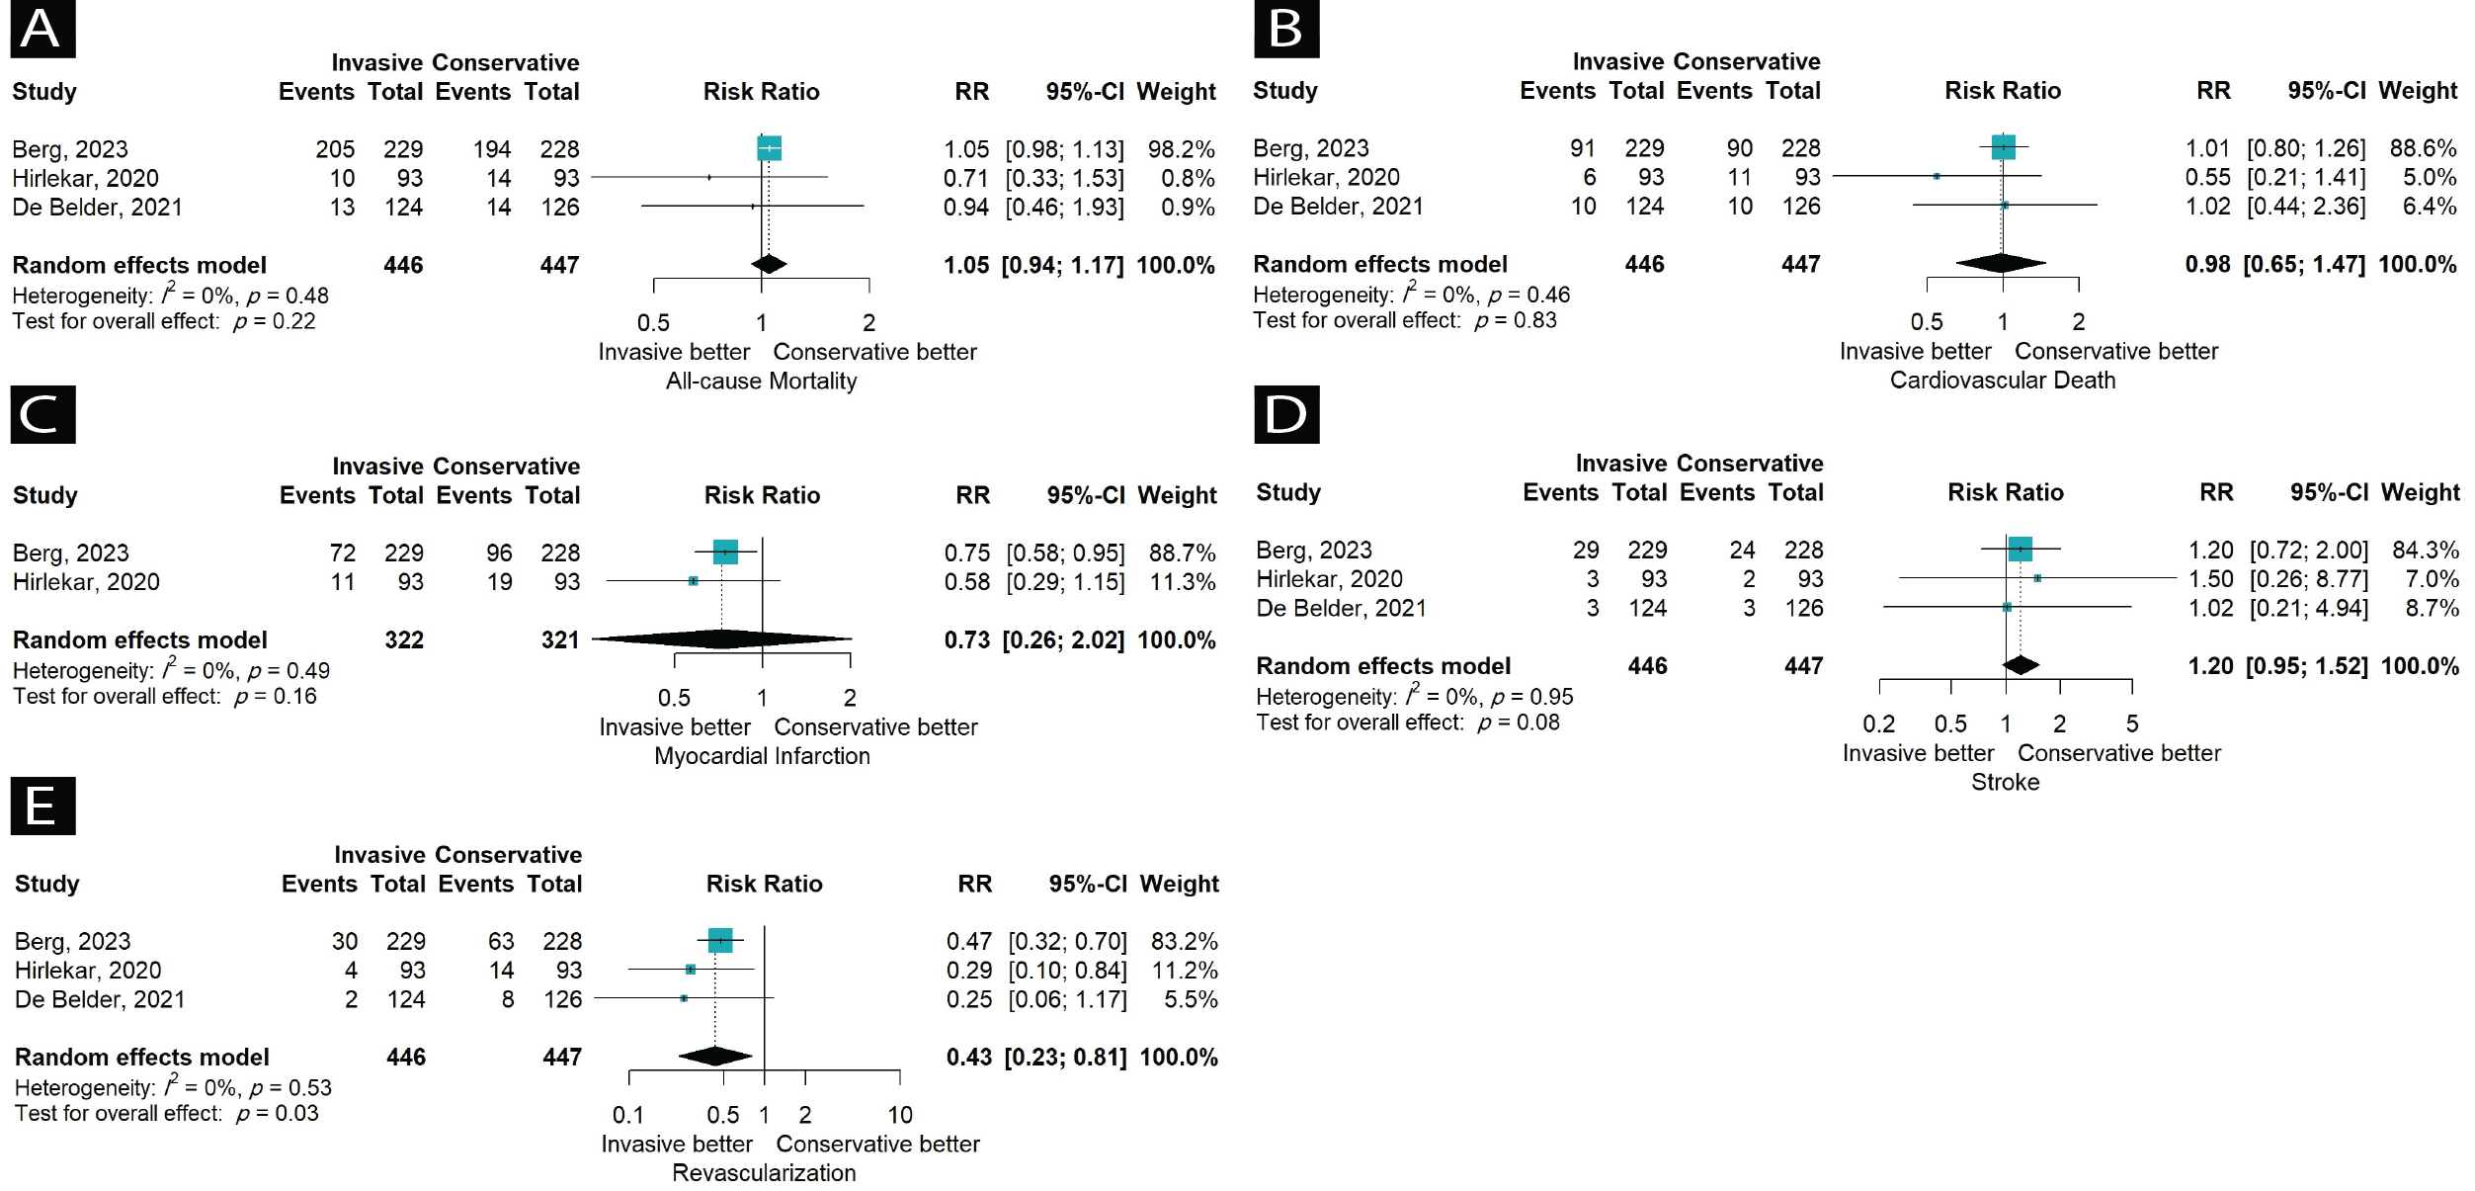
Figure S1. Octogenarians Subgroup Analyses of Outcomes

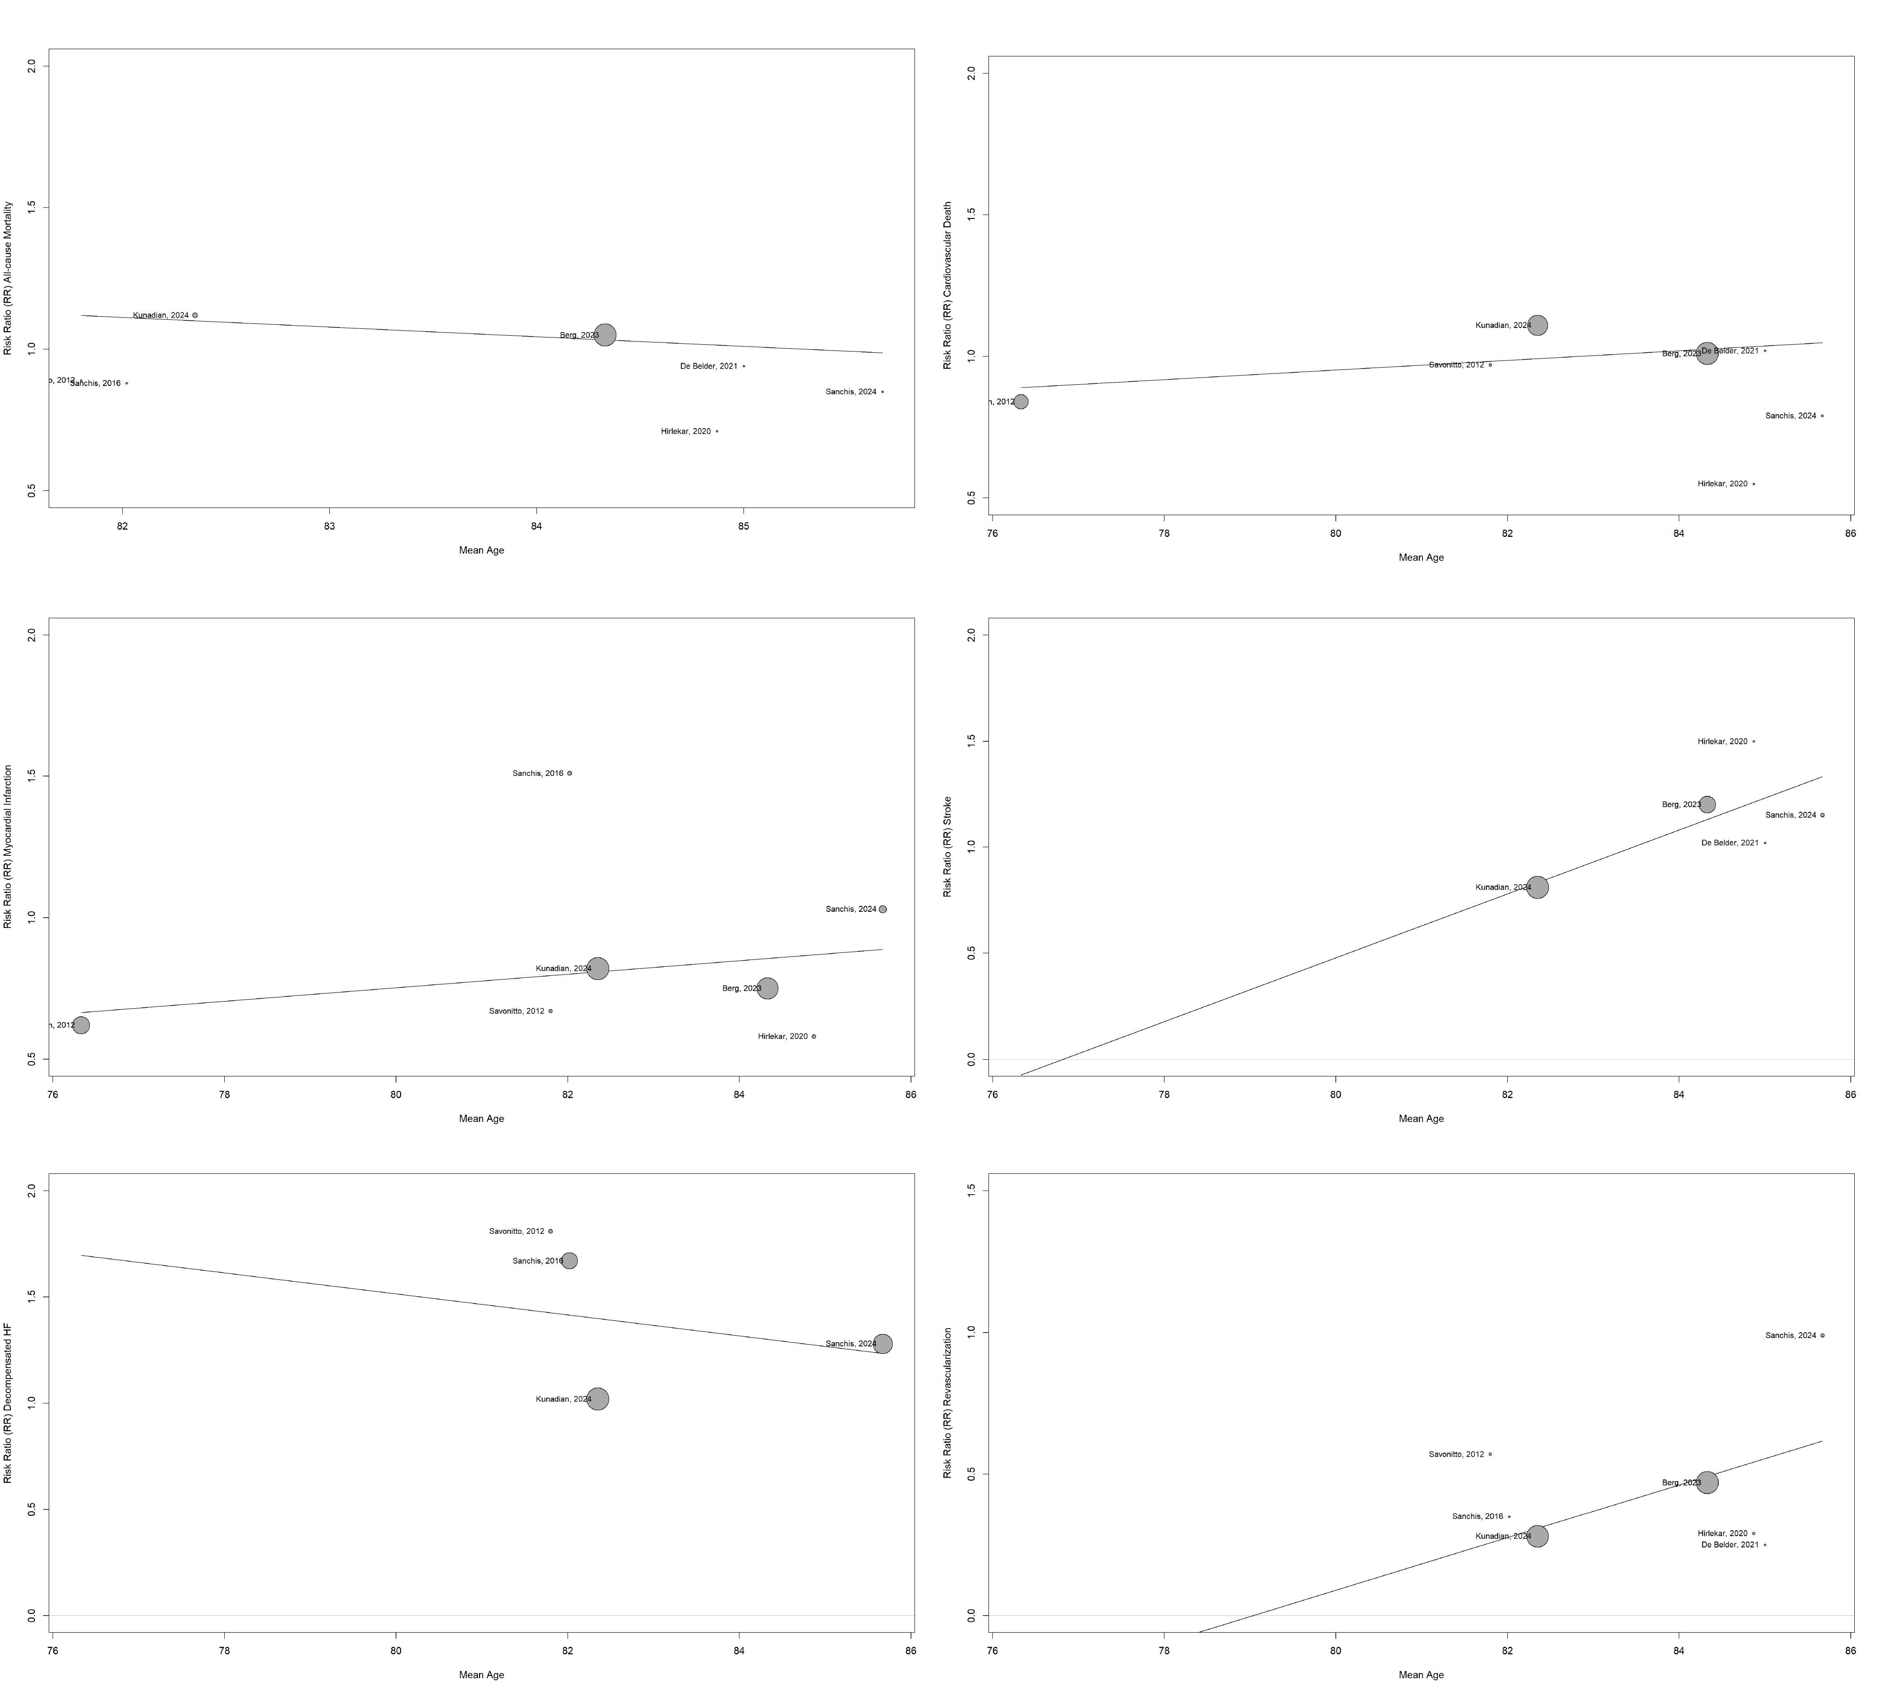
Figure S2. Meta-regression of outcomes by mean age (graphical summary)

Table S4. Meta-regression of outcomes by mean age
Outcome | Estimate (Age) | SE (Standard Error) | Z-value | P-value | CI Lower Bound | CI Upper Bound
All-Cause Death | -0.0341 | 0.0334 | -1.0202 | 0.3076 | -0.0995 | 0.0314
CV Death | 0.0169 | 0.022 | 0.7694 | 0.4416 | -0.0262 | 0.06
Myocardial Infarction | 0.0239 | 0.0269 | 0.8903 | 0.3733 | -0.0288 | 0.0766
Revascularization | 0.093 | 0.1032 | 0.9006 | 0.3678 | -0.1094 | 0.2953
Stroke | 0.1505 | 0.1313 | 1.1463 | 0.2517 | -0.1068 | 0.4079
Decompensated Heart Failure | -0.0493 | 0.1418 | -0.3478 | 0.728 | -0.3272 | 0.2286

Figure S3. Sensitivity Analysis of Bleeding Outcome of Studies with TIMI Definition
