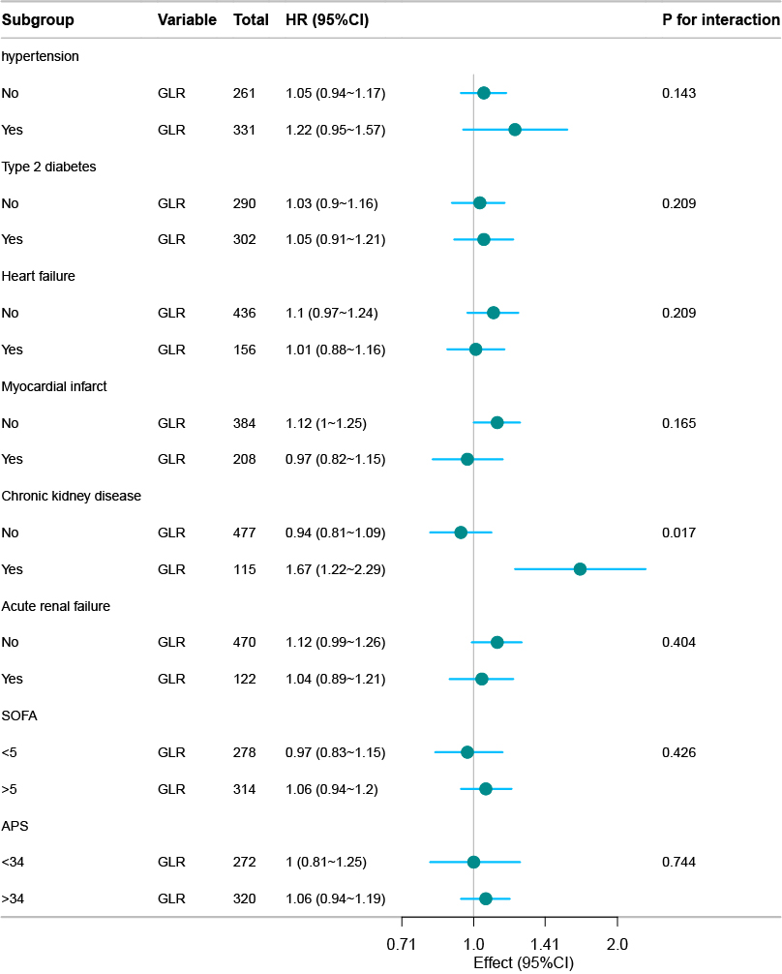
SFigure 3. Stratified analysis of the association of association of GLR with four-year outcome. Adjusted HRs are shown. Interaction was tested adjusted. Subgroups with and adjusted P-interaction <0.05 were considered effect modifiers on the association of GLR with outcome.

