Supplementary Appendix
Supplemental Table 1. Baseline participants characteristics between arrhythmia-free and arrhythmia groups over a 12-month follow-up

Supplemental Figure 1. Study flowchart. PAF, paroxysmal atrial fibrillation; PVI, Pulmonary vein isolation.
Supplemental Figure 2. Kaplan-Meier curves for RF power settings and arrhythmia-free survival stratified by BMI. RF, radiofrequency; BMI, body mass index.
Supplemental Figure 3. Kaplan-Meier curves for RF power settings and arrhythmia-free survival stratified by mitral valve status. RF, radiofrequency.
Supplemental Figure 4. Kaplan-Meier curves for RF power settings and arrhythmia-free survival stratified by tricuspid valve status. RF, radiofrequency.
Supplemental Figure 5. Kaplan-Meier curves for RF power settings and arrhythmia-free survival stratified by anti-coagulation strategy. RF, radiofrequency.

Supplemental table 1. Baseline participants characteristics between arrhythmia-free and arrhythmia groups over a 12-month follow-up
Baseline variables | Overall  (n = 259) | Arrhythmia-free (n = 229) | Arrhythmia  (n = 30)
Age, yrs | 60.9 ± 10.7 | 61.2 ± 10.9 | 58.8 ± 8.9
Male, n (%) | 166 (64.1) | 149 (65.1) | 17 (56.7)
BMI, kg/m² | 24.1 ± 3.34 | 24.1 ± 3.41 | 23.9 ± 2.82
Medical history
Hypertension, n (%) | 117 (45.2) | 104 (45.4) | 13 (43.3)
Diabetes, n (%) | 31 (12.0) | 29 (12.7) | 2 (6.7)
CHD, n (%) | 43 (16.6) | 40 (17.5) | 3 (10.0)
Renal Insufficiency, n (%) | 9 (3.5) | 9 (3.9) | 0 (0)
DCM, n (%) | 1 (0.4) | 1 (0.4) | 0 (0)
SSS, n (%) | 3 (1.2) | 2 (0.9) | 1 (3.3)
Thromboembolism, n (%) | 23 (8.9) | 22 (9.6) | 1 (3.3)
Atrioventricular Block, n (%) | 6 (2.3) | 6 (2.6) | 0 (0)
LVEF, % | 62.9 ± 6.17 | 62.9 ± 6.32 | 62.7 ± 4.99
LV size, mm | 44.1 ± 4.09 | 44.1 ± 4.27 | 43.9 ± 2.36
LA size, mm | 41.2 ± 5.23 | 41.4 ± 5.27 | 39.5 ± 4.64
RV size, mm | 29.8 ± 4.16 | 29.8 ± 4.22 | 30.0 ± 3.72
RA size, mm | 37.1 ± 5.20 | 37.4 ± 5.19 | 34.8 ± 4.81
HAS-BLED | 0.95 ± 1.09 | 1.00 ± 1.09 | 0.66 ± 1.00
CHA2DS2-VASc | 1.79 ± 1.54 | 1.83 ± 1.59 | 1.47 ± 1.04
Anticoagulant, n (%)
Dabigatran | 76 (29.3) | 66 (28.8) | 10 (33.3)
Warfarin | 19 (7.3) | 17 (7.4) | 2 (6.7)
Rivaroxaban | 151 (58.3) | 134 (58.5) | 17 (56.7)
Non | 5 (1.9) | 5 (2.2) | 0 (0)
Mitral Valve, n (%)
normal | 34 (13.1) | 25 (10.9) | 9 (30.0)
mild | 205 (79.2) | 184 (80.3) | 21 (70.0)
moderate to severe | 20 (7.7) | 20 (8.7) | 0 (0)
Tricuspid Valve, n (%)
normal | 32 (12.4) | 21 (9.2) | 11 (36.7)
mild | 197 (76.1) | 178 (77.7) | 19 (63.3)
moderate to severe | 30 (11.6) | 30 (13.1) | 0 (0)
Abbreviation: BMI, body mass index; CHD, coronary heart disease; DCM, dilated cardiomyopathy; SSS, sick sinus syndrome; LVEF, left ventricular ejection fraction; LV, left ventricular; LA, left atrium; RV, right ventricle; RA, right atrium.
Supplemental Figure 1. Study flowchart

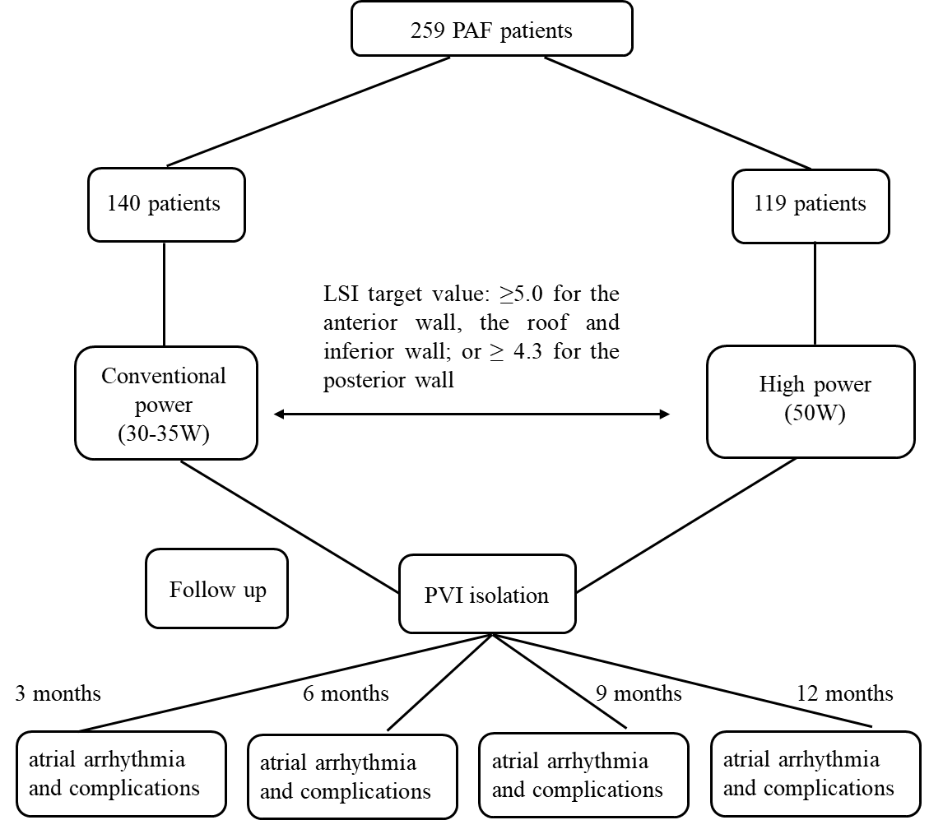
Supplemental Figure 2. Kaplan-Meier curves for RF power settings and arrhythmia-free survival stratified by BMI
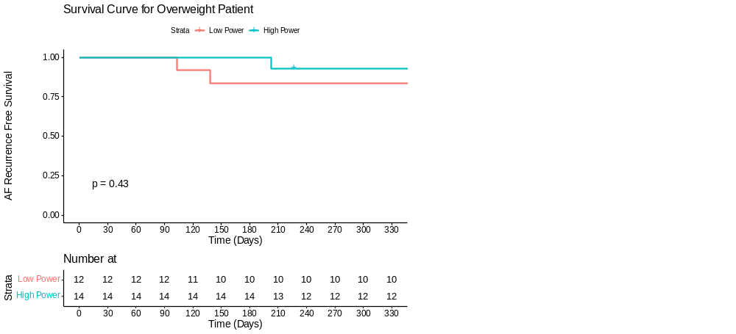
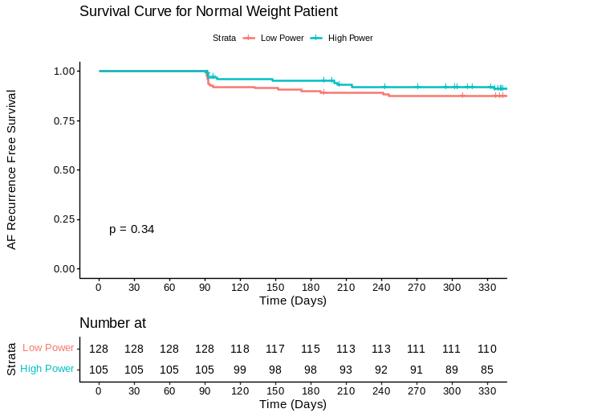

Supplemental Figure 3. Kaplan-Meier curves for RF power settings and arrhythmia-free survival stratified by mitral valve status
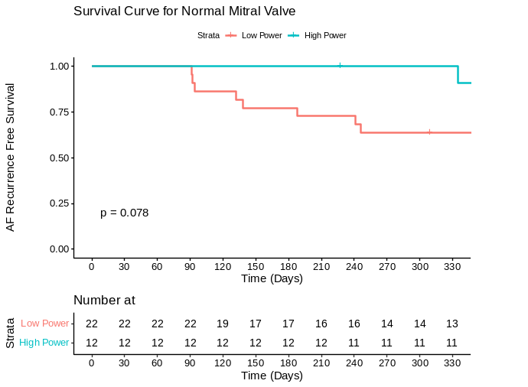
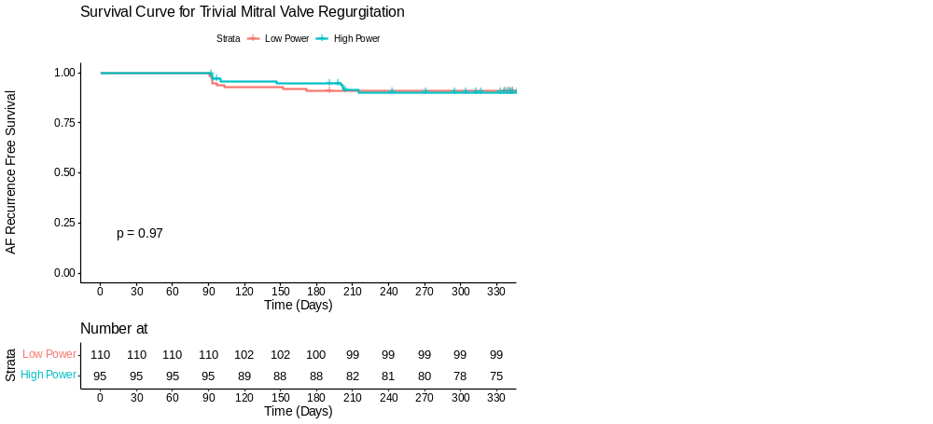
Supplemental Figure 4. Kaplan-Meier curves for RF power settings and arrhythmia-free survival stratified by tricuspid valve status
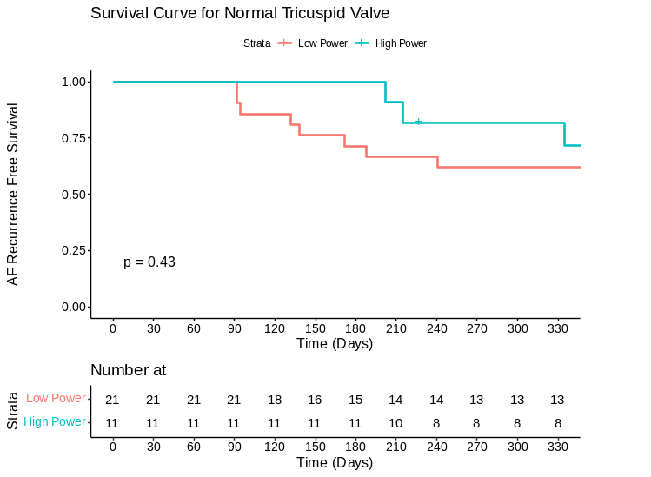
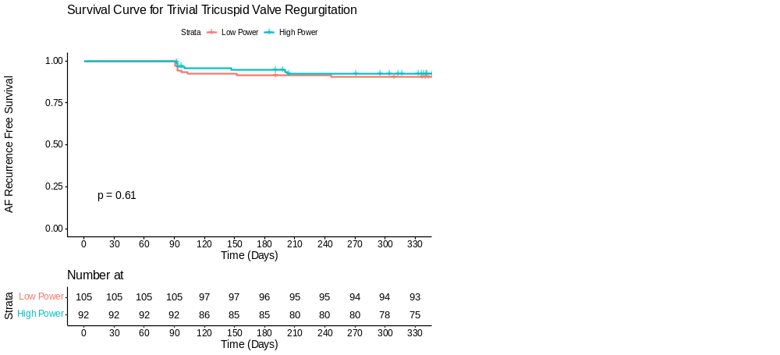

Supplemental Figure 5. Kaplan-Meier curves for RF power settings and arrhythmia-free survival stratified by anti-coagulation strategy
