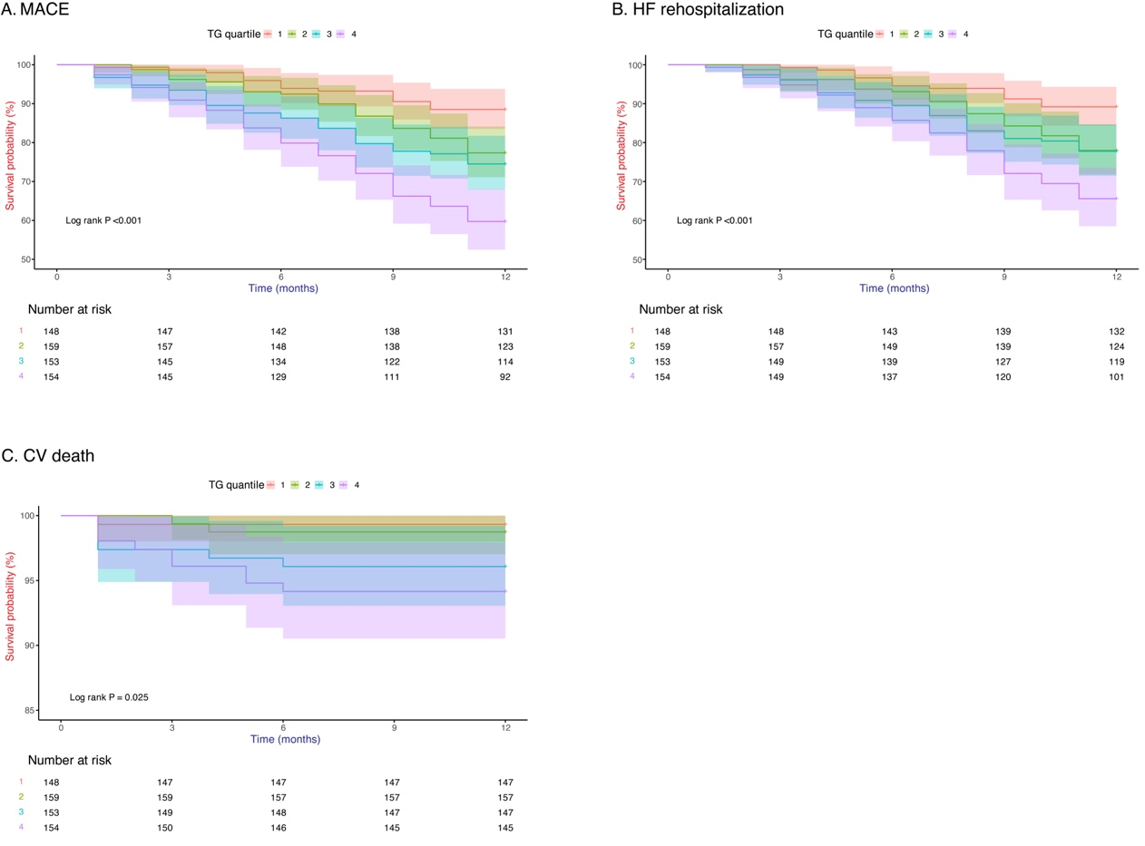
Fig. S1 Kaplan–Meier analyses for different endpoints among the TG ratio quartiles. A: MACE. B: CV death. C: HF rehospitalization. CV, cardiovascular; HF, heart failure.

