Table S1. Subgroup analysis of the association between Serum sST2 levels and MIRI in STEMI patients
Subgroup | Total | Unadjusted |  | Adjusted |  |  | P for interaction
Subgroup | Total | OR (95% CI) |  | 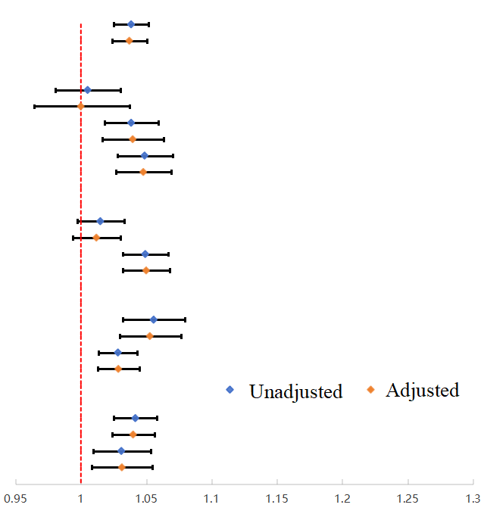  OR (95% CI)
All patients | 223 | 1.0384(1.0253-1.0518) |  | 1.037(1.0237-1.0505)
Age |  |  |  |  |  |  | 0.3967
＜40 | 17 | 1.0051(0.9806-1.0302) |  | 0.9999(0.9641-1.037)
≥40,＜60 | 77 | 1.0384(1.0178-1.0594) |  | 1.0396(1.0165-1.0631)
≥60 | 129 | 1.0487(1.0278-1.0701) |  | 1.0477(1.0266-1.0692)
Gender |  |  |  |  |  |  | 0.3811
Female | 48 | 1.0148(0.9971-1.0329) |  | 1.0118(0.9938-1.03)
Male | 175 | 1.0492(1.032-1.0666) |  | 1.0499(1.032-1.068)
Hypertension |  |  |  |  |  |  | 0.9527
No | 119 | 1.0556(1.0319-1.0798) |  | 1.0527(1.0295-1.0764)
Yes | 104 | 1.0283(1.0136-1.0432) |  | 1.0286(1.0126-1.0447)
Diabetes mellitusn |  |  |  |  |  |  | 0.9202
No | 162 | 1.0416(1.0252-1.0582) |  | 1.0399(1.0236-1.0565)
Yes | 61 | 1.0309(1.0091-1.0532) |  | 1.0313(1.0082-1.0548)
Unadjusted: No variables have been adjusted; Adjusted for age, hypertension, diabetes, BMI, smoking status, IRA, and high thrombus burden.

