Supplementary Figure 1: Cumulative survival risk graph stratified by sex, with all lines meaning the same as the labels in (A). AKI patients (A); non-AKI patients (B); VA patients (C); non-VA patients (D).
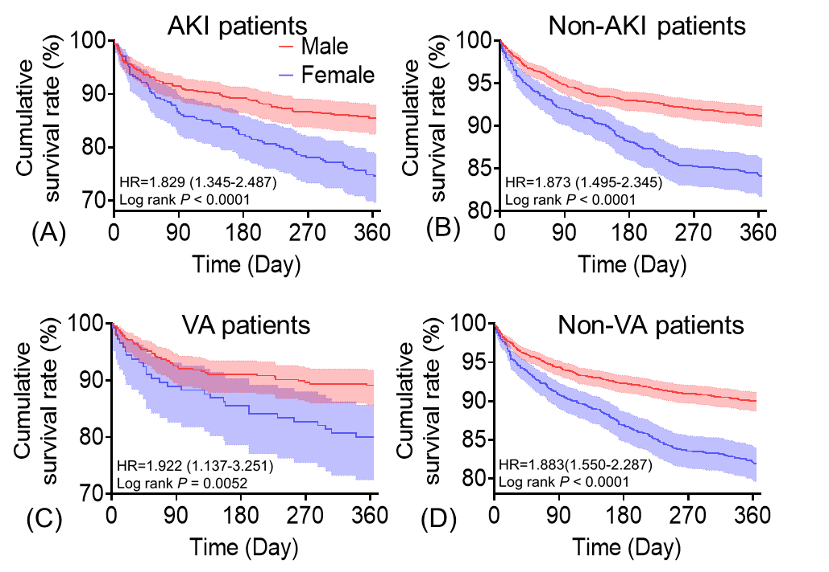

Supplementary Figure 2: Cumulative survival risk plot stratified by gender, with all lines having the same meaning as the labels in (A). Survival plots for males versus females in all patients (A); all patients with atrial fibrillation (B); all patients without atrial fibrillation (C); all patients with hypertension (D); and all patients without hypertension (E).
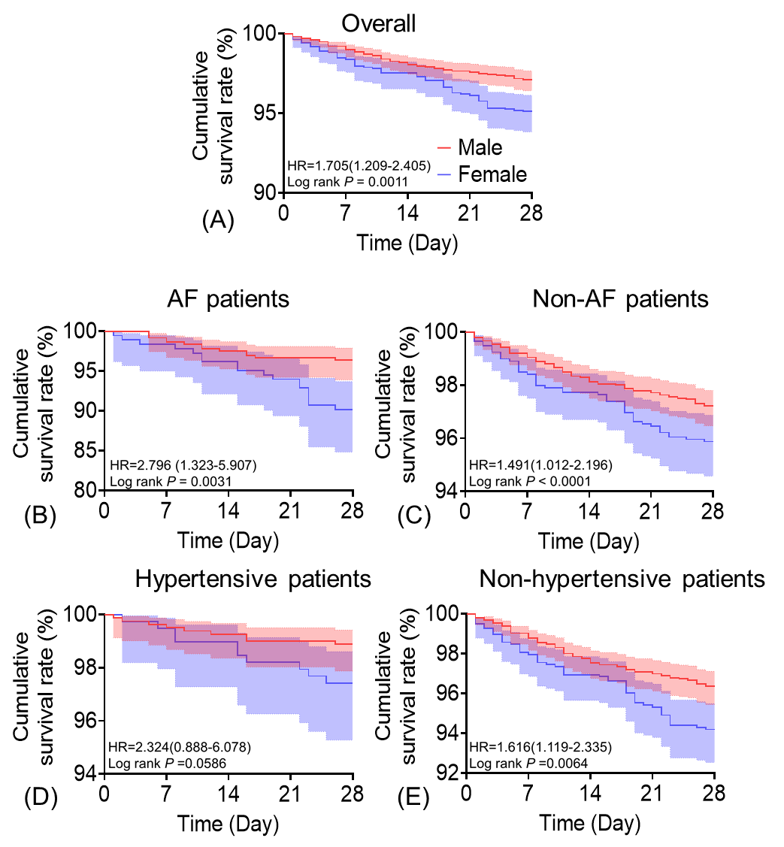

Supplementary Figure 3: Cumulative survival risk plot stratified by gender, with all lines having the same meaning as the labels in (A). All patients with chronic kidney disease (A); all patients with non-chronic kidney disease (B); all patients with type 2 diabetes mellitus (C); all patients with non-type 2 diabetes mellitus(D).
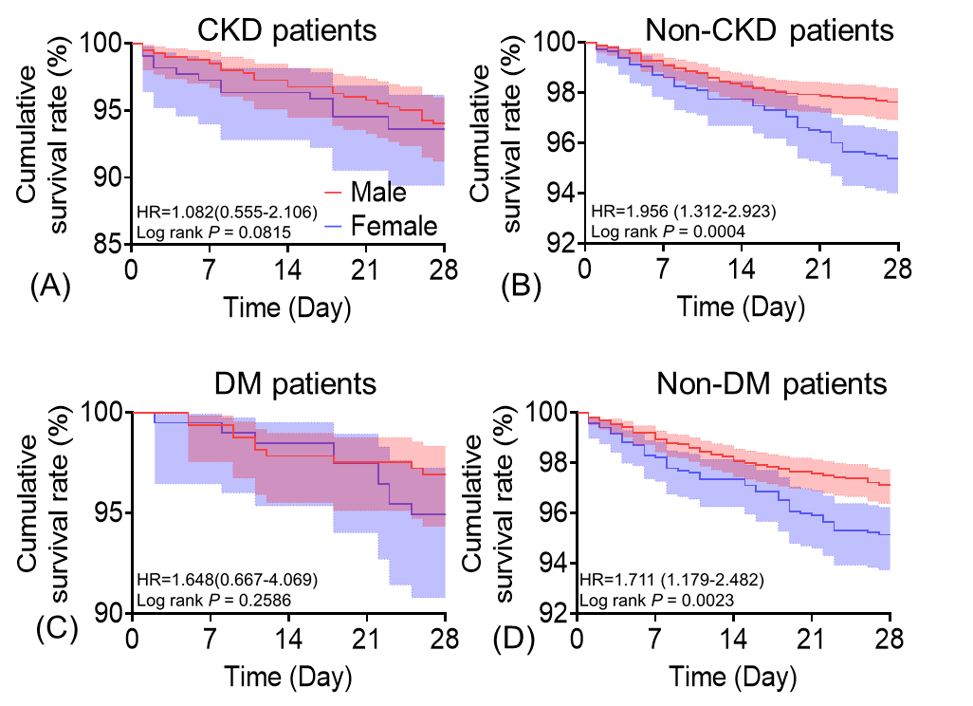

Supplementary Figure 4: Cumulative survival risk graph stratified by sex, with all lines meaning the same as the labels in (A). AKI patients (A); non-AKI patients (B); VA patients (C); non-VA patients (D).
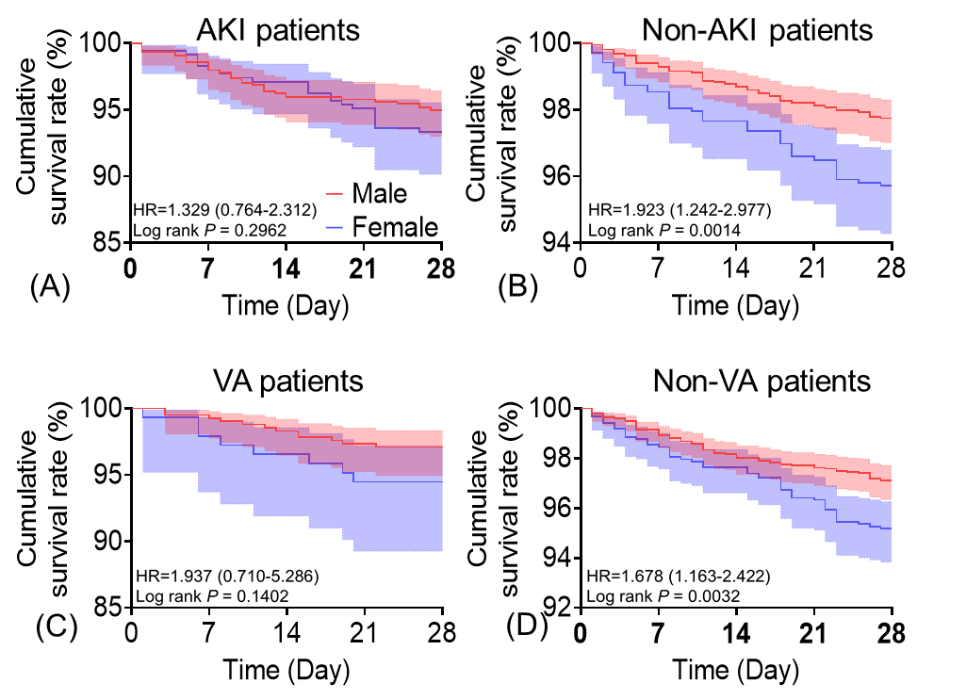

Supplementary Figure 5：Cumulative survival risk maps stratified by sex.
