Supplementary material
Definitions of risk scores: 2
Details of missing data……………………………………………………………...3
Table S1 Composing of complex PCI...............................................................4
Figure S1: The flow of the enrollment. 5
Table S2 Antithrombotic therapy status according to the complexity of PCI 6
Figure S2 Cumulative rate of stroke 7
Figure S3 Cumulative rate of all-cause death 8
Figure S4 Cumulative rate of systematic embolism 9
Figure S5 Cumulative rate of TIMI major bleeding..........................................10
Table S3 Multivariate cox analysis of ischemic driven revascularization 11
Table S4 Multivariate cox analysis of MI 12
Table S5 Antithrombotic therapy based on CHA₂DS₂-Vasc score and the complexity of PCI 13
Figure S6 subgroup analysis of MACE events according to CHA₂DS₂-Vasc score and the complexity of PCI 14

Definitions of endpoints and Calculation of risk scores:

Cardiovascular death was classified according to ARC-2 criteria as death due to a clear cardiovascular cause, procedure related, or those with undetermined cause.

Ischemic stroke was adjudicated as the acute symptomatic episode of focal cerebral, spinal, or retinal dysfunction caused by an infarction of the central nervous system tissue and documented by imaging (e.g., computed tomography [CT] scan or magnetic resonance imaging [MRI] scan).

Transient ischemic attack (TIA) was defined as focal cerebral ischemic event with symptoms lasting <24 h.

Systemic embolism was defined as new acute limb ischemia or objective evidence of sudden loss of perfusion of a limb or an organ.

MI was defined according to the fourth universal definition of MI.

Ischemia-driven coronary revascularization included all coronary revascularization during follow-up that were performed in the context of MI and those for worsening symptoms in combination with evidence of myocardial ischemia.
CHA2DS2-VASc scores: congestive heart failure, hypertension, diabetes, vascular disease, age 65–74 years, and sex category (female) with 1 point and 2 points for age ≥75 years or stroke.
HAS-BLED scores: 1 point each for uncontrolled hypertension with systolic blood pressure over 160 mm Hg, abnormal renal function, abnormal hepatic function, previous ischemic or hemorrhagic stroke, bleeding history or predisposition, elderly (age > 65 years), concomitant use of antiplatelet or non-steroid anti-inflammatory drug (NSAIDs) and excessive alcohol intake per week, and labile international normalized ratio (INR) is applied for patients receiving warfarin with over 3 times INR measurements.
Details of missing data:
BMI (body mass index), HAb1c and LA (left atrium diameter) were imputed with mean value.
LDL (Low-Density Lipoprotein), cTnI (cardiac troponin I) and NE-pro BNP (N-terminal pro-B-type natriuretic peptide) were imputed with median value.
All missing value were less than 5% of overall value.

Table S1: Composing of complex PCI
 | ≥3 separate major coronary vessels | ≥3 stents implanted | ≥3 lesions treated | total stented length >60 mm | Total
Number | 72 | 219 | 166 | 241 | 320

Figure S1: The flow of the enrollment.
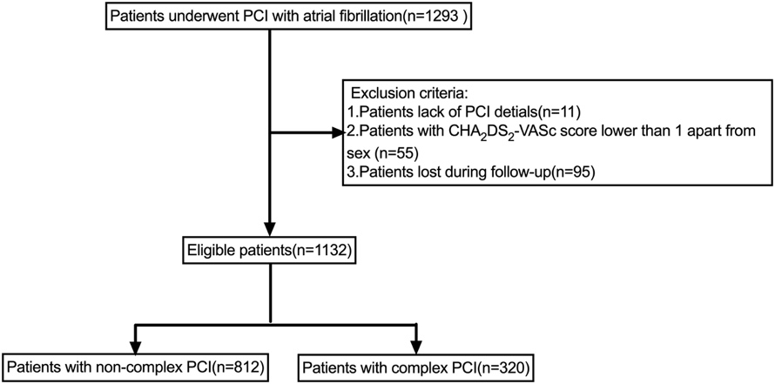
 | Complex PCI | Non-complex PCI | Overall | P value
Antiplatelet therapy | 202(63.1) | 567(69.8) | 769(67.9) | 0.04
DAT | 10(3.1) | 22(2.7) | 32(2.8) | 0.86
TAT | 108(33.8) | 223(27.5) | 331(29.2) | 0.04
OAC usage | 118(36.9) | 245(30.2) | 363(32.1) | 0.04

Table S2 Antithrombotic therapy status according to the complexity of PCI
Data was presented with number (percent)
OAC: oral anticoagulant; PCI: percutaneous coronary intervention;

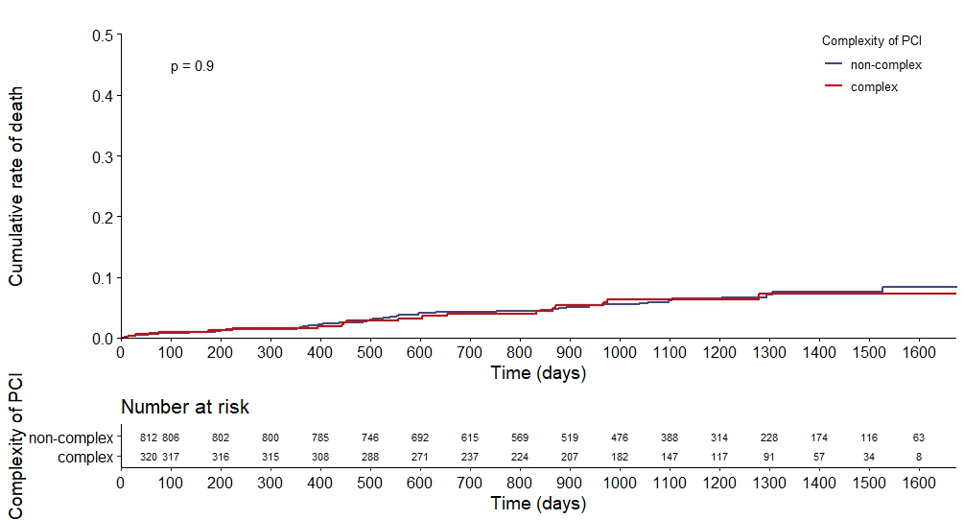
Figure S2 Cumulative rate of all-cause death

Figure S3 Cumulative rate of stroke
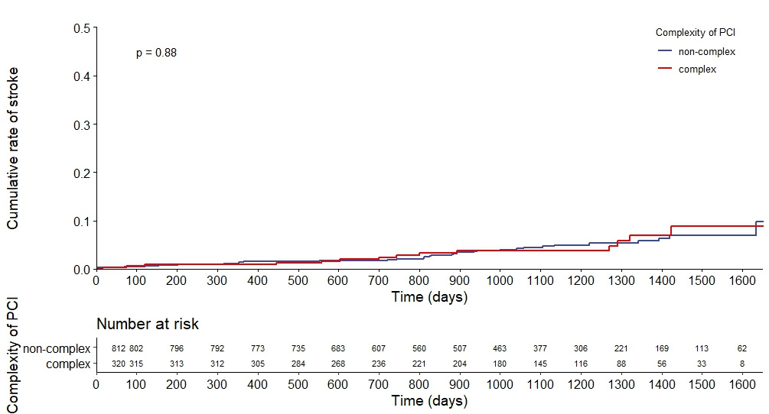

Figure S4 Cumulative rate of systematic embolism
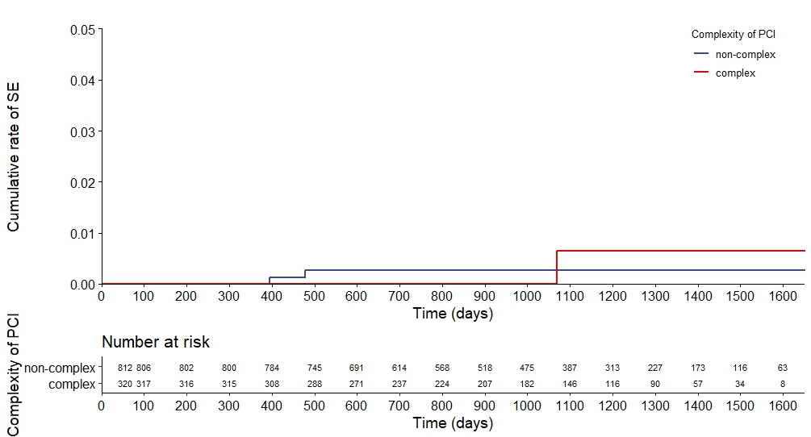
Figure S5 Cumulative rate of TIMI major bleeding

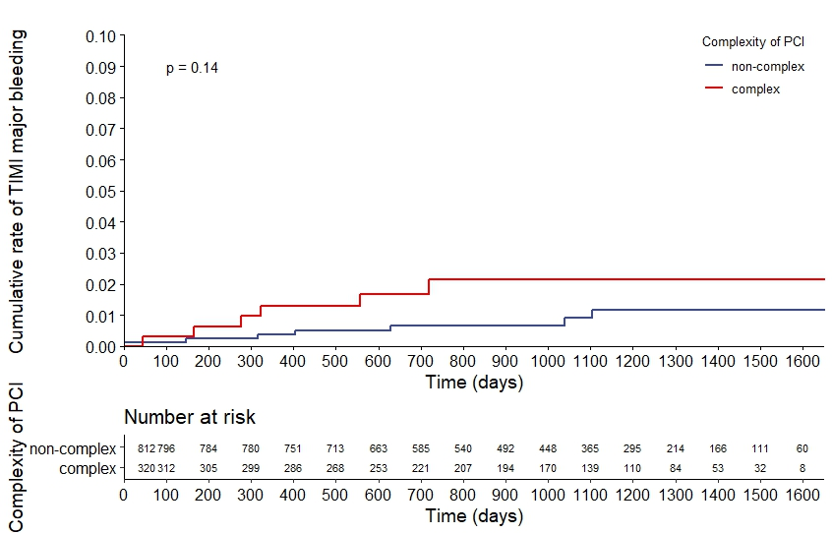

Table S3 multivariate cox analysis of ischemic driven revascularization
 | HR | Lower 95%CI | Upper 95%CI | P value
PCI complexity | 1.8640 | 1.0061 | 3.453 | 0.048
Peak cTnI | 1.0003 | 0.9991 | 1.002 | 0.58
Age | 0.9998 | 0.9595 | 1.042 | 0.99
BMI | 0.9947 | 0.8988 | 1.101 | 0.92
Sex | 1.1184 | 0.4688 | 2.668 | 0.80
Smoke | 1.3735 | 0.9165 | 2.058 | 0.12
Antithrombotic therapy | 2.0323 | 1.5919 | 2.595 | <0.001
History of HF | 1.2781 | 0.5379 | 3.037 | 0.58
History of hypertension | 0.9425 | 0.4404 | 2.017 | 0.88
History of hyperlipidemia | 0.9820 | 0.4928 | 1.957 | 0.96
History of diabetes mellitus | 1.7339 | 0.9310 | 3.229 | 0.08
History of CKD | 1.0146 | 0.2158 | 4.771 | 0.99
Creatinine clearance | 1.0139 | 0.9984 | 1.030 | 0.08
LV | 1.0104 | 0.9469 | 1.078 | 0.76
LVEF | 1.0137 | 0.9674 | 1.062 | 0.57
AF: atrial fibrillation,BMI: body mass index, CKD: chronic kidney disease,HF: heart failure, LV: left ventricular end diastolic diameter, LVEF: left ventricular ejection fraction; PCI: percutaneous coronary intervention

Table S4. Multivariate cox analysis of MI
 | HR | Lower 95%CI | Upper 95%CI | P value
PCI complexity | 2.1686 | 1.00144 | 4.696 | 0.0496
Peak cTnI | 0.9992 | 0.99692 | 1.001 | 0.46
Age | 1.0166 | 0.96536 | 1.070 | 0.53
BMI | 0.9882 | 0.87172 | 1.120 | 0.85
Sex | 0.8175 | 0.26562 | 2.516 | 0.73
Smoke | 1.3973 | 0.83083 | 2.350 | 0.21
Antithrombotic therapy | 1.4888 | 1.11527 | 1.987 | 0.01
History of HF | 1.2831 | 0.44135 | 3.730 | 0.65
History of hypertension | 0.9139 | 0.37248 | 2.243 | 0.84
History of hyperlipidemia | 1.0776 | 0.42236 | 2.750 | 0.88
History of diabetes mellitus | 1.6032 | 0.73893 | 3.479 | 0.23
History of CKD | 0.3233 | 0.03811 | 2.742 | 0.30
Creatinine clearance | 0.9985 | 0.97751 | 1.020 | 0.89
LV | 0.9487 | 0.87471 | 1.029 | 0.20
LVEF | 0.9554 | 0.90444 | 1.009 | 0.10
BMI: body mass index, CKD: chronic kidney disease,HF: heart failure, LV: left ventricular end diastolic diameter, LVEF: left ventricular ejection fraction; PCI: percutaneous coronary intervention

Table S5. antithrombotic therapy based on CHA₂DS₂-VASc score and the complexity of PCI
 | Low CHA₂DS₂-VASc score |  | High CHA₂DS₂-VASc score |  | P value
 | Complex | Non-complex | Complex | Non-complex | P value
Antiplatelet therapy | 124 (68.1) | 323 (70.7) | 78 (56.5) | 244 (68.7) | 0.03*
DAT | 6 (3.3) | 8 (1.8) | 4 (2.9) | 14 (3.9) | 0.45
TAT | 52 (28.6) | 126 (27.6) | 56 (40.6) | 97 (27.3) | 0.02§
DAT: double antithrombotic therapy; TAT: triple antithrombotic therapy

*p value was calculated among four groups based on χ2 test.
p value was calculated between complex and non-complex PCI with low CHA2DS2-VASc score based on χ2 test.
§p value was calculated between complex and non-complex PCI with high CHA2DS2-VASc score based on χ2 test.

Figure S6. subgroup analysis of MACE according to CHA₂DS₂-VASc score and the complexity of PCI
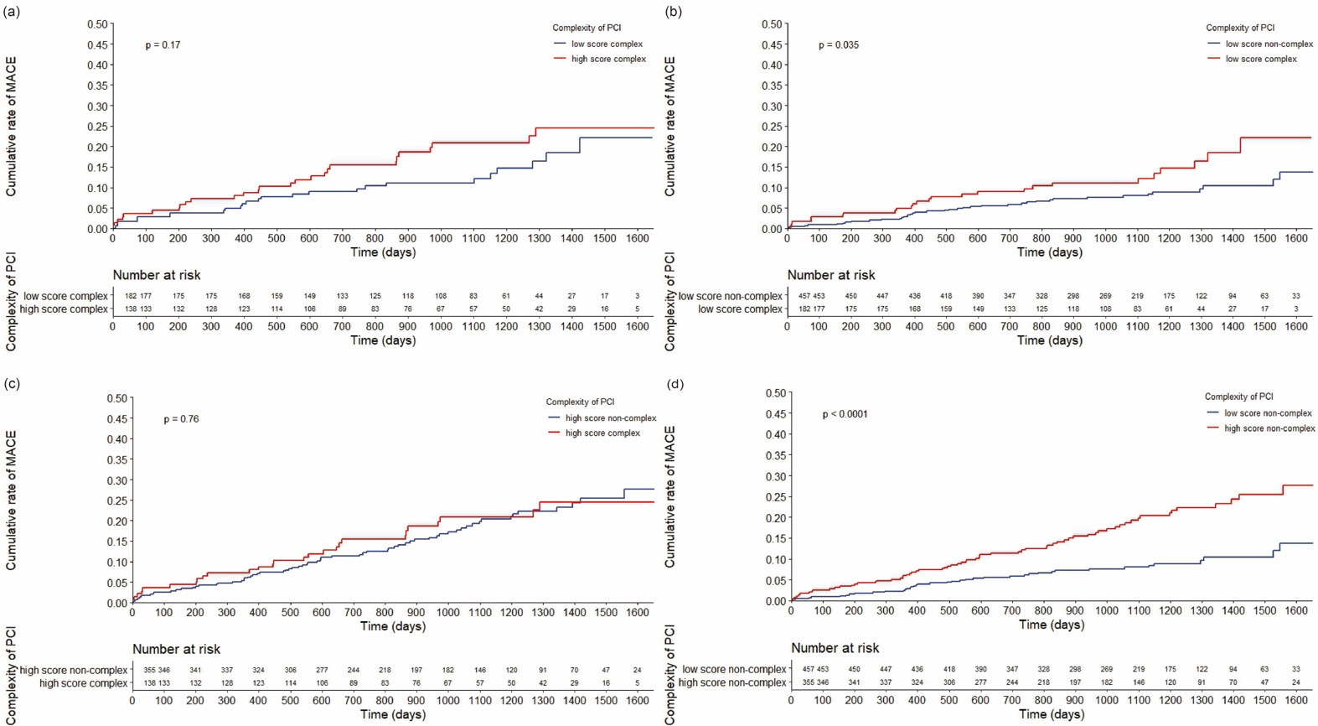
Low score & complex: CHA2DS2-Vasc score from 1 to 3 and complex PCI.
High score & complex: CHA2DS2-Vasc score from 4 to 9 and complex PCI.
Low score & non- complex: CHA2DS2-Vasc score from 1 to 3 and non-complex PCI.
High score & non- complex: CHA2DS2-Vasc score from 4 to 9 and non-complex PCI.

