SUPPLEMENTAL MATERIAL

Study samples

The UK Biobank (UKB) is a prospective cohort study with genotype and detailed phenotype information for up to 502,269 individuals aged 40-69 years when recruited between 2006 and 2010. UKB participant data, linked to National Health Service (NHS) central registers for information on death, cancer registrations, and hospital admissions in England, Scotland, and Wales up to September 1st, 2023, are enriched with demographic characteristics, lifestyle details, and self-reported health outcomes. This comprehensive dataset, which includes hospital admission records from 1985 for Scotland and 1997 for England and Wales, undergoes record linkage based on NHS number, postcode, sex, and age. Collected baseline information encompasses various facets, such as age, gender, continental ancestry, country of birth, education, socioeconomic status, body mass index (BMI), and smoking status. Extracted from linked hospital episode statistic (HES) data are dates, duration of hospitalization, ICD-10 diagnostic codes, and OPCS-4 procedural codes. Genotype data is also available for most participants, which includes positions that are either directly genotyped on one of two arrays (UKB Axiom and UK BiLEVE arrays) or imputed using a reference panel from the Trans-Omics for Precision Medicine (TOPMed). Participants who did not have genetic data were excluded from this study. First available diagnosis dates, derived from hospital episode statistic inpatient data (HESIN) operations and diagnosis were considered for this study. Rehospitalization was defined as the next instance occurring 30 days after the first diagnosis, with endpoints including rehospitalization, cardiovascular death, study end (September 1st, 2023). Events of non-cardiovascular death were censored at the time of death. The starting dates correspond to when a patient was initially diagnosed with a specific disease of interest. UK Biobank was approved by the North West Multi-Centre Research Ethics Committee and all participants provided written informed consent to participate.

Propensity score matching

Propensity score matching, implemented through nearest neighbor stratification using the MatchIt R package (Ho D, Imai K, King G, Stuart E (2011). “MatchIt: Nonparametric Preprocessing for Parametric Causal Inference.” Journal of Statistical Software, 42(8), 1–28. doi:10.18637/jss.v042.i08.), was a pivotal method employed to enhance comparability between treatment and control populations for the subsequent assessment of survival outcomes. The technique involved assigning individuals with available genetic data (either genotyped or TOPMed imputed) into control and treatment groups based on their reported SNP dosage, typically categorized as rounded dosages of 0 and those having at least one of the effect alleles (combining 1 and 2 dosages). Propensity scores were generated to represent the probability of receiving the genetic treatment, considering various baseline covariates.

To ensure a well-balanced comparison, participants were meticulously matched on critical factors listed for each single nucleotide polymorphism (SNP) below. The evaluation of balance before and after matching was conducted using the standardized mean difference, with an absolute value less than 0.1 for total distance serving as a criterion for well-balanced groups. Propensity score matching not only facilitated the control of potential confounding variables but also enhanced the validity of subsequent survival analyses by creating more comparable cohorts based on clinical characteristics.

The study focused on testing SNPs associated with known cardiovascular effects, specifically examining rs11591147 and rs562556 from PCSK9, rs7076938 from ADRB1, and rs4968782 as well as rs4363 from the ACE gene. Regression analyses were conducted using generalized linear model (glm) function of the glmnet package in R, employing both Gaussian and binomial models for linear and binary outcomes. The glmnet package (Version 4.1-8; Friedman et al., 2010) facilitated data analysis. Genotypic information was available for 464,428 participants for rs4968782, 473,376 participants for rs7076938, and 487,227 participants for rs11591147. This robust dataset enables a comprehensive exploration of the genetic associations between these selected SNPs and cardiovascular outcomes, providing valuable insights into the potential role of these genetic variations in cardiovascular health.

The rs11591147 and rs562556 polymorphisms within the PCSK9 gene were investigated, revealing an overall mean standardized difference of less than 0.01 in the examined cohort. The control group consisted of participants homozygous for the G allele while the treatment group consisted of participants with at least one copy of the T allele for rs11591147, or at least one copy of the A allele for rs562556. Covariate adjustments were implemented for sex, C-Reactive Protein, smoking, body mass index (BMI), low density lipoprotein (LDL) levels, first systolic blood pressure reading, diuretics use, angiotensin II receptor blocker (ARB) use, beta-blockers use, ACE inhibitor (ACEi) use, calcium channel blocker use, digoxin use, statins use, anti-coagulants use, age of ischemic heart disease (IHD) diagnosis, and previous disease diagnoses encompassing atrial fibrillation (AF), aortic valve stenosis, chronic renal failure, chronic obstructive pulmonary disease (COPD), heart failure (HF), dilated cardiomyopathy (DCM), hypertrophic cardiomyopathy (HCM), mitral valve disorder, type 1 diabetes (T1D), type 2 diabetes (T2D), unspecific stroke, and ventricular arrhythmias. The exclusion criteria for this study encompassed patients undergoing treatment with ezetimibe and centrally acting anti-hypertensive and vasodilator anti-hypertensive medications. These exclusions were instituted due to the pharmacological actions of these agents, which target LDL cholesterol, akin to the mechanism of PCSK9 inhibitors. In this analysis of PCSK9, only individuals of European ancestry were included due to the observed heightened effect of the SNP within this demographic, enhancing detection sensitivity and statistical power for assessing its influence on the phenotype. Analysis in unmatched data was adjusted for sex and age of disease diagnosis, while analysis in matched data was unadjusted (Supplemental Figure 1).

The rs7076938 polymorphism within the ADRB1 gene was investigated, revealing an overall mean standardized difference of less than 0.01 in the studied population. The control group consisted of participants with at least one copy of the C allele, while the treatment group consisted of participants homozygous for the T allele. Covariate adjustments were made for various factors including sex, C-Reactive Protein level, smoking status, BMI, LDL levels, diuretics use, calcium channel blocker, alpha adrenoceptor blocking drug use, statins use, digoxin use, ARB use, anti-coagulant medication use, previous disease diagnosis for aortic valve stenosis, chronic renal failure, COPD, HF, T1D, T2D, ischemic heart disease (IHD), mitral valve disorder, unspecific stroke, and age of AF diagnosis. We excluded individuals using ACEi or beta-blockers to mitigate confounding effects associated with the excluded medications (Supplemental Figure 2). This matching criterion was used for both the assessment of severe cardiovascular outcomes (CV death/heart transplant) after AF diagnosis and time to rehospitalization or CV death/heart transplant composite outcome from AF. Analysis in unmatched data was adjusted for sex and age of disease diagnosis, while analysis in matched data was unadjusted.

The rs4968782 and rs4363 polymorphisms within the ACE gene was scrutinized, revealing an overall mean standardized difference of less than 0.01 in the studied population. For each SNP, the control group consisted of participants homozygous for the G allele while the treatment group consisted of participants with at least one copy of the A allele. When investigating time to rehospitalization due to all-cause HF or CV death/heart transplant in patients diagnosed with HF, we balanced for sex, C-Reactive Protein level, smoking status, BMI, LDL, diuretics use, calcium channel blocker use, statins use, digoxin use, ARB use, anti-coagulant medication use, aortic valve stenosis status, chronic renal failure status, COPD status, HF status, T2D status, unspecific stroke status, IHD status, and age of HF diagnosis. We excluded individuals using ACEi, beta-blockers, alpha-adrenoceptor blocking drugs, vasodilator anti-hypertensives, and centrally acting anti-hypertensives to mitigate potential confounding effects associated with these medications (Supplemental Figure 3).

Furthermore, in the assessment of severe cardiovascular outcomes (CV death/heart transplant) after first available AF diagnosis, we balanced the data for sex, C-Reactive Protein, smoking, BMI, LDL, diuretics, beta blockers, calcium channel blockers, alpha-adrenoceptor blocking drugs, statins, anticoagulants, antidiabetic medications, age of AF disease diagnosis, and previous disease diagnosis for aortic valve stenosis, chronic renal failure, COPD, HF, unspecific stroke, IHD, T2D, unspecific stroke, ventricular arrhythmias, and cardiac arrhythmias (Supplemental Figure 3). We excluded individuals using ACEi, vasodilator anti-hypertensives, and centrally acting anti-hypertensives to mitigate potential confounding effects associated with these medications. Analysis in unmatched data was adjusted for sex and age of disease diagnosis, while analysis in matched data was unadjusted.

The rs757110 polymorphisms within the ABCC8 gene was scrutinized, revealing an overall mean standardized difference of less than 0.01 in the studied population. For each SNP, the control group consisted of participants homozygous for the C allele while the treatment group consisted of participants with at least one copy of the A allele. For investigations of all survival phenotypes, we balanced for sex, C-Reactive Protein level, smoking status, BMI, LDL, first systolic blood pressure, diuretics use, calcium channel blocker use, statins use, digoxin use, ARB use, anti-coagulant medication use, vasodilator/centrally acting antihypertensives use, antidiabetic drug use, ezetimibe use, alpha adrenoceptor blocking drug use, and age of IHD diagnosis (Supplemental Figure 8).

The rs10305492 polymorphisms within the GLP1R gene was scrutinized, revealing an overall mean standardized difference of less than 0.01 in the studied population. For each SNP, the control group consisted of participants homozygous for the G allele while the treatment group consisted of participants with at least one copy of the A allele. For investigations of all survival phenotypes, we balanced for sex, C-Reactive Protein level, smoking status, BMI, LDL, first systolic blood pressure, diuretics use, calcium channel blocker use, statins use, digoxin use, ARB use, anti-coagulant medication use, vasodilator/centrally acting antihypertensives use, antidiabetic drug use, ezetimibe use, alpha adrenoceptor blocking drug use, and age of IHD diagnosis (Supplemental Figure 9).

In this study, we employed the SurvSNP package (PMID: 22685040) to conduct power calculations, leveraging asymptotic estimates derived from genetic hazard ratios, event rates, study population size, and allele frequencies. These calculations were based on Cox proportional hazards model results obtained before and after genetic matching for rs11591147 and rs562556 polymorphisms within the PCSK9 gene. Our objective was to assess the extent of power enhancement achieved through our methodology when examining the time to severe cardiovascular outcomes from the first available diagnosis of IHD. Power calculations for all SNPs are presented in Supplemental Table 3. Notably, for rs11591147, the power within the unmatched subset was 9.5, demonstrating a substantial increase to 73.4 after matching. Similarly, for rs562556, the power within the unmatched subset was 6.9, exhibiting an increase to 11.16 after matching. These findings underscore the enhancements in statistical power attainable through matched subset analysis, underscoring the pivotal role of selecting appropriate SNPs with substantial effect sizes for robust survival analysis outcomes (Supplemental Figure 6).

To comprehensively elucidate the diverse array of phenotypic manifestations associated with each of the SNPs, we performed phenome-wide association study (PHEWAS) adjusted for age, sex and 10 genetic principal components, and applied additive model. The PHEWAS analyses were performed using the PHESANT (PHEnome Scan ANalysis Tool) software application (PMID: 29040602). This tool facilitates automated phenome scans within the UK Biobank dataset, thereby enabling comprehensive exploration of phenotypic associations. The main dataset from the UK Biobank downloaded in March 2023 was supplemented with custom cardiovascular phenotypes created using HES update version September 2023. For logistic regression we only included phenotypes with cases > 50.

Supplemental Table 1. Phenotype definitions for cardiovascular endpoints and comorbidities used for propensity score matching.
Phenotype | ICD-9 codes | ICD-10 codes | OPCS-4 codes/other definitions
HF/ CV death composite | 4254, 4280, 4281, 4289 | I110, I130, I132, I255, I420, I425, I428, I429, I500, I501, I509
Atrial Fibrillation | 4273 | I48, I480, I481, I482, I483, I484, I489 | K571, K621, K622, K623, K624, X501, X502
Type 1 Diabetes |  | E100, E101, E102, E103, E104, E105, E106, E107, E108, E109
Type 2 Diabetes |  | E110, E111, E112, E113, E114, E115, E116, E117, E118, E119
Chronic Renal Failure | 5850-5859 | N180-N189, I120, I131, I132 | M010-M019
Myocardial Infarction | 4100-4109 | I210-I219
Mitral Valve Disorder | 4240, 3940, 3942, 3949 | I050-1059, I080, I081, I340-I349, I390 | K250-K259, K301, K341, K351
Aortic Valve Stenosis | 4241, 3951, 3959 | I060-I069, I080, I082, I083, I350-I359, I391 | K260-K269, K302
Ischemic Heart Disease | 4100-4109, 4110-4119, 4120-4129, 4130-4139, 4140-4149 | I200-I209, I210-I219, I220-I229, I230-I239, I240-I249, I250-I259
Chronic Obstructive Pulmonary Disease | 4910-4919, 4920-4929, 4960-4969 | J410-J419, J420-J429, J430-J439, J440-J449
Hypertrophic Cardiomyopathy | 4251 | I421, I422
Coronary Artery Disease |  | I210-I219, I220-I229, I230-I239, I252 | K490-K499, K500-I509, K750-K759, K400-K409, K410-K419, K420-K429, K430-K439, K440-K449, K450-K459, K460-K469
Dilated Cardiomyopathy | 4254 | I429, I420
Cardiac Arrythmias |  | I490-I499
Ventricular Arrythmias |  | I470-I479
Unspecific Stroke | 4300-4309, 4310-4319, 4320-4329, 4330-4339, 4340-4349, 4350-4359, 4360-4369 | G450-G459, I600-I609, I610-I619, I620-I629, I630-I639
Ischemic Stroke | 4330-4339, 4340-4349 | I630-I639
Hemorrhagic Stroke | 4310-4319, 4320-4329 | I610-I619, I620-I629
Heart Transplant (Endpoint) |  |  | K011, K012, K018, K019, K021, K022, K023, K024, K025, K026, K028, K029

Supplemental Table 2. Previously known associations for the tested SNPs
Gene | SNP | Phenotype | N (cases/controls or total N) | Effect allele | Other allele | Beta | P
PCSK9 | rs11591147 | IHD | 59775/427336 | G | T | -0.1965 | 1.460E-13
 |  | LDL levels | 463346 |  |  | -0.3055 | < 2E-16
 |  | LDL levels adj. for lipid medication | 463324 |  |  | -0.3548 | < 2E-16
PCSK9 | rs562556 | IHD | 59767/427295 | A | G | 0.0117 | 1.617E-01
 |  | LDL levels | 463299 |  |  | 0.0210 | < 2E-16
 |  | LDL levels adj. for lipid medication | 463177 |  |  | 0.0452 | 1.55E-11
ADRB1 | rs7076938 | HF | 19857/453403 | T | C | 0.0145 | 2.191E-01
 |  | Afib | 39706/433554 |  |  | 0.0217 | 1.231E-02
 |  | SBP | 449353 |  |  | 0.3598 | < 2E-16
 |  | SBP no hypertensive medication | 325934 |  |  | 0.3905 | 7.050E-15
ACE | rs4968782 | HF | 19530/444790 | A | G | -0.0210 | 5.100E-02
 |  | Afib | 38900/425420 |  |  | -0.0179 | 2.382E-02
 |  | SBP | 440786 |  |  | -0.1852 | 4.480E-06
 |  | SBP no hypertensive medication | 319628 |  |  | -0.2214 | 1.810E-06
ACE | rs4363 | HF | 19956/455158 | A | G | -0.0017 | 8.668E-01
 |  | Afib | 39807/435307 |  |  | -0.0061 | 4.240E-01
 |  | SBP | 451093 |  |  | -0.0392 | 3.143E-01
 |  | SBP no hypertensive med | 327167 |  |  | -0.0629 | 1.589E-01
GLP1R | rs10305492 | T2D | 41153/428198 | A | G | -0.0974 | 2.698E-03
 |  | BMI | 447291 |  |  | 0.0119 | 7.193E-05
 |  | IHD | 57647/411704 |  |  | -0.0171 | 5.240E-01
ABCC8 | rs757110 | T2D | 41150/428169 | A | C | -0.0690 | 1.071E-18
 |  | BMI | 447263 |  |  | 0.0292 | 5.560E-04
 |  | IHD | 57644/411675 |  |  | -0.0102 | 1.339E-01
SNPs were tested in additive model, adjusted for age at recruitment, sex and 10 PCs. For SBP analysis all individuals taking ACE inhibitors, Beta-blockers, Centrally acting antihypertensive medication, vasodilator antihypertensive drugs, Alpha-Adrenoceptor Blocking Drugs, ARBs or Calcium-Channel Blockers were excluded from the analysis.

Supplemental Table 3. Power calculations for survival analysis
Gene | RSNUM | Diagnosis | Endpoint | Population | Matched | Power (%)
PCSK9 | rs11591147 | Ischemic Heart Disease | CVD/Heart Transplant | Europeans | No | 9.5
PCSK9 | rs11591147 | Ischemic Heart Disease | CVD/Heart Transplant | Europeans | Yes | 73.4
PCSK9 | rs562556 | Ischemic Heart Disease | CVD/Heart Transplant | Europeans | No | 6.9
PCSK9 | rs562556 | Ischemic Heart Disease | CVD/Heart Transplant | Europeans | Yes | 11.16
ACE | rs4968782 | AF | CVD/Heart Transplant | Europeans | No | 59.23
ACE | rs4968782 | AF | CVD/Heart Transplant | Europeans | Yes | 80.28
ACE | rs4968782 | HF | HF Composite | All | No | 79.81
ACE | rs4968782 | HF | HF Composite | All | Yes | 92.23
ACE | rs4363 | AF | CVD/Heart Transplant | Europeans | No | 19.93
ACE | rs4363 | AF | CVD/Heart Transplant | Europeans | Yes | 22.97
ACE | rs4363 | HF | HF Composite | All | No | 5.65
ACE | rs4363 | HF | HF Composite | All | Yes | 17.96
ADRB1 | rs7076938 | AF | CVD/Heart Transplant | All | No | 98.09
ADRB1 | rs7076938 | AF | CVD/Heart Transplant | All | Yes | 96.15
ADRB1 | rs7076938 | AF | AF Composite | All | No | 8.75
ADRB1 | rs7076938 | AF | AF Composite | All | Yes | 98.4
ABCC8 | rs75740 | Ischemic Heart Disease | CVD/Heart Transplant | All | No | 99.72
ABCC8 | rs75740 | Ischemic Heart Disease | CVD/Heart Transplant | All | Yes | 88.54
ABCC8 | rs75740 | Ischemic Heart Disease | AF Composite | Diabetic | No | 98.10
ABCC8 | rs75740 | Ischemic Heart Disease | AF Composite | Diabetic | Yes | 92.66
GLP1R | rs10305492 | Ischemic Heart Disease | HF Composite | All | No | 70.91
GLP1R | rs10305492 | Ischemic Heart Disease | HF Composite | All | Yes | 71.42

Supplemental Table 4. Demographic and clinical characteristics of patients by PCSK9 rs11591147 genotype and matching status (unmatched vs. matched) included in analysis of time to CV outcome from first IHD diagnosis.
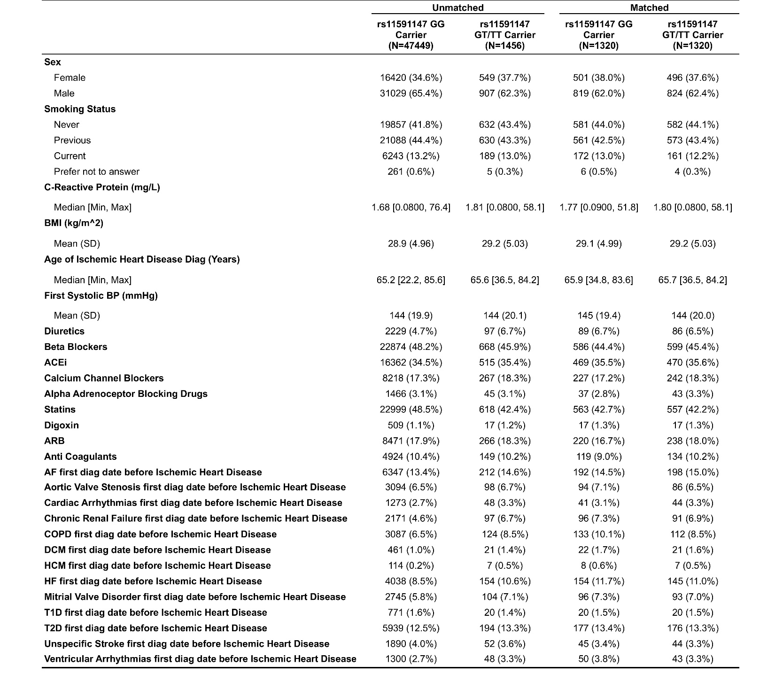

Supplemental Table 5. Demographic and clinical characteristics of patients by PCSK9 rs562556 genotype and matching status (unmatched vs. matched) included in analysis of time to CV outcome from first IHD diagnosis.
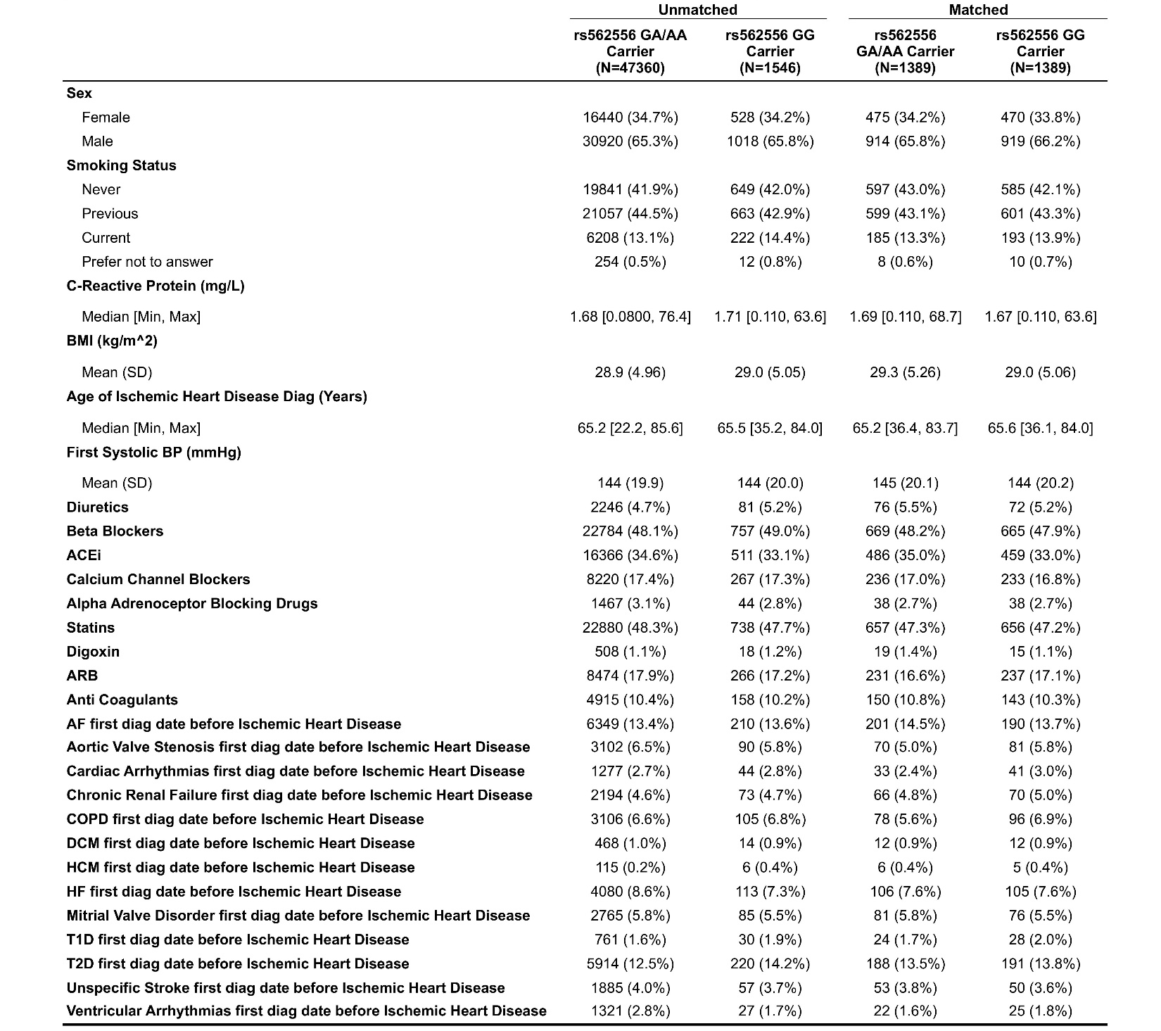

Supplemental Table 6. Demographic and clinical characteristics of patients by ADRB1 rs7076938 genotype and matching status (unmatched vs. matched) included in analysis of time to CV outcome from first AF diagnosis.
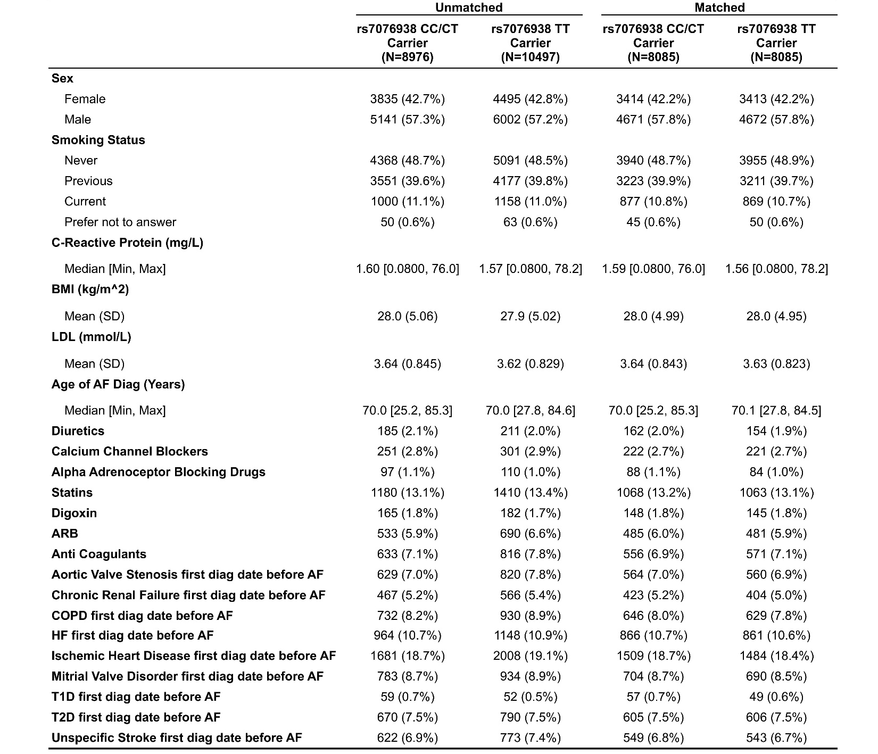

Supplemental Table 7. Demographic and clinical characteristics of patients by ADRB1 rs7076938 genotype and matching status (unmatched vs. matched) included in analysis of time to AF rehospitalization or CV composite outcome from first AF diagnosis.
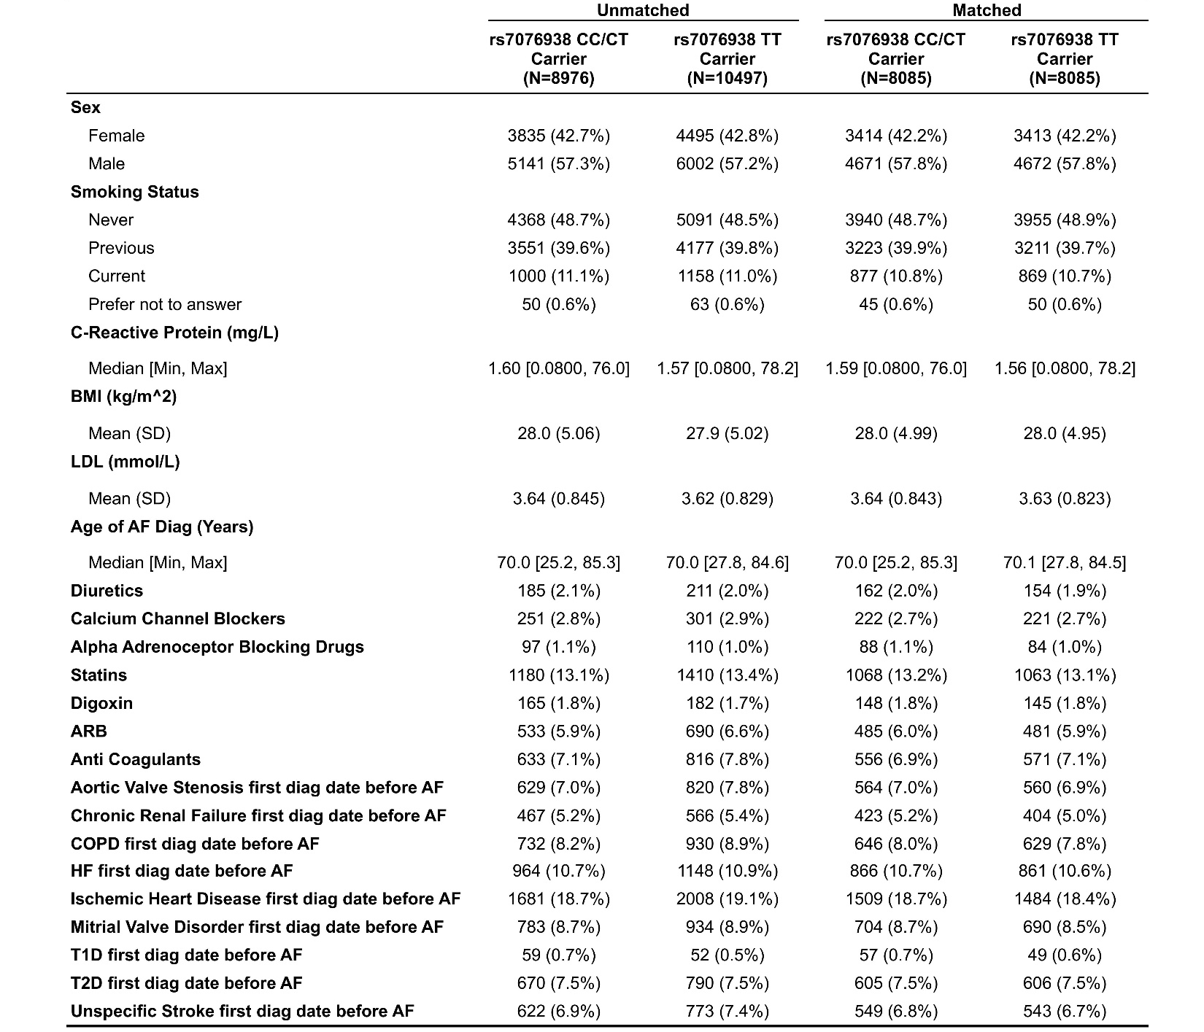

Supplemental Table 8. Demographic and clinical characteristics of patients by ACE rs4968782 genotype and matching status (unmatched vs. matched) included in analysis on time to CV outcome from first AF diagnosis.
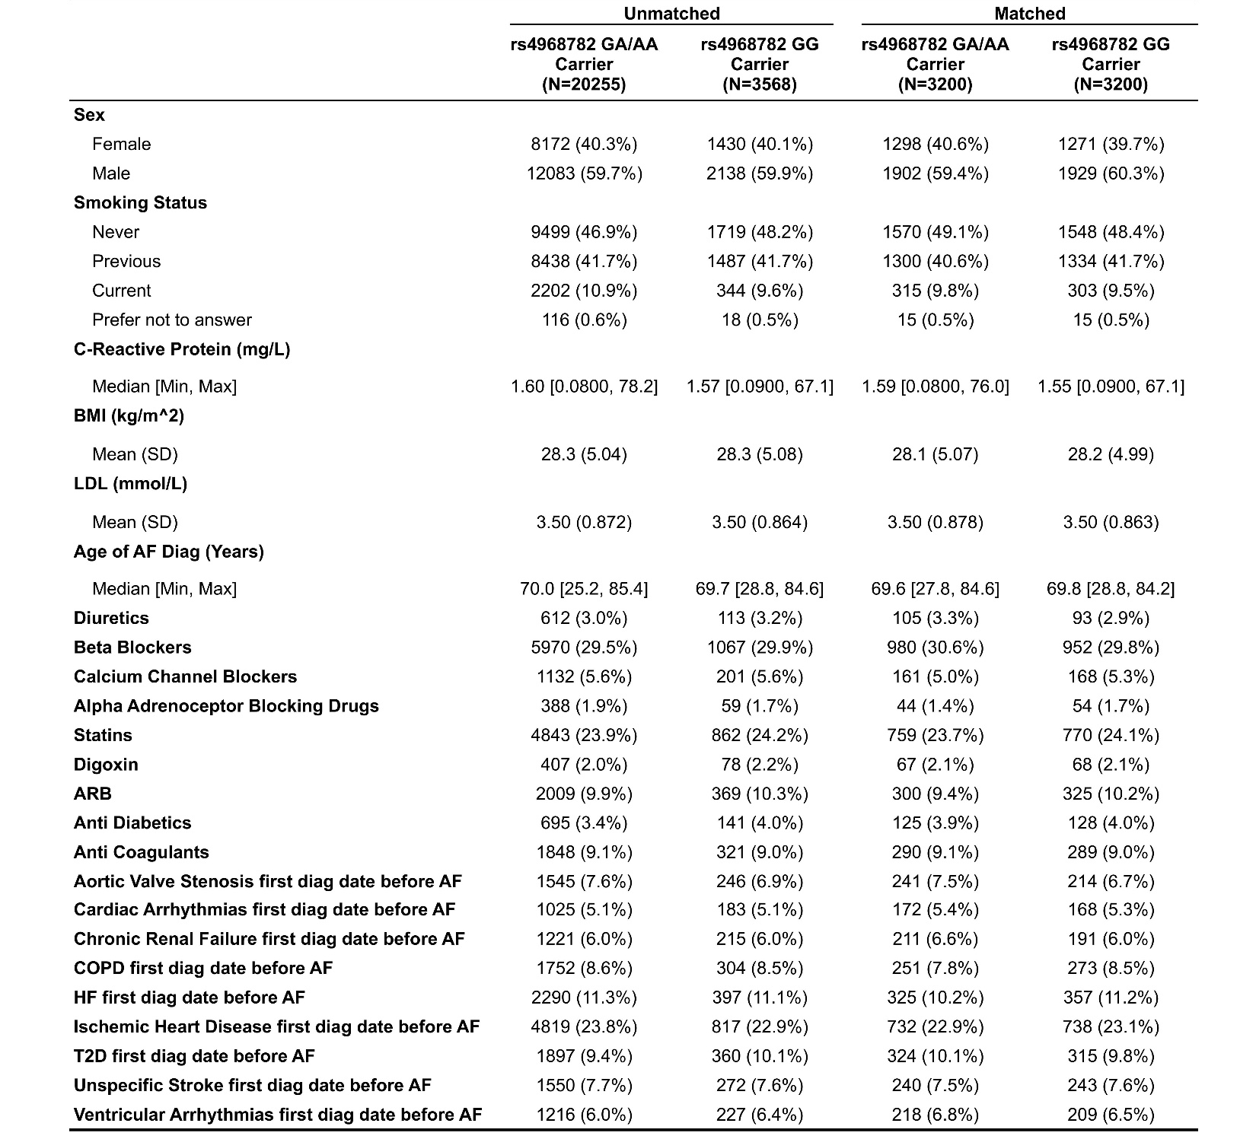

Supplemental Table 9. Demographic and clinical characteristics of patients by ACE rs4968782 genotype and matching status (unmatched vs. matched) included analysis on time to AF rehospitalization/CV composite outcome from first AF diagnosis.
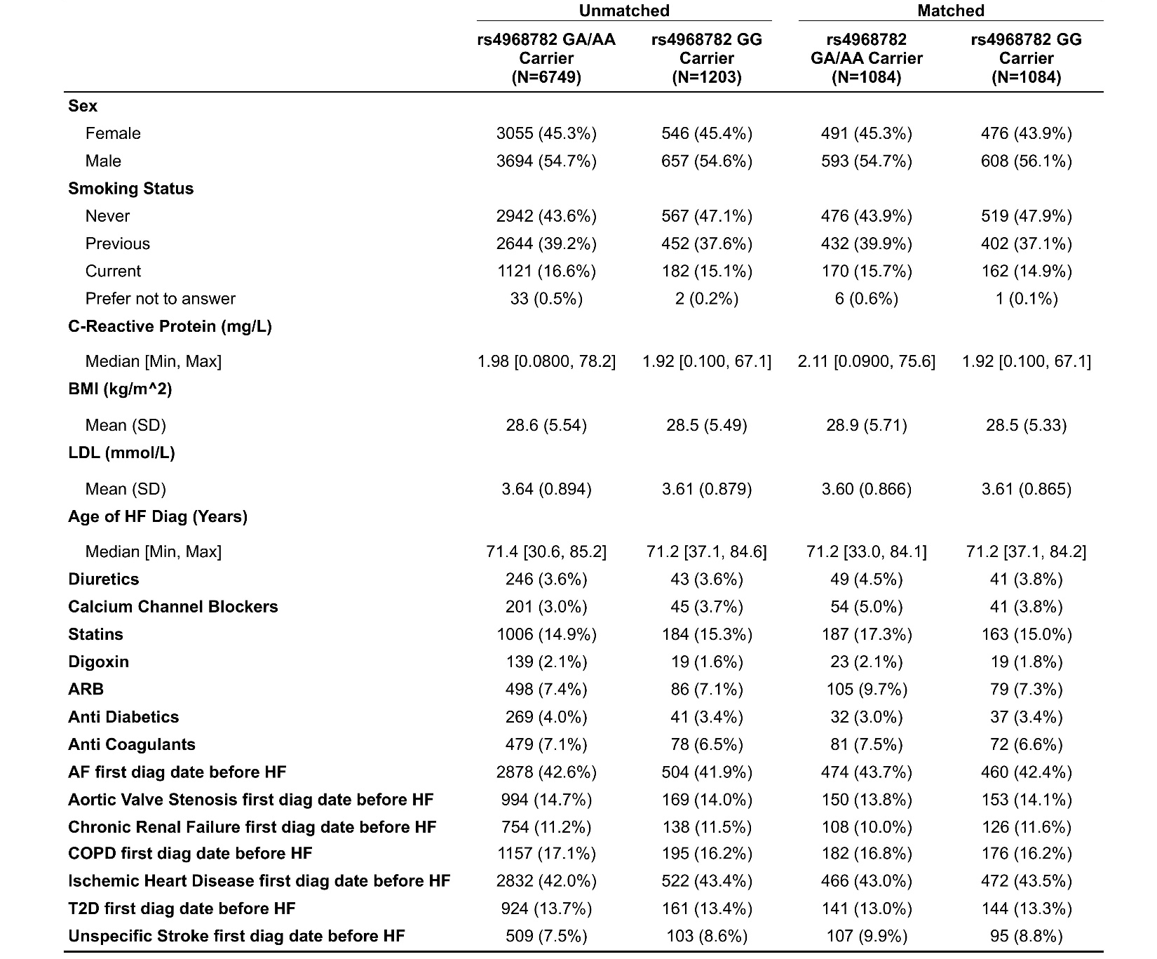

Supplemental Table 10. Demographic and clinical characteristics of patients by ACE rs4363 genotype and matching status (unmatched vs. matched) included in analysis on time to CV outcome from first AF diagnosis.
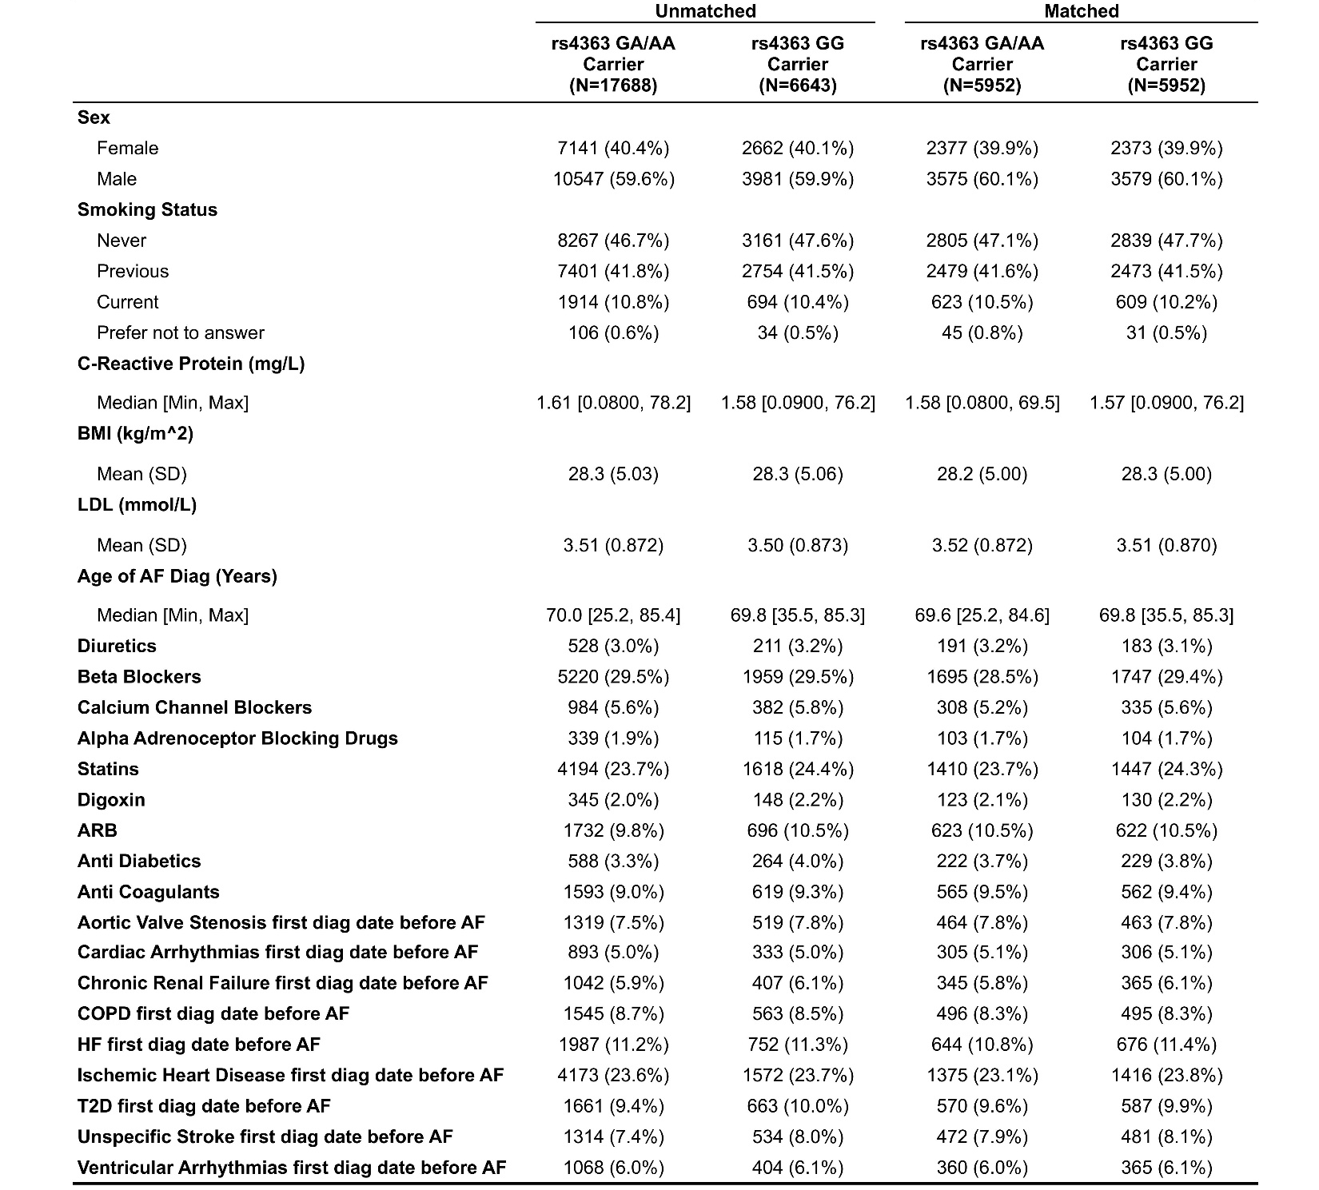

Supplemental Table 11. Demographic and clinical characteristics of patients by ACE rs4363 genotype and matching status (unmatched vs. matched) included in analysis on time to AF rehospitalization/CV composite outcome from first AF diagnosis.
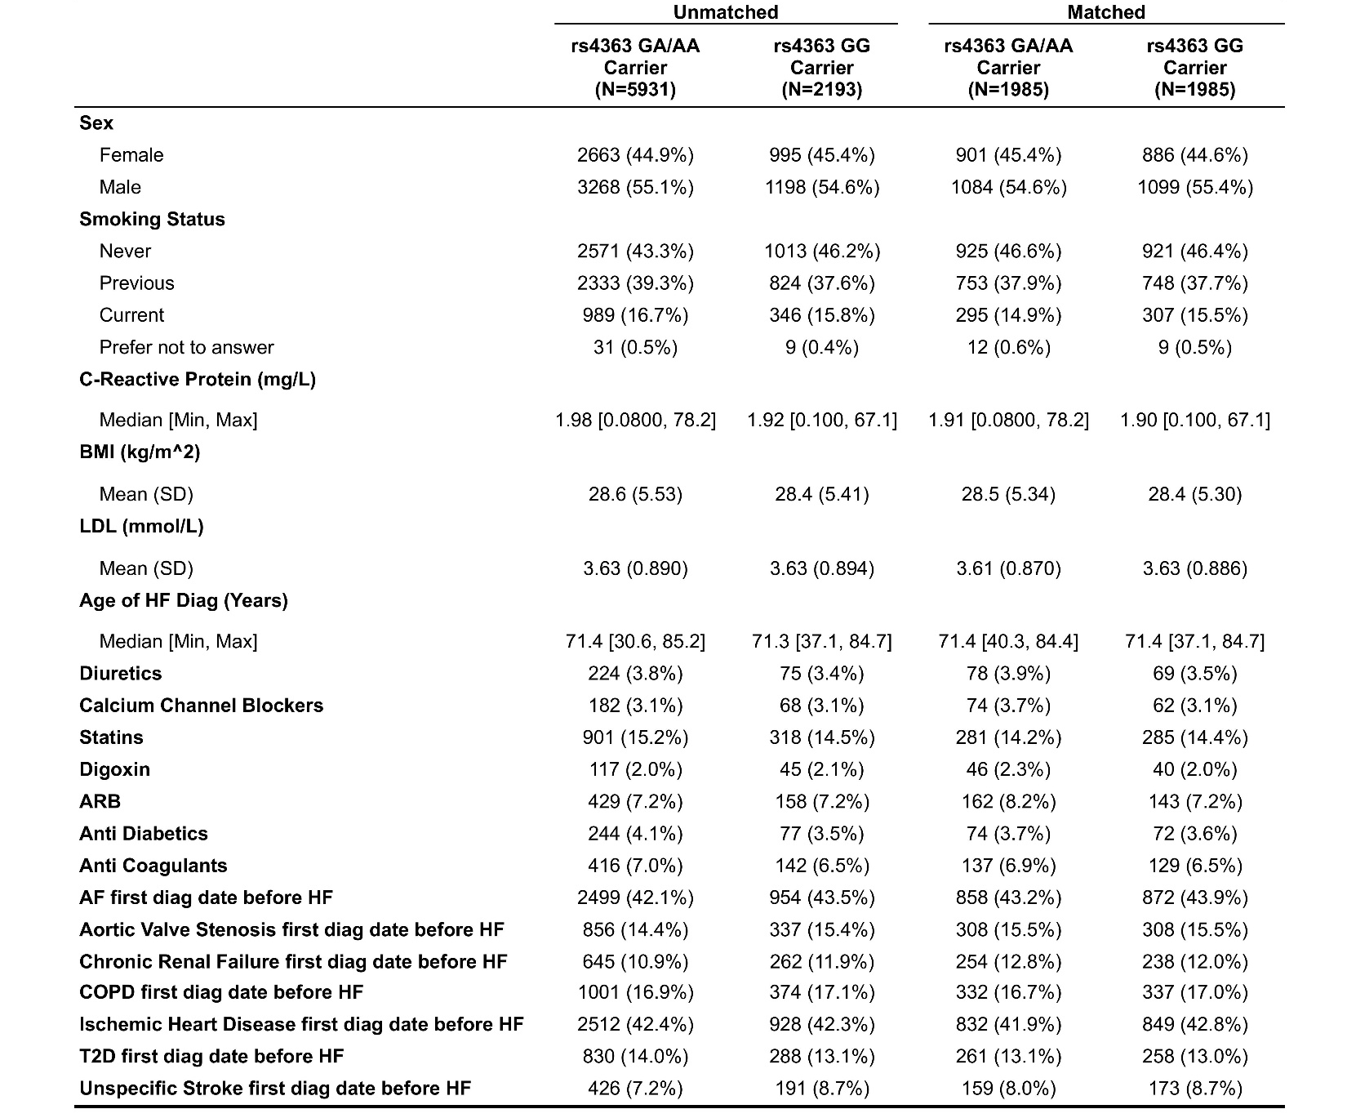

Supplemental Table 12. Demographic and clinical characteristics of patients by ABCC8 rs757110 genotype and matching status (unmatched vs. matched) included in analysis on time to CV outcome from first IHD diagnosis.
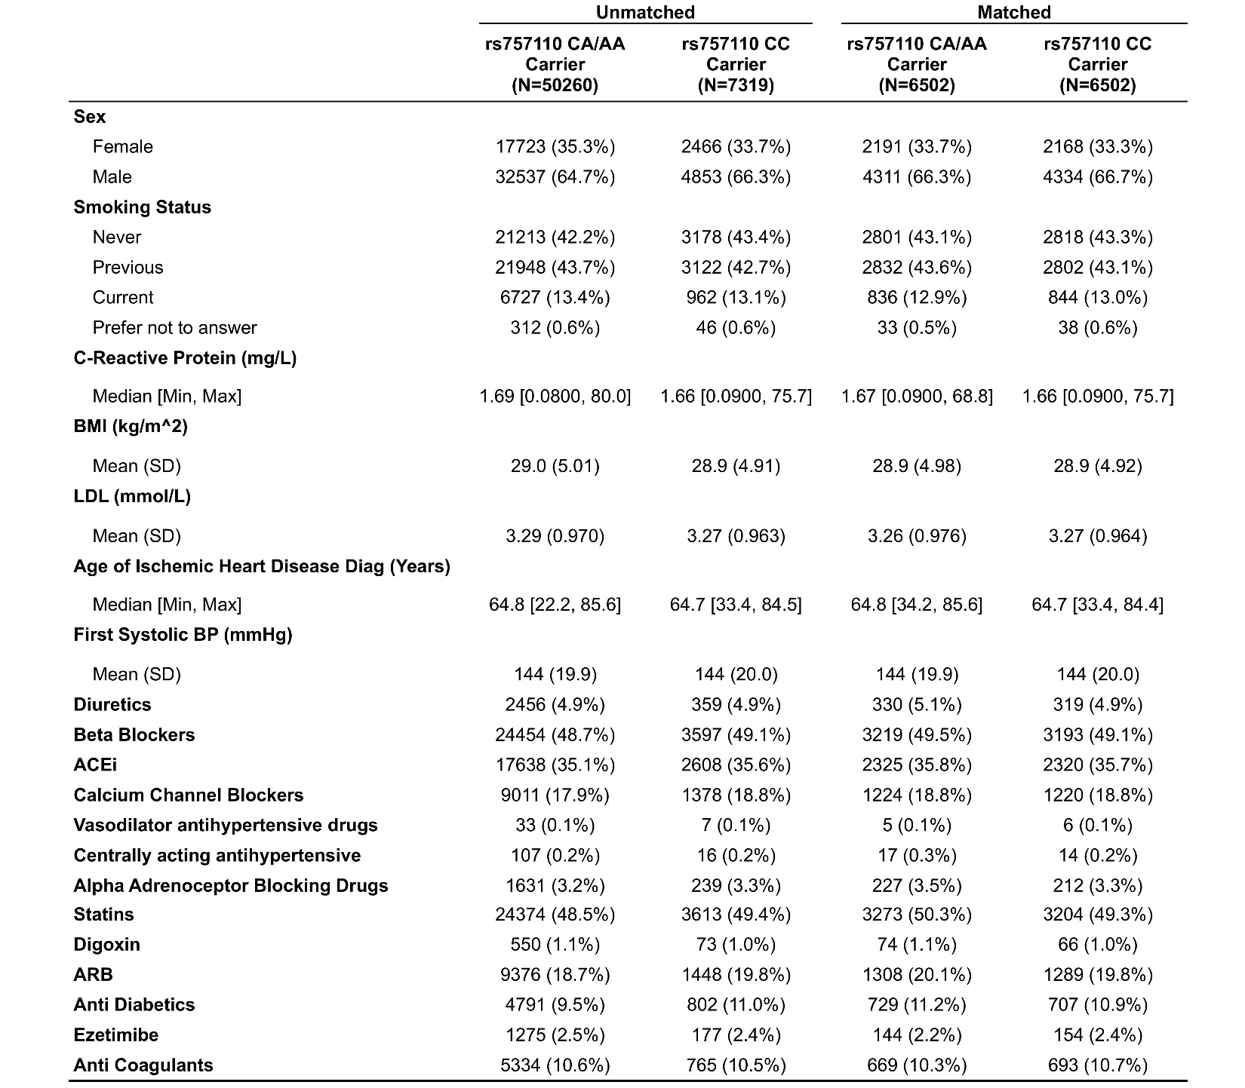

Supplemental Table 13. Demographic and clinical characteristics of diabetic patients by ABCC8 rs757110 genotype and matching status (unmatched vs. matched) included in analysis on time to AF hospitalization or CV outcome from first IHD diagnosis.
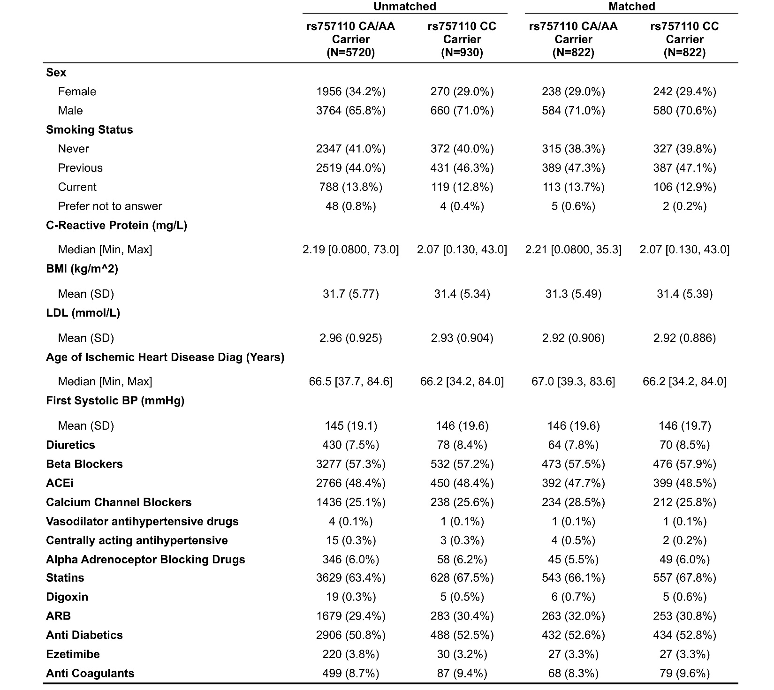

Supplemental Table 14. Demographic and clinical characteristics of diabetic patients by GLP1R rs10305492 genotype and matching status (unmatched vs. matched) included in analysis on time to AF hospitalization or CV outcome from first IHD diagnosis.
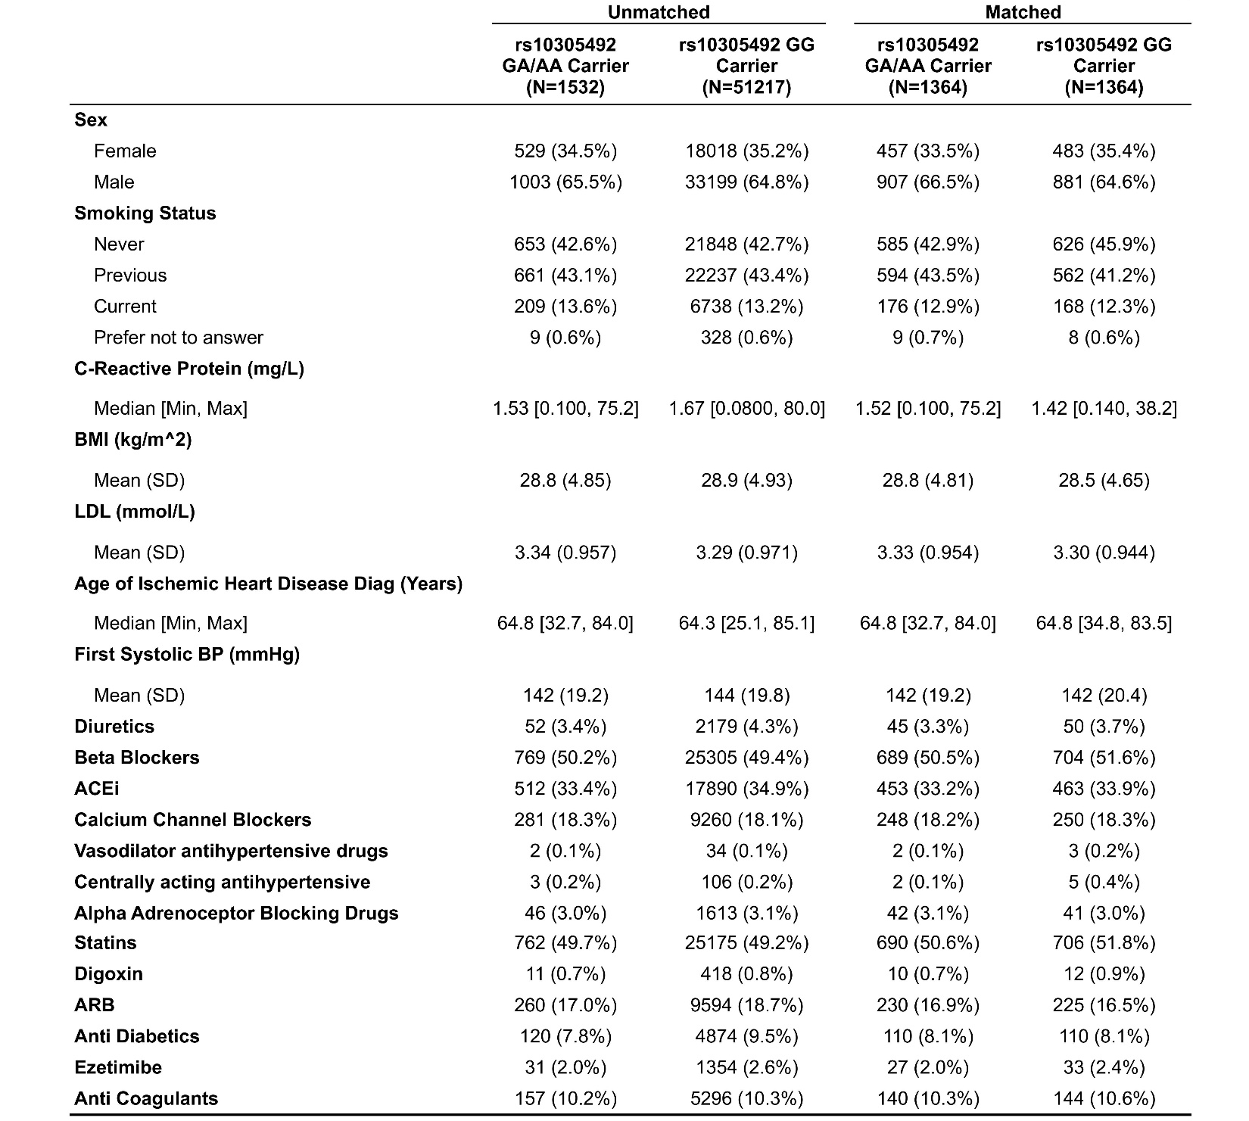
Supplemental Table 15. Additional sub-population analysis for GLP1R and ABCC8.
Gene | Matched | Start | Endpoint | Population | N events/N total | Heterozygous | Homozygous
GLP1R | No | Ischemic Heart Disease | CV death | All | 5414/57582 | HR=0.9; P=0.23 | HR=1.48; P=0.58
GLP1R | Yes | Ischemic Heart Disease | CV death | All | 272/2994 | HR=0.87; P=0.255 | HR=0.91; P=0.924
GLP1R | No | Ischemic Heart Disease | HF/CV death composite | T2D Patients | 1753/6916 | HR=0.96; P=0.797 | HR=2.32; P=0.235
GLP1R | Yes | Ischemic Heart Disease | HF/CV death composite | T2D Patients | 83/308 | HR=0.81; P=0.34 | HR=0.8; P=0.823
GLP1R | No | Ischemic Heart Disease | HF/CV death composite | Non-T2D | 5730/39949 | HR=0.84; P=0.033 | HR=0.75; P=0.77
GLP1R | Yes | Ischemic Heart Disease | HF/CV death composite | Non-T2D | 284/2136 | HR=0.87; P=0.25 | HR=1.0; P=1.0
GLP1R | No | Ischemic Stroke | Ischemic Stroke Rehospitalization/CV death composite | All | 2615/9640 | HR=0.884; P=0.15 | HR=1.35; P=0.77
GLP1R | Yes | Ischemic Stroke | Ischemic Stroke Rehospitalization/CV death composite | All | 131/516 | HR=0.93; P=0.66 | HR=1.38; P=0.75
GLP1R | No | Atrial Fibrillation | Atrial Fibrillation Progression | All | 270/304 | HR=0.93; P=0.83 | HR=0.51; P=0.5
ABCC8 | No | Type 2 Diabetes | CV Mortality | All | 3685/41141 | HR=0.97; P=0.58 | HR=1.0; P=0.95
ABCC8 | Yes | Type 2 Diabetes | CV Mortality | All | 939/10110 | HR=1.05; P=0.53 | HR=1.03; P=0.72
ABCC8 | No | Type 2 Diabetes | Ischemic Stroke/CV death composite | All | 4346/40227 | HR=1.02; P=0.627 | HR=1.04; P=0.37
ABCC8 | Yes | Type 2 Diabetes | Ischemic Stroke/CV death composite | All | 1040/9892 | HR=1.0; P=0.99 | HR=0.93; P=0.39
ABCC8 | No | Type 2 Diabetes | Atrial Fibrillation/CV death composite | All | 6030/37356 | HR=0.96; P=0.35 | HR=0.98; P=0.65
ABCC8 | Yes | Type 2 Diabetes | Atrial Fibrillation/CV death composite | All | 1517/9220 | HR=0.96; P=0.53 | HR=0.91; P=0.16
ABCC8 | No | Type 2 Diabetes | HF/CV death composite | All | 8949/52746 | HR=0.95; P=0.1 | HR=0.98; P=0.59
ABCC8 | Yes | Type 2 Diabetes | HF/CV death composite | All | 2101/11794 | HR=1.01; P=0.84 | HR=1.02; P=0.67
SNPs were tested in additive model, adjusted for age at recruitment, sex and 10 PCs if unmatched, with follow-up time of 15 years.

Supplemental Figure 1. Matching results for PCSK9 11591147 in individuals of European ancestry. Love plot indicates shift towards 0 in absolute standardized mean difference, representing successful matching. Asterisk (*) indicates variables for which the displayed value is the raw (unstandardized) difference in means.

a) | b)
Supplemental Figure 2. Propensity score matching results for ADRB1 rs7076938 for a) time to cardiovascular (CV) death/heart transplant from first atrial fibrillation diagnosis (AF), and b) time to rehospitalization or CV death/heart transplant due to AF. A shift towards 0 for absolute standardized mean difference indicates improvement in differences between populations carrying specific alleles.

a) | b)
Supplemental Figure 3. Propensity score matching results for ACE rs4968782 for a) time to cardiovascular (CV) death/heart transplant from first atrial fibrillation (AF) diagnosis in individuals of European ancestry, and b) time to HF rehospitalization or CV death/heart transplant since the first available all-cause heart failure (HF) diagnosis in participants of all continental ancestries. A shift towards 0 for absolute standardized mean difference represents successful matching.

a)  HR= 1.01; P=0.342 | b)  HR= 1.06; P=0.641
Supplemental Figure 4. Effect of PCSK9 rs562556 on time to cardiovascular (CV) death/heart transplant from first ischemic heart disease (IHD) diagnosis in a) unmatched and b) matched individuals of European ancestry. The time variable represents years to outcome while the allele variable represents control and treatment groups (those with GG genotype versus those with GA/AA genotype).

Supplemental Figure 5. Matching results for PCSK9 rs562556 in individuals of European ancestry. Shift towards 0 in absolute standardized mean difference indicates successful matching. Asterisk (*) indicates variables for which the displayed value is the raw (unstandardized) difference in means.

a)  HR (AA) = 0.97; P=0.197 | b)  HR (AA) = 0.95; P=0.170
c)  HR= 1.01; P=0.887 | d)  HR= 1.04; P=0.449
Supplemental Figure 6. Effect of ACE rs4363 on time to cardiovascular (CV) death/heart transplant from first atrial fibrillation (AF) diagnosis in a) unmatched and b) matched individuals of European ancestry, and time to HF rehospitalization or CV death/heart transplant since first all cause heart failure (HF) diagnosis in c) unmatched and d) matched in participants of all continental ancestries. The time variable represents years to severe cardiovascular outcome (death or transplant) while the allele variable represents control and treatment groups (GG genotype versus GA/AA genotype).

a) | b)
Supplemental Figure 7. Propensity score matching results for ACE rs4363 for a) time to cardiovascular (CV) death/heart transplant from first atrial fibrillation (AF) diagnosis in individuals of European ancestry, and b) time to rehospitalization or CV death/heart transplant due to HF/ CV death composite (HF) in participants of all continental ancestries. A shift towards 0 for absolute standardized mean difference represents successful matching.

a) | b)
Supplemental Figure 8. Propensity score matching results for ABCC8 rs757110 for a) time to cardiovascular (CV) death/heart transplant from first ischemic heart disease (IHD) diagnosis, and b) time to first atrial fibrillation (AF) hospitalization or CV death/heart transplant from first IHD diagnosis in diabetic patients (all continental ancestries). A shift towards 0 for absolute standardized mean difference represents successful matching.

Supplemental Figure 9. Matching results for GLP1R rs10305492. Shift towards 0 in absolute standardized mean difference indicates successful matching. Asterisk (*) indicates variables for which the displayed value is the raw (unstandardized) difference in means.

Supplemental Figure 10. PheWAS results for PCSK9 rs11591147 which includes all participants with available genotype data and adjusted for sex, age of recruitment, and ten genetic principal components.
Supplemental Figure 11. PheWAS results for PCSK9 rs562556. Analysis for all participants with available genotype data, adjusted for sex, age of recruitment, and 10 genetic principal components.

Supplemental Figure 12. PheWAS results for ADRB1 rs7076938. Analysis for all participants with available genotype data, adjusted for sex, age of recruitment, and 10 genetic principal components.
Supplemental Figure 13. PheWAS results for ACE rs4968782. Analysis for all participants with available genotype data, adjusted for sex, age of recruitment, and 10 genetic principal components.

Supplemental Figure 14. PheWAS results for ACE rs4363. Analysis for all participants with available genotype data, adjusted for sex, age of recruitment, and 10 genetic principal components.

Supplemental Figure 15. PheWAS results for ABCC8 rs757110. Analysis for all participants with available genotype data, adjusted for sex, age of recruitment, and 10 genetic principal components.

Supplemental Figure 16. PheWAS results for GLP1R rs10305492. Analysis for all participants with available genotype data, adjusted for sex, age of recruitment, and 10 genetic principal components. Unlabeled green dot representing our most significant finding was “Average Number of Times Bowels Opened per Day” (ukb code 21044), with a p-value rounded to 0 by R and beta of 0.00023.

