TableS1: Weighted Multivariable adjusted models of biomarkers associated with the prevalence of hypertension.
 | Imputation data1 |  | Imputation data2 |  | Imputation data3 |  | Imputation data4 |  | Imputation data5
 | OR (95%CI) | P value | OR (95%CI) | P value | OR (95%CI) | P value | OR (95%CI) | P value | OR (95%CI) | P value
Weight | 1.0051280 (1.0047126 ~ 1.0055437) | <.001 | 1.0051359 (1.0047300 ~ 1.0055419) | <.001 | 1.0051015 (1.0046887 ~ 1.0055144) | <.001 | 1.0050988 (1.0046883 ~ 1.0055095) | <.001 | 1.0051418 (1.0047252 ~ 1.0055585) | <.001
BMI | 1.0153417 (1.0140015 ~ 1.0166837) | <.001 | 1.0153839 (1.0140642 ~ 1.0167053) | <.001 | 1.0153262 (1.0139924 ~ 1.0166618) | <.001 | 1.0152838 (1.0139519 ~ 1.0166174) | <.001 | 1.0153655 (1.0140265 ~ 1.0167062) | <.001
WC | 1.0066516 (1.0061075 ~ 1.0071961) | <.001 | 1.0067106 (1.0061720 ~ 1.0072494) | <.001 | 1.0066864 (1.0061245 ~ 1.0072486) | <.001 | 1.0066528 (1.0061082 ~ 1.0071977) | <.001 | 1.0066606 (1.0061130 ~ 1.0072086) | <.001
WWI | 1.1096987 (1.0956657 ~ 1.1239115) | <.001 | 1.1117566 (1.0975413 ~ 1.1261561) | <.001 | 1.1119567 (1.0971469 ~ 1.1269664) | <.001 | 1.1108839 (1.0968153 ~ 1.1251329) | <.001 | 1.1075522 (1.0938598 ~ 1.1214161) | <.001
WHtR | 2.9677289 (2.6960016 ~ 3.2668434) | <.001 | 3.0055520 (2.7334619 ~ 3.3047262) | <.001 | 2.9992349 (2.7175268 ~ 3.3101457) | <.001 | 2.9698455 (2.6980184 ~ 3.2690593) | <.001 | 2.9682075 (2.6969227 ~ 3.2667811) | <.001
TyG | 1.1173235 ( 1.1027066 ~ 1.1321341) | <.001 | 1.1128090 (1.0971637 ~ 1.1286773) | <.001 | 1.1112893 (1.0961304 ~ 1.1266578) | <.001 | 1.1142050 (1.0988428 ~ 1.1297820) | <.001 | 1.1124020 (1.0978223 ~ 1.1271754) | <.001
TyG-BMI | 1.0016729 (1.0015392 ~ 1.0018066) | <.001 | 1.0016658 (1.0015307 ~ 1.0018010) | <.001 | 1.0016557 (1.0015192 ~ 1.0017922) | <.001 | 1.0016586 (1.0015235 ~ 1.0017937) | <.001 | 1.0016664 (1.0015309 ~ 1.0018020) | <.001
TyG-WC | 1.0006644 (1.0006143 ~ 1.0007144) | <.001 | 1.0006632 (1.0006114 ~ 1.0007151) | <.001 | 1.0006587 (1.0006058 ~ 1.0007115) | <.001 | 1.0006612 (1.0006098 ~ 1.0007126) | <.001 | 1.0006608 (1.0006093 ~ 1.0007122) | <.001
TyG-Weight | 1.0005637 (1.0005207 ~ 1.0006067) | <.001 | 1.0005612 (1.0005177 ~ 1.0006047) | <.001 | 1.0005575 (1.0005137 ~ 1.0006013) | <.001 | 1.0005591 (1.0005157 ~ 1.0006025) | <.001 | 1.0005627 (1.0005192 ~ 1.0006063) | <.001
TyG-WHtR | 1.1160641 (1.1063888 ~ 1.1258240) | <.001 | 1.1159767 (1.1060086 ~ 1.1260345) | <.001 | 1.1151336 (1.1049546 ~ 1.1254063) | <.001 | 1.1153015 (1.1054066 ~ 1.1252850) | <.001 | 1.1150941 (1.1051658 ~ 1.1251116) | <.001

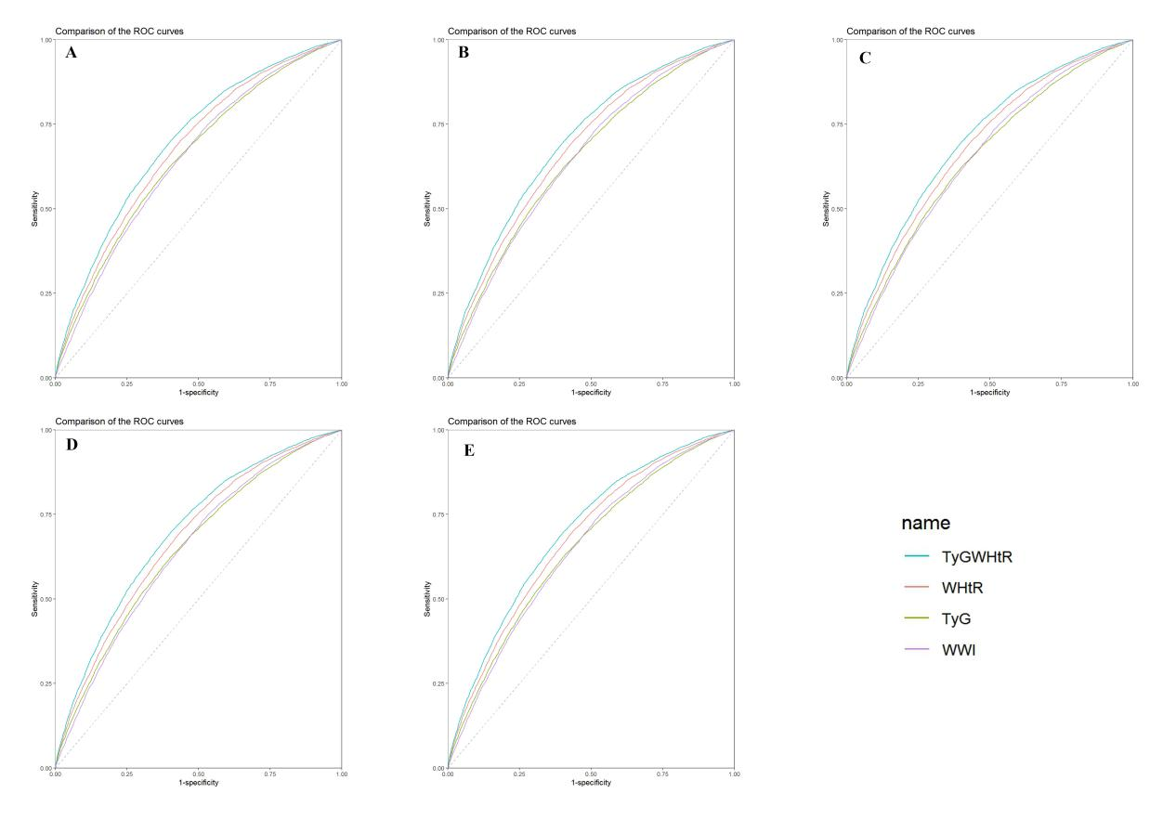
Figure S1 presents the ROC curves for five imputed datasets. The results indicate that TyG WHtR demonstrated the best predictive performance across all datasets.

Analysis in elderly individuals (aged > 60)
Table S2: Weighted Multivariable adjusted models of biomarkers associated with the prevalence of hypertension in elderly aged over 60.
 | Model
 | OR (95%CI) | P value
Weight | 1.0031495 (1.0021420 ~ 1.0041581) | <.001
BMI | 1.0096718 (1.0066373 ~ 1.0127154) | <.001
WC | 1.0040912 (1.0027633 ~ 1.0054209) | <.001
WWI | 1.0598183 (1.0289556 ~ 1.0916068) | <.001
WHtR | 1.9889759 (1.5957471 ~ 2.4791053) | <.001
TyG | 1.0639308 (1.0371157 ~ 1.0914393) | <.001
TyG-BMI | 1.0010492 (1.0007408 ~ 1.0013577) | <.001
TyG-WC | 1.0004059 (1.0002842 ~ 1.0005276) | <.001
TyG-Weight | 1.0003468 (1.0002451 ~ 1.0004486) | <.001
TyG-WHtR | 1.0706708 (1.0489782 ~ 1.0928121) | <.001
Model: Adjust: Gender, Age, Race, Education, Marital status, PIR, Drinking, Smoking, CHF, CHD, Diabetes, Depression, Sedentary Activity, Serum Sodium, Potassium, Creatinine, Sodium Intake, Potassium Intake.

Table S3: ROC curves for biomarkers to improve the identification of hypertension in elderly aged over 60.
 | WWI | WHtR | TyG | TyG-WHtR
AUC (95%CI) | 0.5692  (0.5495 ~ 0.5889) | 0.5977  (0.6660 ~ 0.6850) | 0.5527  (0.533 ~ 0.5724) | 0.5964  (0.577 ~ 0.6157)
P for AUC | <0.001 | <0.001 | <0.001 | <0.001
P for comparison | <0.001 | 0.7508 | <0.001 | Reference
NRI, Categorical  (95%CI) | -0.0213  (-0.0363 ~ -0.0063) | 0.001  (-0.0107 ~ 0.0127) | -0.0308  (-0.0467 ~ -0.0148) | Reference
P | 0.00535 | 0.86873 | 0.00016
NRI, Continuous  (95%CI) | -0.1874  (-0.2556 ~-0.1192) | -0.0438  (-0.1125 ~ 0.0248) | -0.2772  (-0.3447 ~ -0.2097) | Reference
P | <0.001 | 0.21086 | <0.001
IDI  (95%CI) | -0.0087  (-0.0112 ~ -0.0062) | 0  (-0.0016 ~ 0.0015) | -0.0138  (-0.0167 ~ -0.011) | Reference
P | <0.001 | 0.97183 | <0.001

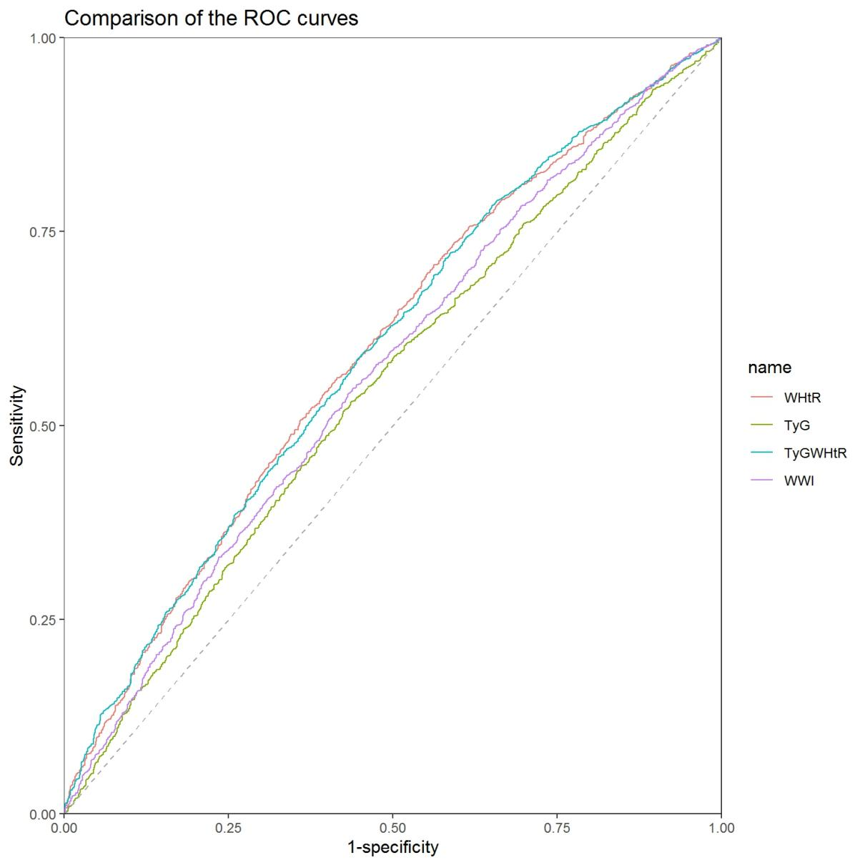
Figure S2. Comparison of ROC curves for WWI, WHtR, TyG, and TyG-WHtR in elderly individuals aged 60 and older. The results indicated no significant difference between WHtR and TyG-WHtR.

