Supplementary Table 1: Age-Adjusted Mortality Rates (AAMR) from Obesity and Hypertension in the US by Gender (2000–2019).
Gender | Year | Age Adjusted Rate | Age Adjusted Rate Lower 95% Confidence Interval | Age Adjusted Rate Upper 95% Confidence Interval | Age Adjusted Rate Standard Error
Female | 2000 | 2.5266 | 2.4266 | 2.6266 | 0.051
Female | 2001 | 2.5508 | 2.4514 | 2.6503 | 0.0508
Female | 2002 | 2.9254 | 2.8199 | 3.0308 | 0.0538
Female | 2003 | 3.3051 | 3.1934 | 3.4168 | 0.057
Female | 2004 | 3.4436 | 3.3303 | 3.5569 | 0.0578
Female | 2005 | 3.6852 | 3.5692 | 3.8012 | 0.0592
Female | 2006 | 3.7926 | 3.6761 | 3.9092 | 0.0595
Female | 2007 | 3.9697 | 3.8509 | 4.0886 | 0.0606
Female | 2008 | 4.2446 | 4.123 | 4.3663 | 0.0621
Female | 2009 | 4.5726 | 4.4464 | 4.6988 | 0.0644
Female | 2010 | 4.7253 | 4.5981 | 4.8524 | 0.0649
Female | 2011 | 5.1617 | 5.0297 | 5.2936 | 0.0673
Female | 2012 | 5.5801 | 5.4434 | 5.7167 | 0.0697
Female | 2013 | 5.8476 | 5.7084 | 5.9868 | 0.071
Female | 2014 | 6.1036 | 5.9626 | 6.2445 | 0.0719
Female | 2015 | 6.5196 | 6.3745 | 6.6647 | 0.074
Female | 2016 | 6.8514 | 6.7035 | 6.9992 | 0.0754
Female | 2017 | 6.9167 | 6.7692 | 7.0643 | 0.0753
Female | 2018 | 7.1683 | 7.019 | 7.3175 | 0.0762
Female | 2019 | 7.5589 | 7.4064 | 7.7115 | 0.0778
Male | 2000 | 2.5781 | 2.4692 | 2.6871 | 0.0556
Male | 2001 | 2.6653 | 2.5557 | 2.7749 | 0.0559
Male | 2002 | 3.1579 | 3.0397 | 3.2761 | 0.0603
Male | 2003 | 3.5421 | 3.4186 | 3.6657 | 0.0631
Male | 2004 | 3.8667 | 3.7388 | 3.9946 | 0.0653
Male | 2005 | 4.2144 | 4.0823 | 4.3466 | 0.0674
Male | 2006 | 4.4526 | 4.318 | 4.5872 | 0.0687
Male | 2007 | 4.8895 | 4.7493 | 5.0297 | 0.0715
Male | 2008 | 5.2381 | 5.0942 | 5.382 | 0.0734
Male | 2009 | 5.8588 | 5.7084 | 6.0092 | 0.0767
Male | 2010 | 6.2634 | 6.1082 | 6.4186 | 0.0792
Male | 2011 | 6.8801 | 6.7185 | 7.0417 | 0.0825
Male | 2012 | 7.5021 | 7.3349 | 7.6693 | 0.0853
Male | 2013 | 7.9298 | 7.7589 | 8.1007 | 0.0872
Male | 2014 | 8.7178 | 8.5393 | 8.8963 | 0.0911
Male | 2015 | 9.3142 | 9.1318 | 9.4966 | 0.0931
Male | 2016 | 9.7771 | 9.5905 | 9.9637 | 0.0952
Male | 2017 | 10.3281 | 10.1381 | 10.5181 | 0.0969
Male | 2018 | 11.1045 | 10.9087 | 11.3003 | 0.0999
Male | 2019 | 11.7789 | 11.5781 | 11.9797 | 0.1025

Supplementary Figure 1: Age-adjusted Mortality Rates’ Annual Percentage Change (APC) from Obesity and Hypertension in the US by Gender (2000–2019).

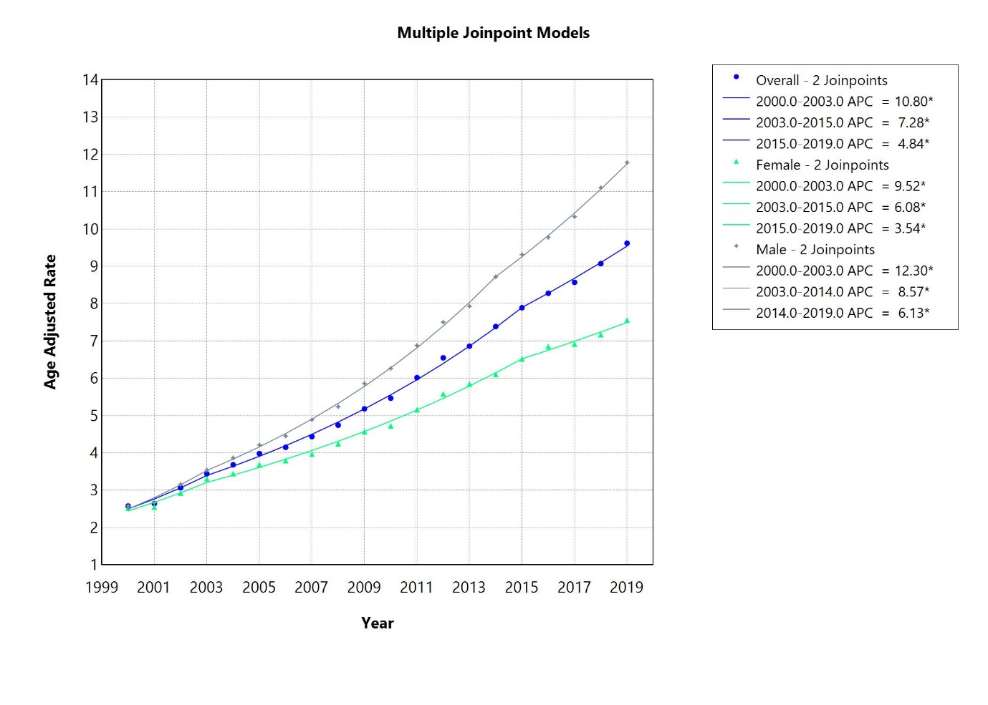

Supplementary Table 2: Age-Adjusted Mortality Rates (AAMR) from Obesity and Hypertension in the US by Race (2000–2019).
Year | Age-Adjusted Mortality Rate
Year | American Indian or Alaska Native | Asian or Pacific Islander | Black or African American | White | Hispanic or Latino
2000 | 2.352 | 0.472 | 5.8589 | 2.2754 | 1.6339
2001 | 2.1943 | 0.2671 | 6.0743 | 2.276 | 1.7655
2002 | 3.2138 | 0.5034 | 6.9884 | 2.6598 | 1.9474
2003 | 3.4592 | 0.6489 | 7.5683 | 3.0657 | 2.5278
2004 | 3.2441 | 0.6201 | 8.355 | 3.2088 | 2.4131
2005 | 3.993 | 0.9132 | 8.4353 | 3.5579 | 2.361
2006 | 5.0872 | 0.7941 | 8.5782 | 3.7198 | 2.9623
2007 | 4.0087 | 1.0619 | 8.968 | 3.9936 | 3.0675
2008 | 4.6478 | 1.3555 | 9.3141 | 4.3268 | 3.173
2009 | 7.1957 | 0.9531 | 10.23 | 4.7274 | 3.916
2010 | 6.2198 | 1.2205 | 10.5346 | 4.9876 | 3.9897
2011 | 5.7663 | 1.3325 | 11.1085 | 5.5428 | 4.3494
2012 | 7.2782 | 1.3244 | 12.0988 | 6.0274 | 4.522
2013 | 7.4591 | 1.1683 | 12.6306 | 6.3738 | 5.0657
2014 | 9.0548 | 1.553 | 13.1797 | 6.877 | 5.1849
2015 | 7.4264 | 1.9633 | 14.2718 | 7.3031 | 5.3803
2016 | 9.6899 | 1.6131 | 14.8787 | 7.6987 | 5.7508
2017 | 8.8822 | 1.9072 | 14.7587 | 8.0456 | 5.842
2018 | 9.9976 | 1.9815 | 15.6508 | 8.5349 | 5.904
2019 | 11.1966 | 2.0345 | 16.6469 | 8.9968 | 6.3345

Supplementary Figure 2: Age-adjusted Mortality Rates’ Annual Percentage Change (APC) from Obesity and Hypertension in the US by Race (2000–2019).
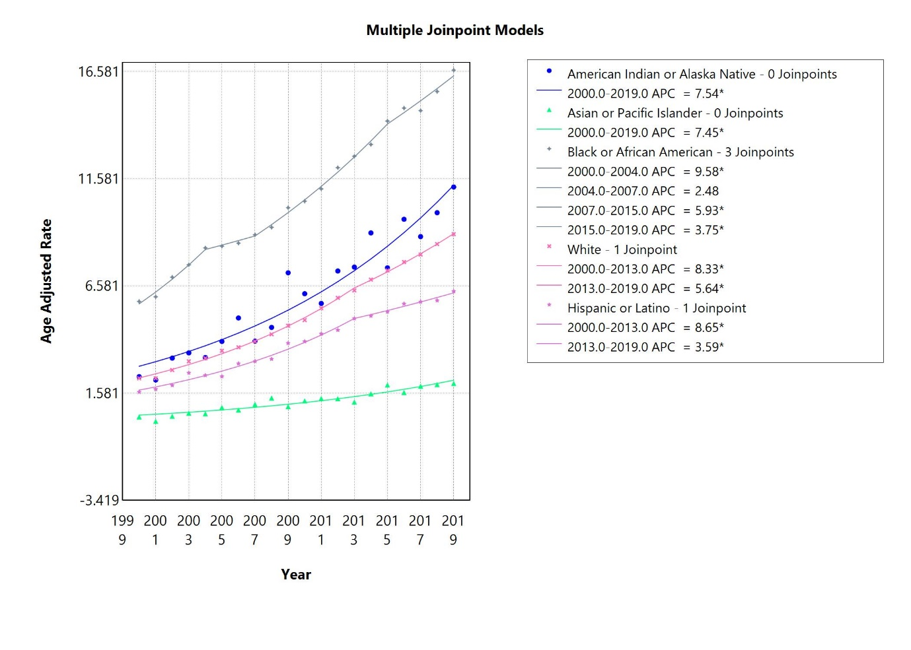

Supplementary Table 3: Age-Adjusted Mortality Rates from Obesity and Hypertension in the US by Metropolitan Status (2000–2019).
Urbanization | Year | Deaths | Age Adjusted Rate | Age Adjusted Rate Lower 95% Confidence Interval | Age Adjusted Rate Upper 95% Confidence Interval | Age Adjusted Rate Standard Error
Metropolitan | 2000 | 3801 | 2.5765 | 2.4946 | 2.6585 | 0.0418
Metropolitan | 2001 | 3979 | 2.6148 | 2.5335 | 2.6961 | 0.0415
Metropolitan | 2002 | 4669 | 3.0041 | 2.9179 | 3.0904 | 0.044
Metropolitan | 2003 | 5420 | 3.4317 | 3.3402 | 3.5233 | 0.0467
Metropolitan | 2004 | 5833 | 3.6128 | 3.5198 | 3.7058 | 0.0475
Metropolitan | 2005 | 6399 | 3.8489 | 3.7542 | 3.9436 | 0.0483
Metropolitan | 2006 | 6841 | 4.0663 | 3.9694 | 4.1632 | 0.0494
Metropolitan | 2007 | 7547 | 4.3701 | 4.2709 | 4.4694 | 0.0506
Metropolitan | 2008 | 8136 | 4.6382 | 4.5366 | 4.7397 | 0.0518
Metropolitan | 2009 | 9140 | 5.1043 | 4.9986 | 5.21 | 0.0539
Metropolitan | 2010 | 9777 | 5.3718 | 5.2642 | 5.4795 | 0.0549
Metropolitan | 2011 | 10900 | 5.895 | 5.7827 | 6.0073 | 0.0573
Metropolitan | 2012 | 12042 | 6.3721 | 6.2566 | 6.4877 | 0.0589
Metropolitan | 2013 | 12910 | 6.7208 | 6.6029 | 6.8387 | 0.0602
Metropolitan | 2014 | 14048 | 7.1924 | 7.0712 | 7.3136 | 0.0618
Metropolitan | 2015 | 15324 | 7.6586 | 7.5349 | 7.7823 | 0.0631
Metropolitan | 2016 | 16291 | 8.0619 | 7.9352 | 8.1885 | 0.0646
Metropolitan | 2017 | 17137 | 8.3127 | 8.1852 | 8.4401 | 0.065
Metropolitan | 2018 | 18365 | 8.7867 | 8.6565 | 8.9169 | 0.0664
Metropolitan | 2019 | 19490 | 9.2057 | 9.0731 | 9.3383 | 0.0676
Non-metropolitan | 2000 | 844 | 2.664 | 2.4835 | 2.8446 | 0.0921
Non-metropolitan | 2001 | 856 | 2.6867 | 2.5058 | 2.8677 | 0.0923
Non-metropolitan | 2002 | 1072 | 3.3352 | 3.1341 | 3.5364 | 0.1026
Non-metropolitan | 2003 | 1167 | 3.5579 | 3.3519 | 3.7638 | 0.1051
Non-metropolitan | 2004 | 1311 | 3.9614 | 3.7449 | 4.1779 | 0.1104
Non-metropolitan | 2005 | 1507 | 4.4679 | 4.2395 | 4.6963 | 0.1165
Non-metropolitan | 2006 | 1571 | 4.5756 | 4.3461 | 4.8051 | 0.1171
Non-metropolitan | 2007 | 1599 | 4.6365 | 4.4051 | 4.8679 | 0.1181
Non-metropolitan | 2008 | 1852 | 5.3058 | 5.0591 | 5.5524 | 0.1259
Non-metropolitan | 2009 | 2028 | 5.705 | 5.4509 | 5.9592 | 0.1297
Non-metropolitan | 2010 | 2131 | 5.9489 | 5.6891 | 6.2086 | 0.1325
Non-metropolitan | 2011 | 2395 | 6.6849 | 6.4086 | 6.9612 | 0.141
Non-metropolitan | 2012 | 2648 | 7.3815 | 7.0898 | 7.6732 | 0.1488
Non-metropolitan | 2013 | 2777 | 7.6761 | 7.3794 | 7.9728 | 0.1514
Non-metropolitan | 2014 | 3083 | 8.4274 | 8.117 | 8.7378 | 0.1584
Non-metropolitan | 2015 | 3321 | 9.0171 | 8.6961 | 9.3381 | 0.1638
Non-metropolitan | 2016 | 3507 | 9.4905 | 9.1601 | 9.821 | 0.1686
Non-metropolitan | 2017 | 3774 | 10.0552 | 9.7176 | 10.3928 | 0.1722
Non-metropolitan | 2018 | 4076 | 10.7168 | 10.3691 | 11.0645 | 0.1774
Non-metropolitan | 2019 | 4548 | 11.9117 | 11.5448 | 12.2787 | 0.1872

Supplementary Figure 3: Age-adjusted Mortality Rates’ Annual Percentage Change (APC) from Obesity and Hypertension in the US by Metropolitan Status (2000–2019).
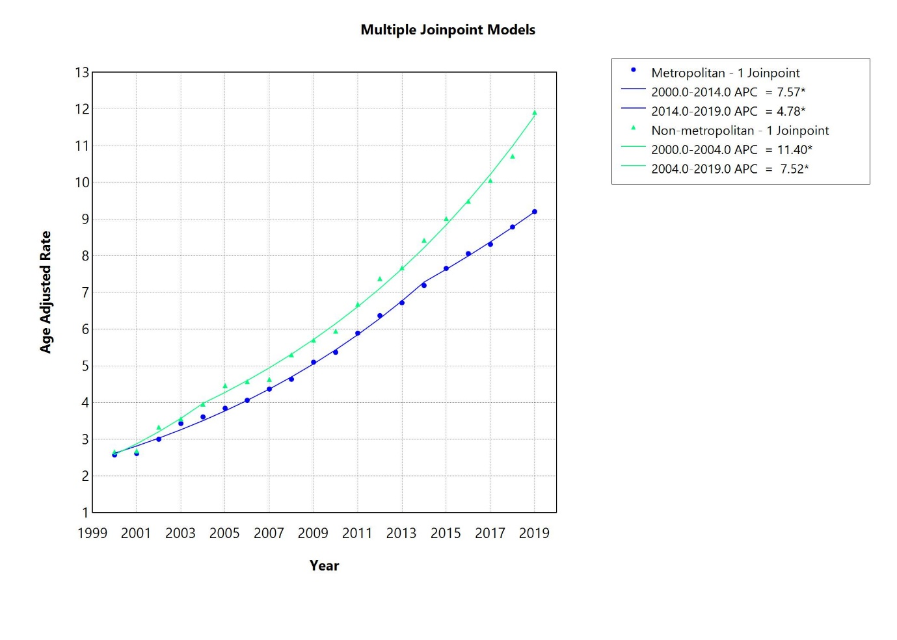

Supplementary Table 4: Age-Adjusted Mortality Rates from Obesity and Hypertension-only in the US (2000–2019).
UCOD | Year | Deaths | Population | Age Adjusted Rate | Age Adjusted Rate Lower 95% Confidence Interval | Age Adjusted Rate Upper 95% Confidence Interval | Age Adjusted Rate Standard Error
Hypertension | 2000 | 44551 | 181984640 | 24.9613 | 24.7295 | 25.1931 | 0.1183
Hypertension | 2001 | 46696 | 184305128 | 25.7272 | 25.4938 | 25.9605 | 0.1191
Hypertension | 2002 | 49638 | 186208028 | 26.9019 | 26.6652 | 27.1387 | 0.1208
Hypertension | 2003 | 53306 | 188090429 | 28.3729 | 28.1319 | 28.614 | 0.123
Hypertension | 2004 | 54621 | 190205384 | 28.6095 | 28.3693 | 28.8497 | 0.1226
Hypertension | 2005 | 57280 | 192551384 | 29.3803 | 29.1392 | 29.6213 | 0.123
Hypertension | 2006 | 56473 | 195019359 | 28.2885 | 28.0546 | 28.5224 | 0.1193
Hypertension | 2007 | 57653 | 197403777 | 28.2237 | 27.9924 | 28.4549 | 0.118
Hypertension | 2008 | 60905 | 199795090 | 29.204 | 28.9709 | 29.437 | 0.1189
Hypertension | 2009 | 61659 | 202107016 | 28.9073 | 28.6778 | 29.1369 | 0.1171
Hypertension | 2010 | 63034 | 203891983 | 29.0627 | 28.8341 | 29.2912 | 0.1166
Hypertension | 2011 | 65038 | 206592936 | 29.126 | 28.9001 | 29.3519 | 0.1153
Hypertension | 2012 | 68030 | 208826037 | 29.7288 | 29.5031 | 29.9545 | 0.1152
Hypertension | 2013 | 71864 | 211085314 | 30.7448 | 30.5174 | 30.9721 | 0.116
Hypertension | 2014 | 73263 | 213809280 | 30.7481 | 30.5226 | 30.9736 | 0.115
Hypertension | 2015 | 78786 | 216553817 | 32.3848 | 32.1555 | 32.6141 | 0.117
Hypertension | 2016 | 82641 | 218641417 | 33.3445 | 33.1138 | 33.5752 | 0.1177
Hypertension | 2017 | 89999 | 221447331 | 35.5465 | 35.3109 | 35.7821 | 0.1202
Hypertension | 2018 | 95789 | 223311190 | 37.119 | 36.8806 | 37.3573 | 0.1216
Hypertension | 2019 | 101994 | 224981167 | 38.8017 | 38.5603 | 39.0432 | 0.1232
Obesity | 2000 | 2938 | 181984640 | 1.6202 | 1.5616 | 1.6788 | 0.0299
Obesity | 2001 | 3076 | 184305128 | 1.6723 | 1.6131 | 1.7314 | 0.0302
Obesity | 2002 | 3613 | 186208028 | 1.9421 | 1.8787 | 2.0055 | 0.0323
Obesity | 2003 | 3944 | 188090429 | 2.0465 | 1.9825 | 2.1104 | 0.0326
Obesity | 2004 | 4144 | 190205384 | 2.1257 | 2.0608 | 2.1906 | 0.0331
Obesity | 2005 | 4569 | 192551384 | 2.2986 | 2.2316 | 2.3655 | 0.0342
Obesity | 2006 | 4664 | 195019359 | 2.3066 | 2.2401 | 2.3732 | 0.034
Obesity | 2007 | 4784 | 197403777 | 2.3635 | 2.296 | 2.431 | 0.0344
Obesity | 2008 | 4945 | 199795090 | 2.3882 | 2.3211 | 2.4553 | 0.0342
Obesity | 2009 | 5340 | 202107016 | 2.507 | 2.439 | 2.5751 | 0.0347
Obesity | 2010 | 5467 | 203891983 | 2.5515 | 2.4828 | 2.6201 | 0.035
Obesity | 2011 | 5879 | 206592936 | 2.7075 | 2.6372 | 2.7778 | 0.0359
Obesity | 2012 | 6115 | 208826037 | 2.7579 | 2.6875 | 2.8283 | 0.0359
Obesity | 2013 | 6369 | 211085314 | 2.8271 | 2.7564 | 2.8977 | 0.036
Obesity | 2014 | 6800 | 213809280 | 2.9951 | 2.9224 | 3.0678 | 0.0371
Obesity | 2015 | 7350 | 216553817 | 3.1946 | 3.1198 | 3.2693 | 0.0381
Obesity | 2016 | 7648 | 218641417 | 3.2949 | 3.2191 | 3.3707 | 0.0387
Obesity | 2017 | 7668 | 221447331 | 3.22 | 3.1459 | 3.294 | 0.0378
Obesity | 2018 | 7834 | 223311190 | 3.2381 | 3.1643 | 3.3119 | 0.0376
Obesity | 2019 | 8286 | 224981167 | 3.3851 | 3.31 | 3.4603 | 0.0384

Supplementary Figure 4: Age-adjusted Mortality Rates’ Annual Percentage Change (APC) from Obesity and Hypertension-only in the US (2000–2019).

